## Using Social Features in SharePoint 2013

**Lab Time**: 45 minutes

**Lab Folder**: C:\Student\Modules\Social

**Lab Overview:** In this lab you will update your profile, create and manage a blog site, post to your newsfeed on your personal site, create a team site for newsfeeds, and work with SkyDrive Pro syncing.

### Exercise 1: Update Your Profile

In this exercise you will learn how to update your profile information such as Basic Information, Contact Information, Personal Details, as well as update Newsfeed settings, and change profile permissions.

#### Log in to SharePoint Site

1. Make sure you have the login information for the SharePoint environment where you will work on your lab exercises. You should have received this log in information from the hosting training company or from your instructor.
2. Make sure you have the URL to the **Team Site** that has been created for you to do your lab work. This URL will be in a form that looks something like this.

https://cpt.atrackspace.com/sites/TeamSite_Student01

1. Launch the Internet Explorer and navigate to the URL of the Team Site mention in the previous step. Note that you should be logged in with a user account that has full control access to the site collection and therefore will be permitted access and create lists.
   1. When prompted to login, enter the user name and password that has been supplied to you and then click **OK**.

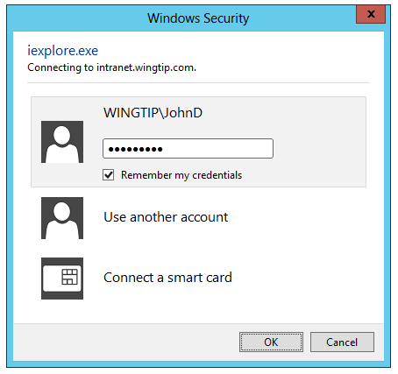

* 1. You should be able to confirm that you are logged into the SharePoint site. For example, if you were logged in as a student named **John Doe**, your name appears in the SharePoint Welcome menu as shown in the following screenshot.

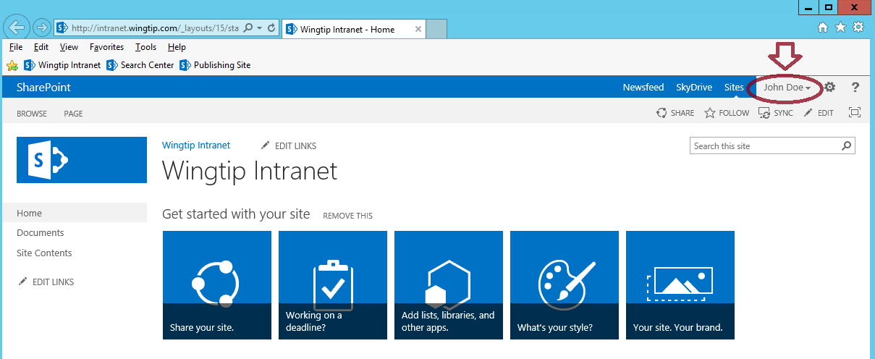

#### Edit Basic Information

1. Click on the logged in user name **John Doe** located to the left of the **Settings** icon and select **About Me**.

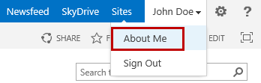

1. From the **Get the most out of SharePoint** dialog, ensure **Let’s get social** is selected and click **OK**.

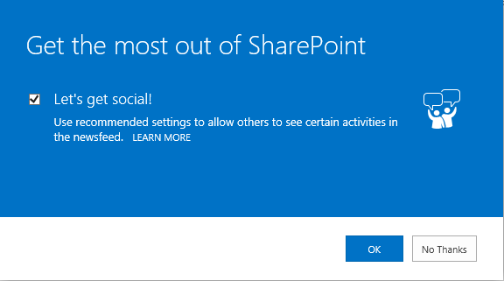

1. In the left navigation click on **About me**.

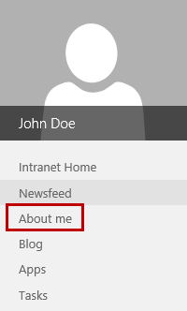

1. From the **About John Doe** page, click on **edit** your profile.

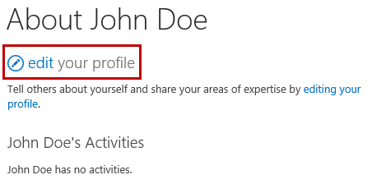

1. From the **Basic Information** panel, place your cursor in the **About me** multi-line text box and type a desired description about yourself.

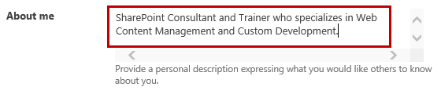

1. Upload a profile picture:
   1. In the **Picture** section, click the **Upload** **picture** button.

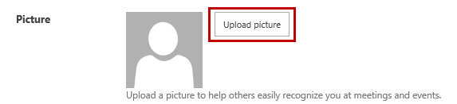

* 1. From the **Choose a picture** dialog click **Browse…**

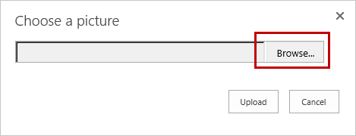

* 1. Navigate to **C:\Student\Modules\Social**. Select **John Doe.jpg** and click **Open**.
  2. From the **Choose a picture** dialog, click **Upload**.
  3. Notice the picture is uploaded and a thumbnail is displayed.

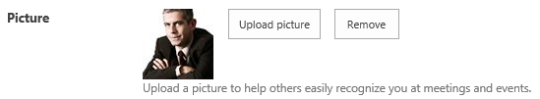

1. In the **Ask Me About** text box, type some topics such as **Workflows; InfoPath; SharePoint Designer** and then click the **Save all and close** button.

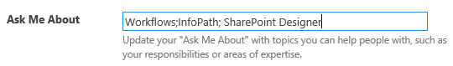

1. From the **Profile Changes** dialog, click **OK**.
2. Once the profile is updated you should see the updated changes.

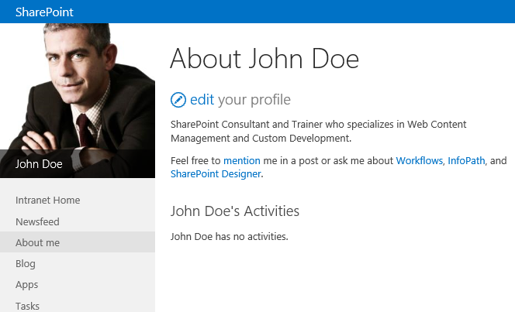

#### Edit Contact Information

1. Go back into edit profile mode. From the **About John Doe** page, click on **edit** your profile.
2. Click the **Contact Information** link.



1. In the **Mobile** **phone** text box, type in a fake phone number.

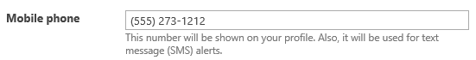

1. Set any other desired values and when finished, click **Save all and close**.
2. From the **Profile Changes** dialog, click **OK**.
3. On the right-hand side of the page click on **SHOW MORE**.The Mobile phone and any other contact information you updated should now display on the page.

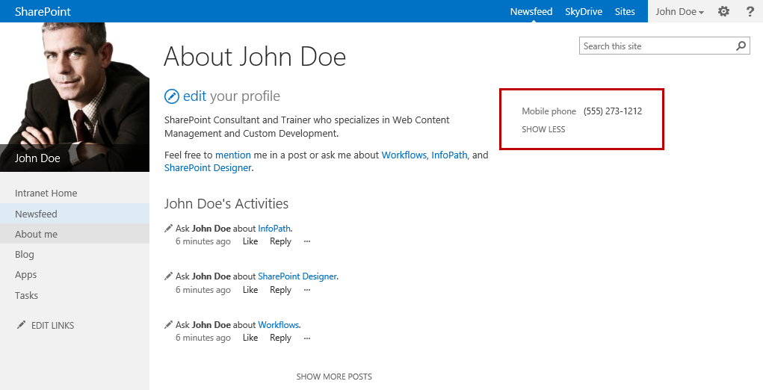

#### Edit Personal Details

1. Go back into edit profile mode. From the **About John Doe** page, click on **edit** your profile.
2. Click the **Details** link.



1. Update the values for the desired properties.

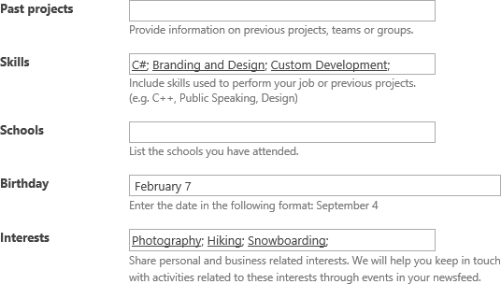

1. Once all desired updates are complete, click **Save all and close**.
2. From the **Profile Changes** dialog, click **OK**.
3. On the right-hand side of the page click on **SHOW MORE** to see the additional details.

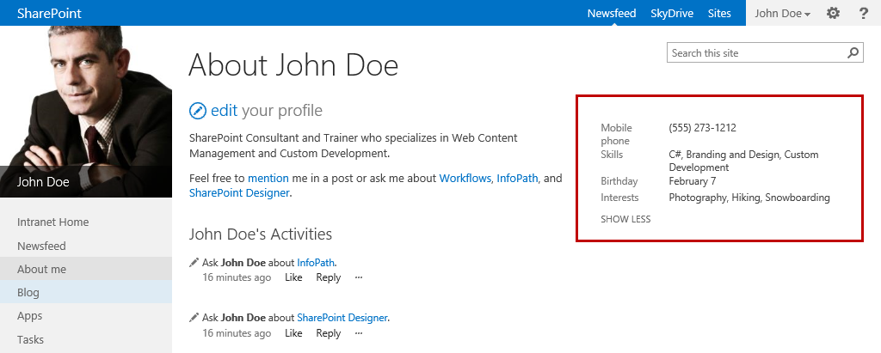

#### Update Newsfeed Settings

1. Go back into edit profile mode. From the **About John Doe** page, click on **edit** your profile.
2. Click the **ellipse (…)** and select **Newsfeed Settings**.

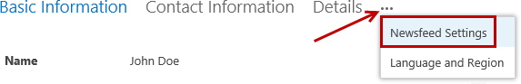

1. In the **Followed #Tags** text box, type any desired tags such as **#workflow;#infopath**.



1. In the **Email Notifications** section, deselect any desired options you want to disable.

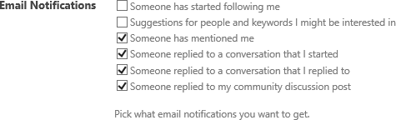

1. Update the People I follow and the Activities I want to share in my newsfeed as desired.

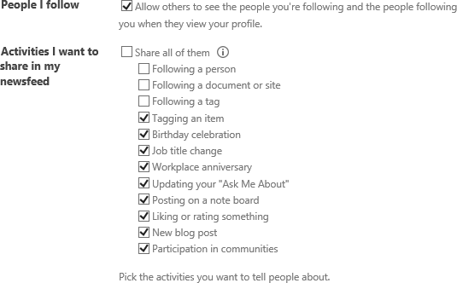

1. Once all desired updates are complete, click **Save all and close**.
2. From the **Profile Changes** dialog, click **OK**.

#### Update Profile Privacy Settings

1. Go back into edit profile mode. From the **About John Doe** page, click on **edit** your profile.
2. Select any of the desired profile links such as **Newsfeed Settings**. Change the **Who can see this?** option for any of the desired properties.

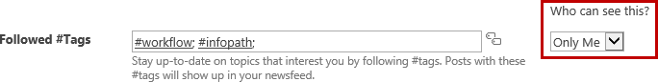

1. Once all desired updates are complete, click **Save all and close**.

### Exercise 2: Create and Manage a Blog

In this exercise you will learn how to create a blog site, use categories for blog posts, manage the blog post layout, and create new blog posts.

#### Create a Blog Site

1. Navigate to the Site Contents.
   1. Click on the **Settings** icon and select **Site contents**.
2. Click **+** **new subsite**.

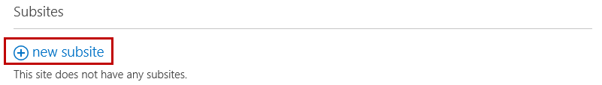

1. From the New SharePoint Site page:
   1. Set the **Title** to **Blog** **Site**.

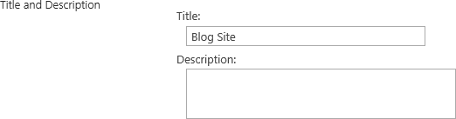

* 1. Set the **URL** to **blogsite**.



* 1. Under **Select a template**, select **Blog**.

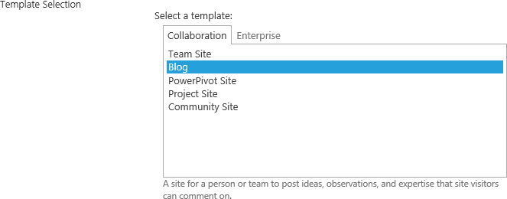

* 1. Leave all other options set to the default and click **Create**.

1. Once the site is created, the Blog Site will open by default.

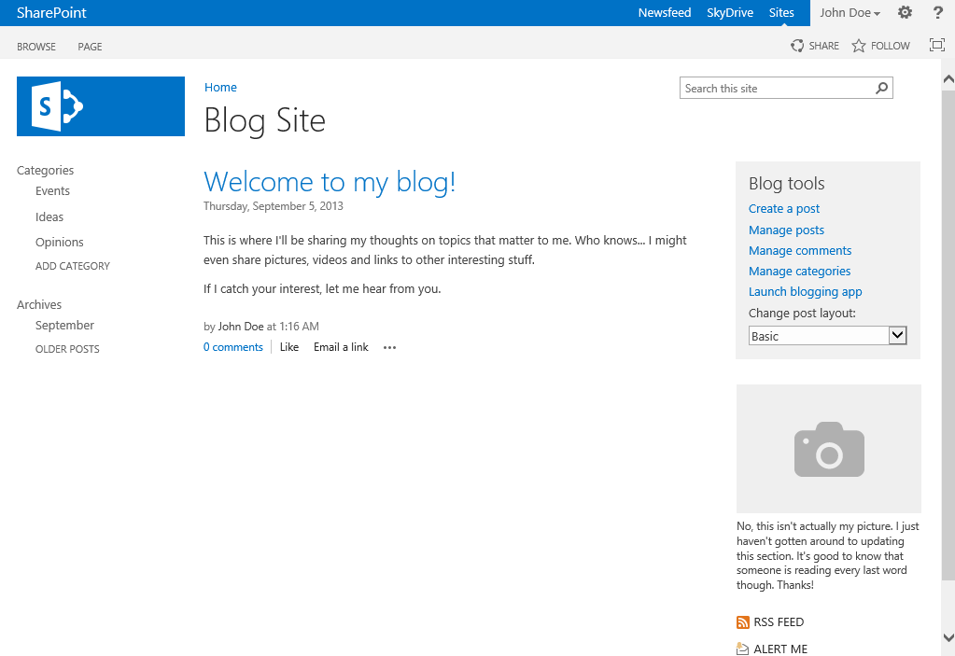

#### Manage Blog Categories

1. From the home page of the **Blog Site** under **Blog tools**, click on the **Manage categories** link.

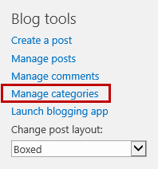

1. Notice the **Categories** list already contains three pre-defined categories (**Ideas**, **Opinions**, and **Events**).

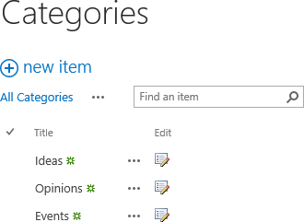

**Note:** You can keep the default categories as is or rename the ones you don’t want. You can also add new categories to the Categories list. Due to a limitation in the item limit of the Categories Summary View, it is recommended to keep the categories to a limit of 30. The Item Limit for the default Summary View cannot be changed, otherwise it will break the Blog Site. This is a known bug that existed in previous versions of SharePoint, and it has not been fixed in SharePoint 2013.

1. To modify an existing category item:
   1. Click the **Edit** icon next to the item you want to modify.

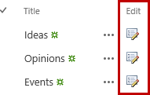

* 1. Replace the value in the **Title** text field to desired value and then click **Save**.

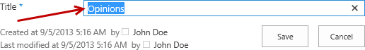

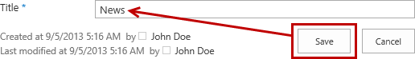

1. Notice the category item **Opinions** was renamed to **News**.

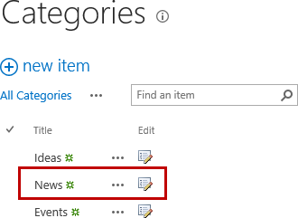

1. To add a new category:
   1. Click **+ new item**.
   2. In the **Title** text box, type a value such as **Training** and then click **Save**.

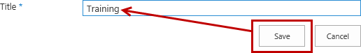

1. Notice the new item has been added.

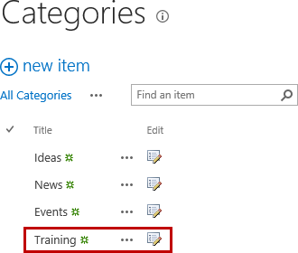

#### Manage Blog Post Layout

1. From the home page of your Blog Site under **Blog tools**, select **Boxed** in the **Change post layout** drop-down menu.

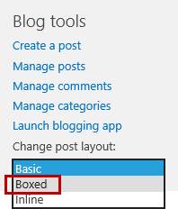

1. Notice the post layout changed to Boxed.

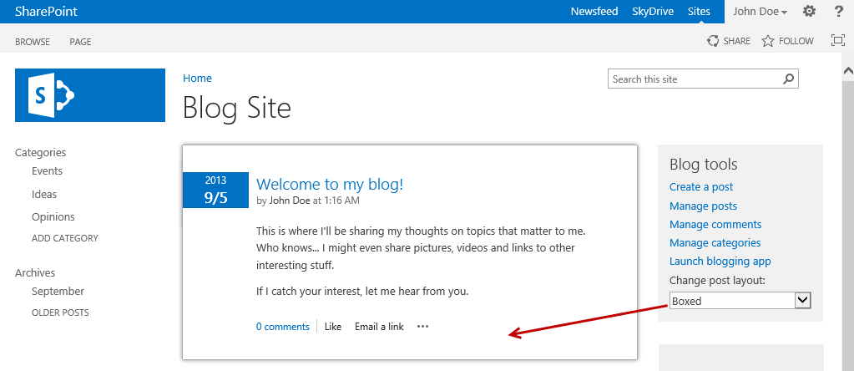

1. Now change the post layout to **Inline**. Under **Blog tools**, select **Inline** in the **Change post layout** drop-down menu.

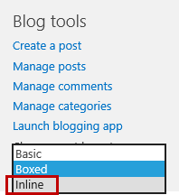

1. Notice the post layout changed to Boxed.

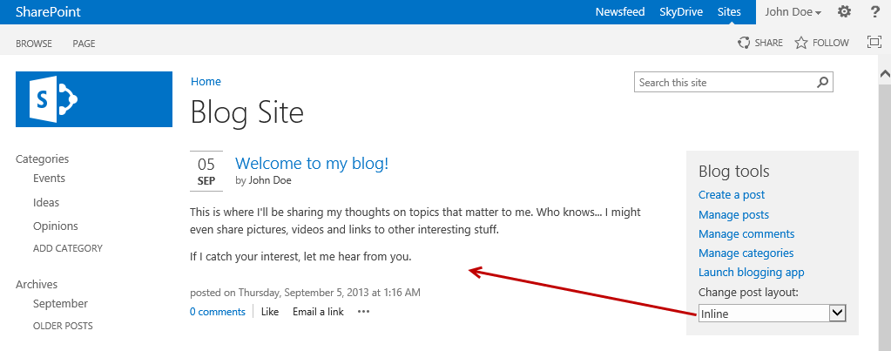

1. Now set **Change post layout** to whichever style you prefer (**Basic**, **Boxed**, or **Inline**).

#### Create Blog Post

1. From the home page of the **Blog Site** under **Blog tools**, click on the **Create a post** link.

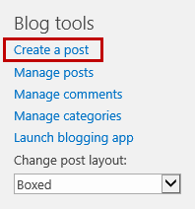

1. From the New Post page:
   1. In the **Title** text box, type a desired value for your blog title.



* 1. In the **Body**, type some text and change the formatting of the text using the options available in the **FORMAT TEXT** tab similar to how you update text in Word 2013.

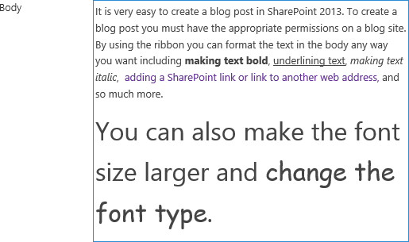

* 1. In the **Category** list, select a desired category value and then click **Add**.

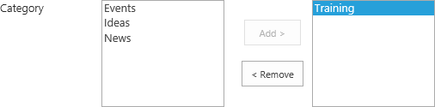

**Note:** Posts can be assigned to a single category or to multiple categories. To assign multiple categories to the post, hold down the **control** key and select the additional values you want to assign and then click **Add**. To remove an assigned category, select the category in the right multi-select box and click **Remove**.

1. Set the **Published** date and time and then click **Publish**.



1. Notice the new blog post is now posted.

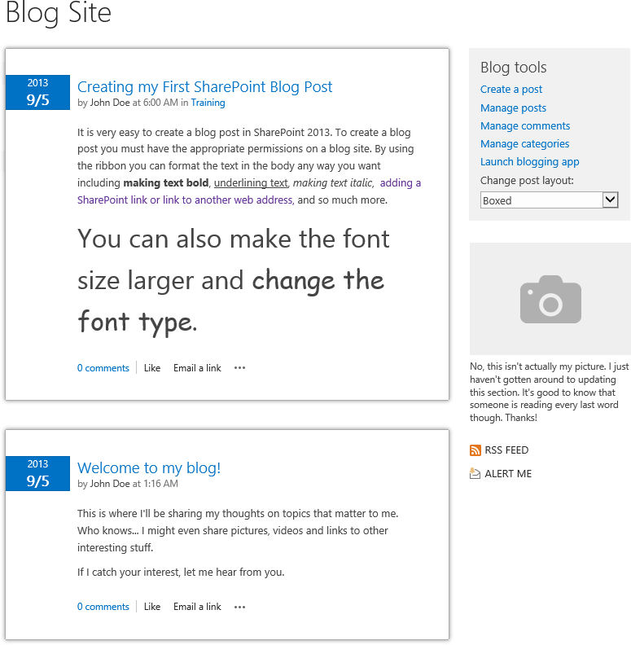

**Note:** The blogs posts are sorted by the Published date in descending order. Depending on the date you set for Published will determine if the post will display before or after the other existing posts. The Published date can be modified anytime for all posts.

1. To filter blog posts, click on a category from the **Categories** navigation menu and notice the posts displayed are only the posts assigned to the selected category.

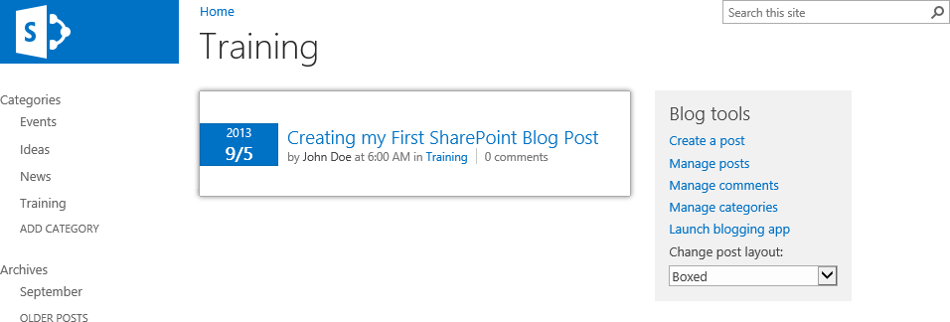

### Exercise 3: Post to Newsfeed

In this exercise you will learn how to post a newsfeed to everyone and add pictures, videos, links, and tags to a newsfeed post.

#### Create Newsfeed Post for Everyone

You can start conversations with people in your organization by posting to a newsfeed, either on your personal site or in team site newsfeeds. In this step, you will post a newsfeed on your personal site.

1. Click on the logged in user name **John Doe** located to the left of the **Settings** icon and select **About Me**.



1. From the **About John Doe** page in the left navigation, click **Newsfeed**.

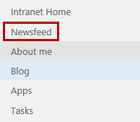

1. To start a conversation, click in the **Start a conversation** box.

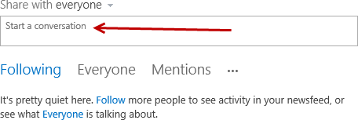

1. Similar to posting on a Facebook wall, start typing your message and then click **Post**.

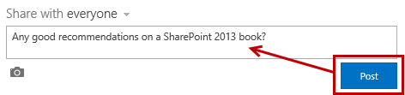

1. Once posted, the new conversation will show up in the **Newsfeed** and in the **About Me John Doe’s Activity** feed. Users can then **Like** or **Reply** to your post just like they can on Facebook wall posts. You can also reply to your own post just by clicking on **Reply**.

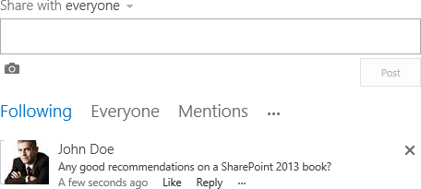

#### Add Picture to a Newsfeed Post

1. Click in the **Start a conversation** box
2. Click on the **picture** icon below the box.

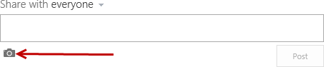

1. From the **Choose a picture** dialog, click **Browse**.

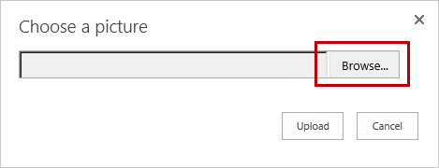

1. Navigate to **C:/Student/Social**. Click on the **NewsfeedPhoto.jpg** file and then click **Open**.

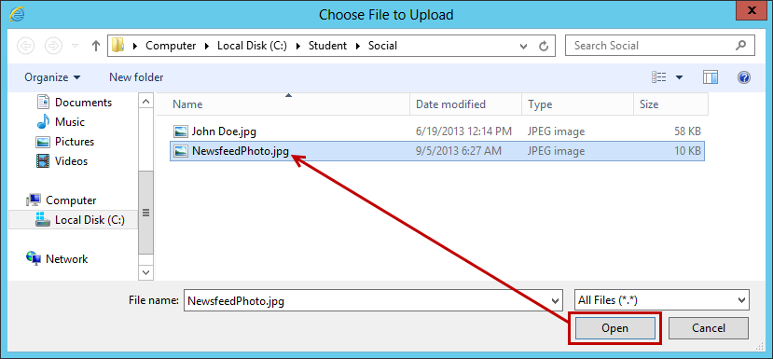

1. From the **Choose a picture** dialog, click **Upload**.

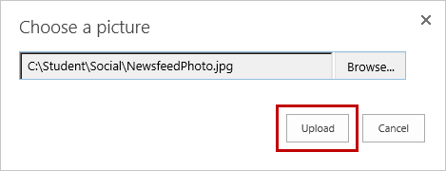

1. Add text to the conversation if desired and then click **Post**.

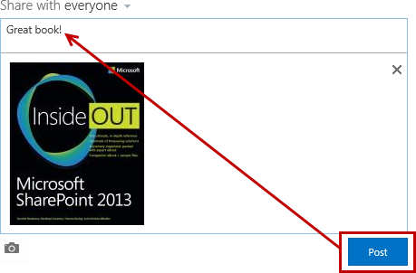

1. Notice the conversation is now posted to the Newsfeed wall.

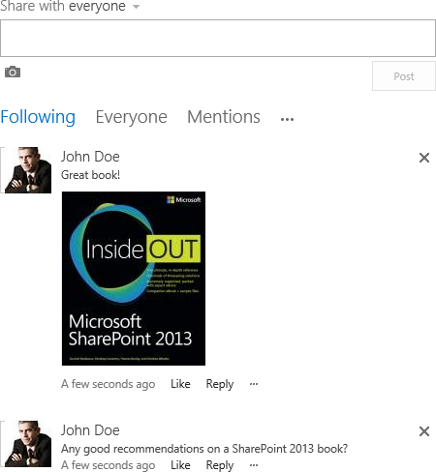

#### Add Website or Video Link to Newsfeed Post

1. Click in the **Start a conversation** box.
2. Just like posting a link on a Facebook wall, either **type** the web address or **paste** a copied address into the multi-line text box.

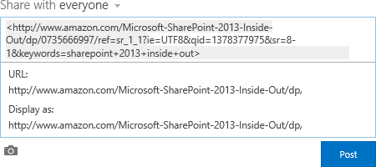

1. Click in the **Display as** box. Type the words you want to appear as the web link and then click the **check mark**.

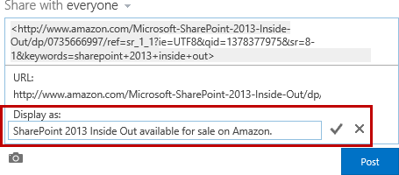

1. The post will preview with the URL and updated Display as text. Make additional changes if desired and when finished, click **Post**.

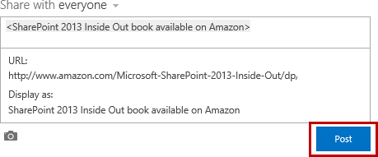

1. The link is now posted.

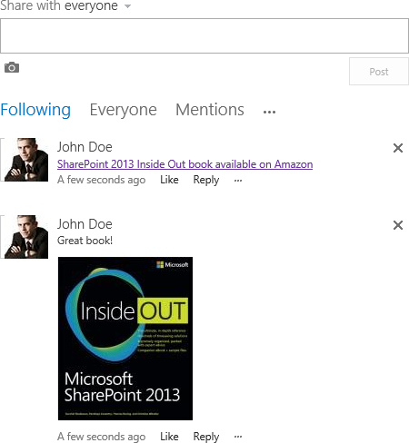

#### Add Document Link to Newsfeed Post

1. Navigate to the SharePoint library that has the document you want to post on the Newsfeed.

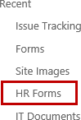

1. Click the **ellipse (..)** menu to open the document callout.



1. Select the document **URL**, right-click and select **Copy**.

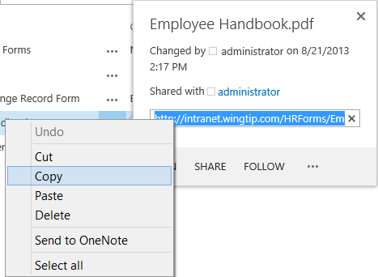

1. Click **Newsfeed** at the top of the page (or go to the team site newsfeed you want to post).



1. Click in the **Start a conversation** box.
2. Right-click and paste the document **URL**.

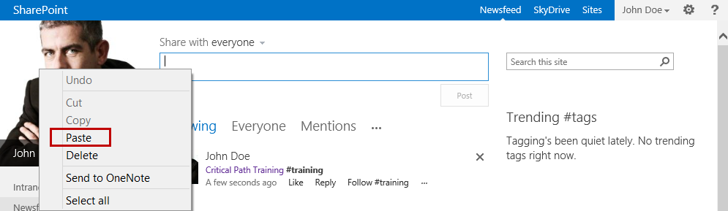

1. Click on the pasted web link to show the **URL** and **Display** **as** for the link.
2. Click in the **Display as** box. Type the words you want to appear as the document link and then click the **check mark**.

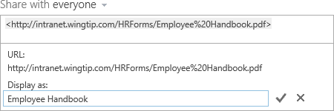

1. Click **Post**.
2. The link to the document is now in the Newsfeed.



#### Add Tags and Mentions to Newsfeed Post

1. Place your cursor in the **Start a conversation** multi-line text box.
2. Type the desired text for the conversation and then add tags to the text such as #training or a tag(s) pertaining to your conversation.

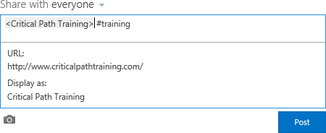

1. Once complete, click **Post**.



1. Click **Follow #training** to follow the hashtag.
2. Click on **#training** in the conversation post to the open the #training hashtag profile page.

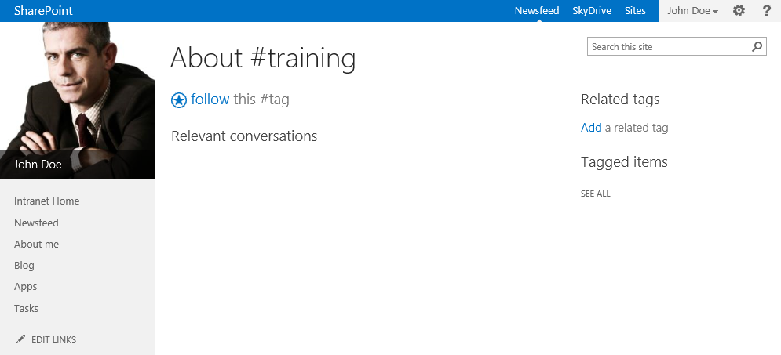

1. If you not did not click **follow** in step 21, you can also follow by clicking on **follow this #tag** from the #training hashtag profile page.

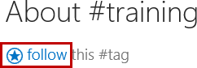

#### Delete a Conversation Post

1. Find the post you want to delete on your **Newsfeed**.
2. Hover your mouse to the right of the post and then click the **X** to delete.



1. From the **Get rid of this conversation** dialog, click **Delete** **it**.

### Exercise 4: Use a Team Site Newsfeed

Sometimes conversations are better suited for a small group of people instead of being on your personal site. In these cases it is best to create and follow a team site that contains its own newsfeed. You can also post to existing Team Sites if you have the appropriate permissions. In this exercise you post a conversation on the Wingtip Intranet Newsfeed and follow the team site.

#### Post a Feed on Team Site

1. Navigate back to the Wingtip Intranet home page. <http://intranet.wingtip.com>
2. Just like the steps you did in the previous exercise, click **Start a conversation** and then start typing your message.
3. Post a web link, document link, or a text conversation.

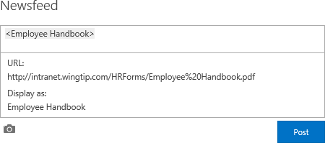

1. Once complete, click **Post**.

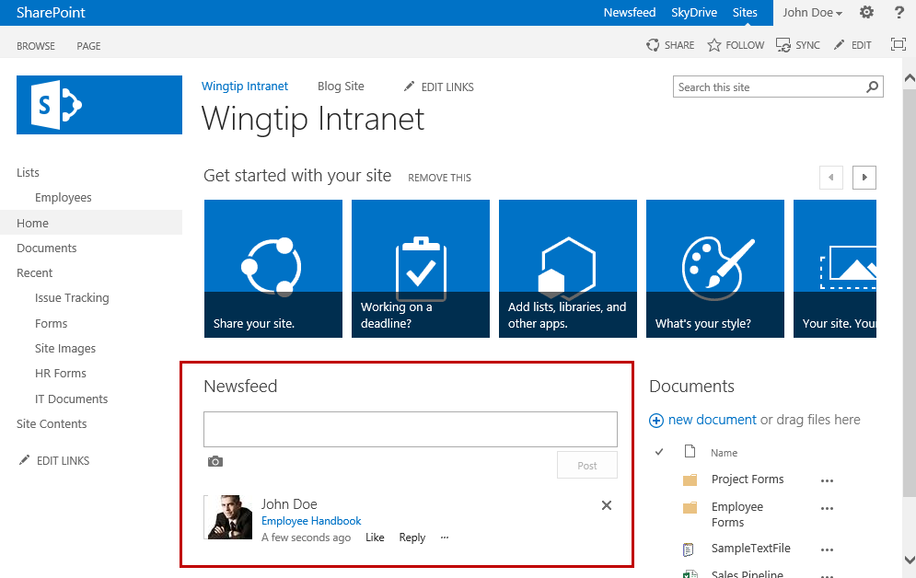

#### Follow and Unfollow Team Site

1. Navigate to the site you want to follow.
2. At the top of the page, click **FOLLOW**.

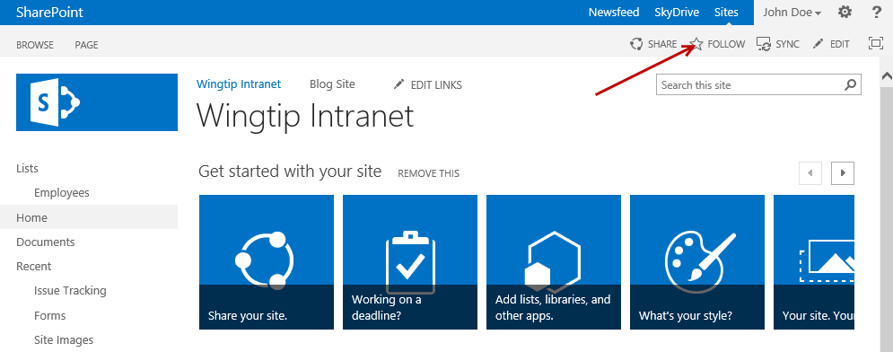

1. A notification will display the site name and the message **Now following this site**. This notification will disappear automatically.

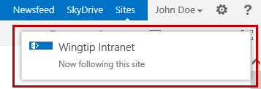

1. If you click on **FOLLOW** again a notification will display saying you are already following the site.

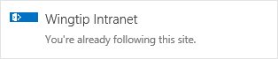

1. To Unfollow a Team Site:
   1. Click on **Newsfeed** located at the top of the page.
   2. Under **I’m following**, click on the **number** (ie. 2) for **sites**.

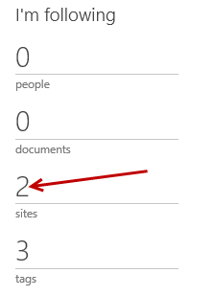

* 1. From the **Sites I’m following** page, find the site you want to unfollow and click **Stop following**.

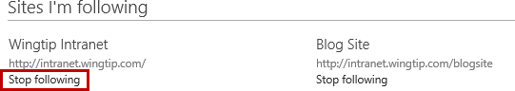

### Exercise 5: Working with SkyDrive Pro

In this exercise you will learn to sync your SkyDrive Pro library to your local computer, sync a site library to your computer, and work with files in a synced SharePoint library.

#### Sync SkyDrive Pro Library to Computer

1. Navigate to your SkyDrive Pro library by clicking in **SkyDrive** at the top of the page.



1. Click **SYNC** located at the top of the page.

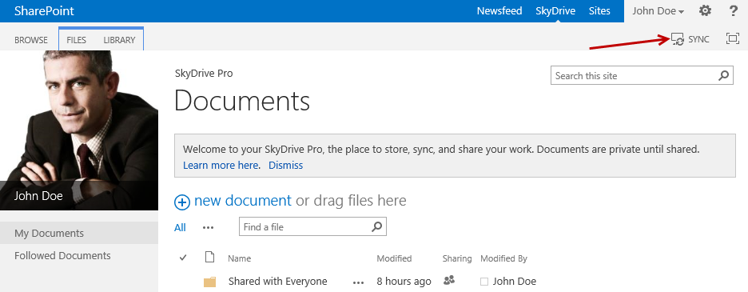

1. In the SkyDrive Pro wizard, click **Sync Now**.

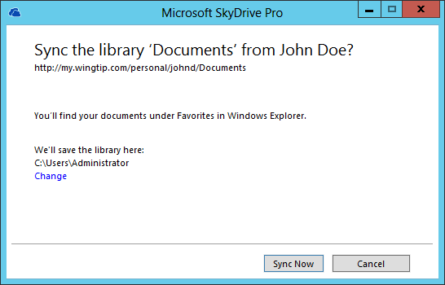

1. Wait for the sync to finish.
2. Click **Show my files…**

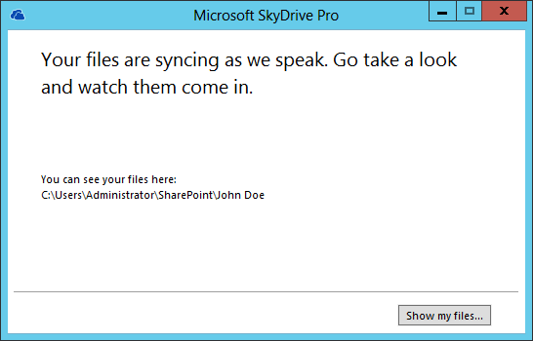

1. The Files Explorer automatically opens and displays your synced library.

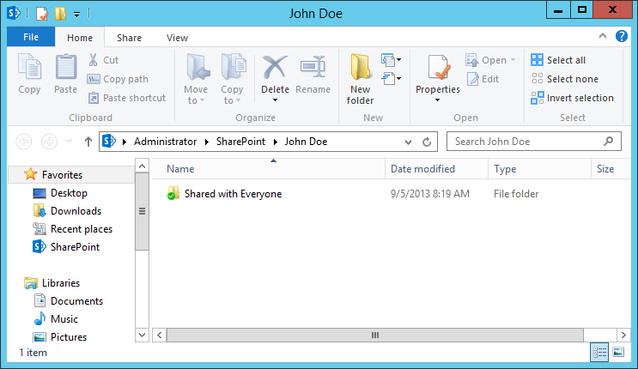

1. Click **Show My Files** to go to the synced library folder.

#### Sync Team Site Library to Computer

1. Navigate to the Team Site library you want to sync such as **IT Documents** located at the Wingtip Intranet root site.
2. Click the **SYNC** button at the top of the page.

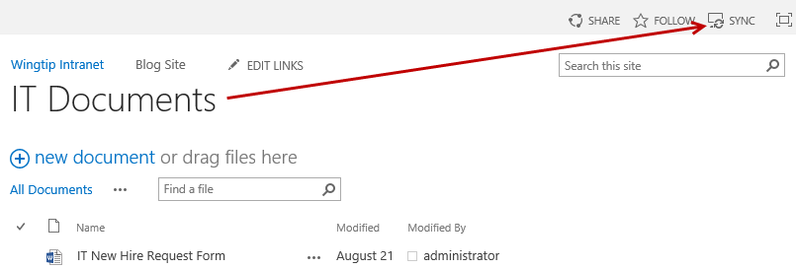

1. From the **Microsoft SkyDrive Pro** library sync dialog, click **Sync Now**.
2. If prompted for credentials, enter the credentials supplied at the beginning of this lab.

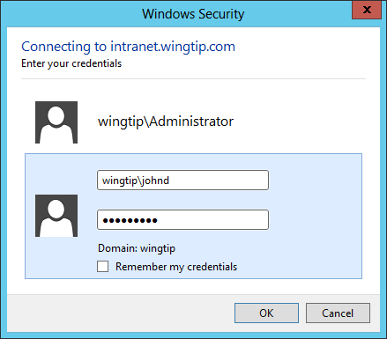

1. In the **Microsoft SkyDrive Pro** dialog, select **IT Documents** from the **Select the library you want to sync** list and then click **Sync** **selected**.

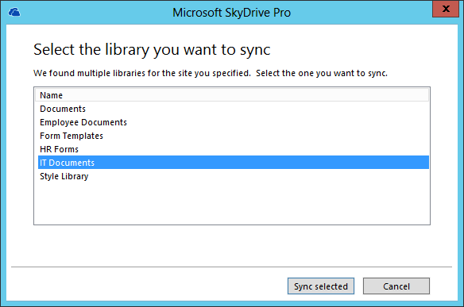

1. In the next dialog, click **Show my files…**

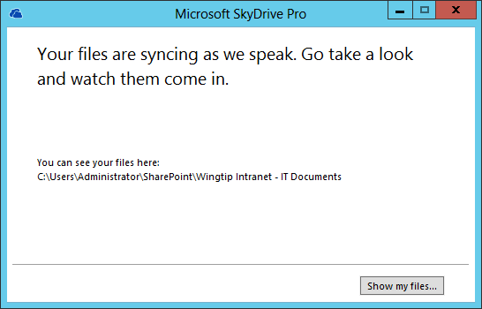

1. The **IT Documents** library is now synced to your local computer.

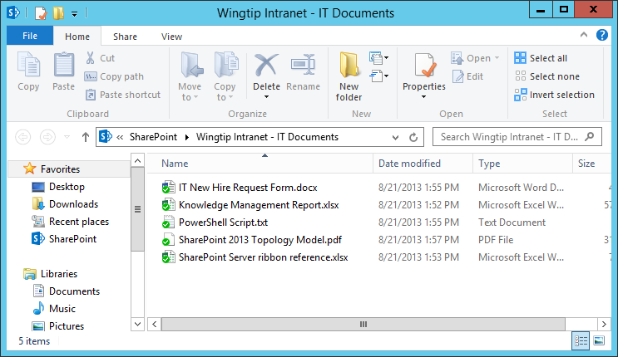

#### Work with Synced Files

1. Open the synced library folder in your file system.
2. Double-click on the **SkyDrive Pro** icon in the Window’s taskbar.

**Note:** Team site library folders are placed under Favorites in the SharePoint folder. You can navigate to the synced folders directly through File Explorer or by double-clicking on the SkyDrive Pro taskbar icon.

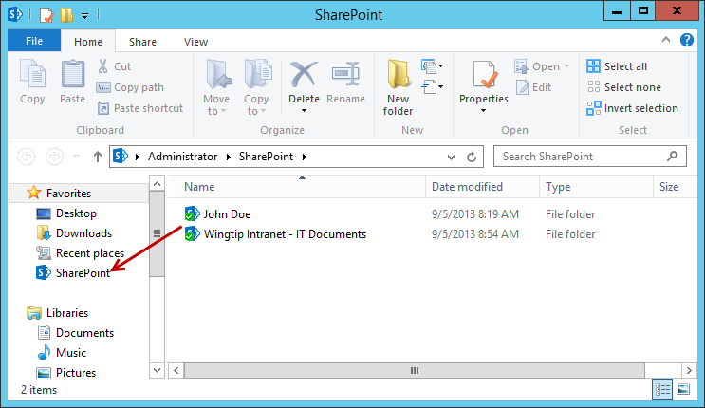

1. Right-click on a file or folder. Click **SkyDrive Pro** and then click one of the available menu options:
   1. Select **Go to Browser** to see the selected file or folder on the SharePoint site in the browser.
   2. Select **Copy link** to copy the file’s Web URL in order to paste the link in another location such as an email.
   3. Select **Share…** to open the **Share** dialog box on the SharePoint site to send an invitation to share the file with other people.

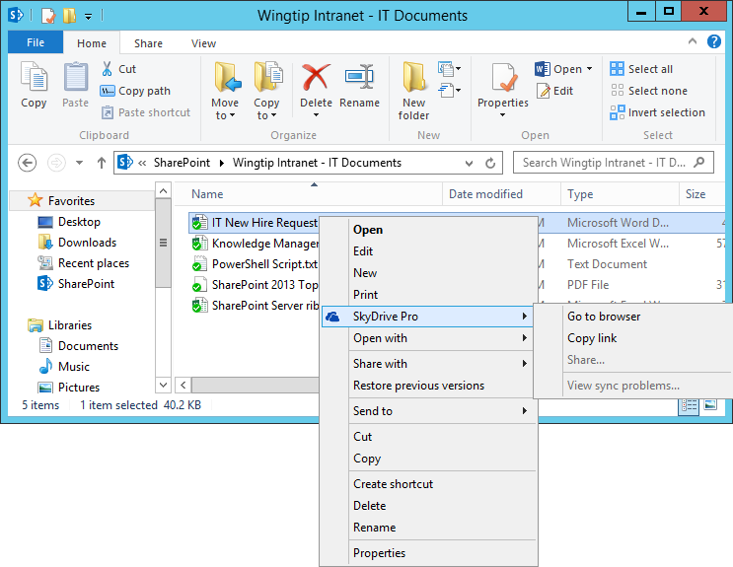

#### Stop Syncing a Library with SkyDrive Pro

1. Click the **SkyDrive Pro** icon in the Window’s taskbar and select **Stop syncing a folder…**

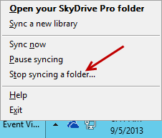

1. Select the folder you want to stop syncing, and then click **Stop syncing**.

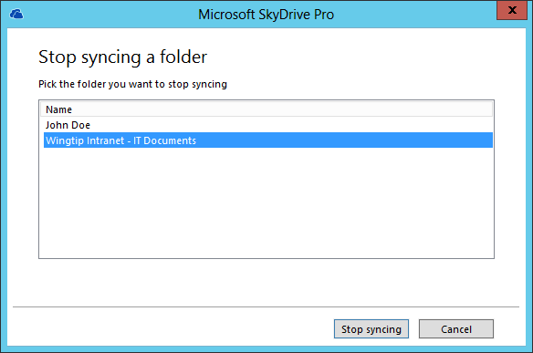

You have now completed this lab exercise.