## Workflow in SharePoint 2013

**Lab Time**: 45-60 minutes

**Lab Folder**: C:\Student\Modules\Workflow

**Lab Overview**: This hands-on lab will walk you through the experience of creating workflows using SharePoint Designer 2013. You will get first person experience in using the new activities, loops and stages capabilities in SharePoint Designer as well as creating workflows.

### Exercise 1: Create Lists for Workflows

In this exercise you will create a workflow that uses stages to group actions/activities.

#### Log in to SharePoint Site

1. Make sure you have the login information for the SharePoint environment where you will work on your lab exercises. You should have received this log in information from the hosting training company or from your instructor.
2. Make sure you have the URL to the **Team Site** that has been created for you to do your lab work. This URL will be in a form that looks something like this.

https://cpt.atrackspace.com/sites/TeamSite_Student01

1. Launch the Internet Explorer and navigate to the URL of the Team Site mention in the previous step. Note that you should be logged in with a user account that has full control and access to the site collection, and therefore will be permitted access and be able to create lists.
   1. When prompted to login, enter the user name and password that has been supplied to you and then click **OK**.

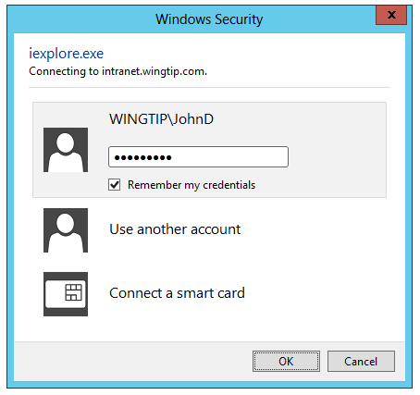

* 1. You should be able to confirm that you are logged into the SharePoint site. For example, if you were logged in as a student named **John Doe**, your name would appear in the SharePoint Welcome menu as shown in the following screenshot.

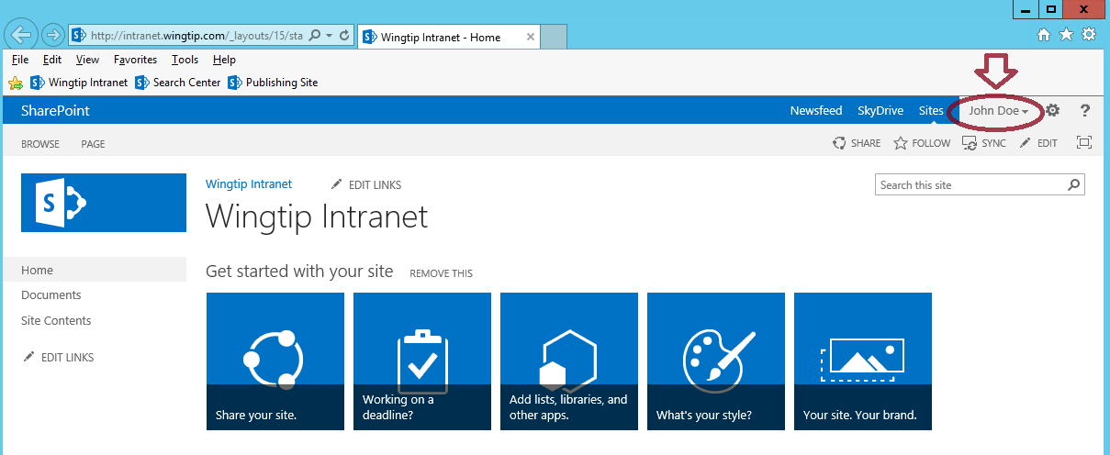

#### Create Announcements Lists

Before creating the workflow you will first create three different Announcements lists in the Intranet site titled Announcements, Customer Announcements, and Employee Announcements.

1. Navigate to **Add an app** to create a new Announcements list.
   1. Click on the **Settings** icon.
   2. Click **Add an app** or click **Site contents >> add an app**.

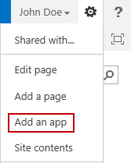

* 1. Click on the **Announcements** tile.

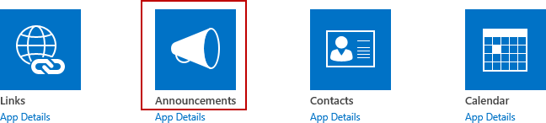

* 1. In the **Name** text box from the popup dialog, type **Announcements** and click **Create**.

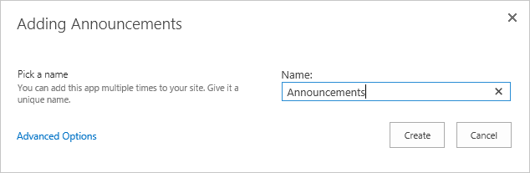

1. Repeat the steps above to create the **Customer Announcements** list and the **Employee Announcements** list.

#### Create Column for Announcements list

1. Navigate to the **Announcements** list settings page.
   1. Click on **Site Contents**. From the **Announcements** list tile, click on the **ellipsis** (…) and select **SETTINGS**.

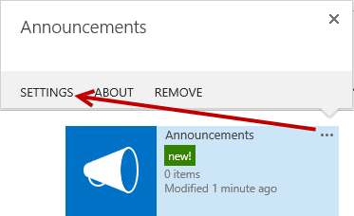

1. From the **Announcements > Settings** page in the **Columns** section click on **Create Column**.

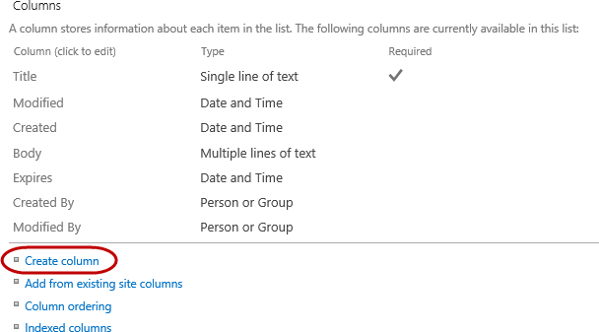

1. In the Create Column page set the following:
   1. **Column name:** Post To
   2. **Type:** Choice (menu to choose from)

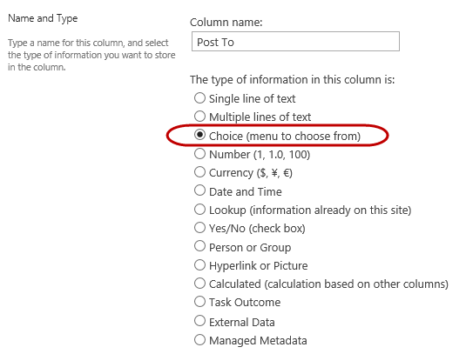

* 1. In the **Type each choice on a separate line** multi-line text box type **Customer**. Hit the Enter key and then type **Employee**.

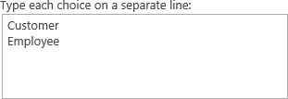

* 1. In the **Default** **value** text box, delete the **Customer** value. Leave it blank and then click **OK**.



### Exercise 2: Create SharePoint Designer 2013 List Workflow

In this exercise you will create a workflow that uses stages to group actions/activities.

#### Create List Workflow

1. Open **SharePoint Designer 2013**:
   1. Windows Keyboard Key 🡪 Type “**SharePoint Designer**” and then select the **SharePoint Designer 2013** application.

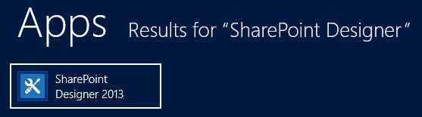

1. Open the lab site collection:
   1. Click the **Open Site** button.
   2. In the **Open Site** dialog, enter the URL for your Team Site in the **Site Name** box and click **Open**.
2. If prompted to login, use your student credentials.
3. Click **Workflows** from the Navigation pane.
4. From the **New** group in the ribbon, choose **List Workflow** and select the **Announcements** list.

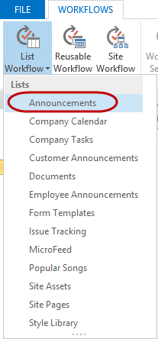

1. From the **Create List Workflow – Announcements** dialog, in the **Name** text box type **Move Announcement**. Ensure **SharePoint 2013 Workflow** is selected in the **Platform Type** drop-down list and then click **OK**.

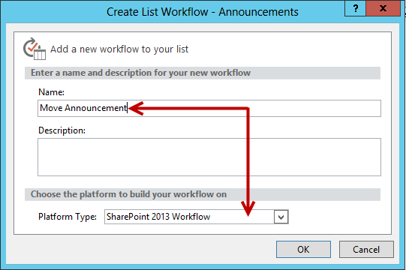

1. Once complete SharePoint Designer will display a Stage titled **Stage 1**.

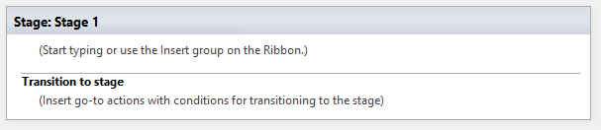

1. Rename **Stage 1** to **MoveToTargetAnnouncmentsList**.

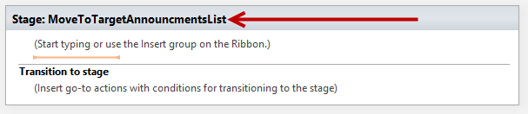

#### Add Stages to Workflow

1. Follow these steps to add a new Stage below **MoveToTargetAnnouncementsList** titled **CustomerAnnouncement**.
   1. Place your cursor below the **MoveToTargetAnnouncementList** Stage, right-click and select **Stage**.

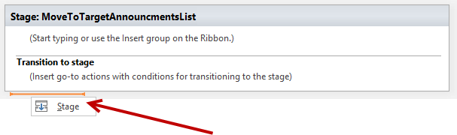

* 1. Rename Stage 2 to CustomerAnnouncement.

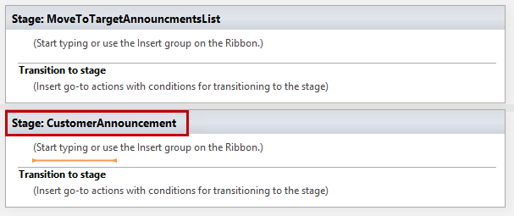

1. Follow these steps to add a new Stage below **CustomerAnnouncement** titled **EmployeeAnnouncement**.
   1. Place your cursor below the **CustomerAnnouncement** Stage, right-click and select **Stage**.

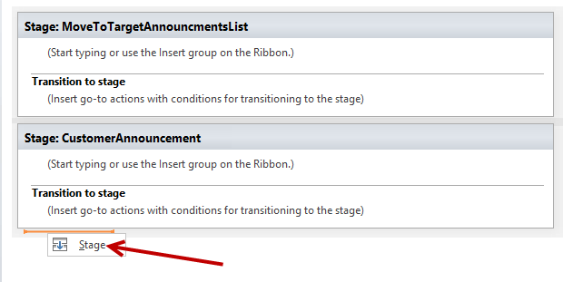

* 1. Rename **Stage 3** to **EmployeeAnnouncement**.

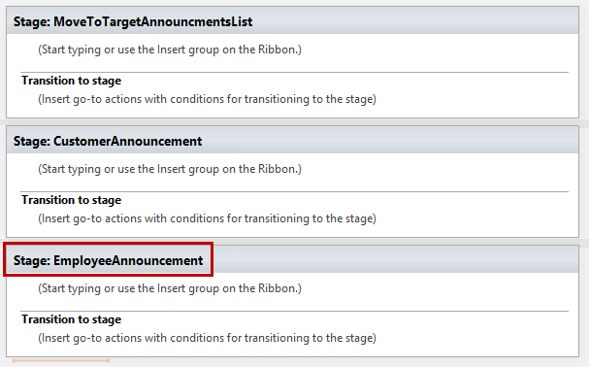

#### Modify Stages

1. Follow these steps to add the condition **If any value equals to value** to the **Transition to stage** section inside the **MoveToTargetAnnouncementsList** Stage.
   1. Right-click inside the **Transition to stage** section and select **If any value equals value**.

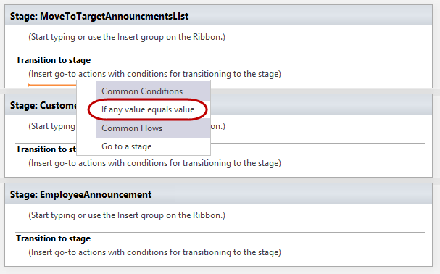

* 1. Click on **value** then click on the **fx** (function) icon.

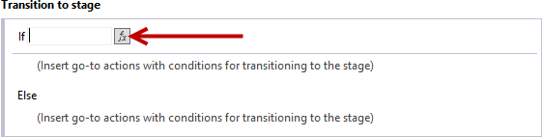

* 1. From the **Define Workflow Lookup** dialog, in the **Field from source** drop-down list select **Post To** and then click **OK**.

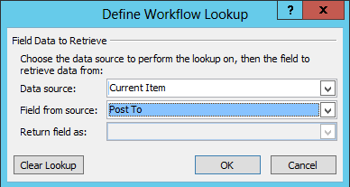

* 1. Set the **value** for the **equals** to **Customer**.

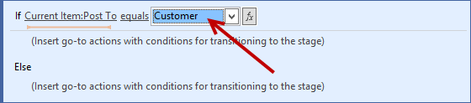

* 1. Right-click on or below the **Insert go-to actions with conditions for transitioning to the stage** and select **Go to a stage**.

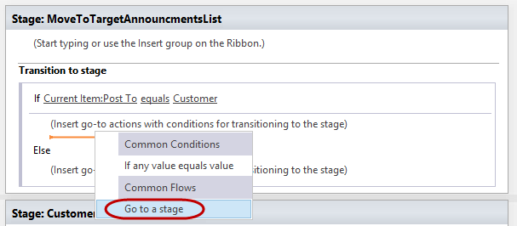

* 1. Set the Go to **stage** to **CustomerAnnouncement**.

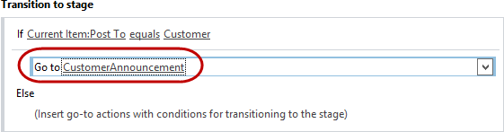

* 1. In the **Else** section, right-click on or below the **Insert go-to actions with conditions for transitioning to the stage** and select **Go to a stage**.

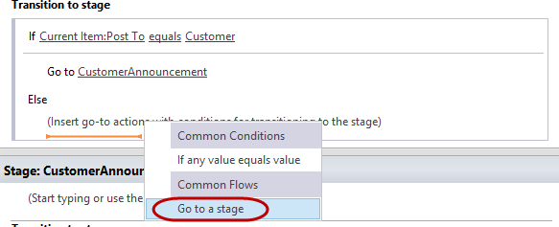

* 1. Set the Go to **stage** to **EmployeeAnnouncement**.

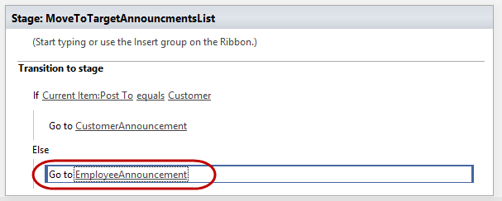

1. Follow these steps to create a Create List Item action in the **CustomerAnnouncements** Stage:
   1. In the **CustomerAnnouncement** Stage, place your cursor below the **Start typing or use the Insert group on the Ribbon** section.

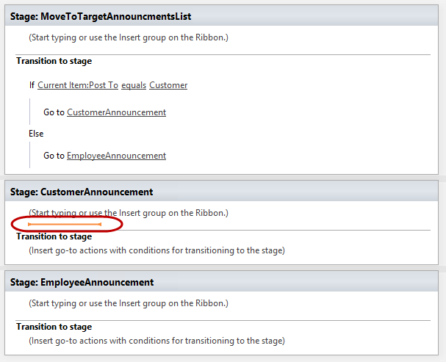

* 1. From the **Action** ribbon button, select **Create** **List** **Item**.

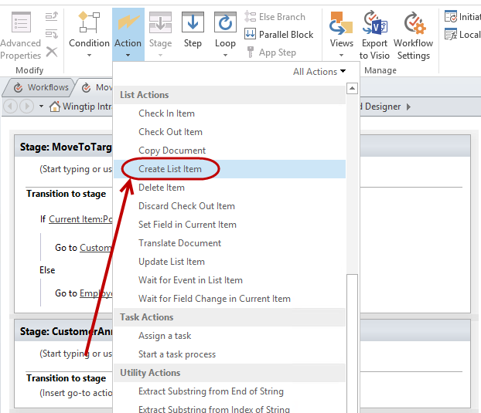

* 1. Click on the **this list** link next to **Create item** **in**.
  2. From the **List** drop-down select **Customer Announcements** and then select the **Title (*)** field and click on the **Modify** button.

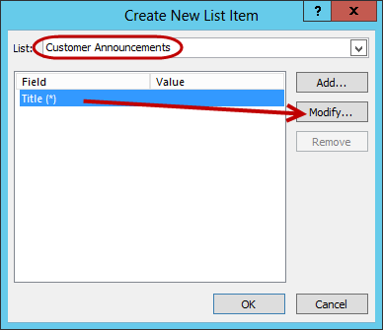

* 1. From the **Value Assignment** dialog for the Title field, click on the **fx** icon.

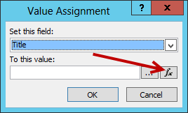

* 1. From the **Lookup for Single line of text** dialog, ensure **Current Item** is selected for the **Data source**. Set the **Field from source** to **Title** and then click **OK**.

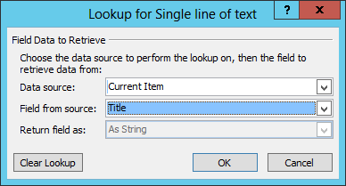

* 1. From the **Value Assignment** dialog, click **OK**.

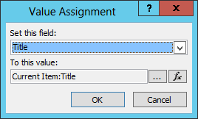

* 1. Now click the **Add** button to add another field.

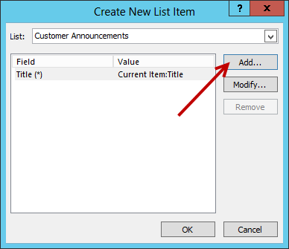

* 1. Select **Body** from the **Set this field** drop-down list and then click on the **fx** icon.

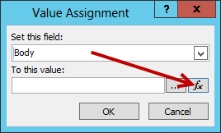

* 1. From the **Lookup for Multiple lines of text** dialog, ensure **Current Item** is selected for the **Data source**. Set the **Field from source** to **Body** and then click **OK**.

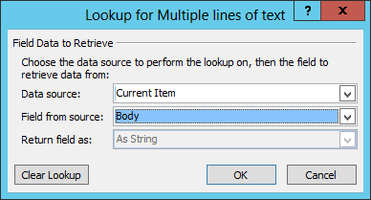

* 1. From the **Value Assignment** dialog, click **OK**.
  2. Notice the **Title** and **Body** fields are configured. Now click **OK**.

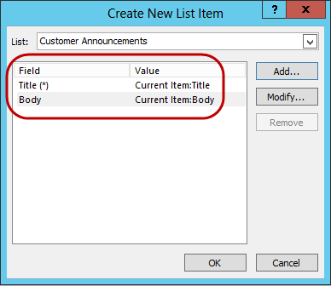

* 1. Place your cursor in the **Transition to stage** section of the **CustomerAccouncement** Stage, right-click and select **Go to a stage**.

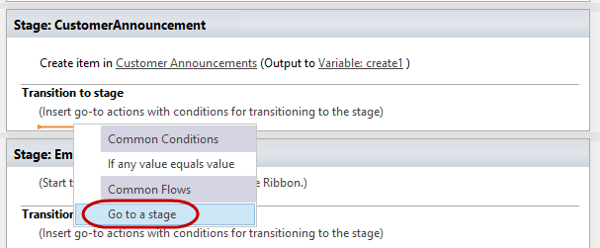

* 1. Set the Go to **stage** to **End of Workflow**.

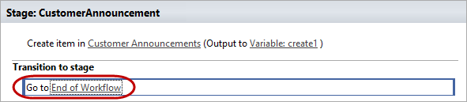

1. Repeat all of step 12 for the **CustomerAnnouncement** Stage. Once complete, your workflow should look like the figure below.

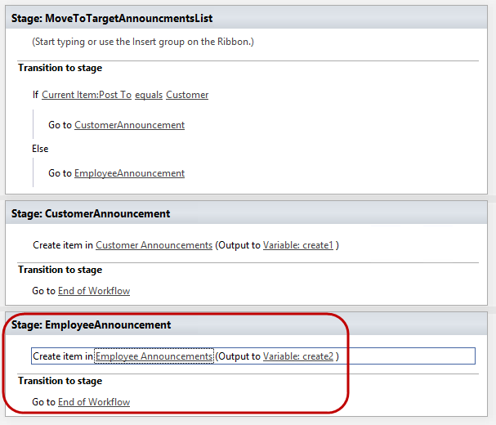

1. Click the **Save** icon in the ribbon to save the workflow.

#### Deploy and Test the Workflow

Now that you have saved the workflow you need to publish and test it. In the following steps you will test the workflow to ensure that it performs as expected.

1. Ensure that you are still on the editing tab for the **Move Announcement** workflow.

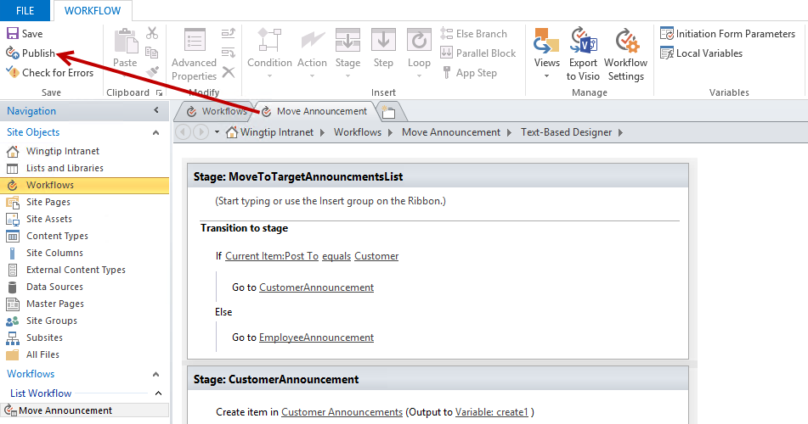

1. From the ribbon, click **Publish**.
2. Once the workflow is published return to the Team Site in the browser.
3. Now create a test announcement for the workflow to process.
   1. In the Quick Launch click the link for the **Announcements** library.
   2. Click **+ new announcement** to open the New Form to create a new announcement.

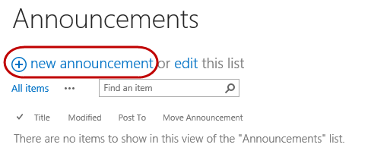

* 1. Set the **Title** to **New Hire Orientation**.
  2. Set the **Body** to **All new employees must attend the new hire orientation**.
  3. Leave **Expires** blank.
  4. In the **Post To** drop-down list, select **Employee** and then click **Save**.

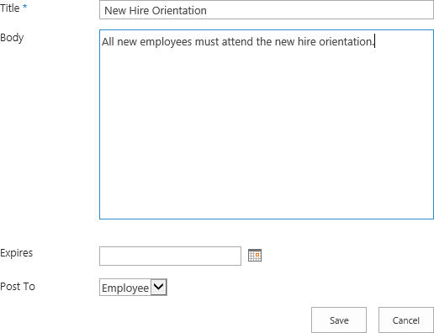

1. You now have to activate the workflow on the new item.
   1. Select the **checkbox** next to the document name in the library and from the **ITEMS** tab in the ribbon choose **Workflows**.

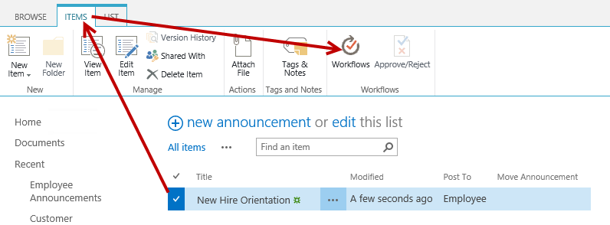

* 1. On the **Announcements: Workflows: New Hire Orientation** page choose the **Move Announcement** link.

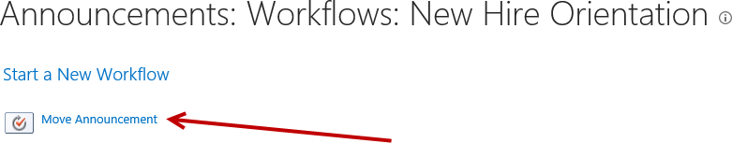

1. After a few moments the workflow will start. You can monitor the progress from the **Announcements** library. A column named **Move Announcement** should read **EmployeeAnnouncement** when it completes successfully.

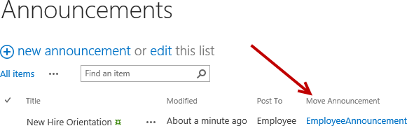

1. Click the **EmployeeAnnouncement** text and you will see the **Workflow Status** for the completed workflow instance. The **Internal** **Status** should display **Completed** and the **Status** should display **EmployeeAnnouncement** (which is the name of the stage completed)

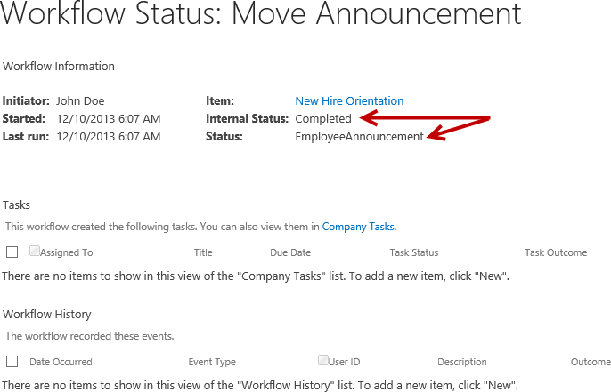

1. Now navigate to the **Employee Announcements** list to ensure the new announcement was created in the list by the workflow. From the **Quick Launch** bar, click on the **Employee** **Announcements** link or click on the **Employee** **Announcements** tile from the **Site** **Contents** page.
2. Notice the **New Hire Orientation** item has been created.

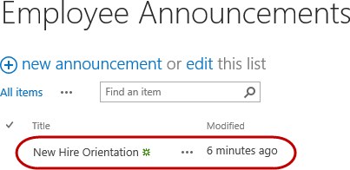

1. Repeat the steps for Customer Announcements.