## Getting Familiar with the VM used in Lab Exercises

**Lab Time**: 30 minutes

**Lab Folder**: C:\Student\GettingStarted

**Lab Overview:** In this lab you will login to the VM image used for class. You will also install Office 2013 Professional and Visio 2013 Professional if these products are not already installed on our VM.

### Exercise 1: Logging on to the WingtipServer Virtual Machine

In this exercise, you will log into the VM that has been provided for your lab exercise. ...

1. Launch the **Hyper-V Manager: Start** 🡪 **Administrative Tools** 🡪 **Hyper-V Manager**.
2. Ensure that a VM has already been configured by the company which is hosting your training class.
3. Open the setting for the VM and verify that it has the following minimum settings.
   1. **Memory**: 12800 MB (which equals 12.5 GB of RAM)
   2. **Processor**: 4 virtual processors

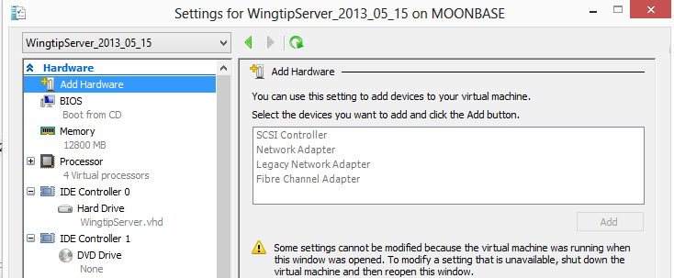

1. Adjust your VM if your settings need adjusting.
2. Start up your VM if it is not already running.
3. Log into the VM using a user name of **WINGTIP\Administrator** and a password of **Password1**.

Once you have successfully logged on to the VM, you can move to the next exercise. If you are having trouble configuring or logging onto the VM, you should ask the instructor or the person responsible for the classroom setup to assist you.

### Exercise 2: Accessing a SharePoint 2013 Team Site

In this exercise, you will navigate to the sites that have already been created on the VM.

1. Ensure you are logged onto the VM with a user name of **WINGTIP\Administrator** and a password of **Password1**.
2. Open the browser and navigate to the SharePoint Team site at **http://wingtipserver**.
   1. Take a moment to navigate around the site and become familiar with the new SharePoint 2013 user interface.
3. Using the browser, navigate to the SharePoint Team site at **http://intranet.wingtip.com**.
   1. Note this team site is just like the other.
4. Using the browser, navigate to Central Administration at **http://wingtipserver:9999**.
   1. Try to answer the questions by looking for answers in central Administration.
      1. How many web applications are in the current farm?
      2. Which service applications are running the current farm?

This lab was just to get you familiar with the SharePoint farm that you will be using for upcoming lab exercises.

### Exercise 3: Installing Office 2013 Professional and Visio 2013 Professional

In this exercise you will install Office 2013 Professional and Visio 2013 Professional.

1. Press the Windows key and determine whether Microsoft Word and Microsoft Visio have already been installed.
   1. If these products have already been installed, you are done with this lab exercise.
   2. If these products are not yet install, complete the following steps in this exercise.
2. Look inside the c:\Install folder. You should see a file named **en_office_professional_plus_2013_x64_dvd_1123674.iso**.
   1. Right-click on **en_office_professional_plus_2013_x64_dvd_1123674.iso** and click the **Mount** menu command.

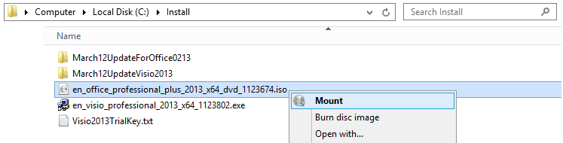

* 1. The Office 2013 installation files will open in a new window.
  2. Double click **setup.exe** to install the Office 2013 Professional.

1. After you install Office 2013 Profession, apply the March 12th updates by running **msoloc2013-kb2768349-fullfile-x64-glb.exe** which is located in the **March12UpdatesForOffice2013** folder.
2. Install Visio 2013 Professional using the setup file in the **c:\Install** folder.
3. After you install Visio 2013 Profession, apply the March 12th updates by running **visioloc2013-kb2752090-fullfile-x64-glb.exe** which is located in the **March12UpdatesForVisio2013** folder.

At this point you have prepared your VM for the remaining lab exercises of this course.