## Creating Site Columns, Content Types and Lists

**Lab Time**: 30 minutes

**Lab Folder**: [[StudentFolder]]\ReusableTypeDefs

**Lab Overview**: In this lab, you will create a new SharePoint field type and define its rendering in an associated field control. You will then create new site columns and content types, which will be used to create a new list in SharePoint.

### Exercise 1: Setup Lab Environment

In this exercise you will setup your environment.

All exercises in this lab assume you will work in a new site collection, http://typedefs.wingtip.com.

1. Setup a new site collection for this lab:
   1. Ensure you are logged into the **WingtipServer** server as **WINGTIP\Administrator**.
   2. Run a PowerShell script, found in the root lab folder for this module:
      1. Right-click **SetupModule.ps1** and select **Run with PowerShell**. This file can be found in the files associated with this lab:

[..]\ReusableTypeDefs

* 1. When the script completes, it will launch a new browser and navigate to the lab site collection.
  2. Close the PowerShell console window.

### Exercise 2: Creating Site Columns & Content Types

In this exercise you will create a few new site columns and content types that leverage these site columns using the Visual Studio SharePoint Tools. You will create a content type for managing contracts.

1. Create a new project in Visual Studio 2012:
   1. Launch **Visual Studio 2012**: **Start** 🡪 **All Programs** 🡪 **Microsoft Visual Studio 2012** 🡪 **Visual Studio 2012.**
   2. Select **File 🡪 New 🡪 Project**.
   3. In the **New Project** dialog:
      1. Find the **App for SharePoint 2013** template under the **Templates 🡪 Visual C# 🡪 Office / SharePoint 🡪 Apps** section.
      2. **Name**: SiteColumnContentType
   4. Click **Ok** to create the project.
   5. In the **New App for SharePoint** wizard, use the following values to complete the wizard.
      1. **What is the name of your App for SharePoint?** Site Column Content Type App
      2. **What site do you want to use for debugging?** <http://typedefs.wingtip.com>
      3. **How do you want to host your app for SharePoint?** SharePoint-hosted
   6. Click **Finish**.
2. Add a new site column:
   1. Using the **Solution Explorer** tool window, right-click the **SiteColumnContentType** project and select **Add 🡪 New Item**.
      1. In the **Add New Item** dialog, select the **Site Column** template from the **Visual C# Items 🡪 Office / SharePoint** category.
         1. **Name:** ReferringCompany
      2. Click **Add**.
   2. Visual Studio will stub out the XML for the new site column. Make one change to it by changing the **Group** attribute to **Wingtip Site Columns**.
3. Add a new content type:
   1. Using the **Solution Explorer** tool window, right-click the **SiteColumnContentType** project and select **Add 🡪 New Item**.
      1. In the **Add New Item** dialog, select the **Content Type** template from the **Visual C# Items 🡪 Office / SharePoint** category.
         1. **Name:** SalesLead
      2. Click **Add**.
      3. In the **SharePoint Customization Wizard** dialog, in **Choose Content Type Settings**, select **Contact** and click **Finish**.
   2. In the **SalesLead** designer, add a new column for the site column you just created:

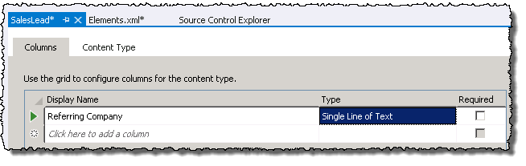

1. Save all changes: **File 🡪 Save All**.

In this exercise you created new site columns and content types that leveraged these site columns using the Visual Studio SharePoint Tools. In the next exercise you will see how to create a new list using this content type.

### Exercise 3: Creating Lists with Visual Studio

In this exercise you will create a new SharePoint list using the SharePoint development tools included in Visual Studio.

1. Open an existing starter project in Visual Studio 2012:
   1. Launch **Visual Studio 2012** as administrator:
      1. **Start 🡪 All Programs 🡪 Microsoft Visual Studio 2012 🡪 Visual Studio 2012**
   2. Select **File 🡪 Open 🡪 Project/Solution**.
   3. In the **Open Project** dialog, select the following project provided in the files associated with this lab:

[..]\ReusableTypeDefs\Exercises\Ex4\SiteColumnContentType.sln

You created this same project in the previous exercise, but to ensure you didn’t have any issues with it you can use the starter project. Otherwise you are free to use the project you completed in the previous exercise.

1. Add a new list to the project:
   1. Using the **Solution Explorer** tool window, right-click the **SiteColumnContentType** project and select **Add 🡪 New Item**.
      1. In the **Add New Item** dialog, select the **List** template from the **Visual C# Items 🡪 Office / SharePoint** category.
      2. **Name:** References.
      3. Click **Add**.
   2. In the **SharePoint Customization Wizard** dialog, in **Choose List Settings**, use the following values to complete the dialog:
      1. **What name do you want to display for your list?** References
      2. **Do you want to create a customizable list or a non-customizable list based on an existing list type?**
         1. **Create a customizable list based on:** Default (Blank)
   3. Click **Finish**.
   4. In the list designer, click the **Content Types** button:

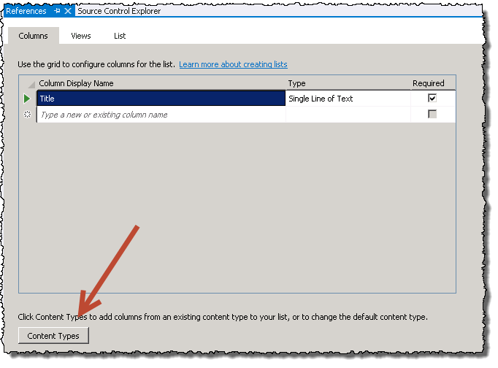

* 1. Remove the two existing content types by selecting each and pressing **[DELETE]**.

In order to delete it you need to select the whole row which can be done by clicking the green arrow to the left of the row.

* 1. Add the content type **SalesLead** which is included in our project and click **OK**.

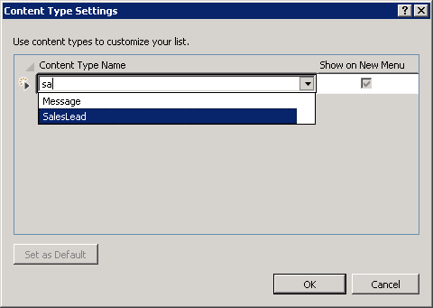

1. Add a link to the homepage to get to the new list you just created:
   1. Right-click the **Pages / Default.aspx** file and select **Open**.
   2. Add the following markup before the last closing **</asp:Content>** element:

<a href="../Lists/References">References</a> list

1. Save all changes: **File 🡪 Save All**.

#### Build and Test the Project

1. Build and test your application by pressing **[F5]** or **Debug 🡪 Start Debugging**.
2. Once the solution has been deployed, Internet Explorer will launch and navigate to the <http://typedefs.wingtip.com> site.
3. Click the **References** link on the app homepage to go to the **References** list.
4. On the **References** list, use the ribbon and select the **Items** tab. Then select the arrow below the **Items** button to show the content types available:

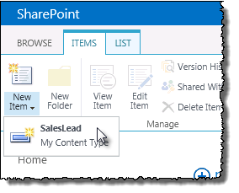

1. Select the **SalesLead** item.
2. On the new form, scroll to the bottom to see the column you added to the Contact content type.
3. Close the browser to stop the debugger and go back to Visual Studio.

In this exercise you used Visual Studio to create new site columns, a content type and a list instance.