## Working with Publishing Sites and WCM

**Lab Time**: 60 minutes

**Lab Folder**: [[StudentFolder]]\WCM

**Lab Overview**: In this lab you will create a new Publishing site using the Web Content Management capabilities in SharePoint 2013. Not only will you leverage the new managed navigation capabilities, but you will also leverage the cross site publishing and the new Design Manager to create a custom branded site.

### Exercise 1: Setup Content Catalog, Taxonomy and Configure Search

In this exercise you will setup your lab environment to create a publishing site. In addition you will run a utility that will create a new site collection based on the Publishing Portal site collection and create a new catalog list with sample data and taxonomy to use for classifying the content. Finally you’ll configure search to index the content and create a few managed properties.

1. Ensure you are logged into the **WingtipServer** server as **WINGTIP\Administrator**.
2. Setup a new web application to host the two new site collections:
   1. Run a PowerShell script found in the root lab folder for this module:
      1. Right-click **SetupModule.ps1** and select **Run with PowerShell**. This file can be found in the files associated with this lab:  
         (Note: Please be patient this may take up to 5 minutes to run)

[..]\WCM

* 1. The script created a new web application at <http://wcm.wingtip.com> and a Publishing site at <http://wcm.wingtip.com/sites/pub>.

1. Now that we have created these sites, we need to activate the publishing feature on the wcm.wingtip.com site in order for the Taxonomy/Term Store/Search features to work correctly on it in later exercises:
   1. Open the <http://wcm.wingtip.com> site in Internet Explorer
   2. Select the **Site Actions** gear in the top-right corner of the site and select **Site Settings**.  
      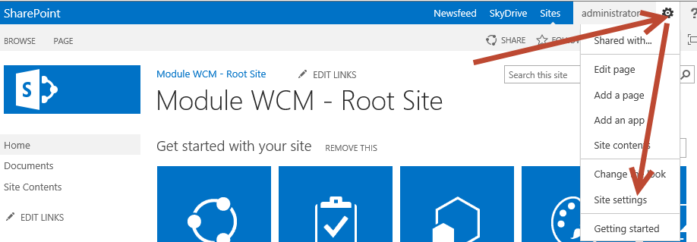
   3. On the **Site Settings** page in the **Site Collection Administration** section select **Site collection features**
   4. Find and **Activate** the **SharePoint Server Publishing Infrastructure** feature.  
      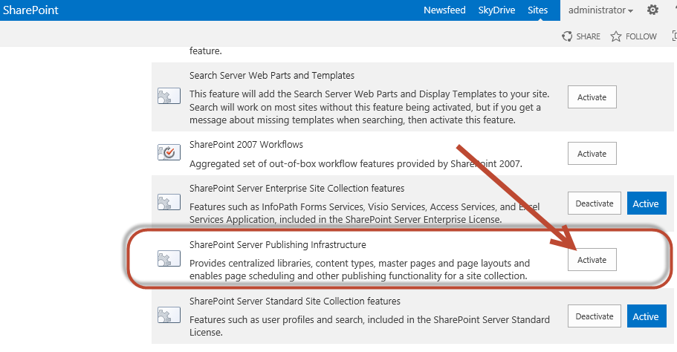
2. Run a utility that will create a new Catalog list in a new site collection as well, fill it with sample data and create a taxonomy that will be used by this catalog.
   1. Run the utility **LoadSampleData.ps1,** found in the files associated with this exercise, from the same PowerShell console you had open:

[..]\WCM\Exercises\Ex1

* 1. While the import utility runs you will see it display its progress. The job of the importer is to create a new site collection and sample data used in the site throughout this lab. In addition it will create a taxonomy used for searching and navigating the content in the list.
  2. When the import utility completes, close the command prompt.

#### Verify Product Catalog & Taxonomy Created

1. Open the browser and navigate to the following site: <http://wcm.wingtip.com/sites/Products>**.**
2. Verify there is a list called **ContosoProducts** using the **Site Contents** link in the **Quick Launch** navigation and selecting the **ContosoProducts** app. This list should contain some data:

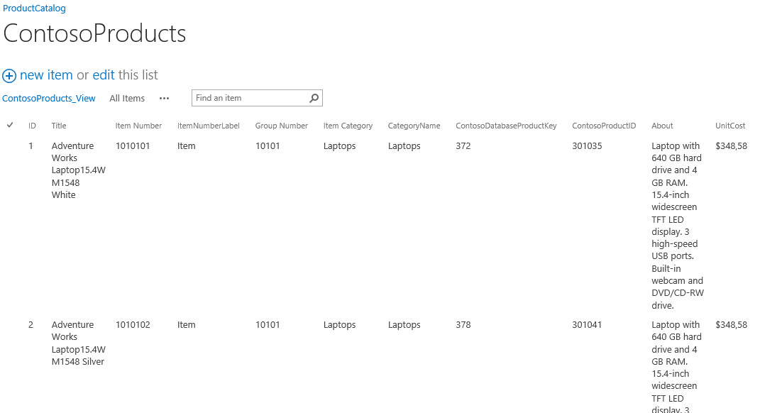

1. Next, ensure the taxonomy was created for the **ContosoProducts** catalog. Select the **Site Actions** gear in the top-right corner of the site and select **Site Settings**.

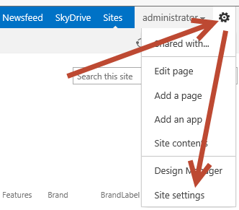

1. On the **Site Settings** page, under the **Site Administration** section, select **Term Store Management**.
2. Verify that a term set called **Product Hierarchy** in the current site collection is present using the **Term Store Management Tool  
   (Note:** this is located underneath the **Site Collection – wcm.wingtip.com-sites-Products** Folder in the hierarchy**.** 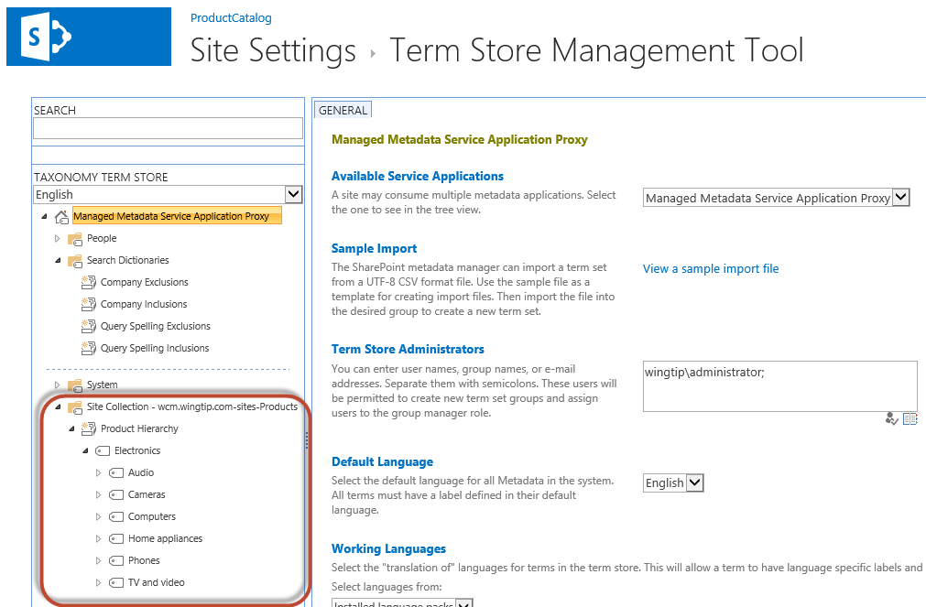

#### Create Managed Properties for Search

1. Open **Central Administration**:
   1. **Windows Keyboard Key 🡪 SharePoint 2013 Central Administration**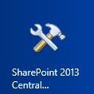
2. Go to the **Search Administration** page:
   1. **Application Management 🡪 Manage Service Applications 🡪 Search Service Application**
3. Before creating managed properties you need to make the search service application aware of all content properties. To do this, you must crawl the content. Start a full crawl of the **ContosoProducts** catalog:
   1. Select **Content Sources** in the left-hand list of links on the **Search Service Application**: **Search Administration** page.
   2. Select the **Local SharePoint Sites** and pick **Start Full Crawl**.

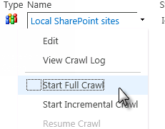

* 1. This step might take 5-10 minutes depending on the performance of the server you are working on. Click the **Refresh** link at the top of the page to monitor the progress of the crawl.
  2. When the crawl is finished, proceed to the next step.

1. Once the content has been crawled you can create a few managed properties that will be used to find the content in the catalog. Select the **Search Schema** link in the left-hand navigation.
2. Create a new managed property by clicking the **New Managed Property** link and using the following information to create it (leave the default values for any selections not specified in the following list):
   1. **Property Name**: ItemId
   2. **Type**: Text
   3. **Searchable**: Checked
   4. **Queryable**: Checked
   5. **Retrievable**: Checked
   6. **Token Normalization**: Checked
   7. **Mappings to Crawled Properties**:
      1. Select **Include content from all crawled properties**
      2. Click **Add a Mapping** button
      3. **Search for a crawled property name**: ProductCatalogItemNumber
      4. Click **Find**
      5. Select **ows_ProductCatalogItemNumber** and click **OK**
      6. Mappings to crawled properties should appear as below:

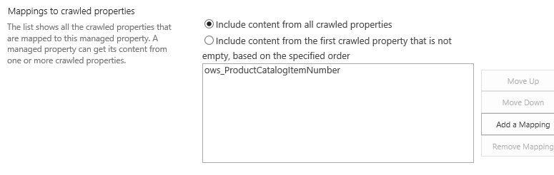

Click **OK** at the bottom of this screen

1. Repeat the process to create the following additional managed properties:
   1. **Property #1**
      1. **Property Name**: Category
      2. **Type**: Text
      3. **Searchable**: Checked
      4. **Queryable**: Checked
      5. **Retrievable**: Checked
      6. **Refinable**: Yes-Active
      7. **Sortable**: No
      8. **Token Normalization**: Checked
      9. **Mapping Property**: ows_taxId_ProductCatalogItemCategory
   2. **Property #2**
      1. **Property Name**: Price
      2. **Type**: Integer
      3. **Searchable**: Checked
      4. **Queryable**: Checked
      5. **Retrievable**: Checked
      6. **Refinable**: Yes-Active
      7. **Sortable**: Yes-Active
      8. **Token Normalization**: Checked
      9. **Mapping Property**: ows_q_TEXT_UnitPrice
   3. **Property #3**
      1. **Property Name**: Color
      2. **Type**: Text
      3. **Searchable**: Checked
      4. **Queryable**: Checked
      5. **Retrievable**: Checked
      6. **Refinable**: Yes-Active
      7. **Sortable**: No
      8. **Token Normalization**: Checked
      9. **Mapping Property**: ows_q_TEXT_Color
2. In order to populate the search index with these new managed properties you must re-crawl the content.
   1. Select **Content Sources** in the left-hand list of links on the **Search Service Application**: **Search Administration** page.
   2. Select the **Local SharePoint Sites** and pick **Start Full Crawl**.
   3. This step might take 5-10 minutes depending on the performance of the server you are working on. Click the **Refresh** link at the top of the page to monitor the progress of the crawl.
3. When the crawl is finished, proceed to the next step.

At this point you have setup the environment to complete the remainder of the lab.

#### Verify Search & Managed Properties

1. Before leveraging the content catalog and search configuration changes in a Publishing site it is recommended you test the contents of the index. Do this by creating a new search site.
   1. Using **Internet Explorer** browse to <http://wcm.wingtip.com>.
   2. Select the **Site Contents** link in the **Quick Launch** navigation.
   3. On the **Site Contents** page, under the **Subsites** section, select the **new subsite** link.
   4. Use the following image to fill in the details in creating a new search site:  
      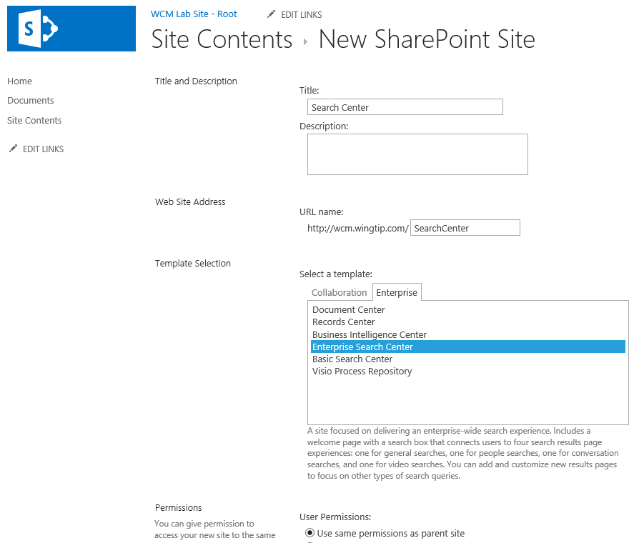
   5. After the site is created you will be redirected to the search page.
2. Try a basic keyword search by entering **camera** and press **ENTER** as a search term. You should see the following (or similar) results:

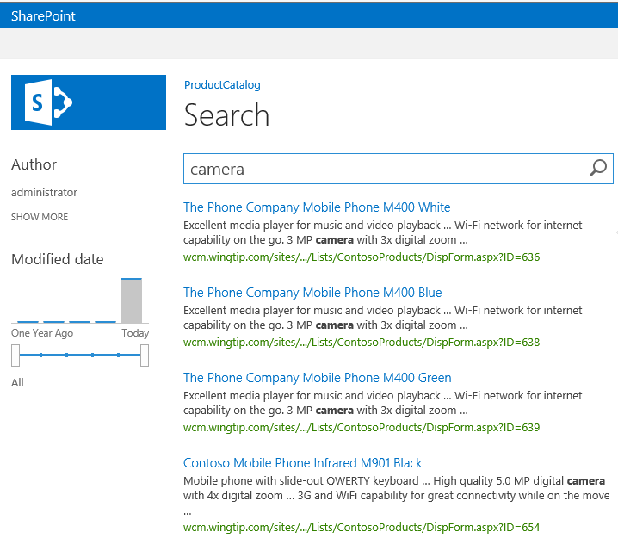

1. Next try a search using the managed properties you previously created by entering a search term such as **category:laptops**. You should see multiple results.
2. Now search for **color:white**. You should see multiple results.
3. Now search for **itemid:1010101**. You should get a single result.

In this exercise you created a new environment, populated it with some content and configured search to have additional managed properties.

### Exercise 2: Create and Populate the Publishing Site with Content

In this exercise you will first create a new page manually using the structured authoring method. Next you will configure the content catalog created in the previous exercise for sharing with other site collections. You will then connect it to the Publishing site and enable managed navigation on the Publishing site.

1. Using **Internet Explorer** navigate to the Publishing site at <http://wcm.wingtip.com/sites/>pub.
2. First add an image to the site to use in a new page:
   1. In the **Quick Launch** navigation, click the **Site Contents** link.
   2. On the **Site Contents** page, select the **Images** library.
   3. Open **Windows Explorer** (**Start 🡪 All Programs 🡪 Accessories 🡪 Windows Explorer**) and navigate to the location of the files for this exercise:

[..]\WCM\Exercises\Ex2

* 1. Within this folder you’ll find two images in the exercise folder. Select both of these files and drag them into the browser near where it says **Drag files here or click to add an item** under the **Images** library title:

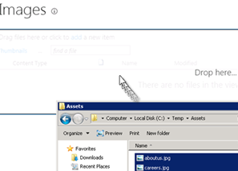

* 1. After a moment the images will have been uploaded to the library:

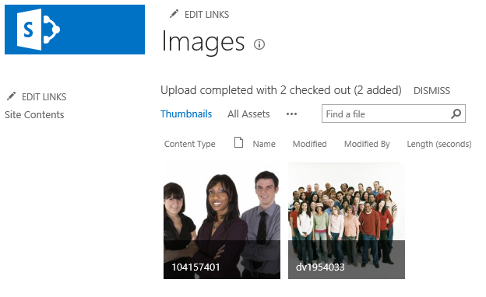

* 1. After uploading the two images, you need to check them in so they can be used. Do this by selecting the checkbox on each image (one at a time) (i.e. select the first image then do steps g and h and then come back to step f and select the other image and do steps g and h):

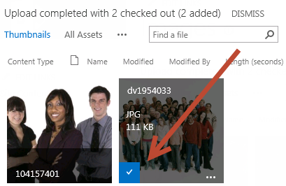

* 1. Next, select the **Files** tab in the ribbon and click the **Check In** button:
  2. When prompted select **Version=1.0 Major Version (Publish)** and click **OK**.

1. Next, create a new page using the structured authoring approach in that you will manually create and edit the content on the actual page:
   1. Add a new page by clicking the gear in the top-right corner of the page and select **Add a Page**:
   2. In the **New Page** dialog, enter **About Us** and click **Create**.

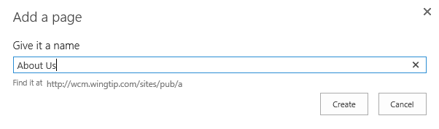

* 1. Enter some text on the page. Use the formatting options under the **Format Text** tab in the ribbon to apply different styles to the text.
  2. Add an image to the page by going to the ribbon and selecting the **Insert** tab, then the arrow below the **Picture** button and select **From SharePoint**:
  3. Select one of the images you uploaded in a previous step and click **Insert**.
  4. Use the picture controls to resize and alter the image.
  5. When finished, click the **Check In** button found in the **Page** tab of the ribbon.

1. Notice how after creating the page, the URL is a SEO-friendly URL and the page shows up in the navigation.   
   (Note: although we can see the page, note that those who are visitors to the site would not see this page currently as it has not been published.)  
   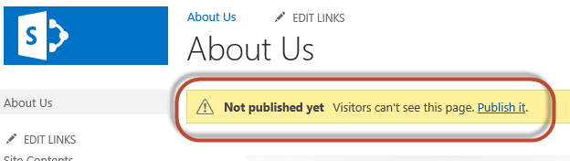
2. Let us examine how the navigation is being created by looking at the site’s navigation taxonomy:
   1. Select the gear in the top-right corner of the page and select **Site Settings**.
   2. Under the **Site Administration** section, select **Term Store Management**.
   3. Expand the term site for the **Site Collection** and then expand **Site** **Navigation** to find the **About Us** term that is linked to the page you just created:

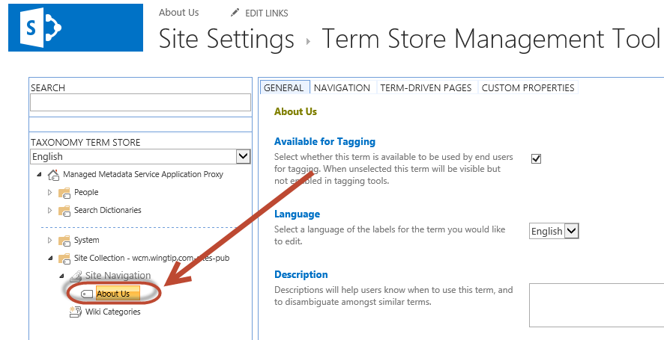

#### Share the catalog list you created in the previous exercise

In order to use the content stored in the ContosoProducts catalog list, you must share it so other site collections can connect to it.

1. Using **Internet Explorer**, navigate to [http://wcm.wingtip.com/sites/products](http://intranet.contoso.com/sites/ProductCatalog).
2. Select the **Site Contents** link in the **Quick Launch** navigation and select the **ContosoProducts** list.
3. Go to the list’s settings by selecting the **List** tab in the ribbon and then the **List Settings** button.
4. On the **List Settings** page, select **Catalog Settings** under the **General Settings** column.
5. On the **Catalog Settings** page, select the following options and click **OK**:
   1. **Catalog Sharing**: Enable this library as a catalog: **Checked**
   2. **Catalog Item URL Fields**: Item Number  
      (Note: Select **Item Number** in the **Available Fields** list and click **Add** to add it to **Selected Fields**)
   3. Navigation Hierarchy: Item Category  
      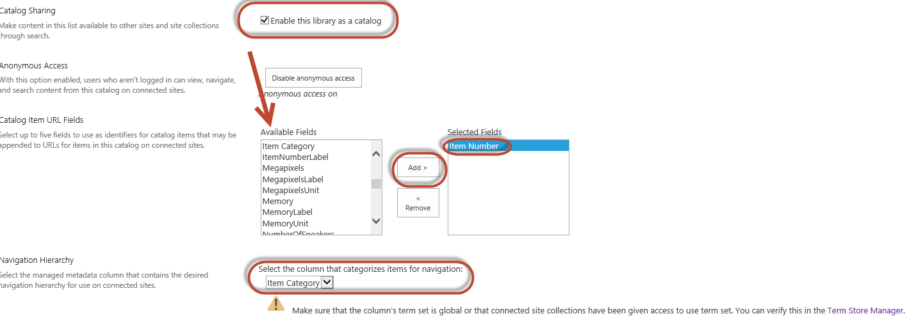

#### Connect the Catalog to the Publishing Site and Enable Managed Navigation

The site collection that contains the ContosoProducts catalog list also contains a term set that should be used for navigation in the Publishing site. In order to use the term set in another site collection it must be shared.

1. Using **Internet Explorer**, navigate to [http://wcm.wingtip.com/sites/products](http://intranet.contoso.com/sites/ProductCatalog).
2. Next, use the **Site Actions** gear icon in the top-right corner to select the **Site Settings** option.
3. Select the **Term Store Management** option under the **Site Administration** section.
4. Select the **Site Collection** grouping for the current site collection as shown in the following figure:

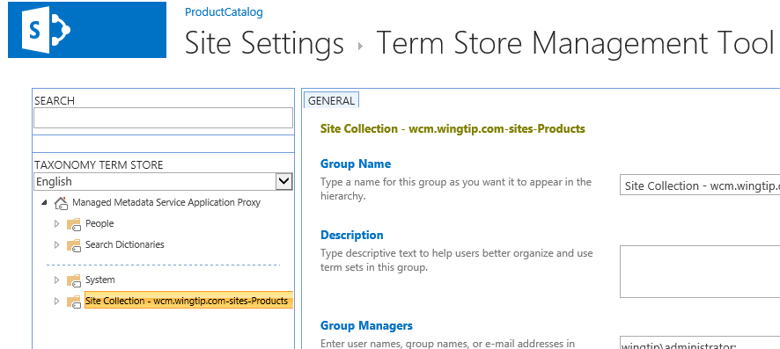

1. Next, enter the URL of the Publishing site collection ([http://wcm.wingtip.com/sites/pub](http://intranet.contoso.com/sites/wcm)) to share the term set with in the **Site Collection Access** box and click **Save**:
2. Verify the term set is available in the Publishing site.
   1. Using **Internet Explorer**, navigate to [http://wcm.wingtip.com/sites/pub](http://intranet.contoso.com/sites/wcm).
   2. Using the **Site Actions** gear icon in the top-right corner, go to the **Site Settings** page.
   3. Under the **Site Administration** section select **Term Store Management**.
   4. Notice that the term set’s site collection from the **Products** site is showing up in the Publishing site.

#### Share the Catalog’s Term Set with the Publishing Site

With the ContosoProducts catalog list shared, you now need to connect the Publishing site to the catalog.

1. Using **Internet Explorer**, navigate to [http://wcm.wingtip.com/sites/pub](http://intranet.contoso.com/sites/wcm).
2. Using the **Site Actions** “gear” icon in the top-right corner, go to the **Site Settings** page.
3. Under the **Site Administration** section, select **Manage Catalog Connections**.
4. Click the link **Connect to a catalog**.
5. The **ContosoProducts** catalog should be listed. Click the **Connect** link on the right:

If the catalog is not shown here, go back to the Search Service Application in Central Administration and restart a full index of the content source as shown in previous steps.

1. On the **Catalog Source Settings** page, select the following options and click **OK**:
   1. **Connection Integration:** Integrate the catalog into my site
   2. **Navigation Hierarchy**:
      1. **Select column that categorizes items for navigation**: Item Category
      2. **Root term of hierarchy**: Electronics
   3. **Navigation Position:** Add to navigation root
   4. **Navigation Pinning:** Pin Terms to site navigation
   5. **Catalog Item URL Behavior:** Make URLs relative to this site
   6. **Catalog Item URL Format**:
      1. **Construct a URL format from catalog properties**: Selected
         1. Remove **ProductCatalogItemNumberOWS** from **Selected Fields**
         2. Add **ItemId** from **Available Fields** to **Selected Fields**
   7. **Category Page:** Create a new page
   8. **Item Page:** Create a new page
2. Notice that after the page loads, the left-hand side navigation is now reflecting not only the **About Us** page we manually created earlier but also the items from the term set:
3. You can see the contents being pulled back automatically by selecting from the navigation **Computers 🡪 Laptops**:

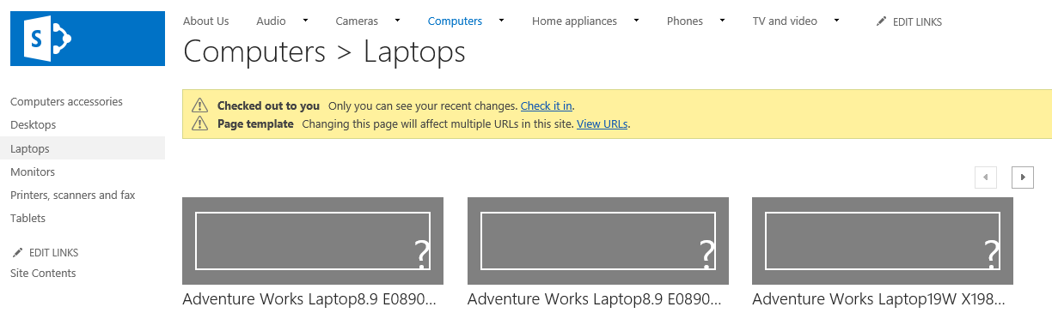  
(Note: this page is checked out and will need to be **checked in** and **published** to allow others to see/use it)

### Exercise 3: Customize Rollup and Detail Pages with the Content by Search Web Part

When you connected the Publishing site to a catalog, SharePoint automatically created page layouts for use as the rollup and detail pages. In this task you will replace them with new ones.

1. Using **Internet Explorer**, navigate to [http://wcm.wingtip.com/sites/pub](http://intranet.contoso.com/sites/wcm).
2. Using the **Site Actions** gear icon in the top-right corner, select **Site Settings**.
3. Under the **Web Designer Galleries**, select **Master Pages and Page Layouts**.
   1. Upload the file **ContosoRollup1Column.aspx** found in the location of the files for this exercise:

[..]\WCM\Exercises\Ex3

1. When prompted, accept all defaults except the following fields in the **Associated Content Type** section:
   1. **Content Type:** Page Layout
   2. **Associated Content Type** section:
      1. **Content Type Group**: Page Layout Content Types
      2. **Content Type Name:** Catalog-Item Reuse
   3. click **Save**
2. Repeat the steps above for **ContosoRollup2Columns.aspx**
3. Using the gear icon in the top-right corner, select **Site Contents**.  
   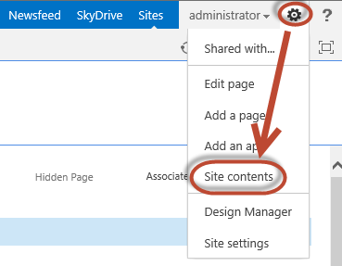
4. On the **Lists, Libraries, and other Apps** section, click on the **Pages** library.
5. On the **Pages** Library, using the ribbon, select the **Files** tab, click the down arrow on the **New Document** button and select **Catalog-Item Reuse**.
6. On the **Create Page** page, use the following to complete the form and click **Create**:
   1. **Title:** Main Category
   2. **URL Name:** MainCategory.aspx
   3. **Page Layout:** (Catalog-Item Reuse) ContosoRollup1Column.aspx

#### Associate Category Pages with the new Rollup Page Template

1. Using **Internet Explorer**, navigate to [http://wcm.wingtip.com/sites/pub](http://intranet.contoso.com/sites/wcm).
2. Using the **Site Actions** gear icon in the top-right corner, select **Site Settings**.
3. Under the **Site Administration** section, select **Term Store Management**.
4. Expand **the Site Collection – wcm.wingtip.com-sites-pub** node and the **Site Navigation** node.
5. Select the **Audio** node
6. In the right-hand pane, select the **Navigation** tab.
7. Next, in the **Navigation Node Type** section, select **Term-Driven Page with Friendly URL**.
8. Then scroll to the bottom and click **Save**.
9. Next, select the **Term-Driven Pages** tab.
10. Under the **Target Page Settings**, check both of the following options and set the **/sites/pub/Pages/MainCategory.aspx** page as the template to use:
    1. Change target page for this term
    2. Change target page for children of this term

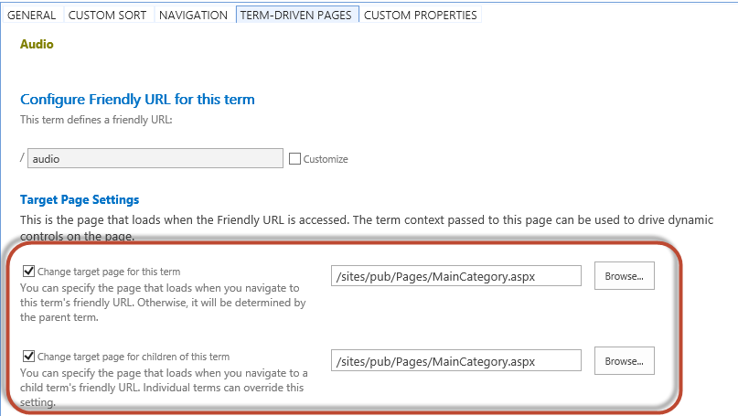

1. Scroll to the bottom and click **Save**.
2. Repeat these steps for the other top-level categories in the navigation: **Cameras, Computers, Home Appliances, Phones** and **TV and Video**.

#### Customize the Main Category Page

1. Using **Internet Explorer**, navigate to [http://wcm.wingtip.com/sites/pub](http://intranet.contoso.com/sites/wcm).
2. In the top-navigation, select **Audio**.
3. The page should load with no content. Now you will modify the template all pages use to dynamically show content based on the URL of the page.
   1. Using the **Site Actions** gear icon in the top-right corner, select **Edit Page**.
   2. When prompted, select **Edit Page Template**. It will warn you how many URLs will be affected by this change:

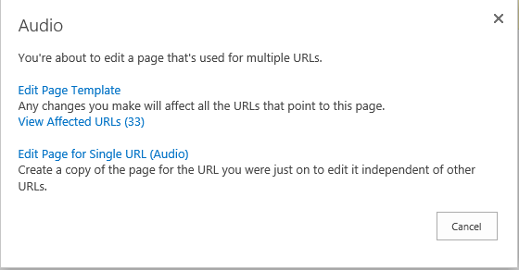

1. Click **Add a Web Part**.
2. From the **Content Rollup** category, select **Content Search** and click **Add**.
3. Select the Web Part that was added to the page and from the ribbon, select the **Web Part** contextual tab on the Ribbon, and then the **Web Part Properties** button:
4. In the **Editor Tool Pane** on the right-hand side of the page, click the **Change Query** button under **Search Criteria**:

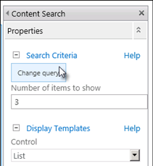

1. Use the following settings to filter the results & notice how the results change to the right of the page.
   1. **Select a query:** ProductCatalog – ContosoProducts Results (Site Collection)
   2. **Restrict by tag:** Restrict by current and child navigation terms

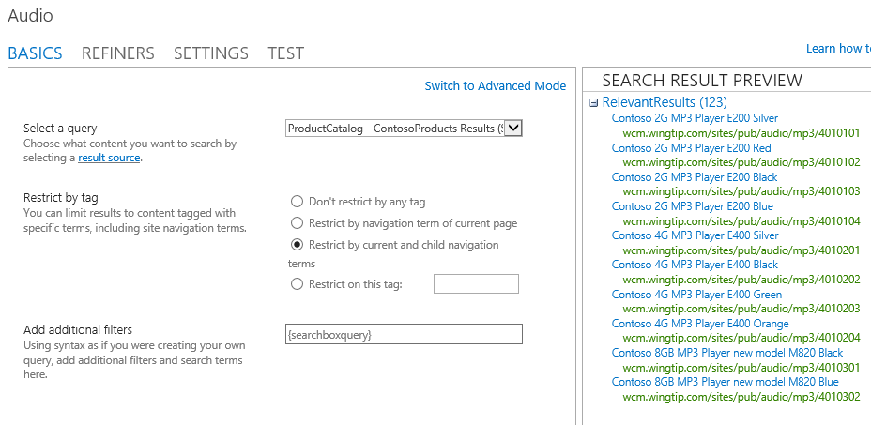

1. Click **OK** to close the query builder.
2. In the Editor Tool Pane, change the **Number of Items to Show** to be **9**, set the **Display Template** for **Item** to be **Picture on top, 3 lines on bottom** and click **OK** to apply all changes.
3. Finally, in the ribbon, on the **Page** tab click **Check In** and then click **Continue** to save the changes to the page to see the new rollup page:  
   (Note: the page has not been published yet, and would need to be before visitors could see this).  
   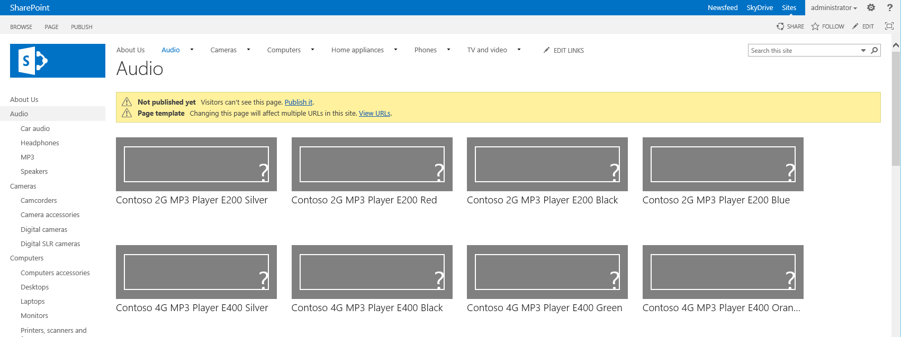
4. If you click on **Cameras**, you’ll notice it has the same changes applied to it.

In this exercise you implemented and customized the rollup page for a section.

### Exercise 4: Implement a Custom Brand with the Design Manager

In this exercise you will implement a custom brand in a SharePoint 2013 Publishing site with the new Design Manager.

1. Open **Internet Explorer** and navigate to [http://wcm.wingtip.com/sites/pub](http://intranet.contoso.com/sites/wcm).
2. Using the **Site Actions** gear icon in the top-right corner, go to the **Site Settings** page.
3. Under the **Look and Feel** grouping, select the **Design Manager** link.
4. The Design Manager is a wizard-based experience. Not all steps are covered in this exercise. Jump to step 3, **Upload Design Files**, by clicking the link on the left-hand navigation.
5. Files can be manually uploaded or copied using a mapped folder. Before doing this, simplify the lab experience by turning off content approval, check in/out requirements and versioning on the Master Page Gallery:
   1. In a new instance or tab of **Internet Explorer**, navigate to [http://wcm.wingtip.com/sites/pub](http://intranet.contoso.com/sites/wcm).
   2. Using the **Site Actions** gear icon in the top-right corner, go to the **Site Settings** page.
   3. Under the **Web Designer Galleries** grouping, select the **Master Pages and Page Layouts** link.
   4. Within the **Master Page Gallery**, use the ribbon to select the **Library** tab and click the **Library Settings** button.
   5. On the library settings page select **Versioning Settings** from the **General Settings** column.
   6. Change the following settings and click **OK**:
      1. **Content Approval**: No
      2. **Document Version History**: No Versioning
      3. **Require Checkout**: No
6. In the Master Page Gallery, on the ribbon, select the **Library** tab and click **Open with Explorer** in the **Connect & Export** group.  
   (Note: this is an alternative to mapping a network drive that you might choose to use if a) you have many locations you wish to copy design items into, and b) you do not plan to do this on a recurring basis in any given location).
   1. If you do **not** receive an error, skip to step 7.
   2. You received an error that:  
      
   3. This is an issue with **Windows Server 2012;** by default the “Desktop Experience” feature is not enabled so you cannot use the File Explorer feature in **SharePoint 2013** or Map a SharePoint location as a network drive.
   4. To enable the Desktop Experience Feature:
      1. **Windows Keyboard Key 🡪** Type **Server Manager** and select that tile
      2. On Server Manager in the right side of the dialog box click **Add roles and features** then Click **Next 🡪Next**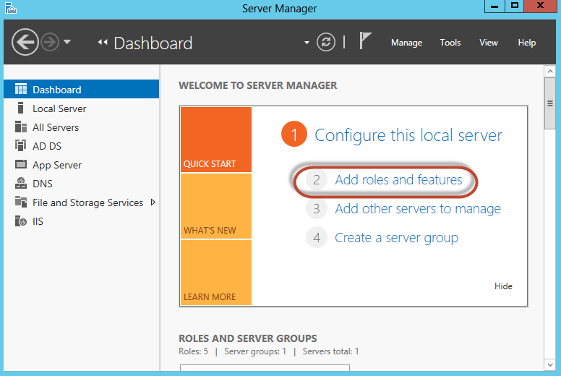
      3. In the **Add Roles and Features Wizard:**
         1. Click on **Features** in Select features
         2. In the Features list expand **User interfaces and infrastructure (Installed)**
         3. Place a check in **Desktop Experience** and then click **Add Features** to the required features dialog box that appears  
            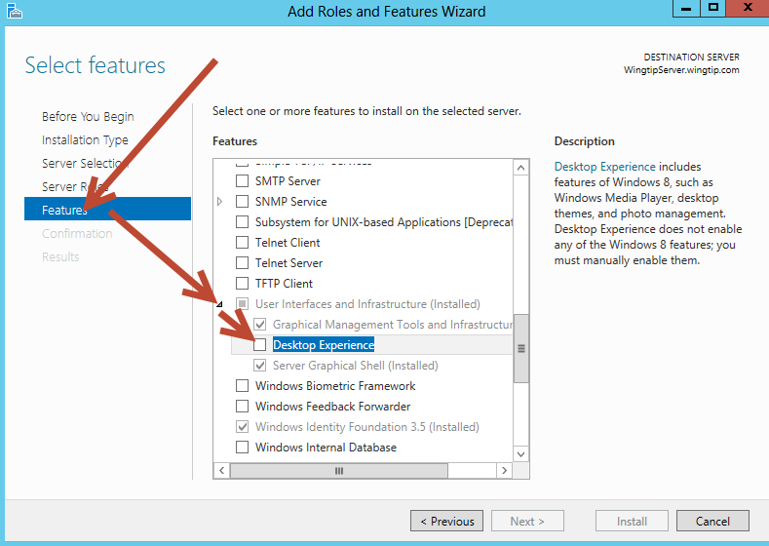
         4. Click **Install**
      4. Restart Windows server when prompted:
         1. **Windows Keyboard key**
         2. **Hover** the mouse in the **bottom right hand corner** of the screen to bring up the “Charm Bar” then click **Settings**.  
            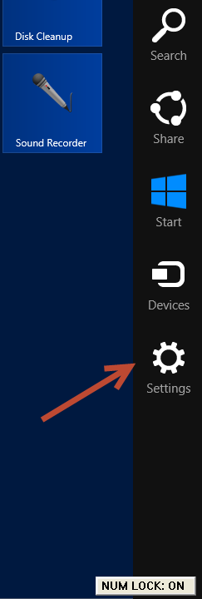
         3. Click **Power** **🡪 Restart**.  
            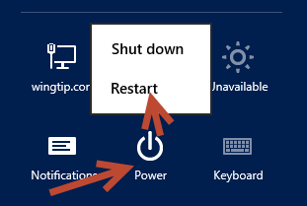
         4. When the Server restarts log back in using the same password (**Password1**)
   5. In Internet Explorer, open [http://wcm.wingtip.com/sites/pub/_catalogs/masterpage](http://intranet.contoso.com/sites/wcm/_catalogs/masterpage)
   6. In the Master Page Gallery, on the ribbon, select the **Library** tab and click **Open with Explorer** in the **Connect & Export** group.
7. You may be prompted to login to confirm you can access the folder
8. Now that we have proven that we can navigate to a SharePoint location using the File Explorer, we need to map a network drive so that we can access this location at a later time:
9. Map the Master Page Gallery location as a network drive from step 3 in the Design Manager:
   1. Copy the URL for the Master Page Gallery ([http://wcm.wingtip.com/sites/pub/_catalogs/masterpage](http://intranet.contoso.com/sites/wcm/_catalogs/masterpage)) to the clipboard.
   2. Open **File Explorer** (**Windows Keyboard Key 🡪** Type **File Explorer** and select the tile).
   3. Click **Computer** in the left-hand panel and then click the **Map Network Drive** label:

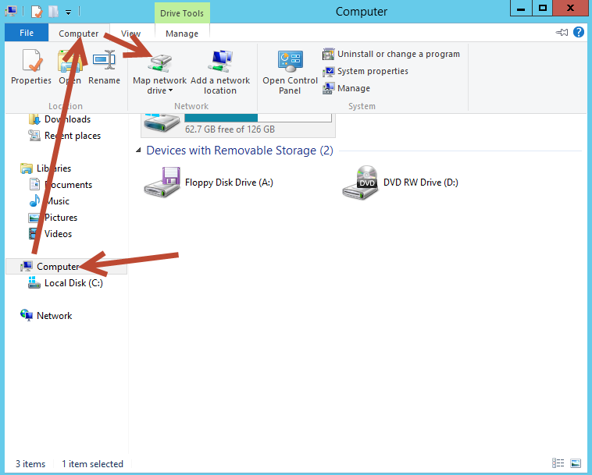

* 1. In the **Map Network Drive** dialog, click the link **Connect to a Web site that you can use to store your documents and pictures**.
  2. In the **Add Network Location** dialog, click **Next**.
  3. Click **Choose** **a custom network location** and click **Next**.
  4. Paste the URL of the Master Page Gallery and click **Next**. You may be prompted to login to confirm you can access the folder:
  5. When prompted, accept the default name of the location and click **Next** & finally **Finish** to complete the wizard.

1. With a mapped folder created for the Master Page Gallery, copy all the contents of the folder associated with this exercise (in the following location) into the Master Page Gallery:

[..]\WCM\Exercises\Ex4

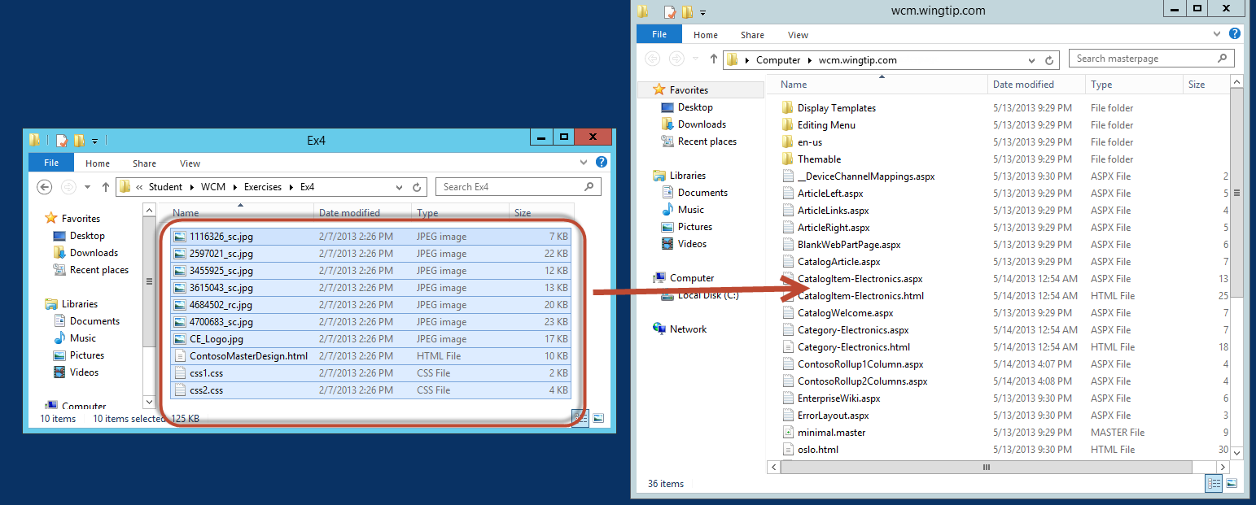

#### Convert the HTML Master Page to a SharePoint Master Page

1. Open **Internet Explorer** and navigate to [http://wcm.wingtip.com/sites/pub](http://intranet.contoso.com/sites/wcm).
2. Using the **Site Actions** gear icon in the top-right corner, go to the **Site Settings** page.
3. Under the **Look and Feel** grouping, select the **Design Manager** link
4. In the **Design Manager**, click on **step 4: Edit Master Pages**.
5. The **Design Manager: Edit Master Pages** page will show all master pages in the Master Page Gallery. You need to convert your HTML file that was previously uploaded to a SharePoint master page.
6. Click the **Convert an existing HTML master page** link.
7. Select the **ContosoMasterDesign.html** file and click **Insert**.

Make sure you select the row and don’t click on the actual file link as clicking the link will take you to that file.

1. Accept and/or click through any a prompts you receive and refresh the page until you see the **ContosoMasterDesign** show up on the page with a status of **Conversion successful**.  
   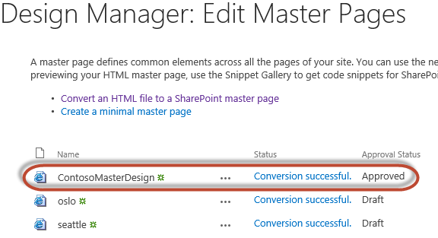
2. Click the **Conversion successful** link for the **ContosoMasterDesign** to open the preview page.  
   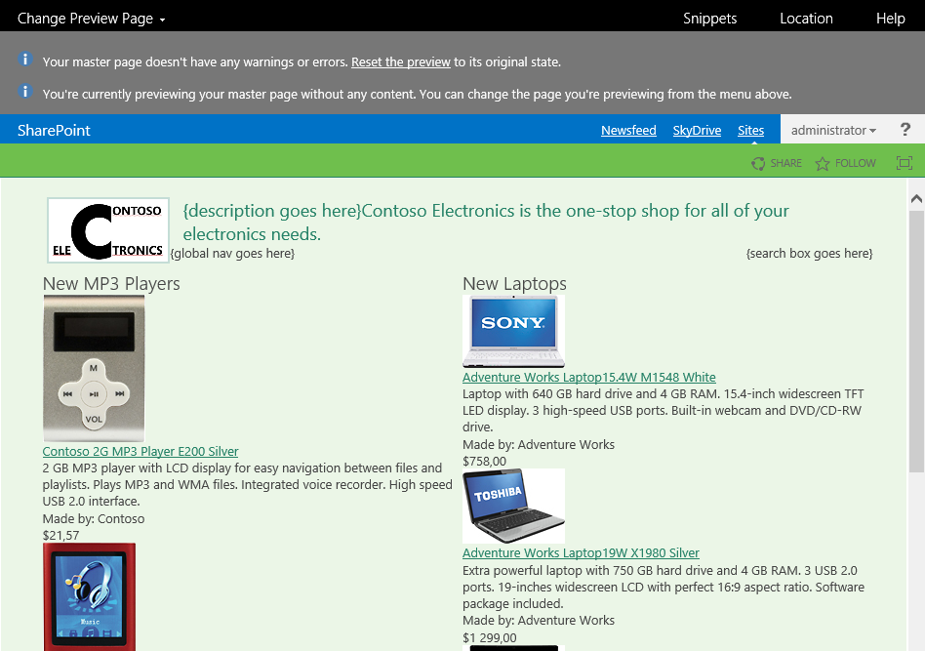

#### Customize and Preview the SharePoint Master Page in Notepad

1. Open **Notepad** (**Windows Keyboard Key 🡪** type **Notepad** and select the tile) and open the **ContosoMasterPage.html** file from the mapped network drive. Ensure you don’t open the *.master version of this file… only the *.html version
2. Jump to line **124** (using the **[CTRL]+[G]** shortcut) and add the following code and save your changes:

<h1>Hello World</h1>

1. Go back to the browser that has the preview open and refresh the page to see the changes immediately take effect:  
   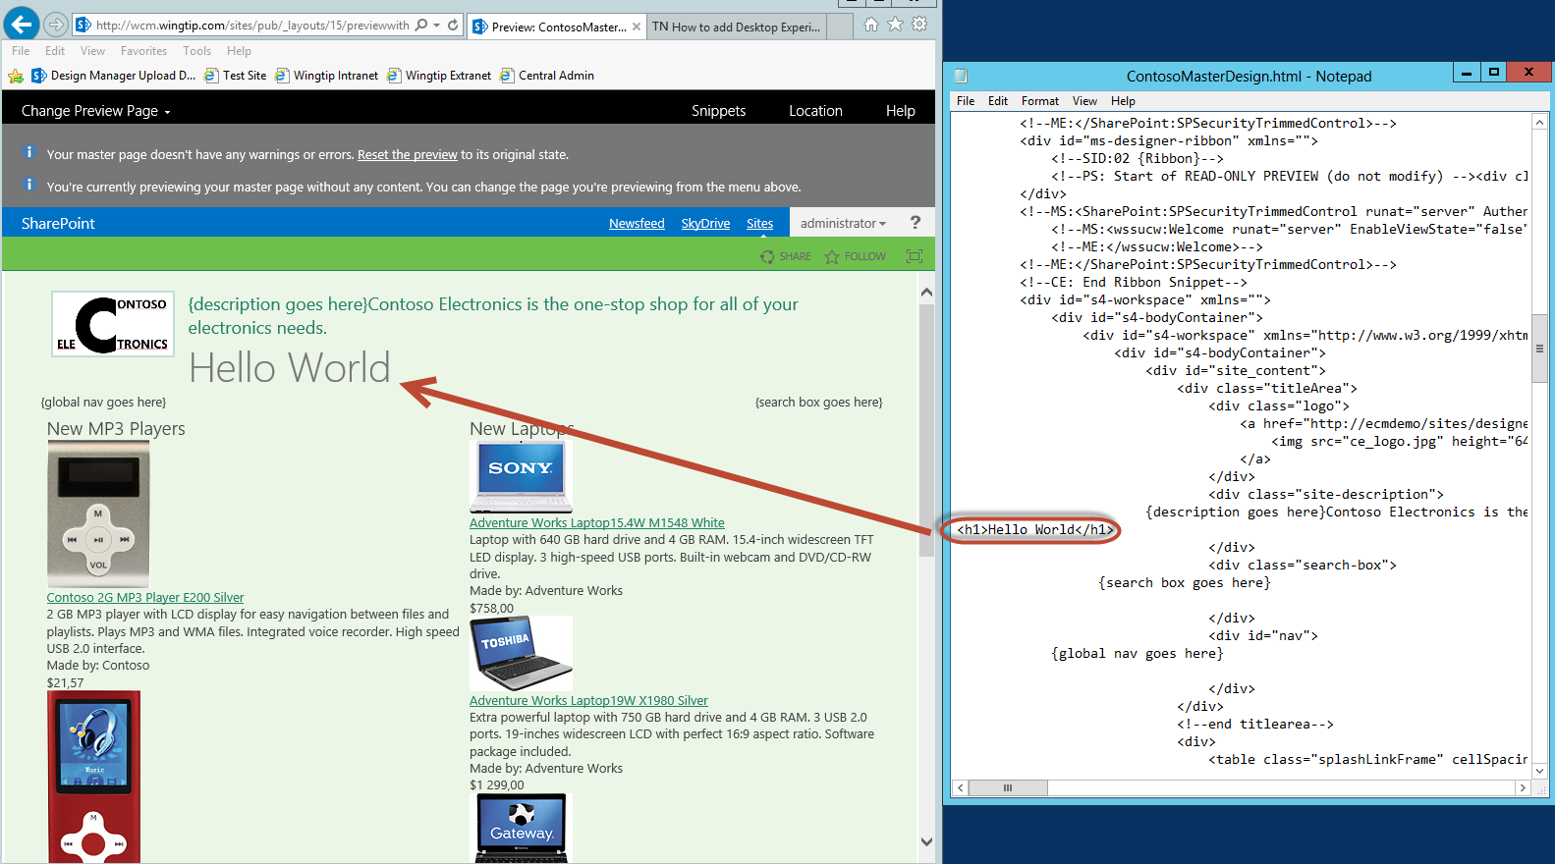
2. That simple change was just to show how the preview experience works. Remove the line you just added in **Notepad** and save the page.
3. Add in global navigation for the site using the Snippet Gallery:
   1. In the master page preview, click the **Snippets** link in the top-right of the page to launch the **Snippet Gallery**.
   2. In the **Snippet Gallery**, Select **Top Navigation** from the Ribbon **Design** tab and
   3. Click the **Copy to Clipboard** button under the **HTML Snippet** to copy the HTML generated by the Snippet Gallery.
   4. Go back to Notepad and replace the following text with the HTML you copied to the clipboard and **save** your changes:  
      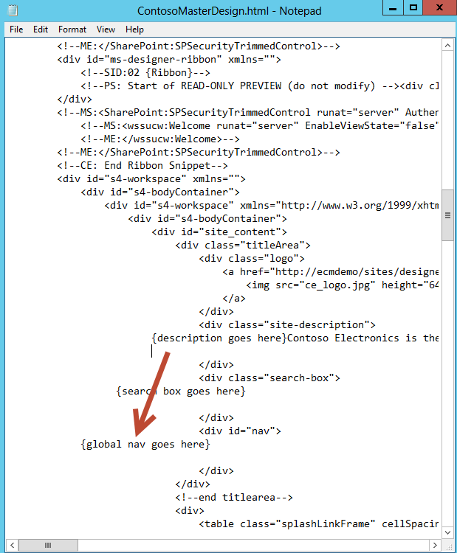

{global nav goes here}

* 1. Go back to the master page preview and refresh the page. You should now see the live navigation being added to the page:  
     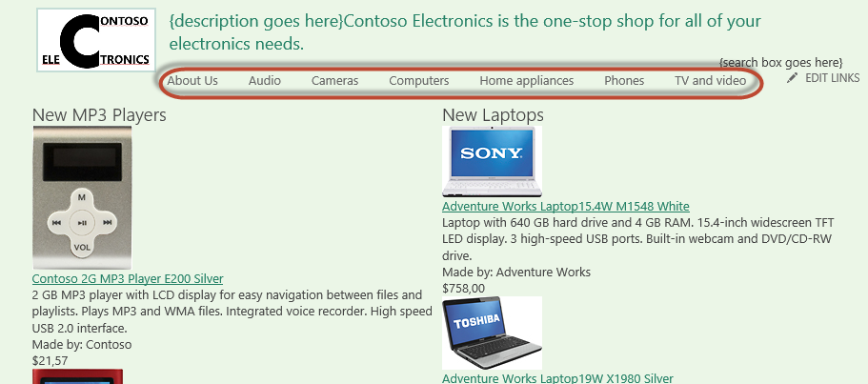

1. Add the search box to the master page.
   1. Jump back to the Snippet Gallery.
   2. Click the **Search Box** button in the **Design** tab of the ribbon.
   3. Click the **Copy to Clipboard** button under the **HTML Snippet** to copy the HTML generated by the Snippet Gallery.
   4. Go back to Notepad and replace the following text with the HTML you copied to the clipboard and save your changes:

{search box goes here}

1. Go back to the master page preview and refresh the page. You should now see the live search box being added to the page:  
   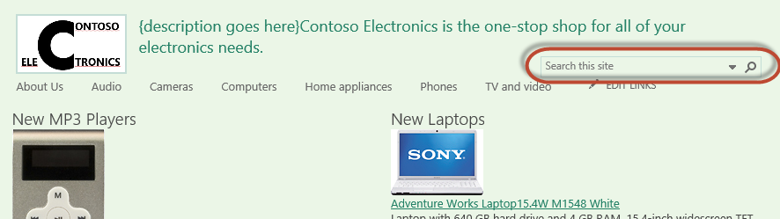
2. Lastly, move the ContentPlaceholderMain control into the area where the rendered content should appear.
   1. In Notepad, find the following HTML comment in the master page:

<!--end titlearea-->

* 1. Immediately following that title you will see a **<DIV>** followed by a **<TABLE>**. The **<TABLE>** contains the static content used in the designer generated master page. Delete this entire table (it starts around line 151 and goes to around line 300).
  2. Jump to the bottom of the master page source. You should a block of HTML that starts with the following markup:

<div name="ContentPlaceHolderMain">

* 1. Select the entire **<DIV>** (including the 3 commented lines after the </DIV> as shown below) and its contents and cut and paste it where the **<TABLE>** was that you just removed.

<div data-name="ContentPlaceHolderMain">

<!--CS: Start PlaceHolderMain Snippet-->

<!--SPM:<%@Register Tagprefix="SharePoint" Namespace="Microsoft.SharePoint.WebControls" Assembly="Microsoft.SharePoint, Version=15.0.0.0, Culture=neutral, PublicKeyToken=71e9bce111e9429c"%>-->

<!--MS:<SharePoint:AjaxDelta ID="DeltaPlaceHolderMain" IsMainContent="true" runat="server">-->

<!--MS:<asp:ContentPlaceHolder ID="PlaceHolderMain" runat="server">-->

<div class="DefaultContentBlock" style="border:medium black solid; background:yellow; color:black; margin:20px; padding:10px;">

This div, which you should delete, represents the content area that your Page Layouts and pages will fill. Design your Master Page around this content placeholder.

</div>

<!--ME:</asp:ContentPlaceHolder>-->

<!--ME:</SharePoint:AjaxDelta>-->

<!--CE: End PlaceHolderMain Snippet-->

* 1. Finally, look for HTML within the **<DIV>** you just moved that starts with this:

<div class="DefaultContentBlock" style="border:medium black solid; background:yellow; color:black; margin:20px; padding:10px;">

This div, which you should delete, represents the content area that your Page Layouts and pages will fill. Design your Master Page around this content placeholder.

</div>

* 1. Delete the markup listed above. This was added by SharePoint to highlight where your dynamic content should appear.
  2. Save your changes.

1. Go back to the master page preview and refresh the page. You should no longer see the static content:  
   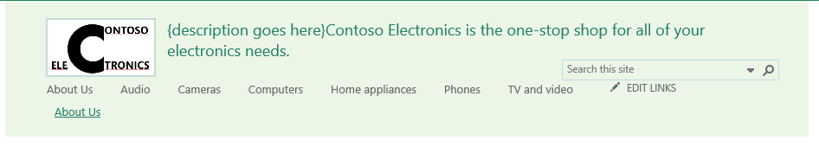

#### Set the Publishing Site to Use the New Master Page

1. Open **Internet Explorer** and navigate to the Publishing site at [http://wcm.wingtip.com/sites/pub](http://intranet.contoso.com/sites/wcm).
2. Use the **Site Actions** gear icon in the top-right corner of the page to jump to the **Site Settings** page.
3. Under the **Look and Feel** grouping, select **Master Page**.
4. Change the **Site Master Page** to **ContosoMasterDesign** and click **OK**.
5. Go back to the homepage of the site to see how your master page is now being used as the site master page. You can also click on the links in the navigation to view how the rollup pages appear.  
   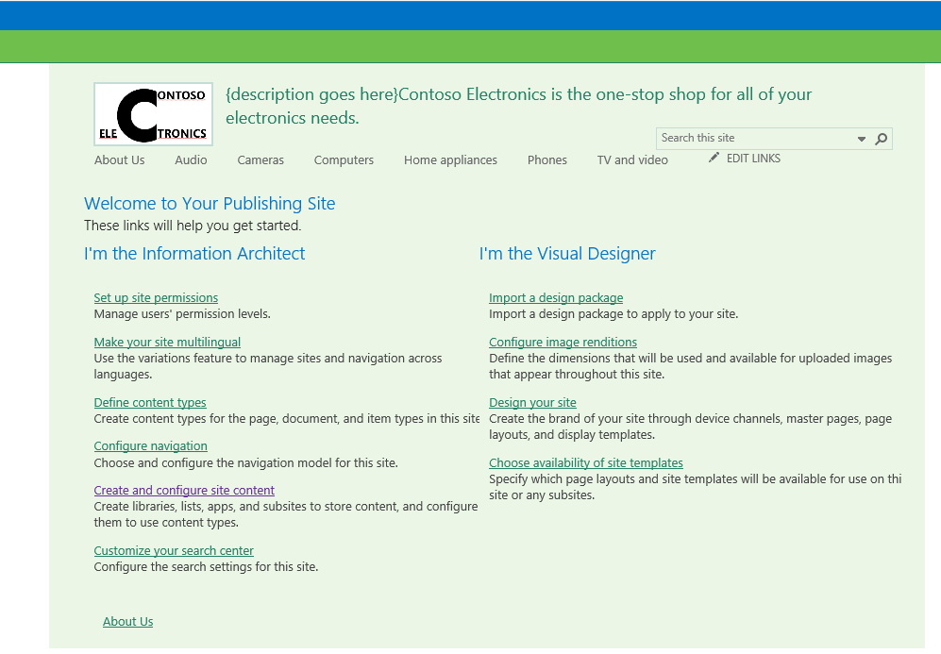

In this exercise you implemented a sample custom brand using the new Design Manager.