## Creating SharePoint Farm Solutions

**Lab Time**: 45 minutes

**Lab Folder**: C:\Student\Modules\FullTrustSolutions

**Lab Overview**: In this lab you will learn how to create SharePoint farm solutions. While Microsoft is pushing their new SharePoint App model as the preferred way to extend SharePoint deployments both on-premises as well as in the cloud with Office 365, there are still a great many things that cannot be accomplished using apps. This is why farm solutions still play an important role in the product.

### Exercise 1: Setup Lab Environment

In this exercise you will setup your environment.

All exercises in this lab assume you will work in a new site collection, http://solutions.wingtip.com.

1. Setup a new site collection for this lab:
   1. Ensure you are logged into the **WingtipServer** server as **WINGTIP\Administrator**.
   2. Run a PowerShell script, found in the root lab folder for this module:
      1. Right-click **SetupLab.ps1** and select **Run with PowerShell**. This file can be found in the files associated with this lab:

C:\Student\Modules\FulltrustSolutions\Lab

* 1. When the script completes, it will launch a new browser and navigate to the lab site collection.
  2. Close the PowerShell console window.

### Exercise 2: Creating Web Parts using Farm Solutions

In this exercise you will create a simple Web Part and add it to a custom Web Part group with a custom icon. This will be done using a farm solution.

1. Create a new project in Visual Studio 2013:
   1. Launch **Visual Studio 2013** as administrator:
      1. **Windows Keyboard Key** 🡪 **Right click** on the **Visual Studio 2013** tile and select **Run as administrator**
      2. Alternatively after pressing the **Windows Keyboard Key** you can simply start typing the name of the program you are looking for (e.g. Visual Studio); this will filter the results to those that match the letters typed on the keyboard)
   2. In Visual Studio select **File 🡪 New 🡪 Project**.
   3. In the **New Project** dialog:
      1. Find the **SharePoint 2013 - Empty Project** template under the following node:
         1. **Templates** 🡪 **Visual C#** 🡪 **Office / SharePoint** 🡪 **SharePoint Solutions**
      2. **Name**: WingtipWebParts
      3. **Location:** C:\Student\Modules\FulltrustSolutions\Lab
      4. **Uncheck** the **Create directory for solution** checkbox
      5. Click **OK** to create the project

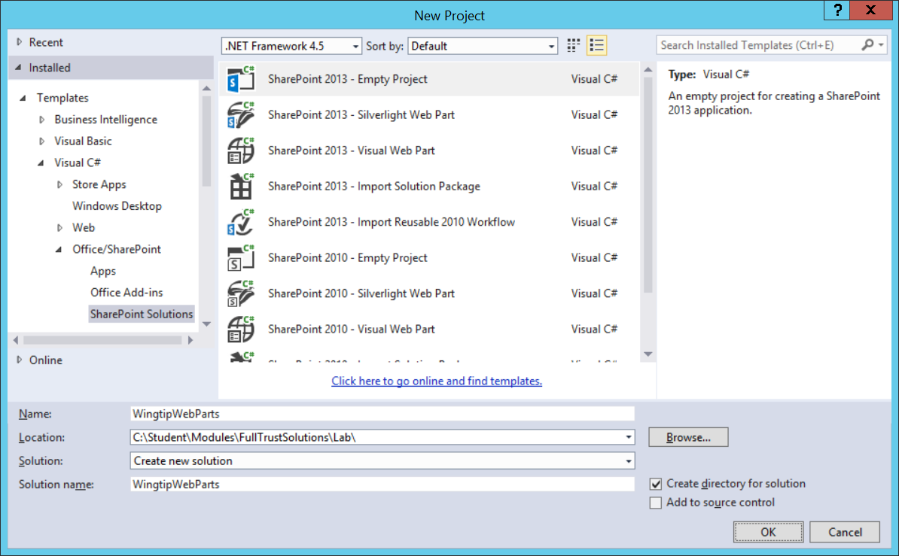

* 1. In the **SharePoint Customization Wizard**, use the following values to complete the wizard.
     1. **What site do you want to use for debugging?** <http://solutions.wingtip.com>
     2. **What is the trust level for this SharePoint solution?** Deploy as farm solution
  2. Click **Finish**

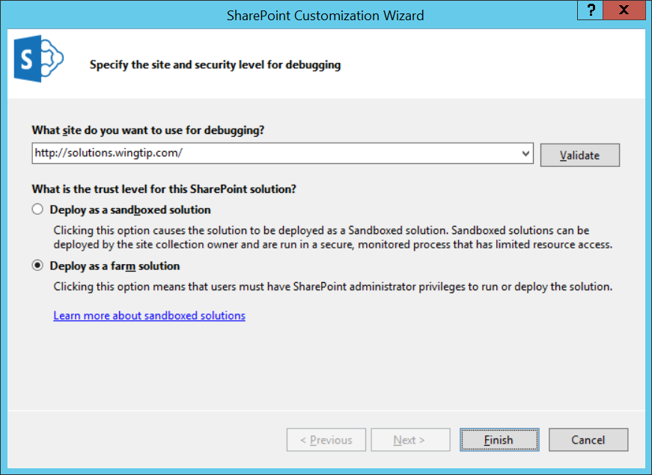

1. After the project has been created, examine its structure in the Solution Explorer.

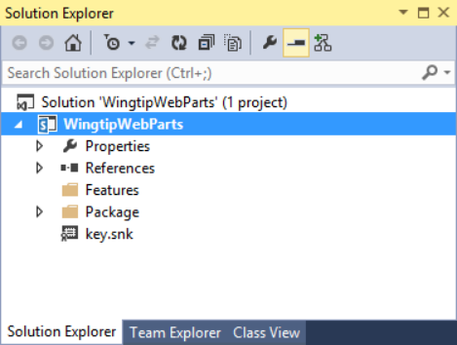

1. Add a few images into your project so they are deployed inside the SharePoint **Images** folder.
   1. Using the **Solution Explorer** tool window, right-click the **WingtipWebParts** project and select **Add 🡪 SharePoint “Images” Mapped Folder**.
   2. Right-click the **Images\WingtipWebParts** folder you just created and select **Add 🡪 Existing Item**.
   3. In the **Add Existing Item** dialog, navigate to the folder associated with this exercise:

C:\Student\Modules\FulltrustSolutions\Lab\StarterFiles

* 1. Select the following files:
     1. FeatureIcon.gif
     2. SiteIcon.gif
     3. WebPartIcon.gif
  2. Click **Add**

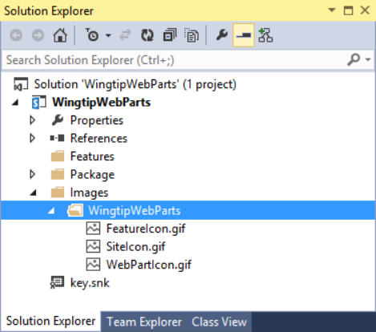

1. Add a Web Part to the project:
   1. Using the **Solution Explorer** tool window, right-click the **WingtipWebParts** project and select **Add 🡪 New Item**.
   2. In the **Add New Item** dialog, select the **Web Part** template from the **Visual C# Items 🡪 Office/SharePoint** category.
      1. **Name:** HelloPart
   3. Click **Add**.
2. Inspect the SharePoint Project Item node for the Web Part named **HelloPart**. Notice it contains three files named **Elements.xml**, **HelloPart.cs** and **HelloPart.webpart**.

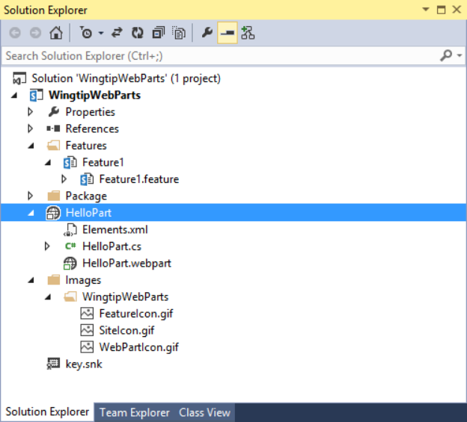

1. Right-click the **HelloPart \ HelloPart.webpart** file and select **Open**.
   1. Update the **<property>** node that has the attribute **name=”Title”** and set the title to **The “Hello” Web Part**.
   2. Update the **<property>** node that has the attribute **name=”Description”** and set the title to **A most compelling Web Part**.
2. The **HelloPart.webpart** file should look like the following code sample:

<?xml version="1.0" encoding="utf-8"?>

<webParts>

<webPart xmlns="http://schemas.microsoft.com/WebPart/v3">

<metaData>

<type name="WingtipWebParts.HelloPart.HelloPart,

$SharePoint.Project.AssemblyFullName$" />

<importErrorMessage>$Resources:core,ImportErrorMessage;</importErrorMessage>

</metaData>

<data>

<properties>

<property name="Title" type="string">The "Hello" Web Part</property>

<property name="Description" type="string">A most compelling Web Part</property>

</properties>

</data>

</webPart>

</webParts>

1. Add three more properties to the **HelloPart.webpart** file, just after the last property by adding the following XML:

<property name="ChromeType" type="string">TitleAndBorder</property>

<property name="CatalogIconImageUrl" type="string">_layouts/15/images/WingtipWebParts/WebPartIcon.gif</property>

<property name="TitleIconImageUrl" type="string">_layouts/15/images/WingtipWebParts/WebPartIcon.gif</property>

1. Now, modify the element manifest that will provision the Web Part definition:
   1. Using the **Solution Explorer** tool window, right-click the **HelloPart \ Elements.xml** file and select **Open**.
   2. Modify the **<Property>** element with the Name=”Group” attribute by setting the **Value** attribute to **Wingtip Web Parts**.
2. Finally, add some logic to the Web Part:
   1. Using the **Solution Explorer** tool window, right-click the **HelloPart \ HelloPart.cs** file and select **Open**.
   2. You should see that the the **CreateChildControls** method is currently empty.
   3. Add the following code to the body of the **CreateChildControls** method:

namespace WingtipWebParts.HelloPart {

[ToolboxItemAttribute(false)]

public class HelloPart : WebPart {

protected override void CreateChildControls() {

var label = new Label() { Text = "Hello Web Part" };

this.Controls.Add(label);

}

}

}

1. Save all changes: **File 🡪 Save All**.

#### Build and Test the Project

1. Build and test your application by pressing **[F5]** or **Debug 🡪 Start Debugging**.
2. Once the solution has been deployed, Internet Explorer will launch and navigate to the <http://solutions.wingtip.com> site.
3. Add the Web Part to the page:
   1. Using the **Site Actions** “gear” icon in the top-right corner, select **Edit Page**.  
      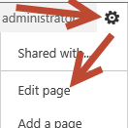
   2. Using the ribbon, select the **Insert** tab and click the **Web Part** button.

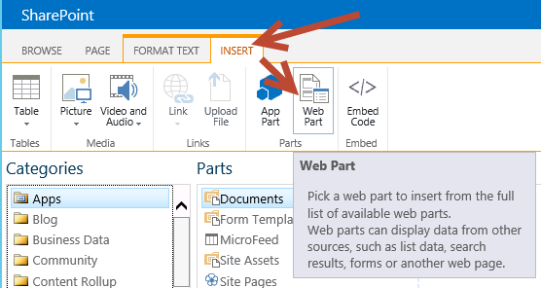

* 1. Select the **The “Hello” Web Part** from the **Wingtip Web Parts** category and click the **Add** button.

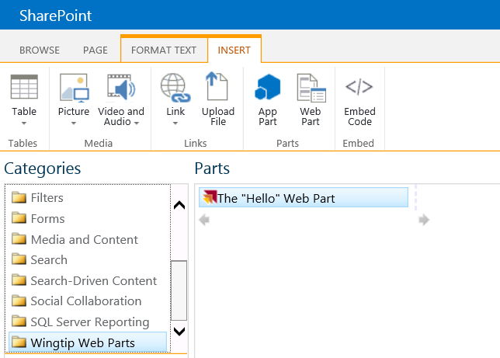

* 1. At this point, you should see your new web part displayed on the page.

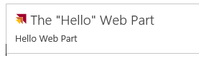

1. Close the browser to stop the debugger and go back to Visual Studio.

In this exercise you created a Web Part, added it to your project and added it to the sample SharePoint site.

### Exercise 3: Creating a Visual Web Part with AJAX Behavior

Now you will add a second Web Part using the Visual Web Part template. This makes it possible to create the UI for a Web Part using an ASP.NET User Control and the Visual Studio User Control Designer. You will also use the UpdatePanel control from ASP.NET AJAX to give your Web Part a Web 2.0 user experience eliminating postbacks.

1. In this exercise, you should continue working with the **WingtipWebParts** project you created in the previous exercise.
2. Add a new Visual Web Part to the **WingtipWebParts** project named **ListInspectorWebPart**:
   1. Using the **Solution Explorer** tool window, right-click the **WingtipWebParts** project and select **Add 🡪 New Item**.
   2. In the **Add New Item** dialog, select the **Visual Web Part (Farm Solution Only)** template from the **Visual C# Items 🡪 Office/SharePoint** category.
      1. **Name:** ListInspectorWebPart
   3. Click **Add**.

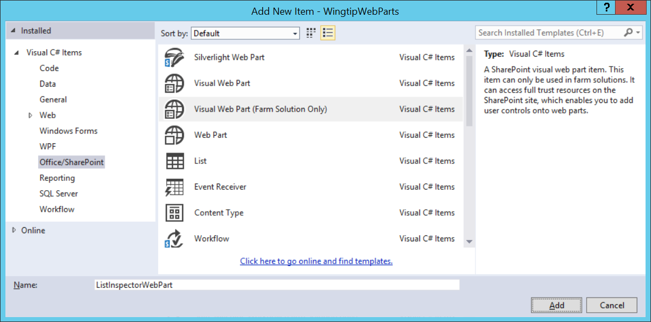

1. Inspect the SharePoint Project Item (SPI) node for the Web Part named **ListInspectorWebPart**. Notice it contains multiple files:

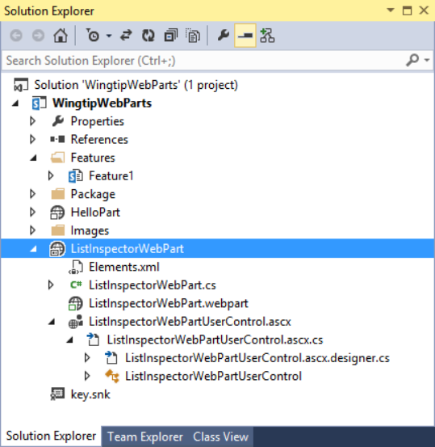

1. Right-click the **ListInspectorWebPart \ ListInspectorWebPart.webpart** file and select **Open**.
2. Update the two existing properties (**Title** & **Description**) and add additional properties, as listed below, to the **ListInspectorWebPart.webpart** file. The properties should look like this:

<property name="Title" type="string">List Inspector Web Part</property>

<property name="Description" type="string">

A Web Part which shows all the lists in the current site and allows you to get several of its property values.

</property>

<property name="ChromeType" type="string">TitleAndBorder</property>

<property name="CatalogIconImageUrl" type="string">_layouts/15/images/WingtipWebParts/WebPartIcon.gif</property>

<property name="TitleIconImageUrl" type="string">_layouts/15/images/WingtipWebParts/WebPartIcon.gif</property>

1. Now, modify the element manifest that will provision the Web Part definition:
   1. Using the **Solution Explorer** tool window, right-click the **ListInspectorWebPart \ Elements.xml** file and select **Open**.
   2. Modify the **<Property>** element with the Name=”Group” attribute by setting the **Value** attribute to **Wingtip Web Parts**.
2. Update the user interface portion of the Web Part:
   1. Using the **Solution E**xplorer tool window, right-click the **ListInspectorWebPart \ ListInspectorWebPart.ascx** file and select **View Designer**.
   2. If the **Toolbox** tool window is not open, click it and then click the pushpin to pin it open:

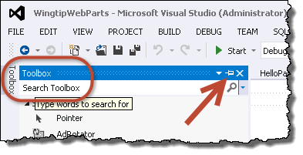

* 1. Using the **Toolbox** tool window, find the **UpdatePanel** control in the **AJAX Extensions** grouping. Drag the **UpdatePanel** onto the design surface.
  2. Using the buttons at the bottom of the designer, click **Source** to switch to the **Source** view:

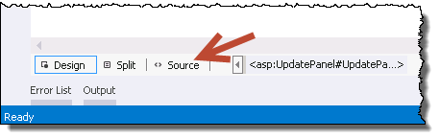

* 1. Add an HTML table to the **<asp:UpdatePanel>** element on the page. You can find the contents of this file in the following file in the folder associated with this exercise:

C:\Student\Modules\FulltrustSolutions\Lab\StarterFiles\ListInspectorTable.txt

1. Using the buttons at the bottom of the designer, click **Design** to switch to the **Design** view:  
   (the ListInspectorWebPart.ascx design view should appear as below:  
   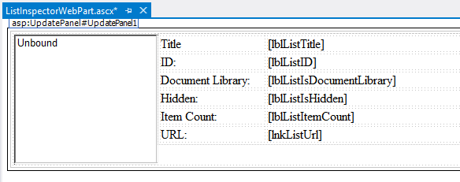
2. Now code the Visual Web Part to make it do something:
   1. Using the **Solution Explorer** tool window, right-click the **ListInspectorWebPart \ ListInspectorWebPart.ascx \ ListInspectorWebPart.ascx.cs** file and select **Open**.
   2. Add the following to the top of the file:

using Microsoft.SharePoint;

using System.Web.UI.WebControls;

* 1. Create two protected fields by adding the following code just inside the class:

protected Guid SelectedListId = Guid.Empty;

protected bool UpdateListProperties = false;

* 1. Add a method named **lstLists_SelectedIndexChanged()** by adding the following to the class. This event handler is already referenced in the markup you added to the **ListInspectorWebPart.ascx** file:

protected void lstLists_SelectedIndexChanged(object sender, EventArgs e)

{

SelectedListId = new Guid(lstLists.SelectedValue);

UpdateListProperties = true;

}

* 1. Add an overridden implementation of the **OnPreRender()** method using the parameter list shown in the following code block.

protected override void OnPreRender(EventArgs e) {

if ((lstLists.SelectedIndex > -1) & (!UpdateListProperties)) {

SelectedListId = new Guid(lstLists.SelectedValue);

}

lstLists.Items.Clear();

SPWeb site = SPContext.Current.Web;

foreach (SPList list in site.Lists) {

ListItem listItem = new ListItem(list.Title, list.ID.ToString());

lstLists.Items.Add(listItem);

}

// when the page reloads, default the selected item to the current list

if (SelectedListId != Guid.Empty) {

lstLists.Items.FindByValue(SelectedListId.ToString()).Selected = true;

}

if (UpdateListProperties) {

SPList list = SPContext.Current.Web.Lists[SelectedListId];

lblListTitle.Text = list.Title;

lblListID.Text = list.ID.ToString().ToUpper();

lblListIsDocumentLibrary.Text = (list is SPDocumentLibrary).ToString();

lblListIsHidden.Text = list.Hidden.ToString();

lblListItemCount.Text = list.ItemCount.ToString();

lnkListUrl.Text = list.DefaultViewUrl;

lnkListUrl.NavigateUrl = list.DefaultViewUrl;

}

}

1. Save all changes: **File 🡪 Save All**.

#### Build and Test the Project

1. Build and test your application by pressing **[F5]** or **Debug 🡪 Start Debugging**.
2. Once the solution has been deployed, Internet Explorer will launch and navigate to the <http://solutions.wingtip.com> site.
3. Add the Web Part to the page:
   1. Using the **Site Actions** “gear” icon in the top-right corner, select **Edit Page**.



* 1. Using the ribbon, select the **Insert** tab and click the **Web Part** button.
  2. Select the **List Inspector Web Part** from the **Wingtip Web Parts** category and click the **Add** button.

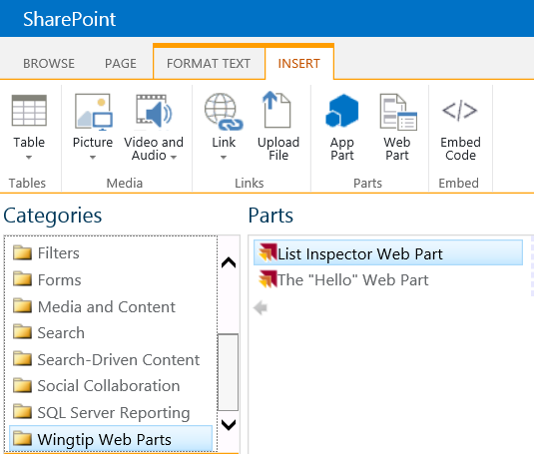

1. Click different lists to see the values refresh to show the respective properties.

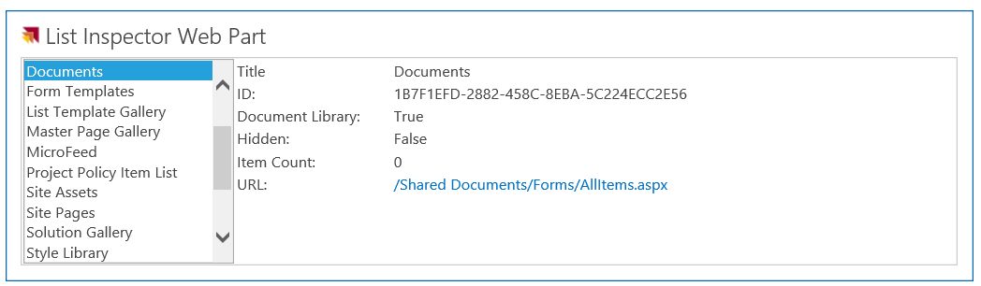

1. Close the browser to stop the debugger and go back to Visual Studio.

In this exercise you created a new Visual Web Part and deployed it as a farm solution.

### Exercise 4: Add Site Pages to a SharePoint Solution

In this exercise you will add some site pages to an existing solution and create links to these new pages.

1. Open an existing starter project in Visual Studio 2013:
   1. Launch **Visual Studio 2013** as administrator.
   2. Select **File 🡪 Open 🡪 Project/Solution**.
   3. In the **Open Project** dialog, select the following project provided in the files associated with this lab:

C:\Student\ Modules\FullTrustSolutions\Lab\StarterProjects\MySitePages\MySitePages.sln

Note: You may get an error from Visual Studio about not having a site URL or debugging site specified. Ignore it for now.

1. Ensure the project is using the lab’s site collection for testing:
   1. Select the project **MySitePages** in the **Solution Explorer** tool window.
   2. Look in the **Properties** tool window and ensure the **Site URL** property is set to <http://solutions.wingtip.com>.
   3. Make sure the **Sandbox Solution** property of the **MySitePages** project is set to a value of **False**.

Remember that the VM you are using to complete lab exercises does not support server-side code from a sandboxed solution.

1. The **MySitePages** project already contains SharePoint Project Items to create a few site columns and two lists. These two lists, **Books** and **Customers**, will be used throughout the remainder of this lab.
2. Create a new module to provision some site pages to the site:
   1. Right-click the project **MySitePages** in the **Solution Explorer** tool window and select **Add 🡪 New Item**.
      1. In the **Add New Item** dialog, select the **Module** template from the **Visual C# Items 🡪 Office / SharePoint** category.
      2. **Name:** WingtipPages
      3. Click **Add.**

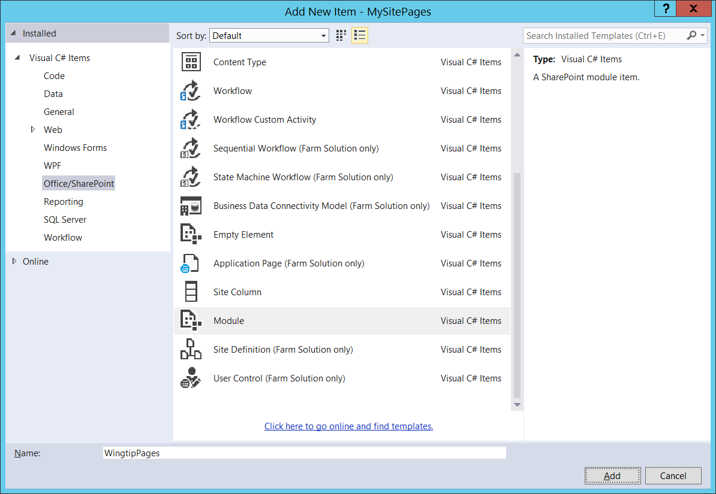

* 1. Your project should look like the one in the following screenshot.

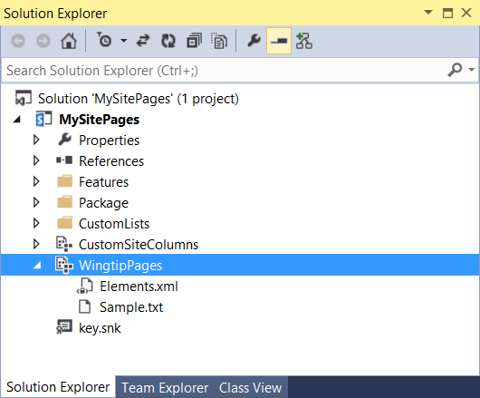

1. Add the provided site pages to the **WingtipPages** module:
   1. Within the **WingtipPages** module, right click **Sample.txt** and select **Delete**.
   2. Right-click the **WingtipPages** module in the **Solution Explorer** tool window and select **Add 🡪 Existing Item**.
   3. In the **Add Existing Item** dialog, add the files **Page1.aspx**, **Page2.aspx**, **Page3.aspx** and **styles.css** from the following folder:

C:\Student\Modules\FullTrustSolutions\StarterFiles

* 1. When you are done, your project should match the following screenshot.

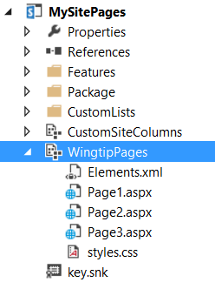

1. Verify the **WingtipPages** module is included in the list of items in the Feature:
   1. In the **Solution Explorer** tool window, expand the **MySitePages** project to the **Features\MainSite** node.
   2. Right-click the **MainSite** Feature and select **View Designer**.
   3. Verify the **WingtipPages** module is listed on the right-hand column **Items in the Feature**. If it isn’t select it and use the arrows between the two columns to add it from the left column: **Items in the Solution**.

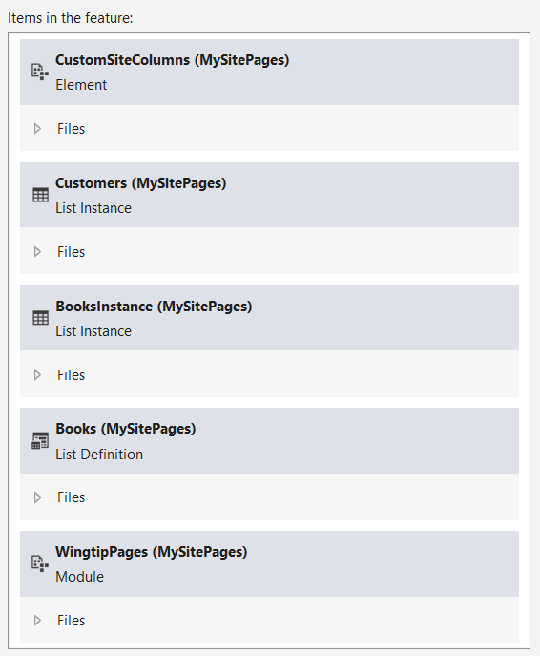

#### Add Navigation Elements to the Site to Surface the New Site Pages

At this point your project will simply create a few pages in the development site. Users would have to know the URL and manually type it into the browser to navigate to these files. To make this more user friendly, write some custom code to add some navigation elements to the site to point to these three new files.

1. In the **Solution Explorer** tool window, expand the **MySitePages** project to the **Features\MainSite** node.
2. Right-click the **MainSite** Feature and select **Add Event Receiver**.

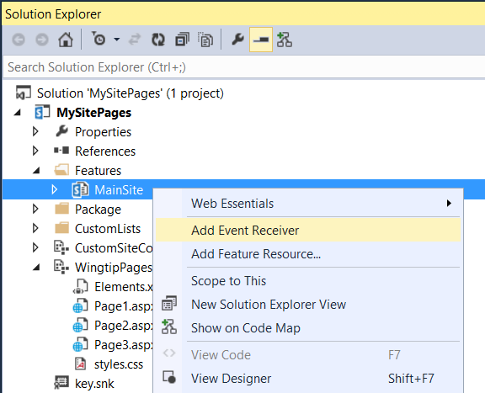

1. Within the **MainSite.EventReceiver.cs** code file, add the following line to the top of the file to add a reference to the SharePoint navigation namespace:

using Microsoft.SharePoint.Navigation;

1. Find the commented out method **FeatureActivated()** and replace it with the following code to create three new links in the top navigation link bar:

public override void FeatureActivated(SPFeatureReceiverProperties properties) {

SPSite siteCollection = properties.Feature.Parent as SPSite;

if (siteCollection != null) {

SPWeb site = siteCollection.RootWeb;

// create menu items on top link bar for custom site pages

SPNavigationNodeCollection topNav = site.Navigation.TopNavigationBar;

topNav.AddAsLast(new SPNavigationNode("Page 1", "WingtipPages/Page1.aspx"));

topNav.AddAsLast(new SPNavigationNode("Page 2", "WingtipPages/Page2.aspx"));

topNav.AddAsLast(new SPNavigationNode("Page 3", "WingtipPages/Page3.aspx"));

}

}

1. While the previous code will create three new links when the Feature is activated, these links are not automatically removed when you deactivate the Feature. In addition, the provisioned files are not automatically removed. To clean up everything done by the Feature activation, find the commented out method **FeatureDeactivating()** and replace it with the following code to delete the links and provisioned pages:

public override void FeatureDeactivating(SPFeatureReceiverProperties properties) {

SPSite siteCollection = properties.Feature.Parent as SPSite;

if (siteCollection != null) {

SPWeb site = siteCollection.RootWeb;

try {

// delete folder of site pages provisioned during activation

SPFolder sitePagesFolder = site.GetFolder("WingtipPages");

sitePagesFolder.Delete();

}

catch { }

SPNavigationNodeCollection topNav = site.Navigation.TopNavigationBar;

for (int i = topNav.Count - 1; i >= 0; i--) {

if (topNav[i].Url.Contains("WingtipPages")) {

// delete node

topNav[i].Delete();

}

}

}

}

#### Update the User Interface of the Provisioned Site Page Page1.aspx

Page1.aspx has references to CSS classes to create a more specialized user interface. In order to get this user interface you need to provision a new CSS file.

1. Add a reference to the CSS file in **Page1.aspx**:
   1. In the **Solution Explorer** tool window, find the **WingtipPages\Page1.aspx** file.
   2. Right-click **Page1.aspx** and select **Open**.
   3. Find the ASP.NET content placeholder **PlaceHolderAdditionalPageHead** and add the following markup to the content of the content placeholder:

<link href="styles.css" rel="stylesheet" type="text/css" />

1. Save all changes: **File 🡪 Save All**.
2. Build and test your application by pressing **[F5]** or **Debug 🡪 Start Debugging**.

Note: If prompted with an **Attach Security Warning** dialog, click **Attach**.

1. Once the solution has been deployed, Internet Explorer will launch and navigate to the default page for the site.
2. In the top navigation, select **Page 1** to navigate to the **Page1.aspx** site page you provisioned.

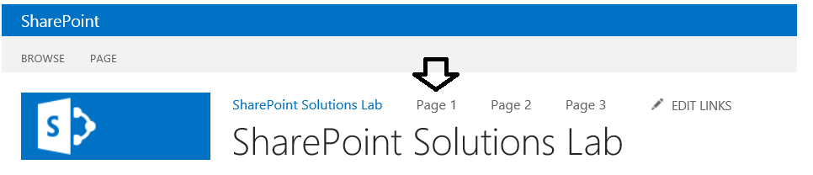

1. Notice how **Page1.aspx** has unique styling compared to just plain old text:

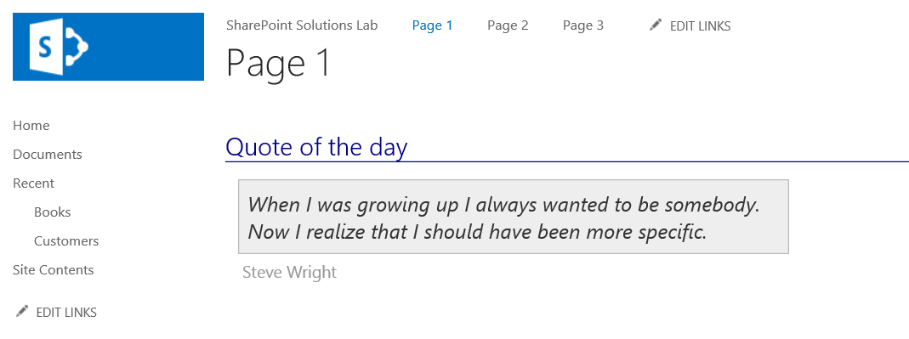

1. Close the browser to stop the debugger and go back to Visual Studio.

#### Update the User Interface of the Provisioned Site Pages Page2.aspx and Page3.aspx

Page2.aspx is a Web Part Page but does not include any Web Parts. In this section you will add a new instance of the XsltListViewWebPart to display the Customer list. For Page3.aspx, which is also a Web Part Page, you will also add a XsltListViewWebPart to show the contents of the Books list.

1. Add a Web Part to **Page2.aspx**:
   1. In the **Solution Explorer** tool window, find the **WingtipPages\Page2.aspx** file.
   2. Right-click **Page2.aspx** and select **Open**.
   3. Find the ASP.NET content placeholder **PlaceHolderMain** and add the following markup to the content of the content placeholder:

<WebPartPages:WebPartZone ID="Main" Title="Main Web Part Zone"

FrameType="TitleBarOnly" runat="server" >

<ZoneTemplate>

<WebPartPages:XsltListViewWebPart

runat="server"

ID="CustomersWebPart"

Title="Customers"

ListUrl="Lists/Customers"

ChromeType="None"

InplaceSearchEnabled="false" >

</WebPartPages:XsltListViewWebPart>

</ZoneTemplate>

</WebPartPages:WebPartZone>

1. Add a Web Part to **Page3.aspx**:
   1. In the Solution Explorer tool window, find the **WingtipPages\Page3.aspx** file.
   2. Right-click **Page3.aspx** and select **Open**.
   3. Find the ASP.NET content placeholder **PlaceHolderMain** and add the following markup to the content of the content placeholder:

<WebPartPages:WebPartZone ID="Main" Title="Main Web Part Zone"

FrameType="TitleBarOnly" runat="server" >

<ZoneTemplate>

<WebPartPages:XsltListViewWebPart

runat="server"

ID="BooksWebPart"

Title="Books"

ListUrl="Lists/Books"

ChromeType="None"

InplaceSearchEnabled="false" >

</WebPartPages:XsltListViewWebPart>

</ZoneTemplate>

</WebPartPages:WebPartZone>

1. Save all changes: **File 🡪 Save All**.
2. Build and test your application by pressing **[F5]** or **Debug 🡪 Start Debugging**.
   1. If prompted with an **Attach Security Warning** dialog, click **Attach**.
3. When the site loads in Internet Explorer, select **Page 2** to navigate to the **Page2.aspx** site page you provisioned. Notice the **Customers** list is displayed in a typical format.

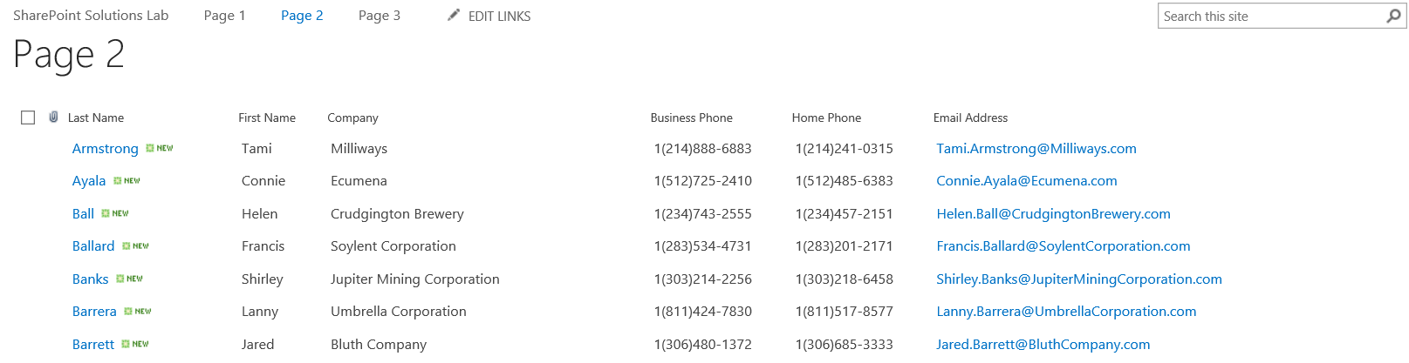

1. Now select **Page 3** and notice it displays the **Books** list in the same format.

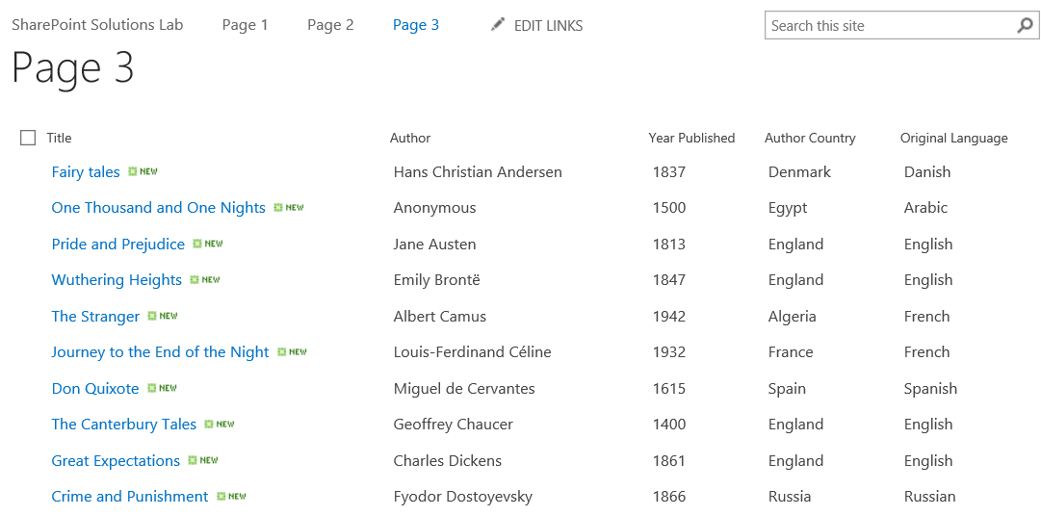

1. Close the browser to stop the debugger and go back to Visual Studio.

In this exercise you added a few site pages to a full trust solution and created links in the navigation pointing to these pages. You are now done with this lab.