## Getting Started with SharePoint Server 2013

**Lab Time**: 20-30 minutes

**Lab Folder**: C:\Student\Modules\GettingStarted\Lab

**Lab Overview:** In this lab you will get up and running with the student VM and begin to experience the new user interface of SharePoint 2013. You will start off by logging into the student VM and navigating around the Wingtip Intranet site at **http://intranet.wingtip.com**. Next, you will navigate to the SharePoint 2013 Central Administration to review the configuration of the local farm and to create a new site collection. Note that the site collection you create in this lab will be for testing purpose only and will not be used in later labs so you can experiment with creating lists and changing the site’s look and feel.

### Exercise 1: Getting Up and Running with the Student VM

In this exercise will you begin by logging into your student VM. Once you have successfully logged in, you will navigate to the Wingtip Intranet Team site and become more familiar with the new changes to the SharePoint 2013 user interface experience.

1. Login to the Student VM using the login **WINGTIP\Administrator** and the appropriate password.
   1. If you’re using a local VM provided by the hosting training company, the password will be **Password1**.
   2. If your student VM is hosted by CloudShare, the password for the **WINGTIP\Administrator** account is going to be unique for each student, system-generated by CloudShare. Also note that the CloudShare VM configuration usually logs you into the VM automatically so you do not have to enter the user name and password.
2. Once you have logged on to the student VM, launch the Internet Explorer and navigate to the site at **http://intranet.wingtip.com**.
   1. It might take a minute or two before the first page of the Wingtip Intranet site appears.
   2. When the home page of the Wingtip Intranet site appears, you should be able to see that it is a brand new SharePoint 2013 Team site.

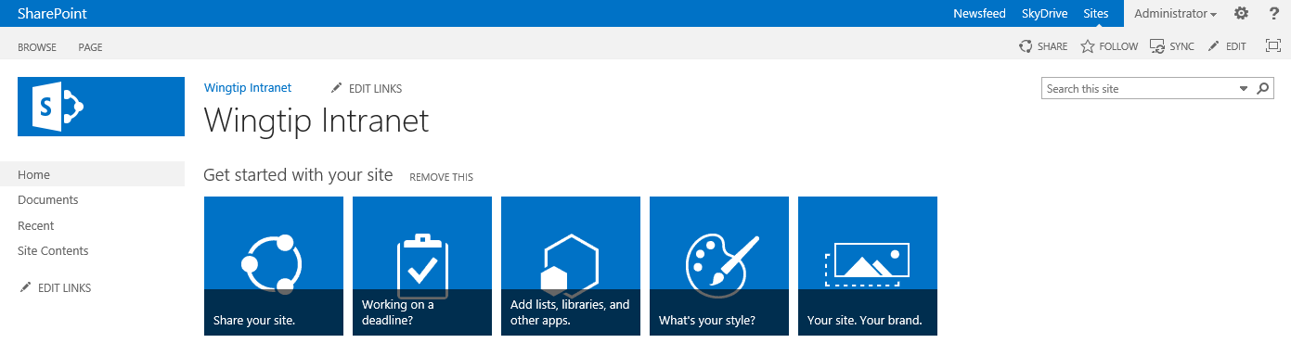

1. Locate the **Site Actions** menu which displays the gear icon on the top right-hand side of the page.
   1. Be careful not to confuse the SharePoint **Site Actions** menu with the Internet Explorer Settings menu which also displays a similar gear icon and is located just slightly above.
   2. Drop down the **Site Actions** menu and review the menu commands inside.

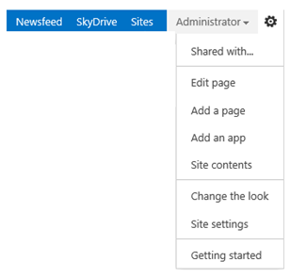

1. In the **Site Actions** menu, click the **Site Contents** menu command to navigate to the **Site Contents** page.
   1. Note that the **Site Contents** page shows list, documents, libraries and apps. Since the Wingtip Intranet site is a brand new Team Site, it has several pre-existing document libraries including **Documents**, **Form Templates**, **Site Assets**, **Site Pages** and **Style Library**.

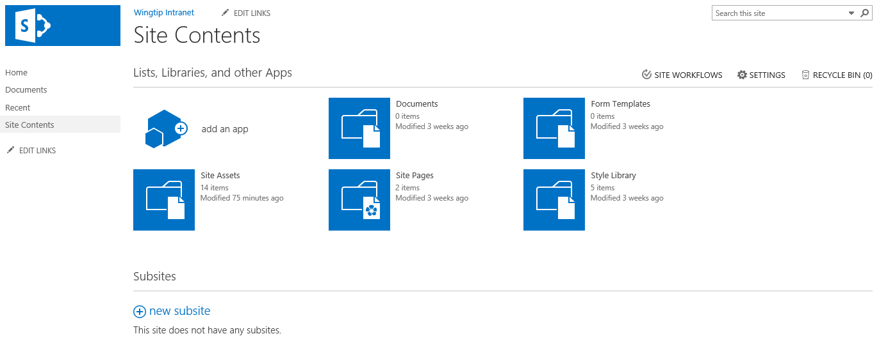

1. In the **Site Actions** menu, click the **Site Settings** menu command to navigate to the **Site Settings** page.
   1. You can see that the **Site Settings** page has sections of administrative links with captions such as **Users and Permissions**, **Look and Feel**, **Web Designer Galleries**, **Site Actions**, **Site Administration**, **Site Collection Administration**.

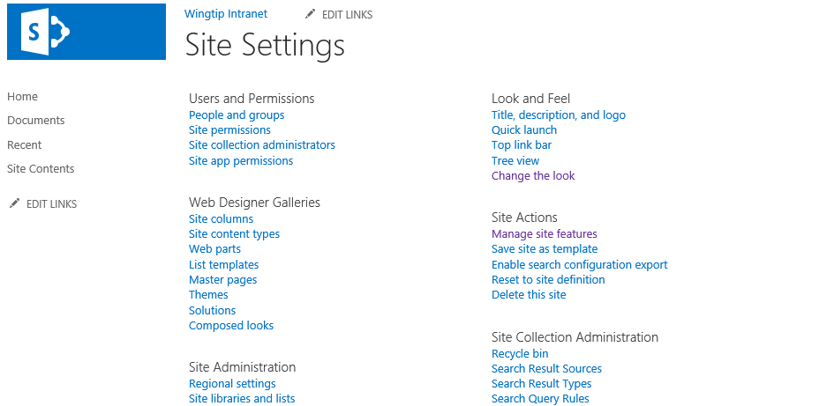

* 1. Take a moment to review each link section on the **Site Settings** page because you will be using many of these site administration links throughout the labs exercises in this course.
  2. Return to the home page of Central Administration.

In this exercise you took a quick look at the Wingtip Intranet team site and learned the basics of moving around in a Team site using the **Site Actions** menu. In the next lab you will create a new site collection so you can begin to experiment with the process of creating lists and changing the look and feel of the site.

### Exercise 2: Installing Office 2013 Professional and Visio 2013 Professional

To complete all the labs, the student VM requires an installation of Microsoft Office 2013 Professional as well as Microsoft Visio 2013 Professional. If your student VM does not already have these products installed, you will install trial versions so that you can complete the student lab exercises.

**NOTE**: If you are using a VM in the CloudShare environment, Microsoft Office 2013 and Microsoft Visio 2013 will already be installed. However, if you are running a local version of SharePoint 2013 Student VM, you must install a trial version of Office 2013 and Visio 2013 using installation files that are already on your VM.

1. Press the **Windows** key and determine whether **Microsoft Word 2013** and **Microsoft Visio 2013** have already been installed.
   1. If these products have already been installed, you are done with this lab exercise and you can move on to **Exercise 3**.
   2. If these products are not yet installed on your student VM, complete the following steps in this exercise.
2. Using Windows Explorer, locate the folder with the Office and Visio installation files on your student VM at **C:\Install**.

If either Microsoft Office 2013 Professional or Microsoft Visio 2013 Professional is not installed and you do not see a **c:\Install** folder on your student VM with Office and Visio installation files, ask your instructor where you can obtain the required installation files.

1. Install Microsoft Office 2013 Professional.
   1. Locate the file named **en_office_professional_plus_2013_with_sp1_x64_dvd_3928183.iso**.
   2. Right-click on **en_office_professional_plus_2013_with_sp1_x64_dvd_3928183.iso** and click the **Mount** menu command.

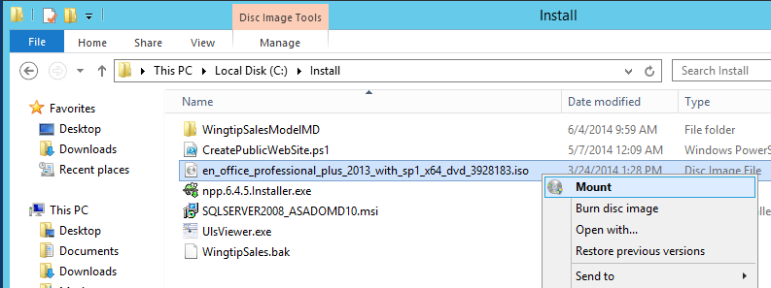

* 1. The Office 2013 installation files will open in a new window.
  2. Double click **setup.exe** to install the Office 2013 Professional.

1. Install Visio 2013 Professional using the setup file in the **c:\Install** folder.

At this point you have installed Office 2013 Professional and Microsoft Visio 2013 Professional prepared your VM for the remaining lab exercises of this course.

### ****Exercise 3:**** Getting Around in Central Administration

In this exercise you will navigate to Central Administration so you can review the configuration of the current farm and create a new site collection.

1. Using Internet Explorer, navigate to **Central Administration** at **http://wingtipserver:9999**.
   1. It might take a minute or two for the home page of Central Administration to display so be patient.
   2. When the home page of Central Administration displays, take a moment to familiarize yourself with the sections and links that are available.

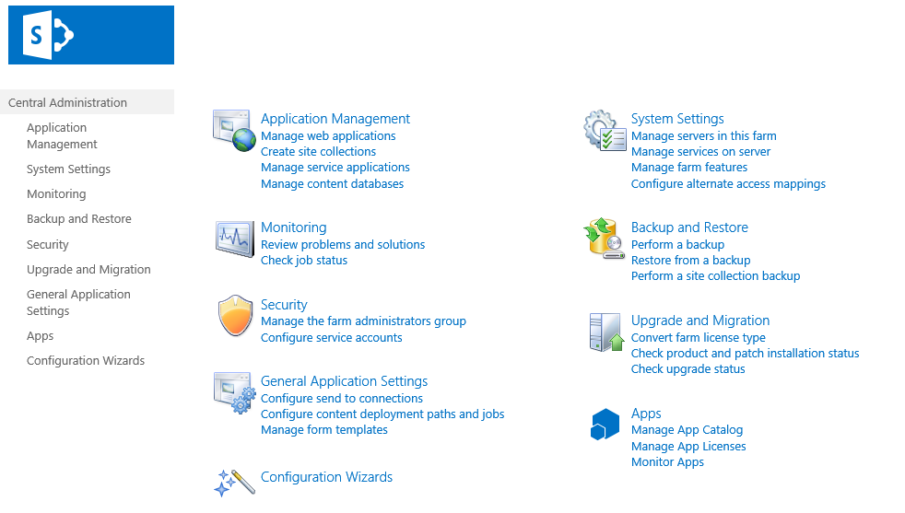

1. Review the web applications in the local Wingtip Toys on-premises farm.
   1. From the home page of Central Administration, locate and click the **Manage web applications** link in the **Application Management** section to navigate to the **Web Application List** page.
   2. You should be able to verify that there are currently four web applications in the local farm.

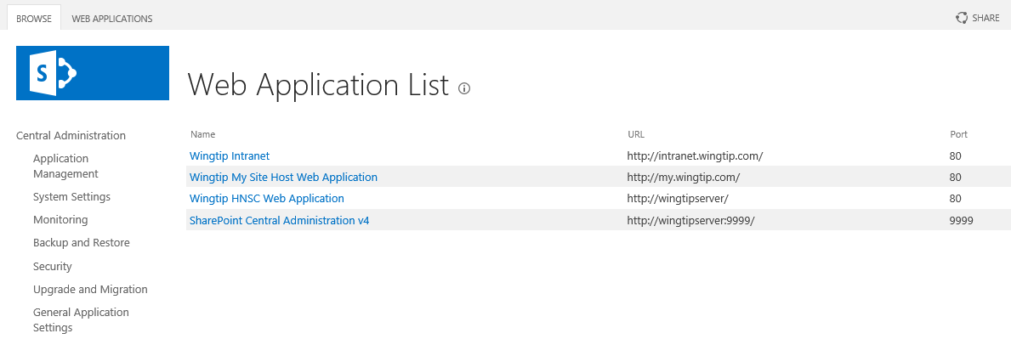

1. Review the service applications in the local Wingtip Toys on-premises farm.
   1. Return to the home page of Central Administration.
   2. From the home page of Central Administration, locate and click the **Manage service applications** link in the **Application Management** section to navigate to the **Manage Service Applications** page.
   3. Take a moment and review the existing service applications.

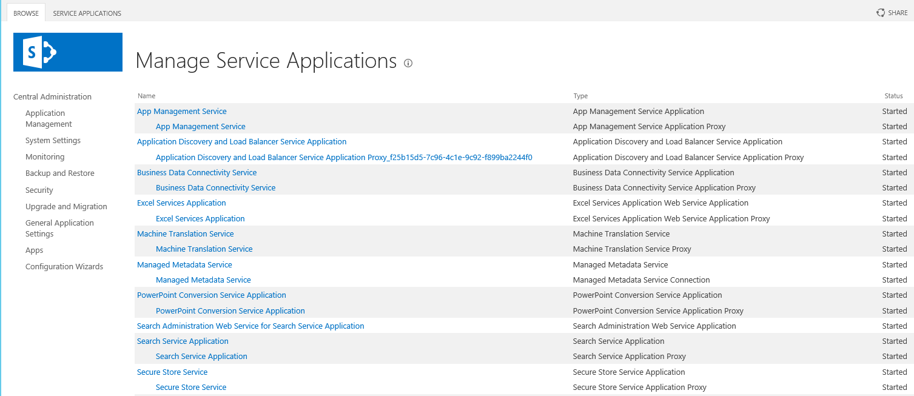

1. Create a new SharePoint 2013 Team Site for testing purposes.
   1. Return to the home page of Central Administration.
   2. From the home page of Central Administration, locate and click the **Create Site Collections** link in the **Application Management** section to navigate to the **Create Site Collection** page.
   3. When the **Create Site Collection** page is displayed, begin by ensuring that the **Web Application** setting at the top of the page references the web application with the URL of <http://intranet.wingtip.com>. If the page references a different web application such as <http://wingtipserver>, use the drop down control to update the target web application to be the one at <http://intranet.wingtip.com>.

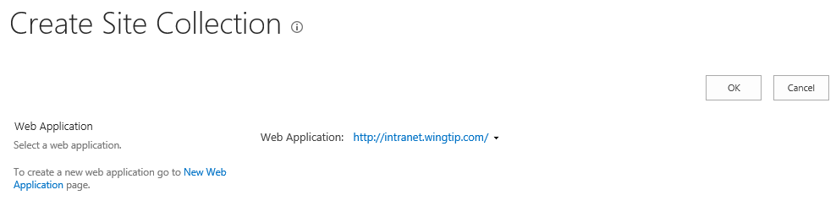

* 1. In the **Title and Description** section of the **Create Site Collection** page, add the following entries.
     1. **Title**: Wingtip Test Site
     2. **Description**: A test site for experimenting with the new SharePoint 2013 Team Site
     3. **URL**: <http://intranet.wingtip.com/sites/Testing>
  2. Your input values should match those in the following screenshot.

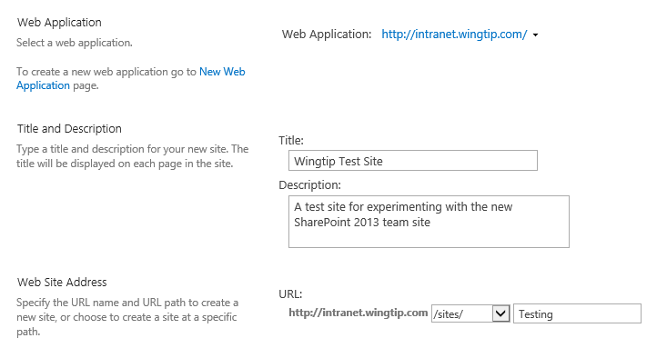

* 1. In the **Template Selection** section of the **Create Site Collection** page, ensure that the **Select experience version** setting is set to **2013** and that the **Select a template** setting is set to **Team Site**. Below in the **Primary Site Collection Administration** section, assign a **User Name** setting of **WINGTIP\Administrator**.

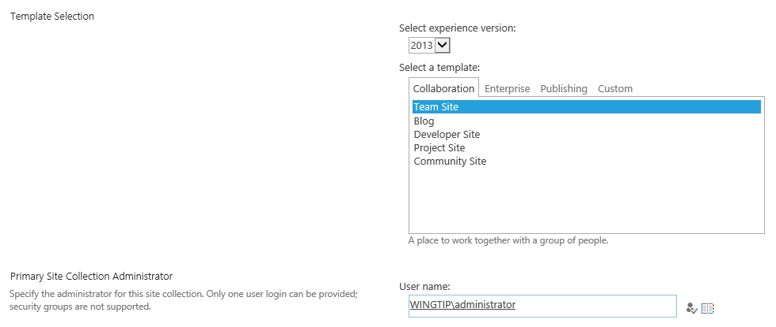

* 1. Click the **OK** button to begin the process of provisioning the new Team site. This might take a few minutes to complete. When the new site collection has been created, the Central Administration site will display a page that contains a link to the new Team site at <http://intranet.wingtip.com/sites/Testing>. Click on this link to navigate to the new Team site.

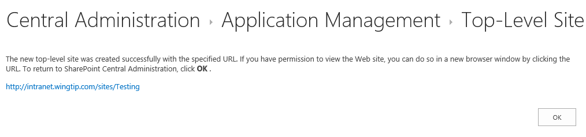

* 1. Wait until the home page displays for the site at: <http://intranet.wingtip.com/sites/Testing>.

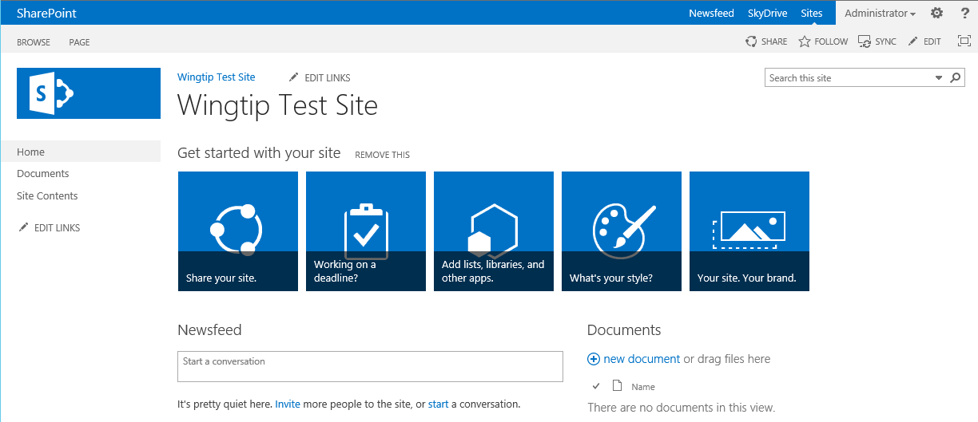

* 1. Once you can see the home page of the new Team site, you can move on to the next exercise.

In this exercise you used Central Administration to create a Team site in a new site collection. In the following exercises, you will begin working with this new site to add content and change its look and feel.

### ****Exercise 4: Activating and Deactivating Site Features****

In this exercise, you will begin to manage features which activate at both the site level and the site collection level.

1. If you are not already there, navigate to the Team site at **http://intranet.wingtip.com/sites/Testing** that you created in the previous exercise.
2. Review the site-collection--scoped features available for activation within a Team site.
   1. Return to the Site Settings page.
   2. On the **Site Settings** page, locate and click the **Site collection features** link in the **Site Collection Administration** section.

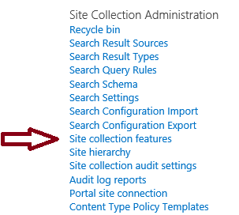

* 1. Take a moment and review all the site-collection-level features shown on this page. You should also take note which site-collection-level features are activated by default in a new site collection and which features are not.

1. Review the site-scoped features available for activation within a Team site.
   1. Use the **Site Actions** menu to navigate to the **Site Settings** page.
   2. On the **Site Settings** page, locate and click the **Manage site features** link in the **Site Actions** section.

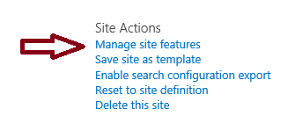

* 1. Take a moment and review all the site-level features shown on this page. You should also note which site-level features are activated by default in a new Team site and which features are not.

1. Deactivate the **Minimal Download Strategy** feature in the test site.
   1. Return to the home page of the testing site.
   2. Inspect the URL shown in the address bar of the browser which is used to navigate to the home page of the test site.

http://intranet.wingtip.com/sites/Testing/_layouts/15/start.aspx

* 1. On the **Site Settings** page, locate and click the link titled **Manage site features** in the **Site Actions** section.
  2. Locate the feature with the title of **Minimal Download Strategy**.

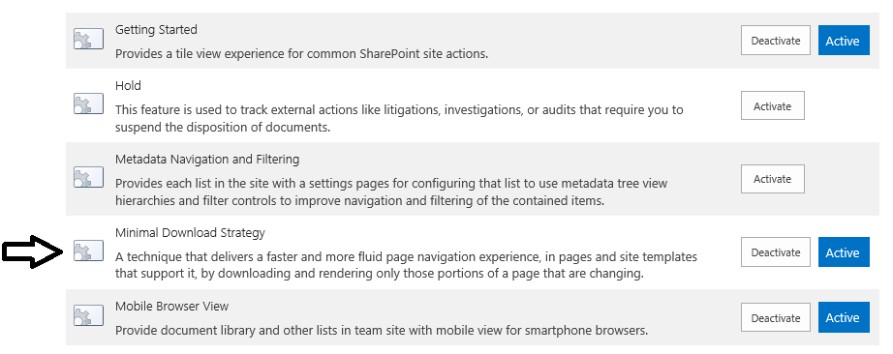

* 1. Click the **Deactivate** button to the right of the **Minimal Download Strategy**. When you do this, the SharePoint UI prompts you to confirm that you want to deactivate the feature, Click the **Deactivate this feature** link to complete the deactivation process.

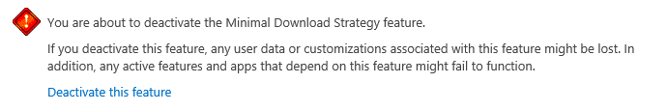

* 1. Once the feature has been deactivated, return to the home page of the site.
  2. Inspect the URL in the address bar of the browser. You should be able to see that the URL to the site is now easier to read.

http://intranet.wingtip.com/sites/Testing/SitePages/Home.aspx

* 1. Return to the home page of the test site.

In this lab, you began working with feature management. It’s essential that you know how to manage features and that you also have an understanding about which features activate at the site level versus features that activate at the site collection level.