## Creating Custom Search Verticals and Apps

**Lab Time**: 60 minutes

**Lab Folder**: C:\Student\Modules\Search\Lab

**Lab Overview**: In this lab you will learn how to work with the improvements Microsoft made to the search platform in SharePoint 2013. This includes seeing how to create custom search experiences as well as executing search queries using the new remote service APIs.

### Exercise 1: Setup Search & Creating the Glossary List

1. Setup a new site collection and create a few users for this lab:
   1. Ensure you are logged into the **WingtipServer** server as **WINGTIP\Administrator**.
   2. Run a PowerShell script, found in the root lab folder for this module:
      1. Right-click **SetupModule.ps1** and select **Run with PowerShell**. This file can be found in the files associated with this lab:

C:\Student\Modules\Search\Lab

* 1. The script will create two sites:
     1. **http://searchdev.wingtip.com**: Developer site collection used to test search apps you’ll build
     2. **http://search.wingtip.com**: Enterprise Search Center site collection
  2. When the script completes, it will launch a new browser and navigate to the **Enterprise Search Center** site collection: **http://search.wingtip.com**.
  3. Close the PowerShell console window.

#### Create Sample Glossary List

1. Using **Internet Explorer** navigate to <http://searchdev.wingtip.com>
2. Create a new SharePoint list to store the Glossary:
   1. Using the **Quick Launch** navigation to the left, select the **Site Contents** link.
   2. On the **Site Contents** page click the **add an app** icon.
   3. On the **Site Contents > Your Apps** page, click **Custom List**.
   4. Name the list “**Glossary**” and click **Create**.
3. Create site columns to add to the list:
   1. Click the **Site Actions** “gear” icon in the top-right corner of the page and select **Site Settings**.
   2. Under the **Web Designer Galleries** section, click **Site columns**.
   3. On the **Site Settings >** **Site Columns** page, click **Create**.
   4. Use the following values to create a new site column:
      1. **Column name**: Product
      2. **Type**: Single line of text
   5. Click **OK**
   6. Repeat the last step to create a few more site columns:
      1. Site Column #2:
         1. **Column name:** Related Term 1
         2. **Type:** Single line of text
      2. Site Column #3:
         1. **Column name:** Related Term 2
         2. **Type:** Single line of text
      3. Site Column #4:
         1. **Column name**: Definition
         2. **Type**: Multiple lines of text
         3. **Additional Column Settings**: Specify the type of text to allow: Plain text
4. Next, add the site columns to the Glossary list:
   1. Using the **Quick Launch** navigation to the left, select the **Glossary** link.
   2. Using the ribbon, click the **List** tab, and then click the **List Settings** button.
   3. In the **Columns** section, click **Add from existing site columns**.
   4. In the **Select Columns** section, select **Custom Columns** from the **Select site columns** dropdown.
   5. Select the following columns from the **Available site columns** list:
      1. Product
      2. Related Term 1
      3. Related Term 2
      4. Definition
   6. Click **Add**
   7. Click **OK**.
5. Update the list view:
   1. In the **Views** section of the **List Settings** page, click **All Items**.
   2. In the **Columns** section do the following:
      1. Check the **Display** checkbox for **ID**, and change the **Position from Left** value to **1**.
      2. Change the **Position** **from** **Left** value for **Product** to **2**.
      3. Change the **Position from Left** value for **Definition** to **4**.
   3. Click **OK** to save your changes to the **All Items** view.

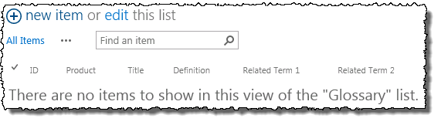

1. Disable Attachments on the list:
   1. Using the ribbon, click the **List** tab, and then click the **List Settings** button.
   2. In the **General Settings** section, click **Advanced Settings**.
   3. In the **Attachments** section, select **Disabled**, and then click **OK**.
   4. Click **OK** for the Message from webpage dialog that opens.

#### Import Sample Data into the Glossary List with Microsoft Access

1. Using **Internet Explorer** navigate to <http://searchdev.wingtip.com>
2. Using the **Quick Launch** navigation to the left, select the **Glossary** link.
3. Using the ribbon, click the **List** tab, and then click the **Open with Access** button in the **Connect & Export** group.
4. Confirm that **Link to data on the SharePoint site** is selected, and then click **OK**.
5. Once the list is open in Access, using the ribbon, select the **External Data** tab and then click **Excel** in the **Import & Link** group.
   1. In the **Get External Data - Excel Spreadsheet** dialog box, click **Browse**.
   2. Upload the **Terms.xlsx** file, found in the files associated with this exercise:

[..]\Search\Exercises\Ex1

* 1. Locate the **Terms.xlsx** worksheet, and click **Open**.
  2. Select **Append a copy of the records to the table**, ensure that **Glossary** is selected in the drop-down list, and then click **OK**.
  3. In the **Import Spreadsheet Wizard**, click **Next**, **Next** and then **Finish**.
  4. In the **Save Import Steps** dialog, click **Close**.

1. Verify the data was Imported
   1. Open the **Glossary** table in **Access**, and confirm that the data was imported.
   2. Close Microsoft Access.
   3. Go back to **Internet Explorer** navigate to <http://searchdev.wingtip.com>
   4. Using the **Quick Launch** navigation to the left, select the **Glossary** link.
   5. Confirm that the glossary data was imported to the list.

#### Execute a Full Crawl with Search

1. Open **Central Administration**: **Start 🡪 All Programs 🡪 Microsoft SharePoint 2013 Products 🡪 SharePoint 2013 Central Administration**.
2. Go to the **Search Administration** page: **Application Management** 🡪 **Manage Service Applications** 🡪 **Search Service Application**.
3. Reset (clear) the existing search index:
   1. On the **Search Administration** page, in the left-hand navigation pane, click **Index Reset** under the **Crawling** group.
   2. On the **Index Reset** page click **Reset Now**.
   3. In the confirmation dialog box that appears, click **OK** to confirm the content index reset.

Wait for the index reset to complete before proceeding, this process will take a few moments.

1. Execute a full search crawl:
   1. On the **Search Administration** page, in the left navigation pane, click **Content Sources** under the **Crawling** group.
   2. On the **Manage Content Sources** page, point to the **Local SharePoint sites** content source, click the arrow that appears, and then click **Start Full Crawl**:

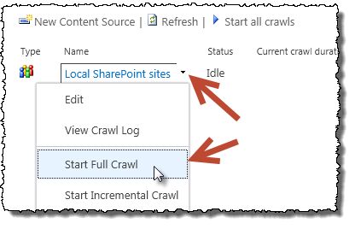

Wait for the Full Crawl to complete before proceeding, this process will take a few moments.

**Note**: Refresh the page to see changes in the crawl status, including completion of the crawl.

1. Verify managed properties automatically created by the crawler:
   1. On the **Search Administration** page, in the left-hand navigation pane, click **Search Schema** underthe **Queries and Results** group.
   2. In the **Managed Property** filter box, type **ows** and click the **Apply** button.
   3. Look in the filtered results and verify the following managed properties are defined, which correspond to the columns in the Glossary list.
      1. DefinitionOWSMTEXT
      2. ProductOWSTEXT
      3. RelatedTerm1OWSTEXT
      4. RelatedTerm2OWSTEXT
2. Test Search:
   1. Using Internet Explorer navigate to **http://search.wingtip.com**.
   2. In the keyword box, enter **Argument** and click **Search**.
   3. Verify that search results are returned from the **Glossary** list.

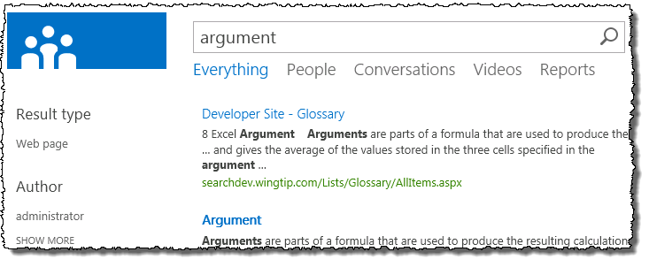

In this exercise you created two new site collections, a new list and crawled the contents to popular the search index.

### Exercise 2: Creating the Search User Interface Vertical

In this exercise you will create the user interface for the glossary search vertical. This interface will consist of a separate view dedicated solely to Glossary search results as well as a “block” view within the main search results experience. In practice, you can choose to implement one, the other, or both views in a solution.

1. Using Internet Explorer navigate to <http://search.wingtip.com>.
2. Create a dedicated search page for displaying Glossary search results:
   1. Select the **Site Actions** “gear” in the top-right corner of the site and select **Site Contents**.
   2. On the **Site Contents** page click the **Pages** list.
   3. Using the ribbon, click the **Files** tab and then click the arrow below **New Document** and select **Welcome Page**.
   4. Use the following to complete the dialog:
      1. **Title:** Glossary
      2. **URL Name:** GlossaryResults
      3. **Page Layout:** (Welcome Page) Search Results
   5. Click **Create**
3. After the **GlossaryResults.aspx** page is created, check it in:
   1. Select the **GlossaryResults** page in the **Pages** library.
   2. Using the ribbon, click the **Files** tab and then **Check In** in the **Open & Check Out** group.
   3. In the **Check In** dialog, select **1.0 Major Version** and click **OK**.
4. Create a **Glossary** link for the search navigation:
   1. Select the **Site Actions** “gear” in the top-right corner of the site and select **Site Settings**.
   2. Click **Search Settings** in the **Search** group.
   3. In the **Configure Search Navigation** section, click **Add** **link**.
   4. In the Navigation Link dialog, use the following to create a new link:
      1. **Title:** Glossary
      2. **Url:** Click Browse and find the **[..]/Pages/GlossaryResults.aspx** page.
   5. Click **OK**
5. Click **OK**.

#### Create a Search Result Source

Create a special result source to flag content coming from the Glossary list in the search results. This will be used later to map a specific rendering to the result.

1. Using **Internet Explorer** navigate to <http://search.wingtip.com>.
2. Select the **Site Actions** “gear” in the top-right corner of the site and select **Site Settings**.
3. Under the **Search** section, click **Result Sources**.
4. On the **Manage Result Sources** page, click **New Result Source**.
5. On the **Site Settings > Add Result Source** page, use the following to complete the form:
   1. **Name:** Glossary
   2. **Protocol:** Local SharePoint
   3. **Type:** SharePoint Search Results
   4. **Query Transformation:** {searchTerms} contentclass:sts_listitem_genericlist path:http://searchdev.wingtip.com/lists/glossary
6. Click **Save**
7. Bind the Results Source to the Search Results Web Part:
   1. Navigate to <http://search.wingtip.com>.
   2. Select the **Site Actions** “gear” in the top-right corner of the site and select **Site Contents**.
   3. On the **Site Contents** page, click **Pages**.
   4. On the **Pages** page, select **GlossaryResults** to go to that page.
   5. Select the **Site Actions** “gear” in the top-right corner of the site and select **Edit Page**.
   6. Select the **Search Results** Web Part and using the ribbon, select the **Web Part** tab and then click the **Web Part Properties** button.

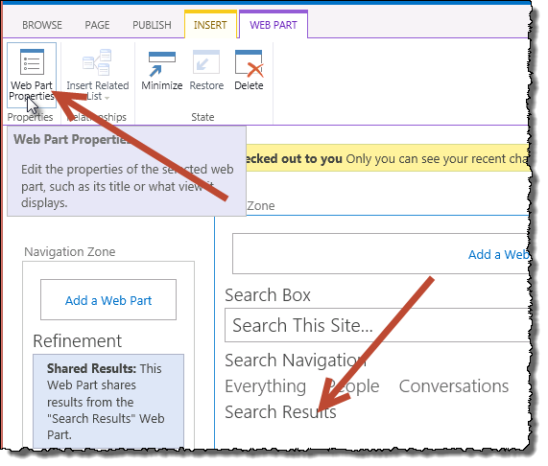

* 1. In the **Search Results** editor tool pane on the right-hand side, under the **Search Criteria** category, click **Change query.**
  2. For the **Select a query** drop-down list, select **Glossary** and click **OK**.

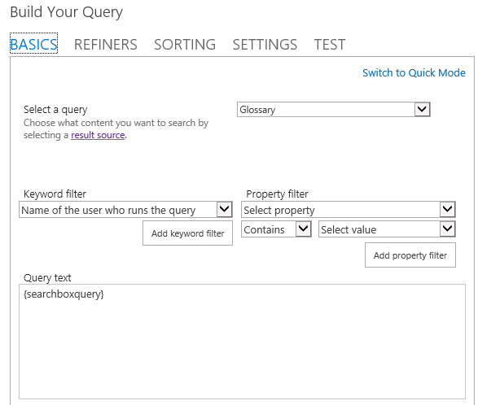

* 1. Click **OK** again to close the editor tool pane.

1. Publish the page:
   1. Using the ribbon, click the **Publish** tab and then the **Publish** button.
   2. Click **Continue**.
2. Test the results:
   1. Ensure you are still on the **GlossaryResults.aspx** page by examining the URL.
   2. Execute a search for **average**.
   3. Your search results should only return items found in the Glossary list:

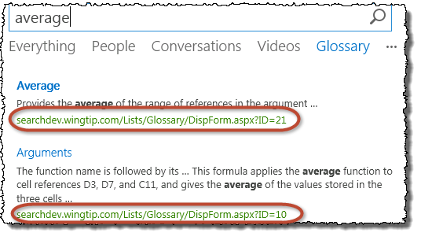

#### Format Search Vertical Results Using Display Templates

Now, create a special rendering for content that will be used when displaying items matching the “Glossary” result source.

1. Open **DefaultGlossary_Orig.html** with Microsoft Visual Studio.
   1. Launch **Visual Studio 2012** by selecting **Start** 🡪 **All Programs** 🡪 **Microsoft Visual Studio 2012** 🡪 **Visual Studio 2012**.
   2. Select **File 🡪 Open 🡪 File**.
   3. When prompted, open the file **DefaultGlossary_Orig.html** found in the files associated with this exercise:

[..]\Search\Exercises\Ex2

1. In the HTML code, search for the following markup:

<a id="CopyLink"

1. Delete this entire HTML anchor tag, starting with the **<a** characters and ending with the characters that close the tag **</a>**.
2. Replace the code that you deleted in the previous step with the HTML line break tag, as follows:

<br />

1. Next, move the product name next to the title. To locate the product name, search for the following characters in the HTML code:

_#= ctx.CurrentItem.ProductOWSTXT =#_

1. The title is located inside the tag **<div id=”Header”>**. When you find this **<div>** tag, on the line after the **TitleLink** anchor tag, Add the following code:

- _#= ctx.CurrentItem.ProductOWSTXT =#_

1. Save the file as **DefaultGlossary.html**.

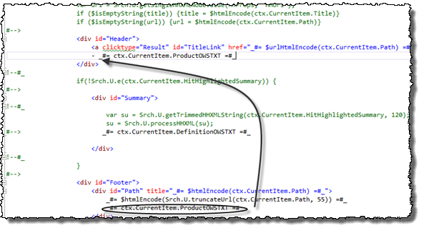

Note the proceeding screenshot has a method named **getTrimmedHHXmlString**. This is not the correct method name. The actual method name you will see in your code is **getTrimmedProcessedHHXMLString**.

1. Upload the Display Template you just created:
   1. Using **Internet Explorer** navigate to <http://search.wingtip.com>
   2. Select the **Site Actions** “gear” in the top-right corner of the site and select **Site Settings**.
   3. Under the **Web Designer Galleries** section, click **Master Pages and Page layouts**.
   4. Navigate to the folder **Display Templates 🡪 Search**.
   5. Using the ribbon, click the **Files** tab and then click **Upload Document**.
   6. Upload the file you just saved: **DefaultGlossary.html**.
   7. On the **Master Page Gallery – DefaultGlossary.html** dialog, use the following values to complete the form:
      1. **Title:** DefaultGlossary
      2. **Managed Property Mappings:** clear everything
   8. Click **Save**.

#### Create a New Result Type

Create a new result type which maps the Result Source “Glossary” to the display template you just created.

1. Using **Internet Explorer** navigate to <http://search.wingtip.com>.
2. Select the **Site Actions** “gear” in the top-right corner of the site and select **Site Settings**.
3. Under the **Search** section, click **Result Types**.
4. Click **New Result Type**.
5. On the **Site Settings > Add Result Type** page, use the following values to complete the form:
   1. **Give it a name:** Glossary Result
   2. **Conditions**:
      1. **Which Source Should Results Match?** Glossary
   3. **Actions**:
      1. **What Should These Results Look Like?** DefaultGlossary
6. Click **Save**.

#### Format Main Search Results

Now you will add a Results Block to show the “Glossary” result sources in a separate block from the main results.

1. Using **Internet Explorer** navigate to <http://search.wingtip.com>.
2. Select the **Site Actions** “gear” in the top-right corner of the site and select **Site Settings**.
3. Under the **Search** section, click **Query Rules**.
4. On the **Site Settings > Manage Query Rules** page, use the following values to complete the form:
   1. **Select a Source:** Local SharePoint Results (system)
5. Click **New Query Rule**
6. On the **Site Settings > Add Query Rule**, use the following values to complete the form:
   1. **Rule Name:** Glossary Core
   2. **Query Conditions**:
      1. Click **Remove Condition** to remove the default condition
   3. **Actions**:
      1. Click **Add Result Block**.
         1. **Query**:
            1. **Select this Source:** Glossary
         2. **Settings**: Select **This Block is Always Shown Above Core Results**.
         3. Click **OK**.
   4. Click **Change ranked results by changing the query**:
      * 1. **Query text**: {searchTerms} contentclass:sts_listitem_genericlist path:http://searchdev.wingtip.com/lists/glossary
        2. Click **OK**.
   5. Click **Save**.

#### Test the Search Vertical

1. Using **Internet Explorer** navigate to <http://search.wingtip.com>.
2. In the search query box, type **Tab** and press **[ENTER]**.
3. Notice the **Everything** search navigation link shows results from the **Glossary** list at the top of the page.
4. Now, click the … to the right of the search navigation links and select **Glossary**.

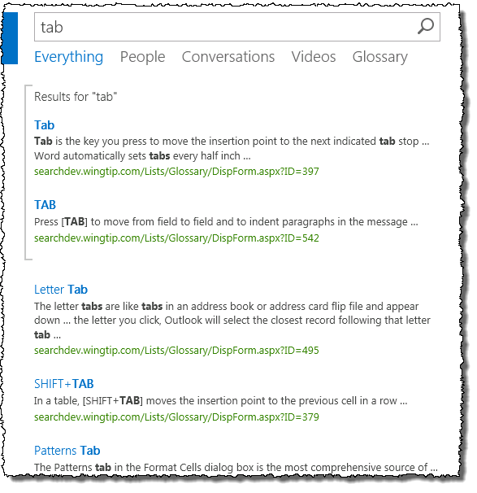

1. Notice that the **Glossary** page only shows results from the **Glossary** list.

In this exercise you created a customized search vertical with special renderings.

### Exercise 3: Search App

In this exercise, you will create a SharePoint App that uses search to display search results. This exercise will help you understand how to request permissions in an App for search and access services in the hosting farm.

1. Launch **Visual Studio** by selecting **Start 🡪 All Programs 🡪 Microsoft Visual Studio 2012 🡪 Visual Studio 2012**.
2. Create a new project:
   1. Select **File 🡪 New 🡪 Project**.
   2. Find the **App for SharePoint 2013** template under the **Templates 🡪 Visual C# 🡪 Office / SharePoint 🡪 Apps** section.
   3. Give the project a name of **SearchApp**.
   4. Click **OK** to create the project.
   5. In the **New App for SharePoint** Wizard, use the following values to complete the wizard:
      1. **What is the name of your App for SharePoint?** Search App
      2. **What site do you want to use for debugging?** <http://searchdev.wingtip.com>
      3. **How do you want to host your app for SharePoint?** SharePoint-hosted
   6. Click **Finish**.
3. Right-click the **Pages \ Default.aspx** file in the **Solution Explorer** tool window and select **View Markup**.
4. Add the following code within the ASP.NET content placeholder **PlaceHolderMain** control:

<div id="toolbarDiv" style="display: none">

<input type="text" style="width: 200px" id="queryTerms" />

<button onclick=”executeQuery($get('queryTerms').value); return false;”>Search</button>

</div>

<div id="resultsDiv"></div>

1. Right-click the **Scripts \ App.js** file in **Solution Explorer** tool window and select **Open**
2. Replace the contents of the **sharePointRead()** method with a call to a new function **showToolbar()**:

function sharePointReady() {

showToolbar();

}

1. Next, delete the following functions that aren’t used:

getUserName() {..}

onGetUserNameSuccess() {..}

onGetUserNameFail() {..}

1. Next, add the following code to the end of the **App.js** file:

function showToolbar() {

$("#toolbarDiv").show();

}

function executeQuery(queryTerms) {

Results = {

element: '',

url: '',

init: function (element) {

Results.element = element;

Results.url = _spPageContextInfo.webAbsoluteUrl +

"/_api/search/query?querytext='" + queryTerms + "'";

},

load: function () {

$.ajax(

{

url: Results.url,

method: "GET",

headers: {

"accept": "application/json;odata=verbose",

},

success: Results.onSuccess,

error: Results.onError

}

);

},

onSuccess: function (data) {

var results =

data.d.query.PrimaryQueryResult

.RelevantResults.Table.Rows.results;

var html = "<table>";

for (var i = 0; i < results.length; i++) {

html += "<tr><td>";

html += results[i].Cells.results[3].Value;

html += "</td><td>"

html += results[i].Cells.results[6].Value;

html += "</td><tr>";

}

html += "</table>";

Results.element.html(html);

},

onError: function (err) {

alert(JSON.stringify(err));

}

}

Results.init($('#resultsDiv'));

Results.load();

}

1. Grant the app necessary permissions:
   1. Right-click the **AppManifest.xml** file in the **Solution Explorer** tool window and select **Open**.
   2. On the **Permissions** tab use the following values to create the permission:
      1. **Scope:** Search
      2. **Permission:** QueryAsUserIgnoreAppPrincipal
2. Save all changes: **File 🡪 Save All**.

#### Build and Test the Project

1. Build and test your application by pressing **[F5]** or **Debug 🡪 Start Debugging**.
2. Once the solution has been deployed, Internet Explorer will launch and navigate to the <http://searchdev.wingtip.com> site.
3. When prompted by SharePoint to grant permissions, click **Trust It**.
4. On the **Site Contents > Your Apps**, click the **Search App** in the **Lists, Libraries and other Apps** section.
5. You should now see a text box and button. Try entering a search term such as **arguments** and clicking the button. Results should subsequently appear below the search box:

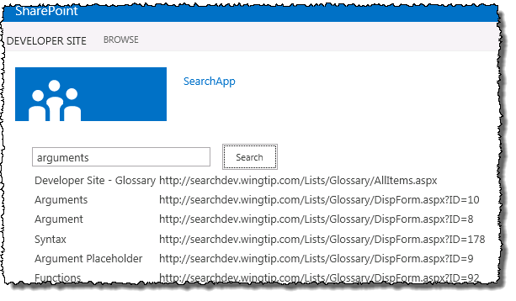

In this exercise you created a SharePoint-Hosted app that used the Search REST API to issue a query and display the results.