## Working with Document Libraries and Document Sets

**Lab Time**: 45 minutes

**Lab Folder**: C:\Student\DocumentLibraries\Lab

**Lab Overview:** In this lab you continue to work on the Wingtip Intranet team site that you began to work with in the previous lab on Content Types. You will create a new Picture Library in the Wingtip Intranet site and upload a set of 32 product images. Next, you will create a new site column and add it to the **Products** list so that each product item can track an URL that points to its image. In the second half of this lab, the exercises will have you create a new site collection for the Wingtip Product Research site. Within this site collection you will create a document library named **Product Proposal** which you will configure with a custom document template. In the final part of this lab, you will create a second document library named **Product Plans** which you will configure with a custom document set to automate creating the standard set of business documents that must be created for each new product plan.

### Exercise 1: Creating the Product Images Picture Library

In this exercise you will create a new picture library named Product Images and then upload a set of product images.

1. Log on to the Student VM using the login **WINGTIP\Administrator** using the appropriate password.
   1. If you’re using a local VM provided by the hosting training company, the password will be **Password1**.
   2. If your student VM is hosted by CloudShare, the password for the **WINGTIP\Administrator** account is going to be a unique, system-generated password for each student. Also note that the CloudShare VM configuration usually logs you into the VM automatically so you do not have to enter the user name and password.
2. Once you have logged on to the student VM, launch Internet Explorer and navigate to the **Wingtip Intranet** site at <http://intranet.wingtip.com>. This is the same site collection you worked with in the previous exercise.
3. You should be able to verify that the Wingtip Intranet site has a Products list that looks like the one in the following screenshot.

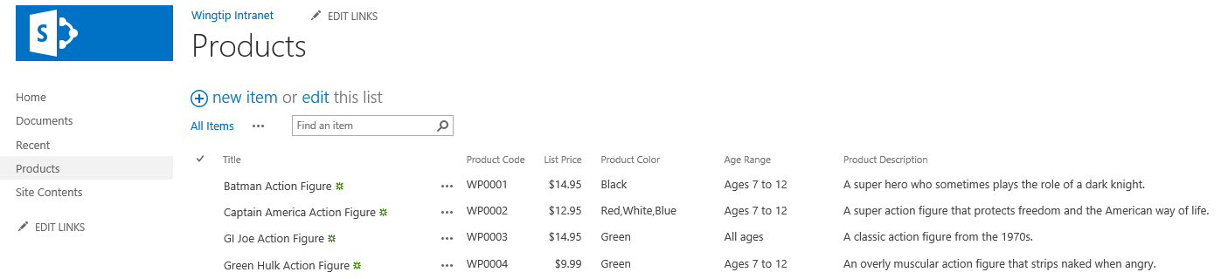

If the Wingtip Intranet site on your VM does not contain the completed work for the previous lab titled Creating Site Columns and Content Types, you will not be able to work through this lab until that work is completed. However, you can run the solution utility for the previous lab which is located at **C:\Student\Modules\ContentTypes\Lab\Solution\ContentTypesSolution.exe**. You can run this utility to update the **Wingtip Intranet** site to contain the types required before starting this lab including the Wingtip site columns, the **Product** content type and the **Products** list.

1. Create the **Product Images** picture library.
   1. From the **Site Actions** menu, click the **Add an app menu** item to navigate to the **Your Apps** page.
   2. On the **Your Apps** page, click the **Picture Library** tile to begin the process of creating a new custom list.

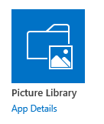

Unlike what you did in the **Getting Started** lab, you will not use any spaces in the name when creating the new picture library. This technique will result in making cleaner URLs to the images in the picture library. After the picture library has been created and its URL has been established, you can then modify the display name for the list to include spaces for better readability.

* 1. Give the new picture library an initial name of **ProductImages**.

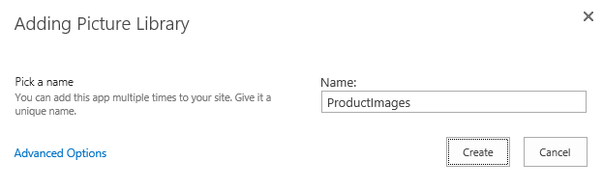

* 1. Click the **Create** button to create the new picture library.
  2. After the picture library has been created, you should be able to see a tile for it on the **Site Contents** page.



* 1. Click on the ellipse (**…**) fly out menu in the top, right-hand corner of the **ProductImages** tile. Click the **SETTINGS** link to navigate to the setting page for the **ProductImages** picture library.

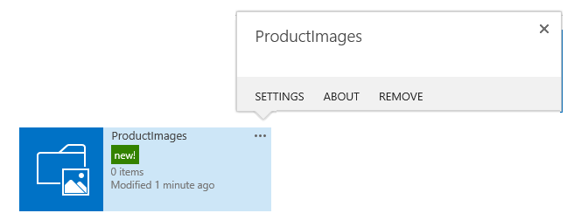

* 1. On the **Settings** page for the **ProductImages** picture library, click the **List name description and navigation** link to navigate to the General Settings page.

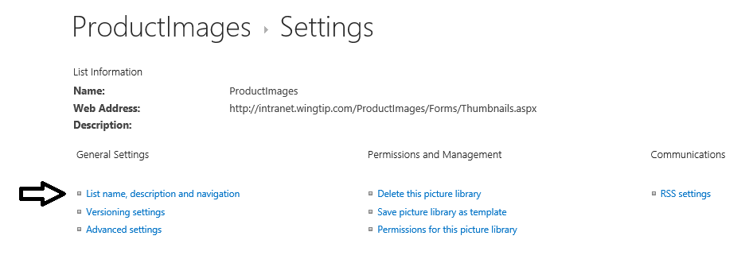

* 1. On the **General Settings** page, modify the **Name** setting for the picture library from **ProductImages** to **Product Images**.

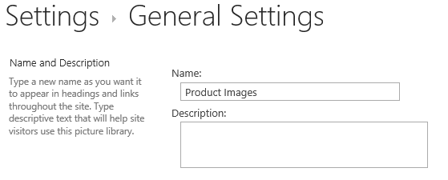

* 1. Scroll down in the **General Settings** page to the **Navigation** section. Set the **Display this picture library on the Quick Launch** to a value of **Yes**.

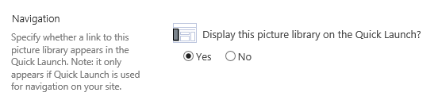

* 1. At the bottom of the **General Settings** page, click the **Save** button to save your work. When you return to the settings page for the picture library you should be able to confirm that the library name was updated from **ProductImages** to **Product Images**. Moreover, the URL to the picture library (i.e. the **Web Address** property) has been created without any spaces.

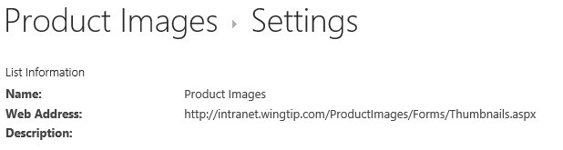

* 1. Click on the **Product Images** link in Quick Launch to navigate to the default view of the **Product Images** picture library.

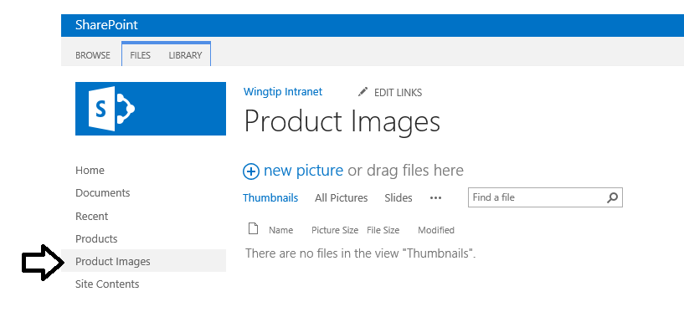

* 1. Now you have completed the steps of creating a new picture library. It’s time to move ahead and upload some product images.

1. Upload a set of product image files to the **Product Images** picture library.
   1. Using the Windows Explorer, navigate to the folder with the Wingtip product at the following path.

C:\Student\ExtraStudentFiles\ProductImages\

* 1. You should be able to confirm that this folder contains a set of thirty-two JPG image files.

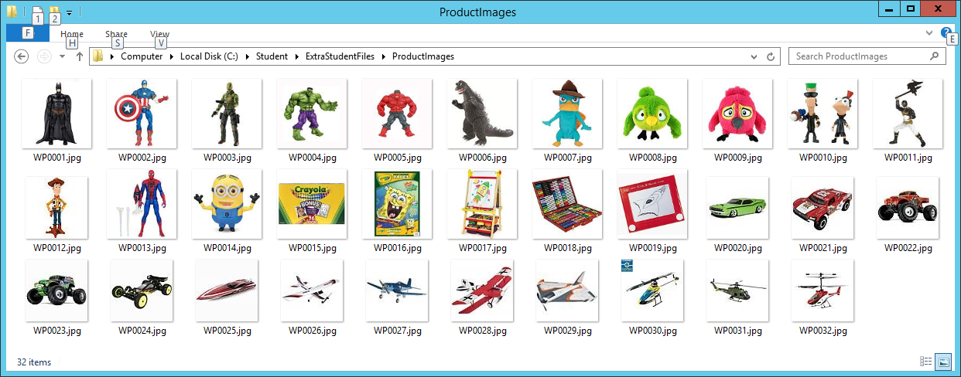

* 1. Perform a drag-and-drop operation between the Windows Explorer and the browser to upload the Wingtip product image files. Begin by selecting all the JPG images files from the **ProductImages** folder.
  2. Once you have selected all the image files, drag-and-drop them as a set onto the middle section of the default view of the **Product Images** library as shown in the following screenshot.

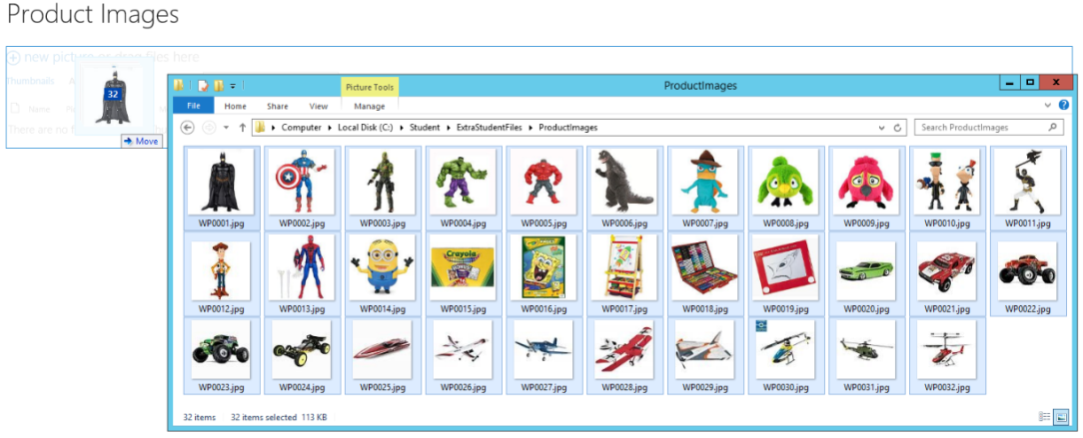

* 1. After you have performed the drag-and-drop operation, the image files should appear in the **Product Images** picture library.

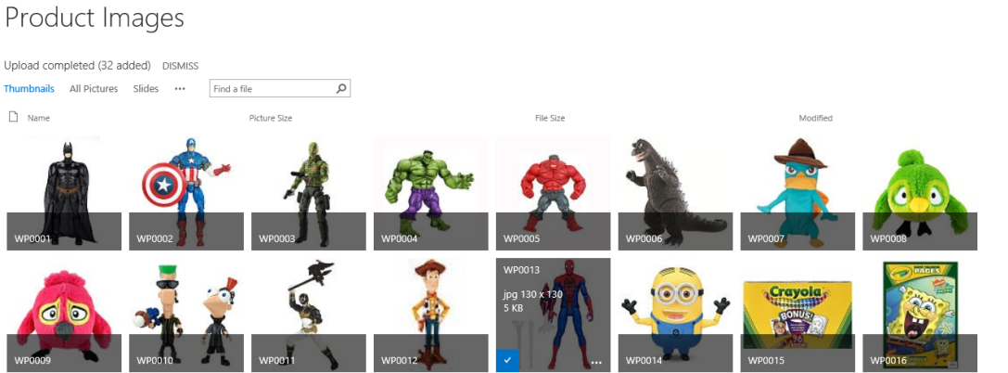

Take note of the special behavior in a picture library. When you hover the mouse over a thumbnail of an image, SharePoint UI overlays a see-through grey tile which displays the dimensions and the size in KB of the image file.

1. You are now done with this exercise. Return to the home page of the Wingtip Intranet site.

In this exercise you created a picture library and imported a set of JPG image files for Wingtip products.

### Exercise 2: Adding a Site Column for Product Image Url

In this exercise you will create a new site column named **Product Image Url** so that each **Product** item can track the URL to its image. After creating the **Product Image Url** site column, you will then add it to the **Product** content type in such a way that it is added to the **Products** list as well.

1. Create the **Product Image Url** site column.
   1. Go to **Site Settings.**
   2. On the **Site Columns** page, click the **Create** link to navigate to the **Create Column** page.
   3. Enter a column name of **ProductImageUrl** and set the column type to **Hyperlink or Picture.**

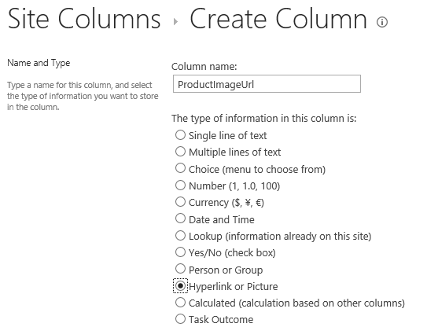

**WATCH OUT**: Be careful to spell the Column name **ProductImageUrl** correctly and also make sure you match the case shown here. Take note that the last two characters are lower case. If you enter a name with a case sensitivity error such as **ProductImageURL**, the utility that is used in a later step to populate the **Products** list will not work correctly. Make sure the name you use is **ProductImageUrl** which only has three upper case letters which as **P**, **I** and **U**.

* 1. In the **Group** section of the **Create Column** page, assign the new site column to the **Existing group** of **Wingtip**.

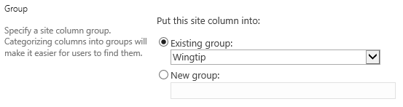

* 1. In the **Additional Column Setting** of **Create Column** page, locate the drop down control for the **Format URL as** setting and change it from a value of **Hyperlink** to a value of **Picture**.

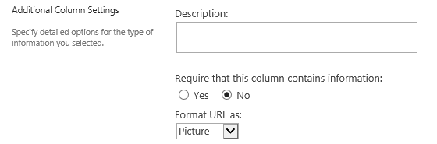

Configuring the format of this site column as **Picture** instead **Hyperlink** will affect how its value is displayed. When you use a format setting of **Picture**, the SharePoint UI will display the image by creating an HTML <img> tag using the URL value as the src property.

* 1. At the bottom of the **Create Column** page, click **OK** to create the new site column. Once the site column has been created, you should be able to see it along with all the other **Wingtip** site columns.

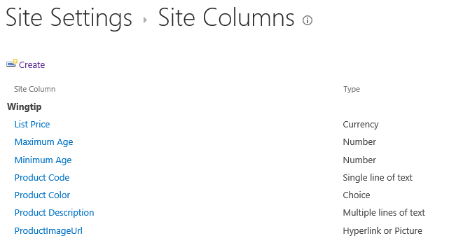

* 1. Once the site column has been created, open it in the **Edit Column** page and add spaces to its display name to update it from **ProductImageUrl** to **Product Image Url**.

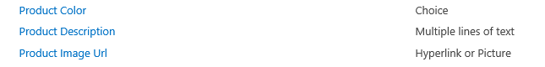

At this point you have finished creating the new site column. The next step is to add this site column to the **Product** content type.

1. Add the **Product Image Url** site column to the **Product** content type.
   1. Use the **Site Actions** menu to navigate to the **Site Settings** page.
   2. Click the **Site content types** link in the **Web Designer Galleries** section to navigate to the **Site Content Types** page.
   3. Select the **Wingtip** group in the **Show Group** control. Once you do this, you should see the **Product** content type.

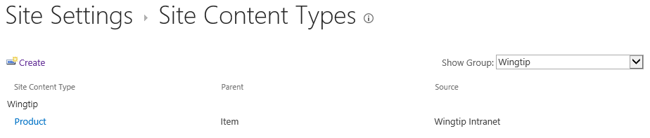

* 1. Click on the link for the **Product** content type to navigate to the **Site Content Type** page for the **Product** content type.

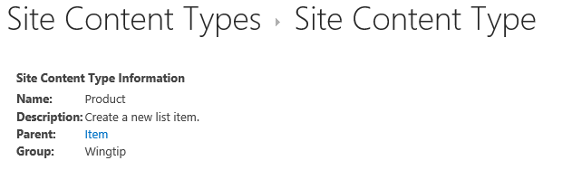

* 1. Scroll down in the **Site Content Type** page for the **Product** content type to the **Columns** section. Click the **Add from existing site columns** link to navigate to the **Add Columns** page.
  2. On the **Add Columns** page, add the **Product Image Url** site column into the **Columns to add** list box.

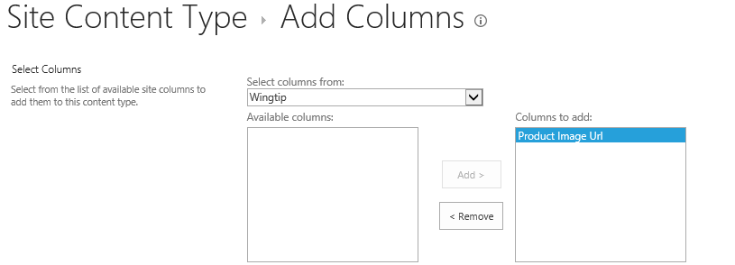

* 1. On the **Add Columns** page, look down in the **Update List and Site Content Types** section. Verify that the **Update all content types inheriting from this type** setting has been assigned a value of **Yes**.

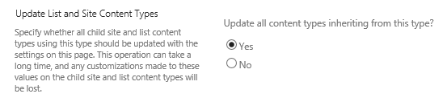

* 1. On the bottom of the **Add Columns** page, click the **Save** button to save your changes.
  2. This action will result in adding the **Product Image Url** site column to the **Product** content type.

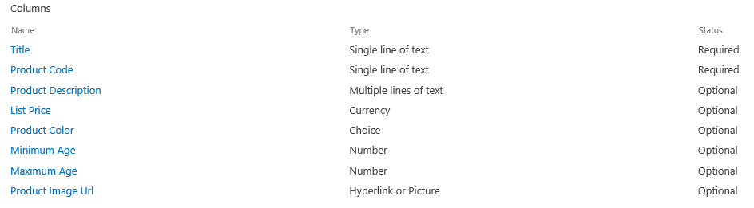

Note that the **Product Image Url** site column has been automatically added to the **Products** list because you chose the option to **Update all content types inheriting from this type**.

1. Modify a **Product** item with a **Product Image Url** value.
   1. Navigate to the default view of the Products list.
   2. Select the **Edit Item** menu command from the list item ellipsis menu (**…**) to open the **Batman Action Figure** product item.

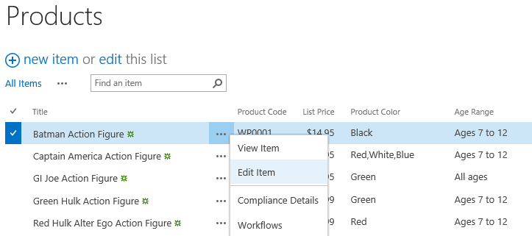

* 1. Look at the bottom of the **Edit Item** page for the Batman Action Figure and locate the caption **Product Image Url**. You should see that this site column displays two textboxes when in edit mode.
  2. In the textbox with the caption **Type the Web address**, enter the URL to the associated product image.

http://intranet.wingtip.com/ProductImages/WP0001.jpg

* 1. In the **Type the description** textbox, enter **Batman Action Figure** image.
  2. When you have correctly entered the data, your page should look like the following screenshot.

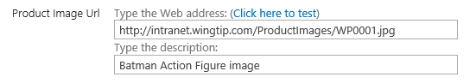

* 1. Click the **Save** button at the bottom of the **Edit Item** page to save your changes to the **Batman Action Figure** item.
  2. Return to the default view of the **Products** list.
  3. Select the **View Item** menu command from the list item ellipsis menu (**…**) to open the **Batman Action Figure** product item. You should be able to see the product image display at the bottom of the page.

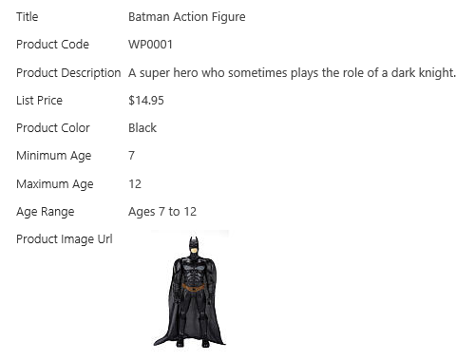

1. Add the **Product Image URL** site column to the default view of the **Products** list.
   1. Navigate to the default view of the **Products** list.
   2. Activate the **List** tab in the ribbon and click on the **Modify View** button to navigate to the **Edit View** page for the default view.

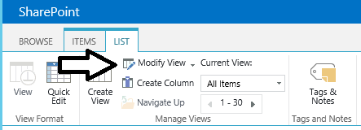

* 1. On the **Edit View** page, add the Product Image Url site column so it appears as the last column shown in the view.

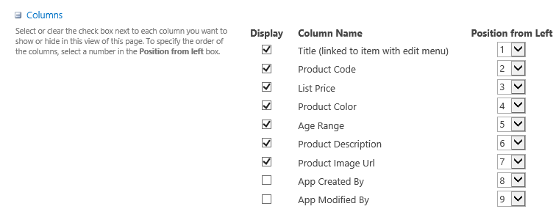

* 1. At the bottom of the **Edit View** page, click **OK** to save your changes. You should now see the Product Image Url column on the far right. Also note that the Batman Action Figure is currently the only item that has a **Product Image Url** value.

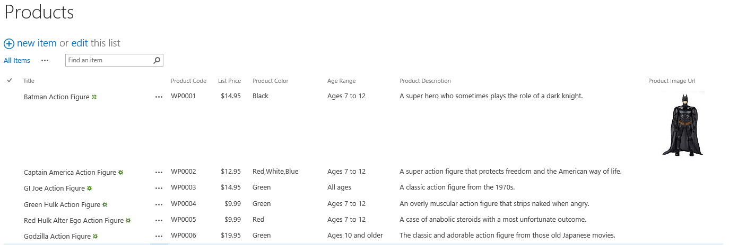

1. Update all product items so that **Product Image Url** site column references the appropriate product image.
   1. Move through each of the products and update them to include the URL which matches this form and matches the Product Code for the current item like this <http://intranet.wingtip.com/ProductImages/WP0002.jpg>.

You don't have to edit the **Product Image Url** column for each product item by hand because the student folder has a utility to update all the URLs for you. This utility is at **C:\Student\Modules\DocumentLibraries\Lab\Utilities\UpdateProductImageUrls.exe**.

* 1. When you are finished updating the Product Image Url values for each product, the default view of the **Products** list should look like the following screenshot.

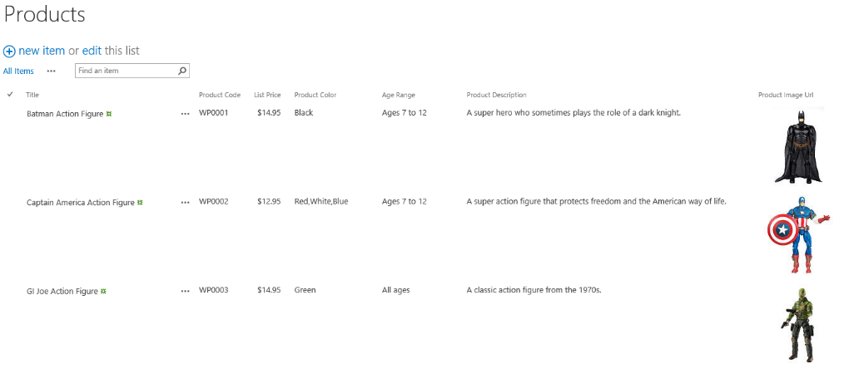

You have now finished your work on the Wingtip Intranet site. The exercise for the remainder of this lab will involve working in a new site collection at **http://intranet.wingtip.com/sites/research**.

### Exercise 3: Creating the Wingtip Product Research Site

In this exercise you will create the Wingtip Product Research Site.

1. Navigate to Central Administration at <http://wingtipserver:9999>.
2. From the home page of Central Administration, locate and click the **Create Site Collections** link in the **Application Management** section to navigate to the **Create Site Collection** page.
3. When the **Create Site Collection** page is displayed, begin by ensuring that the **Web Application** setting at the top of the page references the web application with the URL of <http://intranet.wingtip.com>. If the page references a different web application such as <http://wingtipserver>, use the drop down control to update the target web application to be the one at <http://intranet.wingtip.com>.

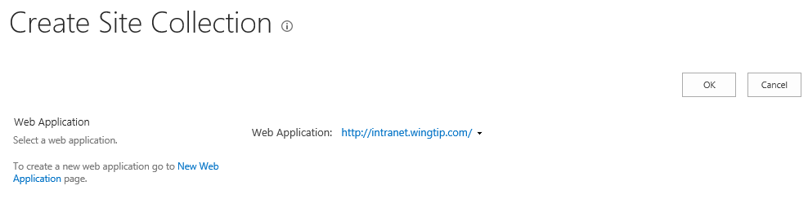

* 1. In the **Title and Description** section of the **Create Site Collection** page, add the following entries.
     1. **Title**: Wingtip Product Research
     2. **Description**: A site for researching and testing potential products
     3. **URL**: http://intranet.wingtip.com/sites/research
  2. Your input values should match those in the following screenshot.



* 1. In the **Template Selection** section of the **Create Site Collection** page, ensure that the **Select experience version** setting is set to **2013** and that the **Select a template** setting is set to **Team Site**. Below in the **Primary Site Collection Administration** section, assign a **User name** setting of **WINGTIP\Administrator**.

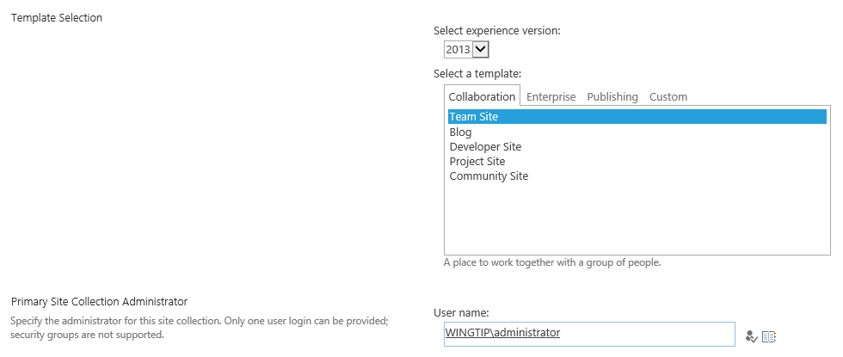

* 1. Click the **OK** button to begin the process of provisioning the new Team site. This might take a few minutes to complete. When the new site collection has been created, the Central Administration site will display a page that contains a link to the new Team site at **http://intranet.wingtip.com/sites/Research**. Click on this link to navigate to the new Team site.

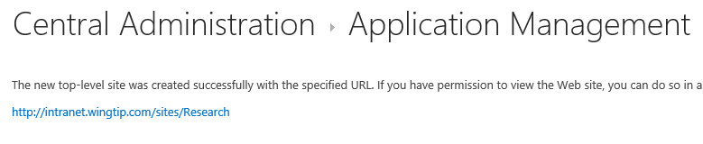

* 1. Wait until the home page displays for the site at <http://intranet.wingtip.com/sites/Research>.

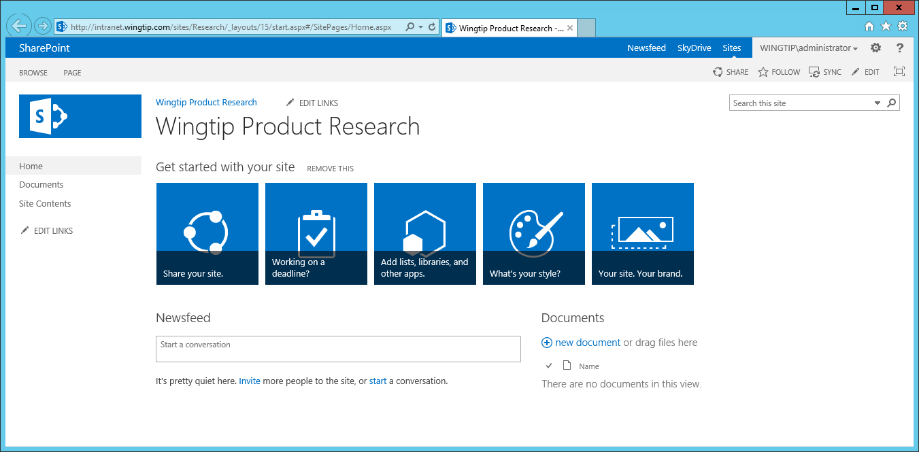

* 1. Once you can see the home page of the new Team site, you can move on to the next exercise.

In this exercise you used Central Administration to create the Wingtip Product Research site as a Team site in a new site collection. In the following exercises, you will begin working with this new site to add document libraries.

### Exercise 4: Adding the Product Proposal Content Type

In this exercise you will create a document-derived content type named **Product Proposal**. You will also configure this content type with support for a custom document template. After that, you will create several new document libraries and configure them to use the **Product Proposal** content type.

1. Create the **Product** **Proposal** content type.
   1. Make sure you are in the Wingtip Product Research Site at <http://intranet.wingtip.com/sites/Research>.
   2. Use the **Site Actions** menu to navigate to the **Site Settings** page.
   3. Click the **Site content types** link in the **Web Designer Galleries** section to navigate to the **Site Content Types** page.
   4. On the **Site Content Types** page, click the **Create** link to navigate to the **New Site Content Type** page.
   5. Enter a **Name** of **Product Proposal**.
   6. Set the **Select parent content type** setting to **Document Content Types**.
   7. Set the **Parent Content Type** setting to **Document**.
   8. In the **Group** section add a New Group value of **Wingtip**.
   9. Ensure your input values look as they do in the following screenshot.

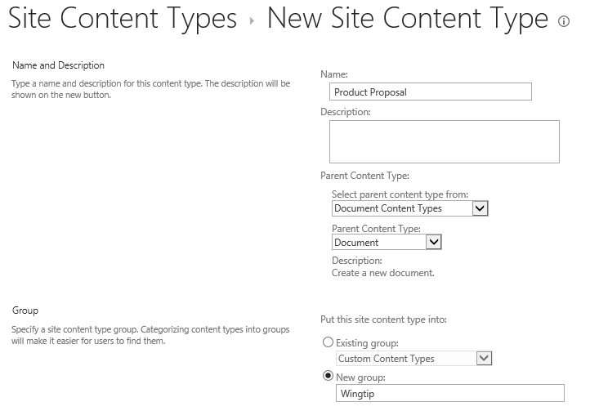

* 1. Click **OK** at the bottom off the **New Site Content Type** page to create the new **Product Proposal** content type.
  2. When you click **OK**, you will be redirected to the **Site Content Type** page for the **Product Proposal** content type.

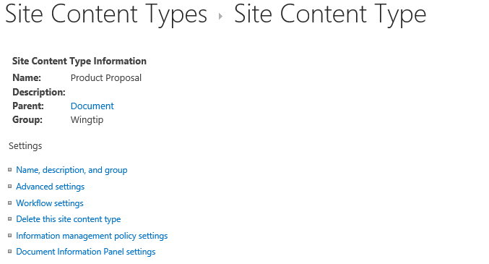

1. Add a custom document template to the **Product Proposal** content type.
   1. On the **Site Content Type** page for the **Product Proposal** content type, click the **Advanced settings** link.
   2. On the **Advanced Settings** page, select the **Upload a new document template** option and click the **Browse** button.

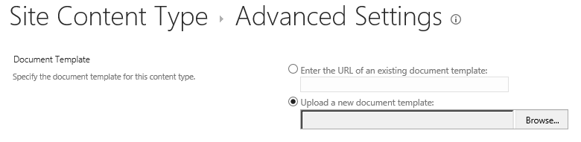

* 1. Select the file at **C:\Student\Modules\DocumentLibraries\Lab\DocumentTemplates\WingtipProductProposal.dotx**.

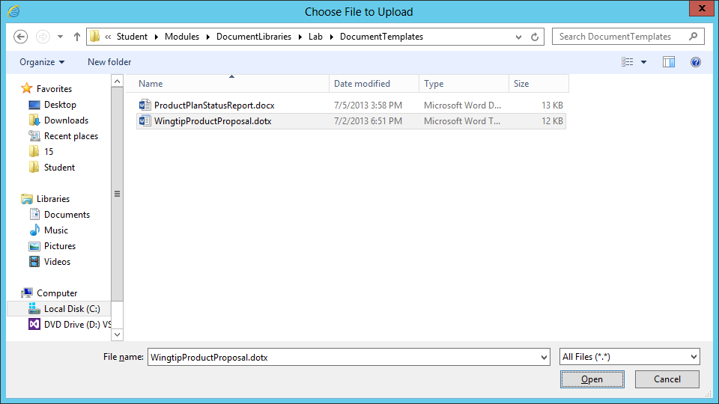

* 1. When you return to the **Advanced Settings** page, click the **OK** button to upload the document template and configure it for use with the **Product Proposal** content type.

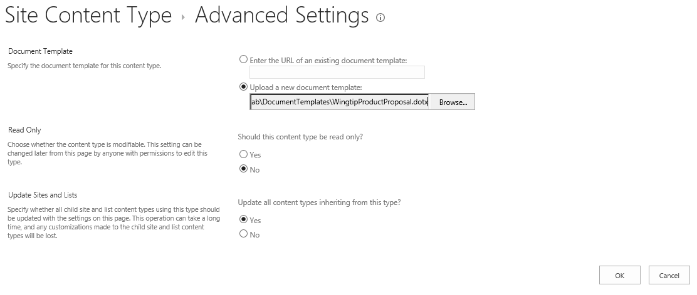

You have now completed the steps of creating the **Product Proposal** content type. Now you will create a document library which will use this content type.

1. Create the **Action Figure Proposals** document library.
   1. From the **Site Actions** menu, click the **Add an app menu** item to navigate to the **Your Apps** page.
   2. On the **Your Apps** page, click the **Document Library** tile to begin the process of creating a new document library.



* 1. Give the new document library an initial name of **ActionFigureProposals**.

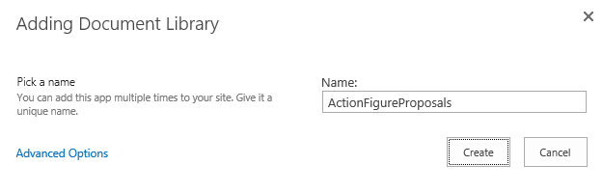

* 1. Click the **Create** button to create the new document library.
  2. After the document library has been created, you should be able to see a tile for it on the **Site Contents** page.



* 1. Click on the ellipse (**…**) fly out menu in the top, right-hand corner of the **ActionFigureProposals** tile. Click the **SETTINGS** link to navigate to the settings page for the **ActionFigureProposals** document library.
  2. On the **Settings** page for the **ActionFigureProposals** document library, click the **List name description and navigation** link to navigate to the **General Settings** page.
  3. Modify the **Name** setting for the document library from **ActionFigureProposals** to **Action Figure Proposals**.

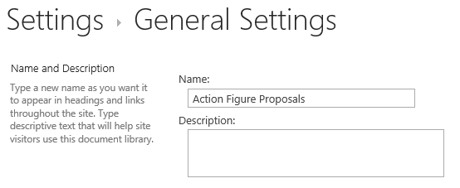

* 1. Scroll down in the **General Settings** page to the **Navigation** section. Set the **Display this document library on the Quick Launch** to a value of **Yes**.

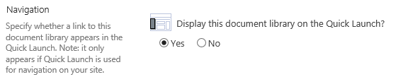

* 1. At the bottom of the **General Settings** page, click the **OK** button to save your work.
  2. When you return to the settings page for the document library you should be able to confirm that the library name has been updated from **ActionFigureProposal** to **Action Figure Proposal**.

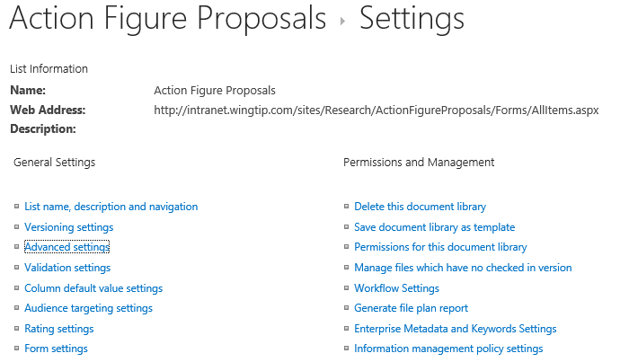

Now that the document library has been created, you can to configure it to use the **Product Proposal** content type.

1. Configure the **Action Figure Proposal** document library to use the **Product Proposal** content type
   1. On the **Settings** page of the **Action Figure Proposals** document library, click the **Advanced settings** link.
   2. On the **Advanced Settings** page, set the **Allow management of content types** option to **Yes**.

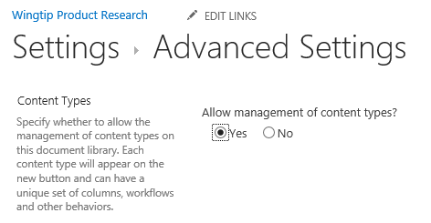

* 1. Click the **OK** button at the bottom of the On the **Advanced Settings** page to save your changes.
  2. When you return to the **Settings** page for the **Action Figure Proposals** document library, you should see it now displays a new **Content Types** section. You can also observe that the **Action Figure Proposals** document library currently contains a single content type which is the standard SharePoint **Document** content type.

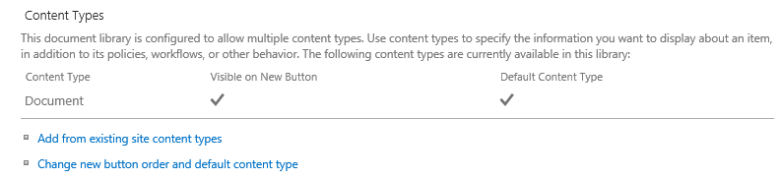

* 1. Click the **Add from existing site content types** link to navigate to the **Add Content Types** page. Add the **Product Proposal** content type as shown in the following screenshot.

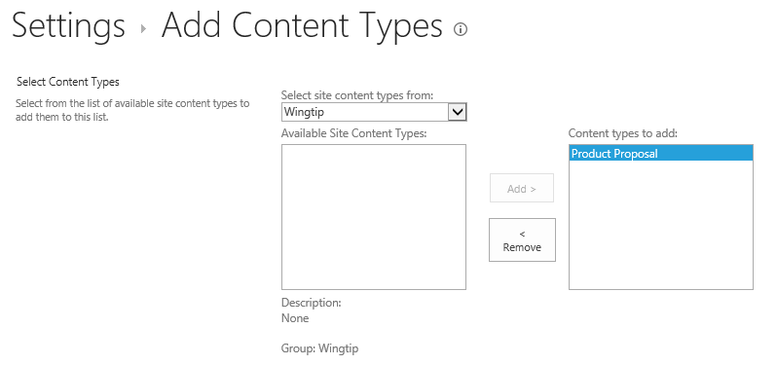

* 1. Click the **OK** button at the bottom of the **Add Content Types** page to save your changes. You should now see that the **Product Proposal** content type has been added along with the existing **Document** content type.

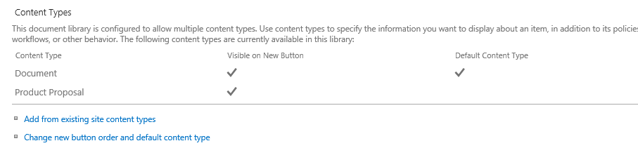

* 1. Remove the **Document** content type. You can accomplish this by clicking the **Document** content type link to navigate to the **List Content Type** page for the **Document** content type. Click the **Delete this content type** link to remove the Document content type from the **Action Figure Proposals** document library. Once you remove the **Document** content type, the **Content Types** section on the Settings page of the Action Figure Proposals document library should include only the Product Proposal content type.

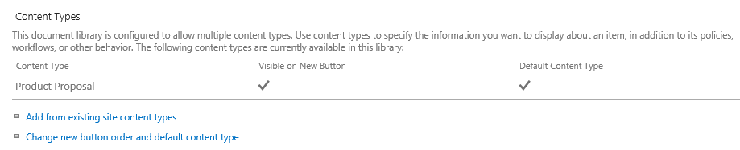

1. Modify the default view of the **Action Figure Proposals** document library.
   1. Click on the **Action Figure Proposals** link in Quick Launch to navigate the default view of the document library.
   2. Take a moment to inspect the user interface of the default view. You can see that there is a new document link for uploading existing documents as well as support for uploading files via drag-and-drop in the browser.

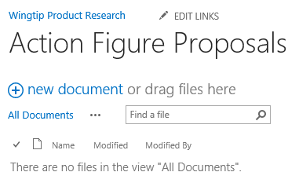

There is a problem with the out-of-box user experience given the scenario. Wingtip research scientists should only be adding proposals by creating them from the correct document template. However, the default user interface for a document library supports and promotes the uploading of existing documents that have already been created. Therefore, you must remove this aspect of the user interface that encourages users to upload pre-existing documents.

* 1. Select the **Edit page** command in **Site Action** to transition the current page into edit mode.

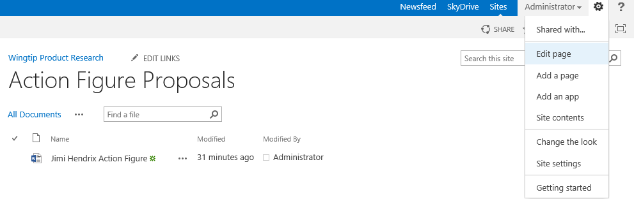

* 1. When the page is in edit mode, you can see it contains a single web part. Drop down the web part menu as shown in the following screenshot and then click **Edit Web Part**.

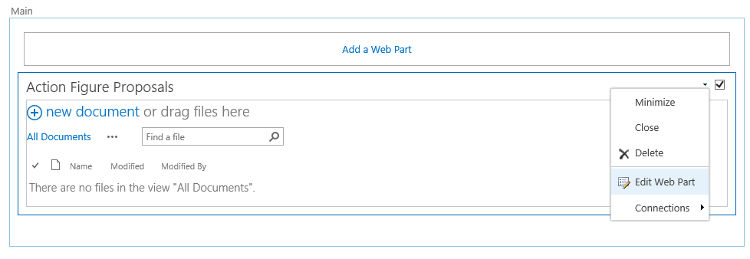

* 1. When you put the web part into edit mode, you will see a task pane on the right-hand side of the browser window. Change the **Toolbar Type** setting to **No Toolbar** and click the **OK** button.
  2. Click on the **Page** tab and click **Stop Editing**.

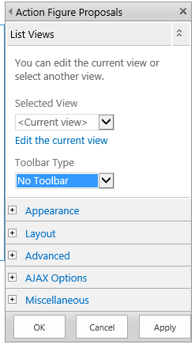

* 1. **You should now be back at the page with the default view of the Action Figure Proposals document library. You should be able to verify that your changes removed the new document link.**

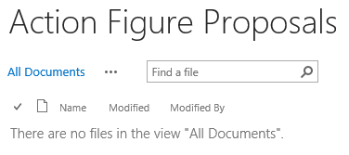

1. **Create a new document in the Action Figure Proposals document library.**
   1. **Make sure you are on the page with the default view of the Action Figure Proposals document library.**
   2. **Activate the Files tab in the ribbon.**
   3. **In the Files tab, drop down the New Document menu and click Product Proposal to create a new document. This action should cause Microsoft Word to start.**

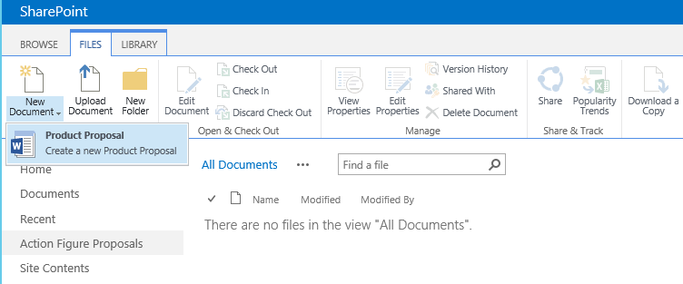

* 1. **Once Microsoft Word has had time to start and initialize, you should see the Wingtip Product Proposal document template load to create a new document.**
  2. **Using Microsoft Word, fill in some sample data in the document such as the sample entries used in the following screenshot.**

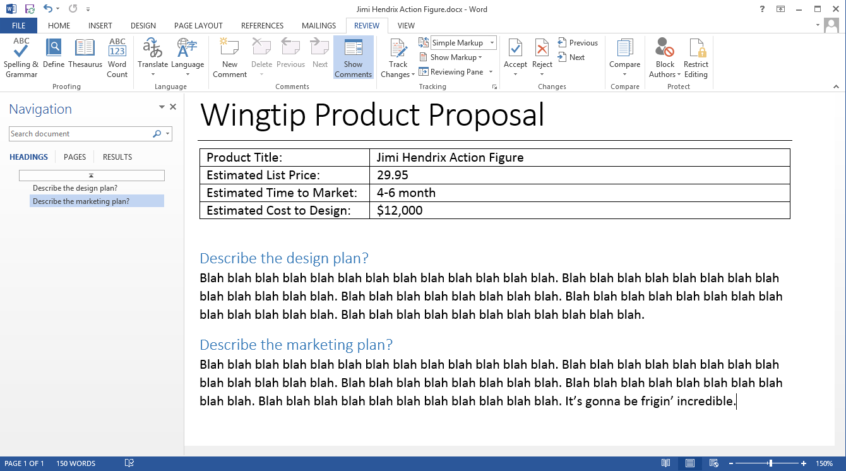

* 1. **Using Microsoft Word, save the new document back to the Action Figure Proposals document library.**
  2. **Return to the browser and make sure you can see the new document in the Action Figure Proposals document library.**

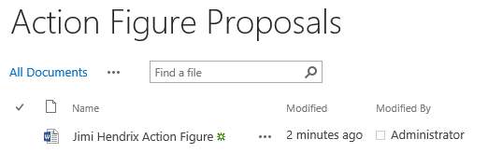

**In this lab you worked with several types of documents and the document library. You also learned how to manage document templates using content types to promote higher levels of reusability and maintainability.**

### Exercise 5: Configuring a Document Library to Support Document Sets

In this exercise you utilize the functionality of document sets to manage the standard set of documents that are required each time Wingtip Toys brings a new product through the research and development phase of the product lifecycle. You will accomplish this by creating and configuring a custom content type named **Product Plan** which inherits from the built-in **Document Set** content type. Next, you will create a document library named **Product Plans** which you will then configure to use the **Product Plan** content type.

1. Navigate to the Wingtip Product Research site at <http://intranet.wingtip.com/sites/research> in the browser.
2. Create the **Estimated Completion Date** site column.
   1. On the **Site Columns** page, click the **Create** link to navigate to the **Create Column** page.
   2. Enter a column name of **EstimatedCompletionDate** and set the column type to **Date and Time**.

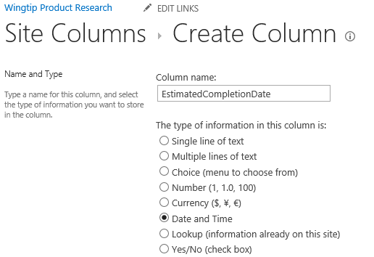

* 1. In the **Group** section, assign the new site column to the **New group** of **Wingtip**.

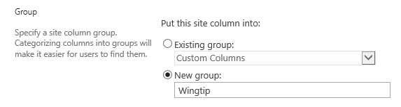

* 1. In the **Additional Column Setting** section, you can leave all the settings with their default values as shown below.

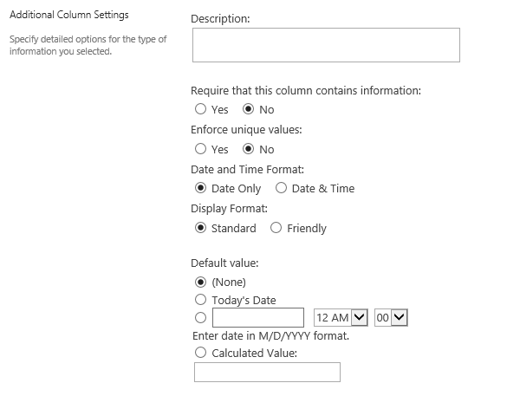

* 1. Click **OK** to create the new site column,
  2. Once the site column has been created, open it in the **Edit Column** page and add a space to its display name to update it from **EstimatedCompletionDate** to **Estimated Completion Date**.

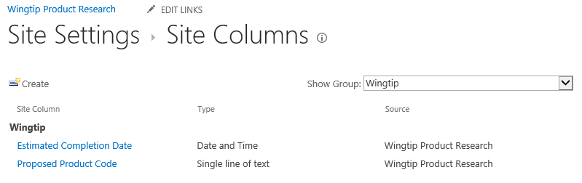

Over the next few steps you will create two content types. First, you will create a content type named **Product Plan Status Report** inheriting from the **Document** content type that will be used add support for a custom document template. After that, you will create a second content type named **Product Plan** inheriting from the **Document Set** content type which will make it possible for you to configure document set features within a standard document library.

1. Create the **Product Plan Status Report** content type.
   1. Use the **Site Actions** menu to navigate to the **Site Settings** page.
   2. Click the **Site content types** link in the **Web Designer Galleries** section to navigate to the **Site Content Types** page.
   3. On the **Site Content Types** page, click the **Create** link to navigate to the **New Site Content Type** page.
   4. Enter a **Name** of **Product Plan Status Report**.
   5. Set the **Select parent content type** setting to **Document Content Types**.
   6. Set the **Parent Content Type** setting to **Document**.
   7. In the **Group** section add a New Group value of **Wingtip**.
   8. Ensure your input values look as they do in the following screenshot.

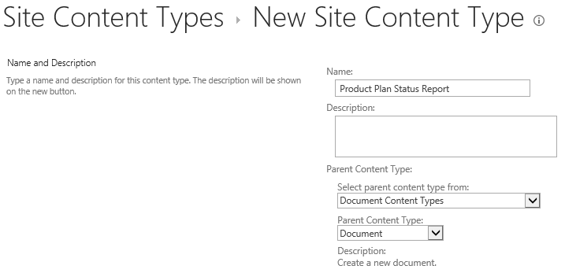

* 1. Click **OK** at the bottom off the **New Site Content Type** page to create the new **Product Plan Status Report** content type.
  2. When you click **OK**, you will be redirected to the **Site Content Type** page for the **Product Plan Status Report** content type.

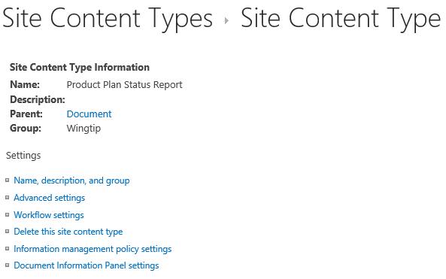

1. Add a custom document template to the **Product Plan Status Report** content type.
   1. On the **Site Content Type** page for the **Product Plan Status Report** content type, click the **Advanced settings** link.
   2. On the **Advanced Settings** page, select the **Upload a new document template** option and click the **Browse** button.



* 1. Select the file at **C:\Student\Modules\DocumentLibraries\Lab\DocumentTemplates\ProductPlanStatusReport.docx**.

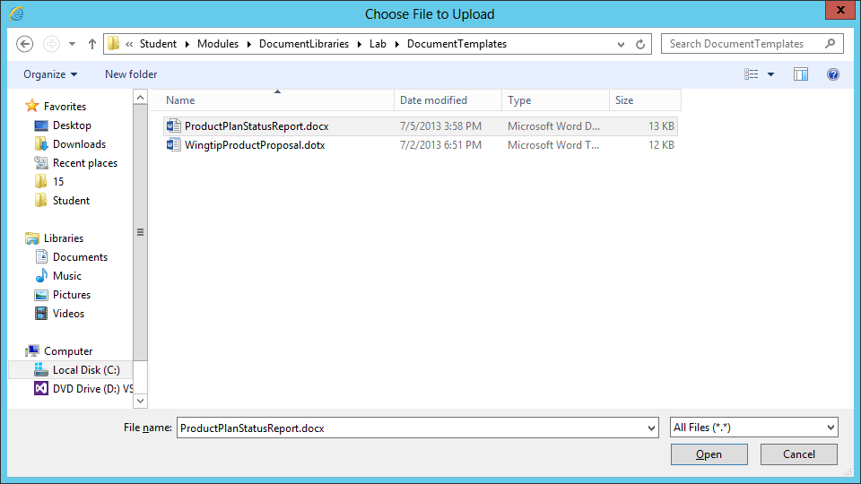

* 1. You should see that your actions have added a path to the textbox associated with the **Upload a new document template** option.

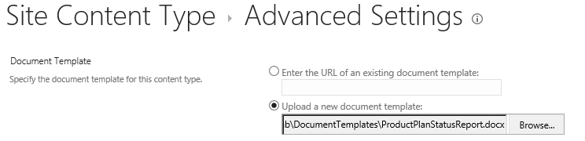

* 1. Scroll to the bottom of the **Advanced Settings** page and click the **OK** button to upload the document template and configure it for use with the **Product Plan Status Report** content type.

1. Create the **Product Plan** content type.
   1. Make sure you are in the Wingtip Product Research Site at <http://intranet.wingtip.com/sites/Research>.
   2. Use the **Site Actions** menu to navigate to the **Site Settings** page.
   3. Click the **Site content types** link in the **Web Designer Galleries** section to navigate to the **Site Content Types** page.
   4. On the **Site Content Types** page, click the **Create** link to navigate to the **New Site Content Type** page.
   5. Enter a **Name** of **Product Plan**.
   6. In the **Select parent content type from** dropdown menu, select **Document Set Content Types**.
   7. In the **Parent Content Type** dropdown menu, select **Document Set**.
   8. In the **Group** section, select the **Existing group** radio button and select **Wingtip** from the dropdown menu as shown in the following screenshot.

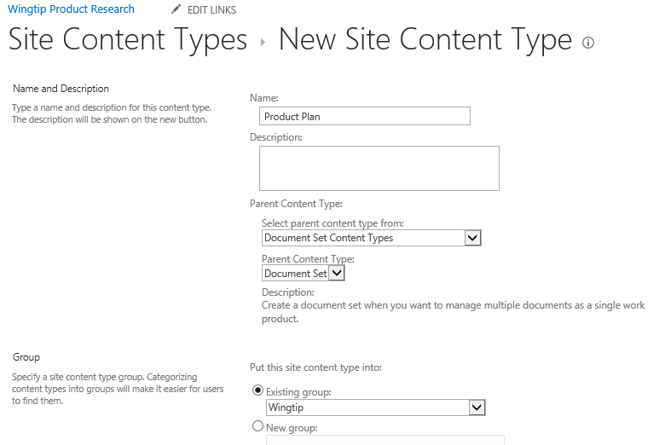

* 1. Click OK to create the **Product Plan** content type and navigate to its setting page.

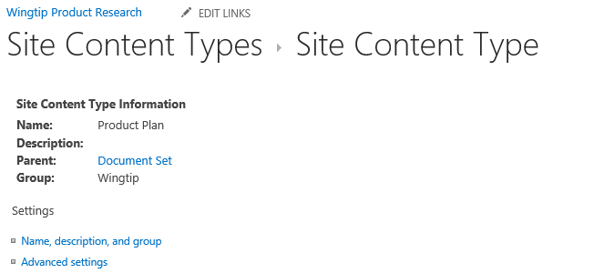

* 1. Inspect the existing set of site columns in this content type.

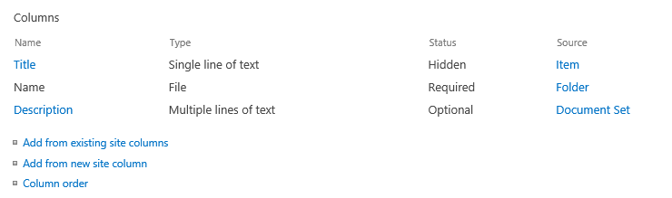

* 1. Add the **Estimated Completion Date** column by clicking the **Add from existing site columns** link and then adding the column using the **Add >** button as shown in the following screenshot.

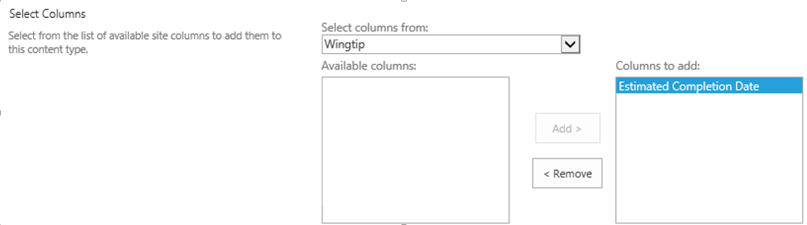

* 1. Here is what you should have

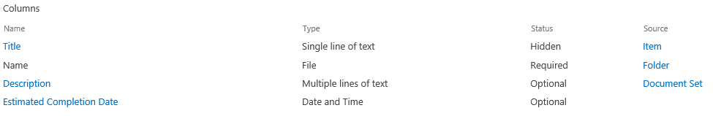

* 1. Navigate to the Document Set Settings page.

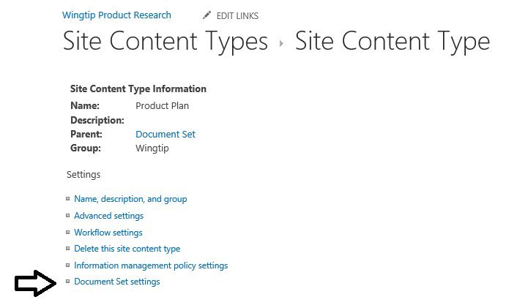

* 1. Configure the list of allowed content types to include the **Product Plan Status Report** content type.

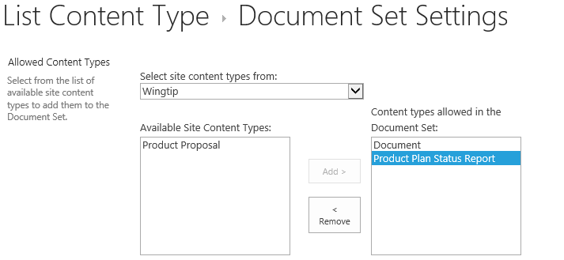

* 1. Using Windows Explorer, inspect the following folder and see what documents are inside.

C:\Student\Modules\DocumentLibraries\Lab\ProductPlanDefaultContent

* + 1. You should see a document named **Product Design Specification.docx**.
    2. You should see another document named **Product Plan Schedule.xlsx**.
  1. Move back to the browser and the Document Set Settings page where you are configuring the Product Plan document set. Scroll down to the Default Content section and add the two documents named **Product Design Specification.docx** and **Product Plan Schedule.xlsx** as default content.

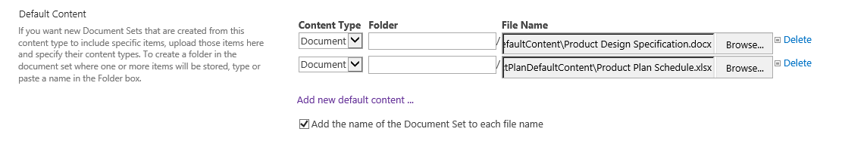

* 1. Leave all the checkboxes unchecked in the **Shared Columns** section.
  2. Add the Estimated Completion Date site column to the list of Welcome Page Columns.

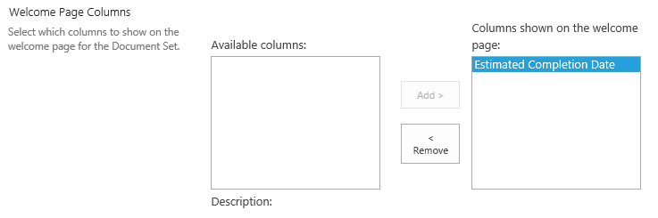

* 1. Check the checkbox to update the welcome page.

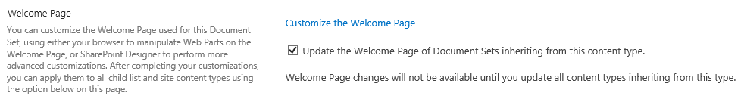

* 1. Click OK to save your changes.

You have now completed work on the Product Plan content type where you can now test your work. In the next step, you will create a new document library and then configure it to use the Product Plan content type.

1. Create the **Product** **Plans** document library.
   1. From the **Site Actions** menu, click the **Add an app menu** item to navigate to the **Your Apps** page.
   2. On the **Your Apps** page, click the **Document Library** tile to begin the process of creating a new document library.



* 1. Give the new document library an initial name of **ProductPlans**.

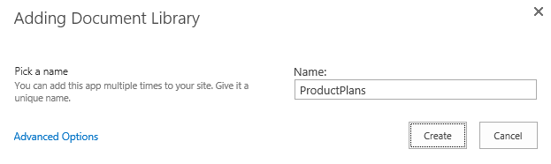

* 1. Click the **Create** button to create the new document library.
  2. After the document library has been created, you should be able to see a tile for it on the **Site Contents** page.

  
Click on the ellipse (**…**) fly out menu in the top, right-hand corner of the **ProductPlans** tile. Click the **SETTINGS** link to navigate to the settings page for the **ProductPlans** document library.

* 1. On the **Settings** page for the **ProductPlans** document library, click the **List name description and navigation** link to navigate to the **General Settings** page.
  2. Modify the **Name** setting for the document library from **ProductPlans** to **Product Plans**.

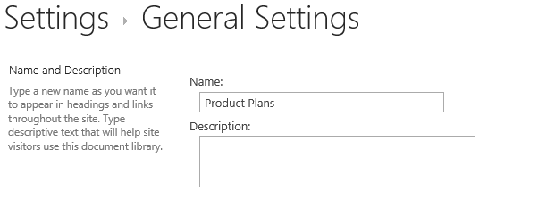

* 1. Scroll down in the **General Settings** page to the **Navigation** section. Set the **Display this document library on the Quick Launch** to a value of **Yes**.



* 1. At the bottom of the **General Settings** page, click the **OK** button to save your work.
  2. When you return to the settings page for the document library you should be able to confirm that the library name has been updated from **ProductPlans** to **Product Plans**.

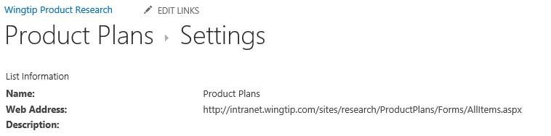

Now that the document library has been created, you can to configure it to use the **Product Plan** content type.

1. Configure the **Product Plans** document library to use the **Product Plan** content type
   1. On the **Settings** page of the **Product Plans** document library, click the **Advanced settings** link.
   2. On the **Advanced Settings** page, set the **Allow management of content types** option to **Yes**.



* 1. Click the **OK** button at the bottom of the On the **Advanced Settings** page to save your changes.
  2. When you return to the **Settings** page for the **Product Plans** document library, you should see it now displays a new **Content Types** section. You can also observe that the **Product Plans** document library currently contains a single content type which is the standard SharePoint **Document** content type.



* 1. Click the **Add from existing site content types** link to navigate to the **Add Content Types** page. Add the **Product Plan** content type as shown in the following screenshot.

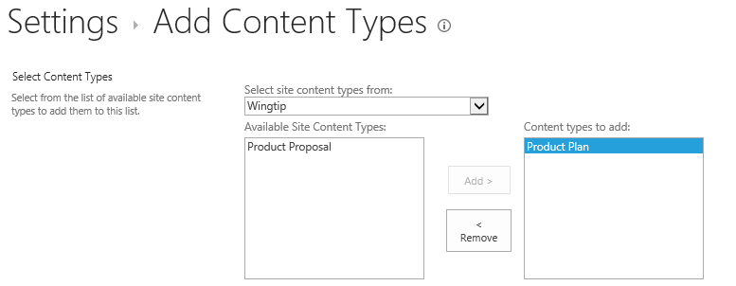

* 1. Click the **OK** button at the bottom of the **Add Content Types** page to save your changes. You should now see that the **Product Plan** content type has been added along with the existing **Document** content type.

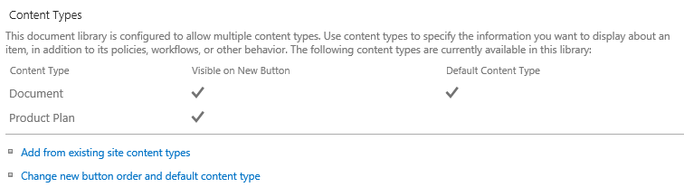

* 1. Remove the **Document** content type. You can accomplish this by clicking its link to navigate to the **List Content Type** page for the **Document** content type. Click the **Delete this content type** link to remove the Document content type from the **Action Figure Proposals** document library. Once you remove the **Document** content type, the **Content Types** section on the Settings page of the Action Figure Proposals document library should include only the Product Proposal content type.

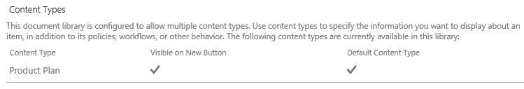

1. Modify the page with the default view of the **Product Plan** document library.
   1. Click on the **Product Plans** link in Quick Launch to navigate the default view of the document library.
   2. Take a moment to inspect the user interface of the default view. You can see that there is a new document link for uploading existing documents as well as support for uploading files via drag-and-drop in the browser.

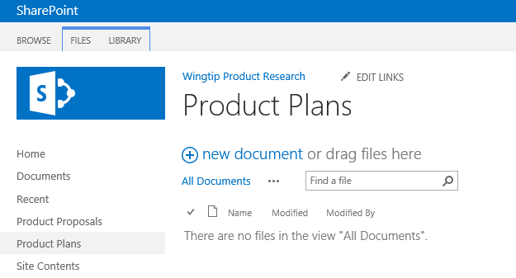

There is a problem with the out-of-box user experience when you configure a standard document library to support document sets. The default user interface for a document library supports and promotes the uploading of existing documents that have already been created. However, the uploading of a file to create a document set instance is not supported. Therefore, you should always remove the **new document** link because it leads the user down a road to failure.

* 1. Select the **Edit page** command in **Site Action** to transition the current page into edit mode.

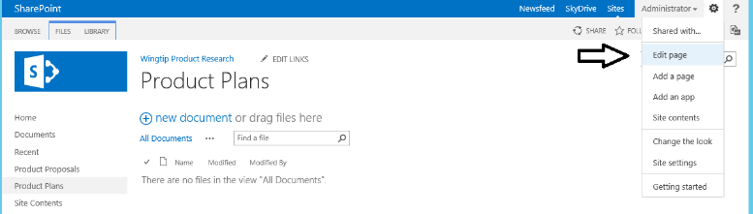

* 1. When the page is in edit mode, you can see it contains a single web part. Drop down the web part menu as shown in the following screenshot and then click **Edit Web Part**.

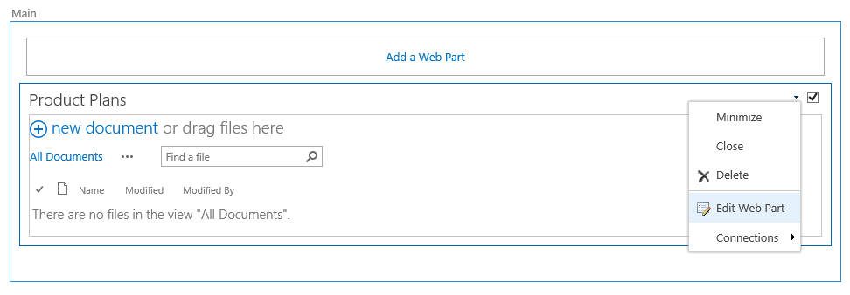

* 1. When you put the web part into edit mode, you will see a task pane on the right-hand side of the browser window. Change the **Toolbar Type** setting to **No Toolbar** and click the **OK** button. Click the **Page** tab and choose **Stop Editing**.

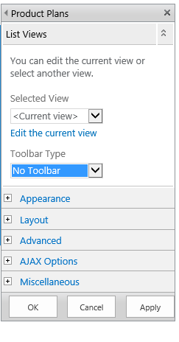

* 1. **You should now be back at the page with the default view of the Product Plans document library. You should be able to verify that your changes removed the new document link.**

1. Create a document set instance for the Jimi Hendrix Action Figure.
   1. Navigate to the default view of the Product Plans.
   2. Create a new Product Plan

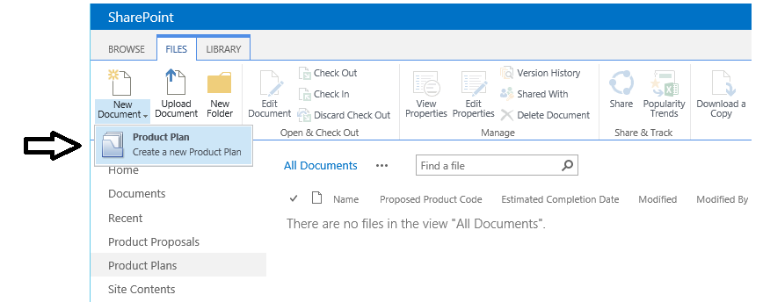

* 1. When prompted, fill in the column properties as shown below.

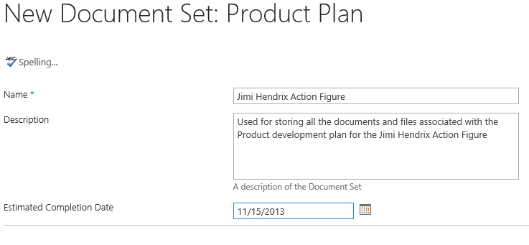

* 1. After you have filled out the data in the New Document Set page, click the Save button to create a new instance of the Product Plan document set.

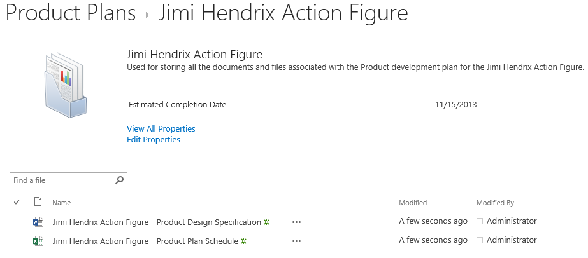

1. Using the above steps, create a document set instance for the Ringo Starr Action Figure.

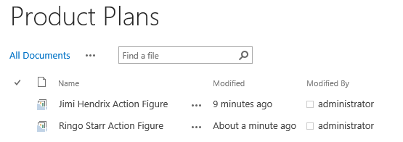

1. Create a Weekly status report.
   1. Ensure you can create a new document using the Product Plan Status Report document template.

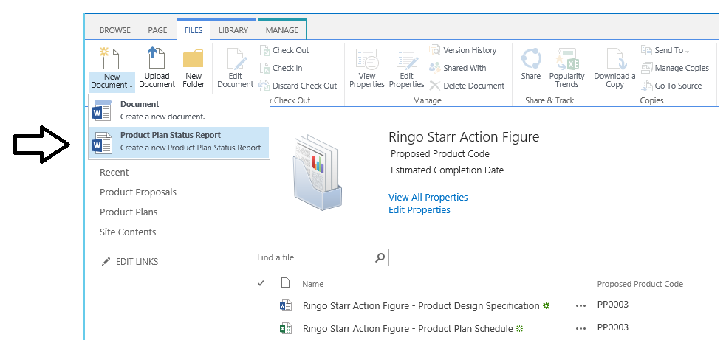

* 1. Fill in the details in the new document as shown below.

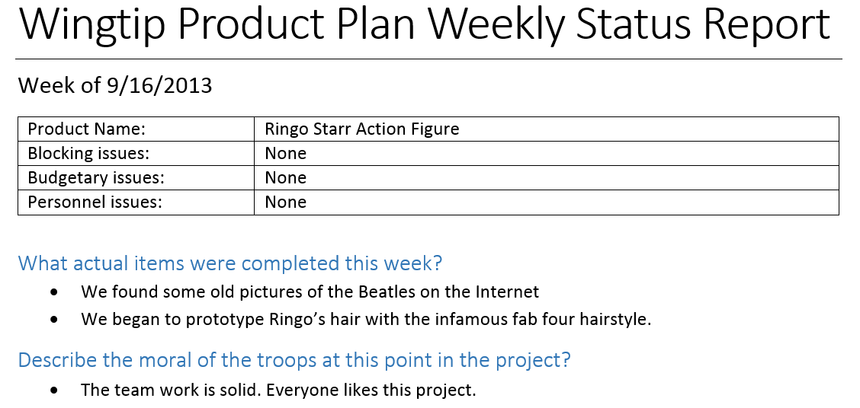

* 1. Save your work.

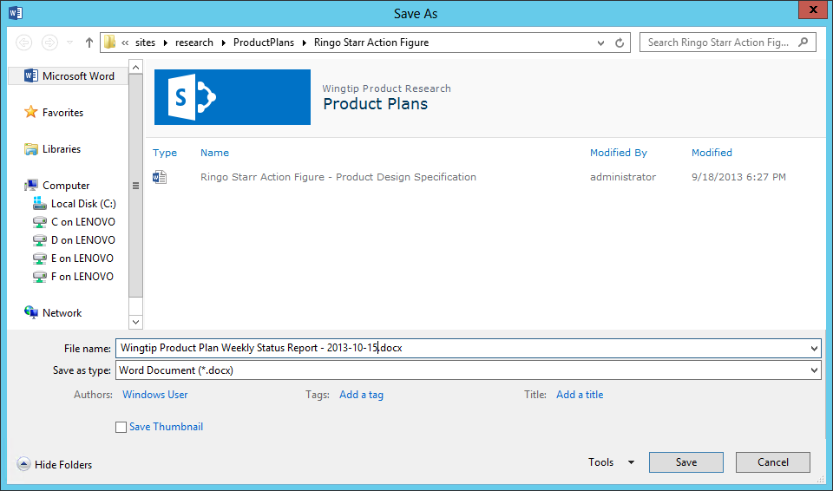

**You have now completed all the exercises in this lab for this module.**