## Working with Excel Services 2013

**Lab Time**: 60 minutes

**Lab Folder**: C:\Student\Modules\ExcelServices\Lab

**Lab Overview**: In this module you will work with Excel Services to publish workbooks and to expose a data table as an OData source.

### Exercise 1: Publish an Excel Workbook using Excel Services

In this exercise you will setup your environment for using a BI Center site collection. If you do not already have a BI Center site at <http://intranet.wingtip.com/sites/bicenter> create a new site as follows. If you already have a site, start on step 3.

1. Create a new site collection for this lab based on the Business Intelligence Center site template.
   1. Ensure you are logged into the **WingtipServer** server as **WINGTIP\Administrator**.
   2. Navigate to Central Administration.
   3. Click on **Application Management** then click on the **Create site collections** link.
2. Create a new site Business Intelligence Center site with a **Title** of **BI Center** and a URL of <http://intranet.wingtip.com/sites/bicenter>. Choose the **Business Intelligence Center** template from the **Enterprise** tab.

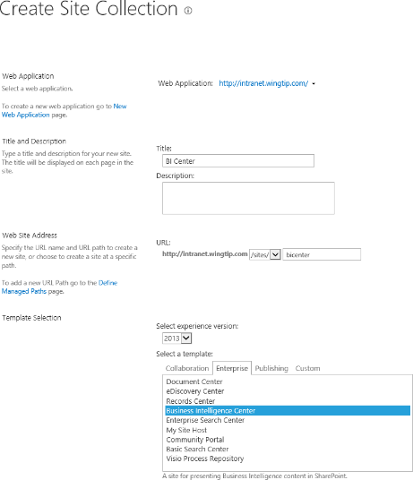

1. Once the site has been created, navigate to its home page.

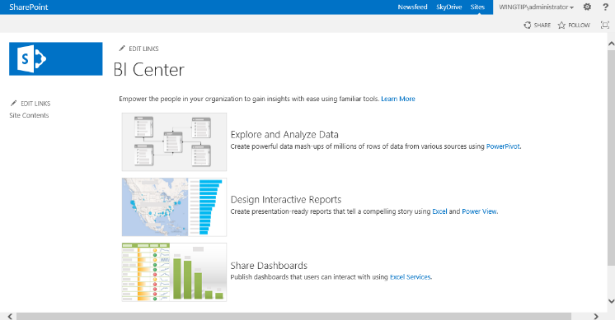

1. From the left navigation pane, click **Site Contents** then click on the **Data Connections** tile.



1. Copy the URL from the browser address bar.

The Data Connections library location must be added to the Excel Services Trusted Data Connection Libraries. The location you just copied will be pasted into the location for the setting in Central Administration.

1. Go back to Central Administration.
2. Under Application Management click **Manage service applications**.
3. Click on the **Excel Services Application** link.
4. Click on the **Trusted Data Connection Libraries** link.



1. Click on **Add Trusted Data Connection Library**.



1. Paste the URL of the Data Connection library in the **Address** text box and then click **OK**.



1. Locate the **Loan calculator** workbook in your student folder at the following path.

C:\Student\Modules\ExcelServices\Lab\Loan calculator.xlsx

1. Open the file in Excel and examine what's inside.
2. Add browser parameters:
   1. Click on the File tab.
   2. Select the Browser View Options button.

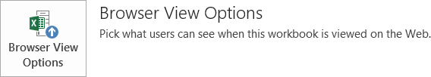

* 1. From the **Parameters** tab, click the **Add** button.
  2. Select all of the available field parameters and then click **OK**.
  3. Click **OK** to close Browser View Options dialog.

1. **Save** the file.
2. Now navigate to your Business Intelligence site <http://intranet.wingtip.com/sites/bicenter>.
3. Click on **Site Contents** in the left navigation and then click on the **Documents** tile.
4. Upload the Loan Calculator.xlsx file to the Document library:
   1. From the **Documents** library, click **+New Document** to open the **Add a Document** dialog.
   2. **Browse** to the location of the file and then click **Open**.
   3. Click **OK**.
5. Click on the **Loan Calculator** link to open the file in the browser.
6. Fill in all the input parameters as shown in the following screenshot and then click **Apply**. Notice the data updates in the workbook.

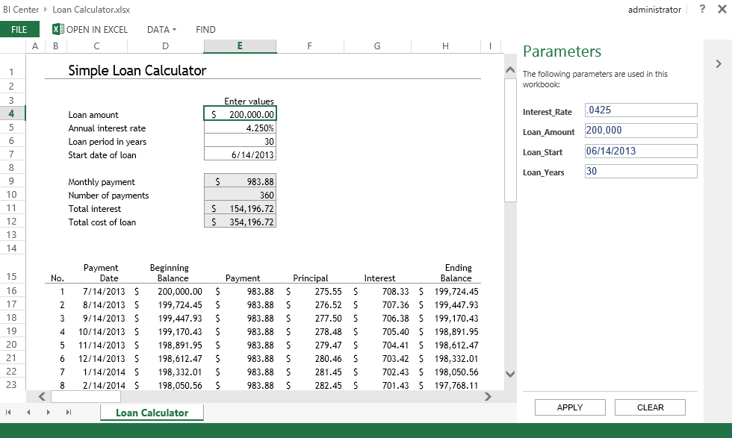

### Exercise 2: Expose an Excel Table as an OData Data Source

In this exercise you will create a dashboard in Excel that will have imported data from an OData data feed.

1. Create a new Blank Workbook in Excel 2013.
2. From the Data tab, click **From Other Sources** located in the Get External Data group and then choose **From OData Data Feed**.
3. In the Location of the data feed box, specify the URL of the data feed. For this example use: <http://services.odata.org/AdventureWorksV3/AdventureWorks.svc>

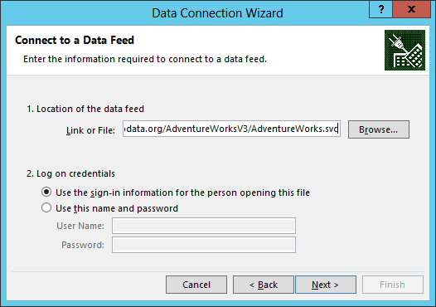

1. In the **Log on credentials** section, choose **Use the sign-in information from the person opening this file**.
2. Click **Next**.
3. Select the **CompanySales** and **TerritorySalesDrilldown** check boxes. Then click the **Next** button.

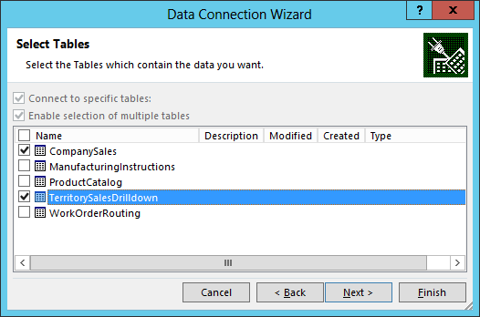

1. On the **Save Data Connection File and Finish** step, change the **File Name** to **ExcelServicesODataFeed.odc** and change the **Friendly Name** to **Excel Services OData Feed**. Then click **Finish**.

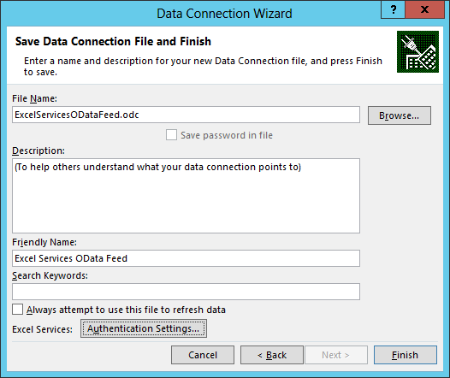

1. On the **Import Data** step, follow these steps:
   1. Select the **Table** option.
   2. Make sure the **Add this data to the Data Model** option is selected.
   3. Click **OK**.
2. Keep Excel open. **Sheet 2** has been updated with data and **Sheet 3** was added with data to the workbook.

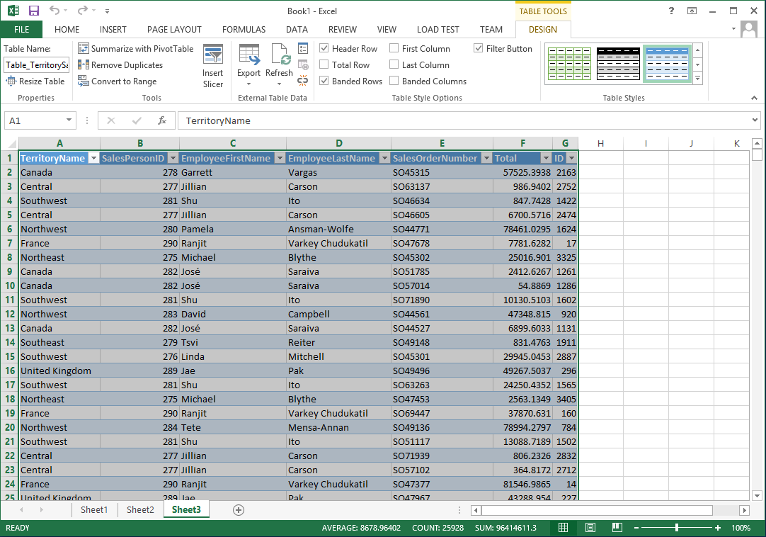

Now that the data has been imported into Excel from an OData data feed, the next step is to create a relationship between the tables of data. To do this, we’ll use the PowerPivot add-in for Excel. If the PowerPivot tab is not visible in Excel, enable the add-in by following the steps below.

1. In Excel, from the **File** tab select **Options**.
2. Choose **Add-Ins** located in the left navigation of the Excel Options dialog.
3. From the **Manage** drop-down list, select **COM Add-Ins** and then click the **Go** button.



1. Select the **Microsoft Office PowerPivot for Excel 2013** option and then click **OK**.

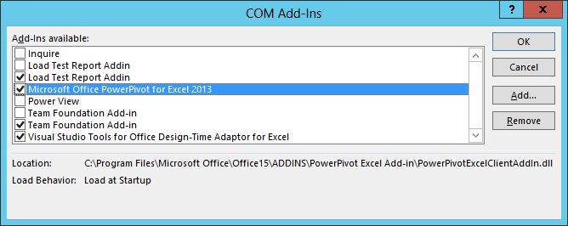

1. In Excel, click on the **PowerPivot** tab and then click on the **Manage** ribbon button.

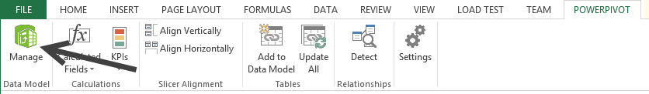

1. The PowerPivot for Excel window opens. From the **PowerPivot for Excel** window click the **Design** tab and then click on the **Create** **Relationship** ribbon button.

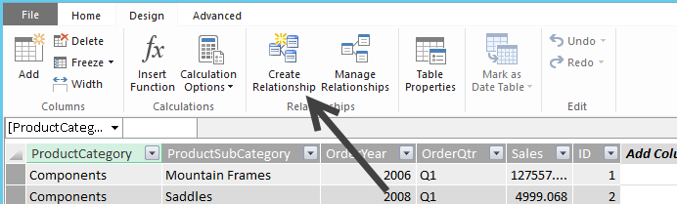

1. From the Create Relationship dialog, specify the following:
   1. Ensure **CompanySales** is selected for the **Table** drop-down list.
   2. In the **Column** drop-down list select **ID**.
   3. In the **Related Lookup Table** drop-down list, select **TerritorySalesDrilldown**.
   4. In the **Related Column Lookup** drop-down list, verify **ID** is selected.

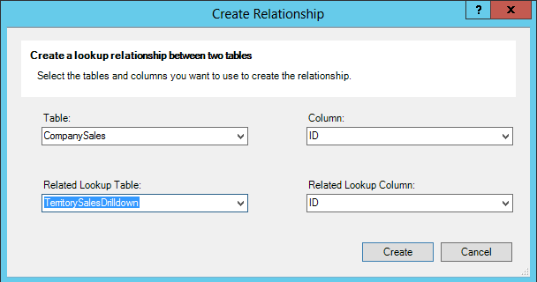

1. Click **Create** and then close the **PowerPivot for Excel** window. Keep Excel open.

Now that you have imported two tables of data into Excel and created a relationship between the tables, you can now create reports and filters that will use the two tables as a single data source. Follow the next steps to create ProductSales and GeoSales PivotChart dashboard reports. The ProductSales report will show the product sales and the GeoSales will show the sales amounts across different geographical regions.

1. In Excel, select **Sheet1**.
2. From the **Insert** tab, click on **PivotChart** which is located in the Charts section to open the PivotChart dialog.

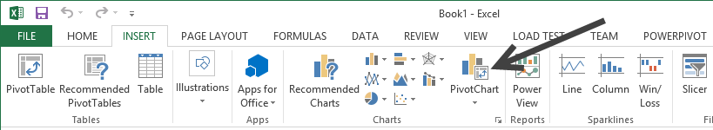

1. In the **Choose the data that you want to analyze** section, select the **Use an external data source** option.

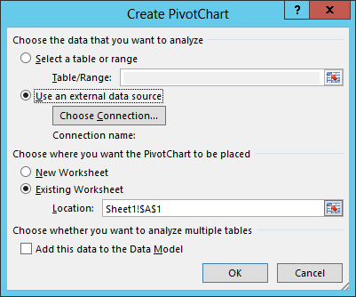

1. Click **Choose Connection**.
2. From the **Tables** tab, select the **Tables in Workbook Data Model** option and click **Open**.

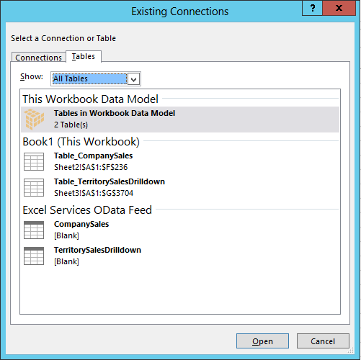

1. In the **Create PivotChart** dialog, choose the **Existing Worksheet** option and then click **OK**. **Chart1** opens for editing.

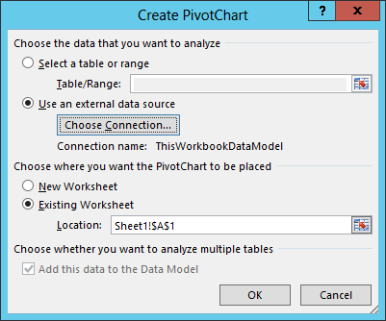

1. In the **PivotChart Fields** pane, follow these steps:
   1. From the **CompanySales** section, drag **ProductCategory** to the **Legend (Series)** field well.
   2. In the **CompanySales** section, select the **Sales** checkbox.

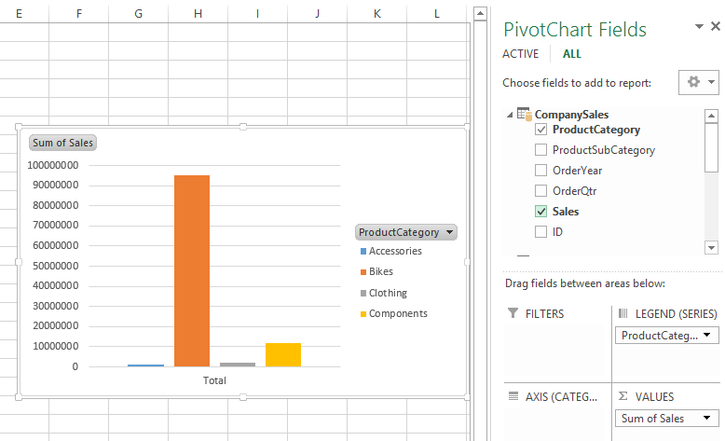

1. Now move the PivotChart report close to the upper-left corner of the worksheet by dragging the chart to the corner of cell D1 in the worksheet.
2. Rename the PivotChart report by following the steps below:
   1. Right-click on the PivotChart report and select **PivotChart Options**.
   2. Change the **PivotChart Name** from **Chart1** to **ProductSalesReport**.
   3. Click **OK**.

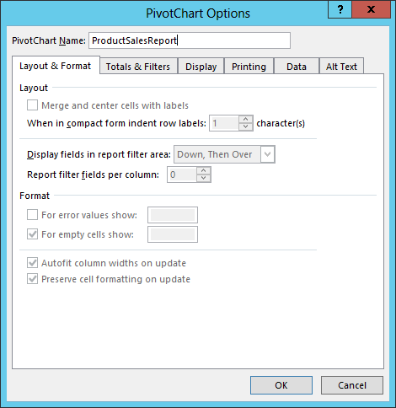

1. Save the worksheet to the Desktop and name it **Adventure Works Sales Report**. Keep the workbook open.
2. In the same worksheet, click on cell **D17**.
3. From the **Insert** tab, click on **PivotChart**.
4. In the **Choose the data that you want to analyze** section, select the **Use an external data source** option.
5. Click **Choose Connection**.
6. From the **Tables** tab, select the **Tables in Workbook Data Model** option and click **Open**.
7. In the **Create PivotChart** dialog, choose the **Existing Worksheet** option and then click **OK**. **Chart2** opens for editing.
8. Move the PivotChart under the first chart.
9. In the PivotChart Fields pane, follow these steps:
   1. In the **CompanySales** section, select the **Sales** checkbox.
   2. From the **TerritorySalesDrilldown** section, drag **TerritoryName** to the **Legend (Series)** field well.

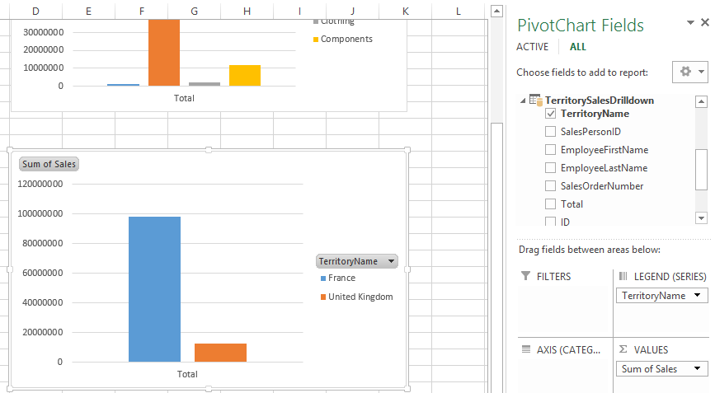

1. Rename the PivotChart report by following the steps below:
   1. Right-click on the PivotChart report and select **PivotChart Options**.
   2. Change the **PivotChart Name** from **Chart2** to **GeoSalesReport**.
   3. Click **OK**.
2. **Save** the file and then keep it open.
3. Before publishing the workbook, make some minor display changes by doing the following:
   1. In Excel, click the **View** tab.
   2. To remove gridlines uncheck the **Gridlines** checkbox located in the **Show** group.
   3. To rename the worksheet, right-click on the **Sheet1** tab and select **Rename**. Type a new name such as **SalesInfo**.
   4. **Save** the file and then close Excel.
4. To publish the workbook follow these steps:
   1. Open your BI Center site <http://intranet.wingtip.com/sites/bicenter>.
   2. Navigate to the **Documents** library. Click on **Site Contents** in the left navigation and then click on the **Documents** tile.
   3. Click the **+New Document** link to open the **Add a Document** dialog.
   4. **Browse** to the location of the file and then click **Open**.
   5. Click **OK**.
5. Click on the link to open the file in the browser.

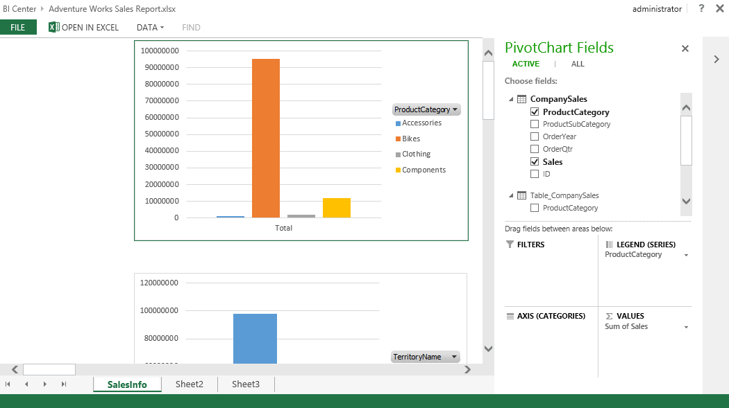

You have now completed this Exercise.

### Exercise 3: Present the Chart in a Web Part

1. Return to the home page of the BI Center.
2. Click **Site Actions | Edit Page**.
3. Delete the Untitled Web Part from the home page.

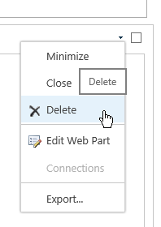

1. In the **Main** web part zone, click **Add a Web Part**
2. Choose the **Business Data Category** and the **Excel Web Access** Web part.

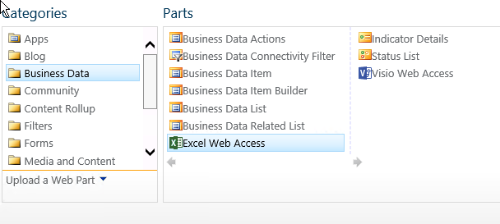

1. Click **Add**.
2. Select a workbook for the web part to access by clicking the text **Click here to open the tool pane**.
3. In the **Workbook Tool pane** click the **ellipsis** button next to the Workbook text box.
4. Browse into the **Documents** library and chose the **Excel Services Sample Workbook.xlsx** file.
5. Click **Insert**.
6. Scroll to the bottom of the tool pane and click OK.
7. In the ribbon, click **Stop Editing**.
8. You should now see the entire Workbook displayed in the web part.

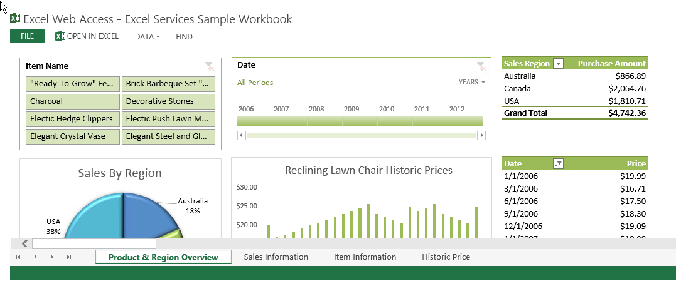

#### Display only one item from the workbook using Excel Services REST Protocol

1. Click Site **Actions | Edit Page**
2. Click **Add** a Web Part in the **Main** web part zone.
3. Click the **Media and Content Category** and chose the **Image Viewer Web Part**.
4. Click **Add** to add the Web Part to the page.
5. Click the text **Open the tool pane** to access the web part properties.
6. In the Image Link text box type the following Url:

**/sites/bicenter/_vti_bin/ExcelRest.aspx/Documents/Excel Services Sample Workbook.xlsx/model/charts('Chart 7')**

This isn’t as scary as it looks…

1. Click the Test Link text to ensure you typed the address correctly. It should show the chart from inside the workbook.

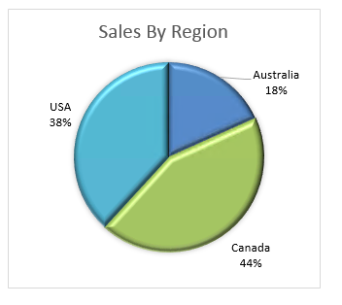

1. Return to the Web Part tool pane and click **OK**.
2. In the Ribbon, choose **Stop Editing**

You have now learned two methods to add Excel charts to a SharePoint page.