## Working with the Managed Metadata Service

**Lab Time**: 60 minutes

**Lab Folder**: C:\Student\Modules\ManagedMetadata\Lab

**Lab Overview**: In this module you will gain hands on experience working with SharePoint 2013 Managed Metadata service application. The Managed Metadata Service Application (MMS) provides services for Content Type Syndication, Metadata Term Set Management and other key farm wide features that are used by other services like Search and the User Profile Service.

**Note:** Run the C:\Student\Modules\ManagedMetadata\Create-eDiscoverySite.ps1 script before you start this lab. Preferably while the lecture is going on.

### Exercise 1: Configure Enterprise Content Type Syndication

In this exercise you will configure Enterprise Content Type Syndication. The purpose of Enterprise Content Type Syndication is to create a central repository of Content Types that can be used throughout the SharePoint environment. When the central Content Type is updated, the changes are published (or syndicated) to all of the Site Collections that subscribe to the central location. In this lab you will configure the Intranet site as the Content Type Syndication hub. This will be the source of Enterprise Content Types. You will go on to publish the Product content type to other sites in the Intranet Web application.

1. Configure the **Managed Metadata Service** to use the Intranet site as the Content Type Hub.
   1. Open SharePoint 2013 Central Administration.
   2. Select **Application Management | Manage Service Applications.**
   3. Select the **Managed Metadata Service** (be careful not to click the link, you just want to select the line).

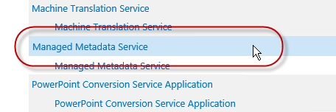

* 1. Click the **Properties** button in the ribbon.
  2. Scroll down to the **Content Type hub** field and enter **http://intranet.wingtip.com**
  3. Check the “**Report syndication import errors…**” check box.

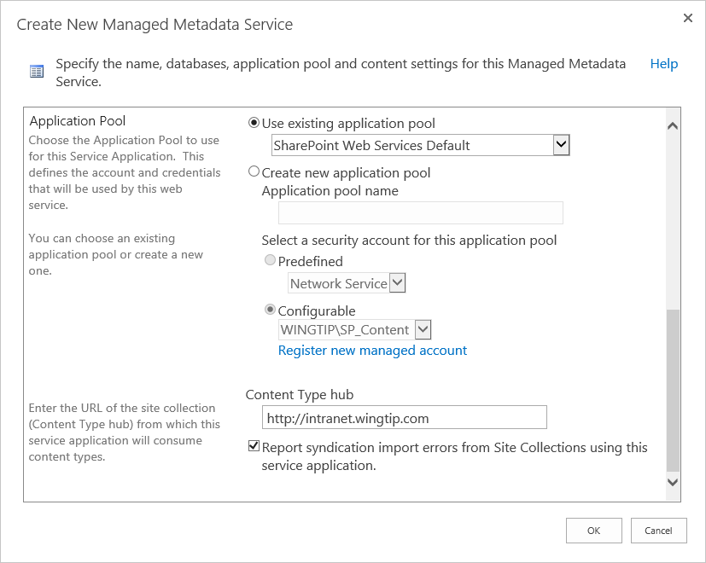

* 1. Click **OK**.

If you receive an error that the Feature was not enabled on the Site Collection, you will have to manually activate the feature at the end of this exercise. Don’t worry, we’ll cover that shortly.

* 1. In Central Administration on the **Manage Service Applications** page, select the **Managed Metadata Service - Managed Metadata Service Connection** (the line below the one you just selected) and choose **Properties** from the ribbon.

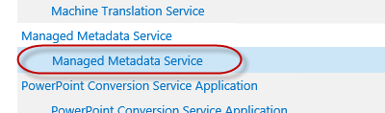

* 1. In the **Edit Managed Metadata Service Connection** dialog, check all **four checkboxes** ensuring that the service will consume the Content Type Gallery from the Intranet site.

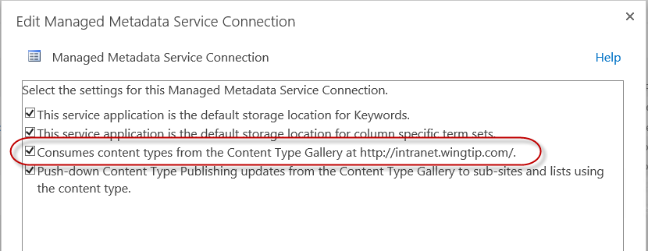

* 1. Click **OK** to close the dialog.

1. Ensure that features are activated and configure the Product content type for syndication.
   1. Open a browser and navigate to **http://intranet.wingtip.com**
   2. Open **Site Settings | Site Collection Features**
   3. Locate the **Content Type Syndication Hub Feature**.

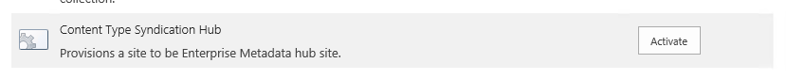

* 1. If it has not been activated, click **Activate**.

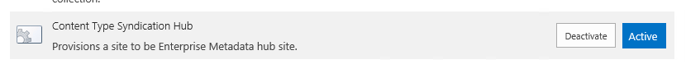

* 1. Navigate to **Site Settings | Site content types**.
  2. Click the **Product** content type under **Wingtip** Content Type group.
  3. In the **Settings** section of the **Product** content type chose **Manage publishing for this content type**.
  4. Ensure that **Publish** is selected and click **OK**.

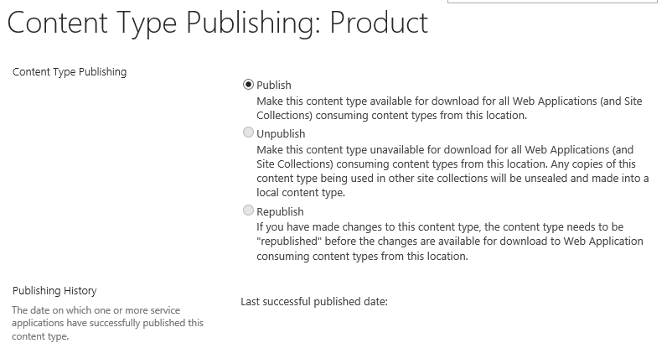

Now that you have set up publishing we need to check that the Content Types are being published. In the real world this process can take up to an hour. For the sake of time, you will run a script to force the process. Locate the script **C:\Student\Modules\ManagedMetadata\Lab\Run-TimerJobs.ps1,** right click, and choose **Run with PowerShell**.

1. Confirm that the Intranet content types have published properly.
   1. Browse to **http://intranet.wingtip.com/sites/research**
   2. Navigate to **Site Settings | Site Content Types** and you should see the **Wingtip** Content Types Group and the **Product** Content Type that was synchronized from the Intranet site.
2. Check the status of the content type publication from the Intranet Site.
   1. Browse to **http://intranet.wingtip.com**
   2. Navigate to **Site Settings | Site content types**.
   3. Choose the **Product** content type.
   4. Click **Manage publishing for this content type**.
   5. You should see that the settings are now set to **Republish** and the **Publishing History** reflect the last few minutes.

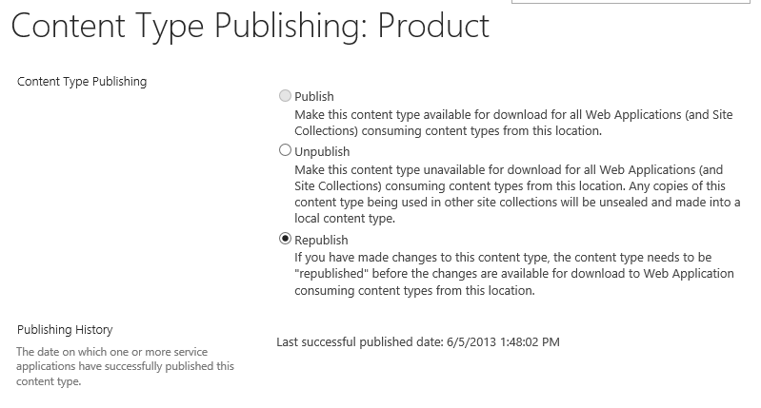

* 1. Click **OK** to close the form.

In this exercise you configured the farm for a Content Type Hub and then published the Product content type to other site collections in the Web Application Intranet.

### Exercise 2: Create a New Term Set

In this exercise you will create a new taxonomy group using the Managed Metadata term store tool and use it within a site. This metadata term set will enable researchers working on new products to tag their products based on the phase of development. You will also import a hierarchical term set prepared for you by your corporate taxonomist.

1. Browse to the site **http://intranet.wingtip.com/**
2. Navigate **to Site Settings | Term store management** under the **Site Administration** section.
3. Add the **wingtip\administrator** to the **Term Store Administrators Group**. Click **Save**.

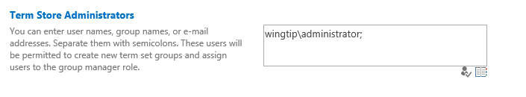

1. In the **Term Store Management Tool** click the **Managed Metadata Service** and choose **New Group**.

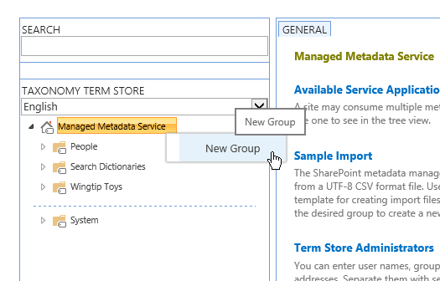

1. Name the group “**Research Department**”.
2. Click the **Research Department** node and choose **New Term Set**. Name the term set **Project Status**.
3. Click the **Project Status** node and choose **Create Term**. Create the following terms under **Project Status.**

* Development
* Financial Evaluation
* Technical Evaluation
* Safety Evaluation
* Patent Application
* Approval Requested
* Approved
* On Hold
* Cancelled

1. Your complete term set should look like this:

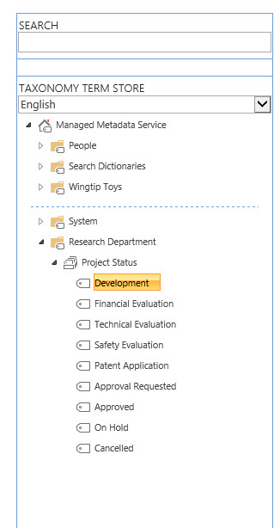

You just manually created a flat term set. This is a great option for simple term sets that would also work in a Choice field. Choice fields cannot contain hierarchical data, which requires the Managed Metadata field type. In the next exercise you will import a hierarchical term set rather than create it by hand.

1. In the **Term Store Management Tool** click the **Managed Metadata Service** and choose **New Group**.
2. Name the group **Wingtip Toys**.
3. Hover and click on the new **Wingtip Toys** group and click **Import Term Set**.

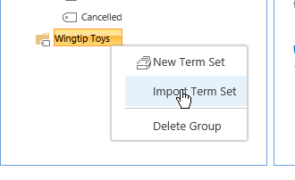

1. In the **Term set import** dialog browse to C:\Student\Modules\ManagedMetadata\Lab\WingtipProductCategories.csv

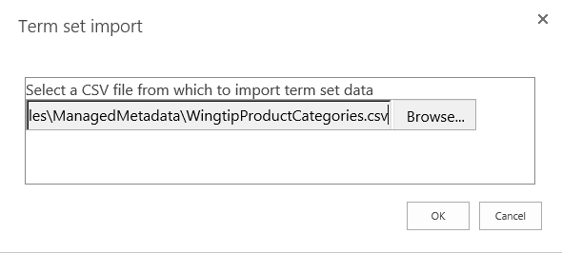

1. Click **OK**.

The Term Set import file is a comma separated value file with a hierarchical structure that enables Term Store administrators to quickly create Term Sets in SharePoint 2013. If you are interested in the structure open the file in Excel and see for yourself!

1. If the process completed successfully you should now see the imported hierarchical term set **Product Category**.

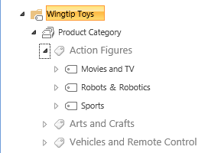

In this exercise you used two techniques to create term sets, one manual and one via import. Which did you prefer? I thought so.

### Exercise 3: Add a Managed Metadata Column to a Content Type

In this exercise you will add Managed Metadata columns to the Product content type to enhance the functionality of the content type. You will use the Term Sets that you just created and update the Product with the Product Category. Since the research department has a unique need, you will enhance the Product content type specifically for the Research Department.

1. Navigate to the Intranet **http://intranet.wingtip.com**.
2. Navigate to **Site Settings | Site Content Types**.
3. Click the **Product** content type.
4. On the **Site Content Type settings** page in the **Columns** section, choose **Add from new site column**.
5. Create a new **Site Column** with the following settings:
   1. Name: **ProductCategory**
   2. Type: **Managed Metadata**
   3. Group: **Wingtip**
   4. Description: **Wingtip Product Category**
   5. Display Format: **Display the entire path to the term in the field**
   6. Term Set Settings: **Use managed term set: Product Category**

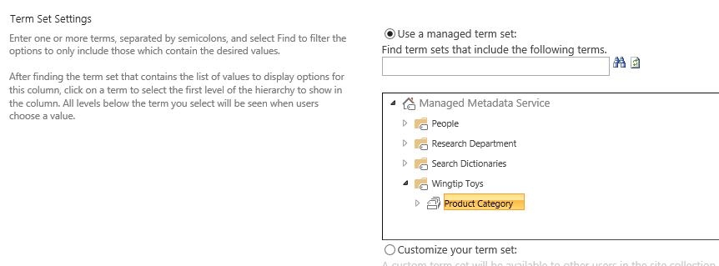

* 1. Ensure that **Update List and Site Content Types** is set to **Yes**.
  2. Click **OK**. You will be returned to the **Content Type Settings** page.
  3. Rename the Column by clicking the **ProductCategory** column name.
  4. On the Change Content Type Column page chose **Edit site column**.
  5. Add a space so that the column name reads: **Product Category**
  6. Click **OK** to save your changes. Click **OK** to complete the edit.
  7. Click the **Manage publishing for this content type**.
  8. Ensure that **Republish** is selected and click **OK**.

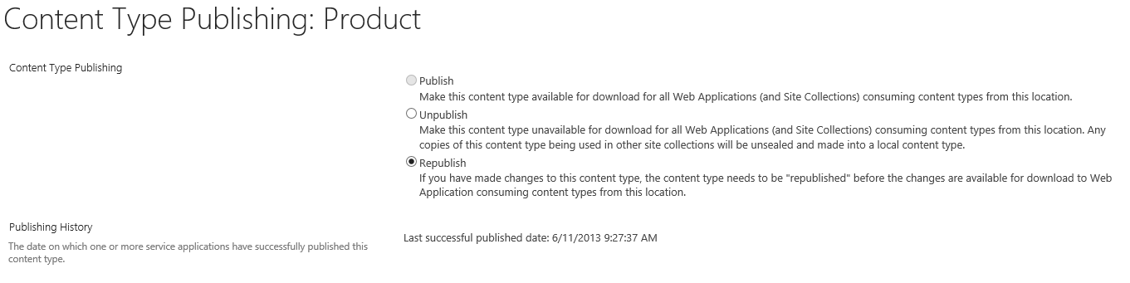

At this point, in the real world you would wait for your changes to publish to the Research site. We don’t have the luxury of time, so run the script in C:\Student\Modules\ManagedMetadata\Lab\Run-TimerJobs.ps1 to force the timer jobs to run.

You have now syndicated the Product content. The research department has a unique need to add a new column to the Product content type. You cannot add columns to an Enterprise Content type, but you can create a new content type based on an enterprise content type. In this section we’ll do just that.

1. Browse to the Research site at **http://intranet.wingtip.com/sites/research**
2. Navigate to **Site Settings | Site Content Types**. Click **Create** to create a new content type.
3. Create a new content type with the following settings:
   1. Name: **Research Product**
   2. Description: **Research product based on the product content type**
   3. Parent Content Type: **Wingtip > Product**
   4. Group: **Wingtip**

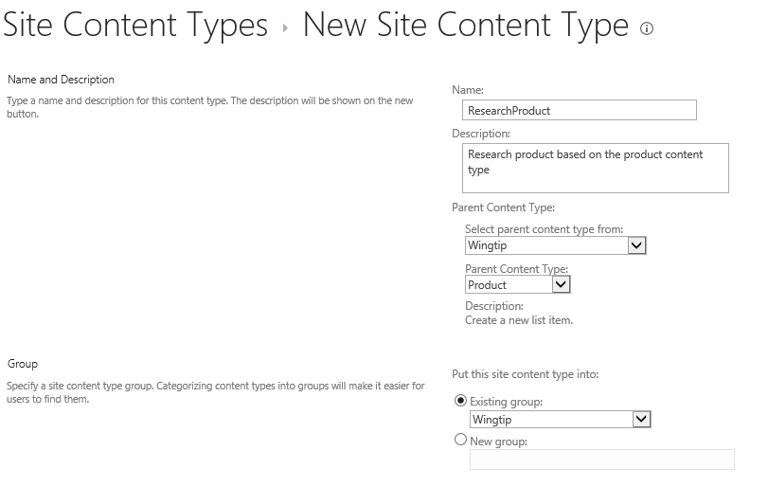

1. Click **OK** to create the content type.
2. Click the **Site Content Types** heading to return to the list of Site Content types. Change the **Show Group** selector to **Wingtip**.
3. Scroll to the bottom of the page and you should see that you now have a new content types under **Wingtip**.

Now that you have created the Research Product content type, you need to create a list so that we can begin tracking our Product projects.

1. Navigate to **Site Contents**.
2. Click **Add an App**. Choose **Custom List** and give it the name **ProductEvaluations**. Click **Create**.
3. Rename the list by choosing the **List tab** and clicking **List Settings** from the ribbon.
4. Choose **List name, description and navigation** and rename the list **Product Evaluations**.
5. Provide a description of “**Research Department Product Evaluations**”.
6. Change the Quick Launch setting to **Show on Quick launch** and click **Save**.
7. Click **Advanced settings** and click the **Allow management of content types?** Radio button to **Yes**.
8. Click **Ok**.
9. In the Content Types Section choose **Add from existing site content types**.
10. From the **Wingtip** group choose the **Research Product** content type and choose **Ok**.
11. Click **Change new button order and default content type** and change **Research Product** to order 1. **Uncheck** the **Visible** checkbox for **Item** content type.
12. Click **OK**.
13. Click **Product Evaluations** to return to the list. Test your work by clicking **new item**. You should see a **New Item** form for a **Research** **Product Content Type**. Enter at least one new item at this time with data in the **Product Category** field. Click **Save**.

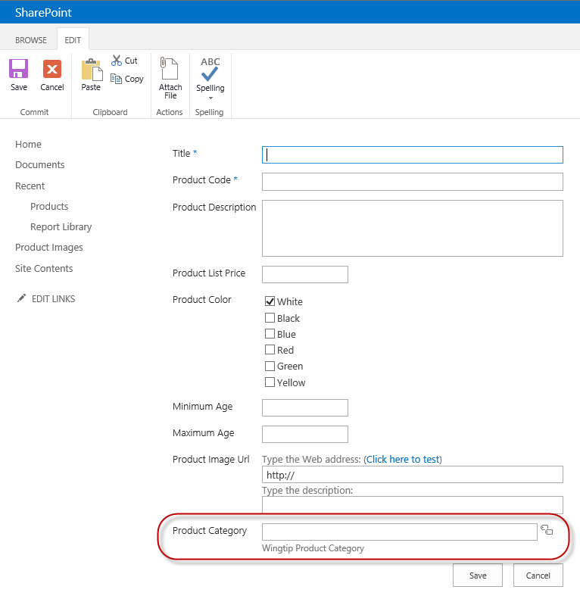

You just learned how to add metadata columns to lists and how to work with the enterprise content types.

### Exercise 4: Create and Configure an eDiscovery Site

In this exercise you will use the eDiscovery Center created at the beginning of the lab. You will create a new eDiscovery Case.

If you haven’t already done so, create a new eDiscovery Site by running the Create-eDiscovery Site Script C:\Student\Modules\ManagedMetadata\Lab\Create-eDiscoverySite.ps1 When the browser opens you will see the new eDiscovery site.

1. Navigate your browser to **http://intranet.wingtip.com/sites/ediscovery**
2. Create a new case by clicking the **Create new case** button.
3. Each case creates a new SharePoint eDiscovery Case site. Create your new case with the following settings:
   1. Title: **Action Figure Failure**
   2. Description: **Heads fall off the action figures and present a choking hazard**.
   3. URL: **heads**
   4. Navigation: **Yes** (Show on Quick Launch)
   5. Navigation inheritance: **Yes** (Use top link bar)
4. Click **Create**.
5. You should see your new Case site.

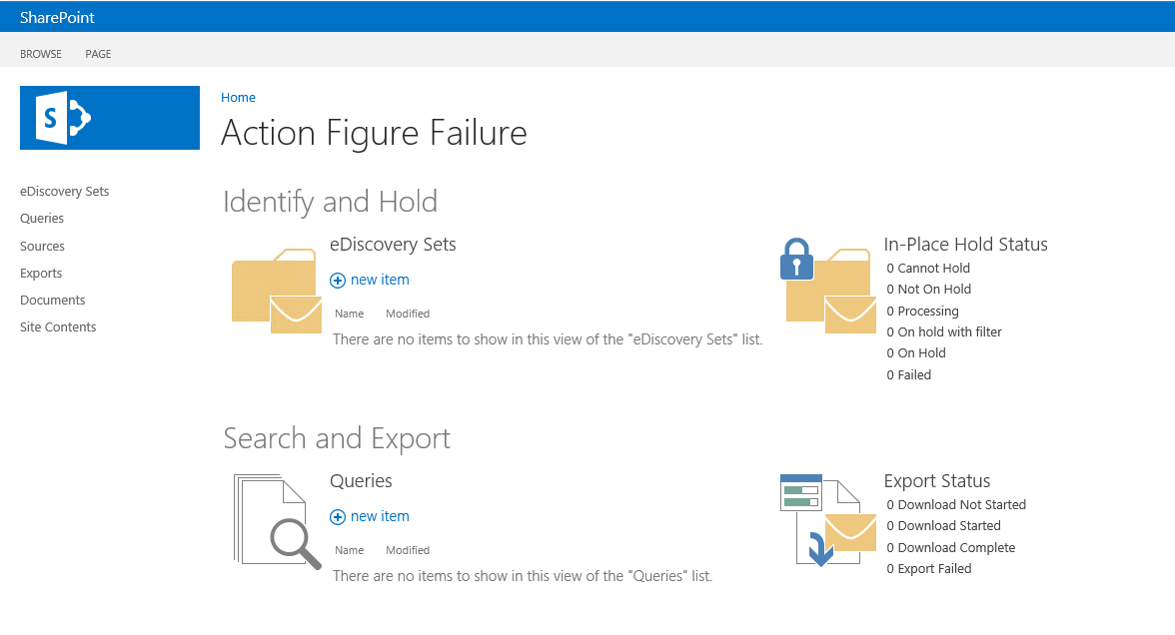

1. Create a new **eDiscovery Set** to begin the investigation of the issues. Under eDiscovery Sets click **new item** and provide the following information:
   1. eDisovery Set Name: **Testing Documents**
   2. Click **Add and Manage Sources**. Under **Locations** add the Research site **http://intranet.wingtip.com/sites/research**. Click the button to resolve the address and it should change to the site title **Wingtip Product Research**. Add the Product Testing site **http://intranet.wingtip.com/sites/producttesting**. Click the button to resolve the address to **Wingtip Product Testing**. (The Product Testing site was created previously. In our lab scenario, it is used by a different team.)

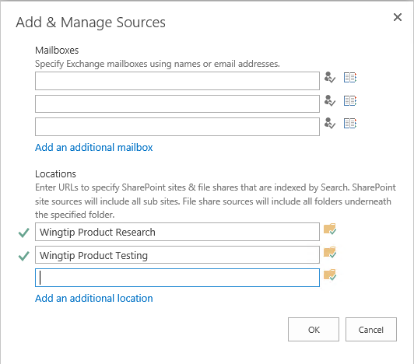

* 1. Click **OK**.
  2. In the Filter box enter the query **head OR failed OR “action figure”**. Click **Apply Filter**.
  3. You will see a number of results for your query. Click **Save**.

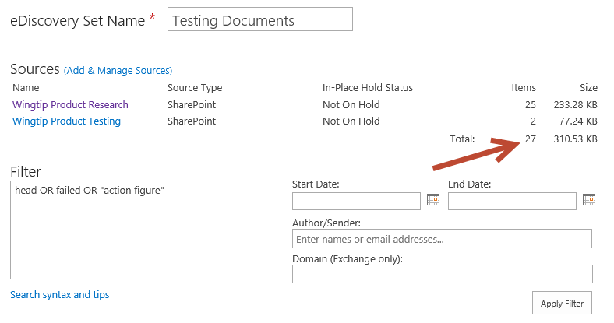

Note that is this step does not work correctly, you might need to perform a full crawl by the SharePoint Search crawling component.

1. Queries can be used to evaluate search queries and export the result sets from SharePoint.
   1. Click **Queries** on the quick launch
   2. Click **new item** and provide the following information:
      1. Name: **Failed Heads**
      2. Query: **head OR failed OR “action figure”**
   3. Click the **Search** button and see that you have some documents returned from **Wingtip Product Testing** and **Wingtip Research**. Switch to the **SharePoint** tab to see the details of documents from SharePoint. Use the File Extension refiner to view only files of a specific type.
   4. Click **Save**. Click **Close**
2. The legal team has decided they need to see the work related to the investigation. You have been requested to export all of the items related to the case.
   1. Click **Export** on the quick launch. On the **Exports page**, click **new item**.
   2. Place a **check mark** next to the **Failed Heads** Query you created earlier and click **Next**
   3. On the **Export New Item** page confirm the settings for the export and click **Ok**.
   4. On the **Export Download** page, click **Download Results**.
   5. The **eDiscovery Download Manager** will load. Use the **Browse** button to select your **Desktop** as the download location. Click **OK**.
   6. Use the **Export Location** link in the eDiscovery Download Manager to view the exported files.
3. Review the different types of documents that were exported.
   1. In Windows Explorer navigate to the **Wingtip Product Testing** folder and see that there is a folder structure similar to the site. Follow the folders to the Shared Documents folder and locate the files that were exported.
   2. Return to the root folder and locate the **Wingtip Product Research** folder. Follow the folders to the research folder and note how the contents of the site is contained in folders that match the lists you previously created. Lists are exported as Excel compatible files and documents are exported in their original format.
4. Based on your review the legal team has decided to place a hold on the content.
   1. Return to the **eDiscovery Sets** list and choose the **Testing Documents** item.
   2. Choose the **Enable In-Place Hold** radio button and chose **Save**.

In this module you created an eDiscovery site and then initiated a Case and executed queries to locate documents related to a case. When necessary, you then exported the relevant documents and placed a legal hold.