## Working with a SharePoint 2013 Publishing Portal

**Lab Time**: 45-60 minutes

**Lab Folder**: C:\Student\Modules\Publishing\Lab

**Lab Overview:** In this lab you will create a new SharePoint 2013 Publishing site and you will begin to configure it as Wingtip’s public facing website. Along the way, you will work with publishing functionality for adding publishing pages, configuring the metadata-driven navigation and using Design Manager.

### Exercise 1: Create a new SharePoint 2013 Publishing Site

In this exercise you will create a new publishing site and improve its home page.

1. Log onto the student VM as **WINGTIP\Administrator** using the appropriate password for your environment.
   1. If you’re using a local VM provided by the hosting training company, the password will be **Password1**.
   2. If your student VM is hosted by CloudShare, the password for the **WINGTIP\Administrator** account is going to be a unique, system-generated password for each student. Also note that the CloudShare VM configuration usually logs you into the VM automatically so you do not have to enter the user name and password.
2. Run a Windows PowerShell script to create a new Publishing site.
   1. Using Windows Explorer, locate the Windows PowerShell script named **CreatePublishingSite.ps1** at the following path.

C:\Student\Modules\Publishing\Lab\CreatePublishingSite.ps1

* 1. Right-click on the script and click **Run with PowerShell**.

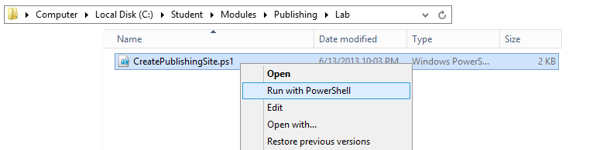

* 1. When the **CreatePublishingSite.ps1** script runs, it create a new site collection at <http://www.wingtip.com>. The site collection is created with a Publishing site as its top-level site. After creating the Publishing site, the script then launches the Internet Explorer and navigates to the home page of the new site.

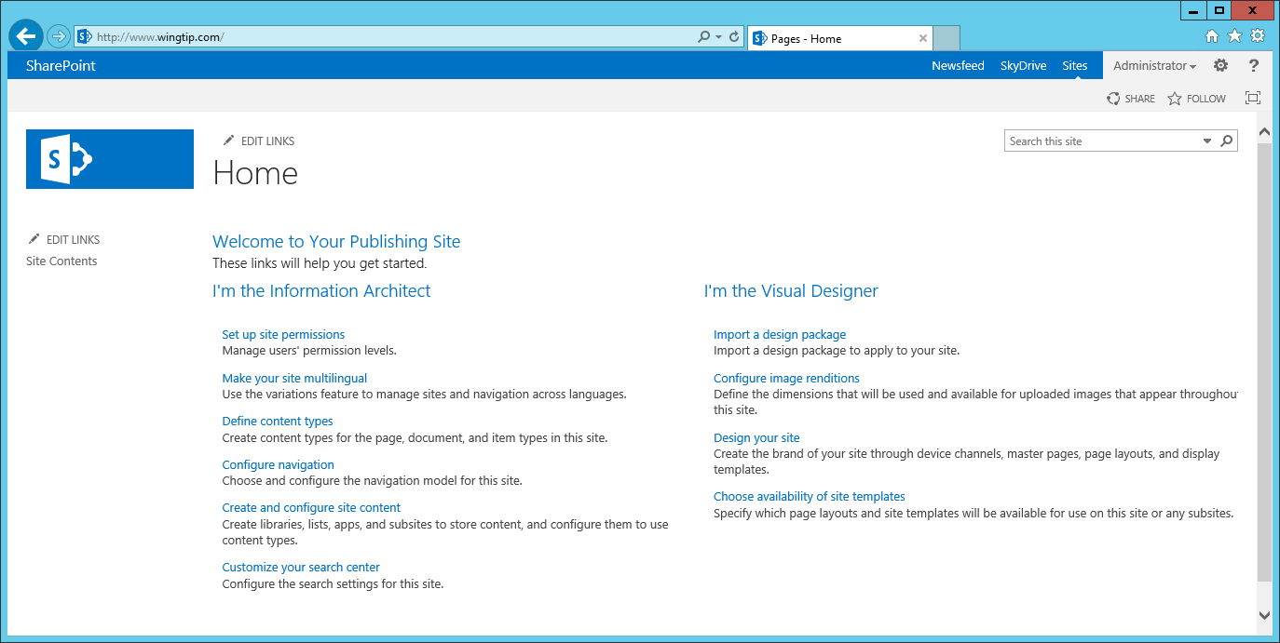

1. Make the home page of the publishing site a little prettier.
   1. Click the **Edit page** command from **Site Actions** to transition the home page into edit mode.
   2. Change the **Title** to **Wingtip Toys**.
   3. In the **Page Content** edit control, change the heading to **Welcome to Wingtip Toys**.
   4. Add three to four placeholder paragraphs of sample Wingtip marketing copy under the heading as shown in the screenshot below. If you would like to copy-and-paste some placeholder text, you can use the content in the file named **HomePageCopy.txt** in the folder for this lab.

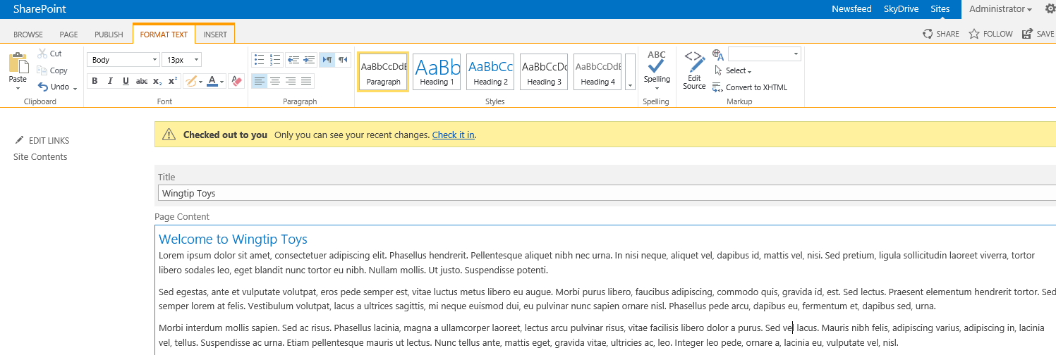

* 1. Scroll down below the **Page Content** field in the home page and locate the four web parts that are on the page. Use the **Delete** command in the web part menu to delete all four of these web parts.

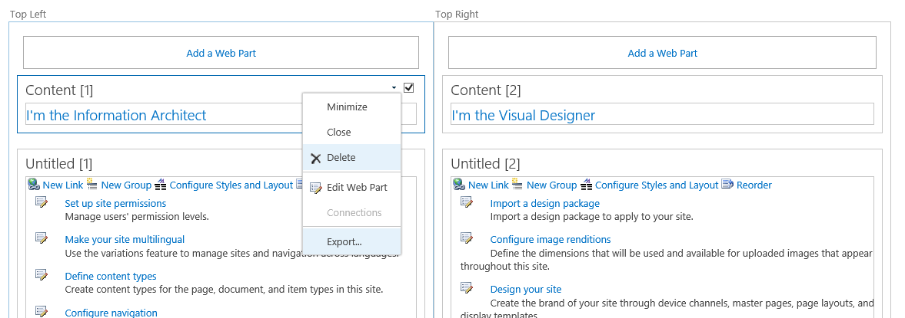

* 1. When you are done, all the web part zones on the page should be empty.

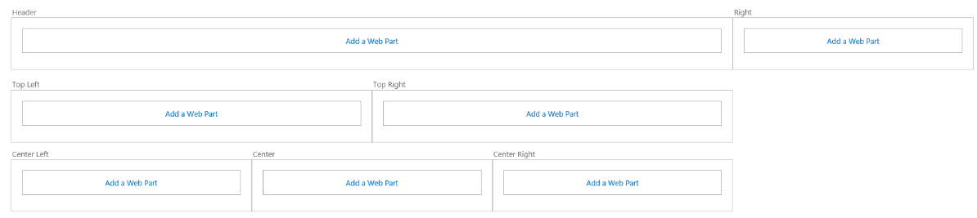

* 1. Save your changes to the home page using the **Save** button in the ribbon.

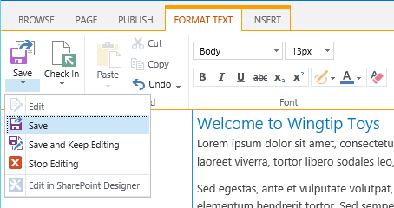

* 1. Check in you changes to the home page by clicking the **Check it in** link.

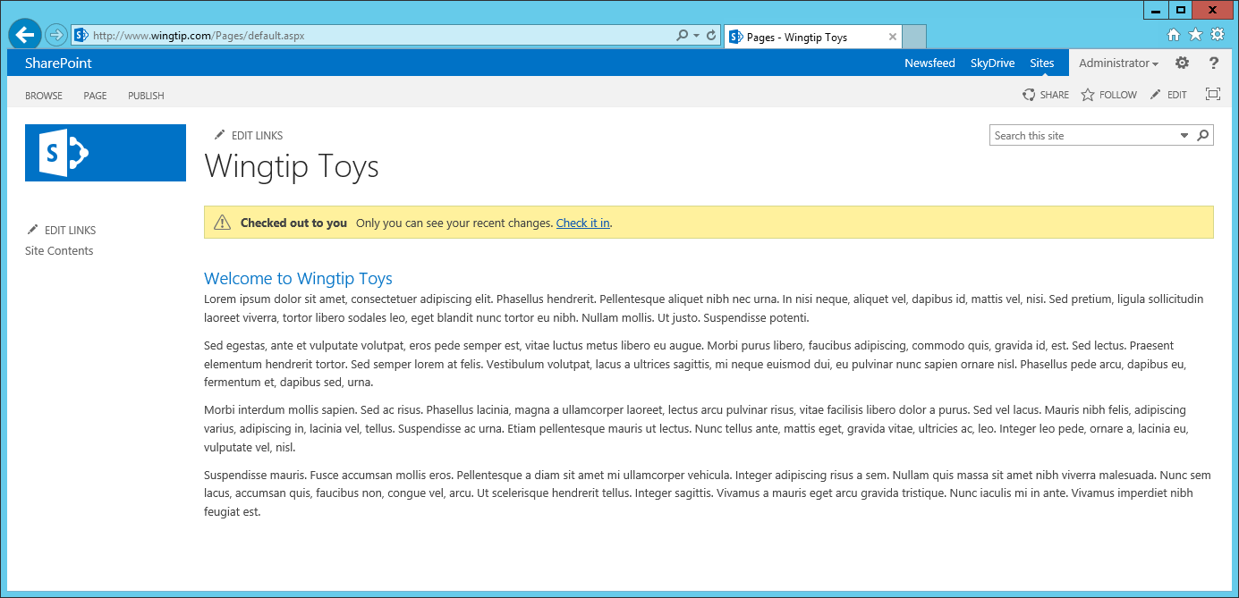

* 1. Add a small comment to the **Check In** dialog and click **Continue**.

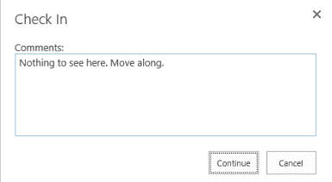

* 1. Click **Publish this draft** to publish your changes.

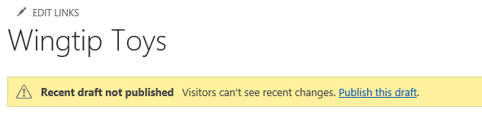

* 1. You should now see the changes to the home page.

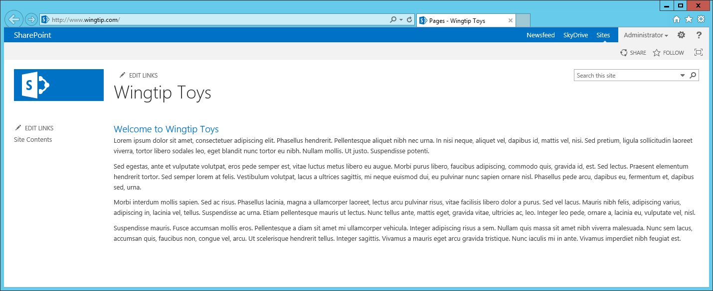

### Exercise 2: Add Content to the Wingtip Toys Publishing Site

In this exercise you will add a few images to the Images library and add them to pages.

1. Add a set of images to the site to use in a new page:
   1. In the **Quick Launch** navigation, click the **Site Contents** link.
   2. On the **Site Contents** page, select the **Images** library.
   3. Using Windows Explorer, navigate to the following folder

C:\Student\Modules\Publishing\Lab\Images

* 1. Within this folder you’ll find several images that have been supplied by the Marketing department of Wingtip Toys. Select all these files in the Windows Explorer and drag-and-drop them into the browser near where it says **Drag files here or click to add an item** under the **Images** library title:

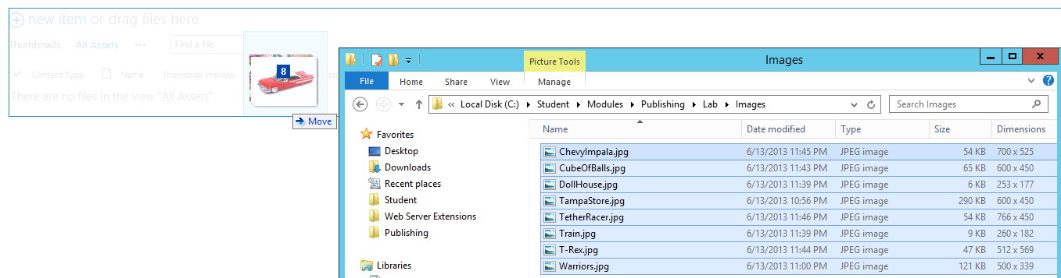

* 1. After a moment the images will be visible in the **Images** library.

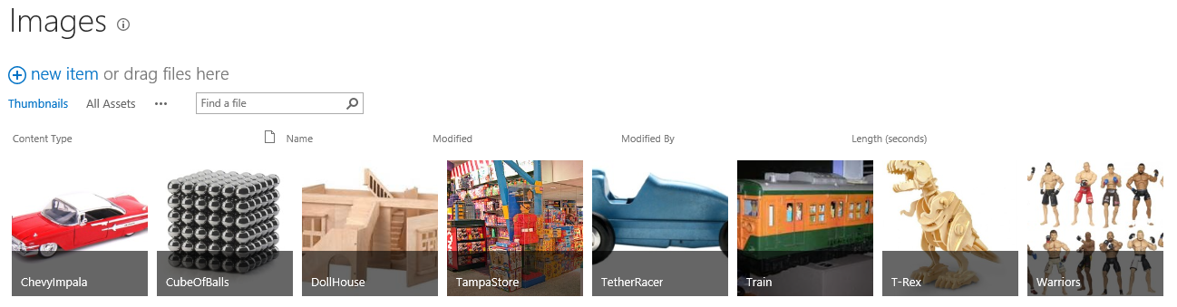

* 1. After uploading the images, you need to check them in so they can be used. Do this by moving to the **All Assets** view and selecting all the images at once. Once all the items have been selected, click the **Check In** button in the ribbon.

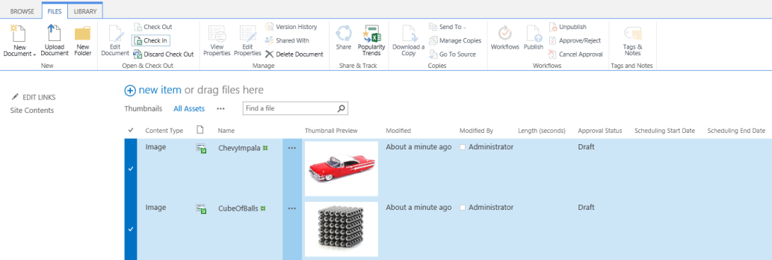

* 1. When prompted select **Major Version (Publish)** and click **OK**.

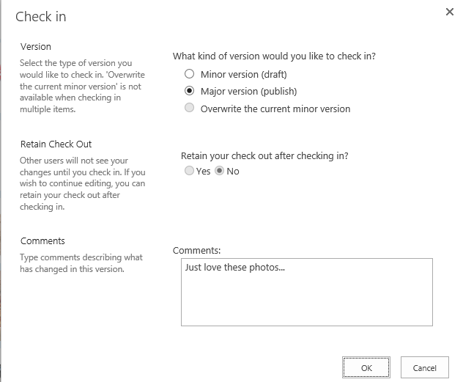

* 1. You should be able to confirm that the **Approval Status** of all the images is now **Approved**.

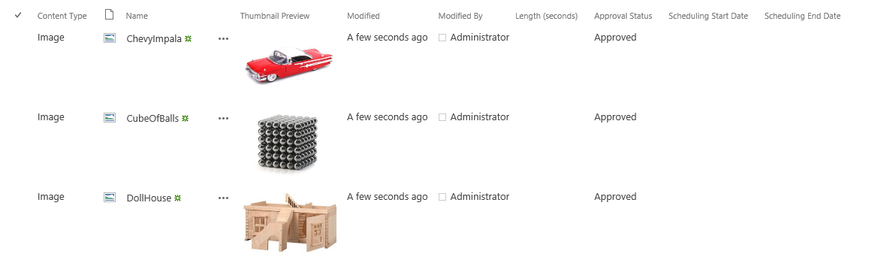

1. Next, create a new page and edit its content.
   1. Add a new page by clicking the **Add a Page** command in **Site Actions**.
   2. In the **New Page** dialog, enter **About Us** and click **Create**.

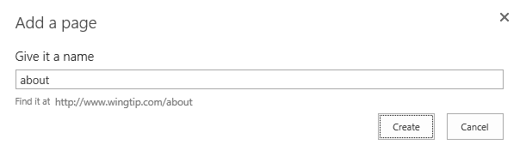

* 1. Enter some text on the page so it looks somewhat like the following screenshot. Feel free to use the text in the **AboutPageCopy.txt** file in the lab folder.

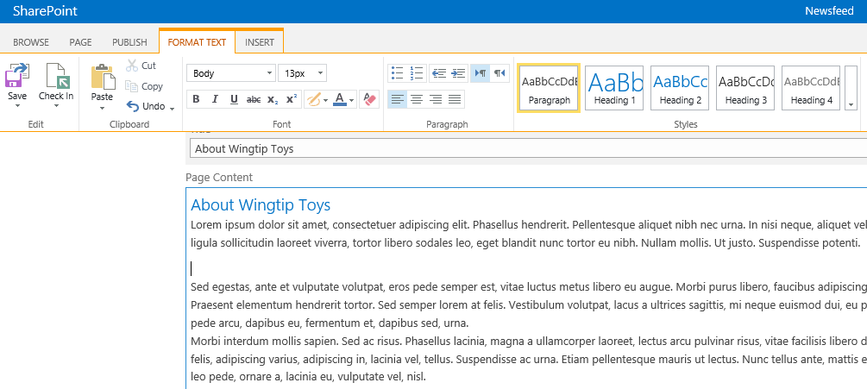

* 1. Place the cursor after the first paragraph and add a new line. Add an image to the page by going to the ribbon and selecting the **Insert** tab, then the arrow below the **Picture** button and select **From SharePoint**:

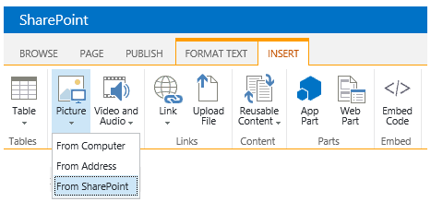

* 1. Select the ChevyImpala.jpg image you uploaded in a previous step and click **Insert**.

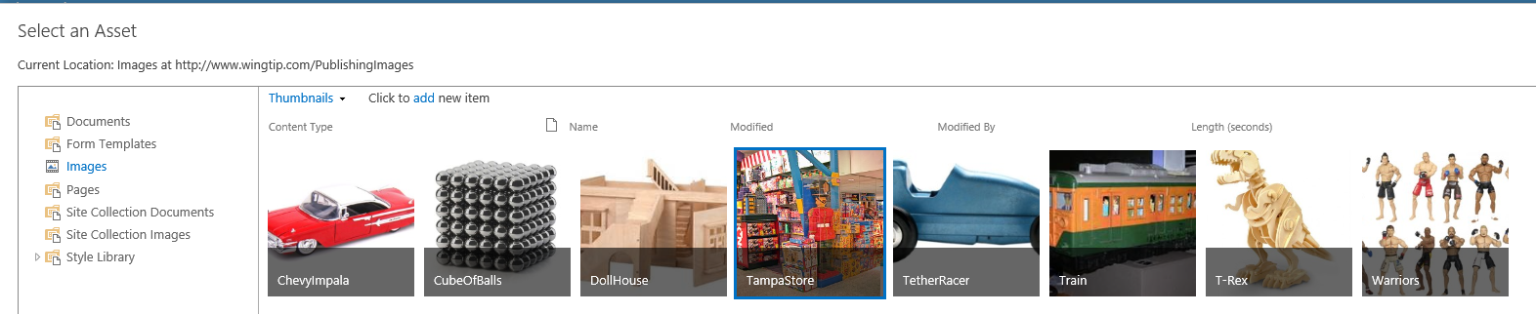

* 1. Resize the image and float it to the Left using the ribbon as shown in the following screenshot..

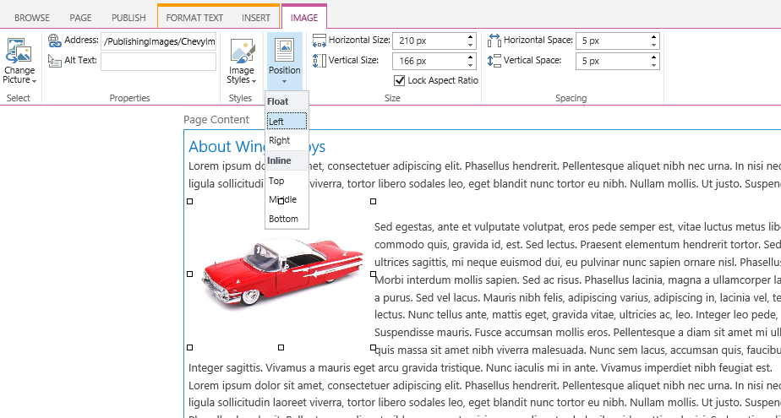

* 1. When finished, click the **Check In** button found in the **Page** tab of the ribbon.

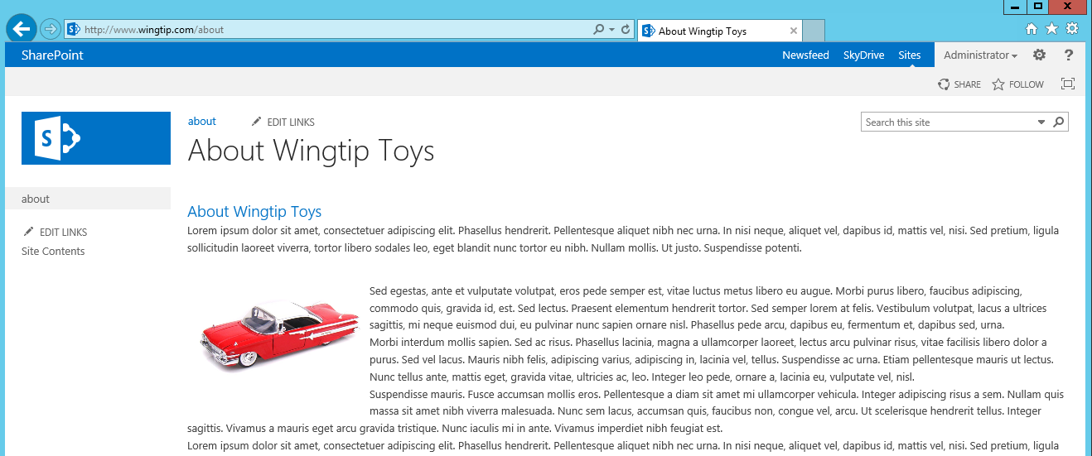

Notice how after creating the page, the URL is a SEO-friendly URL and the page shows up in the navigation.

1. Examine how the navigation is being created by looking at the site’s navigation taxonomy:
   1. Select the gear in the top-right corner of the page and select **Site Settings**.
   2. Under the **Site Administration** section, select **Term Store Management**.
   3. Expand the term set for the **Site Collection** and then expand **Site** **Navigation** to find the **About Us** term that is linked to the page you just created:

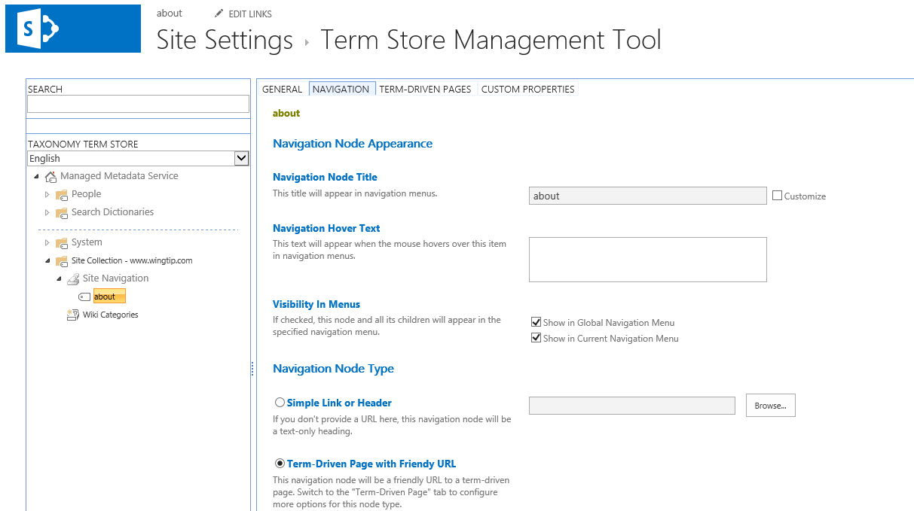

In this exercise, you have gone through the process of adding a publish page to the site’s metadata-driven navigation scheme.

### Exercise 3: Use Design Manager to Integrate a new Look and Feel

In this exercise you will implement a custom brand in a SharePoint 2013 Publishing site with the new Design Manager.

1. You will start by adding the design files to the master page gallery of the publishing site. Files can be manually uploaded or copied using a mapped folder. Before doing this, simplify the lab experience by turning off content approval, check in/out requirements and versioning on the Master Page Gallery:
   1. Navigate to <http://www.wingtip.com>.
   2. Using the **Site Actions** gear icon in the top-right corner, go to the **Site Settings** page.
   3. Under the **Web Designer Galleries** grouping, select the **Master Pages and Page Layouts** link.
   4. Within the **Master Page Gallery**, use the ribbon to select the **Library** tab and click the **Library Settings** button.
   5. On the library settings page select **Versioning Settings** from the **General Settings** column.
   6. Change the following settings and click **OK**.
      1. **Content Approval**: No
      2. **Document Version History**: No Versioning
      3. **Require Checkout**: No
2. In the Master Page Gallery, on the ribbon, select the **Library** tab and click **Open with Explorer** in the **Connect & Export** group.

This is an alternative to mapping a network drive that you might choose to use if you have many locations you wish to copy design items into, and you do not plan to do this on a recurring basis in any given location.

1. You may be prompted to login to confirm you can access the folder. If so, login as WINGTIP\Administrator.

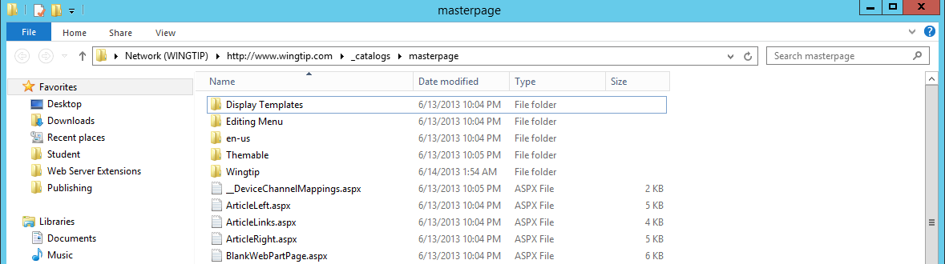

1. Open a second instance of the Windows Explorer and navigate to the following path.

C:\Student\Modules\Publishing\Lab\masterpage

1. Inside this folder, locate the **WingtipMaster.html** file and the **Wingtip** folder.

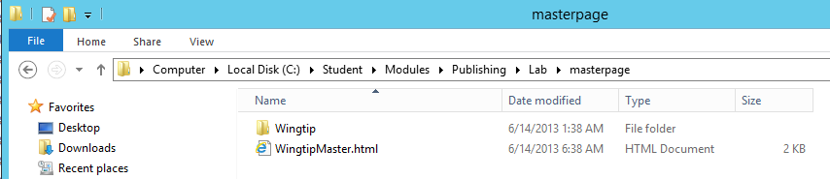

1. Drag and drop the **WingtipMaster.html** file and the **Wingtip** folder on the Windows Explorer window with the master page gallery.

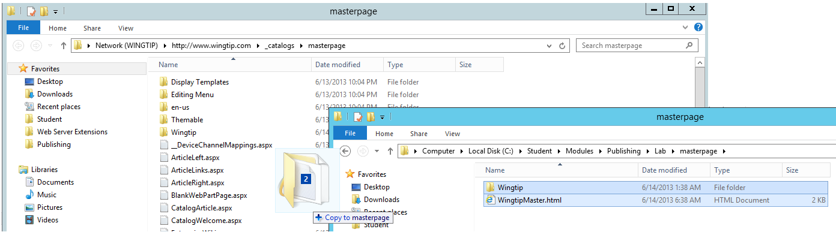

1. In the browser, click the **Design Manager** command in **Site Actions**.
2. In the **Design Manager**, click on **step 4: Edit Master Pages**.
3. The **Design Manager: Edit Master Pages** page will show all master pages in the Master Page Gallery. You need to convert your HTML file that was previously uploaded to a SharePoint master page.
4. Click the **Convert an HTML file to a SharePoint master page** link.
5. Select the **WingtipMaster.html** file and click **Insert**.

Make sure you select the row and don’t click on the actual file link as clicking the link will take you to that file.

1. Accept and/or click through any a prompts you receive and refresh the page until you see the **WingtipMasterDesign** show up on the page with a status of **Conversion successful**.

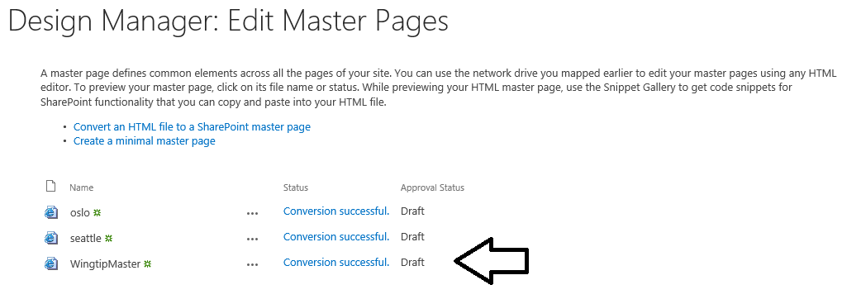

1. Click the **Conversion successful** link for the **WingtipMaster** to open the preview page.

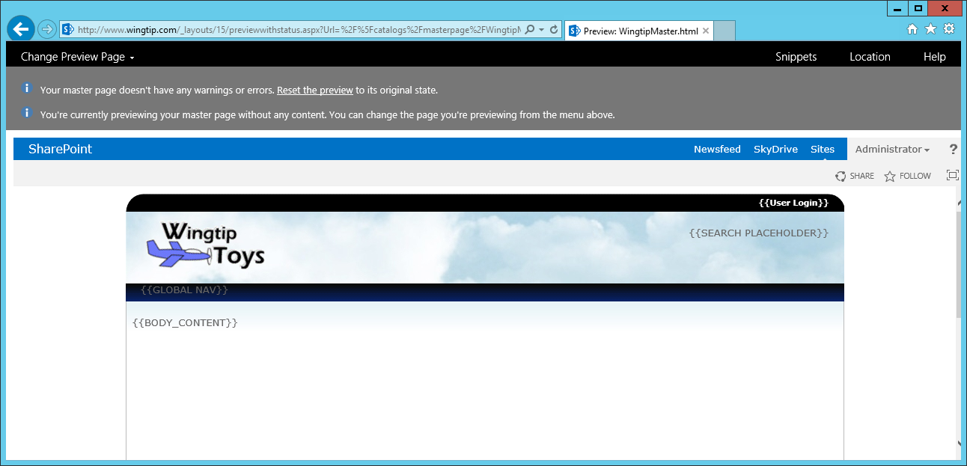

1. Open **Notepad** (**Windows Keyboard Key 🡪** type **Notepad** and select the tile) and open the **WingtipMaster.html** file from the mapped network drive. Ensure you don’t open the *.master version of this file… only the *.html version
2. Add in global navigation for the site using the Snippet Gallery:
   1. In the master page preview, click the **Snippets** link in the top-right of the page to launch the **Snippet Gallery**.
   2. In the **Snippet Gallery**, Select **Top Navigation** from the Ribbon **Design** tab and
   3. Click the **Copy to Clipboard** button under the **HTML Snippet** to copy the HTML generated by the Snippet Gallery.
   4. Go back to Notepad and replace the following text with the HTML you copied to the clipboard and **save** your changes.

{{GLOBAL NAV}}

* 1. Go back to the master page preview and refresh the page. You should now see the live navigation being added to the page.

1. Add the search box to the master page.
   1. Jump back to the **Snippet Gallery**.
   2. Click the **Search Box** button in the **Design** tab of the ribbon.
   3. Click the **Copy to Clipboard** button under the **HTML Snippet** to copy the HTML generated by the Snippet Gallery.
   4. Go back to Notepad and replace the following text with the HTML you copied to the clipboard and **save** your changes:

{{SEARCH PLACEHOLDER}}

1. Go back to the master page preview and refresh the page. You should now see the live search box added to the page.
2. Lastly, move the **ContentPlaceholderMain** control into the area where the rendered content should appear.
   1. In Notepad, find the following HTML content in **WingtipMaster.html**:

<div class="customBottom">

* 1. Immediately following locate the **<div>** element with a **data-name** attribute of **ContentPlaceHolderMain**.

<div data-name="ContentPlaceHolderMain">

* 1. Select the entire **<div>** (including the 3 commented lines at the end of the <div> element and its contents and cut and paste it into the **{{BODY_CONTENT}}** placeholder.

<div class="customBody">

<div data-name="ContentPlaceHolderMain">

<!--CS: Start PlaceHolderMain Snippet-->

<!--SPM:<%@Register Tagprefix="SharePoint" Namespace="Microsoft.SharePoint.WebControls" ... -->

<!--MS:<SharePoint:AjaxDelta ID="DeltaPlaceHolderMain" IsMainContent="true" runat="server">-->

<!--MS:<asp:ContentPlaceHolder ID="PlaceHolderMain" runat="server">-->

<div class="DefaultContentBlock"

style="border:medium black solid; background:yellow; color:black; margin:20px; padding:10px;">

This div, which you should delete, represents the content area that your Page Layouts

and pages will fill. Design your Master Page around this content placeholder.

</div>

<!--ME:</asp:ContentPlaceHolder>-->

<!--ME:</SharePoint:AjaxDelta>-->

<!--CE: End PlaceHolderMain Snippet-->

</div>

</div>

* 1. Finally, delete the **div** element which has the class attribute if **DefaultContentBlock**. The section should look like the following code.

<div class="customBody">

<div data-name="ContentPlaceHolderMain">

<!--CS: Start PlaceHolderMain Snippet-->

<!--SPM:<%@Register Tagprefix="SharePoint" Namespace="Microsoft.SharePoint.WebControls" ... -->

<!--MS:<SharePoint:AjaxDelta ID="DeltaPlaceHolderMain" IsMainContent="true" runat="server">-->

<!--MS:<asp:ContentPlaceHolder ID="PlaceHolderMain" runat="server">-->

<!-- HTML content deleted from here -->

<!--ME:</asp:ContentPlaceHolder>-->

<!--ME:</SharePoint:AjaxDelta>-->

<!--CE: End PlaceHolderMain Snippet-->

</div>

</div>

* 1. **Save** your changes.

1. Go back to the master page preview and refresh the page. You should no longer see the static content.
2. Close the Preview page.
3. On the Snippet Gallery page use the **Site Actions** gear icon in the top-right corner of the page to navigate to the **Site Settings** page.
4. Under the **Look and Feel** grouping, select **Master Page**.
5. Change the **Site Master Page** to **WingtipMaster** and click **OK**.
6. Go back to the homepage of the site to see how your master page is now being used as the site master page. You can also click on the links in the navigation to view how the other pages appear.

In this exercise you implemented a sample custom brand using the new Design Manager.