## Working with User Profiles and MySites

**Lab Time**: 60 minutes

**Lab Folder**: C:\Student\Modules\UserProfiles\Lab

**Lab Overview**: In this module you will explore the User Profile Service and learn what features and functions it supports. You will configure a custom User Profile field to track the Twitter Accounts and Product Specialties of the employees at Wingtip Toys. You will learn how to share documents and content within SharePoint and how to follow People, Sites and Documents that are of interest to you and receive updates about those items in your Newsfeed.

**Lab Setup:** Before working on this lab please run the script located at **[Lab files]\User Profiles\CreateUserProfiles.ps1**. You can run this PowerShell script by right-clicking it in the Windows Explorer and choosing the command **Run with PowerShell**.

### Exercise 1: Configure the User Profile Service

In this exercise you will explore the User Profile Service and learn about the features that support the user experience in SharePoint 2013. The user profile service is the heart of SharePoint’s People system. It stores information about the users and manages synchronization of user information.

Note: As an end user you will likely never administer the User Profile Service, but in order to better understand how the Service works this lab begins with a walk through of Features from Central Administration.

1. Browse to Central Administration for SharePoint 2013.
2. Chose **Application Management | Manage Service Applications**.
3. Click the **User Profile Service Application** to Manage the Service.
4. Once in the management section for the User Profile Service there are a few specific features in the **People Section** that you should note:
   1. **Manage User Properties** – User Properties are how SharePoint stores information about users, whether it is imported from Active Directory or entered by the end user. In the next section you will add a couple fields to enhance the user profiles for Wingtip Toys.
   2. **Manage User Profiles** – As an Administrator you can update and manage profiles for users through this option.
   3. **Manage Audiences** – Audiences are a method of targeting and personalizing content to display for specific user populations.

You have asked the IT department to create two Audiences so that you can target content on a site you are planning. You will play the role of a SharePoint Administrator and perform this configuration now.

1. In the People section click **Manage Audiences**.
2. On the View Audiences page click **New Audience**.
3. On the **Create Audience** page create a new audience with the following attributes:
   1. Name: **Scientists**
   2. Description: **Wingtip Scientists**
   3. Owner: **wingtip\administrator**
   4. Include users who: **Satisfy all of the rules**
4. Click **OK**
5. On the **Add Audience Rule** page add a rule to limit the audience to the Wingtip Scientists Group:
   1. Operand: **User**
   2. Operator: **Member Of**
   3. Value: **Wingtip Scientists**
6. Click **OK**
7. On the View Audience Properties page you will see the result of the audience you just created. Audiences are “compiled” from time to time by SharePoint. Force the compilation by clicking **Compile Audience** link in the page. The page should refresh to show three members and no Compilation Errors.

In this exercise you added an audience to SharePoint 2013 and explored the User Profile Service a bit. In the next exercise you will do a bit more work with the User Profile service to enhance the User Experience.

### Exercise 2: Extend User Profiles with Custom Properties

SharePoint User Profile properties are an excellent way to engage your users and gather information. In this exercise you will configure two new User Profile fields tailored to the company culture at Wingtip Toys. First, your HR Department has asked you to configure a field to track the product categories that employees work with regularly. Since you already have the Product Category information in the Managed Metadata Service, you will create a User Profile Field that makes use of that term set. The second field they wish to add will enable the employees to share their Twitter accounts with the company.

1. Browse to Central Administration for SharePoint 2013.
2. Navigate to **Application Management | Manage Service Applications.**
3. Click the link to manage the **User Profile Service Application**.
4. Click **Manage User Properties** from the **People** section.
5. This list is all of the properties that SharePoint maintains for users. You need to create two new fields in a new Section. Click **New Section** in the tool bar and supply the following information
   1. Name: **WingtipToysInformation**.
   2. Display Name: **Wingtip Toys Information**
   3. Default User Profile Subtype: **Checked**
6. Click **OK**. Scroll to the bottom of the properties list and you should see the new Section you just created.
7. Click **New Property** in the toolbar.
8. On the **Add User Profile Property** page enter the following information:
   1. Name: **ProductCategories**
   2. Display Name: **Product Categories**
   3. Type: **string (Multi Value)**
   4. Length: **200**
   5. Multivalue Separator: **Comma**
   6. Pick a Term Set for this property: **Product Category**
   7. Default User Profile Subtype: **Checked**
   8. Description: **What product categories are you working on?**
   9. Policy Setting: **Optional**
   10. Default Privacy Setting: **Everyone**
   11. User Override: **Unchecked**
   12. Replicable: **Unchecked**
   13. Edit Setting: **Allow users to edit values for this property**
   14. Show in the profile properties…: **Checked**
   15. Maximum number of values…: **2**
   16. Show on the Edit Details page: **Checked**
   17. Show updates to the property…: **Unchecked**
   18. Alias: **Unchecked**
   19. Indexed: **Checked**
9. Click **OK**.
10. Click **New Property** on the toolbar.
11. On the **Add User Profile Property** page enter the following information:
    1. Name: **TwitterUserName**
    2. Display Name: **Twitter User Name**
    3. Type: **string (Single Value)**
    4. Length: **50**
    5. Configure Term Set…: **Unchecked**
    6. Default User Profile Subtype: **Checked**
    7. Description: **What is your Twitter Account Name (without the @)**
    8. Policy Setting: **Optional**
    9. Default Privacy Setting: **Everyone**
    10. User Override: **Unchecked**
    11. Replicable: **Unchecked**
    12. Edit Setting: **Allow users to edit values for this property**
    13. Show in the profile properties…: **Checked**
    14. Show on the Edit Details page: **Checked**
    15. Show updates to the property…: **Unchecked**
    16. Alias: **Unchecked**
    17. Indexed: **Checked**
12. Click **OK**.
13. Now that you have added the properties we need to update a few profiles to test our work. Return to the User Profile Service Application through **Central Administration | Application Management | Manage Service Applications | User Profile Service Application**.
14. In the **People** Section click **Manage User Profiles**.
15. In the Find profiles search box enter **wingtip** and click **Find**.
16. Hover over the user **wingtip\AC** and chose **Edit My Profile**

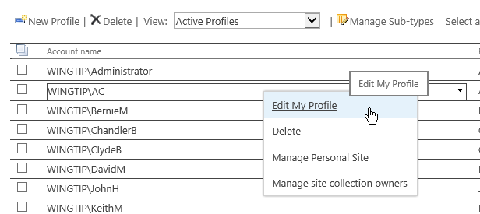

1. Scroll to the very bottom of the page and you should see the two properties that you created. Add the **Product Categories Scrapbooking** and **Football** to AC’s profile. Click **OK**.
2. For **Twitter User Name** add the value **AndrewConnell**.
3. Click **Save** and **Close**.
4. Using the same steps edit the following profiles using the following information
   1. **MattMcD**
      1. **Cute and Huggable, Tough Guys**;
      2. **MatthewMcD**
   2. **TedP**
      1. **Beads and Jewelry, Cute and Huggable**
      2. **TedPattison**
   3. **ScotH**
      1. **Trains, Robots & Robotics**
      2. **ScotHillier**

### Exercise 3: Personalize Page Views using Audience Targeting

In this exercise you will use the Audience and User Profile fields that you configured in the previous exercise to conditionally present content to users.

1. Browse to the Intranet Home Page: **http://intranet.wingtip.com**
2. On the **Page** tab choose **Check Out** and then **Edit**.
3. Click in the right column under the Documents Web part. On the Insert tab chose **Web part**. Select the **Content Editor Web part** from the **Media and Content** group. Click the **Add** button to add it to the page.
4. Click the link in the Web part to Add new content and enter “Message for Scientists”.
5. Select the Content Editor Web part **Edit Menu**.
6. Scroll to the bottom of the Web part tool panel and expand the **Advanced** section. At the bottom of the **Advanced** section click the **Browse** link on the **Target Audiences** field.
7. In the **Select Audience dialog** enter “**Scientist**” and click the **Search** button. Select **Wingtip Scientists** and click **Add**. Click **OK**. Check in the page to save your changes.

To test this setting you have to view the page as a **Scientist**. In the next Exercise you will log in as KenS using Remote Desktop. Browse to http://intranet.wingtip.com as **KenS**. You should see the Scientist message.

### Exercise 4: Explore the SharePoint 2013 MySite

In this exercise you will login as Ken a Wingtip Toys employee. In this lab environment you need to remote into the same machine that you are currently logged in as.

1. From the Server Start Screen choose Remote Desktop connection.

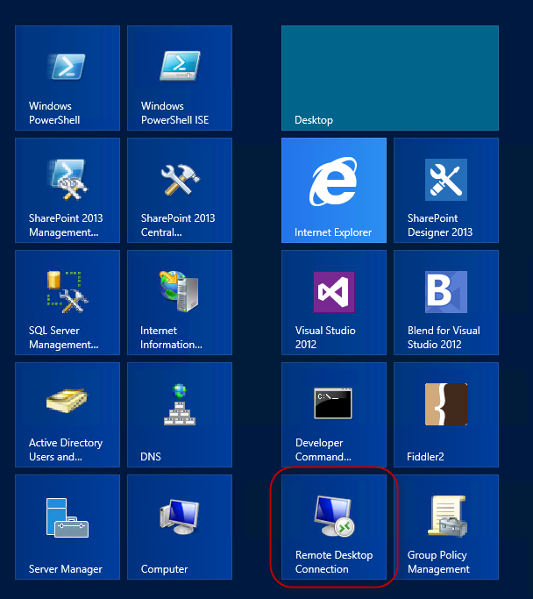

1. Connect to server address: WingtipServer
2. The credentials are wingtip\kens and Password1
3. Open Internet Explorer and browse to <http://intranet.wingtip.com>. The welcome menu should indicate that you are logged in as Ken Sanchez. (Do you see the message for Scientists?)
4. Click **Newsfeed**. SharePoint should indicate that you are visiting your My Site.

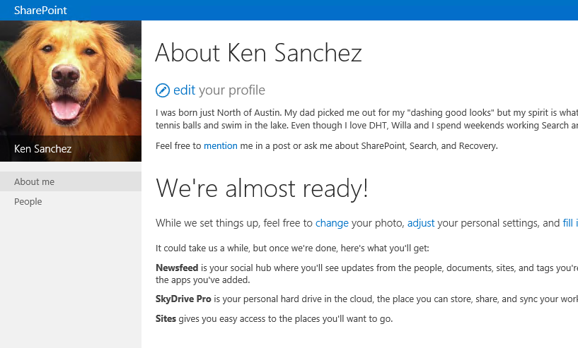

1. Click the **Sites** menu item and SharePoint will prompt you to “Get Social!” Click **OK**. (If it doesn’t don’t sweat it.) SharePoint is doing a lot of processing in the background getting your My Site ready to go. You may notice after a few minutes that the site begins to show new lists and sites on the left navigation and the “We’re almost ready!” note goes away.

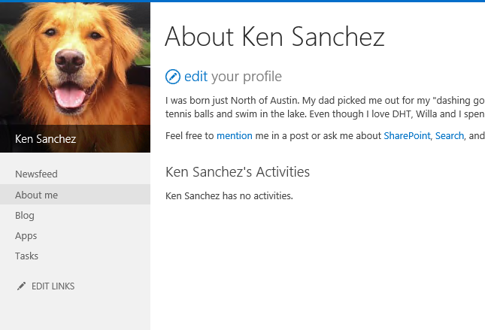

1. Try a few things on your My Site like:
   1. **Edit your profile**.
   2. View your **Newsfeed**. It’ll be empty, but you can click the **Follow** link to start following People. Give it a try.
   3. Create a new **Micro Blog post**. Try the text “**Does anyone know a #SharePoint developer like @TedP**” What you should notice is as you type SharePoint highlights the **hashtag** and **mention** and create a post linked to the tag #SharePoint and Ted’s profile.

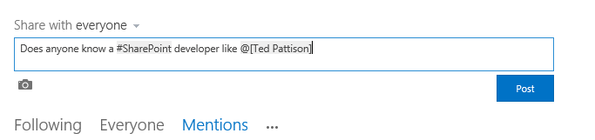

* 1. Click **Post** and SharePoint will add your profile photo.

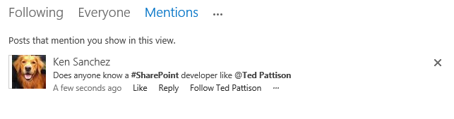

In this exercise you saw the Audience Targeted content for your Audience. You also explored a few of the Social features of the My Site host.

### Exercise 5: Sharing Documents and Content

In this exercise, you will learn how to share content with other users.

1. While still logged in as Ken, browse to your Documents library by clicking **OneDrive**. This is a document library just for you. If you put documents into the **Shared with Everyone** folder, anyone who knows it’s there will be able to view the documents. If you put the files at the root of this folder it’s up to you to share them. Let’s do it.
2. Drag the files from **the C:\Student\Modules\UserProfile\Lab\Files** directory into the Documents library.
3. After the upload is complete. Hover over a document and click the ellipsis. In the hover card chose **SHARE**.

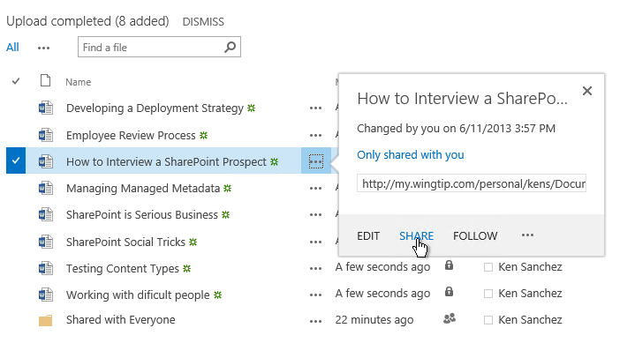

1. In the Share dialog you will see that the document is only shared with you. Add **AC** and **Scot** by typing their names separated by a semicolon. Notice that you can choose “Can Edit” and “Can View”. Leave it as **Can Edit**.

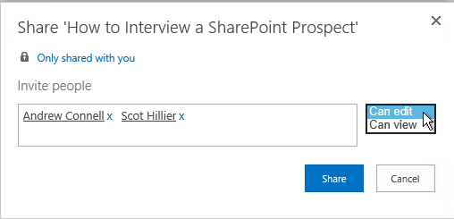

1. Click **Share**.
2. You will see a confirmation notice and the share icon will change next to your document.

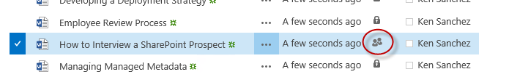

In this exercise you shared documents with colleagues and chose the permission level for the users.

### Exercise 6: Following People, Sites and Documents

SharePoint provides tools to keep you informed of changes going on in your SharePoint environment. People, Documents, Sites, and Tags can be followed. Any changes to the items you follow will trip notices in your news feed. In this exercise you will learn how to Follow these items and see the status on your Newsfeed.

1. To follow a person, begin on your **About Me** page and you should see the post that you created earlier. Click the **Ted Pattison** link in your post to view **Ted’s profile**.
2. On Ted’s profile page choose **follow this person.**

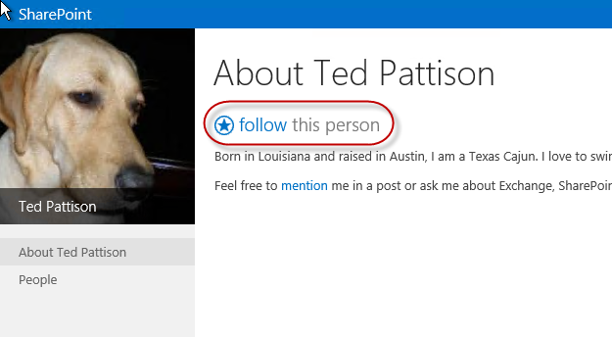

1. You will see a brief notification that you are now following Ted.

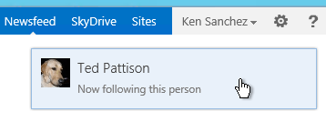

1. Return to your profile by clicking **Ken Sanchez | About Me**.
2. On your profile you will see a notification that you are now following Ted.

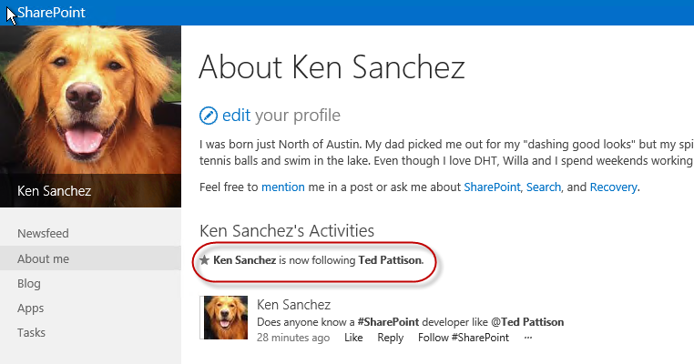

1. To follow documents browse to a library where you have access, like your **SkyDrive**.
2. Click the **ellipses** button and chose **FOLLOW**.

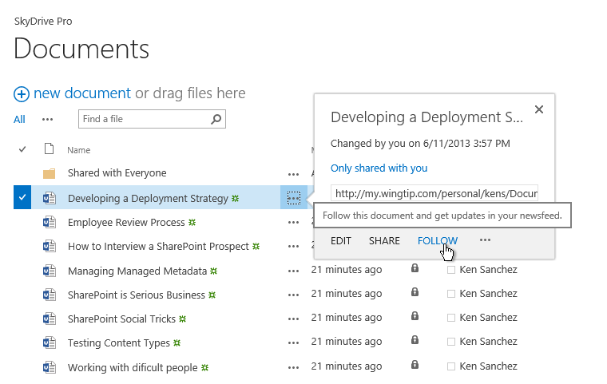

1. You will see a notification that you are now following that document.

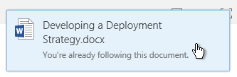

1. Follow sites by browsing to any site that you have access to, like **http://intranet.wingtip.com**.
2. Click the **Follow** star

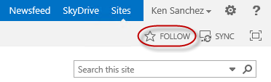

1. You will see a notification that you are now following the site.

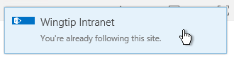

1. To view your followed Sites, People, Tags, and Documents, visit your Newsfeed. Clicking any of the numbers will show you the list of items you follow.

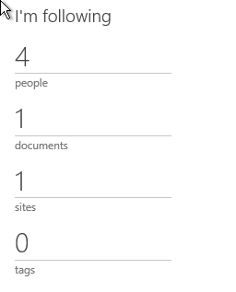

In this exercise you learned how to follow content and track the items on your MySite.