## Creating Workflows in SharePoint 2013

**Lab Time**: 45-60 minutes

**Lab Folder**: C:\Student\Modules\Workflow\Lab

**Lab Overview**: This hands-on lab will walk you through the experience of creating workflows using SharePoint Designer 2013. You will get first person experience in using the new activities, loops and stages capabilities in SharePoint Designer as well as creating workflows.

### Exercise 1: SharePoint 2010 Workflow in SharePoint Designer 2013

In this exercise you will create a workflow using the SharePoint 2010 workflow option in SharePoint Designer 2013. This approach is valid when you want to create a 2010 style workflow that is not supported by the new Workflow Manager in SharePoint 2013. The availability of this approach is dependent on how the farm is configured for workflow.

1. Login to the Student VM using the login WINGTIP\Administrator and the appropriate password.
   1. If you’re using a local VM provided by the hosting training company, the password will be Password1.
   2. If your student VM is hosted by CloudShare, the password for the WINGTIP\Administrator account is going to be unique for each student, system-generated by CloudShare. Also note that the CloudShare VM configuration usually logs you into the VM automatically so you do not have to enter the user name and password.
2. Once you have logged on to the student VM, launch the Internet Explorer and navigate to the Wingtip Toys research site which is located at the URL of <http://intranet.wingtip.com/sites/research>.

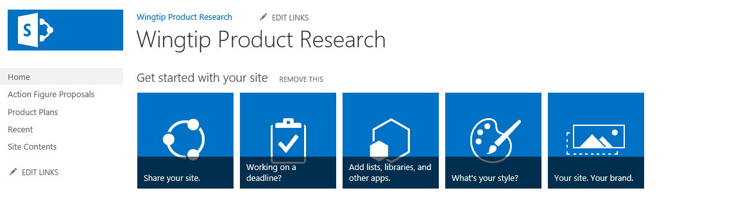

1. Open SharePoint Designer 2013: Windows Keyboard Key 🡪 Type “SharePoint Designer” and then select the SharePoint Designer 2013 application.



1. Open the lab site collection:
   1. Click the **Open Site** button.
   2. In the **Open Site** dialog, enter <http://intranet.wingtip.com/sites/research> in the **Site Name** box and click **Open**.
2. If prompted to login, use the credentials for **WINGTIP\administrator**.
3. Click **Workflows** from the Navigation pane.
4. From the **New** group in the ribbon, choose **List Workflow** and select the **Action Figure Proposals** library.

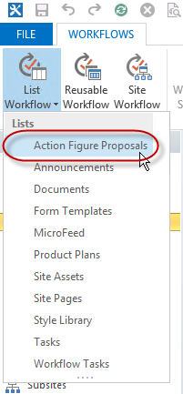

1. In the **Create List Workflow** dialog provide the name **Create Product Plan Workflow** and select the Platform Type: **SharePoint 2010 Workflow**.

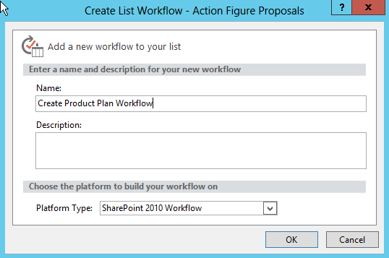

1. Click **OK**.
2. In **Step 1** type **log** and press **Enter** to add a **Log to History List** action. (Alternatively, you could use the menus to add the action but this approach is much faster.)
3. Change the **“this message”** text to **Starting Create Product Plan workflow**.
4. Below the Log action add a Create List Item action and set the values of “this list” to:
   1. List: **Product Plans**
   2. Content Type ID: **Product Plan**
   3. Path and Name(*): **Current Item:Name**

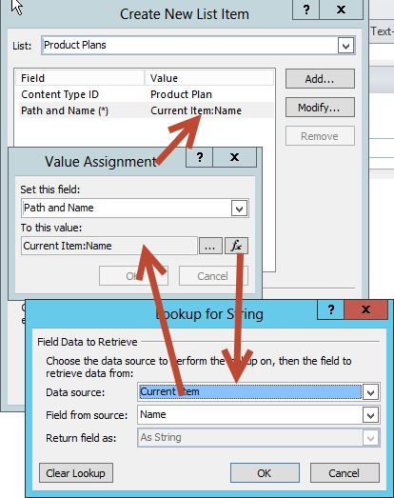

1. Click OK to get back to the workflow designer.
2. Add another **Log to history action** and change the **message** to **Product Plan workflow complete**. Your workflow should look like the following image:

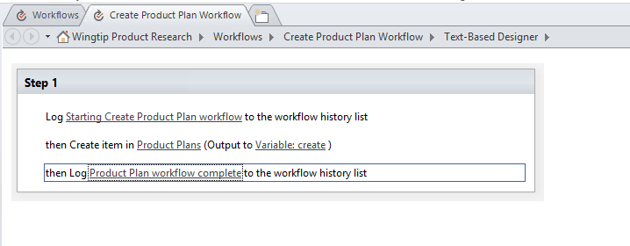

1. When you are done click **Check for Errors** in the ribbon.
2. Click **Save** to save your work.

#### Deploy and Test the Workflow

Now that you have saved the workflow you need to publish and test it. In the following steps you will test the workflow to ensure that it performs as expected.

1. Ensure that you are still on the editing tab for the Create Product Plan workflow.

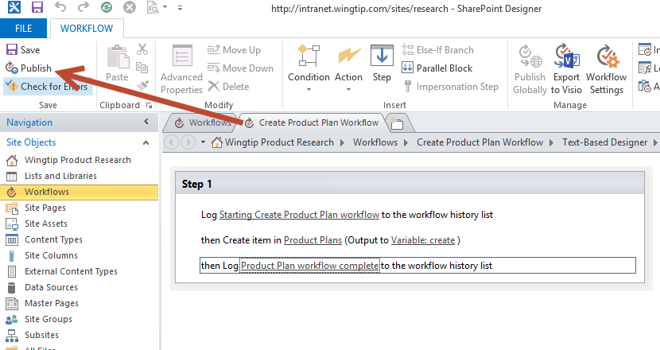

1. From the ribbon, click **Publish**.
2. Once the workflow is published return to the Research team site in the browser at <http://intranet.wingtip.com/sites/research>.
3. We have to create a test document for the workflow to process.
   1. In the Quick Launch click the link for the **Action Figures Proposals** library.
   2. From the **Files** tab in the ribbon, choose **New Document | Product Proposal**.
   3. Add a Product Title of **Joe Ely Action Figure**.
   4. **Save** the document back to the **Action Figures Proposals** library with the name **Joe Ely Action Figure**.
   5. Close **Word** and return to the **Action Figures Proposals** library in the browser.
4. You now have to activate the workflow on the new document.
   1. Select the **checkbox** next to the document name in the library and from the **Files** tab in the ribbon choose **Workflows**.

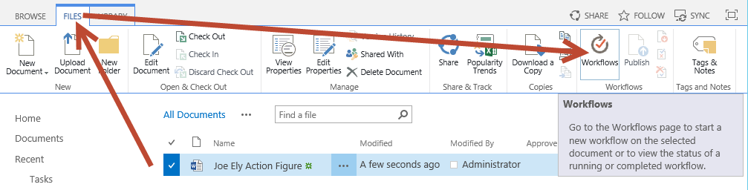

* 1. On the **Action Figure Proposals: Workflows: Joe Ely Action Figure** page choose the **Create Product Plan Workflow** link.

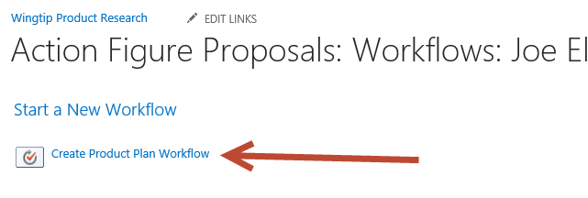

* 1. On the initiation form click **Start**.

1. After a few moments the workflow will start. You can monitor the progress from the **Action Figures Proposals** library. A column named **Create Product Plan Workflow** should read **Completed** when it completes successfully.
2. Click the **Completed** text and you will see the **Workflow Status** for the completed workflow instance. The workflow history list shows the log messages that you created.

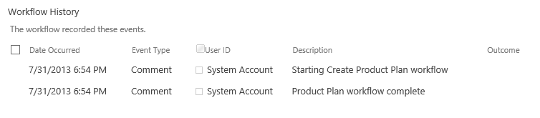

1. Click the link for the **Product Plans** library on the **Quick Launch** and you will see that a new **Product Plan** (Document Set) has been created with the default documents inside.

In this exercise you created a SharePoint 2010 style workflow with SharePoint Designer 2013. There are some features of SharePoint workflow that are no longer available in the new style SharePoint 2013 workflow. This exercise showed that you may still be able to create workflows using SharePoint 2010 activities.

### Exercise 2: Visio 2013 & SharePoint Designer 2013 Workflows

In this exercise you will create a new workflow using Visio 2013 and SharePoint Designer 2013. In this workflow you will leverage the new support for stages.

1. Login to the Student VM using the login WINGTIP\Administrator and the appropriate password.
   1. If you’re using a local VM provided by the hosting training company, the password will be Password1.
   2. If your student VM is hosted by CloudShare, the password for the WINGTIP\Administrator account is going to be unique for each student, system-generated by CloudShare. Also note that the CloudShare VM configuration usually logs you into the VM automatically so you do not have to enter the user name and password.
2. Once you have logged on to the student VM, launch the Internet Explorer and navigate to the Wingtip Toys research site which is located at the URL of <http://intranet.wingtip.com/sites/research>.



Before using SharePoint Designer 2013, you will first model the Workflow Using Visio 2013

1. Open **Visio 2013**: **Windows Keyboard Key 🡪 Type “visio”** and then select the Visio 2013 application.



1. When **Visio** loads, select the **Microsoft SharePoint 2013 Flowchart** template icon:

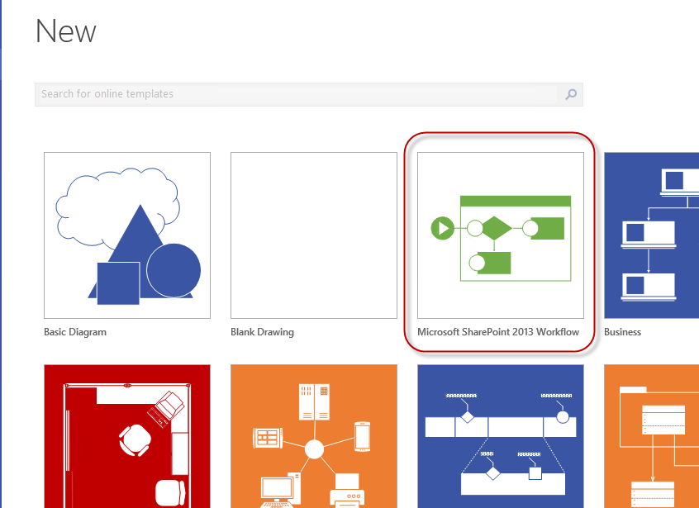

1. Click the **Create** button.
2. When the designer loads, right-click the dark blue heading of **Stage 1** and select **Edit Text**. Rename the stage to **Stage Init**.
3. Add three more stages to the designer by dragging the **Stage** shape from the **Shapes** task pane and rename them to the following stages as shown in the follow figure:
   1. **Stage Ready for approval** *(top middle)*
   2. **Stage Not ready for approval** *(bottom middle)*
   3. **Stage End** *(far right)*

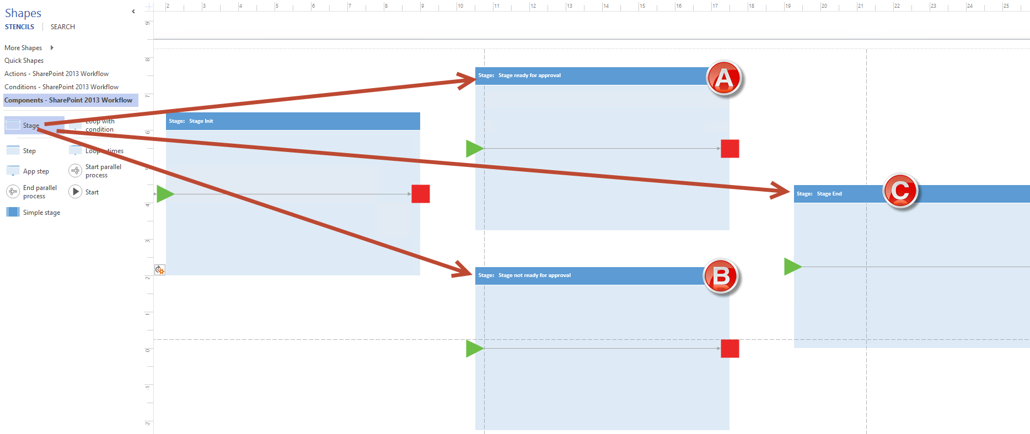

1. Add activities to **Stage Init**:
   1. Using the **Shapes** pane, select the category of **Actions – SharePoint 2013 Workflow** and then add the following actions to **Stage Init**:
      1. **Log to history list**
      2. **Set workflow variable**
      3. **Log to history list**

**Make sure** when you add the actions you are dropping them on the connector (i.e the black line connecting the Green triangle and red square) within the stage. If you don’t do this, you will have to fix up the connections before saving the workflow.

1. Rename the actions by right-clicking each one and selecting **Edit Text**. Give each action a descriptive name as follows:
   1. **Log to history list** = Log entering Stage Init
   2. **Set workflow variable** = Get the assigned Approver
   3. **Log to history list** = Log variable values
2. Using the **Shapes** pane, select the **Conditions – SharePoint 2013 Workflow** category and add an **If any value equals value** condition to the workflow immediately to the right of **Stage Init** (i.e. to the right of the Red Square).
   1. Rename this condition to **If approver is not blank**.
3. Using the **Connector** tool, found in the **Home** tab of the ribbon in the **Tools** group, connect the red box from **Stage Init** to the condition you just added.
   1. To Connect the Red Box with the Orange Circle, Click on the **Connector** tool in on the Home tab and then place your **mouse pointer near the right hand edge of the red box** (you should see a **small green square** show up
   2. Click on the small green square on the right edge of the Red Box and drag towards the Orange Circle until you see the small green square appear on the left edge of the Orange Circle.
   3. Release the left mouse button.
4. The **Stage Init** should look like the following figure:

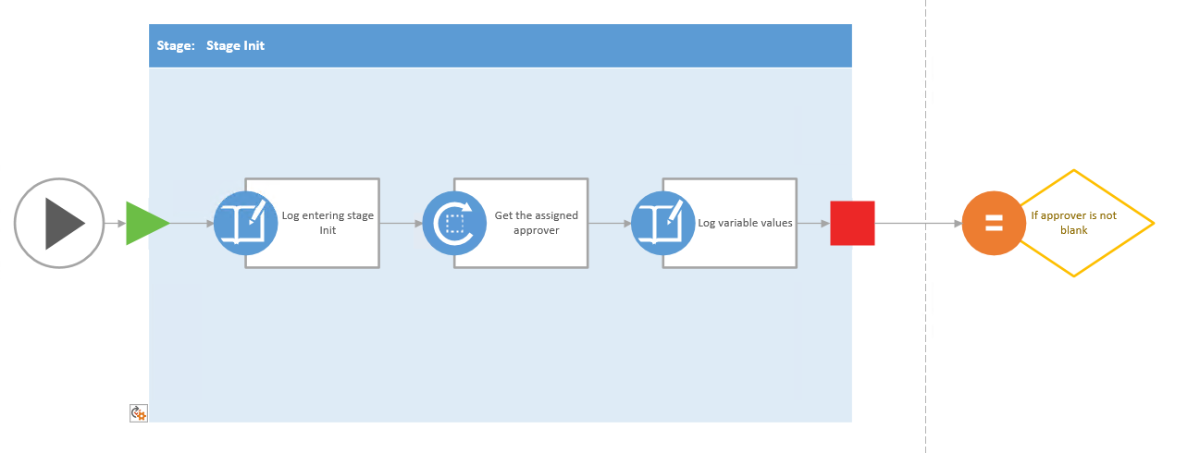

1. Using the same technique with the Connector tool draw two connections from the condition, one to the start arrow of **Stage ready for approval** and one to the **Stage not ready for approval**.
2. Right-click the connector to **Stage ready for approval** and select **Yes**.
3. Right-click the connector to **Stage not ready for approval** and select **No**.
4. The condition connections should look like the following figure:

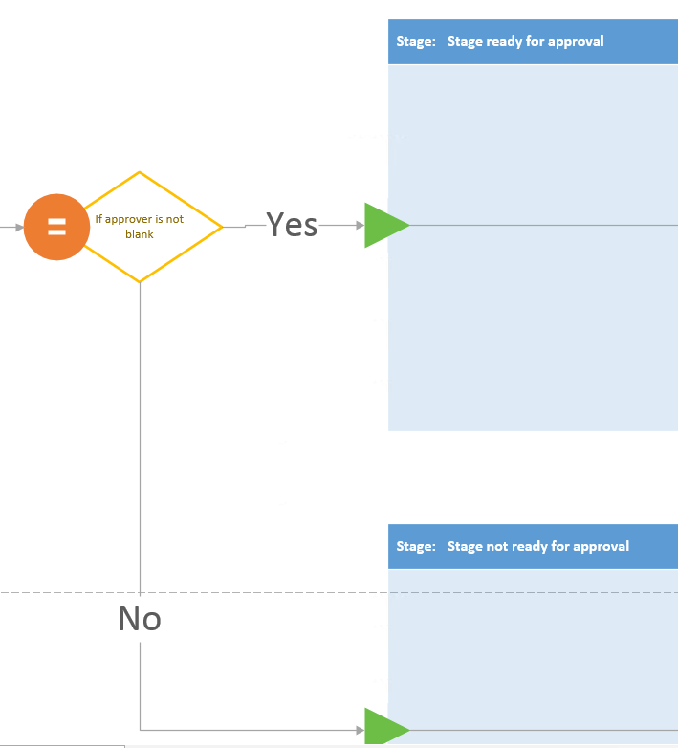

1. Using the same techniques you just applied, update **Stage ready for approval** by adding the following actions and renaming them it so it looks like the following figure:
   1. **Log to history list** = Log entering Stage ready for approval
   2. **Assign a task** = Assign task to approver

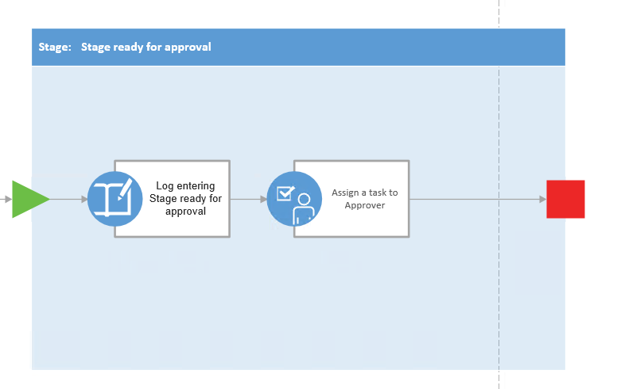

1. Update the **Stage not ready for approval** by adding the following actions so it looks like the following figure:
   1. **Log to history list** = Log entering Stage not ready for approval
   2. **Log to history list** = Log nothing to change

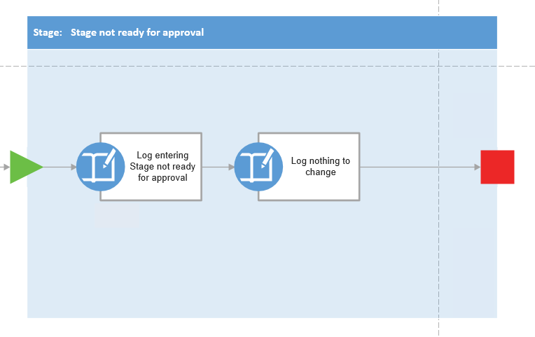

1. Using the **Connector** tool, connect the terminating red square on the right of **Stage ready for approval** to the green arrow on **Stage End**.
2. Repeat the previous step connecting the **Stage not ready for approval** to **Stage End**.
3. Add a **Log to history list** action to the **Stage End** stage.
   1. Rename it to **Log Stage End**
4. Save your changes selecting **File 🡪 Save**.
   1. When prompted, save the file to the **desktop** with a filename of **ProjectApproval.vsdx**.
5. Close **Visio 2013**.

At this point you have designed your workflow using Visio 2013. This simulates the process of creating a workflow with a business user without access to SharePoint Designer 2013 or a connection to SharePoint 2013.

#### Complete the Workflow into SharePoint Designer 2013

1. Open SharePoint Designer 2013: Windows Keyboard Key 🡪 Type “SharePoint Designer” and then select the SharePoint Designer 2013 application.



1. Open the lab site collection:
   1. Click the **Open Site** button.
   2. In the **Open Site** dialog, enter <http://intranet.wingtip.com/sites/research> in the **Site Name** box and click **Open**.
   3. If prompted to login, use the credentials for **WINGTIP\administrator**.
2. Import the workflow created with Visio 2013:
   1. Select **Workflows** in the **Navigation** pane.
   2. In the ribbon’s **Manage** group, select **Import from Visio 🡪 Import Visio 2013 Diagram**.
   3. Find the **ProjectApproval.vsdx** drawing you created on your desktop using Visio 2013 and click **Open**.
   4. In the **Create Workflow** dialog, set the following values and click **OK**:
      1. **Name:** Project Approval Workflow
      2. **Workflow Type:** List Workflow
      3. **SharePoint List:** Action Figure Proposals

When the workflow loads you’ll notice it looks identical to the drawing in Visio. In fact, it almost seems like it opened Visio, but if you look at the application title, you’ll see you still have the <http://intranet.wingtip.com/sites/research> site open in SharePoint Designer 2013.

1. Before proceeding create a new field in the Action Figure Proposals library to assign the Approver. In SharePoint Designer:
   1. Chose **Lists and Libraries** from the Navigation panel.
   2. Under **Document Libraries**, chose the link for **Action Figure Proposals**.
   3. On the **Action Figure Proposals summary page** in the **Customization** section, choose **Edit list columns**.
   4. On the ribbon, in the **New** group, choose **Add New Column** and select type **Person or Group**.
   5. Name the new field **Approver**.
   6. Click **Save**.
2. You now have to configure the workflow properties. Return to the **Project Approval Workflow** tab.
3. Select the first action **Log entering Stage Init** in **Stage Init**. Notice a little tile appears in the lower left corner. Click it and select **Properties**:

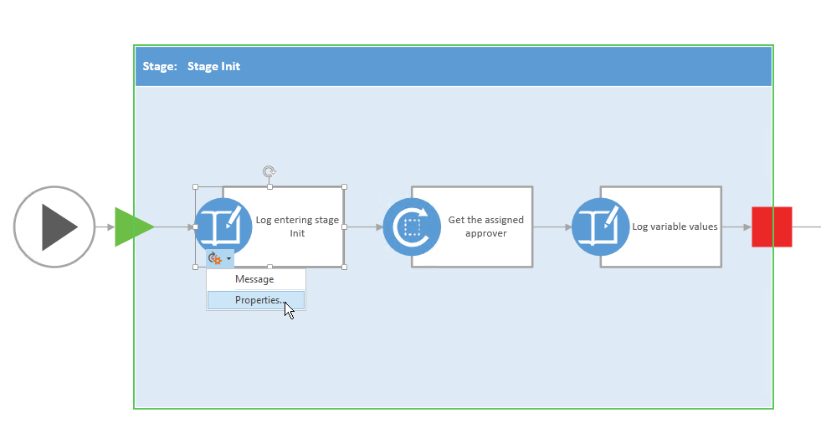

* 1. In the **Log to History List Properties** dialog, set the **Message** to **Entering Stage Init…** by clicking the **…** button, entering the text and click **OK** twice to accept your changes.

1. Open the **Get the assigned approver** action’s **Properties** dialog using the same process in the last step to get the tile to appear except don’t select **Properties…** instead select **Variable**.

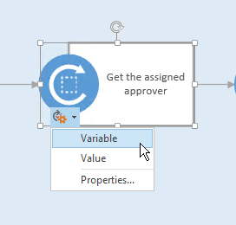

* 1. For the **Variable** property, click the drop down and select **Create a new variable**.
     1. **Name:** ProjectApprover
     2. **Type:** String
     3. Click **OK**
  2. Click into the **Value** property and click the **fx** button and select the following options:

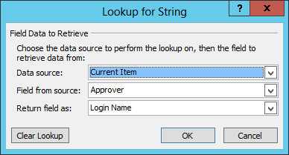

* 1. Click **OK** twice

1. Open the **Log variable values** action’s **Properties** dialog using the same process as before.
   1. Click into the **Message** field and click the **…** builder button.
   2. Enter the following message, using the **Add or Change Lookup** button to add the values shown in the following figure:
      1. Type in the **Current Approver:** then click the **Add or Change Lookup** button with the cursor positioned to the right of the entry to add the **Lookup for String** entry as shown below.

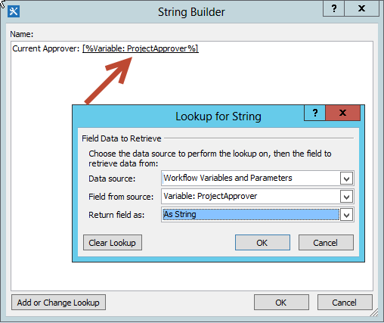

* 1. Click **OK** twice

1. Switch from the Visual Designer view to the **Text-Based Designer** by clicking the **Views** button in the ribbon in the **Manage** group.
2. Locate the **Transition to stage** section within **Stage Init**. Update the path the workflow should take depending on the values selected:
   1. In the first part of the **If** statement, select the following linked phrases and update their values:
      1. **value** (the first one): Variable: ProjectApprover  
         (Hint: use the **fx** button to add this and select **Workflow Variables and Parameters** as your Data source).
      2. **equals:** Change to **is not empty**

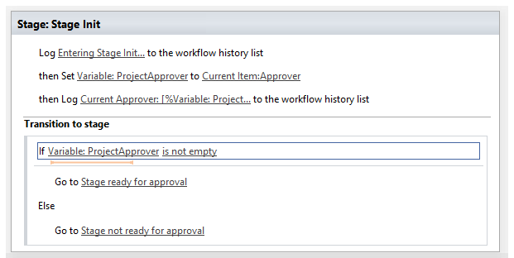

1. Update the **Stage ready for approval** to reflect what you see in the following figure using the techniques you learned in the previous steps.
   1. Set the **Log to History List** action message to “**Entering stage ready for approval**”.
   2. For the Task assignment change **this user** to the ProjectApprover by selecting the Workflow lookup for a User… option and return the Login Name as shown:

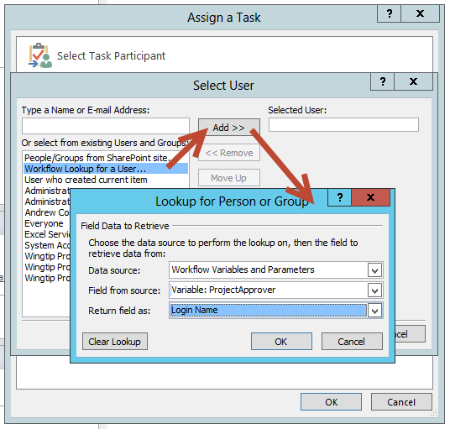

* 1. Click **OK** twice
  2. Using the text builder set the Task Title to **Please Approve: [%Current Item:Title%]**
  3. Your Task assignment should look like this:

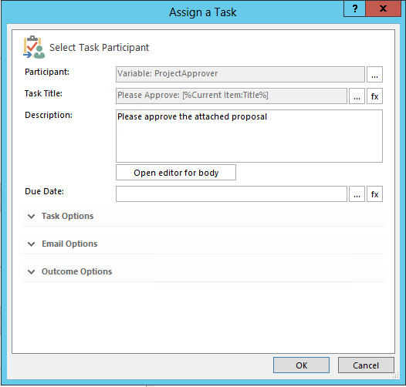

* 1. Click **OK** and your **Stage ready for approval** should look like the following:

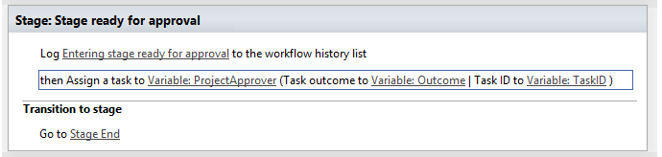

1. Update the **Stage not ready for approval**…
   1. Set the **message** for the first **Log to history list** action to **Entering Stage not ready for approval**.
   2. Set the **message** for the second **Log to history list** action to **Approver not assigned**.
2. Finally, in the **Log to history list** action within the **Stage End**, click the **message** link and enter **Workflow complete**.
3. Click the **Check for Errors** button and resolve any errors noted.
4. Click the **Save** button in the ribbon group **Save** to save your workflow.

#### Deploy and Test the Workflow

1. Publish the workflow to SharePoint 2013 and Workflow Manager:
   1. Click the **Publish** button in the ribbon group **Save**.
2. Create a new **Proposal** document to be a test subject:
   1. Open **Internet Explorer** and browse to <http://intranet.wingtip.com/sites/research>.
   2. In the **Quick Launch** to the left of the page, select **Action Figure Proposals**.
   3. Create a new proposal from the ribbon by selecting **Files** tab and choose **Product Proposal** from the **New Document** button.
   4. After Word opens with the Product Proposal template complete the proposal as follows:
      1. Product Title: **Robert Earl Keen Action Figure**
      2. Estimated List Price: **$14.95**
      3. Estimated Time to Market: **3 Months**
      4. Estimated Cost to Design: **$15,000**
   5. Click **Save** and title the document **Robert Earl Keen Action Figure.** Ensure that you save the document back to the **Action Figures Proposals** library and that you supply a document **Title**.

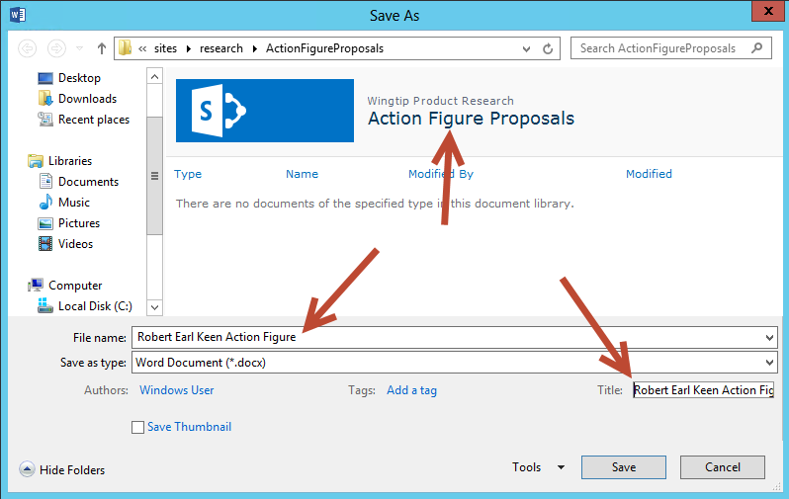

* 1. **Close Word**.

1. Start a new instance of your workflow:
   1. In the browser **Refresh** the **Action Figures Proposal** library and you should see your new proposal.
   2. In the **Action Figures Proposal** library, select the **Robert Earl Keen Action Figure** document (i.e. click on the **check mark area** to the left of the **Robert Earl Keen Action Figure** document). Within the ribbon, select the **Files** tab and then click the **Workflows** button under the **Workflows** group.

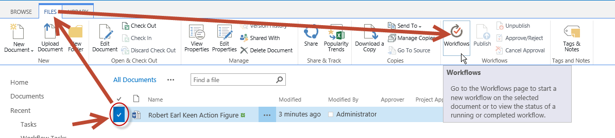

* 1. On the **Action Figure Proposals: Workflows: Robert Earl Keen Action Figure** page, click **Project Approval Workflow** under the **Start a New Workflow** heading.
  2. The workflow will initialize and run to completion. Since we did not add an Approver the workflow history should show that the Approver was not assigned and finish with **Workflow complete**.

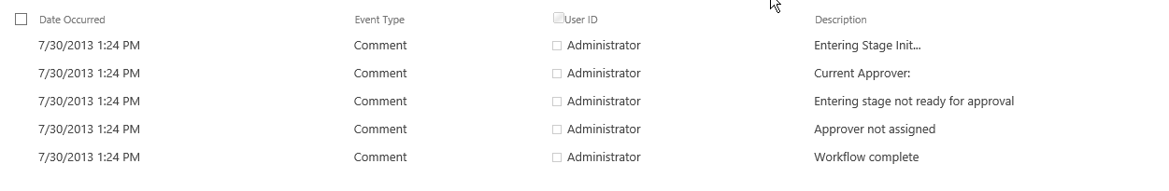

* 1. Return to the Action Figures Proposal library and Edit the properties of the Proposal.

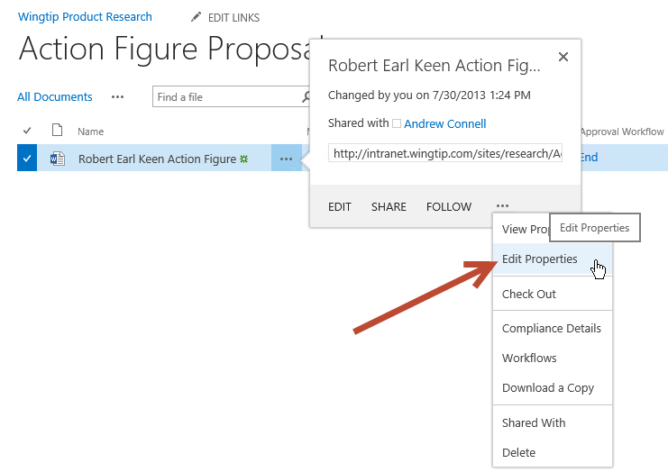

* 1. Set the **Approver** to a User like **Matthew McDermott**.
  2. Click **Save**.
  3. Reinitiate the workflow as you did before by selecting the proposal and choose **Workflows** from the **Files** tab.
  4. Start the **Project Approval Workflow**. You will be returned to the library. After a moment refresh the screen and you should see that the document is now in **Stage ready for approval**.
  5. Click the status link **Stage ready for approval** and you should see that the workflow has entered the **Stage ready for approval** and created an **approval task for Matthew McDermott**.

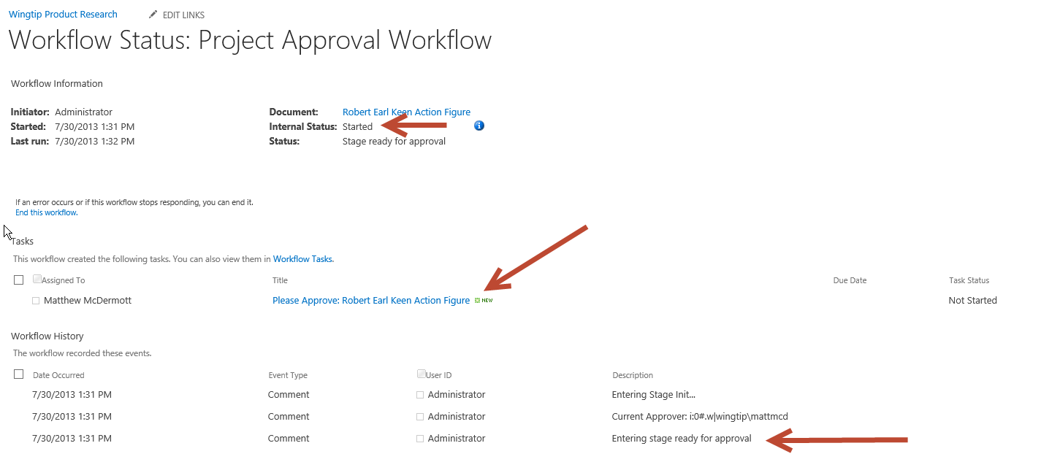

* 1. If this were a real workflow you would wait for Matthew to approve or reject the task and the workflow would complete. In this lab you can chose **Edit** from the **Task drop down menu** and click **Approved** to complete the workflow.
  2. Refresh the **Workflow Status** page and you should see that the **Internal Status** is now **Completed** and the **Workflow History** list ends with **Workflow Complete**.

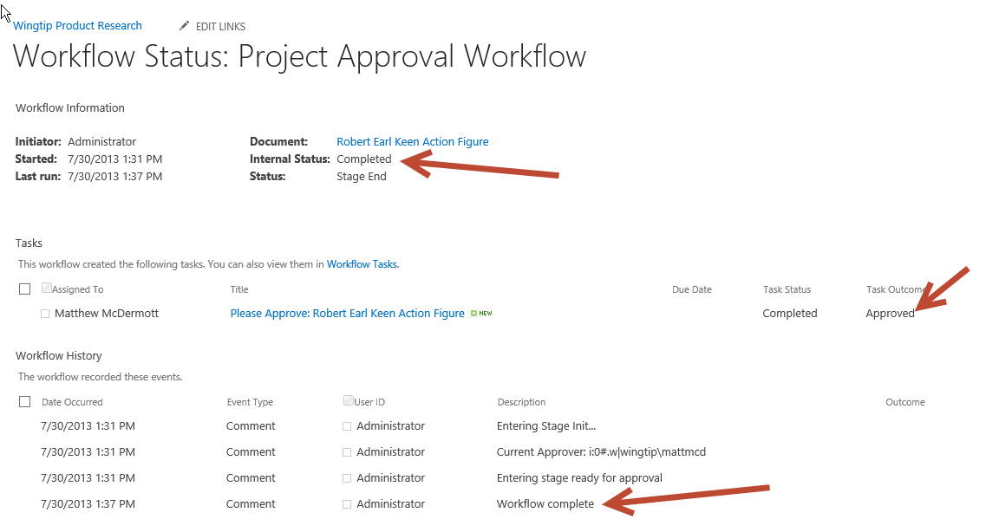

In this exercise you created a new workflow first with Visio 2013 and then completed it using SharePoint Designer 2013. You got some hands on experience with the new stages support and design tools in SharePoint 2013 & Workflow Manager.

### Exercise 3: Call a SharePoint 2010 Workflow from a SharePoint 2013 Workflow

There may come a time when your workflow requirements compel you to take a hybrid approach to your workflow solution. In this exercise we will join our two workflows using a new SharePoint 2013 workflow Activity called **Start SharePoint 2010 List Workflow**.

1. In SharePoint Designer 2013 reopen the **Project Approval Workflow**.
2. In the **Text-Based Designer** view click the title bar for **Stage: Stage ready for approval** to select it.
3. From the Ribbon in the **Insert** group, choose **Stage**.
4. Rename the new stage **Call Create Product Plan**.
5. Add a new **Start a List Workflow** activity to the stage. Change the parameters as follows:
   1. SharePoint 2010 list workflow:
      1. List: **Action Figure Proposals**
      2. Workflow: **Create Product Plan Workflow**

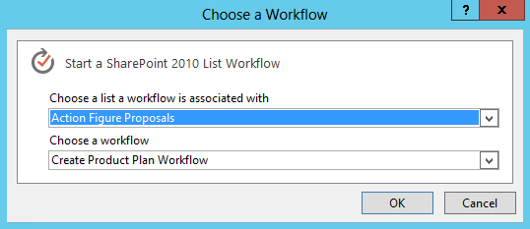

* + 1. Click **OK**.
  1. Click **parameters** and click **OK**. The text should now read “**no parameters**”.
  2. This item: **Current Item**
  3. Click **OK**.

1. In the Transition to stage section create a **Go to a stage** transition to **Stage End**. Your stage should look like this:

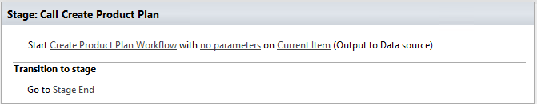

1. Now change the **Stage: Stage ready for approval** to route the approved document to our new stage.
   1. In the Stage: Stage ready for approval delete the Go to Stage End action.
   2. In the Transition to stage section add an **If any value equals value** condition.
   3. Change the **first value** to the **Variable: Outcome** (use the ***fx*** button and look in **Workflow Variables and Parameters**) and the second value to **Approved**.
   4. In the top of the condition (the true part) add a **Go to stage** action and change the target to **Call Create Product Plan**.
   5. In the bottom (the false part) add a **Go to stage** action and change the target to **Stage End**. Your stage should look like this:

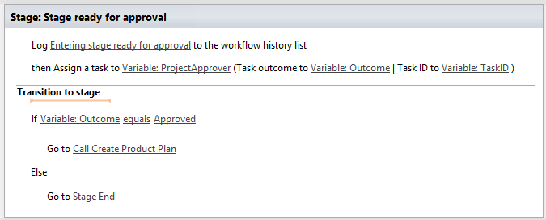

1. Click **Check for Errors** in the ribbon and correct any issues.
2. Click **Save**.

#### Publish and Test the new workflow

1. Now you need to publish the updated workflow and test it. In a browser, return to the **Action Figure Proposals** library and create a new proposal.
   1. From the Files tab chose **New Document | Product Proposal**.
   2. Provide a Product Title of **Lyle Lovett Action Figure**.
   3. Save the document back to the **Action Figure Proposals** library and give it a name of **Lyle Lovett Action Figure**.
   4. Close **Word**.
2. Back in the **Action Figure Proposals** library you should see your saved document.
3. **Edit the Properties** of the Document and add an **Approver** of **Matthew McDermott**.

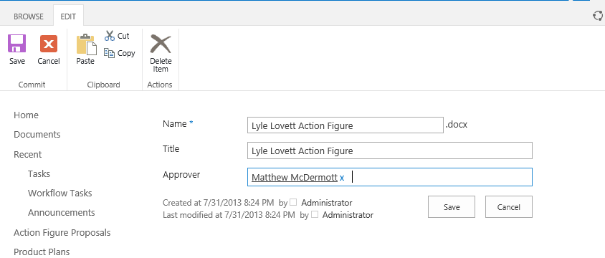

1. Click **Save**
2. As you have done before, select the document and chose **Files | Workflows**.
3. Start the **Project Approval Workflow**.
4. Monitor the workflow status from the Document Library. Once the status reads **Stage ready for approval**, **click** the status text to view the workflow status.
5. **Click the task title** to navigate to the task and view the task details.
6. **Edit the Task assignment** and click **Approved** to force the approval.
7. You will be returned to the Workflow Status page. Refresh the page in in time you will see that the workflow completed successfully.
8. Click the link for the **Product Plans** library in the Quick Launch and you should see a new **Lyle Lovett Action Figure** Product Plan**.**

In this lab you linked a SharePoint 2013 workflow to a SharePoint 2010 workflow and used conditional branching to route your workflow to different stages.