## Creating and Configuring Display Templates

**Lab Time**: 45 minutes

**Lab Folder**: C:\Student\Modules\DisplayTemplates\Lab

**Lab Overview**: In this lab you will get hands-on experience working with Display Templates in SharePoint 2013. SharePoint uses display templates to present information. JavaScript can be used to perform many different visual and functional tasks. In this lab you will get a feel for how to use HTML and JavaScript to present information.

**Beta Class Notes:** This lab requires a Products list with images configured on the Intranet. It also requires that a Search Crawl has run after the list is created. The list creation and population utilities will create the list.

1. RecreateWingtipIntranetSite
2. ContentTypesSolution.exe
3. DocumentLibrariesSolution.exe

### Exercise 1: Adding JavaScript code to a page using the Script Editor Web Part

In this exercise you will use a utility web part to add JavaScript to a page. This is a simple Hello World demo to understand how to inject script into a SharePoint page.

1. Locate the **SharePointGenerateCustomers.exe** utility in the lab files. Double click the utility to run it. This will create a Customers list in the Intranet Team Site and populate it with data.
2. Browse to the [Team Site]. Choose the **Customers** list from the quick launch.
3. Choose **Settings | Edit Page**.
4. In the **Main** web part zone click **Add a Web Part**.
5. Under **Categories** select the **Media and Content** folder.
6. Under **Parts** select the **Script Editor Web Part**. Click the **Add** button to insert the web part into the page.

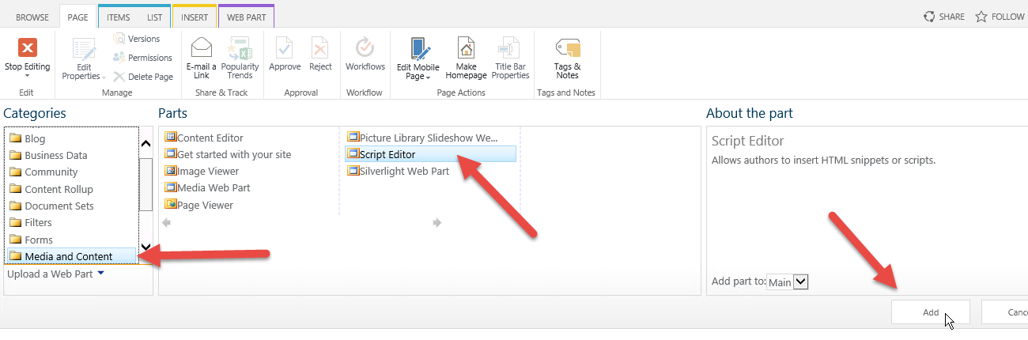

1. You should now see the **Script Editor** Web part on the page. Click **EDIT SNIPPET** in the Web part.
2. Open **HelloWorld.js** from the lab files folder in **NotePad** and **Copy** the entire contents to the clipboard. **Paste** the script code from the **HelloWorld.txt** file into the **Embed** dialog. Click **Insert** to close the dialog.

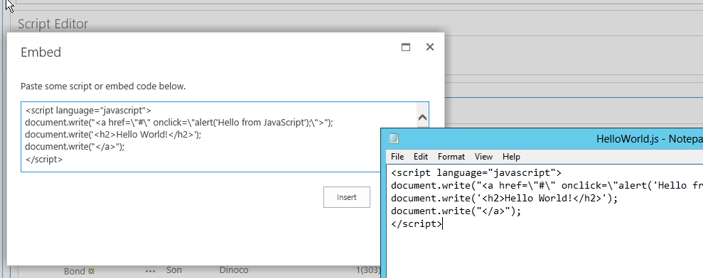

1. Click **Stop Editing** in the ribbon to save your changes. When the page reloads you should see the text “Hello World” on the page. Click **Hello World** and you should see an alert message from the web page that says “Hello from JavaScript”.

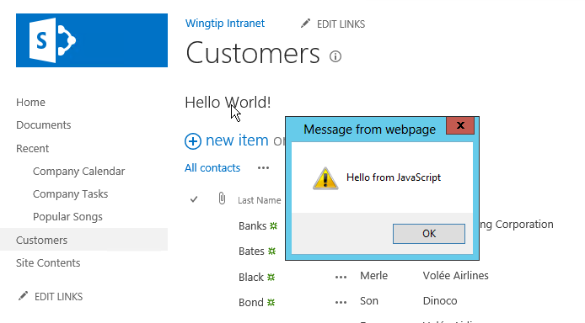

**In this lab you added a simple code snippet to a SharePoint page to add functionality from JavaScript. In the next lab you will expand on this technique to change the look and feel of an out of the box SharePoint list view.**

### Exercise 2: Customizing a SharePoint List Display Template using JavaScript

In this exercise you will create a new Customers list and then change the display of the list by adding JavaScript to the page that dramatically changes the look of the items on the page.

1. Remain on the Customers AllItems.apsx page. Click **Settings | Edit Page**.
2. Click **EDIT SNIPPET** in the body of the **Script Editor** Web part.
3. Open the **CustomerTemplate.txt** file in Notepad and **Copy** the entire contents to the clipboard.
4. **Paste** the code into the **Embed** dialog and click **Insert** to close the dialog.
5. **Click Stop Editing** on the **Page** tab of the ribbon.
6. The page should render a very different look for the view.

**In this lab you changed the look of a SharePoint list form by using JavaScript and a custom render template.**

### Exercise 3: Creating Display Templates for Search Results

Display Templates are the key to presenting Search results. You will begin in Design Manager and create a copy of an existing template. You will then modify that template to look the way you want it, including the picture of the product in the search result.

1. Browse to the Search Center at **http://intranet.wingtip.com/search**
2. Navigate to **Settings |** **Design Manager**.
3. From the **Design Manager** home page, choose **3. Upload Design Files**.
4. On the **Design Manager: Upload Design Files** page, click the link for **http://intranet.wingtip.com/search/_catalog/masterpage**. This will open an Explorer window to the site’s **Master Page Gallery**.

If the browser throws an error, remove the “@80” from the URL and try again.

1. Navigate to **Display Templates/Search**
2. Locate the **Item_Picture.html** file and copy it to your desktop.
3. Rename the file to **Item_Product.html**.
4. Open the file in **Notepad++**
5. Find the **<title>** tag and change it to **<title>Product Item</title>**
6. Locate the **<mso:ManagedPropertyMapping** node andadd the following properties, all on one line, as follows:
   1. ,'ProductCodeOWSTEXT':'ProductCodeOWSTEXT'
   2. ,'ProductColorOWSCHCM':'ProductColorOWSCHCM'
   3. ,'ProductDescriptionOWSMTXT':'ProductDescriptionOWSMTXT'
   4. ,'ProductImageUrlOWSURLH':'ProductImageUrlOWSURLH'
   5. ,'ProductListPriceOWSCURR':'ProductListPriceOWSCURR'
7. Locate the tag <div id="_#= $htmlEncode(itemId)tag and delete the highlighted lines below.

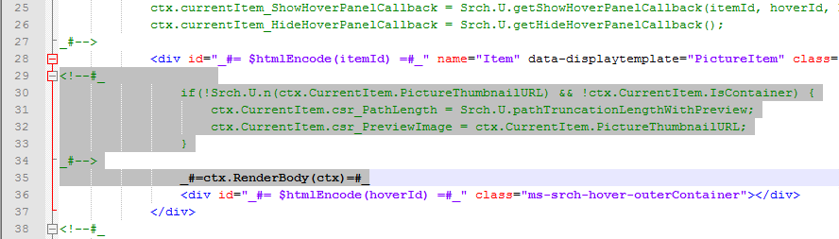

1. Locate the **[labfiles]\DisplayTemplates\Lab\SearchProduct.txt** file and paste it into the space you just created. (Or if you love typing, you can type it all in.)
2. **Save** the file.
3. Drag the file into the **Search** directory to copy it to SharePoint.
4. Refresh the directory and you should notice that SharePoint made a copy of your file with a .JS extension.

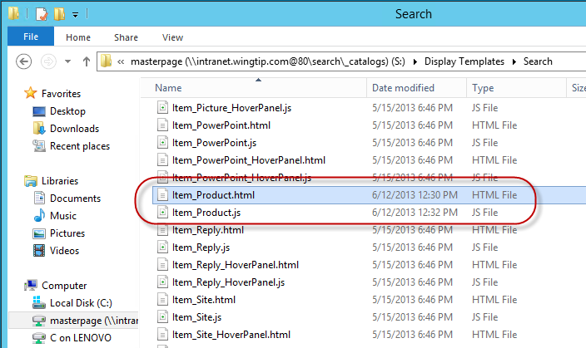

1. Now you need to tell SharePoint to use your display template. You do this by creating a **Result Type** rule. In the Search site **http://intranet.wingtip.com/search** choose **Site Actions | Site Settings**.
2. Click **Search Result Types** under **Site Collection Administration**.
3. On the **Manage Result Types** page chose **New Result Type**.
4. Complete the new **Result Type** as follows:
   1. Name: **Products**
   2. Which source should results match?: **Local SharePoint Results**
5. Click **Show more conditions** and set the Custom Property as follows:
   1. Property: **ContentType**
   2. **Equals any of…**
   3. Value: **Product**

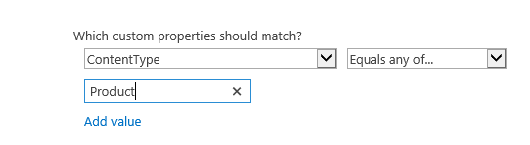

1. Complete the Result Type by assigning the Display Template you created to the **What should these results look like**: **Product Item**
2. Click **Save**.
3. To test your work return to the **Search** site and execute a Product search like **“Action”** or **“WP*”** and you should see a different result type. (Your action figures may be on page 2 of the results.)

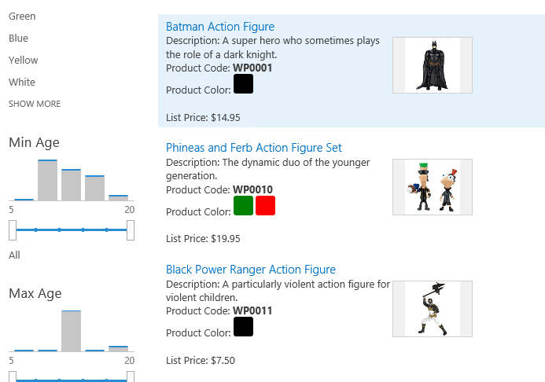

In this lab you created a custom display template and associated it with the Product Content Type with a Result Type.

### Exercise 4: Configuring the Content By Search Web Part with a Display Template

In this exercise you will add a Content by Search Web part to the [www.wingtip.com](http://www.wingtip.com) site and configure it with an out of the box Display Template. Then you will upload a custom Display template.

1. Browse to the [Publishing Site].
2. Click **Site Settings | Edit Page**.
3. Locate the Right Web part zone and click **Add a Web Part**.
4. Select the **Content Rollup** folder in the **Categories** list. Select the **Content Search** web part in the **Parts** list.
5. Click the **Add** button to insert the Web part into the zone.
6. In the **Content Search** Web part, click the menu and chose **Edit Web Part**. (Alternatively you can select the Web part and then chose the **Web Part** tab in the ribbon and chose **Web Part Properties**.)
7. In the **Content Search Properties** panel click the **Change Query** button.
8. Click the link **Switch to Advanced Mode**.
   1. Ensure the **Select a query** selection is **Local SharePoint Results (System)**.
   2. Clear the **Query text** box and enter **ContentType:Product**. Click the **Test query** button and you should see results from the Product list.

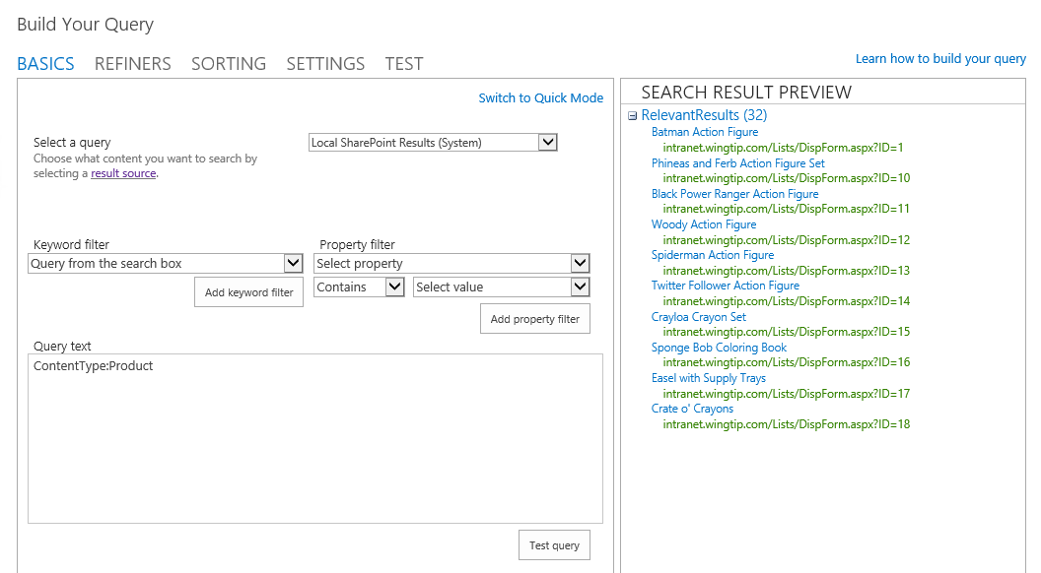

* 1. Click **OK** to close the dialog.

1. Change the **Number of items to show** to **5**.
2. Expand the **Property Mappings** section and **check** **Change the mapping of managed properties…**
   1. Change the **Picture URL** property to **ProductImageUrlOWSURLH**.
   2. Change **Line 2** to **ProductDescriptionOWSMTXT**.
   3. Change **Line 3** to **ProductCodeOWSTEXT**.
   4. Click **OK**.

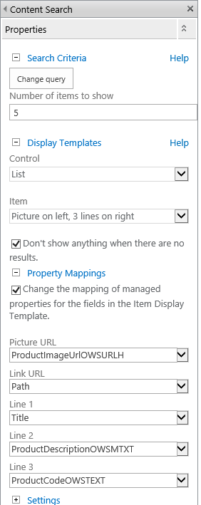

1. Check in the page and you should see your configured Products list.

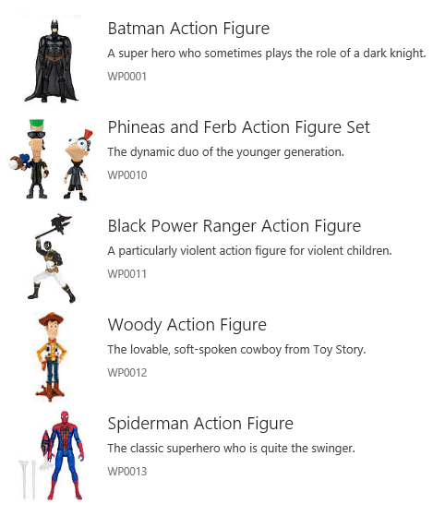

If the out of the box look of the Content Search Web part does not meet your needs you can change the look with Display Templates. In this case it does not display the available colors. We’ll fix that now.

1. Return to the **Master Page Gallery** window in Windows Explorer.

If you closed the window, select **Site Actions | Design Manager**. In **Design Manager** click the link for **Step 3**. Choose the link **[Publishing Site]/_catalogs/masterpage** to open the library in Windows Explorer.

1. The display templates for the Content Search Web part are stored in the “Content Web Parts” folder. Browse to **[Publishing Site]_catalogs\masterpage\Display Templates\Content Web Parts.**
2. Locate the file **Item_Picture3Lines.html**. Copy it to your desktop.

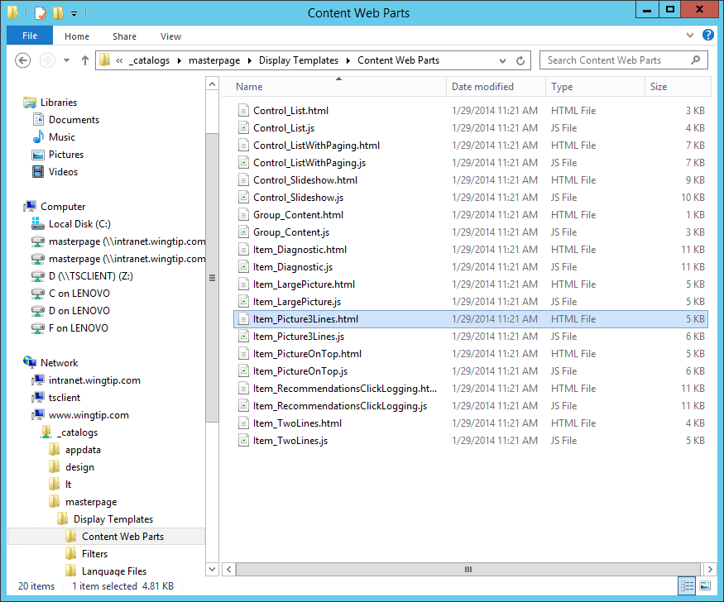

1. Rename the file to **Item_Product3Lines.html**. Open the file with Notepad.
2. Locate the **<title>** tag and change it to:

<title>Product on left, 3 lines on right</title>

1. Locate the tag **<mso:ManagedPropertyMapping** and add the following code to the end of the tag, just inside the closing tag.

,'ProductColorOWSCHCM'

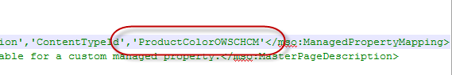

1. Locate the last comment before the end of the closing </div> tags and add a new line. This should be line 114.

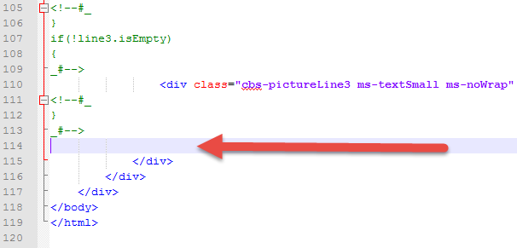

1. Open the **ProductColor.txt** file from [Lab Files]\DisplayTemplates\Lab and paste it on line **114**.

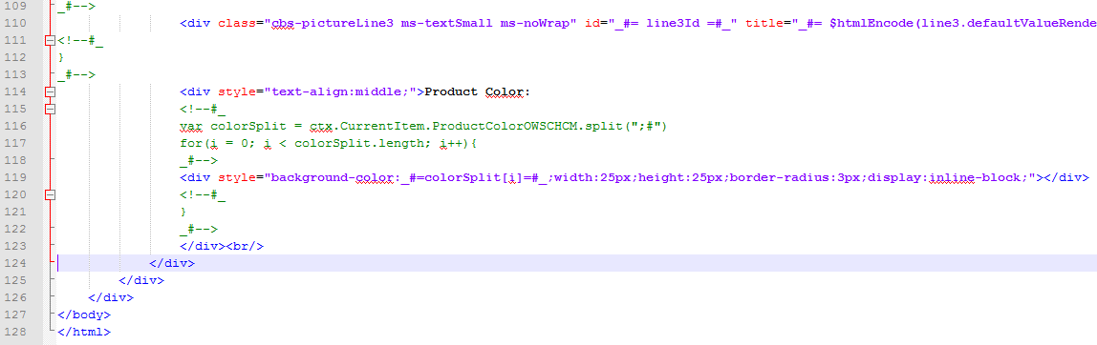

1. **Save** the file and close Notepad.
2. Copy the file back to the **Content Web Parts** directory**. Refresh** the view and notice that there is now a **Item_Product3Lines.js** file created by SharePoint.

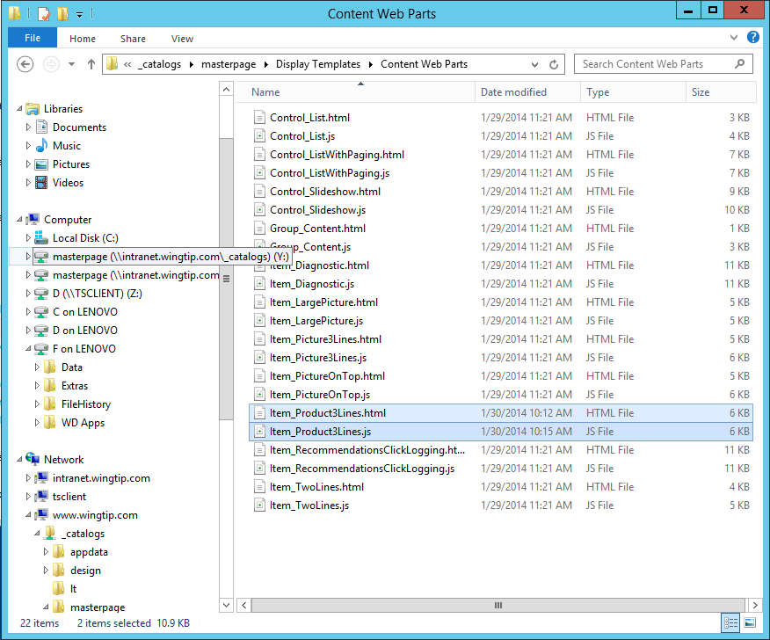

1. Return to the home page in the browser and **Edit** the page. In the ribbon chose **Page | Edit**.
2. **Edit** the **Content Search** Web part.
3. In the **Display Templates** section change the **Item** selection to **Product on left, 3 lines on right**. (This will clear the previous values you entered.)
4. Expand the **Property Mappings** section. Select the **checkbox** to **Change the mapping…**
5. Update the property mappings as follows:
   1. Picture URL: **ProductImageUrlOWSURLH**
   2. Line 2: **ProductDescriptionOWSMTXT**
   3. Line 3: **ProductCodeOWSTEXT**
6. Click **OK** to save the Web part settings.
7. **Save** the page and your web part should now display the custom fields from the Product content type.

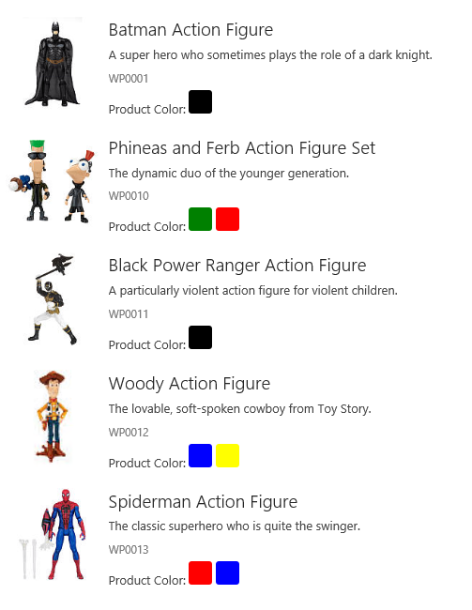

**In this lab you configured a Content by Search web part with a custom query and used the fields editor to display custom content type fields. Then you created a custom display template and configured it in the Web part tool panel.**