## Creating and Testing Custom Master Pages

**Lab Time**: 45 minutes

**Lab Folder**: C:\Student\Modules\MasterPages\Lab

**Lab Overview**: In this lab you will get hands-on experience creating a new custom master page and adding it to the Publishing Site so you can work on it in editing mode.

### Exercise 1: Creating a Custom Master Page

In this exercise you will create a custom master page named **denver.master** which uses the content of the standard master page named **seattle.master** as its starting point.

1. Launch the Windows Explorer and access the mapped Z:\ drive that you created in the previous lab on Design Manager. This should allow you to see and modify the files that are inside the master page gallery of the Publishing Site.

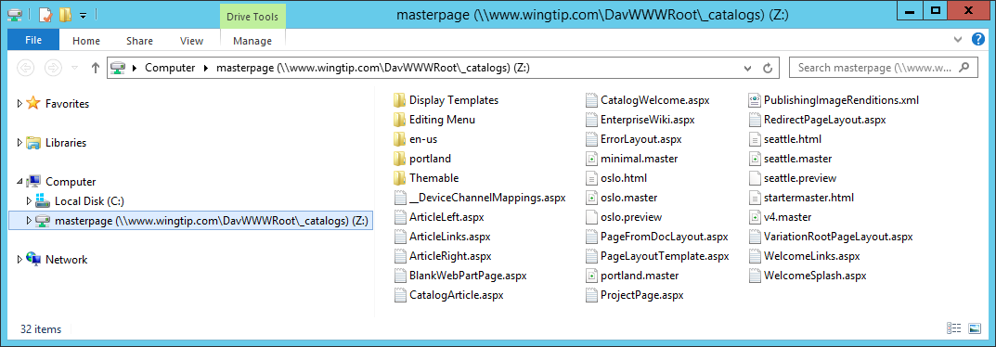

If you do not see a mapped **Z:\** drive, you did not yet complete the previous lab on Design Manager or you did not persist the settings for the mapped drive. If this is the case, you should stop your work on this lab until you go back to the **Design Manager** lab and complete **Exercise 1: Mapping the Master Page Gallery** in which you will create a mapped **Z:\** drive to access the Master Page Gallery. Once you have completed this previous exercise, you may then continue on from this point in this lab exercise.

1. Locate the custom master page named **denver.master** that you will use as a starting point.
   1. Open a second instance of the Windows Explorer and navigate to the folder for this lab at the following path.

C:\Student\Modules\MasterPages\Lab

* 1. When you look inside the **C:\Student\Modules\MasterPages\Lab** folder, you will see a folder named **MasterPages**.
  2. If you look inside the **MasterPages** folder, you will find a master page file named **denver.master** and a folder named **denver**.

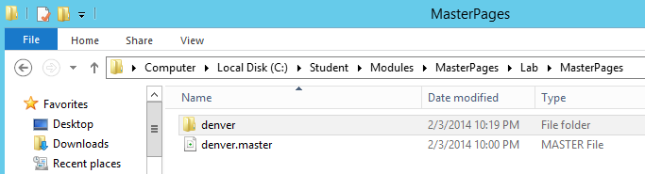

* 1. If you look inside the **denver** folder, you will see it contains a single CSS file named **styles.css** and a folder named **img**.

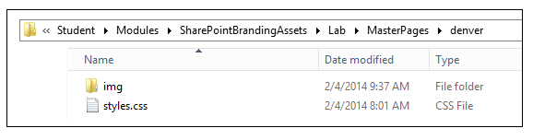

* 1. The **img** folder contains two imagery files named **RainyWindow.jpg** and **wingtip-logo-small.png**.

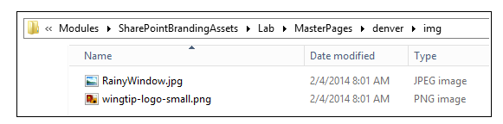.

Note that **denver.master** is currently a reformatted copy of **seattle.master**. Over the course of this lab, you will make modifications to the custom master page file **denver.master** to make it different and unique from **seattle.master**.

1. Add **denver.master** and the associated CSS file to the Master Page Gallery.
   1. **Position the first Windows Explorer view with the mapped Z:\ drive and the second Windows Explorer view with denver.master so you can see both windows at the same time.**
   2. **In Windows Explorer, select the master page file named denver.master and the denver folder at the same time and then drag and drop them onto the mapped Z:\ drive to copy these files to the Master Page Gallery.**

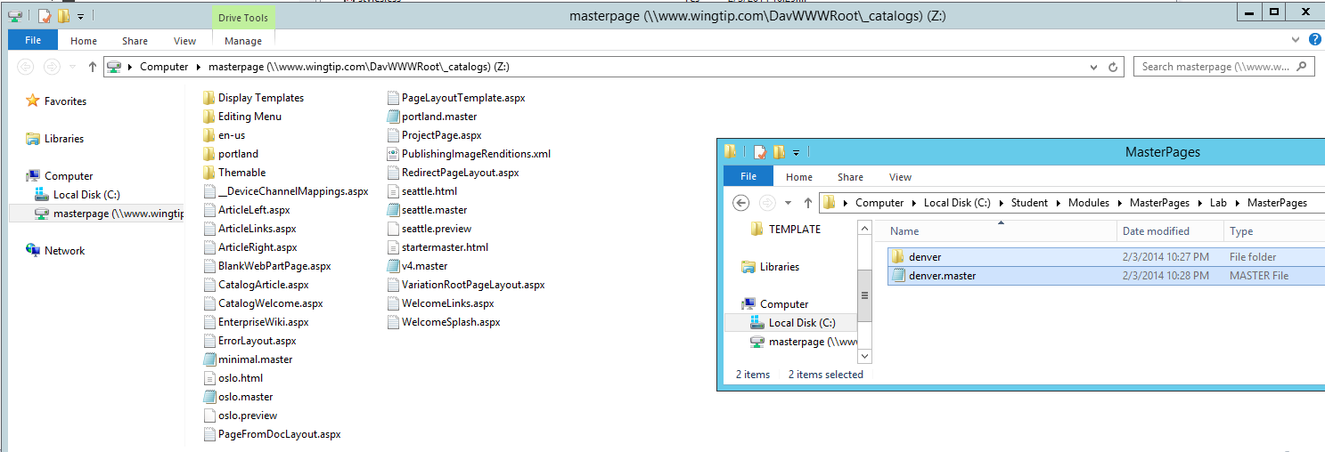

* 1. When you are done, you should be able to see **denver.master** and the **denver** folder in the mapped **Z:\** drive.

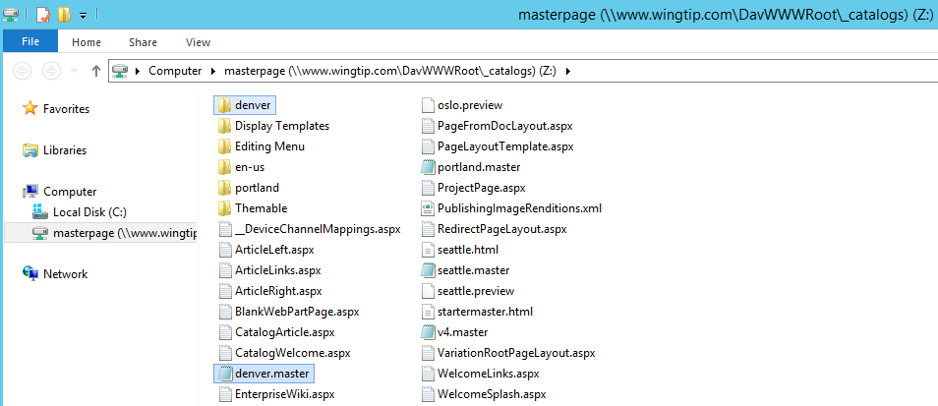

1. Publish the custom master page named **denver.master**.
   1. Launch Internet Explorer and navigate to the Publishing Site at <http://www.wingtip.com> if you are not already there.
   2. Using the **Site Actions** menu, navigate to the **Site Settings** page.
   3. In Web Designer Galleries section, click the Master pages and page layouts link to navigate to the Master Page Gallery.
   4. Locate the file for the custom master page named **denver.master**.
   5. Drop down the ECB menu of the **denver.master** file and click **Publish a Major Verion**.

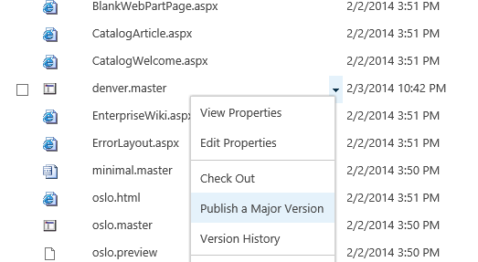

* 1. When you publish a master page like this, SharePoint prompts you with a page to add comments. You can leave the **Comments** field empty and click **OK** to complete the publishing process.

1. Apply the custom master page named **denver.master** as the Site Master Page.
   1. Using the **Site Actions** menu, navigate to the **Site Settings** page.
   2. In **Look and Feel** section, click the **Master page** link to navigate to the **Site Master Page Settings** page.
   3. On the **Site Master Page Settings** page, drop down the menu that shows the master pages which can be applied to the current site. You should see that **denver** is now available in addition to the other master pages such as **seattle** and **oslo**.
   4. In the **Site Master Page** section, specify the master page to be **denver** and check the checkbox with the caption **Reset all subsites to inherit this site master page setting**. Do not make any changes to the **System Master Page** section yet. When your page looks like the following screenshot, click the **OK** button to save your changes.

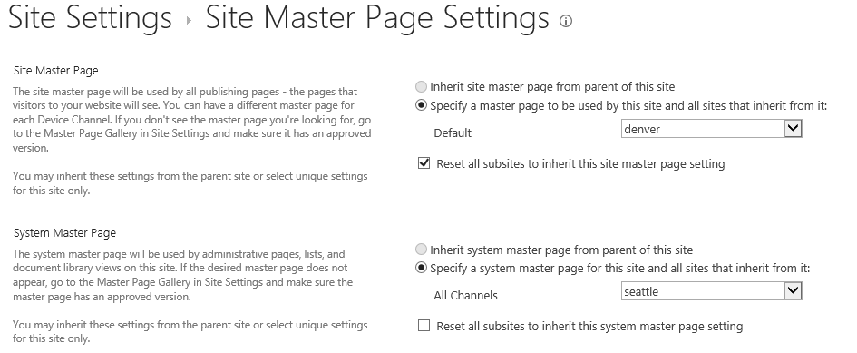

* 1. Click on the **Home** link in the top link bar to navigate to the welcome page in the top-level site. At this point, all the publishing pages throughout the site collection should be rendered using **denver.master**. However, you cannot see any changes yet because **denver.master** is currently an exact copy of **seattle.master**.

1. Make a simple edit to **denver.master**.
   1. Using Windows Explorer, locate the **denver.master** file which is located in the mapped Z:\ drive.
   2. Right click on **denver.master** and click the command **Open with >> Notepad** to open the master page in **Notepad.exe**.

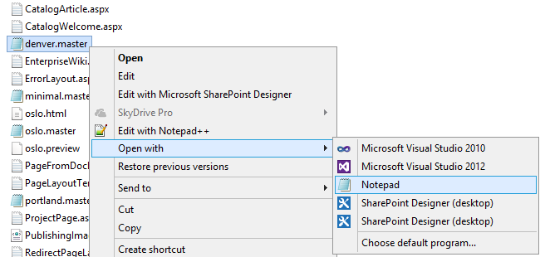

If you prefer a different editor than Notepad.exe, you can open the master page in a richer editor such as Visual Studio, Notepad ++ or Dream Weaver. The one tool which will not work in this situation is the SharePoint Designer which can only open files inside a SharePoint site using HTTP. SharePoint Designer cannot be used to open files from a local drive or a mapped drive.

* 1. **Once you have opened denver.master in a text editor, you will see that it contains quite a bit of content.**
  2. **Scroll down the master page and locate the opening <body> tag.**

****<SharePoint:CssRegistration ID="CssRegistration1" Name="Themable/corev15.css" runat="server" />****

****</head>****

****<body>****

****<SharePoint:ImageLink ID="ImageLink1" runat="server"/>****

****<SharePoint:SPNoScript ID="SPNoScript1" runat="server"/>****

* 1. **Insert your cursor directly after the opening <body> tag and insert a few new spaces. Add a test <div> element with a simple text message This is a Test as shown in the following a code listing.**

****<SharePoint:CssRegistration ID="CssRegistration1" Name="Themable/corev15.css" runat="server" />****

****</head>****

****<body>****

****<div>This is a Test</div>****

****<SharePoint:ImageLink ID="ImageLink1" runat="server"/>****

****<SharePoint:SPNoScript ID="SPNoScript1" runat="server"/>****

* 1. **Save your changes to denver.master. However, make sure to leave denver.master open in the editor you are using because you will soon return to this editor to make additional changes to denver.master.**

1. **Test your work.**
   1. **Using the browser, navigate to the welcome page for the Publishing Site at** <http://www.wingtip.com>**.**
   2. **Refresh the page.**
   3. **You should see your test message from the edit you made to denver.master.**

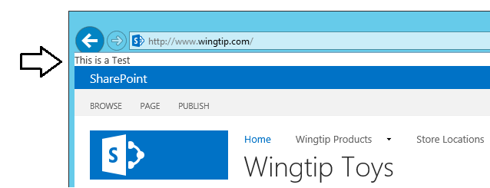

* 1. **Return to the editor where you are editing denver.master.**
  2. **Remove the <div> element you added in the previous step and save your changes.**
  3. **Using the browser, refresh the welcome page of the Publishing Site. You should see that the test message has now disappeared.**

**As you can see, you can make changes to a custom master page with an editor like Notepad, Notepad++ or Visual Studio and save your changes which are instantly reflected on the pages in the site where you have applied our custom master page.**

### Exercise 2: Linking a Custom Master Page to a CSS File

In this exercise you will link the custom master page named **denver.master** to its associated CSS file named **styles.css**.

1. Using Windows Explorer, look inside the Denver folder of the mapped **Z:\** drive and locate the CSS file named **styles.css**.

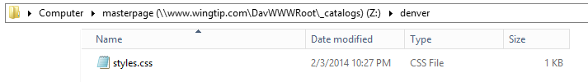

1. Open **styles.css** by right-clicking the file and selecting the **Open With** menu command with an editor such as Notepad, Notepad++ or Visual Studio. Once you open **styles.css**, you should be able to see it contains a single CSS rule to make a very obvious change to the styling of the page by adding a top margin of 50px and a background color of red.

body {

margin-top: 50px;

background-color: red;

}

The main reason we added this CSS rule to **styles.css** was to make it obvious when you have successfully linked to this style sheet.

1. Link **denver.master** to **styles.css**.
   1. Return to the editor in which you are editing the master page files named **denver.master**.
   2. Scroll within the page until you find the closing tag for the **<head>** section.

<SharePoint:CssRegistration ID="CssRegistration1" Name="Themable/corev15.css" runat="server" />

</head>

<body>

<SharePoint:ImageLink ID="ImageLink1" runat="server"/>

* 1. **Insert your cursor directly before the closing <head> tag and insert a few new spaces.**
  2. **Add a CssRegistration control just before the closing head section using the attributes shown in the following a code listing.**

<SharePoint:CssRegistration ID="CssRegistration1" Name="Themable/corev15.css" runat="server" />

<SharePoint:CssRegistration

name="<% $SPUrl:~sitecollection/_catalogs/masterpage/denver/styles.css %>"

After="SharePointCssFile" runat="server" />

</head>

<body>

<SharePoint:ImageLink ID="ImageLink1" runat="server"/>

* 1. Save your changes to **denver.master**.

1. **Test your work.**
   1. **Using the browser, navigate to the welcome page for the Publishing Site at** <http://www.wingtip.com>**.**
   2. **Refresh the page.**
   3. **You should see a big red section at the top of the page which means you have successfully linked denver.master to the CSS files named styles.css.**

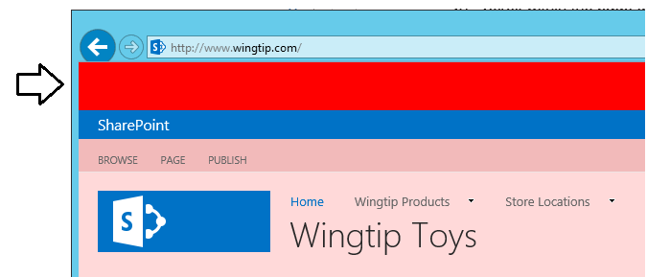

* 1. **Return to the editor where you are editing styles.css.**
  2. **Remove the CSS rule in styles.css so that this CSS file is empty and then save your changes to styles.css.**
  3. **Using the browser, refresh the welcome page of the Publishing Site. You should see that the red section of the page has disappeared.**

1. **Add a CSS rule to change the color of the left-hand side of the Suite Bar.**
   1. **Add the following code to styles.css.**

****#suiteBarLeft {****

****background-color: #000044;****

****}****

* 1. **Save your changes to styles.css.**
  2. **Return to the home page of the Publishing site and refresh the page. You should that the left-hand side of the Suite Bar now displays in a darker shade of blue.**

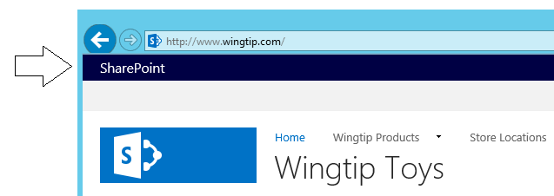

1. **Hide a few of the unwanted standard SharePoint page elements.**
   1. **Examine the upper right-hand side of the page. Locate the three suite bar links NewsFeeds, SkyDrive and Sites and the Help icon in the top row. Also note the presence of the Promoted Actions which include the SHARE button and the FOLLOW button in the row below.**

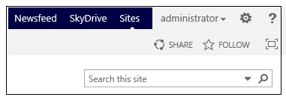

* 1. **Return to the editor with styles.css.**
  2. **Add a CSS rule to hide the suite bar links.**

****#DeltaSuiteLinks {****

****display: none;****

****}****

* 1. **Add a CSS rule to hide the Help icon.**

****#ms-help {****

****display: none;****

****}****

* 1. **Add a CSS rule to hide the promoted action button.**

****.ms-promotedActionButton {****

****display: none !important;****

****}****

* 1. **Test your work. You should see that the suite links, the Help icon and the promoted actions have been removed from the page.**

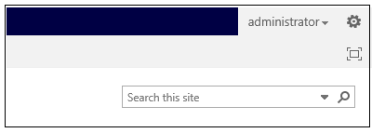

1. **Add a CSS rule to hide the EDIT LINKS link in the top link bar.**
   1. **Note the presence of the EDIT LINKS link in the top link bar.**

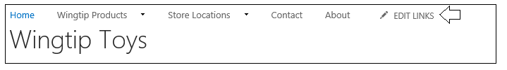

* 1. **Add the following CSS rule to styles.css and save your changes.**

****.ms-navedit-editSpan {****

****display: none;****

****}****

* 1. **Test your work by returning to the browser and refreshing the home page of the Publishing Site. You should see that the EDIT LINKs link has been removed from the top link bar.**

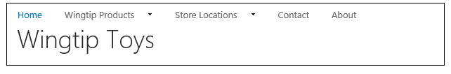

1. **Add a CSS rule to hide the Site Contents link in Quick Launch.**
   1. **Note the presence of the Site Contents link in Quick Launch.**

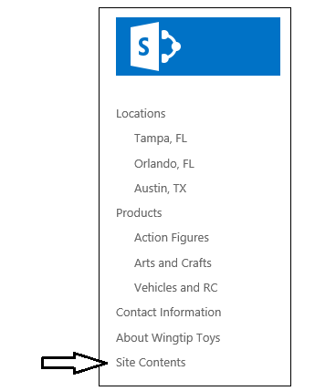

* 1. **Add the following CSS rule to styles.css and save your changes.**

****.ms-core-listMenu-verticalBox > a.ms-core-listMenu-item[href$="viewlsts.aspx"] {****

****display: none;****

****}****

* 1. **Test your work by returning to the browser and refreshing the home page of the Publishing Site. You should see that the Site Contents link has been removed from Quick Launch.**

1. **Add a few CSS rules to add a custom site logo.**
   1. **Currently, your custom master page is displaying the standard SharePoint site logo.**

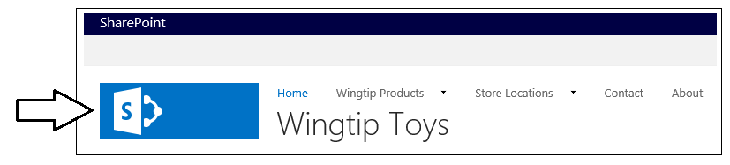

* 1. **Add the following CSS rules to replace the standard SharePoint site logo with a custom site logo.**

****#s4-titlerow{****

****margin-top: 0px;****

****padding-top: 0px;****

****}****

****.ms-siteicon-img {****

****display: none;****

****}****

****#siteIcon {****

****margin-top: 8px;****

****margin-left: 20px;****

****background-image: url('img/wingtip-logo-small.png');****

****background-repeat: no-repeat;****

****}****

****#siteIcon, .ms-siteicon-a {****

****width: 132px;****

****height: 80px;****

****}****

* 1. **Save your changes and see what you have done.**

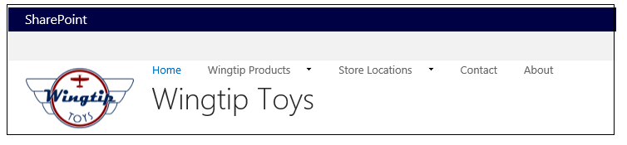

1. **Style the search box.**
   1. **Look at search box as it currently exists. Notice that it is pushed up against the row above.**

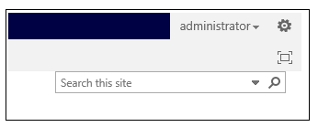

* 1. **Add the following CSS rule to provide a little padding for the search box.**

****#DeltaPlaceHolderSearchArea{****

****margin-top: 16px;****

****margin-right: 8px;****

****}****

* 1. **Save styles.css and then return to the browser and refresh the page. You should see the search box now has a bit of padding and isn’t pressed up against the row above.**

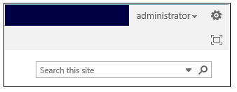

1. **Modify the custom master page to support a fixed width page.**
   1. **Make sure you have denver.master open in an editor.**
   2. **Scroll down in denver.master until you find the following line of code.**

****<a id="HiddenAnchor" href="javascript:;" style="display: none;"></a>****

* 1. **Insert your cursor after that <a> element and insert a few spaces between that line and the following line that has the opening tag for the div element with an id of suiteBar. Add a new opening tag for a div element with an id of page_width.**

****<a id="HiddenAnchor" href="javascript:;" style="display: none;"></a>****

****<div id="page_width">****

****<div id="suiteBar" class="ms-dialogHidden noindex">****

* 1. **Now scroll down the master page until just before the bottom where you will find the following closing tag.**

****</SharePoint:SharePointForm>****

* 1. **Insert your cursor before that </SharePoint:SharePointForm> element and insert a few spaces between that line and the line that comes before. Add the closing tag for the page_width div element.**

****</div>****

****</SharePoint:SharePointForm>****

* 1. **When you are done, confirm that the page_width div you added now contains the div elements with the ids of suiteBar, ms-hcTest, s4-ribbonrow and s4-workspace.**

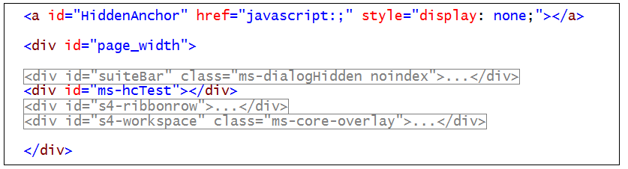

* 1. **Locate the div with the id of s4-workspace and apply the s4-nosetwith class**

****<div id="s4-workspace" class="ms-core-overlay s4-nosetwidth">****

* 1. **Save your changes to denver.master.**

1. **Add a CSS rule to apply a fixed page width to the div element with the id of page_width.**
   1. **Return to styles.css in the editor.**

****body.ms-backgroundImage{****

****background-image: url("img/RainyWindow.jpg");****

****background-repeat: repeat;****

****background-size: auto;****

****}****

****#page_width {****

****width: 1024px;****

****margin: auto;****

****background-color: white;****

****}****

****#s4-bodyContainer{****

****width: 960px;****

****margin:auto;****

****}****

****.ms-dialog #s4-workspace{****

****background-color: white;****

****}****

****.ms-dialog #s4-bodyContainer{****

****margin: 0px;****

****width: auto;****

****}****

****.ms-dlgContent #s4-bodyContainer{****

****width: auto;****

****}****

* 1. **Save your changes to styles.css and go refresh the page to see what you have done. You should see your page now has a fixed width.**

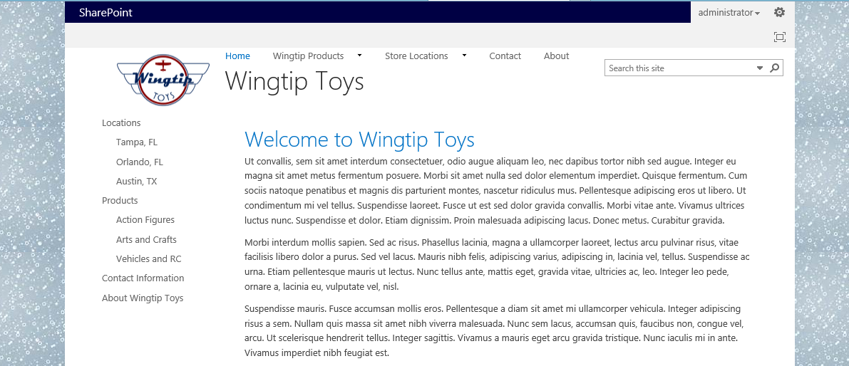

1. **Move the control tags for the top link bar into their own row.**
   1. **Locate the following line in denver.master.**

****<SharePoint:AjaxDelta ID="DeltaTopNavigation" ...****

* 1. **Cut the entire SharePoint:AjaxDelta control tag to the Windows clipboard.**
  2. **Scroll down and locate the open tag for the div element with an id of contentRow and add a new div with the id of top_nav.**

****<div id="top_nav">****

****</div>****

****<div id="contentRow">****

* 1. **Copy the contents of the Window Clipboard into the top_nav div to add the top link bar.**
  2. **Save your changes to denver.master.**
  3. **Add styling for the top link bar by copy and pasting the contents of the file named toplinkbrstyles.css.txt which you can find in the CheaterSnippets folder. Copy the CSS rules out of this file and paste them into the bottom of styles.css.**
  4. **Save changes to styles.css and refresh the page to see the effect of your changes.**

