## Creating and Configuring Page Layouts

**Lab Time**: 45 minutes

**Lab Folder**: C:\Student\Modules\PageLaoyouts\Lab

**Lab Overview**: In this lab you will get hands-on experience working with.

### Exercise 1: Creating Site Columns and a Page-derived Content Type

In this exercise you will work with page layouts.

1. Launch the browser and navigate to the Publishing Site at **http//:www.wingtip.com**.
2. Select **Site Actions » Site Settings**.
3. Select **Galleries** **»** **Site columns**. You will see all the existing site columns for the current site.
4. To create a new column, click **Create**. On the **New Site Column** page use the following information to create a new site column:
   1. **Column Name**: Driving Directions
   2. **Type of information in this column is**: Full HTML content with formatting and constraints for publishing
   3. **Group**: New Group » Wingtip Site Columns

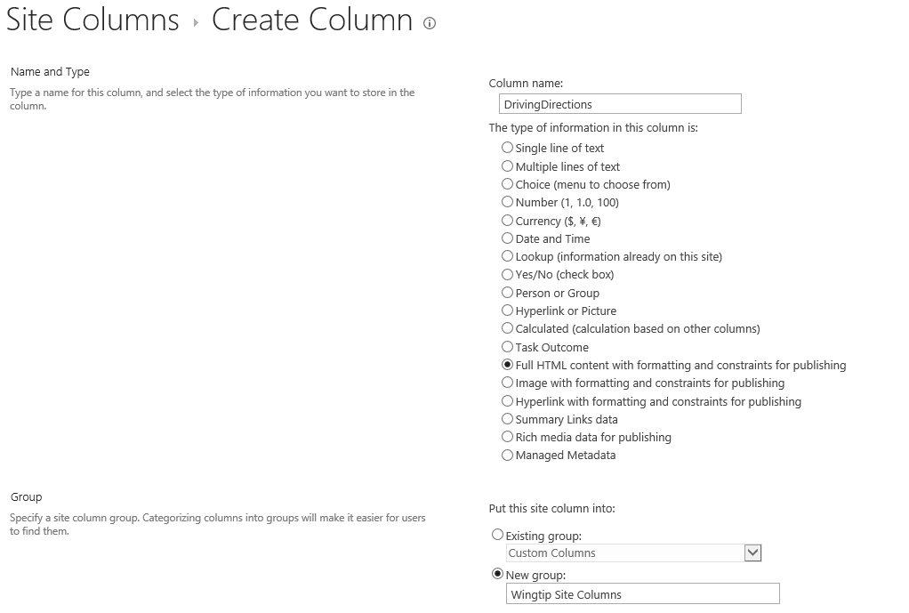

* 1. Click the **OK** button on the bottom of the page to save the new site column.

1. Create a second site column using the following details:
   1. **Column Name**: StoreHours
   2. **Type of information in this column is**: Full HTML content with formatting and constraints for publishing
   3. **Group**: Existing Group » Wingtip Site Columns
2. After you have created these two site columns, you should be able to verify that you have added them to the site column gallery.

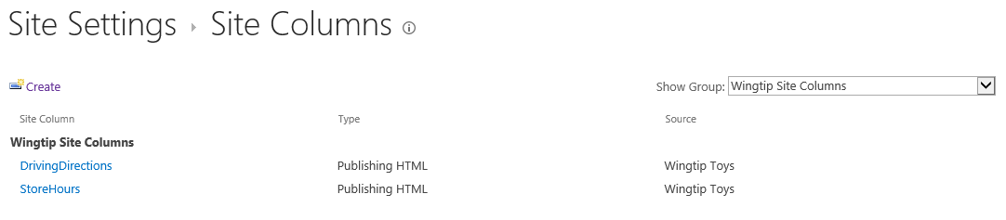

1. Modify the site column display names to include spaces. When you are done, they should appear as the site columns shown in the following screenshot.

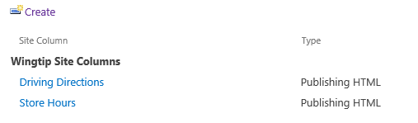

Now that you have created two site columns, you will now create a content type which utilizes the two site columns you just created. This will be a page-derived content type that will serve as the associated content type for a custom page layout you will create in the following exercise.

1. Select **Site Actions » Site Settings**.
2. Select **Galleries** **»** **Site content types**. You will see all the existing content types for the current site.
3. To create a new content type, click **Create**. When the **New Content Type** page appears, use the following information to create the content type:
   1. **Name:** Store Location Page
   2. **Select parent content type from:** Publishing Content Types
   3. **Select parent content type:** Page
   4. **Group:** New group » Wingtip Content Types

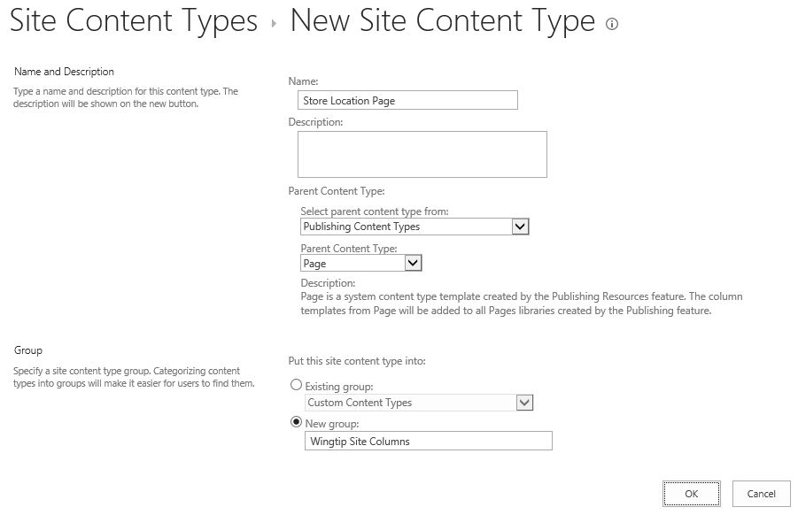

1. After creating the content type, you should be taken to its settings page.

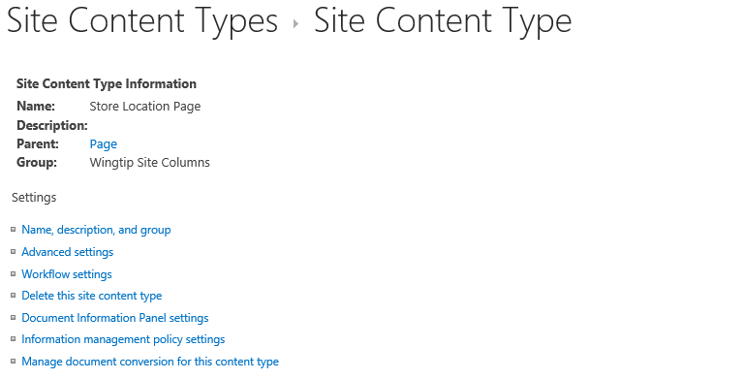

1. Note the existing set of site columns in the content type

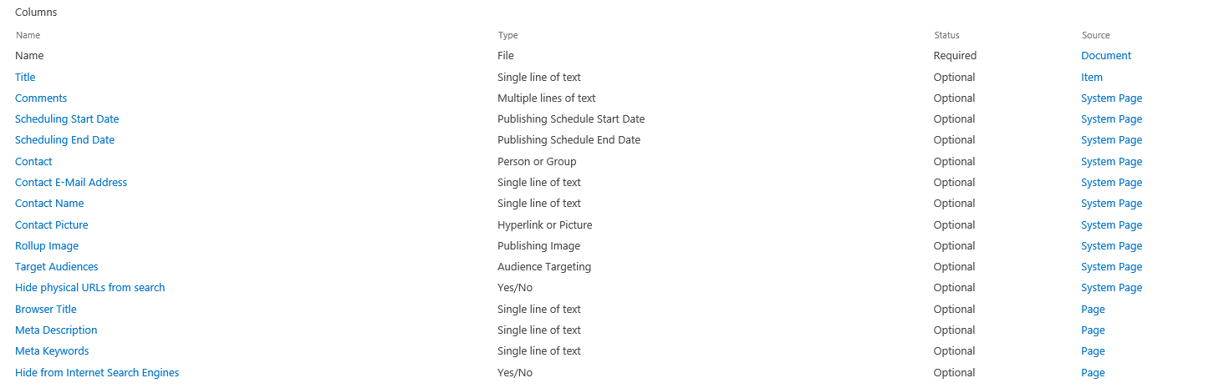

1. You will now add the two Site Columns that are provided in every Publishing site. Click the **Add from existing site columns** link.
   1. Select columns from **Page Layout Columns**. Select **Page Content** and click **Add**.

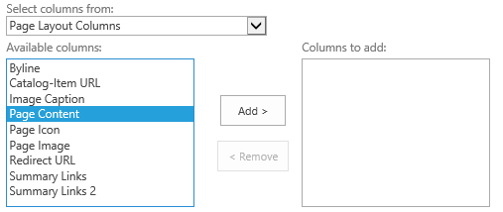

* 1. A dialog with a warning appears, but you can just ignore it and click **OK**.

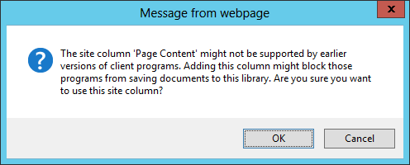

* 1. Add the Page Image site column.

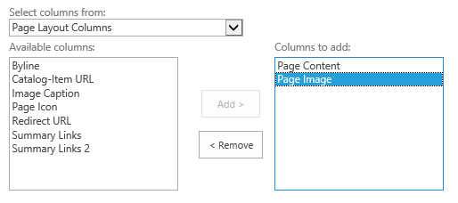

* 1. You will now add the two Site Columns that you created earlier that are specific to the Wingtip publishing site.
  2. Select columns from **Wingtip Site Columns**. Select **Driving Directions** and **Store Hours**.

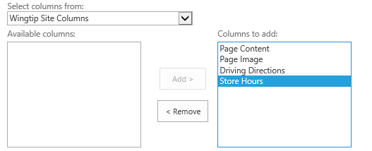

* 1. Now click the **OK** button to save your changes.
  2. After adding the **s**ite columns, your content type should have the columns shown in the following screenshot.

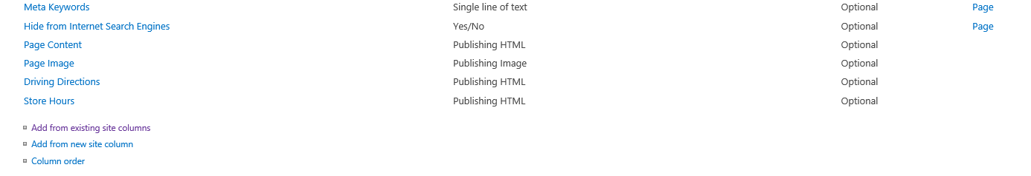

Now you have created a page-derived content type. Next, you will create a page layout based upon this content type.

### Exercise 2: Creating a Custom Page Layout

In this exercise you will work with page layouts.

1. Add the starter page layout to the Master Pages Gallery.
   1. Using Windows Explorer, look in the following folder.

C:\Student\Modules\PageLayouts\Lab\MasterPages

* 1. You should see two page layouts and a CCS file.

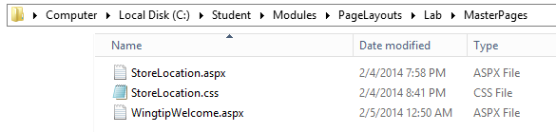

* 1. Add these three files to the Z:\ drive that is mapped to the Master Page Gallery.

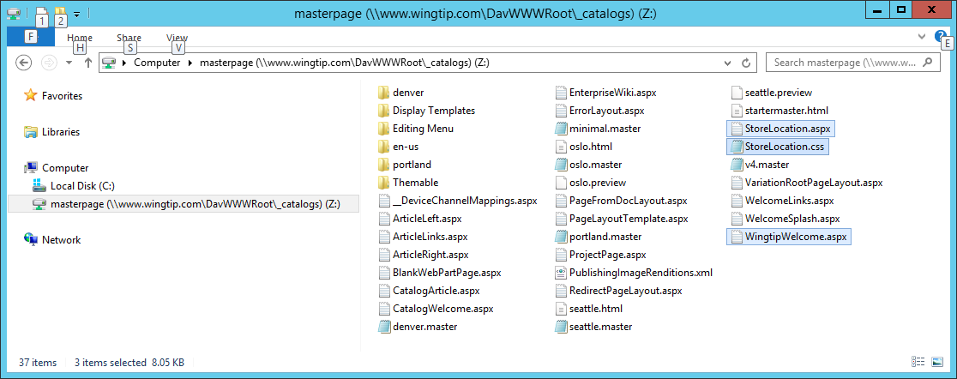

1. Using Internet Explorer, return the Publishing site.
2. Navigate to the **Site Settings** page using the **Site Actions** menu.
3. Click **Master pages and page layouts**.
4. Use the drop down menu on StoreLocation.aspx to run **Select Edit Properties**.

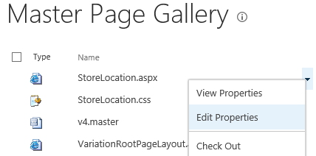

1. Update the properties of **StoreLocation.aspx** so they match the following screenshot. It is particularly important that you change its **Content Type** to **Page Layout** and then change its **Associated Content Type** to **Store Location Page**.

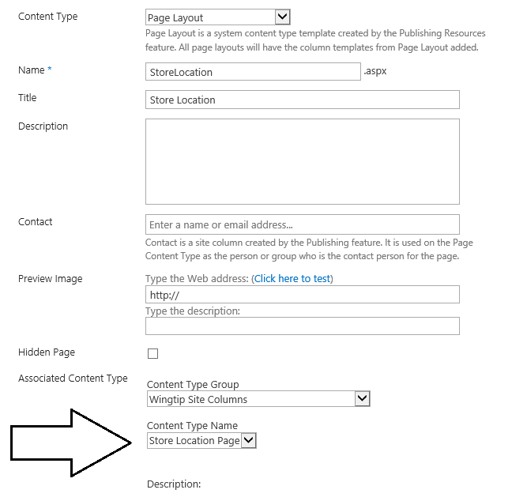

1. Click the **Save** button to save your changes to the properties of **StoreLocation.aspx**.
2. Use the drop down menu on **StoreLocation.aspx** to run the **Publish a Major Version** command.

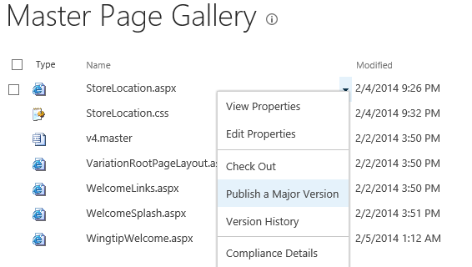

1. You must publish the associated CSS file as well. Use the drop down menu on **StoreLocation.css** to run the **Publish a Major Version** command.

Now you will configure the second page layout named **WingtipWelcome.aspx**.

1. Use the drop down menu on **WingtipWelcome.aspx** to run **Select Edit Properties**.
2. Update the properties of **WingtipWelcome.aspx** so they match the following screenshot. It is particularly important that you change its **Content Type** to **Page Layout** and then change its **Associated Content Type** to **Welcome Page**.

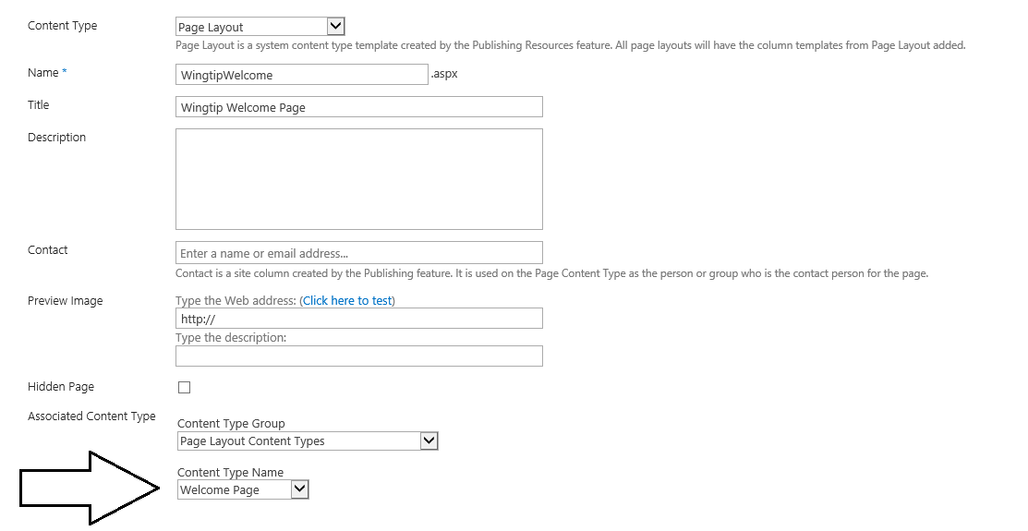

1. Click the **Save** button to save your changes to the properties of **WingtipWelcome.aspx**.
2. Use the drop down menu on **WingtipWelcome.aspx** to run the **Publish a Major Version** command.
3. Apply the page layout named **WingtipWelcome.aspx**.
   1. Navigate to the welcome page for the Locations site at <http://www.wingtip.com/Locations>.
   2. As the **Site Actions** menu command **Edit Page** to switch the page into edit mode.
   3. Use the **Page Layout** drop down menu on the **Page** tab in the ribbon to change the Page Layout to Wingtip Welcome.

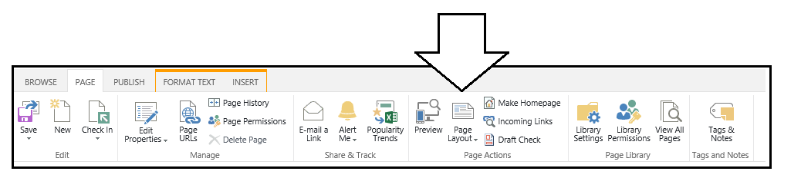

* 1. Inspect the Web Parts Zones that have been added by the new page layout.

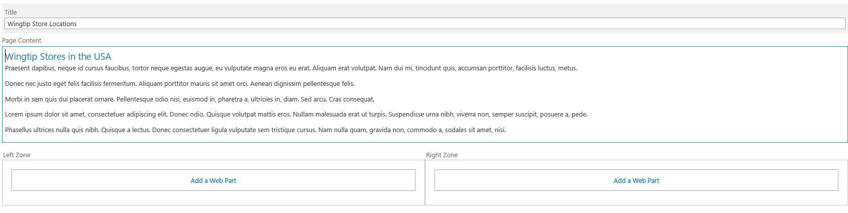

1. Apply the page layout named **StoreLocation.aspx**.
   1. Navigate to the publishing page named **tampa.aspx** in the Location site.
   2. As the **Site Actions** menu command **Edit Page** to switch the page into edit mode.
   3. Use the **Page Layout** drop down menu on the **Page** tab in the ribbon to change the Page Layout to Wingtip Store Location.
   4. Inspect the Field Controls on the page that have been added by the new Page Layout.

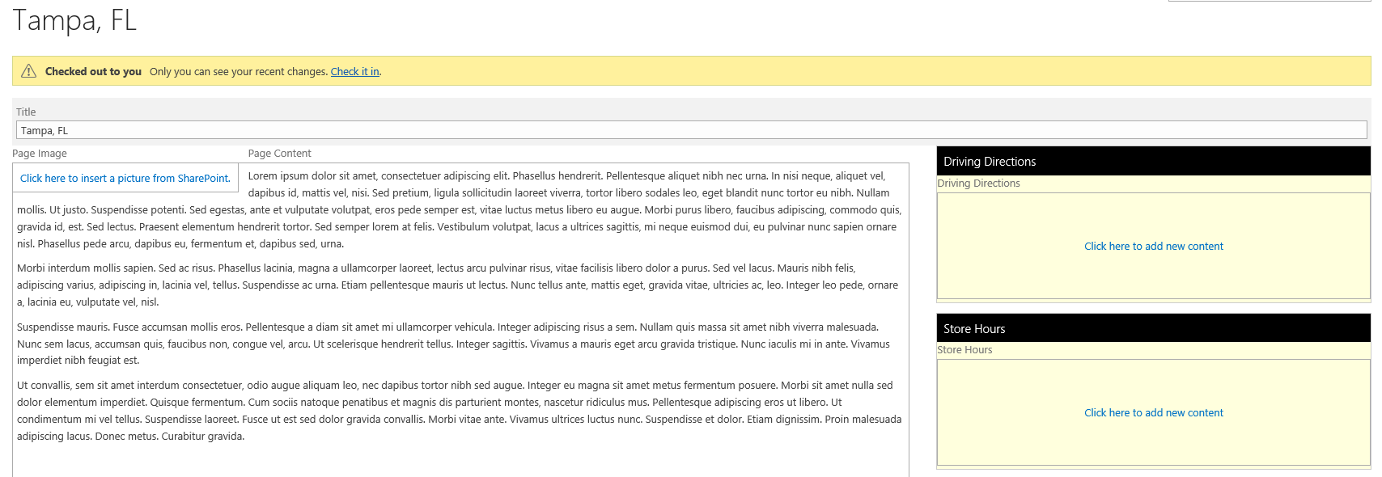

* 1. Add some test content into the Driving Directions field and the Store Hours Field. Add a picture to the page image.

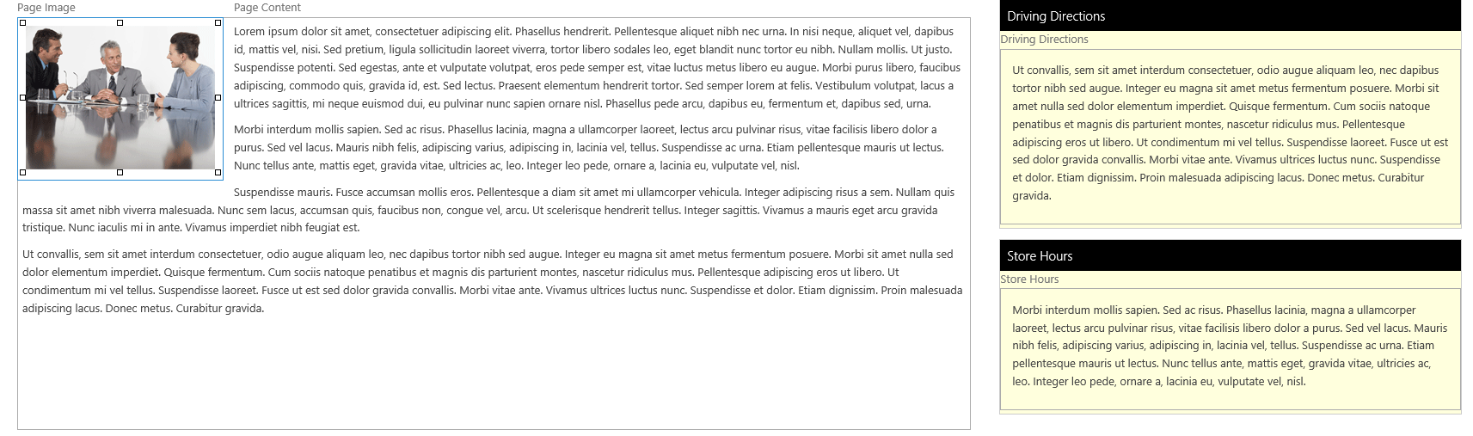

* 1. Publish the page **tampa.aspx** and see what it looks like to a site visitor.

