## Working with a Responsive Design and Device Channels

**Lab Time**: 45 minutes

**Lab Folder**: C:\Student\Modules\ResponsiveDesign\Lab

**Lab Overview**: In this lab you will get hands-on experience working with responsive web design standards and techniques to create a mobile friendly web site.

### Lab Setup: Master Page Change

Before starting this lab, please change the site and system pages back to the austin.

1. Go to Wingtip’s publishing sites (<http://www.wingtip.com>) in your browser.
2. **In your web browser, go to Site Actions menu and select Site Settings.**
3. **On the Site Settings page, select Master Page under Look and Feel.**
4. Change the site master page settings to use the **portland** master. Be sure to check the checkbox below the master page selector to reset all subsites to use the new master pages settings. **Select OK**.

### Exercise 1: Writing Media Queries

In this exercise you will write a media query that will call an alternate CSS for screen sizes smaller than 1024px.

1. **Open SharePoint Designer, and select Wingtip Toys.**

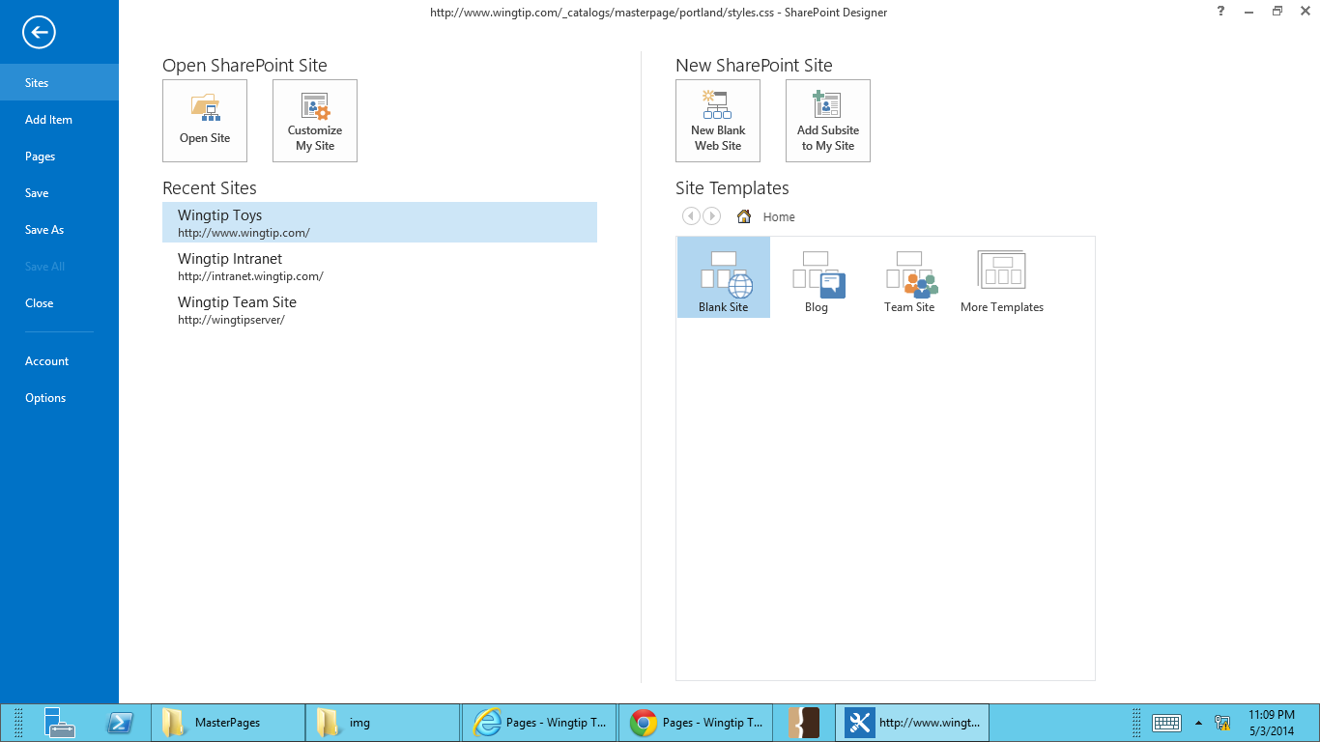

1. **Open the portland folder by going to All Files -> _catalogs -> masterpage -> portland.**
2. **On your computer, open the Lab file associated with this lab. Drag and drop styles1000.css and styles640.css into the open portland folder in SharePoint Designer.**
3. **Open portland.master by going to All Files -> _catalogs -> masterpage. Under Customization, select Edit file.**
4. **Add the meta tag for responsive design at line 15.**

**<meta name="viewport" content="width=device-width; initial-scale=1.0; user-scalable=1;"/>**

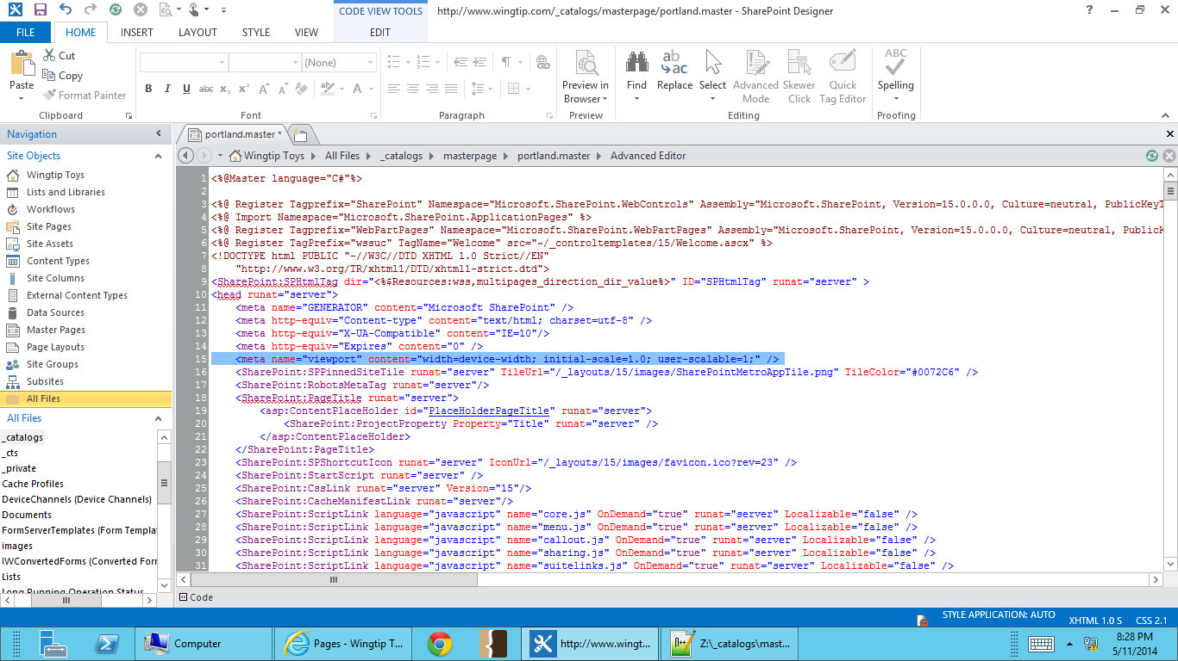

1. **Add the media query links to your responsive CSS files just before your closing head tag </head>.**

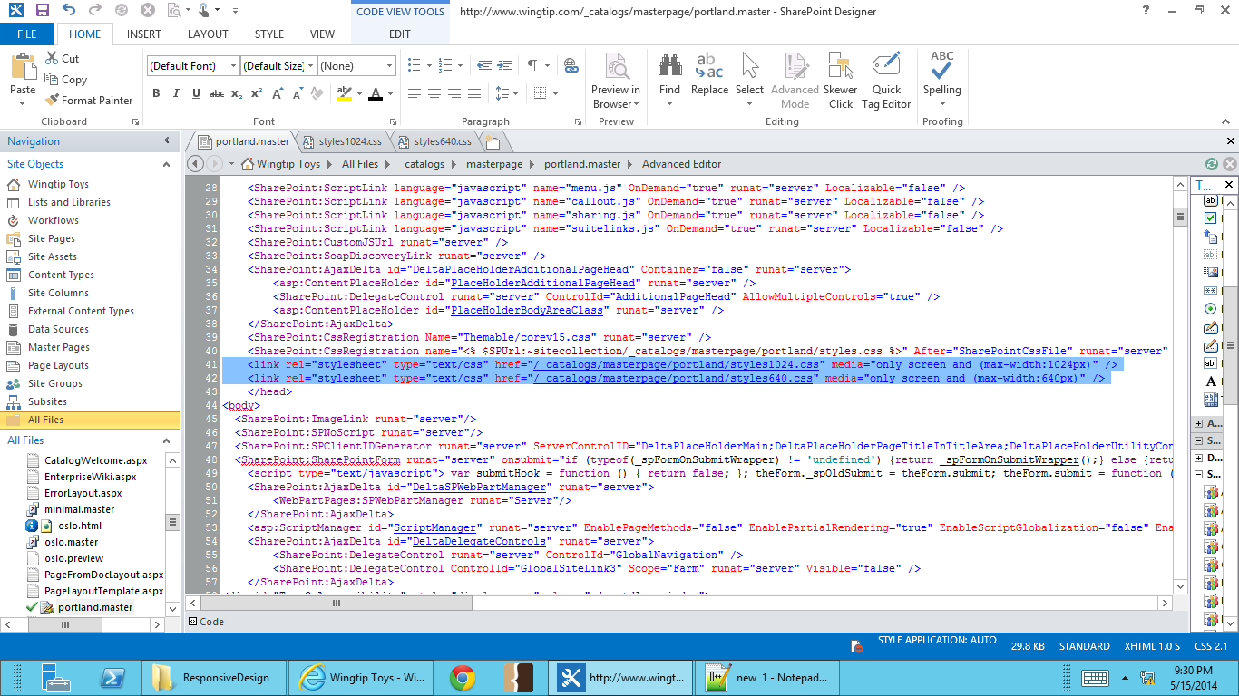

****<link rel="stylesheet" type="text/css" href="/_catalogs/masterpage/portland/styles1024.css" media="only screen and (max-width:1024px)" />****

****<link rel="stylesheet" type="text/css" href="/_catalogs/masterpage/portland/styles640.css" media="only screen and (max-width:640px)" />****

**The media queries shown here are set up to find specific values for screen width. For browser with a width of 1024px and smaller, style1024.css will be applied. After this call, we have another media query set for browser widths 640px and smaller. Due to the rules of cascading style sheets, browsers with widths 640px and smaller will use styles640.css.**

1. **Save the changes to you master page.**
2. **Go to the Wingtip publishing site (**<http://www.wingtip.com>**) in your browser. Change the width of your browser and see the affect the CSS files called in the different media queries have on the display of your content.**

**Browser widths greater than 1024px**

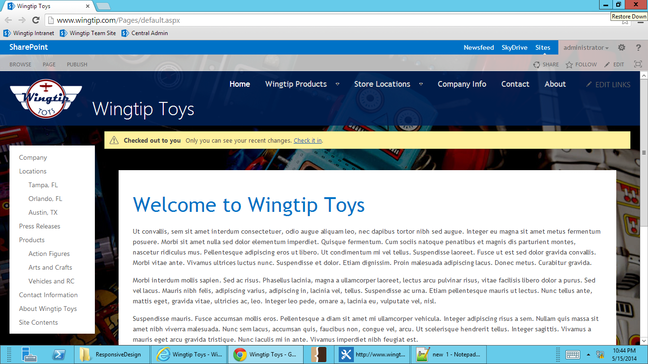

**Browser widths smaller than 1024px**

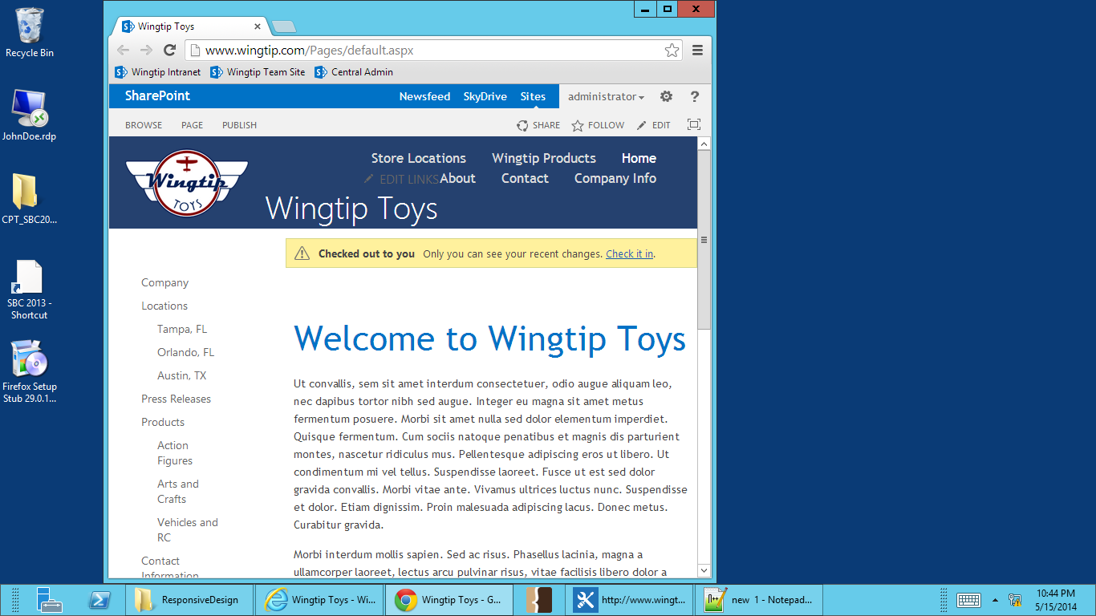

**Browser widths smaller than 640px**

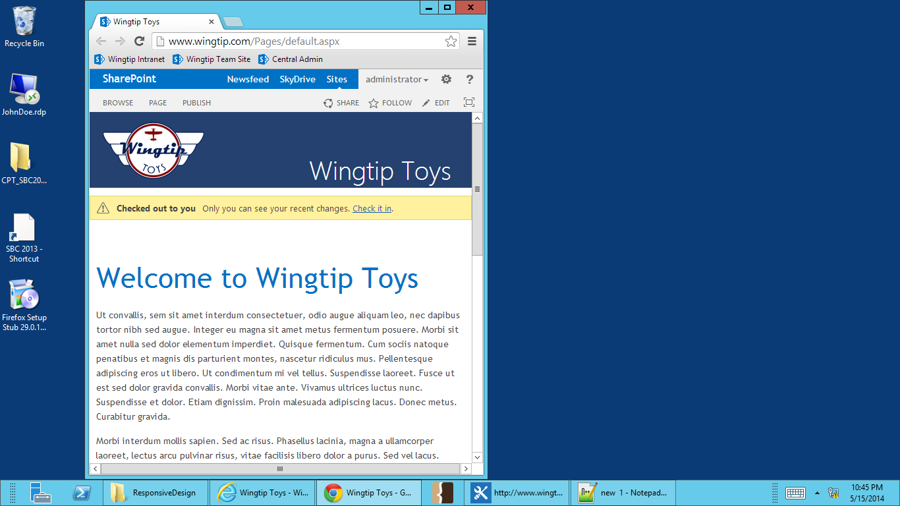

### Exercise 2: Creating a Device Channel

In this exercise you will create a device channel for and iPad. You will then set up that your new device channel to use a different master page than the default channel.

1. Go to Wingtip’s publishing sites (<http://www.wingtip.com>) in your browser.
2. **In your web browser, go to Site Actions menu and select Design Manager.**
3. **Select step 2. Manage Device Channels.**
4. **Select Create a channel.**

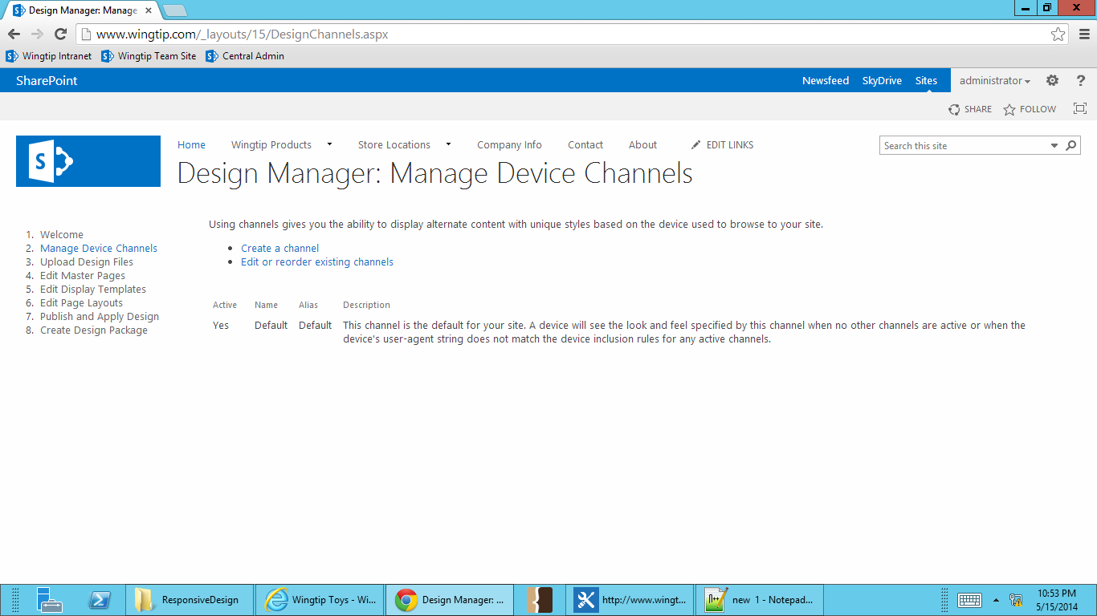

1. **File in the information for the device channel:**
   1. **Name: iPad**
   2. **Alias: iPad**
   3. **Description: Device channel for iPad**
   4. **Device Inclusion Rules: iPad**
   5. **Check the Active checkbox**
   6. **Save**

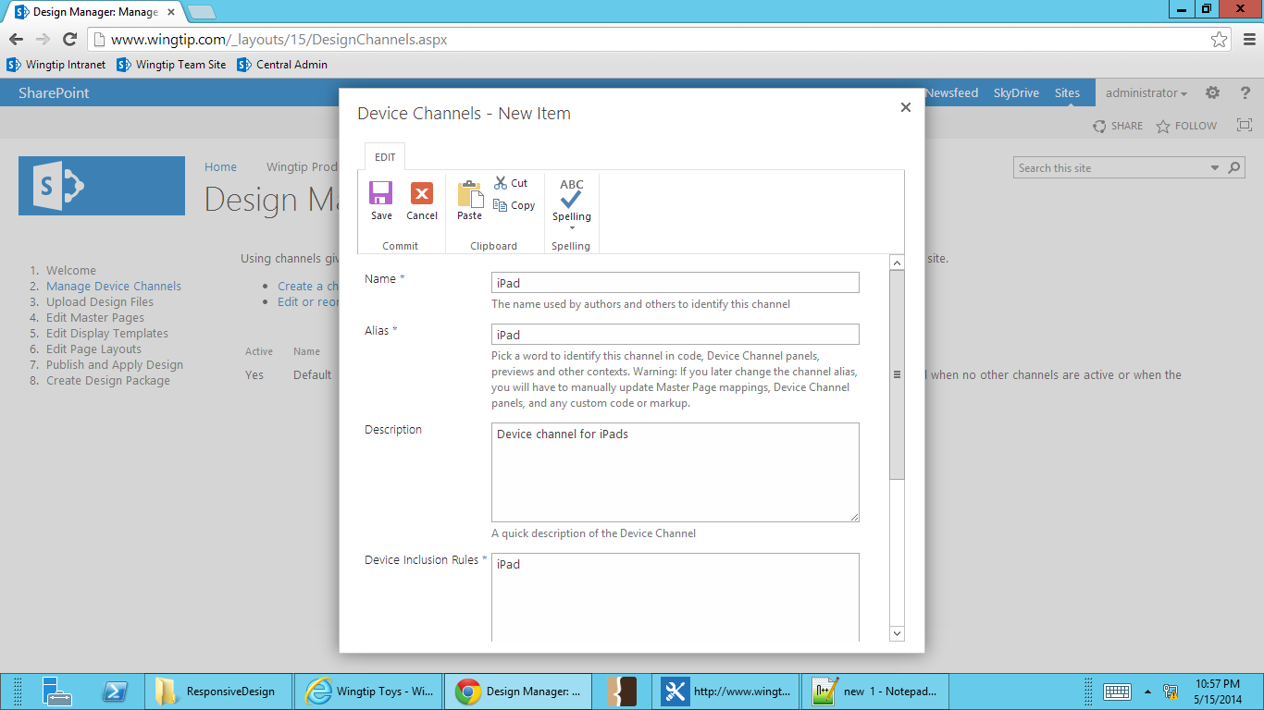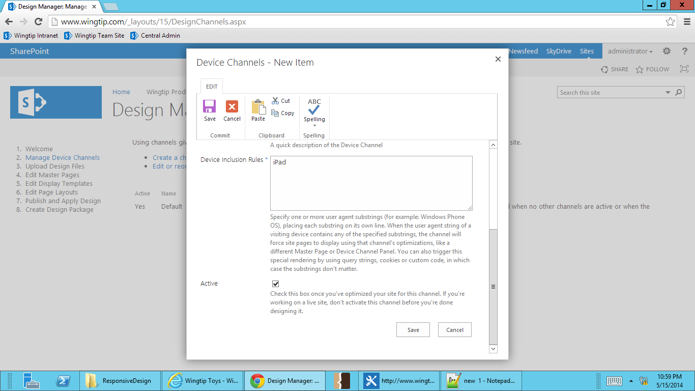

1. **You will see that you now have a device channel for iPads.**

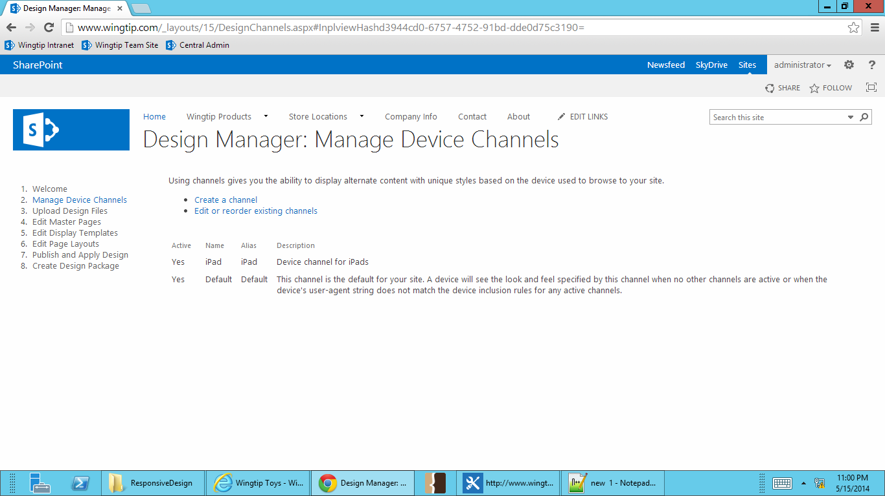

### Exercise 3: Associate a Master Page with a Device Channel

In this exercise you will associate a master page to your new iPad device channel.

1. Go to Wingtip’s publishing sites (<http://www.wingtip.com>) in your browser.
2. **In your web browser, go to Site Actions menu and select Site Settings.**
3. **Under Look and Feel, select Master page.**
4. **You’ll see that you now see the default channel and your iPad device channel available in your Master Page settings.**

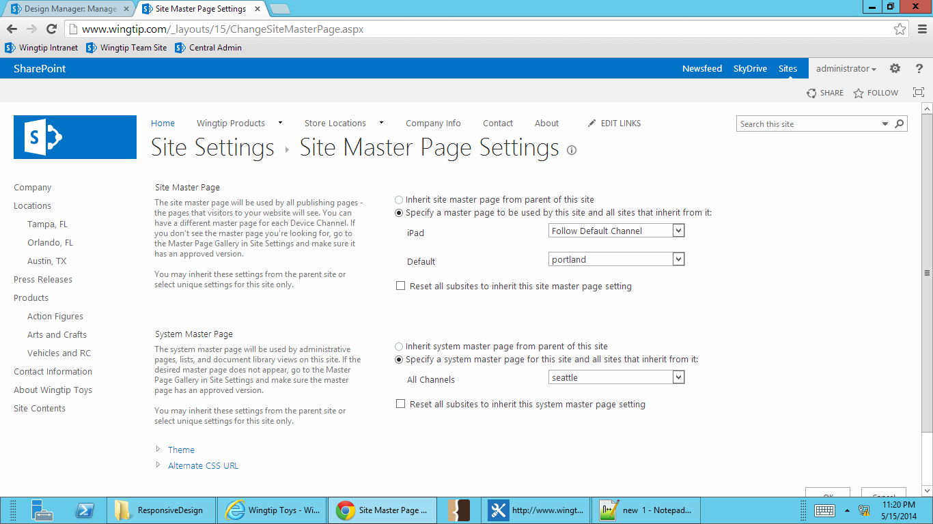

1. **When a device channel is activated, it will be set to follow the default channel until changed. Change the iPad device channel to use the Austin master.**

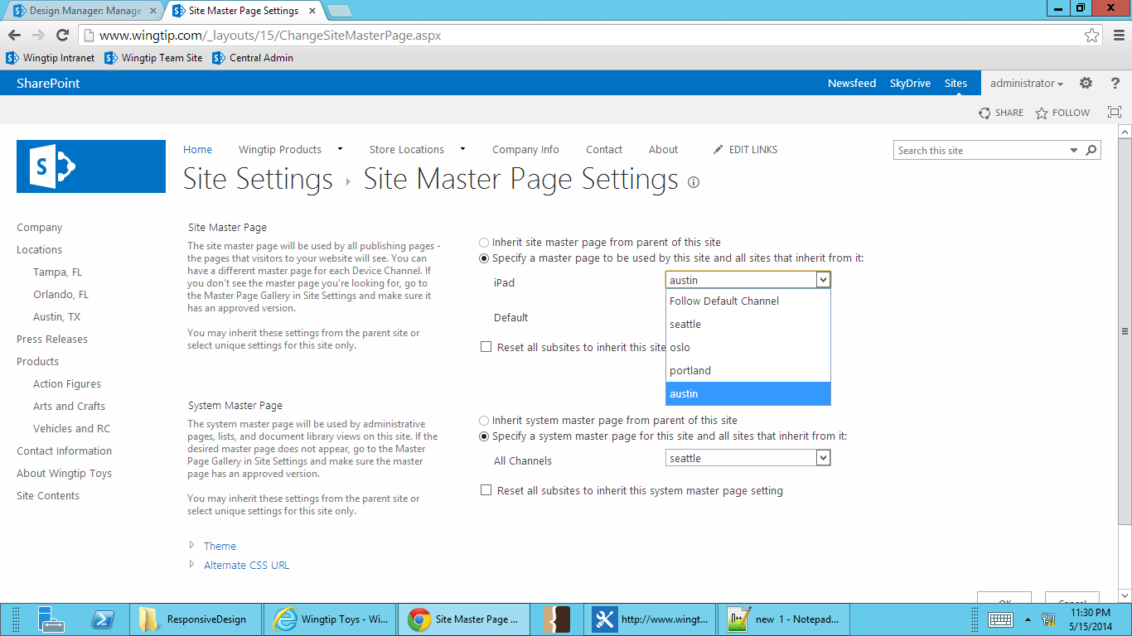

1. **To test your iPad device channel, go back to the Wingtip home page.**
2. **In the Ribbon, go to the Page tab. Select the Preview button, and choose iPad.**

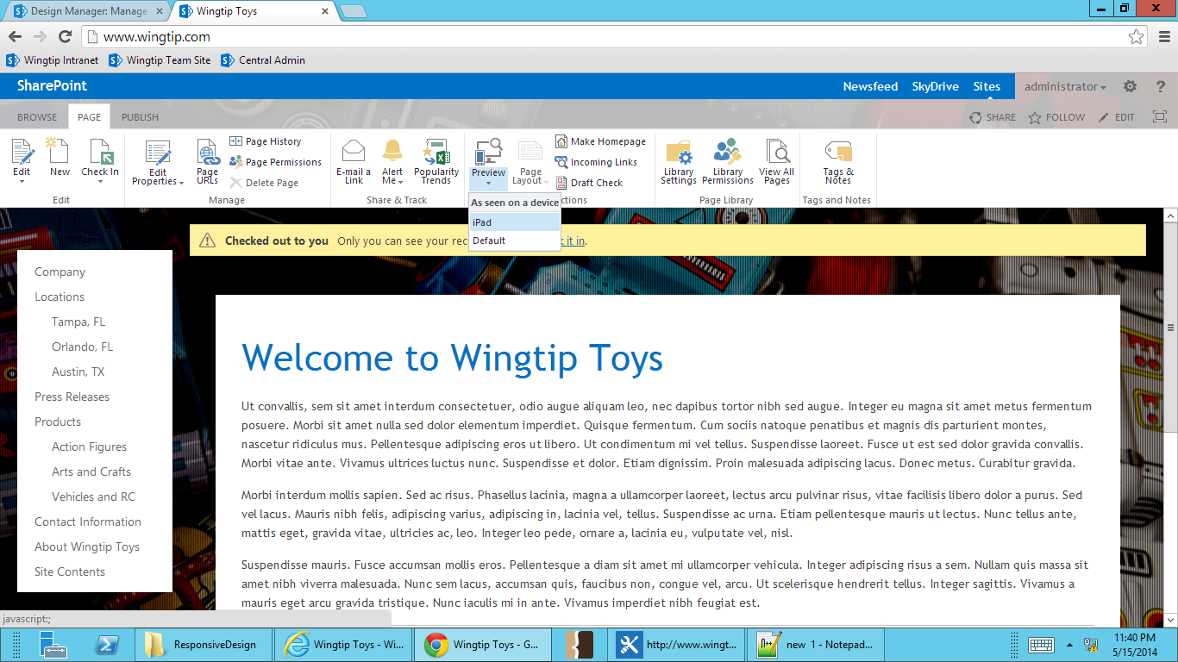

1. **The device channel preview will open in a new browser window. You can see by the URL that you’re viewing you page in preview mode for your iPad device channel.**

