## Working with SharePoint Branding Assets

**Lab Time**: 45 minutes

**Lab Folder**: C:\Student\Modules\SharePointBrandingAssets\Lab

**Lab Overview**: In this lab you will get hands-on experience working with.

### Exercise 1: Opening SharePoint Sites using SharePoint Designer 2013

In this exercise you will open the Team Site at <http://intranet.wingtip.com> with SharePoint Designer 2013 to inspect the elements inside the site. Then you will open the Publishing Site with SharePoint Designer so you can see some of the basic differences between a Team Site and a Publishing Site from the perspective of a SharePoint-centric web designer like yourself.

1. Ensure you are logged into the **Student VM** as **WINGTIP\Administrator**.
2. Launch SharePoint Designer 2013 from the Windows Start Page.



1. Once SharePoint Designer 2013 has started, click on the Open Site button and open the site at <http://intranet.wingtip.com>. If you are prompted to log in, enter a User Name of **WINGTIP\Administrator** and a password of **Password1**.

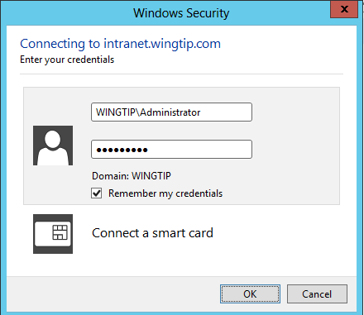

1. Once SharePoint Designer finishes loading the Team Site, it displays a screen as shown in the following screenshot with a set of **Site Objects** in the **Navigation** view on the left-hand side of the screen.

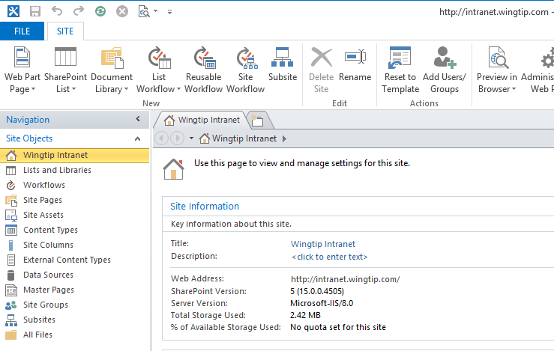

1. Navigate through the site by clicking the following **Site Objects** in the **Navigation** section to get a quick look at the elements found in each one.
   1. Lists and Libraries *(this shows the list and libraries in the current site)*
   2. Site Pages *(this shows the wiki pages and web part pages in the Site Pages library)*
   3. Site Assets *(this shows the set of media files that have been uploaded by users)*
   4. Master Pages *(this shows a set of master pages and page layouts in the Master Page Gallery)*
2. Examine the contents of the Master Page Gallery and locate the two standard SharePoint 2013 master pages which are named **seattle.master** and **oslo.master**.

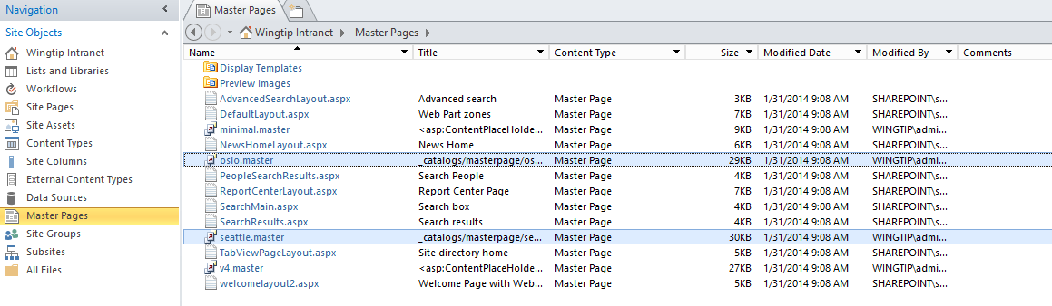

The view of the Master Page Gallery that SharePoint Designer provides for a Team Site is a little confusing. That’s because it displays both master pages (*.master) and page layouts (*.aspx). What confusing is that these page layout files will never be used in a standard Team Site and any other site collection that doesn’t have the publishing features enabled.

1. Click on the **All Files** view at the bottom of the **Navigation** section. When you do this, SharePoint Designer displays a view of root folder of the currently opened site which includes a set of folders and files.

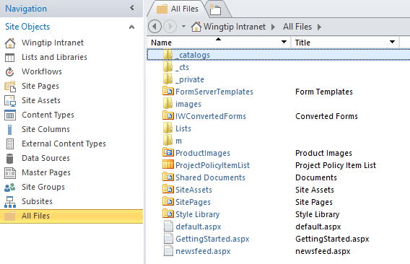

1. In the **All Files** view, click on the **_catalogs** folder and then the **masterpages** folder to navigate to the root folder for the **Master Page Gallery**.

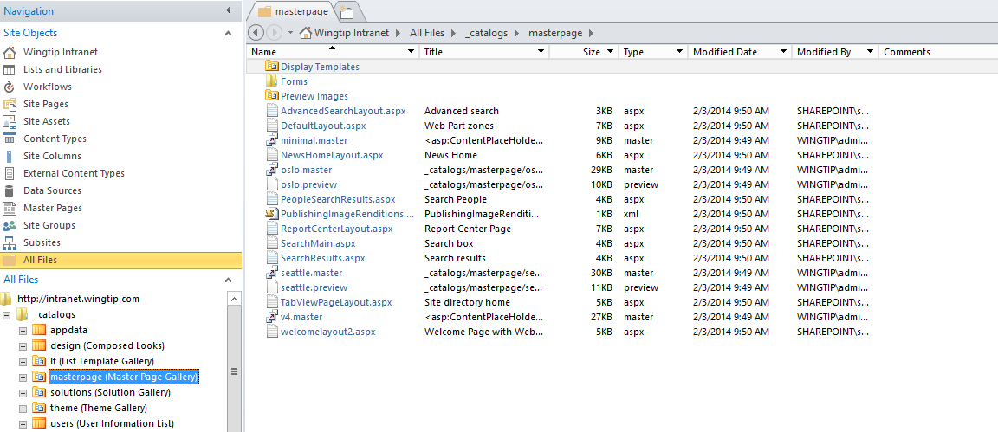

Now you know how to get around in **All Files** view. This is useful because there are several handy SharePoint branding techniques that can only be performed in SharePoint Designer when using **All Files** view.

At this point, you have just looked but you haven’t made any changes with SharePoint Designer. Now you will close the Team Site at <http://intranet.wingtip.com> and open the Publishing Site at <http://www.wingtip.com>. Over the next few steps you will actually begin to use SharePoint Designer to get some work done.

1. **In SharePoint Designer, close the Team Site by clicking File >> Close.**
2. Click on the **Open Site** button and open the site at <http://www.wingtip.com>. If you are prompted to log in, enter a User Name of **WINGTIP\Administrator** and a password of **Password1**.
3. Once the Publishing Site has opened in SharePoint Designer, navigate through the site by clicking the following **Site Objects** in the **Navigation** section to get a quick look at the elements found in each one.
   1. Lists and Libraries *(you will see more lists and libraries in the Publishing Site than you saw in the Team Site)*
   2. Site Pages *(this will be empty because the Publishing Site has no Wiki Page library named Site Pages)*
   3. Site Assets
   4. Master Pages *(note that this now only shows master pages and not page layouts)*

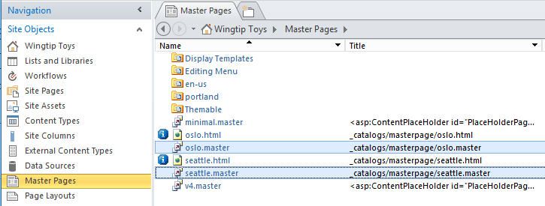

* 1. Page Layouts *(this Site Objects node is available when working with Publishing Sites but not Team Sites)*

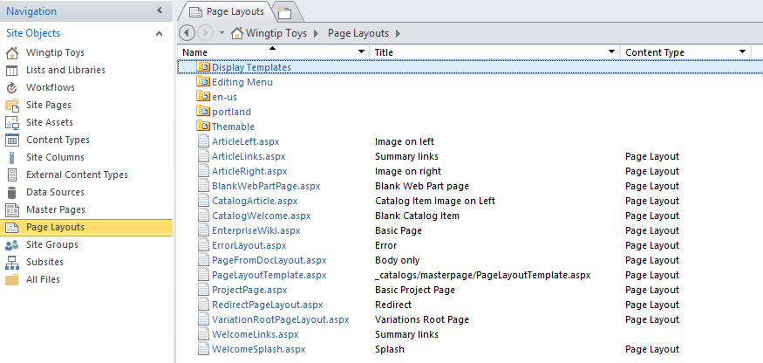

Now that you have inspected the current set of master pages in the Master Page Gallery of the Publishing Site, you are now going to use SharePoint Designer to upload the set of files for a custom master page and its associated design files. Note that this exercise does not involve you editing a master page. Instead, you will simply upload and configure a custom master page that has been provided to you. Later in the course, you will learn how to actually create a custom master page and edit the content yourself.

### Exercise 2: Use SharePoint Designer 2013 to Upload a Custom Master Page

In this exercise you will continue to work with the Publishing Site with SharePoint Designer. Now you will upload a custom master page and its associated design files.

1. Ensure the Publishing Site is open in SharePoint Designer and that you are looking at the **All Files** view.
2. In the **All Files** view, click on the **_catalogs** folder and then the **masterpages** folder to navigate to the root folder for the **Master Page Gallery**.
3. **Locate the files for the custom master page named portland.master.**
   1. **Leave SharePoint Designer 2013 open because you will be returning in a few steps.**
   2. **Open the Windows Explorer and navigate to the folder at the following path:**

**C:\Student\Modules\SharePointBrandingAssets\Lab\MasterPages**

* 1. **You should see a custom master page file named portland.master and a nested folder named portland.**

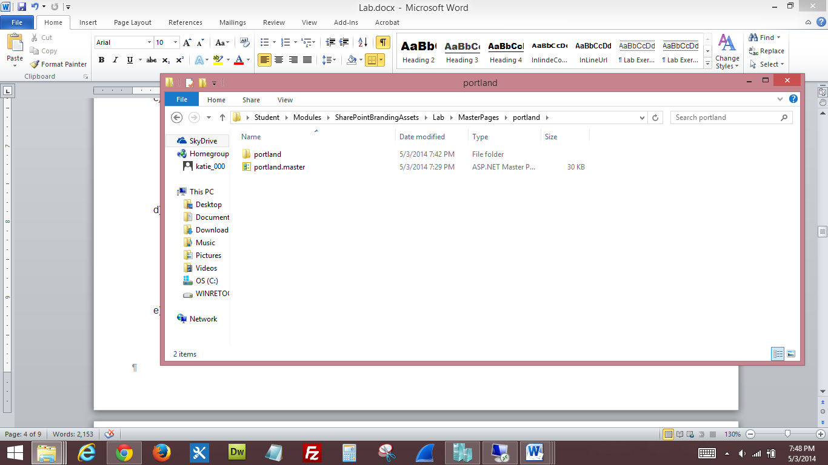

* 1. **If you look inside the portland folder, you will find a CSS file named styles.css and another nested folder named img.**

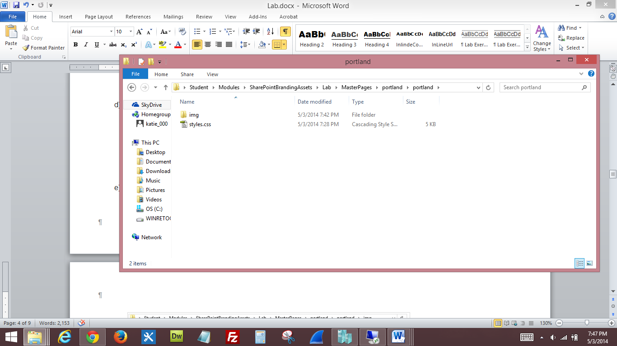

* 1. **If you look inside the img folder, you will find two imagery files named RainyWindow.jpg and wingtip-logo-small.png.**

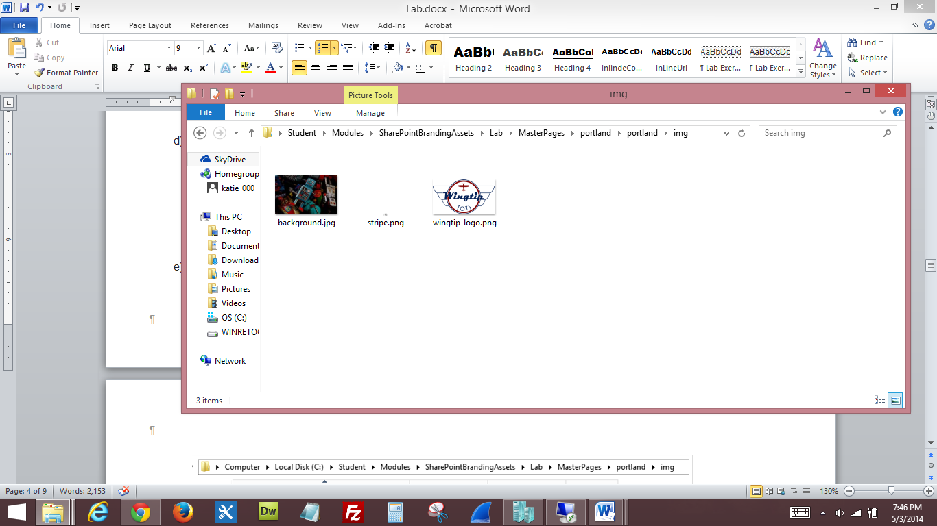

**This is a pretty simple example of a custom master page. A custom master page typically has one or more of its own CSS files such as styles.css and a set of imagery files such as background.jpg, stripe.png and wingtip-logo.png. While this custom master page only has two associated imagery files, many people create custom master pages where the number of imagery files can reach into the 100s.**

**SharePoint categorized the extra CSS files and imagery files used by a master page as “Design Files”. Therefore, you can say that the custom master page named portland.master has three associated design files.**

**This next step is a bit tricky the first time you do it. You are going to drag and drop the custom master page file named portland.master and its three associated design files from the Windows Explorer into the SharePoint Designer. As you will see, this provides a quick and easy way to upload a custom master page into a SharePoint site.**

1. **Use SharePoint Designer to upload the custom master page to the Master Page Gallery.**
   1. **Position Windows Explorer and SharePoint Designer so you can see both windows at the same time.**
   2. **In Windows Explorer, select the master page file named portland.master and then drag and drop it onto the masterpages folder in the All Files view of SharePoint Designer.**

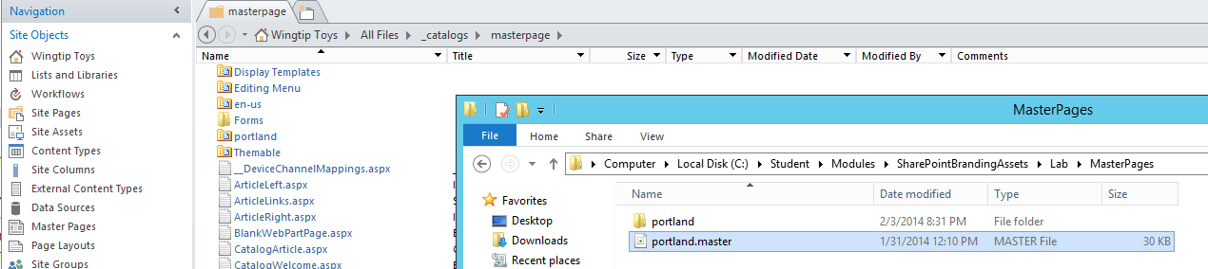

* 1. **Next, perform a similar operation by dragging and dropping the portland folder from the Windows Explorer onto the masterpages folder in the All Files view of SharePoint Designer.**
  2. **After you have performed these steps, you should be able to verify that the portland.master file and the portland folder can be seen in the view provided by the SharePoint Designer.**

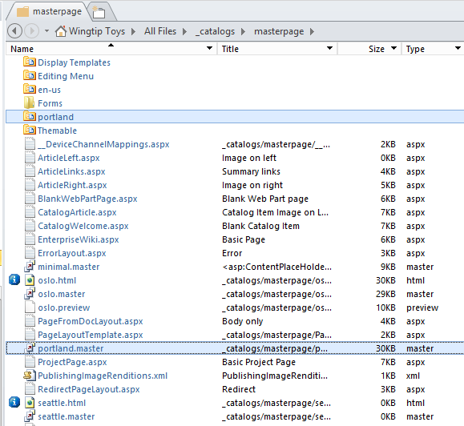

**At this point you are done working with SharePoint Designer. You will now accomplish the remaining steps to configure the custom master page portland.master using the browser. You can close SharePoint Designer if you’d like or you can leave it open if you want to continue experimenting with what you can do with this tool.**

### Exercise 3: Approving and Applying a Custom Master Page

In this exercise you will use the browser to approve the custom master page and apply it to the Publishing Site.

1. Launch the Internet Explorer and navigate to the Publishing Site at [**http://www.wingtip.com**](http://www.wingtip.com).
2. Inspect the master pages in the Master Page Gallery.
   1. Using the **Site Actions** menu, navigate to the **Site Settings** page.
   2. In **Web Designer Galleries** section, click the **Master pages and page layouts** link to navigate to the Master Page Gallery.

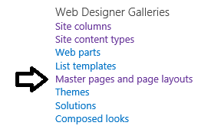

* 1. You should be able to verify that you can see the file named **portland.master** as well as the **portland** folder.

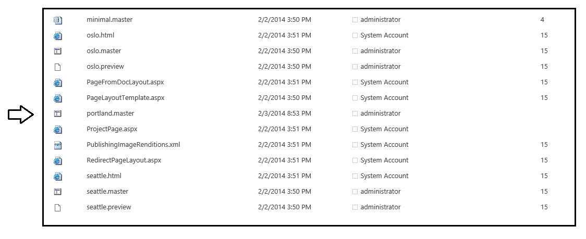

1. Inspect the set of master pages that can be applied to the current site.
   1. Using the **Site Actions** menu, navigate to the **Site Settings** page.
   2. In **Look and Feel** section, click the **Master page** link to navigate to the **Site Master Page Settings** page.

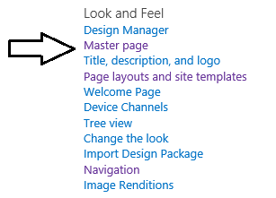

* 1. On the **Site Master Page Settings** page, drop down the menu that shows the master pages which can be applied to the current site. You should see the two master pages provided out of the box which are **seattle** and **oslo**.

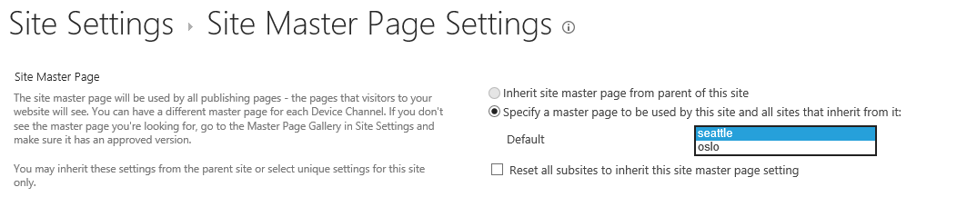

The reason you cannot see the custom master page named **portland** is due to the fact that the master page files named **portland.master** has not been published. The key point is that you can only apply a master page once it has been published.

1. Publish the custom master page named **portland.master**.
   1. Using the **Site Actions** menu, navigate to the **Site Settings** page.
   2. In **Web Designer Galleries** section, click the **Master pages and page layouts** link to navigate to the **Master Page Gallery**.
   3. Locate the file for the custom master page named **portland.master**.
   4. Drop down the ECB menu of the **portland.master** file and click **Publish a Major Verion**.

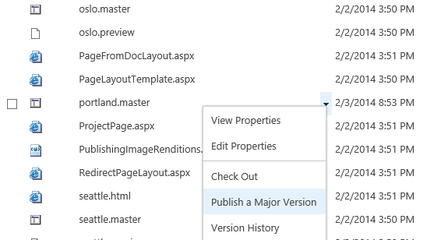

* 1. When you publish a master page like this, SharePoint prompts you with a page to add comments. You can leave the **Comments** field empty or add a comment as the one shown in the following screenshot.

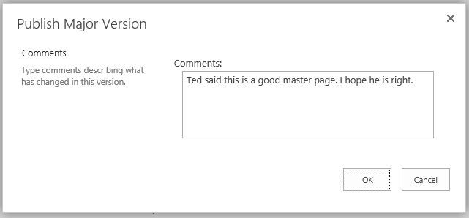

* 1. Click the **OK** button on the **Publish Major Version** page to complete the publishing process.

1. Apply the custom master page named **portland.master** as the Site Master Page.
   1. Using the **Site Actions** menu, navigate to the **Site Settings** page.
   2. In **Look and Feel** section, click the **Master page** link to navigate to the **Site Master Page Settings** page.
   3. On the **Site Master Page Settings** page, drop down the menu that shows the master pages which can be applied to the current site. You should see that **portland** is now available in addition to **seattle** and **oslo**.

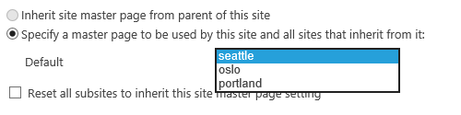

* 1. In the **Site Master Page** section, specify the master page to be **portland** and check the checkbox with the caption **Reset all subsites to inherit this site master page setting**. Do not make any changes to the **System Master Page** section. When your page looks like the following screenshot, click the OK button to save your changes.

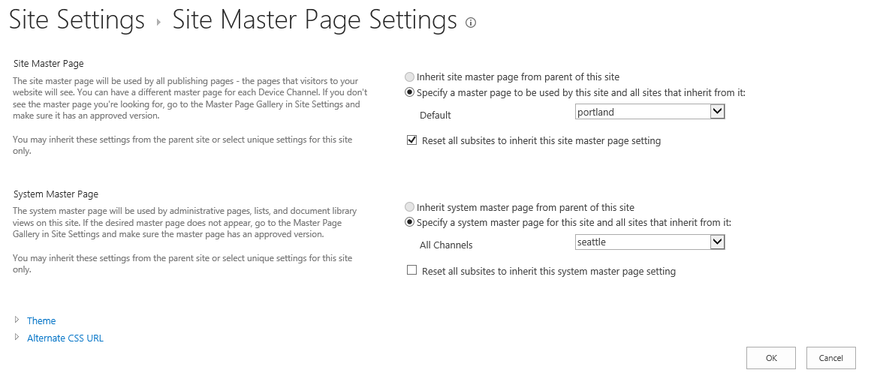

* 1. Click on the **Home** link in the top link bar to navigate to the welcome page in the top-level site. At this point, you should see that the site has a new look and feel.

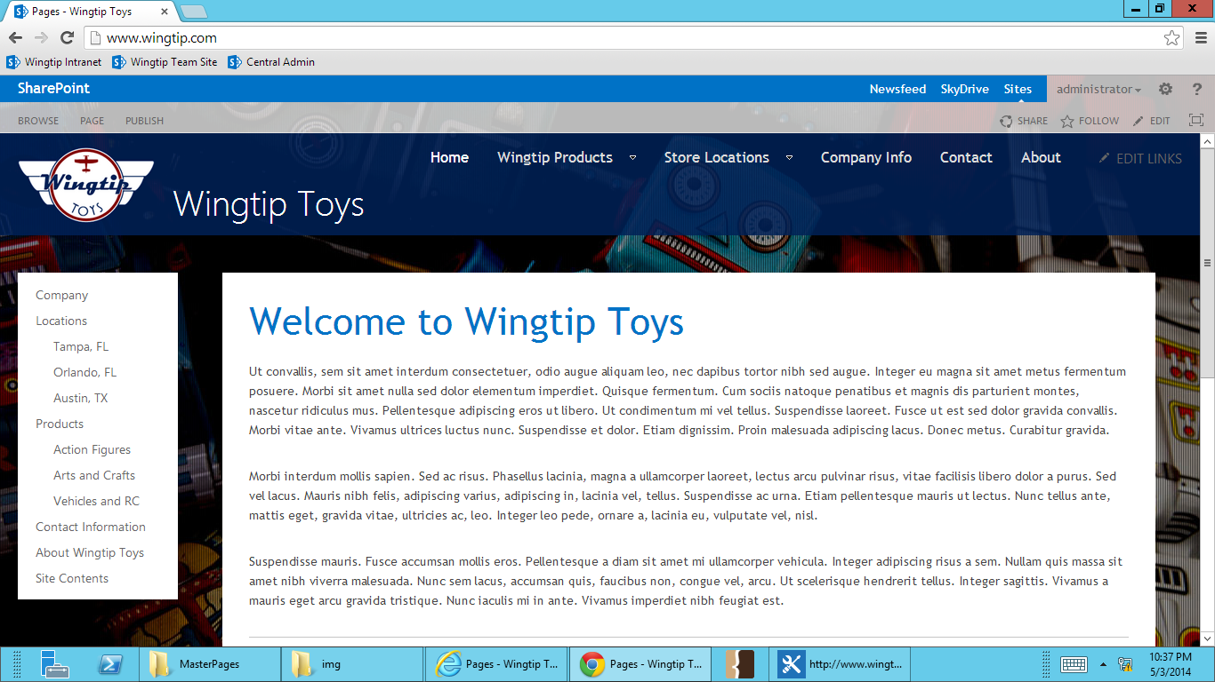

* 1. Navigate around the site using the links in the top link bar as well as the links in Quick Launch. Every page you see should be displayed using the custom master page **portland.master**. That’s because every page you can navigate to using the top link bar and Quick Launch are publishing pages that use the Site Master Page setting.

1. Apply the custom master page named **portland.master** as the System Master Page.
   1. Use the **Site Actions** menu to navigate to the **Site Settings** page.
   2. You should observe that the Site Settings page does not use the custom master page. Instead, it is still using the default master page name **seattle.master**.
   3. In **Look and Feel** section of the **Site Settings** page, click **Master page** to navigate to the **Site Master Page Settings** page.
   4. In the **System Master Page Settings** section, specify the master page to be **portland** and check the checkbox with the caption **Reset all subsites to inherit this site master page setting**. Now the **Site Master Page** section and the **System Master Page** section should look the same. When your page looks like the following screenshot, click the **OK** button to save your changes.

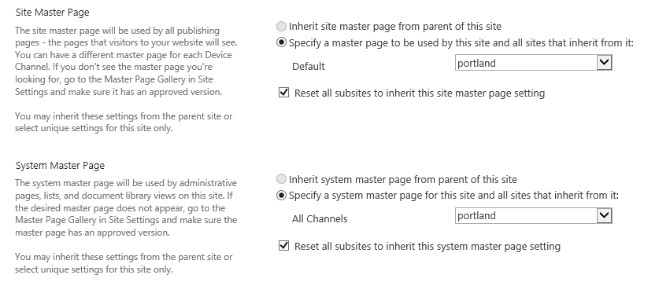

* 1. At this point, you should be able to see that the custom master page named **portland.master** is being used to display all pages within the site including system pages such as the **Site Settings** page.

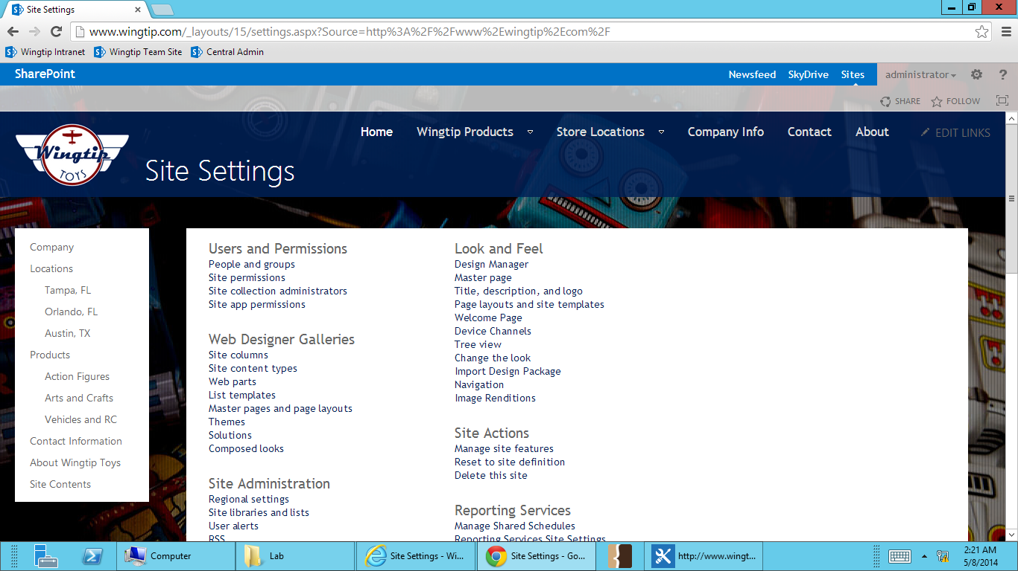

1. **As a final step, a**pply the standard master page named **seattle** as the Site Master Page and System Master Page.
   1. Using the **Site Actions** menu, navigate to the **Site Settings** page.
   2. In **Look and Feel** section, click the **Master page** link to navigate to the **Site Master Page Settings** page.
   3. On the **Site Master Page Settings** page, change the Site Master Page and the System Master Page back to **seattle.master**.
   4. Click **OK** to save your changes.

**At this point, you have now successfully completed this lab.**