## Working with Team Sites and Publishing Sites

**Lab Time**: 45 minutes

**Lab Folder**: C:\Student\Modules\TeamVersusPublishing\Lab

**Lab Overview**: In this lab you will get hands-on experience working with various aspects of a Team site and a Publishing site.

### Exercise 1: Working with a Team Site in SharePoint 2013

In this exercise you will work with a Team Site to add content and configure the navigation by adding navigation links to the top linktop bar and Quick Launch.

1. Login to the Student VM using the login **WINGTIP\Administrator** and the appropriate password.
   1. If you’re using a local VM provided by the hosting training company, the password will be **Password1**.
   2. If your student VM is hosted by CloudShare, the password for the **WINGTIP\Administrator** account is going to be unique for each student, system-generated by CloudShare. Also note that the CloudShare VM configuration usually logs you into the VM automatically so you do not have to enter the user name and password.
2. Once you have logged on to the student VM, launch the Internet Explorer and navigate to the site at **http://intranet.wingtip.com**.
   1. It might take a minute or two before the first page of the Wingtip Intranet site appears.
   2. When the home page of the Wingtip Intranet site appears, you should see that it is a brand new SharePoint 2013 Team site.

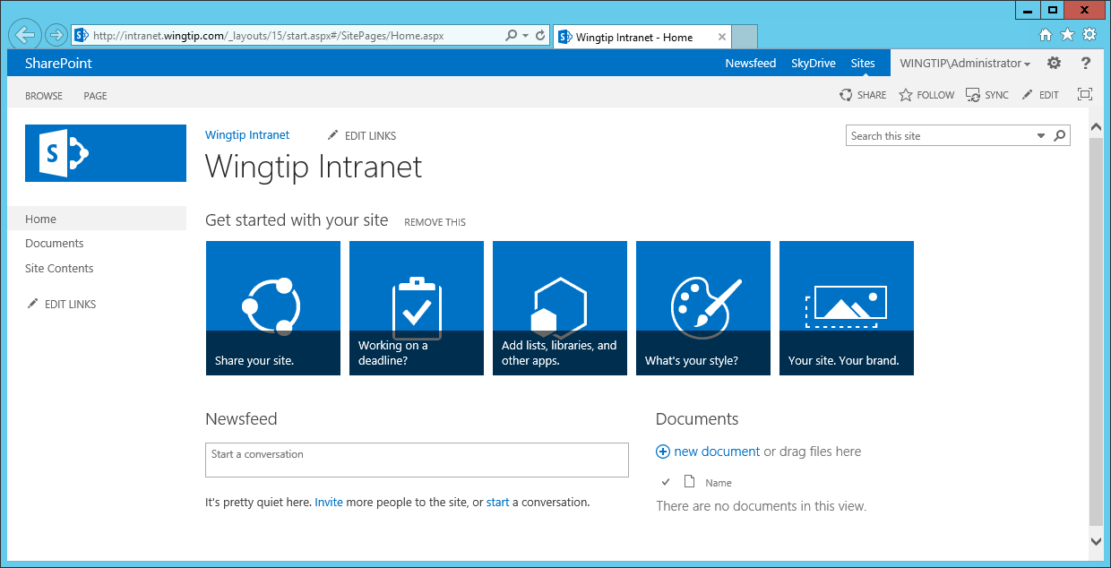

1. Click each of the navigation links in the Quick Launch bar on the left-hand side of the page to see where they take you.
   1. When you click on the **Home** link, you will navigate the home page of the site;
   2. When you click on the **Documents** link, you will navigate a document library named **Documents** that is automatically added to every new Team Site.
   3. When you click on the **Site Content** link, you will navigate the **Site Content** page which list the lists, libraries and apps that have been added to the current site. The lists and document libraries you see currently on this page of those that are automatically included when you create a new Team Site as a top-level site.

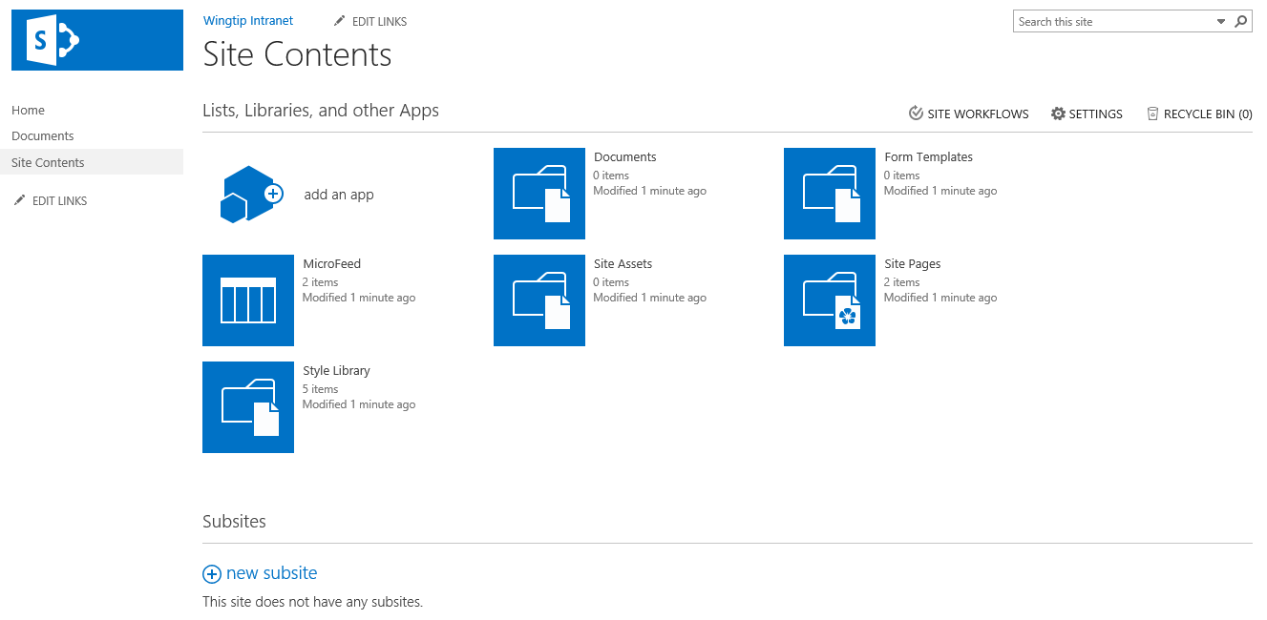

You should take note that the **Site Settings** page also displays a **Subsites** section at the bottom which shows any child sites that existing under the current site as well as a link for creating new child site. You should be able to determine that the Wingtip Intranet site current has no subsites.

* 1. Return to the home page of the Wingtip Intranet site.

1. Run the utility program named **AddTeamSiteContent.exe**
   1. Open Windows Explorer and locate the **Student** folder at **c:\Student**.
   2. Locate located the **AddTeamSiteContent.exe** utility program in your students folder at the following path.

C:\Student\Modules\TeamVersusPublishing\Lab\AddTeamSiteContent.exe

* 1. **Double click on** the **AddTeamSiteContent.exe** utility program to run it.
  2. The **AddTeamSiteContent.exe** utility program should run for 10 to 20 seconds and then complete.
  3. Click ENTER to close the console window for the **AddTeamSiteContent.exe** utility program.
  4. Close the Windows Explorer.

1. **Inspect the new content that has been added to the Team Site**
   1. **Return to Internet Explorer, navigate to the Team Site at** <http://intranet.wingtip.com> **if you are not already there.**
   2. **Refresh the home page.**
   3. **You should see that the Wingtip Intranet site now has new content as well as new links in the top link bar.**

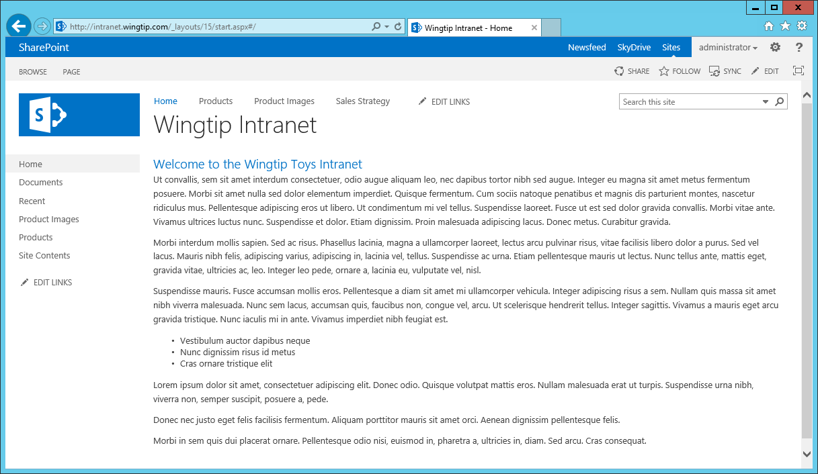

* 1. **Inspect the Products list by clicking the navigation link in the top link bar.**

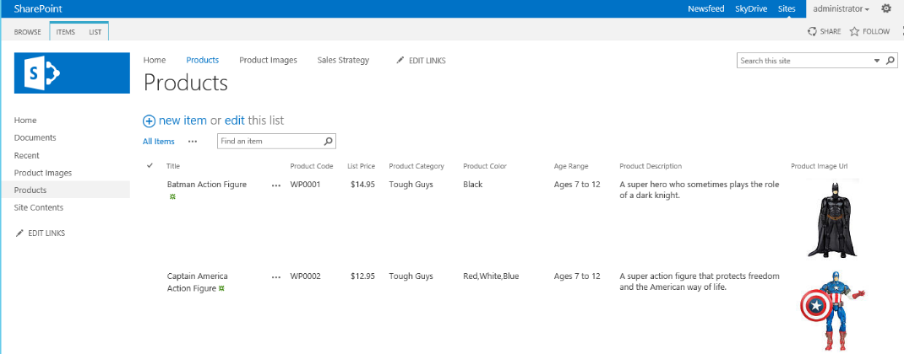

* 1. **Inspect the Product Images library by clicking the navigation link in the top link bar.**

**.**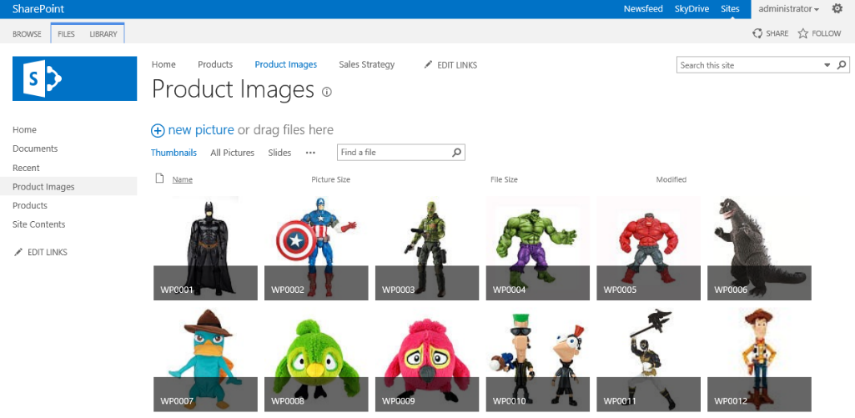

* 1. **Inspect the Sales Strategy wiki page by clicking the navigation link in the top link bar.**

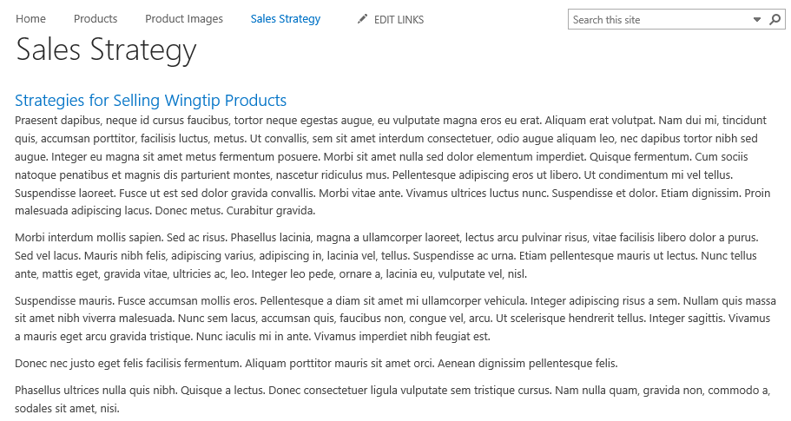

1. **Inspect the wiki pages that exist inside the Site Pages wiki page library.**
   1. **Click on the Site Content link in Quick Launch and locate the Site Pages tile.**

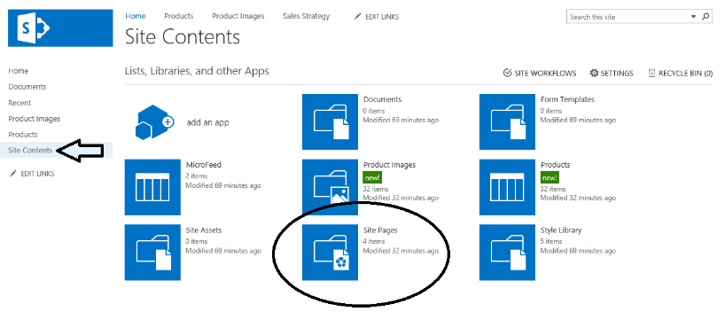

* 1. **Click on the Site Page tile on the Site Contents page to navigate to the Site Pages wiki page library. You should be able to see that several wiki pages already exist.**

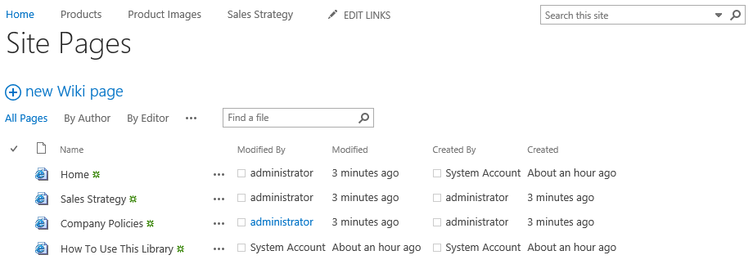

1. **Add a navigation link to the top link bar for the wiki page named Company Policies.aspx.**
   1. **Use the Site Actions menu to navigate to the Site Settings page.**

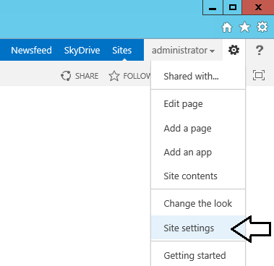

* 1. **On the Site Settings page, locate and click the Top link bar link in the Look and Feel section.**

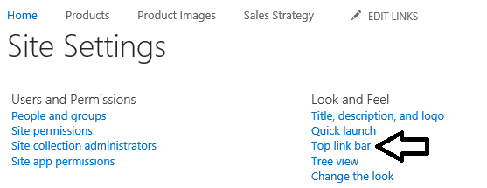

* 1. **On the Top Link Bar page, inspect the existing set of navigation links.**

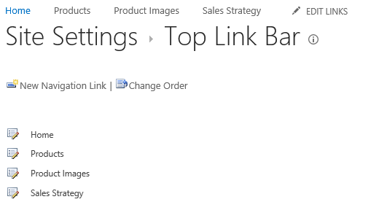

* 1. **Click on New Navigation Link to create a new navigation link.**
     1. **Type a Web Address of /SitesPages/Company Policies.aspx.**
     2. **Type a description of Company Policies.**
     3. **Click OK to create the new navigation link.**

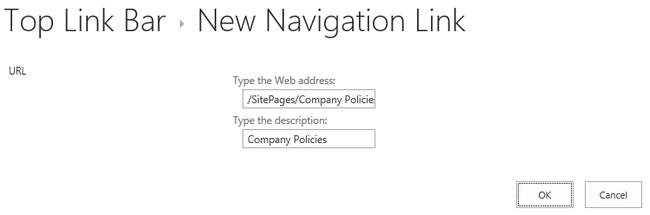

* 1. **Test your work by return to the home page and refresh it with the {F5} key. You should see that the new navigation link appears as the last navigation link of the Top link bar.**

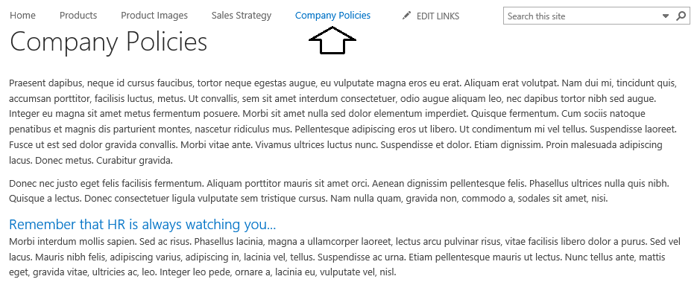

1. **Create a new SharePoint list for the Wingtip Calendar.**
   1. From the **Site Actions** menu, click the **Add an app menu** item to navigate to the **Your Apps** page.
   2. On the **Your Apps** page, click the **Calendar** tile to begin the process of creating a new custom list.

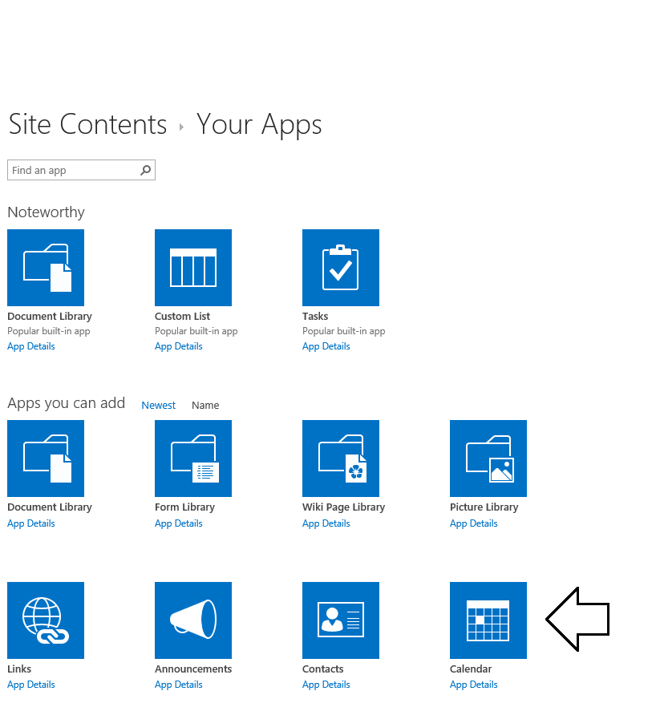

* 1. When prompted, enter a list name of **Schedule** and click **Create**.

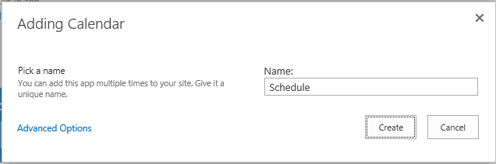

* 1. Once the **Schedule** list has been created, you should be able to see a tile for it in the **Site Contents** page.

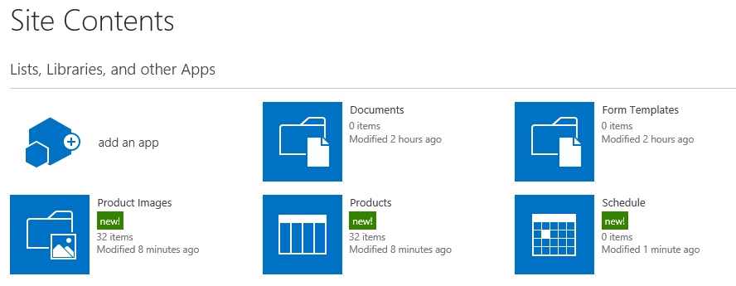

* 1. On the **Site Content** page, click on the **Schedule** tile to navigate to the Calendar list named **Schedule**. You should be able to see that the default view of this list displays a calendar view.

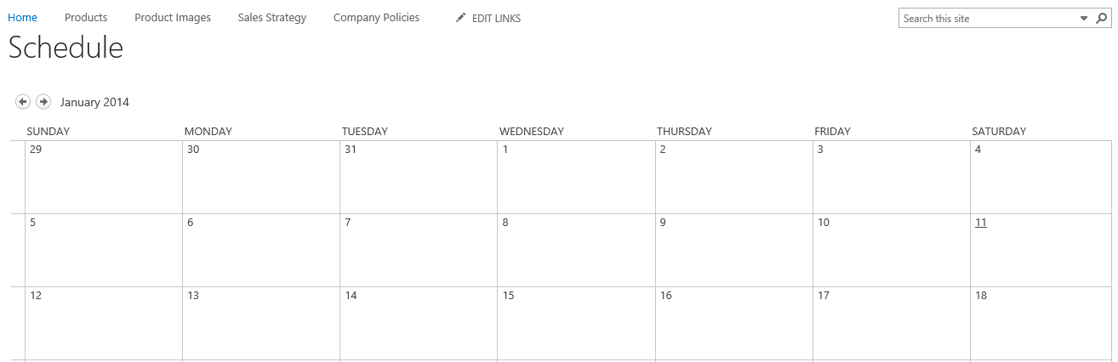

* 1. You have now finished the steps of creating the new list. Now it's time to change its navigation settings.

1. Navigate to the List Settings page of the **Schedule** list.
   1. Return to the **Site Contents** page.
   2. On the **Site Contents** page, click the ellipse (**…**) fly out menu in the top, right-hand corner of the Schedule tile and then click the **SETTINGS** link to navigate to the **Settings** page for the new **Schedule** list.

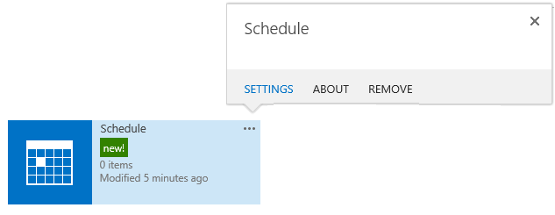

* 1. Review the information and links shown on the **Settings** page for the **Schedule** list.

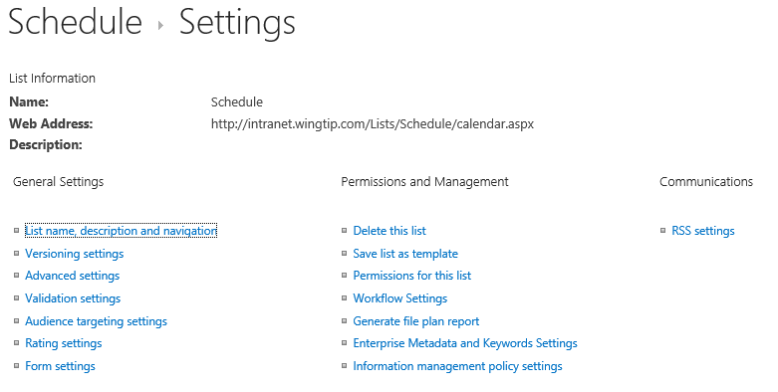

* 1. In the **General Settings** section of the **Settings** page, click the **List name, description and navigation** link to navigate to the **General Settings** page for the list.
  2. **On the General Setting page, set the Display this list on Quick Launch setting to Yes and then click the Save button.**

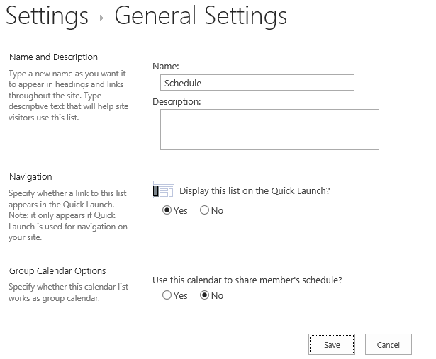

* 1. **Verify that the link to the Schedule list has been added to Quick Launch. Click the link to make sure it works correctly.**

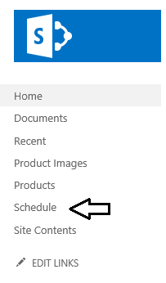

1. **Add new navigation link to the Top link bar for the Schedule list.**
   1. **Navigate to the Site Settings page.**
   2. **In the Look and Feel section of the Site Settings page, click the link Top link bar.**
   3. **On the Top Link Bar page, click New Navigation Link.**
   4. **For the link's Web Address, enter a value of /Lists/Schedule/calendar.aspx.**
   5. **For the link's Description, enter a value of Schedule.**
   6. **Click OK to create the new navigation link.**
2. **Navigate to the home page to test out the new navigation link. You should see the new Schedule navigation link at the very right in the Top link bar. Click this navigation link to make sure it works.**

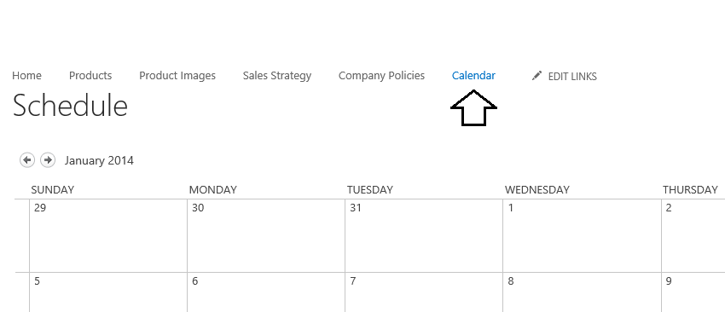

1. **Change the ordering of the navigation links in the top link bar.**
   1. **Navigate to the Site Settings page.**
   2. **Click Top link bar to navigate to the Top Link Bar page.**
   3. **On the Top Link Bar page, locate and click the Change Order link.**

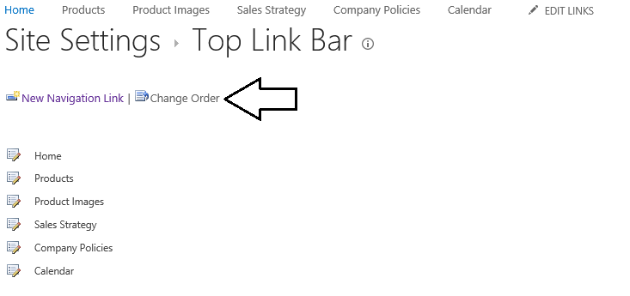

* 1. **On the Top Link Bar > Change Order page, use the Link Order column to move the Calendar link up to the forth position so it is locate just below the Product Images link. Click the OK button to save your changes.**

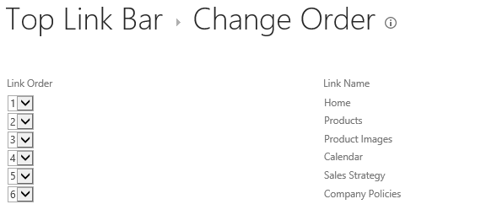

* 1. **Refresh the home page and verify that the reordering worked as expected. You should now see the Calendar link is now in between the Product Images link and the Sales Strategy link.**

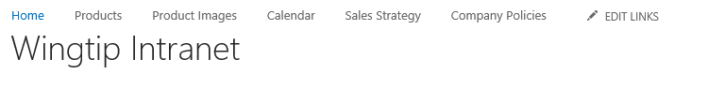

* 1. **Return to the home page of the Wingtip Intranet site.**

**In this lab you worked with content and navigation settings in a Team Site.**

### **Exercise 2: Activating and Deactivating the MDS Feature**

In this exercise, you will begin to manage features which activate at both the site level and the site collection level.

1. In this exercise you will continue to work with the Team site at [**http://intranet.wingtip.com**](http://intranet.wingtip.com)**.** 
   1. Navigate to the Team Site at [**http://intranet.wingtip.com**](http://intranet.wingtip.com) in the Internet Explorer if you are not already there.
   2. Navigate to the **Site Settings** page using the **Site Action** menu.

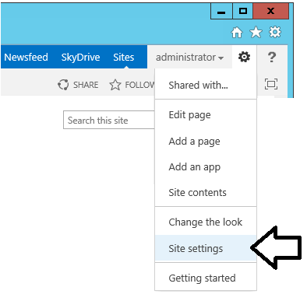

* 1. On the **Site Settings** page, locate and click the **Site collection features** link in the **Site Collection Administration** section.

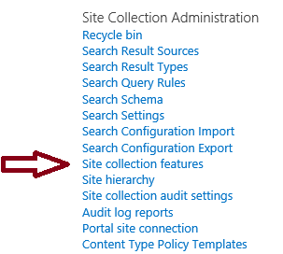

* 1. Take a moment and review all the site-collection-level features shown on this page. You should also take note which site-collection-level features are activated by default in a new site collection and which features are not.

1. Review the site-scoped features available for activation within a Team site.
   1. Use the **Site Actions** menu to navigate to the **Site Settings** page.
   2. On the **Site Settings** page, locate and click the **Manage site features** link in the **Site Actions** section.

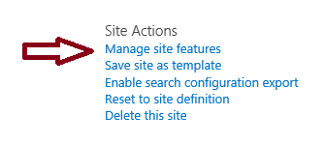

* 1. Take a moment and review all the site-level features shown on this page. You should also note which site-level features are activated by default in a new Team site and which features are not.

1. Inspect the URLs created by the **Minimal Download Strategy** feature.
   1. Return to the home page of the Wingtip Intranet site.
   2. Inspect the URL shown in the address bar of the browser which is used to navigate to the home page of the test site.

http://intranet.wingtip.com/_layouts/15/start.aspx

* 1. Navigate from page to page and inspect the URLs be used. You should see that all requests targeting the site will point to the **start.aspx** page and include an extra segment with a pound sign ($) and a relative URL to the actual target page.

http://intranet.wingtip.com/_layouts/15/start.aspx#/Lists/Products/AllItems.aspx

1. Deactivate the **Minimal Download Strategy** feature to see how It changes things.
   1. On the **Site Settings** page, locate and click the link titled **Manage site features** in the **Site Actions** section.
   2. Locate the feature with the title of **Minimal Download Strategy**.

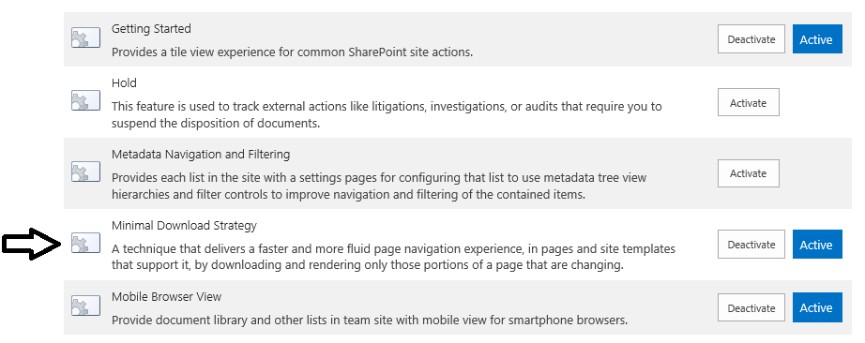

* 1. Click the **Deactivate** button to the right of the **Minimal Download Strategy**. When you do this, the SharePoint UI prompts you to confirm that you want to deactivate the feature, Click the **Deactivate this feature** link to complete the deactivation process.

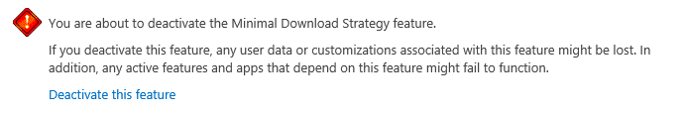

* 1. Once the feature has been deactivated, return to the home page of the site.
  2. Refresh the home page.
  3. Inspect the URL in the address bar of the browser. You should be able to see that the URL to the site is now easier to read.

http://intranet.wingtip.com/SitePages/Home.aspx

* 1. Navigate from page to page and see how the URLs that are used are now easier to understand.

1. Now that you have tested the Team Site with the MDS feature turned off, it is time to reactivate it.
   1. On the **Site Settings** page, locate and click the link titled **Manage site features** in the **Site Actions** section.
   2. Locate the feature with the title of **Minimal Download Strategy**.
   3. Click the A**ctivate** button to the right of the **Minimal Download Strategy**.
   4. Return to the home page of the Wingtip Intranet site.
   5. Refresh the home page.
   6. Navigate from page to page using the Top link bar and verify that the URLs are now once again formatted using MDS.

In this lab, you began working with feature management. It’s essential that you know how to manage features and that you also have an understanding about which features activate at the site level versus features that activate at the site collection level.

### **Exercise 3: Working with a Publishing Site in SharePoint 2013**

In this exercise, you will make a few simple changes to modify the look and feel of the site.

1. Launch the Internet Explorer and navigate to the Publishing Site at **http://www.wingtip.com**.
   1. It might take a minute or two before the first page of the Wingtip Toys publishing site appears.
   2. When the home page of the Wingtip Toys publishing site appears, you should see that it is a brand new publishing site.

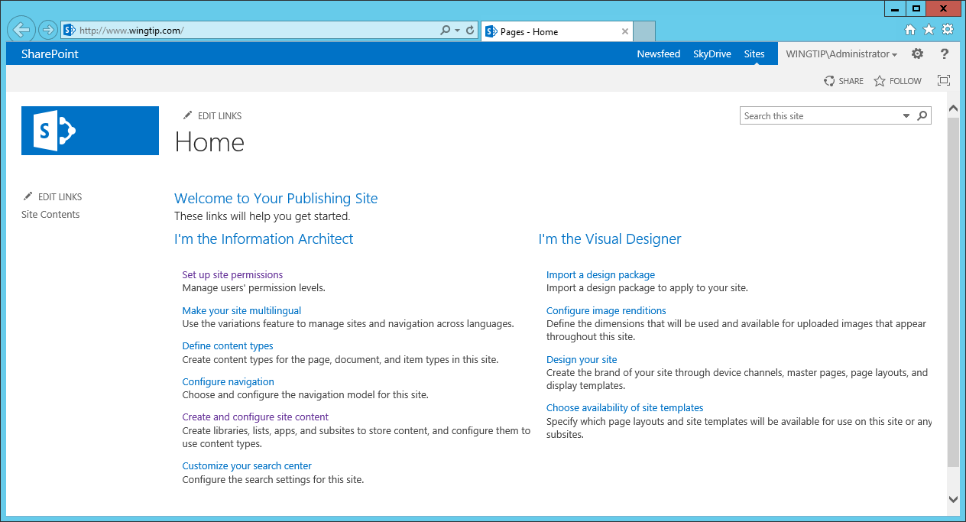

1. Click on the **Site Content** link in Quick Launch to navigate to the **Site Content** page. Just as in a Team Site, the **Site Contents** page in a Publishing Site shows you the lists, libraries and apps that have been added to the current site. The lists and document libraries you see currently on this page of those that are automatically included when you create a new Publishing Site as a top-level site.

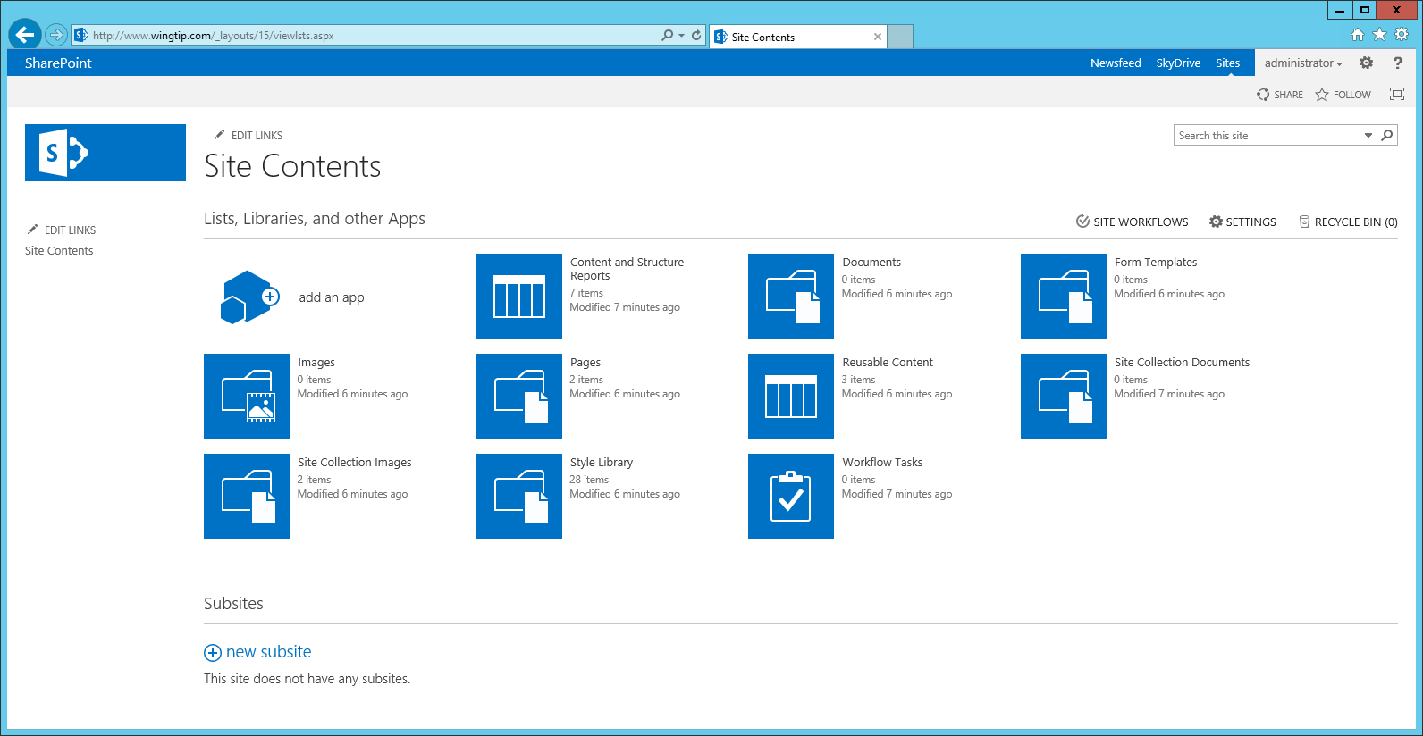

You should take note that there are no **Subsites** in this newly-created, top-level Publishing Site. This is different from SharePoint 2010 where SharePoint Server automatically created a subsite named Press Releases when you created a new site collection using the Publishing Portal Template.

1. Examine the **Pages** document library.
   1. Click on the **Pages** tile on the **Site Contents** page.
   2. You should see two publishing pages named **default** and **PageNotFoundError**.

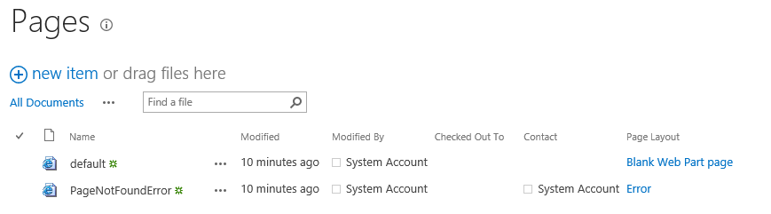

* 1. Click on the publishing page named **default.aspx** to navigate to the page.

1. Return to the home page of the Wingtip Toys Publishing Site.
2. Run the utility program named **AddPublishingSiteContent.exe**
   1. Open Windows Explorer and locate the **Students** folder at **c:\Student**.
   2. Locate located the **AddPublishingSiteContent.exe** utility program in your students folder at the following path.

C:\Student\Modules\TeamVersusPublishing\Lab\AddPublishingSiteContent.exe

* 1. **Double click on** the **AddPublishingSiteContent.exe** utility program to run it.
  2. The **AddPublishingSiteContent.exe** utility program should run for 10 to 20 seconds and then complete.
  3. Click ENTER to close the console window for the **AddPublishingSiteContent.exe** utility program.
  4. Close the Windows Explorer.

1. **Inspect the new content that has been added to the Publishing Site**
   1. **Return to Internet Explorer.**
   2. **Navigate to the home page of the Publishing Site at** <http://www.wingtip.com> **if you are not already there.**
   3. **Refresh the home page.**
   4. **You should see that the Publishing Site now has new content in the home page. It also has several new pages, subsites and navigation links.**

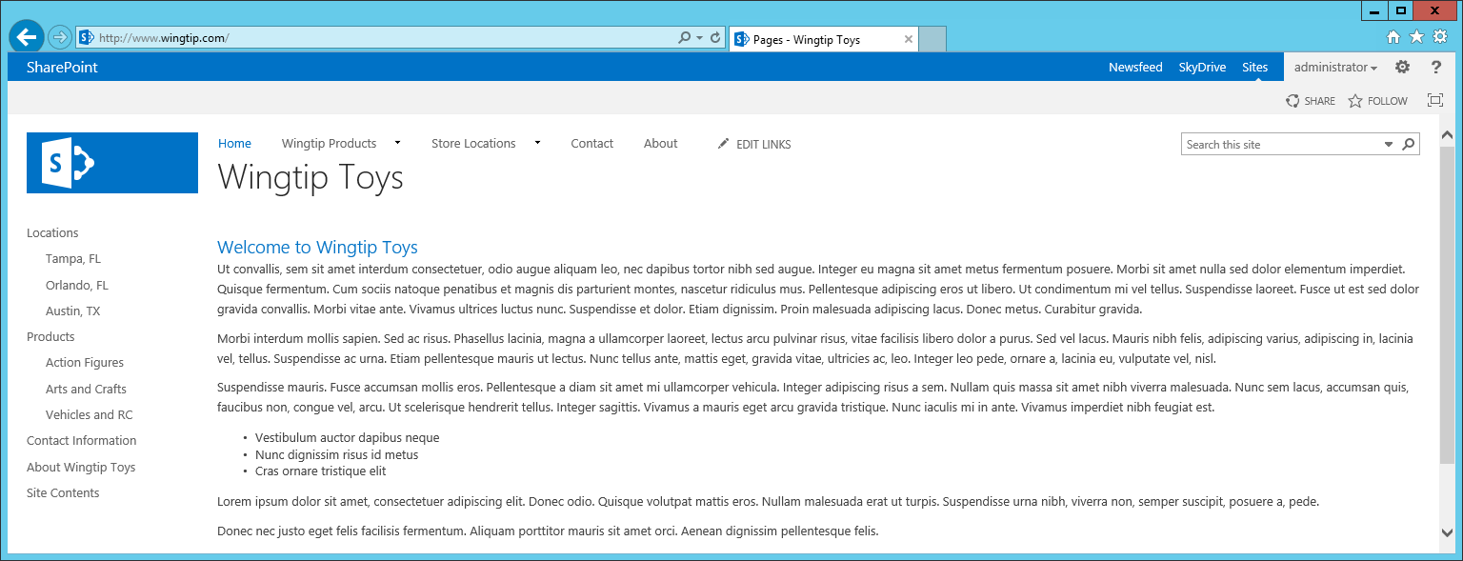

* 1. **Inspect the set of publishing pages in the Pages library of the top-level site.**
     1. **Navigate to the Site Contents page.**
     2. **Click on the Pages title.**
     3. **Observe that there are two new publishing pages that have been added named about.aspx and contact.aspx.**

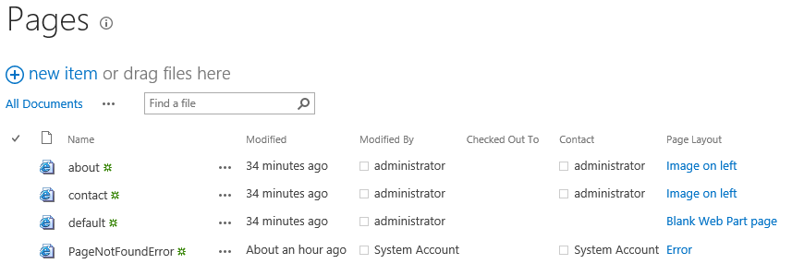

1. **Examine the publishing pages in the subsites named Locations and Products.**
   1. **Navigate to the Site Contents page of the top-level Publishing Site.**
   2. **In the Subsites section at the bottom of the Site Contents page, you should see that there are now two subsites named Locations and Products.**

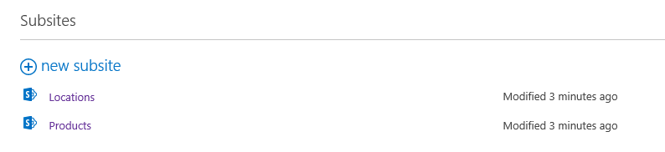

* 1. **In the Subsites section of the Site Contents page, click on the Locations link to navigate to the Locations subsite.**
  2. **Once you have navigated to the Locations subsite, click on the Site Contents link to see its lists and libraries.**
  3. **On the Site Contents page of the Locations subsite, click the Pages tile to see the publishing pages inside this subsite.**
     1. **The site has a publishing page named default.aspx that serves as the site's home page.**
     2. **You can also see three other publishing pages named austin.aspx, tampa.aspx and orlando.aspx.**

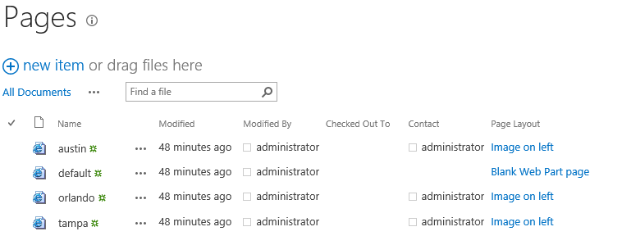

* 1. **Click on the Home link in the top link bar to navigate back to the home page of the top-level site.**

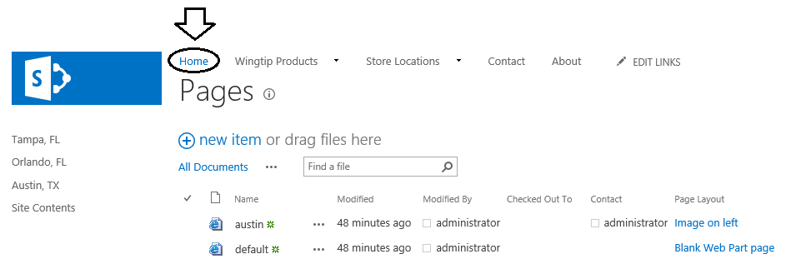

* 1. **Click on the Site Contents link in Quick Launch on the top-level site to navigate to the Site Contents page.**
  2. **In the Subsites section of the Site Contents page, click on the Products link to navigate to the Products subsite.**



* 1. **Once you have navigated to the Products subsite, click on the Site Contents link to see its lists and libraries.**
  2. **On the Site Contents page of the Products subsite, click the Pages tile to see the publishing pages inside this subsite.**
     1. **The site has a publishing page named default.aspx that serves as the site's home page.**
     2. **You can also see three other publishing pages named actionfigures.aspx, artandcrafts.aspx and vehicles.aspx.**

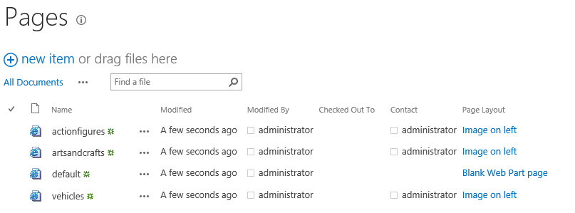

* 1. **Click on the Home link in the top link bar to navigate back to the home page of the top-level site.**

1. **Navigate around the Wingtip Toys publishing site using the navigation links in the top link bar.**
   1. **Test every link in the top link bar including the ones in the dropdown menus.**
   2. **Notice that the links in the top link bar remain unchanged as you move from page to page and across site boundaries.**
   3. **You should also be able to see that the top link bar navigates to publishing pages using friendly URLs as those shown in the following list.**

****http://www.wingtip.com/****

****http://www.wingtip.com/about****

****http://www.wingtip.com/contact****

****http://www.wingtip.com/store-locations****

****http://www.wingtip.com/store-locations/tampa****

****http://www.wingtip.com/store-locations/orlando****

****http://www.wingtip.com/store-locations/austin****

****http://www.wingtip.com/wingtip-products****

****http://www.wingtip.com/wingtip-products/action-figures****

****http://www.wingtip.com/wingtip-products/arts-and-crafts****

****http://www.wingtip.com/wingtip-products/vehicles-and-rc****

1. **Navigate around the Wingtip Toys Publishing Site using the navigation links in Quick Launch.**
   1. **Use the Home link in the top link bar to navigate to the home page of the top-level site. You will see what the Quick Launch looks like when you are one a page in the top-level site. Note that there are links to publishing pages across all three sites.**

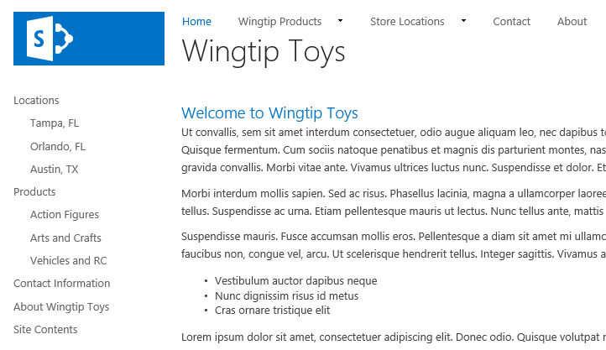

* 1. **Click on the About Wingtip Toys link at the bottom of Quick Launch to navigate to the About Wingtip Toys page.**
  2. **Look at the URL in the address bar of the Internet Explorer. You should be able to see that this is not a friendly URL but instead an URL which contains the names of the Pages library and the file name of the publishing page.**

****http://www.wingtip.com/Pages/about.aspx****

**Note that the Quick Launch has been configured in this scenario with Structural Navigation whereas the top link bar has been configured using the new Managed Navigation features introduced in SharePoint 2013. The important point is that friendly URLs are supported when using Managed Navigation but are not supported when using Structural Navigation.**

* 1. **Click on the Action Figures link in Quick Launch to navigate to the Action Figures publishing page in the Products subsite.**
  2. **On the Action Figures page, examine the Quick Launch menu and see how it has changed. It displays links to all the publishing pages in the current site.**

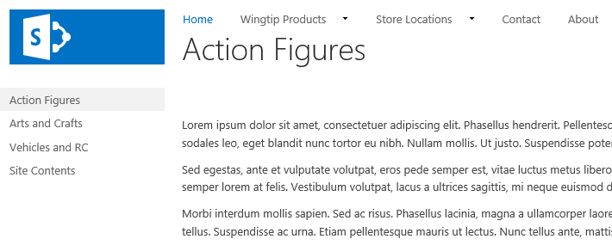

* 1. **Navigate around inside the Products site by clicking each of the three links which includes Action Figures, Arts and Crafts and Vehicles and RC. You should observe that the Quick Launch remains the same while you remain inside the same site.**

**Now you have added two subsites and several publishing pages to your Publishing Site. This will makes things easier when you begin your branding work in later lab exercises because you have something much better than a new content-free site to work on. In the next lab, you will configure anonymous access for your Publishing Site so you can see your site from the perspective of a typical visitor which is an essential aspect of testing your branding work.**

### **Exercise 4: Configuring Anonymous Access for Testing Purposes**

In this exercise, you will configure the Publishing Site to support anonymous access and then test the site using the browser so you know how to switch back and forth between navigating the site as the anonymous user and authenticating as a privileged user which will let you add and approve pages.

1. Launch the Internet Explorer and navigate to the Publishing Site at <http://www.wingtip.com> if you are not already there.
2. Navigate to the **Site Settings** page using the **Site Action** menu.
3. Click the **Site permissions** link in the **Users and Permissions** section to navigate to a built-in page named **user.aspx**.

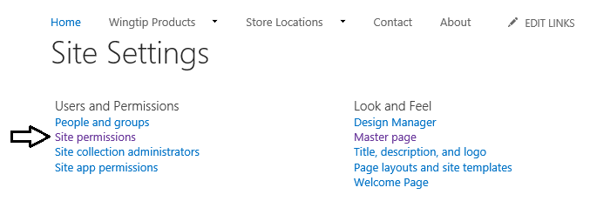

1. **Look in the Permissions tab in the ribbon at the top of the page. Click the Anonymous Access button.**

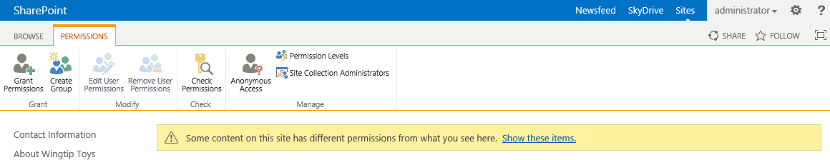

1. **On the Anonymous Access configuration page, select the Entire Web site option for Anonymous Access settings. Click the OK button to save your changes.**

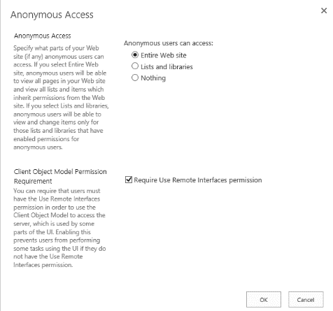

1. **After you have configured anonymous access for the site, close all instances of the Internet Explorer.**

**In order to test out whether anonymous access is working, you must shut down the Internet Explorer and restart it. When you restart the Internet Explorer and return to the Publishing Site, you should be able to verify that you are running as an anonymous user.**

1. **Restart the Internet Explorer and navigate back to the Publishing Site at** <http://www.wingtip.com>**.**
2. **Look at the upper, right-hand side of the page and verify that you can see a Sign In link as shown in the following screenshot.**

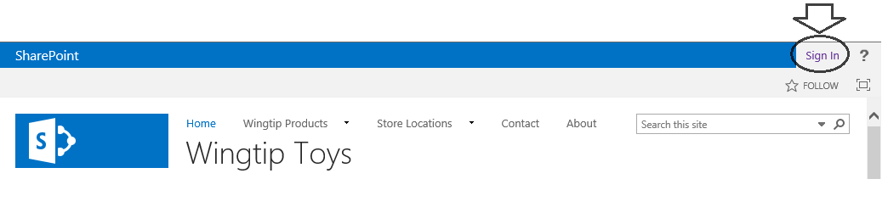

**Whenever you see the Sign In link, it means that you are running as the anonymous user. It’s important to periodically test your work by running as the anonymous user so you can see how things look from the perspective of a user who can only see content and branding files that have been approved or that have been checked in as a major version.**

**If you get a warning that says Microsoft Office needs permission to run, click the Always run on this site button to make the warning go away.**

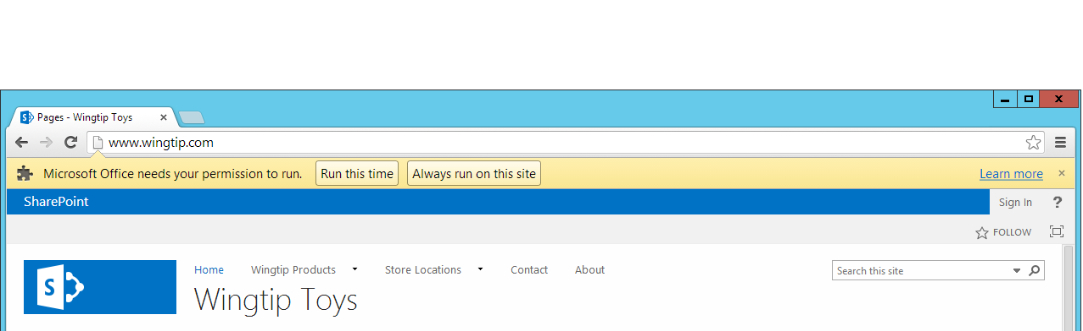

**Later in this course in the module that covers creating custom master pages, you will be shown the real way to deal with this situation by adding JavaScript code to the master page to prevent SharePoint from adding the components that are causing these warnings.**

1. **Navigate around the site as the anonymous user. You should be able to navigate to the same set of publishing pages as before using the top link bar and Quick Launch.**
2. **Notice what page elements are missing for the anonymous user.**
   1. **You should notice that the Site Actions menu is not displayed to the anonymous user.**
   2. **You should notice that the Site Contents link is not displayed to the anonymous user.**
   3. **The Sign In link has replaced the standard SharePoint Welcome menu.**
3. **Click on the Sign In link in the top right corner of the page to authenticate. Once you have been authenticated, you should see the page restore the Welcome menu, the Site Actions menu and the Site Contents link.**

### **Exercise 5: Creating, Editing and Approving Publishing Pages**

In this exercise, you will create a new subsite and add new publishing pages. Along the way, you will be required to approve publishing pages and to create new managed navigation terms to ensure all the publishing pages you have added are accessible through links in the top nav bar which are based on friendly URLs.

1. Launch the Internet Explorer and navigate to the Publishing Site at [**http://www.wingtip.com**](http://www.wingtip.com) if you are not already there.
2. Create a new subsite named **Company**.
   1. Navigate to the **Site Contents** page of the top-level site.
   2. Below in the **Subsite** section of the **SIte Contents** page, click the **new subsite** link.

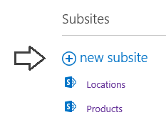

* 1. Fill in the information on the **New SharePoint SIte** page as follows:
     1. Add a **Title** of **Company**.
     2. Leave **Description** blank.
     3. Configure the URL name as **http://www.wingtip.com/Company**.
     4. Pick the site template named **Publishing Site**.

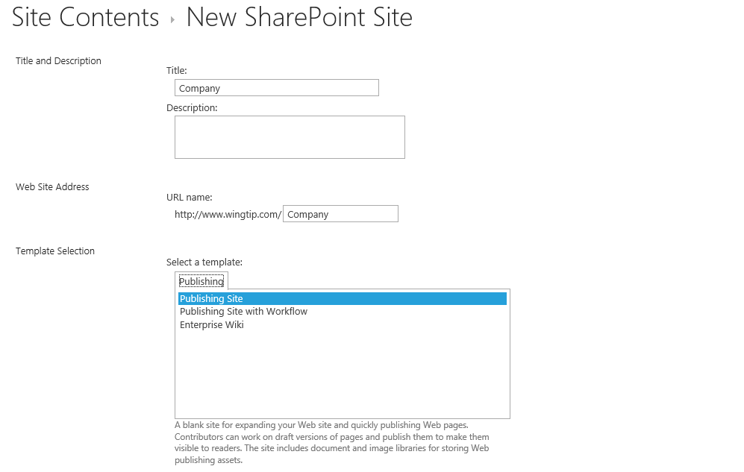

* 1. In the **Permissions** section, select the **User Permissions** option which is **Use same permissions as parent site**.
  2. Change the **Navigation inheritance** setting to **Yes**.
  3. Click the **Create** button to complete the process of creating the new site.

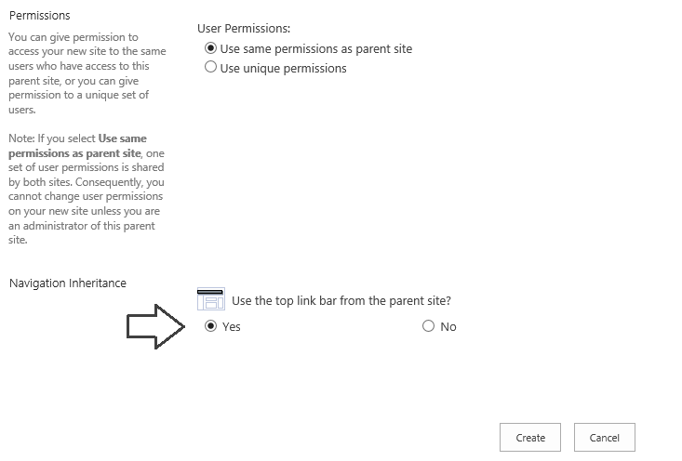

* 1. Note that when the site is first created, SharePoint might show the top link bar in a state that is not yet configured as shown in the following screenshot.

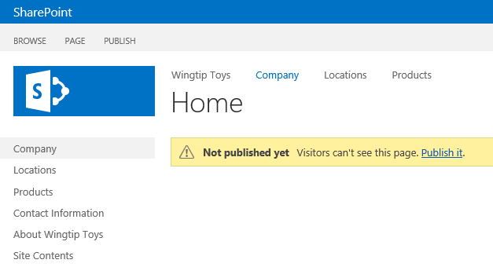

* 1. When you refresh the page, the top link bar, you should be able to see that the new Welcome page for the site which is located at <http://www.wingtip.com/Company> displays the top link bar using the same navigation links as the other pages in the site because the site has inherited the top link bar settings from its parent site.

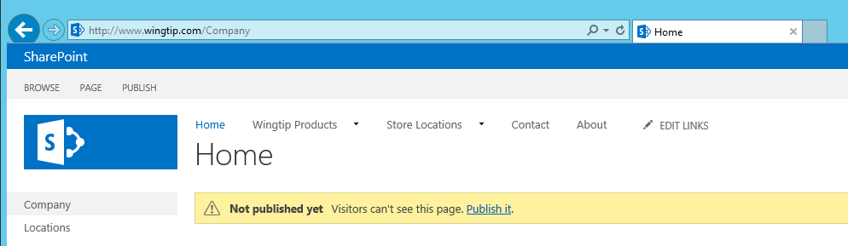

1. Create a Navigation Term with a friendly URL for the **Company** site.
   1. Click on the **Home** link in the top link bar to navigate to the top-level site.
   2. Use the **Site Actions** menu to navigate to the **Site Settings** page of the top-level site.
   3. In the **Site Administration** section, locate and click on the **Term Store Management** link.
   4. On the **Term Store Management** page, locate the **Site Navigation** termset.

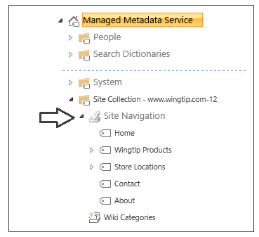

* 1. Use the dropdown menu of the top-level node of the **SIte Navigation** termset to run the **Create Term** menu command.

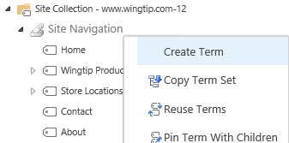

When the new node is created, give it a name of **Company Info** as shown in the folling screenshot.

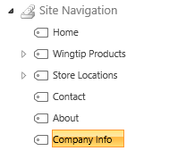

* 1. With the node for the **Company Info** navigation term selected, inspect the settings in the **GENERAL** tab. You do not need to change anything on this tab but you should look through what settings are available.

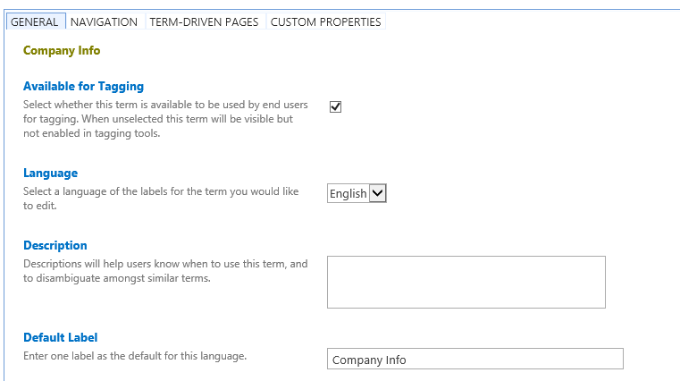

* 1. Move to the **NAVIGATION** tab. The one change you need to make on this tab in the **Visibility in Menus** section is to uncheck the **Show in Current Navigation Menu** option shown as shown in the following screenshot. When you are done, click the **Save** button at the bottom of the page to save your changes. Note you might need to scroll down if you cannot see the Save button.

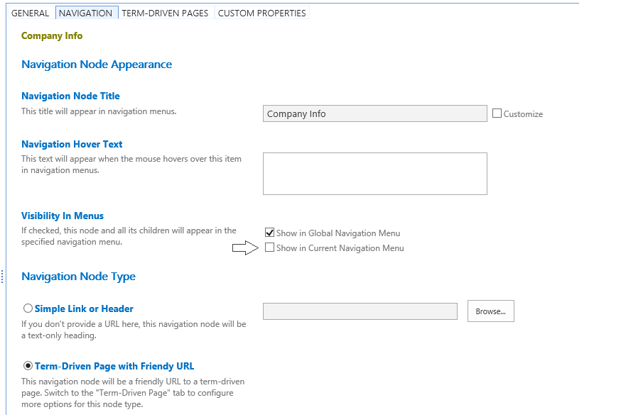

* 1. Move to the **TERM-DRIVEN PAGES** tab. Check the **Change target page for this term** checkbox and then add an URL value of **/Company/Pages/default.aspx** as shown in the following screenshot. When you are done, click the **Save** button at the bottom of the page to save your changes.

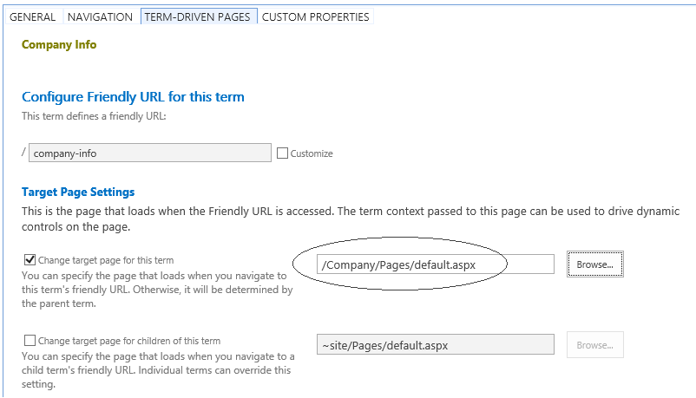

Now you have properly configured the new navigation term. The next step is to reorder the top-level navigation terms so the **Company Info** link doesn't show up last in the top link bar.

* 1. Select the top-level node for the **Site Navigation** termset.
  2. Select the **CUSTOM SORT** tab.
  3. Reorder to navigation terms as shown in the following screenshot so that the **Company Info** link is shown after the **Store Locations** link but before the **Contact** link. Click the **Save** button to save your changes.

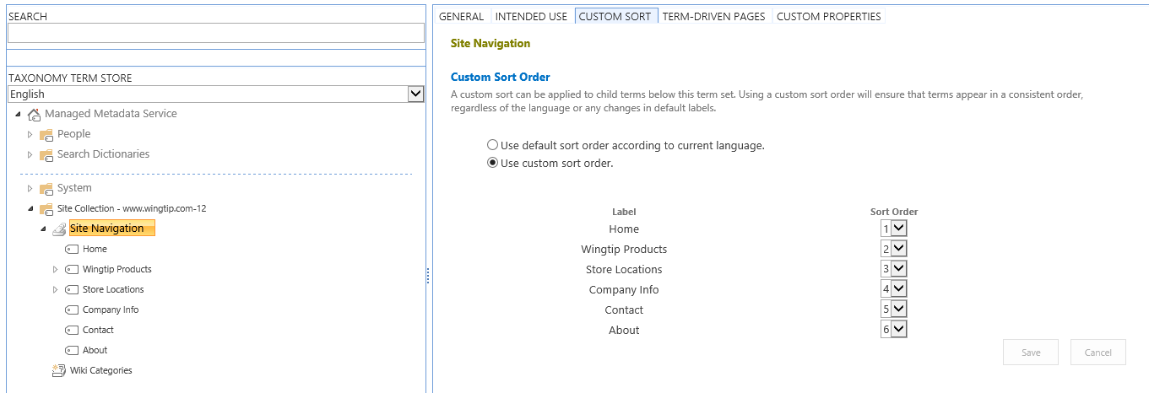

1. Navigate to the home page of the top-level site, refresh the page and inspect the top link bar. The **Company Info** link should be displayed between the **Store Locations** link and the **Company Info** link.

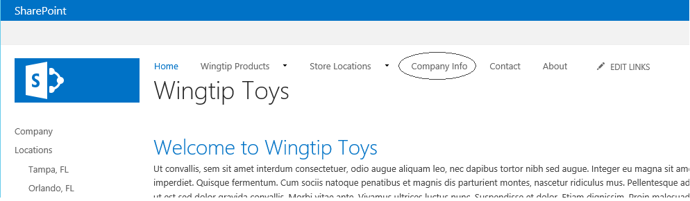

1. Click on the **Company Info** link to navigate to the welcome page of the **Company** site. You should be able to see a message telling that the page has not yet been published. You should also be able to see the URL in the browser address bar which is <http://www.wingtip.com/company-info>.

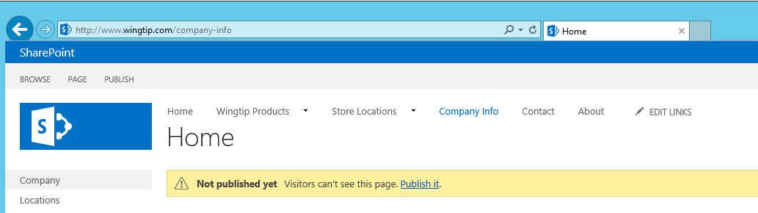

1. Inspect the site as the anonymous user.
   1. Shut down all instances of the Internet Explorer.
   2. Launch the Internet Explorer and navigate to the Publishing site at <http://www.wingtip.com>. You should be able to see the **Sign In** link to verify that you are accessing the site as an anonymous user.
   3. Note that the **Company Info** link is not showing in the top link bar.
2. Publish the welcome page of the new **Company** site.
   1. Click the **Sign In** link to authenticate. Once you do, the **Company Info** link should reappear in the top link bar.
   2. Click the **Company** Info link to navigate to the welcome page of the **Company** site.
   3. Click the Publish It link to publish the welcome page.

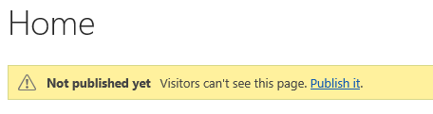

1. Inspect the site as the anonymous user.
   1. Shut down all instances of the Internet Explorer.
   2. Launch the Internet Explorer and navigate to the Publishing site at <http://www.wingtip.com>. You should be able to see the **Sign In** link to verify that you are accessing the site as an anonymous user.
   3. Note that the **Company Info** link is now showing in the top link bar because you published the welcome page for the Company site.
2. Create a second publishing page in the **Company** site.
   1. Make sure you are currently inside the **Company** site. If you are not sure, you can click the **Company Info** link to navigate to the Welcome page of the **Company** site.
   2. Select the **Add a page** menu item command from the **Site Actions** menu.
   3. Give the new page a name of **Company Background** and click the **Create** button.

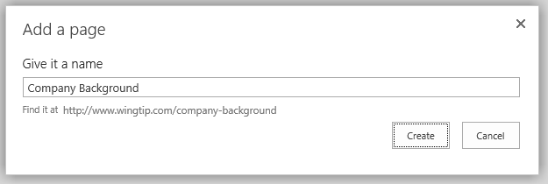

* 1. Once the page has been created, place your cursor inside the **Page Content** field control as shown in the following screenshot. Type in a simple text message such as **“Testing 1, 2, 3”** and click **Save** button in ribbon.

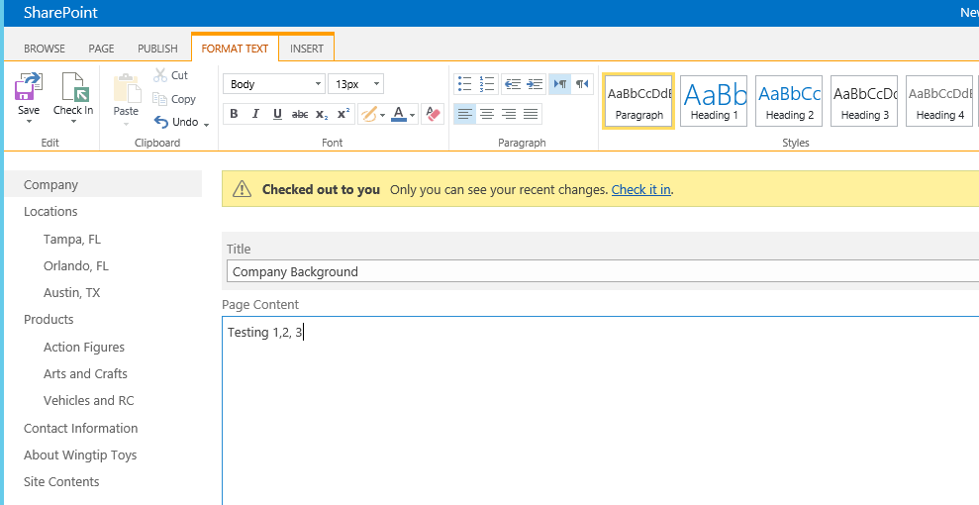

* 1. Once you have saved the new page, click the **Check it** in link. There is no need to add comments on the **Check In** page so you can just click the **Continue** button to finish the check in process.

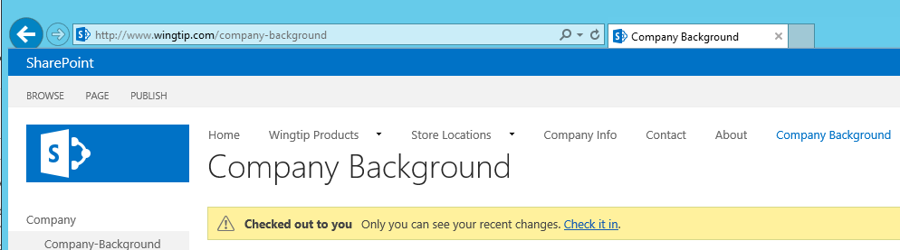

1. Look in the top link bar. You should notice that the **Company Background** link is showing as a top-level link in the top link bar. This is not what you want because this new page should be a child link to the **Company Info** link for the **Company** site.
2. Create a Navigation Term with a friendly URL for the **Company** site.
   1. Click on the **Home** link in the top link bar to navigate to the top-level site.
   2. Use the **Site Actions** menu to navigate to the **Site Settings** page of the top-level site.
   3. In the **Site Administration** section, locate and click on the **Term Store Management** link.
   4. On the **Term Store Management** page, locate the **Site Navigation** termset.
   5. Locate the **Company Background** navigation termset at the bottom.

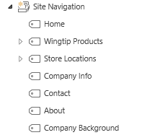

* 1. Use the dropdown menu of the **Company Background** navigation term to run the **Move** command. Move this term so it is a child term of the **Company Info** navigation term as shown in the following screenshot.

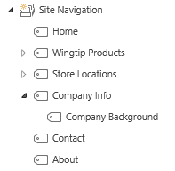

* 1. Return to the home page of the top-level site and refresh the page. The **Company Background** link should now be a child link of the **Company Info** link.

1. In the top link bar, drop down the **Company Info** link and click the **Company Background** link to navigate to the **Company Background** page.

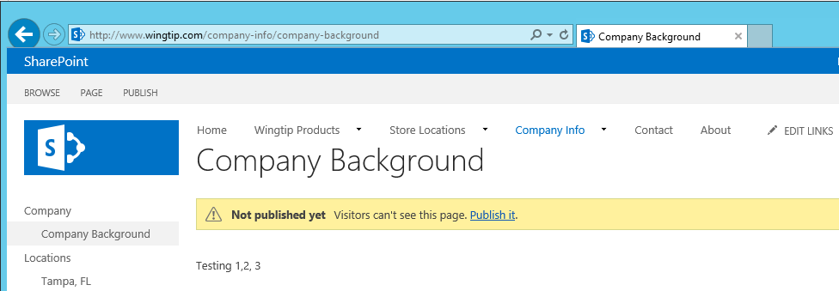

1. On the **Company Background** page, click the **Publish It** link to publish the page.
2. Change navigation for **Company** site.
   1. Make sure you are at a page in the **Company** subsite.
   2. Use the **Site Actions** menu to navigate to the **Site Settings** page.
   3. In the **Look and Feel** section, find and click the **Navigation** link to navigate to the **Navigation** settings page.
   4. Reconfigure the **Current Navigation** by selecting **Structural Navigation: Display only the navigation items below the current site** as shown in the following screenshot. Also ensure to check both the **Show subsites** option and the **Show pages** option. Click **OK** to save your changes.

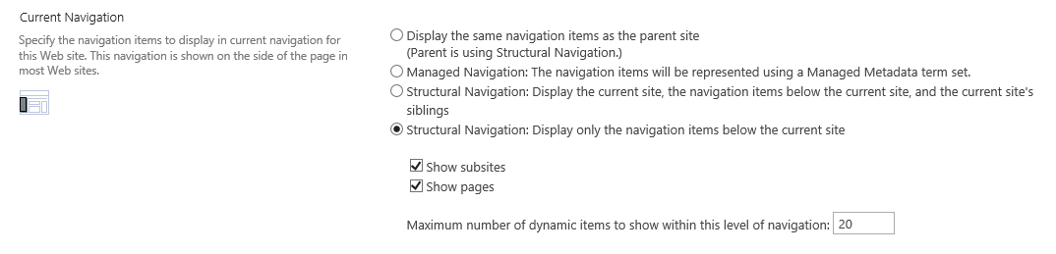

1. Return to a page in the **Company** site and inspect the Quick Launch to see your changes.
2. Finish your work by inspect the site as the anonymous user.
   1. Shut down all instances of the Internet Explorer.
   2. Launch the Internet Explorer and navigate to the Publishing site at <http://www.wingtip.com>. You should see the **Sign In** link.
   3. Navigate around the site and make sure the anonymous user can navigate to the **Company** site welcome page and the **Company Background** page.

**You are now done with this lab. You have learned to create a subsite as well as how to create and approve publishing pages. You also learned to work with the new managed navigation scheme of SharePoint 2013 ensuring that you can configure access to publishing pages using friendly URLs.**