Configuring Security with SharePoint Apps
Lab Time: 60 minutes
Lab Folder: [[StudentFolder]]\Security
Lab Overview: In this lab you will create SharePoint apps that utilize some of the new security features provided in SharePoint 2013.

Exercise 1: Setup Lab Environment
In this exercise you will setup your environment.
All exercises in this lab assume you will work in a new site collection, http://security.wingtip.com.
- Setup a new site collection for this lab:
  - Ensure you are logged into the WingtipServer server as WINGTIP\Administrator.
  - Run a PowerShell script, found in the root lab folder for this module:
    - Right-click SetupModule.ps1 and select Run with PowerShell. This file can be found in the files associated with this lab:
[..]\Security
  - When the script completes, it will launch a new browser and navigate to the lab site collection.
  - Close the PowerShell console window.

Exercise 2: Create a SharePoint-Hosted App that Requires Custom Permissions
In this exercise you will create a SharePoint-Hosted App that uses the client-side object mode (CSOM) to retrieve the title of the site at the top of the current site collection. This CSOM call will fail unless the app requests and is granted the proper permissions during the installation of the app.
- Create a new project in Visual Studio 2012:
  - Launch Visual Studio 2012 as administrator:
    - Start All Programs Microsoft Visual Studio 2012 Visual Studio 2012.
  - Select File New Project.
  - In the New Project dialog:
    - Find the App for SharePoint 2013 template under the Templates Visual C# Office / SharePoint Apps section.
    - Name: AppPermissionsLab
  - In the New App for SharePoint wizard, use the following values to complete the wizard and click Finish.
    - What is the name of your App for SharePoint? App Permissions Lab
    - What site do you want to use for debugging? http://security.wingtip.com
    - How do you want to host your app for SharePoint? SharePoint-hosted
- Open the Default.aspx file which defines the app’s user interface and replace the HTML content inside the Content control with the ContentPlaceHolderID of PlaceholderMain with the following HTML content.
<asp:Content ContentPlaceHolderID="PlaceHolderMain" runat="server">

<div id="toolbar">
<input type="button" id="cmdGetSiteInfo" value="Get Site Info" />
</div>

<div id="results" style="margin-top: 12px; font-size: 32pt;" />

</asp:Content>
- Inside Default.aspx, also update the page title by update the text inside the Content control with the ContentPlaceHolderID of PlaceHolderPageTitleInTitleArea with the following text.
<asp:Content ContentPlaceHolderID="PlaceHolderPageTitleInTitleArea" runat="server">
My Start Page in the App Web
</asp:Content>
- When you are done, save your changes and close Default.aspx.
- Open the App.js file which defines your app’s behavior. Delete all the code from App.js and replace it with the following JavaScript code.
// the following code can be copy-and-pasted from Ex2/StarterFiles/App.js.txt

$(onPageReady);

function onPageReady(){
$("#cmdGetSiteInfo").click(onGetSiteInfo);
}

function onGetSiteInfo() {

// create URL to make REST call into host web
var urlHostSite = _spPageContextInfo.siteAbsoluteUrl;
var urlRestCall = urlHostSite + "/_api/web?$select=Title, Url";

// issue web service request against host web
var ajaxOptions = {
url: urlRestCall,
type: "GET",
headers: { "ACCEPT": "application/json;odata=verbose" },
contentType: "application/json",
success: onComplete,
error: onError,
};

$.ajax(ajaxOptions);
}

function onComplete(data) {
var siteTitle = data.d.Title;
$("#results").html($("<p>").text("Title of top-level site: " + siteTitle));
};

function onError(error) {
var errorNumber = error.status;
var errorMessage = errorNumber + " - " + error.statusText;
$("#results").html($("<p>").text("An error has occurred: " + errorMessage));
}
- Make a few observations about the JavaScript code you just added to App.js.
  - It used jQuery to wire up an event handlers to the click event of the cmdGetSiteInfo command button.
  - It uses the jQuery $.ajax function to make a call into the new SharePoint REST API.
  - It used the REST API to retrieve the title of the top-level site in the site collection where the current app web reside.
  - An app does not possess default permissions to access the host web.
- When you are done, save your changes and close App.js.
- Build and test your application by pressing [F5] or Debug Start Debugging.
- Once the app has been deployed, Internet Explorer will launch and navigate to the app’s start page in the app web.
- Click the Get Site Info button.
  - At this point, the JavaScript code behind the button should fail while attempting to make a REST API call due to a lack of permissions.
  - Notice how the SharePoint API prompts the user for new credentials foir 3 attempts and then fails the attempt.
- Stop the debugging session by closing the browser.
- Return to Visual Studio and the AppPermisionsLab project..
- Open the App Manifest in the visual designer and navigate to the Permissions tab.
- Add a permission request scoped at current Site Collection for Read permissions.
- When you make this change in the visual designer, it automatically adds the following XML into the app manifest,
<AppPermissionRequests>
<AppPermissionRequest Scope="http://sharepoint/content/sitecollection" Right="Read" />
</AppPermissionRequests>
- Save your changes and close AppManifest.xml.
- Now it is time to test the app a second time. Build and test your application by pressing [F5] or Debug Start Debugging.
- This time the app installation involves user interaction because the app is making a permission request. You will be promoted with a dialog that looks like the dialog shown in the following screenshot.
- Click the Trust It button to approve the app’s permission request.
- When the app’s start page appears, click the Get Site Info button. This time the app should succeed in making the REST API call because it was granted the required permissions.
- Close the browser windows and close the AppPermissionsLab project in Visual Studio.
In this exercise, you developed and tested an app that required extra permissions. You were required to add a permission request in order for the app to accomplish a specific task which required permissions beyond what permissions an app has by default.

Exercise 3: Create a Test Certificate for Working with S2S Trusts
In this exercise you will create a new self-signed certificate for a SharePoint app that will utilize the S2S authentication model. You will build the app in the next exercise. This exercise is about getting everything prepared.
- Look inside the folder for this lab and locate the folder Security\Exercises\Ex3.
  - Inside this folder you should be able to locate these two PowerShell scripts.
    - CreateTestCertificateForS2STrust.ps1
    - CreateTrustedSecurityTokenIssuer.ps1
- Open the PowerShell scripted named CreateTestCertificateForS2STrust.ps1 in the PowerShell ISE.
  - Take a moment to review what this script does.
$makecert = "C:\Program Files\Microsoft Office Servers\15.0\Tools\makecert.exe"
$certmgr = "C:\Program Files\Microsoft Office Servers\15.0\Tools\certmgr.exe"

# specify domain name for SSL certificate
$domain = "appserver.wingtip.com"

# create output directory to create SSL certificate file
$outputDirectory = "c:\Certs\"
New-Item $outputDirectory -ItemType Directory -Force -Confirm:$false | Out-Null

# create file name for SSL certificate files
$publicCertificatePath = $outputDirectory + $domain + ".cer"
$privateCertificatePath = $outputDirectory + $domain + ".pfx"

Write-Host
Write-Host "Creating .cer certificate file..."
& $makecert -r -pe -n "CN=$domain" -b 01/01/2012 -e 01/01/2022 -eku 1.3.6.1.5.5.7.3.1 -ss my -sr localMachine -sky exchange -sp "Microsoft RSA SChannel Cryptographic Provider" -sy 12 $publicCertificatePath

Write-Host
Write-Host "Registering certificate with IIS..."
& $certmgr /add $publicCertificatePath /s /r localMachine root

# get certificate to obtain thumbprint
$publicCertificate = Get-PfxCertificate -FilePath $publicCertificatePath
$publicCertificateThumbprint = $publicCertificate.Thumbprint

Get-ChildItem cert:\\localmachine\my | Where-Object {$_.Thumbprint -eq $publicCertificateThumbprint} | ForEach-Object {
Write-Host " .. exporting private key for certificate (*.PFK)" -ForegroundColor Gray
$privateCertificateByteArray = $_.Export("PFX", "Password1")
[System.IO.File]::WriteAllBytes($privateCertificatePath, $privateCertificateByteArray)
Write-Host " Certificate exported" -ForegroundColor Gray
}
  - Execute the script using the Windows PowerShell ISE. After you execute this script, you should be able to see that it created two certificate files in the c:\Certs folder.
- The next step is to create a trusted security token issuer for the certificate you have just created. Open the script named CreateTrustedSecurityTokenIssuer.ps1 in the Windows PowerShell ISE and take a moment to review its content.
Add-PSSnapin "Microsoft.SharePoint.PowerShell"

$issuerID = "11111111-1111-1111-1111-111111111111"

$targetSiteUrl = "http://wingtipserver"
$targetSite = Get-SPSite $targetSiteUrl
$realm = Get-SPAuthenticationRealm -ServiceContext $targetSite

$registeredIssuerName = $issuerID + '@' + $realm

Write-Host $registeredIssuerName

$publicCertificatePath = "C:\Certs\appserver.wingtip.com.cer"
$publicCertificate = Get-PfxCertificate $publicCertificatePath

Write-Host "Create token issuer"
$secureTokenIssuer = New-SPTrustedSecurityTokenIssuer `
-Name $issuerID `
-RegisteredIssuerName $registeredIssuerName `
-Certificate $publicCertificate `
-IsTrustBroker

$secureTokenIssuer | select *
$secureTokenIssuer | select * | Out-File -FilePath "SecureTokenIssuer.txt"

# configure SharePoint to suppport S2S Trusts with HTTP in addition to HTTPS
$serviceConfig = Get-SPSecurityTokenServiceConfig
$serviceConfig.AllowOAuthOverHttp = $true
$serviceConfig.Update()
- Execute CreateTrustedSecurityTokenIssuer.ps1 using the Windows PowerShell ISE.
  - When the script runs it create a text file named SecureTokenIssuer.txt.
  - Open this file and observe that it contains information about the trusted security token issuer that you registered.
- Close all the files you have opened in this exercise.
In this exercise you created a test certificate for configuring S2S trusts and registered a trusted security token issuer based on that test certificate. Now you can create a provider-hosted app that uses this trusted security token issuer as long as the provider-hosted app has access to the password-protected PFX file with the private key.

Exercise 4: Create a S2S High Trust SharePoint Provider-Hosted App
In this exercise you will create a new SharePoint Provider-Hosted app that will leverage the certificate and client ID generated in the previous exercise to implement a high-trust app that utilizes S2S authentication.
- Create a new project in Visual Studio 2012 for hosting your app:
  - Launch Visual Studio 2012 as administrator:
    - Start All Programs Microsoft Visual Studio 2012 Visual Studio 2012
  - Select File New Project.
  - In the New Project dialog:
    - Find the App for SharePoint 2013 template under the Templates Visual C# Office / SharePoint Apps section.
    - Name: SecureApp
  - In the New App for SharePoint wizard, use the following values to complete the wizard and click Next.
    - What is the name of your App for SharePoint? Secure App
    - What site do you want to use for debugging? http://security.wingtip.com
    - How do you want to host your app for SharePoint? Provider-hosted.
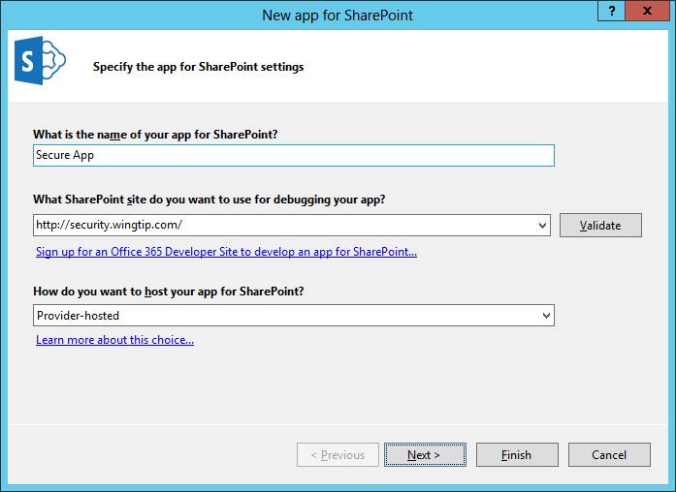
  - Click the Next button to move to the next screen. Do not click the Finish button.
  - You should now be at the Configure authentication settings page. File this page out as follows.
    - Certificate location: C:\Certs\appserver.wingtip.com.pfx
    - Password: Password1
    - Issuer ID: 11111111-1111-1111-1111-111111111111
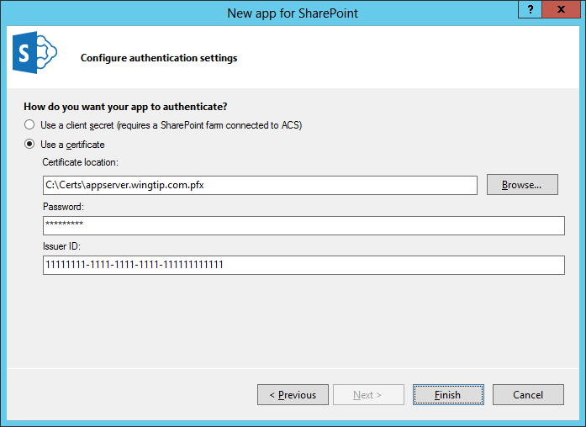
  - Click Finish to complete the wizard and create the new provider-hosted app project.
- Once the Visual Studio solution for the SecureApp project has been created, look inside the SecureAppWeb project and locate the locate source file named Defautl.aspx.cs.
- Open OpenDefault.cs and inspect the C# code inside the Page_Load event handler that was automatically added by Visual Studio. You can see that this code is creating a S2S client content using the client-side object model.
protected void Page_Load(object sender, EventArgs e) {
// The following code gets the client context and Title property by using TokenHelper.
// To access other properties, you may need to request permissions on the host web.

Uri hostWeb = new Uri(Request.QueryString["SPHostUrl"]);

using (var clientContext =
TokenHelper.GetS2SClientContextWithWindowsIdentity(hostWeb, Request.LogonUserIdentity))
{
clientContext.Load(clientContext.Web, web => web.Title);
clientContext.ExecuteQuery();
Response.Write(clientContext.Web.Title);
}
}
- Now test the app and see if it can make the S2S call onto the SharePoint host.
  - Press the {F5} key to start a debugging session.
  - You will be prompted to trust the app since it is being installed with a S2S trust,
  - Click the Trust It button to complete the app installation.
  - After the app has been installed, the Visual Studio debugger should redirect you to the app’s start page in the remote web. You should see a very simple page with the title of the host web.
  - Keep the browser window open because you will use it in the next step.
- Inspect an S2S call using the Fiddler utility.
  - Launch the Fiddler utility application. This can be accomplished from the Windows Start page,
  - Return to the browser window in Internet Explorer that you were using in the previous step. The Secure App should still be running in the Visual Studio debugger.
  - Refresh the Start page of the Secure App by pressing the F5 key. This will issue a new CSOM call from server-side code executing in the app's remote web to the SharePoint host..
  - Once you have refreshed the page, return to Fiddler and inspect the requests.
  - Find the request with the URL of /_vti_bin/client.svc/ProcessQuery. This is the Fiddler data shown for a CSOM request.
  - Inspect the headers of this request and locate the Authenticate header. You should be able to see that it contains a large value which is the S2S access token created by the TokenHelper class.
In this exercise you created a new SharePoint Provider-Hosted App that uses S2S security.

