CBD365 Student Computer/VM Setup Guide

Install Windows 10 - x64 bit
Apply all Windows updates
Install Chrome
Enable PowerShell Script Execution
Set-ExecutionPolicy ByPass

Install Azure PowerShell Modules
- Azure: core set of cmdlets for managing Azure services
- AzureRM. set of cmdlets for managing resource groups
- AzureProfile. A set of cmdlets for managing authentication and execution context.
Install Azure Powershell modules using Web Platform Installer or from PowerShell Gallery
Install-PackageProvider -Name NuGet -MinimumVersion 2.8.5.201 -Force
Set-PSRepository -Name PSGallery -InstallationPolicy Trusted
Install-Module Azure -AllowClobber
Install-Module AzureRM -AllowClobber
Test Azure Login
Login-AzureRmAccount

Moving resources

Install SharePoint Online Management Shell
Install version 16.0.6008.1200 (1/6/2017) or later
https://www.microsoft.com/en-us/download/details.aspx?id=35588

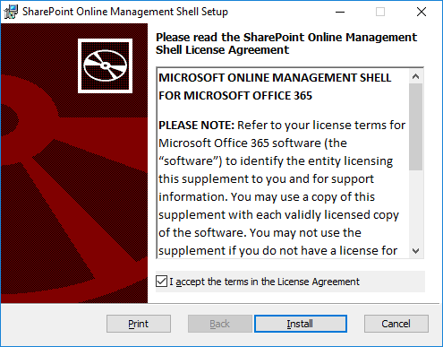
Type cd\ ENTER
CLS ENTER
Connect-SPOService -Url https://pbi365-admin.sharepoint.com -credential student@pbi2017.onmicrosoft.com

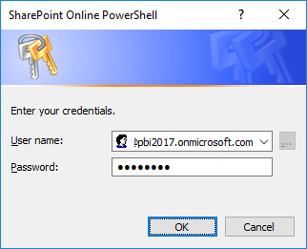

Install Node.js 64-bit
https://nodejs.org/en/download/

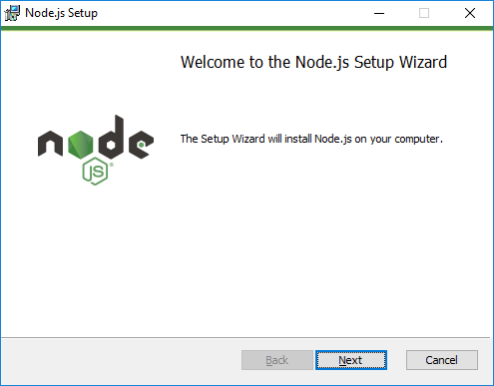
Agree to terms and accept all default settings.

Install GIT
https://git-scm.com/download
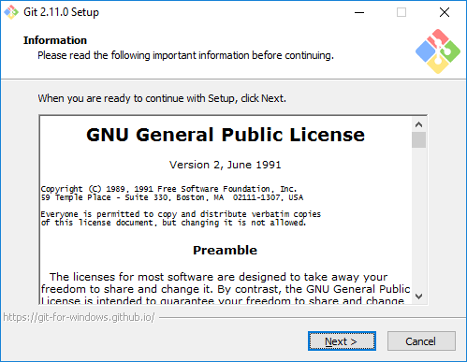
Agree to terms and accept all default settings.

Install Visual Studio 2017 RC
https://aka.ms/vs/15/release/vs_Enterprise.exe
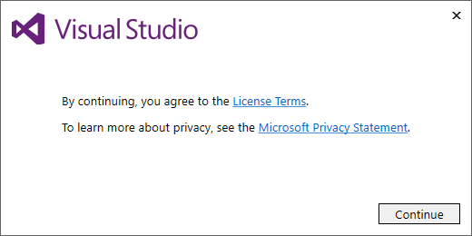

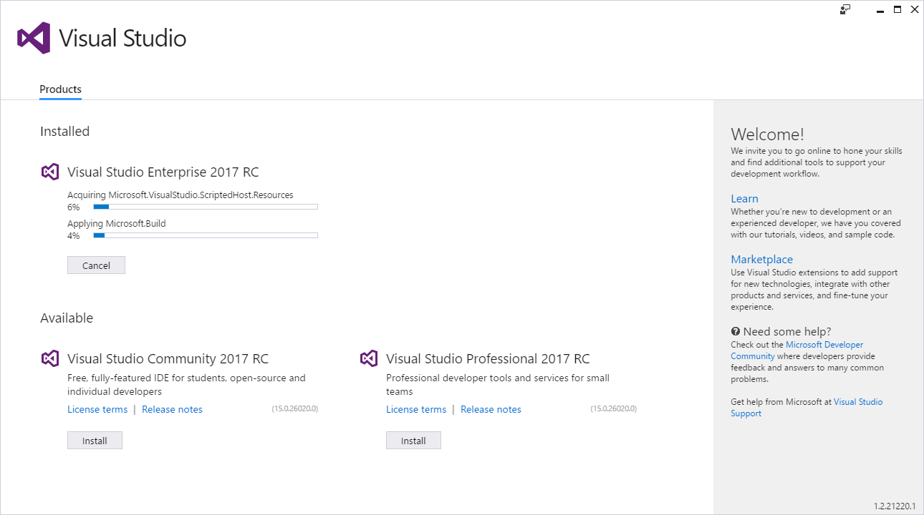

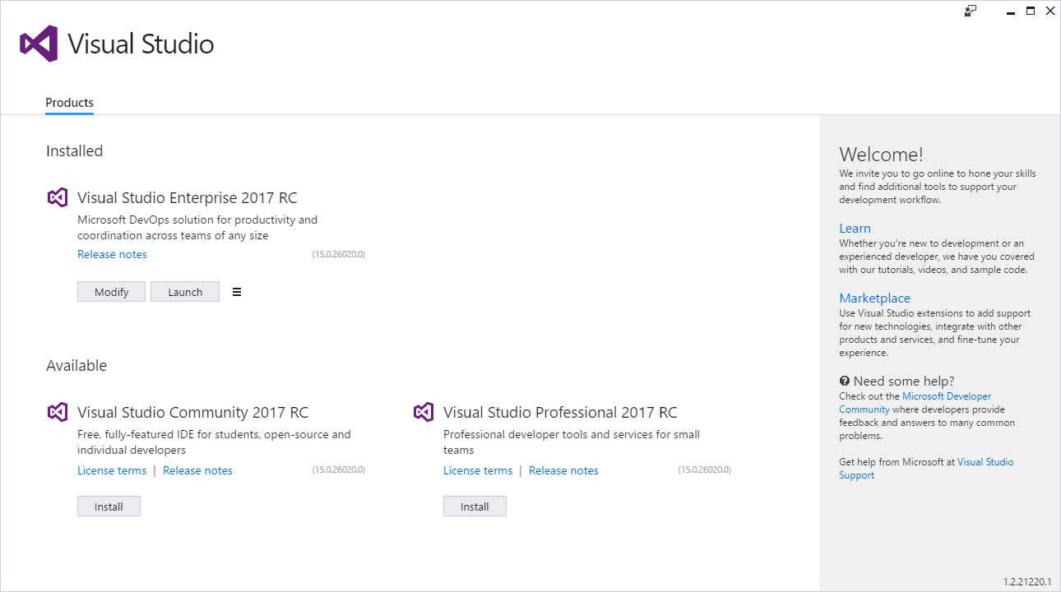

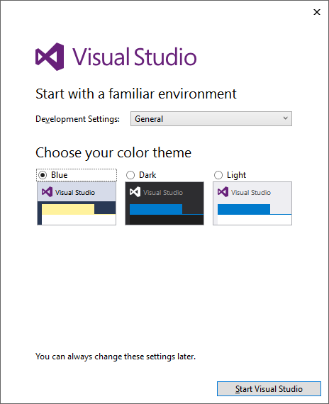
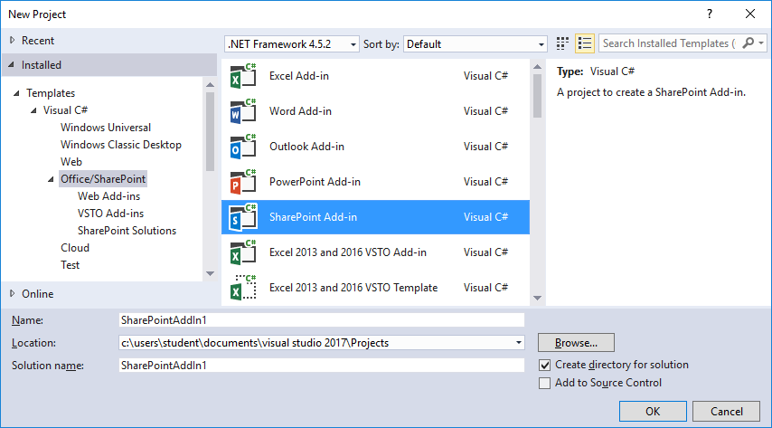

Install Fiddler
https://www.telerik.com/download/fiddler
