# About the Hands-on Labs

**Day-Of Building Business Solutions with Microsoft Flow (DOFLO)** includes a rich set of hands-on lab exercises designed to reinforce the key concepts and techniques that you learned in the lectures. The lab exercises for this training course were designed to run on a workstation or laptop running the Windows operating system. We recommend that you use Windows 10 but you can also Windows 8.1.

**DISCLAIMER**: While it is possible to complete many of the lab exercises for this course using a Mac instead of a Windows PC, the writeups for the lab exercises in this training course assume that you are using a Windows PC.

### GitHub Repository for this course

Student files for this course are maintained in a GitHub file repository at <https://github.com/CriticalPathTraining/DOPAP>**.**

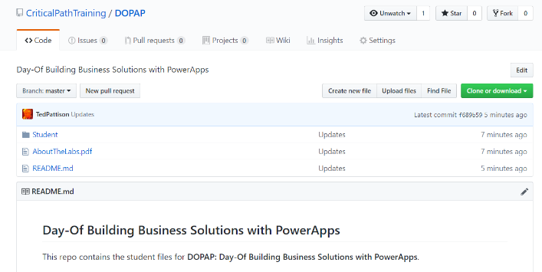

### Student Workstation Prerequisites

All lab exercises should be completed on a student workstation that has the following software.

1. Windows 10 or Windows 8.1.
2. One or more Internet browsers (Chrome, Edge, IE, etc.)
3. *[Optional]* Microsoft Excel 2016 or Microsoft Excel 2013

### Copying the Student Lab Files to Your Windows PC

The most recent version of the electronic student files for this course are kept in the **Student** folder of the GitHub repository for this course. You can download the zip archive for this repository from the following URL.

[**https://github.com/CriticalPathTraining/DOPAP/archive/master.zip**](https://github.com/CriticalPathTraining/DOPAP/archive/master.zip)

It is recommended that you that you download the master zip archive and make a local copy of the **Student** folder so that you have a local copy of the files you will need on your computer workstation when going through these labs exercise. Once you download the master zip archive, open it and copy the **Student** folder to a new local folder.

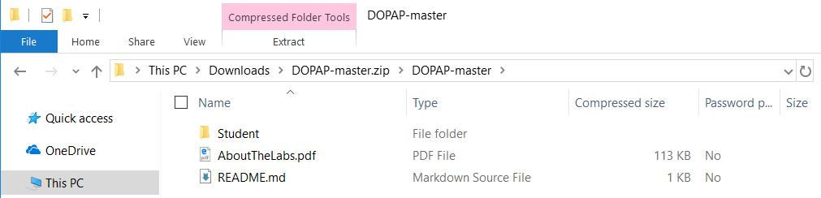

Copy the **Student** folder from the master zip archive to a new local folder at **C:\Student**.

