# Setting Up an Online Classroom in Office 365

**Setup Time**: 45-60 minutes

**Overview**: This setup document covers how to create and configure an online classroom for a training class from Critical Path Training which requires a trial Office 365 tenant with a user account for each student and a set of SharePoint sites. One valuable aspect of creating a new and isolated Office 365 tenant is that you will have tenant-level administrative permissions allowing you to configure the tenant with multiple user accounts for each student that is attending the class.

Note that **t**his work can be done by the instructor of the class or by the support staff of the hosting training company.

### Task 1: Create a new Office 365 Trial Tenant for the Online Classroom

In this task, you will create a new Office 365 tenant which allows you to create up to 25 user accounts with Enterprise E5 trial licenses.

1. Navigate to the following URL:

<https://go.microsoft.com/fwlink/p/?LinkID=698279&culture=en-US&country=US>

1. Fill out the form on the first page with requested required information to create a new Office 365 trial account.
   1. You are presented with the following form.

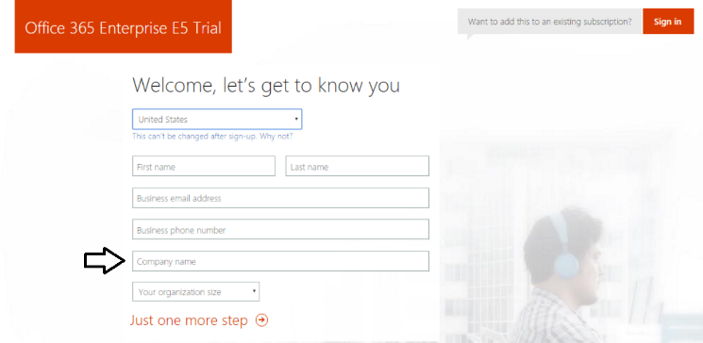

* 1. Use the instructor’s information to fill in **First name**, **Last name** and **Business email address**.
  2. Enter a valid **Business phone number**.
  3. Note that the value you use for **Company name** will be used to name the new Office 365 tenancy and the main SharePoint team site. Therefore, create enter a friendly value for **Company name** such as **CPT Labs for BBS365**.
  4. Once you have filled out the form, click **Next**

1. On the next page, you are prompted to provide a user ID, company name and password.

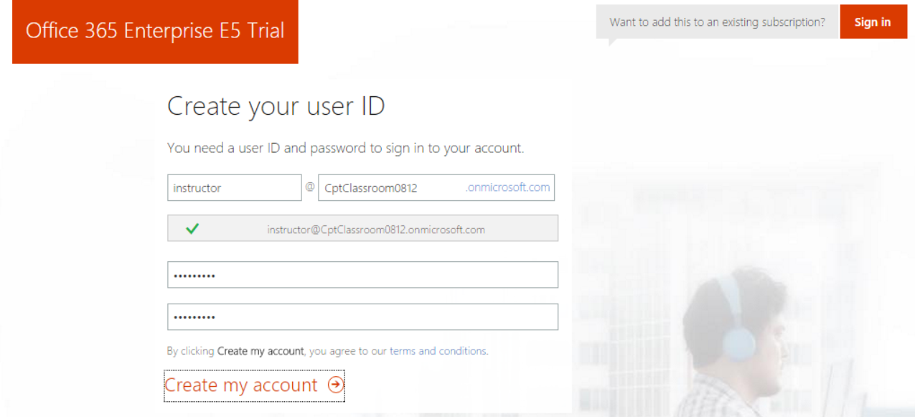

Note that the company name you enter on this page will be used to create the domain name for your new Office 365 trial tenant. For example, if you were to enter a company name of **CptClassroom0812**, it would result in the creation of a new Office 365 tenant within a domain of **CptClassroom0812.onMicrosoft.com**. The user name you enter will be used to create the first user account which will be given administrative rights within the trial tenant. If you enter a user name of **Instructor**, then the email address as well as user principal name for this account will be **Instructor@CptClassroom0812.onMicrosoft.com**.

1. Once you have filled in the required information on the **Create your user ID** page, click the **Create my account** link.
2. Complete the validation form in step 3 by proving you are not a robot.
   1. Select the **Text me** option and then provide the number of your mobile phone and click the **Text me** link.



* 1. After you click **Text me**, a Microsoft service will send you a text message that contains an access code.
  2. You retrieve the access code form your mobile device and use it to complete the validation process.

1. Once you have completed the validation process, click the **You’re ready to go…** link to navigate to the portal welcome page for your new Office 365 trial tenant. Note that you should already be logged on using the user account that was created during the sign up process.

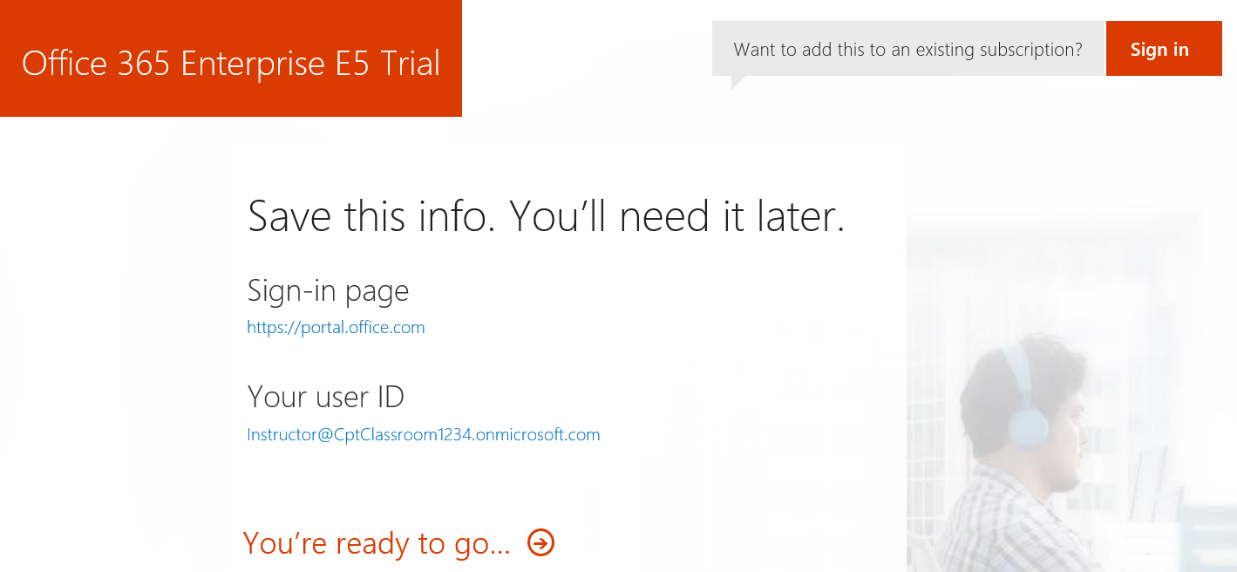

At this point, you have already created your new Office 365 tenant which can support creating up to 25 user accounts with Office 365 Enterprise E5 trial licenses. Note that some Office 365 services within your new Office 365 tenant such as the Office 365 admin center can be accessed immediately. Other services within your Office 365 tenant such as SharePoint Online are not ready immediately and will take some time to provision.

1. At this point, you should be located on the portal welcome page of Office 365. You will notice that this page shows the progress of the Office 365 environment in setting up each of the individual services that make up your new Office 365 tenant. Click the **Admin** tile to proceed to the Office **365 admin center**.

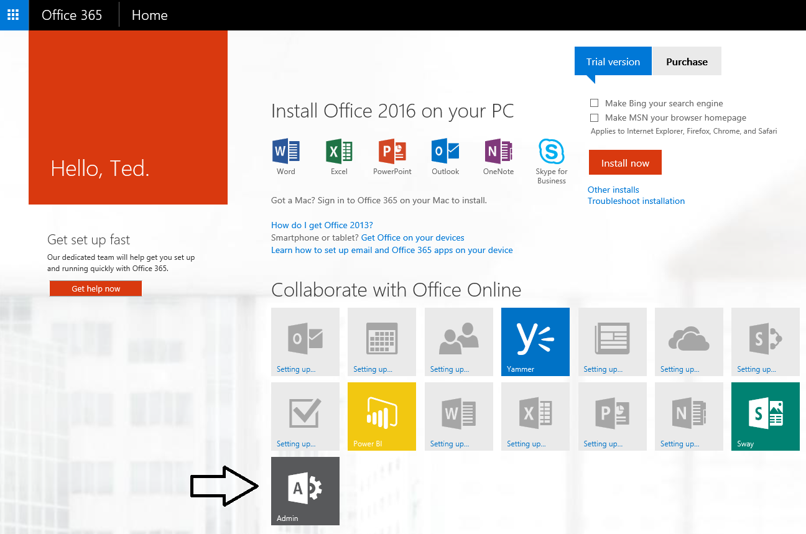

As of April 2016, you will initially be presented with the new user interface experience for the Office 365 Admin center which is currently in preview. While it will be possible for you to fall back on the older UI experience for the Office 365 Admin center, we assume you will use the new preview edition so that is what we will show in the screenshots for this lab.

1. Verify that you are able to access the home page of the **Office 365 admin** **center**.
   1. The following screenshot shows what the Office 365 Admin center looks like as of April 2016 with the introduction of the new user interface experience.

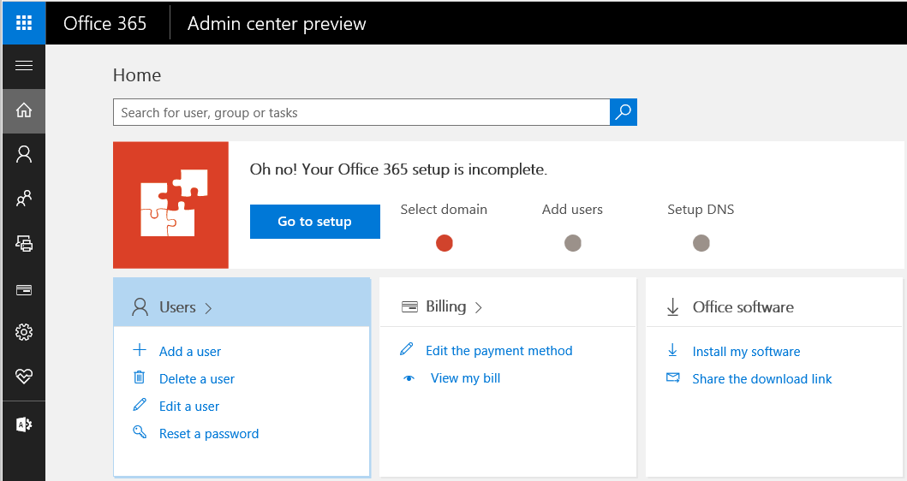

* 1. Locate the top **Menu** button for the left navigation menu. It’s the second button from the top which sites just beneath the Office 365 App Launcher menu button.

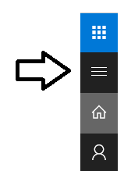

* 1. Click the top **Menu** button several times and see how it toggles the left navigation between a collapsed and expanded mode.

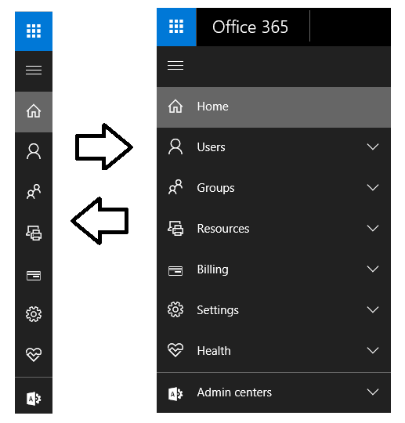

If you are interested in getting more familiar with the **Office 365 admin center**, take a minute to explore the administrative pages behind the left navigation menu in the Office 365 admin center.

### Task 2: Configure Your Computer to Run Remote PowerShell Scripts

In this task, you will.

1. Install **Microsoft Online Services Sign-In Assistant for IT Professionals RTW**.

<http://go.microsoft.com/fwlink/?LinkID=286152>

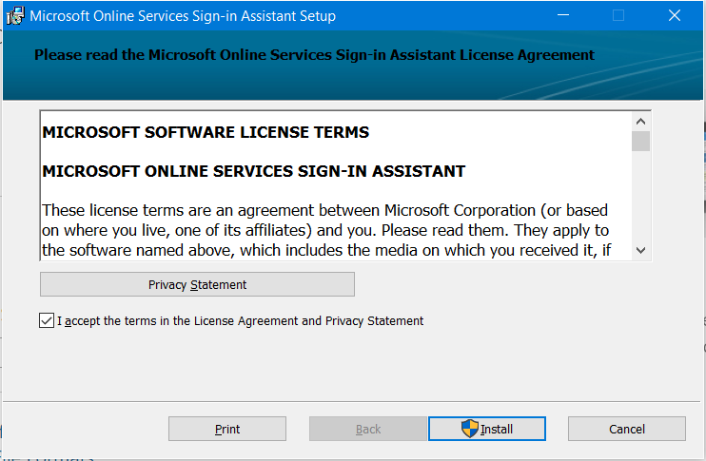

1. Install Azure Active Directory Module for Windows PowerShell (64-bit version),

<http://go.microsoft.com/fwlink/p/?linkid=236297>

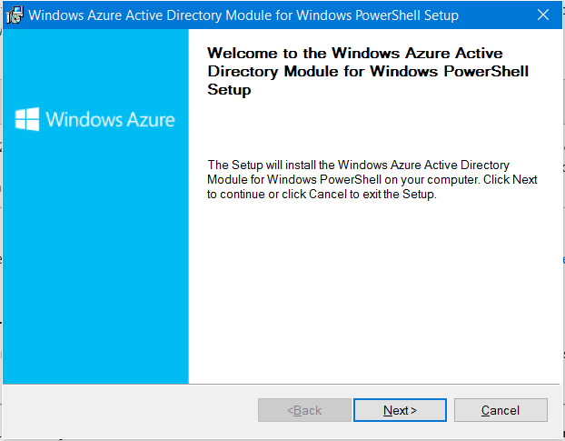

1. Install the **SharePoint Online Management Shell**.
   1. Using the browser, navigate to <https://www.microsoft.com/en-us/download/details.aspx?id=35588>.
   2. Download and install the **SharePoint Online Management Shell**.

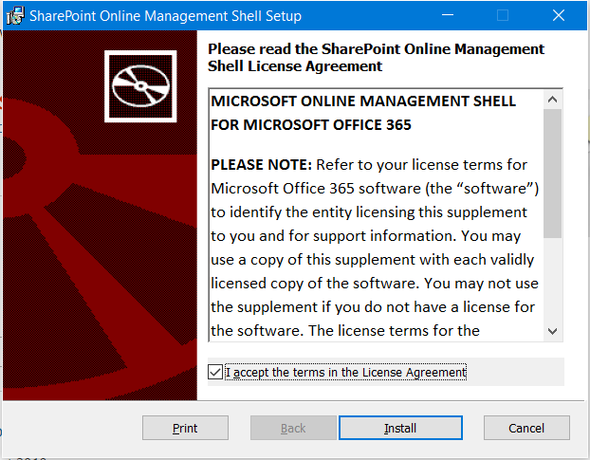

### Task 3: Run PowerShell Script to Create Student Accounts

### Task 4: Run PowerShell Script to Create Student Site Collections