Creating Power BI Content

# Overview

## The estimated time to complete the lab is 30 minutes

In this lab, you will sign in to the Power BI service by using the account provided to you, and then create an app workspace. You will then open a Power BI Desktop file, and interact with the existing report. You will enhance the report with a filter, and then publish the Power BI Desktop file to your app workspace. Lastly, in your app workspace, you will create a new report, and also assemble a dashboard.

You will create a report that looks like the following.

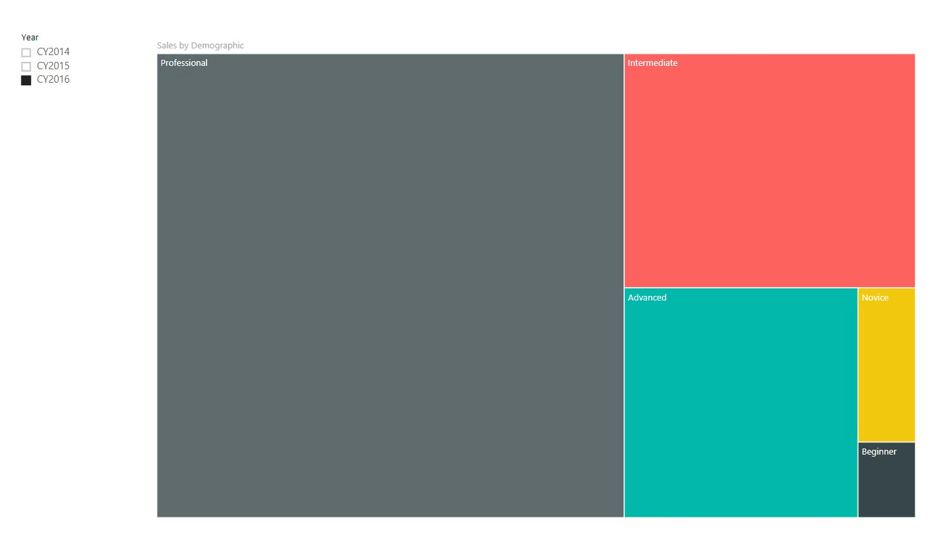

You will create a dashboard that looks like the following.

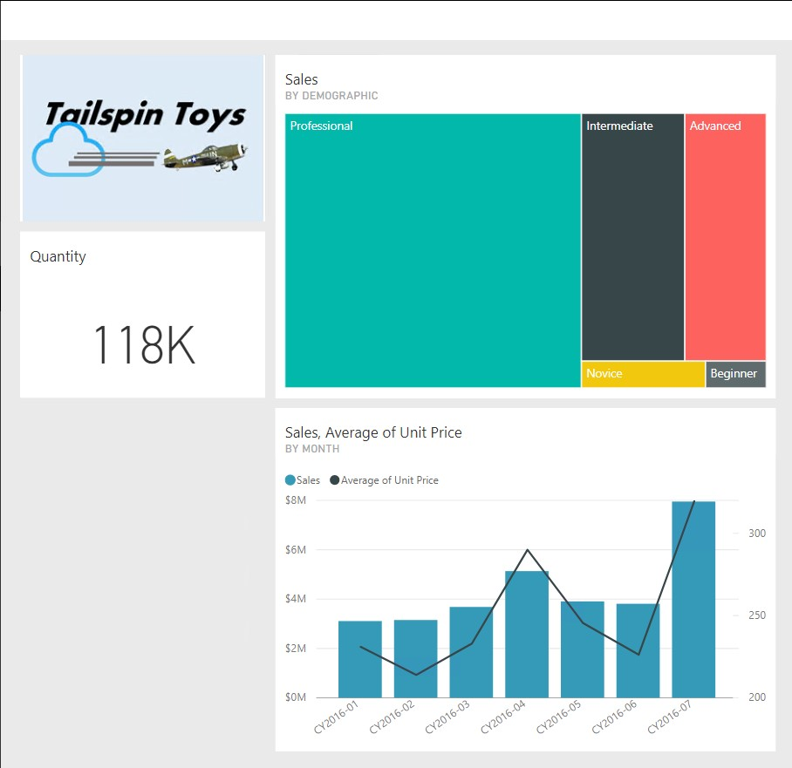

# Signing In to Power BI

In this exercise, you will sign in to Power BI, and verify your account license.

## Signing In to Power BI

In this task, you will sign in to Power BI.

*A personal account has been created for you, and you must use this account to complete all the course labs. You have been provided with admin privileges—please do not use these privileges to create, modify or delete users or content that is not yours.*

1. Open Google Chrome.

*So that the lab activities do not conflict within existing authentication tokens on your PC, it is recommended that you open an incognito Google Chrome window.*

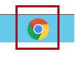

1. In Internet Explorer, navigate to [http://powerbi.com.](http://powerbi.com/)
2. Click **Sign In** (located at the top-right corner).



1. Enter the account details provided to you.
2. Check the **Keep Me Signed In** checkbox.



1. Click **Sign In**.



1. When prompted to update the password, reenter the provided password, and then enter and confirm a new password.

*It is important that you remember the new password, as you will be required to re-enter it in later labs.*

1. Click **Update Password and Sign In**.



1. Open the **<CourseFolder>\PowerBIDevIAD\MySolution.txt** file in Notepad.
2. For future reference, enter your Power BI account and new password.

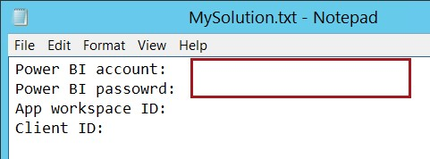

*You will require the Power BI credentials when embedding Power BI content.*

1. Save the **MySolution.txt** file.

## Verifying the Power BI License

In this task, you will verify your account license.

1. At the top right corner, click the **Settings** command (cog), and then select **Manage Personal Storage**.

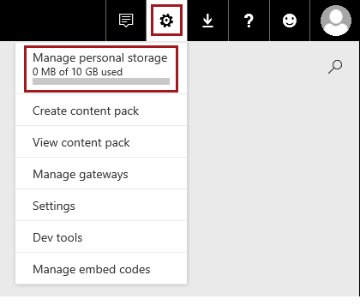

1. At the top-left corner in the pane, verify that your account is a **Pro user**.

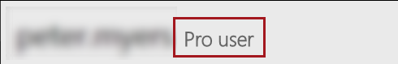

*A* ***Power BI Pro*** *license is required when authoring and embedding Power BI content.*

# Creating an App Workspace

In this exercise, you will create an app workspace.

## Creating an App Workspace

In this task, you will create an app workspace.

1. In the **Navigation Pane** (located at the left), click **Workspaces**, and then click **Create App Workspace**.

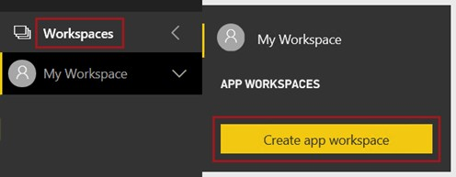

*App workspaces in Power BI are built on Office 365 groups.*

1. In the **Create an App Workspace** pane (located at the right), in the **Name Your Workspace** box, enter a unique name that you recognize.

*App workspace names must be uniquely named within the tenant.*

1. Expand the **Advanced** section (you may need to scroll down).
2. Verify that the **Premium** setting is set to **On**.

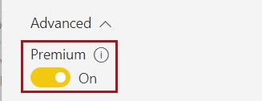

*When embedding content for non-Power BI users, the app workspace must be created on dedicated capacity made available with the Power BI Premium license.*

1. To create the app workspace, click **Save**.



*If you receive an error, reload (F5) the web page, and then in the* ***Navigation Pane*** *click* ***Workspaces****, and then select your workspace.*

## Reviewing the App Workspace

In this task, you will review the app workspace.

1. In this task, you will create an app workspace. In the **Navigation Pane**, notice that the app workspace is decorated with a diamond icon.

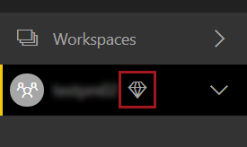

*An app workspace is like a personal workspace. It can own all types of Power BI content.*

1. In the **Navigation Pane**, click **Workspaces**, and then in the pop out pane, in the **App Workspaces** group, to the right of the app workspace you created, click the ellipsis.

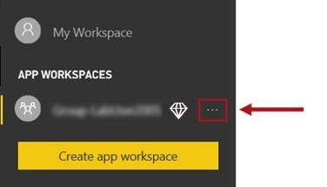

1. Review the available commands to edit or leave the app workspace.

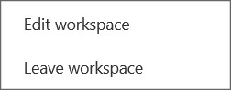

1. To edit the app workspace, select **Edit Workspace**.
2. Verify that your Power BI account is an admin for the workspace.

*The Power BI account used to embed content must be an admin of the app workspace.*

*It is a good practice to create a dedicated Power BI account for embedding, referred to as the master app account. In this course, for practical reasons, you will use your personal account.*

1. To close the pane, click **Cancel**.



1. In the browser, copy the app workspace ID (the GUID between the forward slashes) to the clipboard.



1. For future reference, enter your app workspace ID into the **MySolution.txt** file.

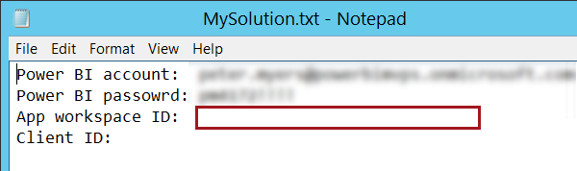

*You will require the app workspace ID when embedding the app workspace Power BI content.*

1. Save the **MySolution.txt** file.

# Publishing a Power BI Report

In this exercise, you will open a Power BI Desktop file. You will then interact with the report, add a report filter, and then publish the report to the Power BI service.

## Opening the Power BI Desktop File

In this task, you will open a Power BI Desktop file.

1. Open Power BI Desktop.

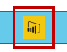

1. To close the startup screen, at the top-right corner, click **X**.



1. To open an existing file, click the **File** tab, and then select **Open**.
2. In the **Open** window, navigate to the **<CourseFolder>\PowerBIDevIAD\Lab01A\Assets** folder.
3. Select the **US Sales Analysis.pbix** file, and then click **Open**.

*The file consists of a cached data model sourcing data from a SQL Server database. It also consists of a two-page report enabling the analysis of US regional sales.*

*You do not have access to the SQL Server database. Do not attempt to refresh the data already cached in the data model.*

## Interacting with the Report

In this task, you will interact with the report.

1. At the bottom left-corner, notice that the first page of the report is named **Regional Sales Analysis**.

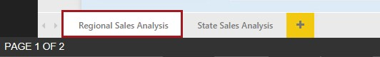

1. In the **Year** slicer, expand the dropdown list, select **CY2016**, and then collapse the dropdown list.

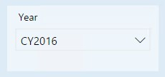

1. To filter by a particular month, in the combo chart, click any column, and notice that all of the report page visualizations filter by that month.
2. To zoom out the stacked bar chart, hover over **Sales by Demographic** chart, and then click **Focus Mode**.



1. To revert back, click **Back to Report**.



1. To clear the cross-filter, click in a blank area of the combo chart (or click the highlighted column).
2. Select the **State Sales Analysis** report page.

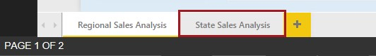

1. Set the **Year** slicer to **CY2016**.
2. Set the **Category** slicer to **Co-Axial** and **Collective pitch**.

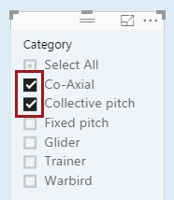

1. In the map visual, to determine the sales value for a state, hover the cursor over the state of California.

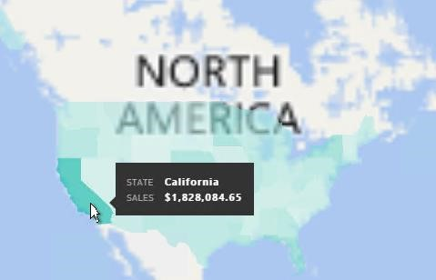

1. Set the **Category** slicer to **Select All**.

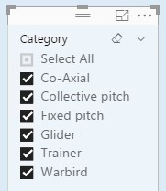

1. Return to the **Regional Sales Analysis** page.

## Adding a Report Filter

In this task, you will add a report filter.

1. In the **Fields** pane (located at the right), expand the **Region** table.

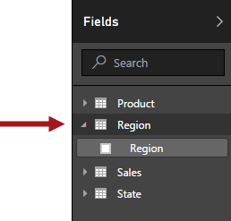

1. Drag the **Region** field (not table) into the **Report Level Filters** drop zone of the **Filters** pane.

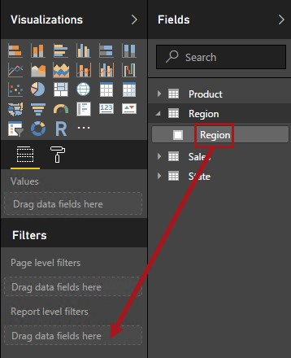

1. Notice the basic filtering options, enabling the multi-selection of regions.

*The selection will filter all report pages.*

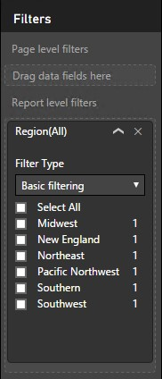

*You will programmatically pass filter values in when embedding the report in* ***Lab 02B****.*

## Publishing the Report

In this task, you will publish the report to the Power BI service.

1. On the **File** menu, select **Save**.
2. On the **Home** ribbon, from inside the **Share** group, click **Publish**.

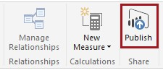

1. In the **Power BI Desktop** window, in the box, enter your Power BI account.

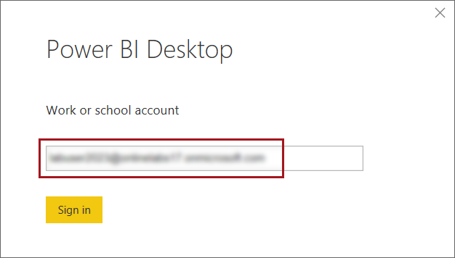

1. Click **Sign In**.
2. In the **Sign In to Power BI Desktop** window, enter your password, and then click **Sign In**.

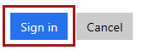

1. In the **Publish to Power BI** window, select the app workspace you created earlier in this lab.
2. Click **Select**.

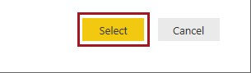

1. When the Power BI Desktop report has been published, click **Got It**.

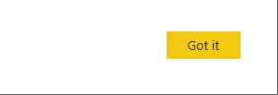

*The publication process has created a dataset (based on the data model), and also a report in the app workspace.*

1. To close Power BI Desktop, on the **File** menu, select **Exit**.

# Creating Content in the Service

In this exercise, you will first review the published content, and then create a report and also a dashboard.

## Reviewing the Published Content

In this task, you will review the published content in the Power BI portal.

1. In the Power BI portal, in the **Navigation Pane**, expand the app workspace.

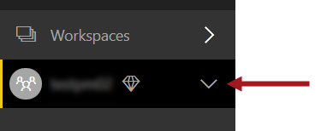

1. Verify that the workspace now contains a dataset and a report. If they do not appear, reload (F5) the browser.

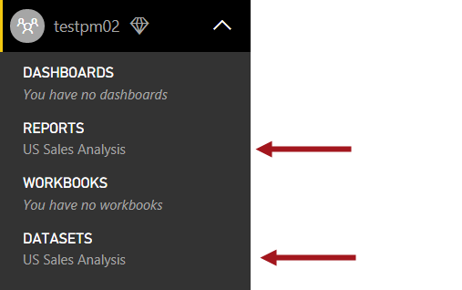

## Creating a Report

In this task, you will create a Power BI report.

1. To create a report, in the **Navigation Pane**, click the **US Sales Analysis** dataset.
2. Notice that a blank report canvas enables the creation of a new report layout.

*The report design experience is almost identical to the Power BI Desktop report design experience.*

1. To rename the report page, at the bottom-left corner, double-click **Page 1**.

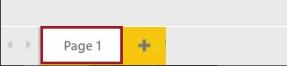

1. Replace the text with **Product Demographics**, and then press **Enter**.



1. In the **Fields** pane, expand the **Sales** table, and then drag the **Year** field to the report canvas.

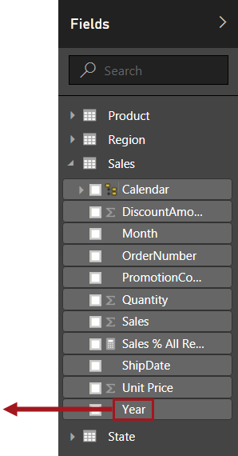

1. Notice that this action resulted in the creation of a table visualization.

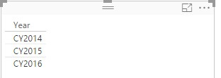

1. To modify the visualization to a slicer, in the **Visualizations** pane, select the **Slicer** icon.

*Tip: Hovering over a visualization type icon will reveal a tooltip that describes the visualization type.*

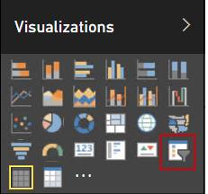

1. Resize the slicer, and then reposition it as follows.



1. In the **Year** slicer, select **CY2016**.
2. To add a second visual, first click a blank area of the report canvas.

1. In the **Visualizations** pane, click the **Treemap** visualization.

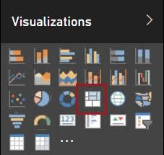

1. Resize the treemap, and then reposition it as follows.



1. In the **Fields** pane, expand the **Product** table.
2. Drag the **Demographic** field into the treemap visual.
3. From the **Sales** table, drag the **Sales** field into the treemap visual.
4. To add a report filter, first click a blank area of the report canvas.
5. Expand the **Region** table, and then drag the **Region** field into the **Report Level Filters** drop zone.
6. To save the report, at the top-right corner, click **Save**.

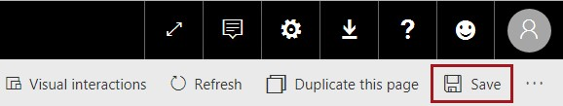

1. In the **Save Your Report** window, in the box, enter **Product Demographics**.

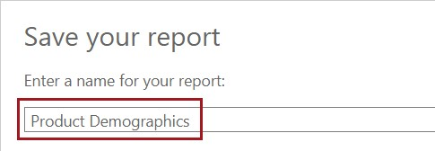

1. Click **Save**.

*You will embed this report into a web app in* ***Lab 02A****.*

## Creating a Dashboard

In this task, you will create a Power BI dashboard. You will create a dashboard by pinning visuals from both reports.

1. To create a report, in the **Navigation Pane**, select the **US Sales Analysis** report.

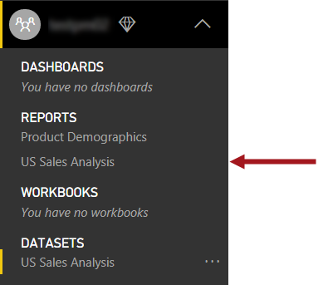

1. In the report, hover the cursor over the Tailspin Toys logo, and then click the **Pin Visual** icon.



1. In the **Pin to Dashboard** dialog window, notice that the **New Dashboard** option is selected.

1. In the box, enter **US Sales Analysis**.

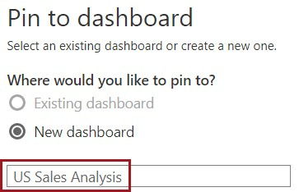

1. Click **Pin**.

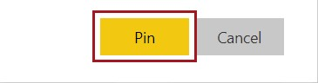

1. Also pin the following two visuals to the dashboard:
   * Quantity card
   * Sales and Average of Unit Price by Month combo chart 7. In the **Navigation Pane**, select the **Product Demographics** report.
2. Pin the treemap to the dashboard.
3. In the **Navigation Pane**, select the **US Sales Analysis** dashboard.

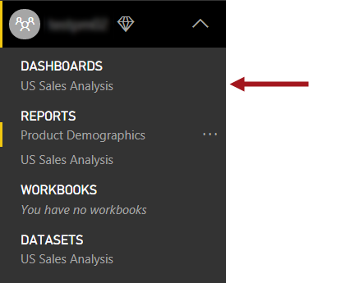

1. To resize the logo tile, hover over the tile, and then drag the bottom-right corner to resize to 1 x 1.



1. Drag the tiles to reposition them as follows.



*You will embed this dashboard into a web app in* ***Lab 02A****.*

# Summary

In this lab, you signed in to the Power BI service by using the account provided to you, and then created an app workspace. You then opened a Power BI Desktop file, and interacted with the existing report. You enhanced the report with a filter, and then published the Power BI Desktop file to your app workspace. Lastly, in your app workspace, you created a new report, and also assemble a dashboard.