PDB365 Student Computer and VM Setup Guide
Setup Time: 60 minutes
Setup Overview: These setup instructions walk through the steps required to configure a Windows PC or a virtual machine (VM) that will be used by students when working on the lab exercises for PDB365: Power BI Developer Bootcamp. These setup instructions assume you already have a Windows PC or a VM running a 64-bit edition of Windows 10 or Windows 8.1. These setup instructions also assume that you have enough permissions on your PC to install the software and applications required for Power BI development.

Task 1: Install the 64-bit Version of Node.js
In this task, you will install Node.js.
- Launch a browser and navigate to the following link.
https://nodejs.org/en/download/
- Download the installation files for Node.js for Windows.
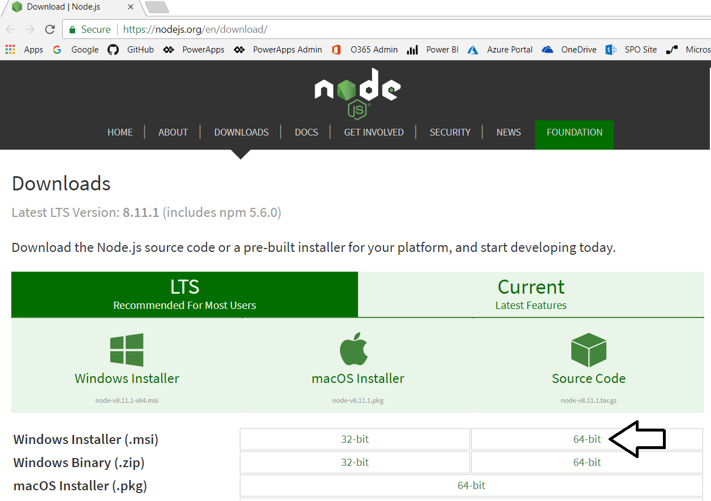
- Run the Node.js installation program.
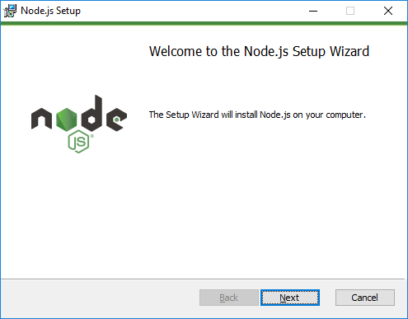
- Agree to terms and accept all default settings.
- When the installation is complete, you should be able to locate the Node.js command prompt from the Windows Start menu.

Task 2: Install GIT
In this exercise, you will install the git utility.
- Launch a browser and navigate to the following link.
https://git-scm.com/download
- Download the installation files for git for Windows.
- Run the installation program. When prompted, agree to the terms and accept all the default settings.
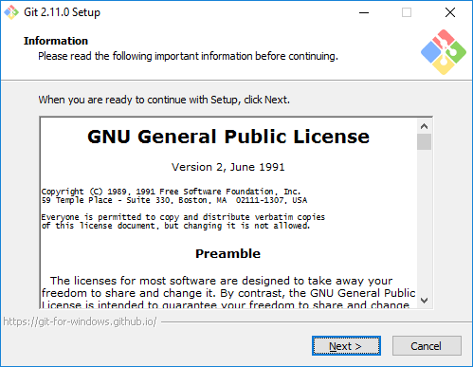
- Wait until the installation is complete.

Task 3: Install Visual Studio Code
In this setup task, you will install Visual Studio Code.
- Launch a browser and navigate to the following link.
https://code.visualstudio.com/download
- Download the installation files for Visual Studio Code for Windows.
- Run the installation program for Visual Studio Code.
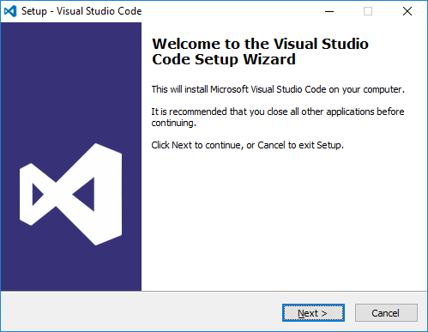
- When you get to the Ready to Install dialog, click Next to continue.
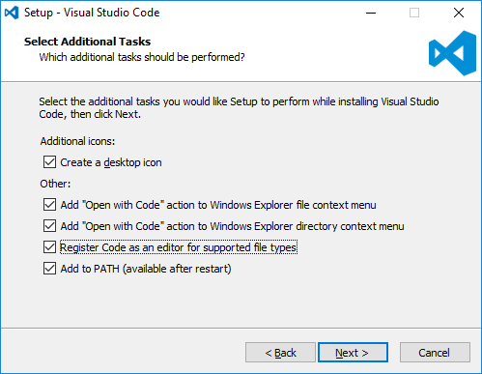
- Click Install.
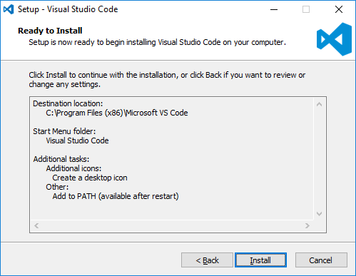
- Move through the dialogs of the installation program until you reach the Completing the Visual Studio Code Setup Wizard dialog. Click Finish.
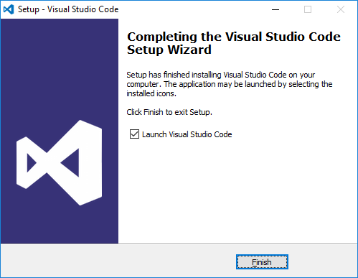
- When the installation program completes, it should launch Visual Studio Code.
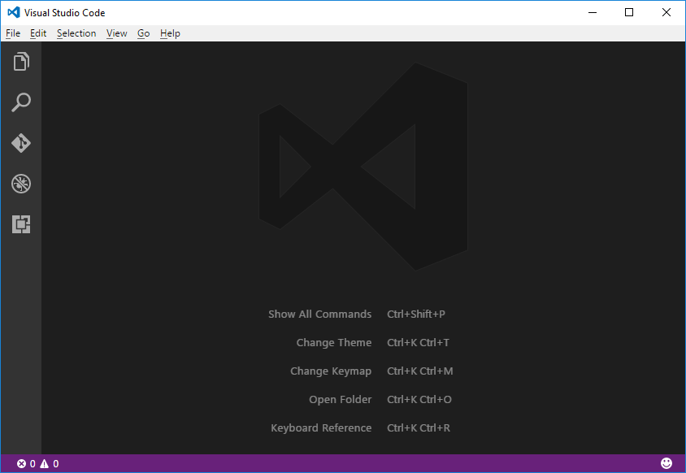

Task 4: Install Visual Studio 2017
In this exercise, you will install Visual Studio 2017.
- Launch a browser and navigate to the following link. This will download the installation files for Visual Studio 2017.
https://aka.ms/vs/15/release/vs_Enterprise.exe
- Click Continue to run the installation program for Visual Studio 2017.
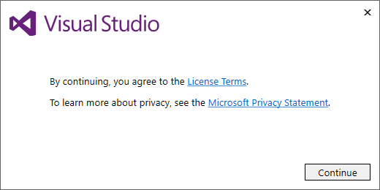
- Under Workloads tab in the Windows section, select the following workloads
  - Universal Windows Platform development
  - .NET desktop development
- Under Workloads tab in the Web and Cloud section, select the following workloads
  - Web development
  - Azure development
  - Node.js development
  - Data storage and processing
  - Office/SharePoint development
- In the Individual components tab, take a moment to inspect the components that will be installed. Note there is no need to modify anything in the Individual components tab.
- Move ahead in the installation program to the Summary section. Locate and click the Install button in the bottom right corner to begin the installation.
- Instalation will take about 20-30 minutes. When the installation is complete, you will see the a page telling you that Visual Studio 2017 has been installed.
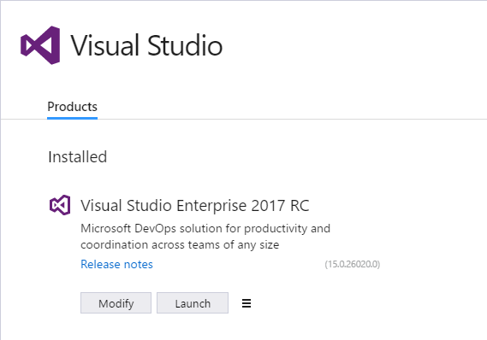
- Launch Visual Studio 2017.
  - When you see the Welcome screen, it will prompt you to sign into Visual Studio Online. However, there is no need for you to log onto Visual Studio Online. Instead, click the Not now, maybe later link at the bottom of the Welcome screen
  - On the next screen, select a Development Setting for the color theme and then click Start Visual Studio.
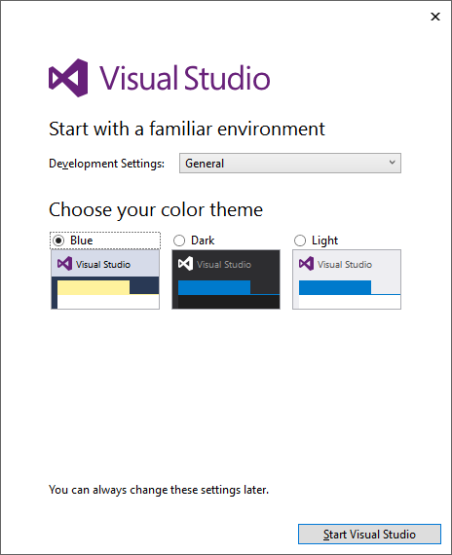
  - Once Visual Studio has started, select the File > New Project command.
  - On the left hand side of the New Project dialog, select Installed > Templates > Visual C# > Office/SharePoint.
  - Make sure you see the SharePoint Add-in project template. If you see the SharePoint Add-in project template, it means you have installed Visual Studio 2017 with the Office/SharePoint toos.
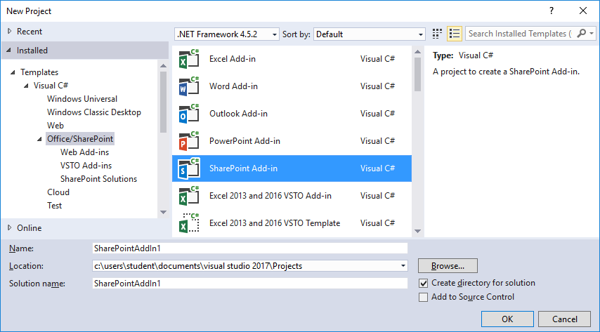

Task 5: Install Fiddler
In this exercise, you will install the Fiddler developer utility.
- Launch a browser and navigate to the following link.
https://www.telerik.com/download/fiddler
- Download the installation files for Fiddler.
- When the Fiddler installation program starts, it prompts you to accept the licensing agreement. Click I Agree.
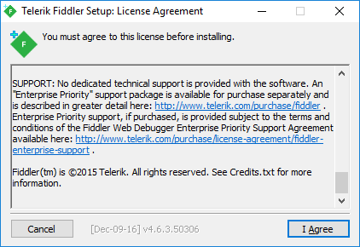
- Next, click the Install button to run the Fiddler installation program.
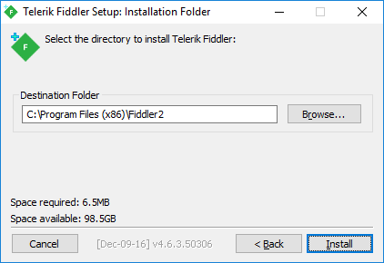
- When the Fiddler installation program completes, launch Fiddler from the Windows Start menu.
- When Fiddler starts for the first time, it prompts you with the AppContainer Configuration dialog. Click the Cancel button to dismiss the dialog and prevent this dialog from reappearing later.
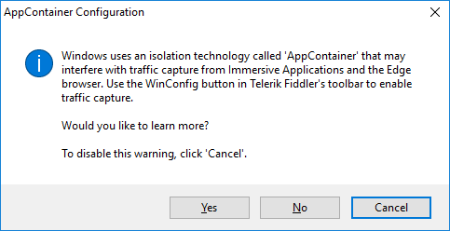
- Once Fiddler has started, click the WinConfig button in the toolbar in the top left-hand corner of the Fiddler window to display the AppContainer Loopback Exemption Utility dialog.
- In the AppContainer Loopback Exemption Utility dialog, select Microsoft Edge on the left and then click Save Changes.
- Configure Fiddler support inspecting HTTPS request that are using SSL.
  - Select the Tools > Telerik Fiddler Options… command
  - On the General tab of the Telerik Fiddler Options dialog, uncheck the Notify me for updates on startup checkbox.
  - On the HTTPS tab of the Telerik Fiddler Options dialog, check the Decript HTTPS traffic checkbox.
  - Click Yes when prompted whether to Trust the Fiddler Root Certificate?
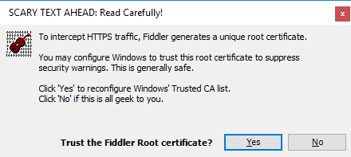
  - Click Yes, when you see the following dialog which asks Do you want to install this certificate.
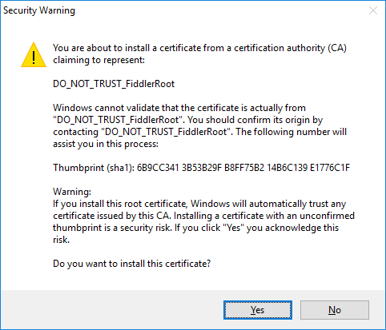
  - Click Yes one more time when you see the TrustCert Confirmation dialog.
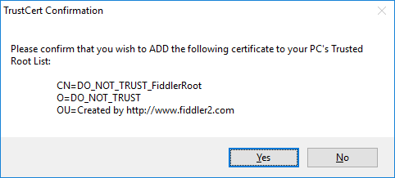
  - You should now see a dialog that confirms that Fiddler's root certificate has been added to the machine root list.
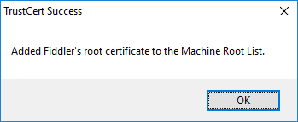
  - Click OK to dismiss the Telerik Fiddler Options dialog.
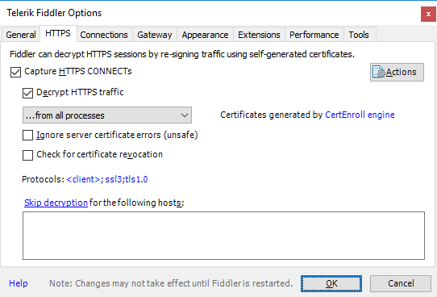
- Start Fiddler and then launch the Microsoft Edge browser and navigate to a URL with SSL such as https://bing.com. Make sure you can use Fiddler to monitor HTTPS request.

