Developer Setup Guide for React.js Development
Setup Time: 60-90 minutes
Setup Overview: These setup instructions walk through the steps required to configure a Windows PC or a virtual machine (VM) that will be used by students when working on the lab exercises for MSD365: Modern SharePoint and Office 365 Development. You can also use these instructions to prepare for general development with React.js, Node.js, npm and Webpack.

Task 1: Install and Configure Windows 10 or Windows 8.1
In this step you will install the Windows 10 or Windows 8.1 operating system.
- Install the x64 bit edition of Windows and apply all Windows updates.
- Install the Chrome browser.
- Enable the execution of PowerShell scripts.
  - Open a PowerShell command shell running as Admin.
  - Type in and execute the following PowerShell command.
Set-ExecutionPolicy ByPass
  - When prompted to confirm to the operation, type Y and press ENTER to confirm that you want to enable script execution.

Task 2: Install the 64-bit Version of Node.js
In this task, you will install Node.js.
- Launch a browser and navigate to the following link.
https://nodejs.org/en/download/
- Download the installation files for Node.js for Windows.
- Run the Node.js installation program.
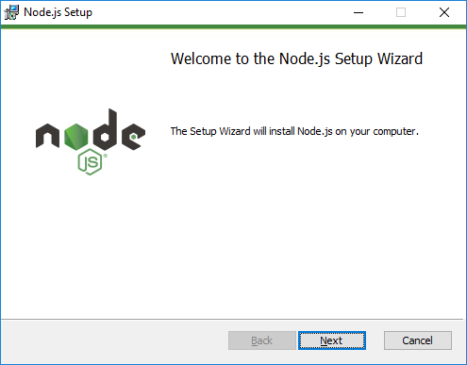
- Agree to terms and accept all default settings.
- When the installation is complete, you should be able to locate the Node.js command prompt from the Windows Start menu.

Task 3: Install GIT
In this exercise, you will install the git utility.
- Launch a browser and navigate to the following link.
https://git-scm.com/download
- Download the installation files for git for Windows.
- Run the installation program. When prompted, agree to the terms and accept all the default settings.
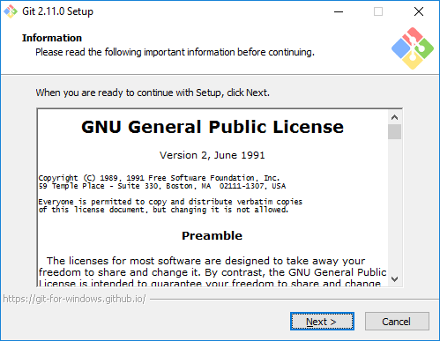
- Wait until the installation is complete.

Task 4: Install Visual Studio Code
In this setup task, you will install Visual Studio Code.
- Launch a browser and navigate to the following link.
https://code.visualstudio.com/download
- Download the installation files for Visual Studio Code for Windows.
- Run the installation program for Visual Studio Code.
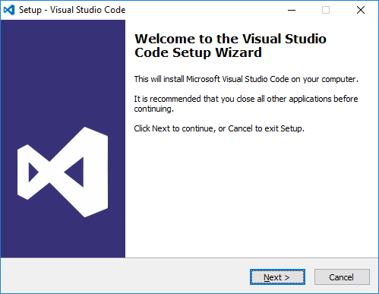
- When you get to the Ready to Install dialog, click Next to continue.
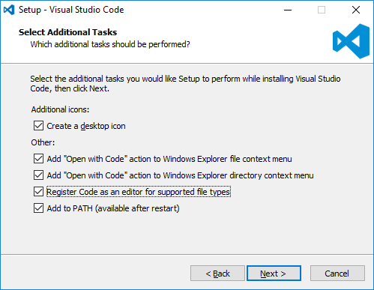
- Wait until the installation is complete.
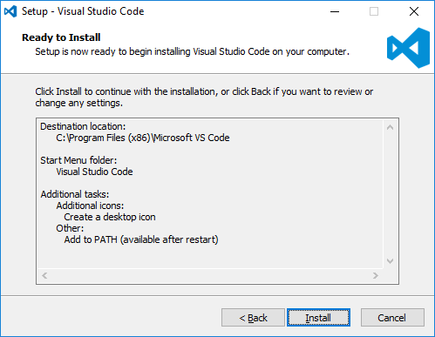
- Move through the dialogs of the installation program until you reach the Completing the Visual Studio Code Setup Wizard dialog. Click Finish.
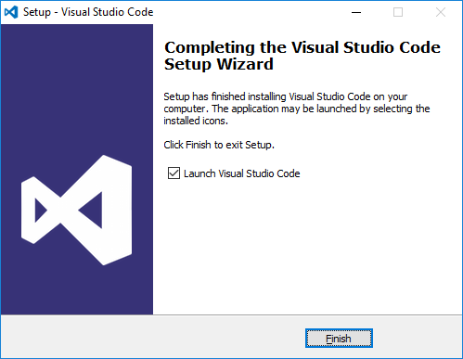
- When the installation program completes, it should launch Visual Studio Code.
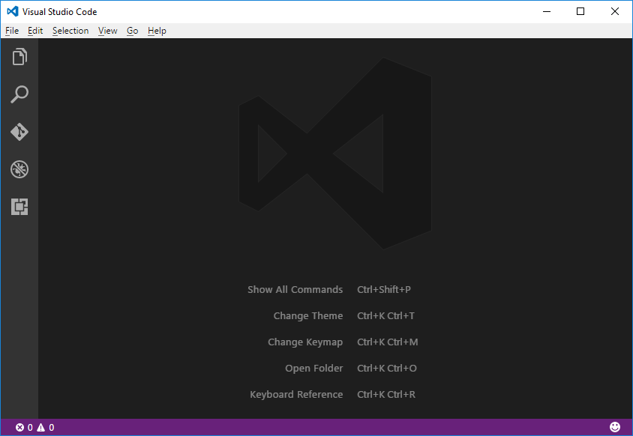

Task 5: Install The SharePoint Online Management Shell
In this task you will install the PowerShell library which is used to managed sites in SharePoint Online.
- Install The SharePoint Online Management Shell
  - In the browser, navigate to https://www.microsoft.com/en-us/download/details.aspx?id=35588
  - Click the Download button to download the installation program.
  - Make sure to select the download for the 64-bit version which has an x64 in its name.
  - Begin the installation program and accept all the default settings.
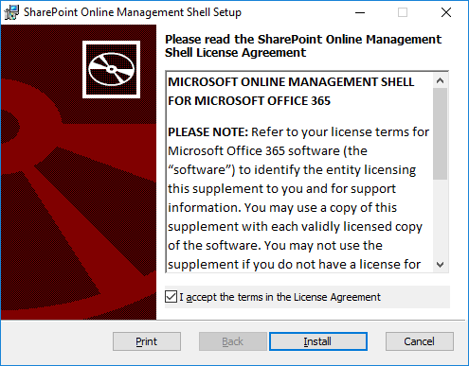
  - Follow the instructions to complete the installation.
- If you already have an Office 365 environment with SharePoint Online, you can test out the installation with the following steps. If you don’t already have an Office 365 environment with SharePoint Online, you can move ahead to the next step.
  - Press the Windows key to display the Windows Start menu and type in SharePoint. You should see the SharePoint Online Management Shell appear in the Start menu. Click on SharePoint Online Management Shell to launch a PowerShell console window.
  - Type cd\ into the console window and press ENTER to move the current directory to the root of the C:\ drive.
  - Type cls into the console window and press ENTER to clear the screen.
  - Type in the following PowerShell command and press ENTER. Make sure to replace cbd365 with the name of your Office 365 tenant and the name student with your account name,
Connect-SPOService -Url https://msd365-admin.sharepoint.com -credential student@msd365.onmicrosoft.com
  - When this command executes, it will prompt you to login. When prompted, log in using your Office 365 account credentials.
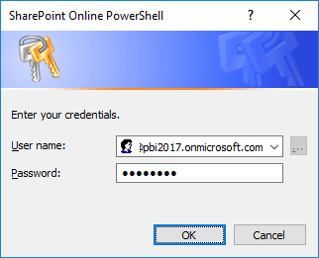
  - Once you have authenticated, the call to Connect-SPOService should return.
  - Type in Get-SPOSite and press ENTER
When the call to Get-SPOSite executes, it should display a list of the SharePoint Online sites in the current Office 365 tenancy. If you see the list of SharePoint Online sites, you know that the SharePoint Online Management Shell has been correctly installed.

Task 6: Install Fiddler
In this exercise, you will install the Fiddler developer utility.
- Launch a browser and navigate to the following link.
https://www.telerik.com/download/fiddler
- Download the installation files for Fiddler.
- When the Fiddler installation program starts, it prompts you to accept the licensing agreement. Click I Agree.
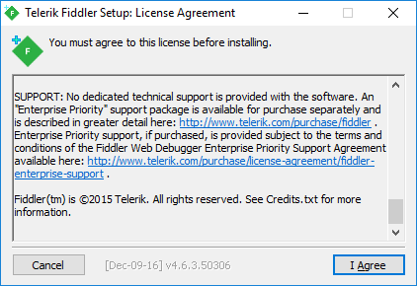
- Next, click the Install button to run the Fiddler installation program.
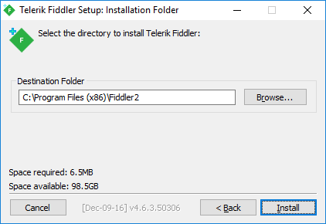
- When the Fiddler installation program completes, launch Fiddler from the Windows Start menu.
- When Fiddler starts for the first time, it prompts you with the AppContainer Configuration dialog. Click the Cancel button to dismiss the dialog and prevent this dialog from reappearing later.
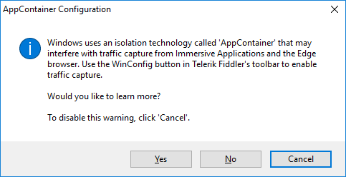
- Once Fiddler has started, click the WinConfig button in the toolbar in the top left-hand corner of the Fiddler window to display the AppContainer Loopback Exemption Utility dialog.
- In the AppContainer Loopback Exemption Utility dialog, select Microsoft Edge on the left and then click Save Changes.
- Configure Fiddler support inspecting HTTPS request that are using SSL.
  - Select the Tools > Telerik Fiddler Options… command
  - On the General tab of the Telerik Fiddler Options dialog, uncheck the Notify me for updates on startup checkbox.
  - On the HTTPS tab of the Telerik Fiddler Options dialog, check the Decript HTTPS traffic checkbox.
  - Click Yes when prompted whether to Trust the Fiddler Root Certificate?
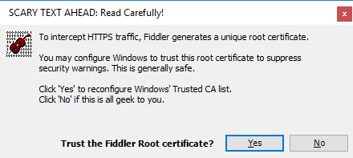
  - Click Yes, when you see the following dialog which asks Do you want to install this certificate.
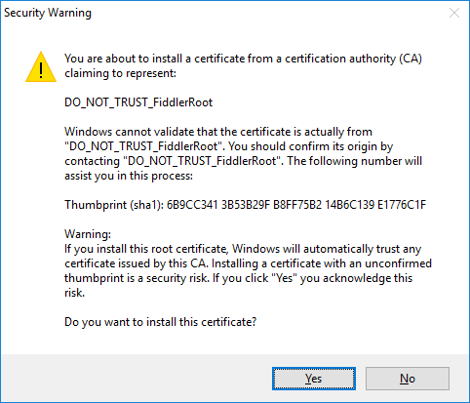
  - Click Yes one more time when you see the TrustCert Confirmation dialog.
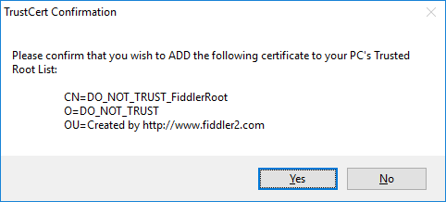
  - You should now see a dialog that confirms that Fiddler's root certificate has been added to the machine root list.
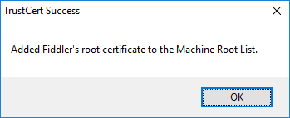
  - Click OK to dismiss the Telerik Fiddler Options dialog.
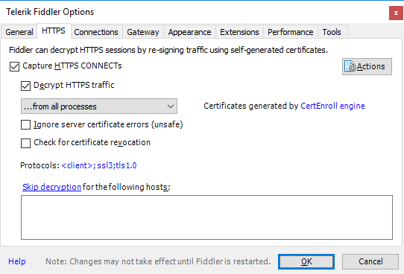
- Start Fiddler and then launch the Microsoft Edge browser and navigate to a URL with SSL such as https://bing.com.
- Make sure you can use Fiddler to monitor HTTPS request.

