# tink_her2

RFID Activated Automatic Shopping Trolley🎯(Hardware)

Basic Details

Team Name: Cookie Byte

Team Members

Member 1: Tessa Maria Sunil - MACE

Member 2: Varuna PM - MACE

Member 3: Nanditha R - MACE

Project Description

Our project is an innovative solution for those who are unable to use a shopping trolley. Once the RFID has been activated by the customer card, the trolley follows the RFID tag till the shopping is over. Afterwards, if the trolley has been abandoned at the sidelines of the parking lot, a master card can be used to return all of them to the initial charging point.

The Problem statement

Device a solution to help people, disabled or just unable to use a shopping cart, easily maneuver large amounts of groceries.

The Solution

We try to achieve the solution by automating the process of pulling the cart along, which is the task requiring most physical exertion.

Technical Details

Technologies/Components Used

For Software: Arduino IDE, HTML, CSS and JavaScript

For Hardware: IR sensor, RFID card and reader, ultrasonic sensor, Arduino driver shield (L298) , servo motor (micro) , gear motor, ESP 32 microcontroller and Arduino UNO microcontroller

Project Documentation

Screenshots

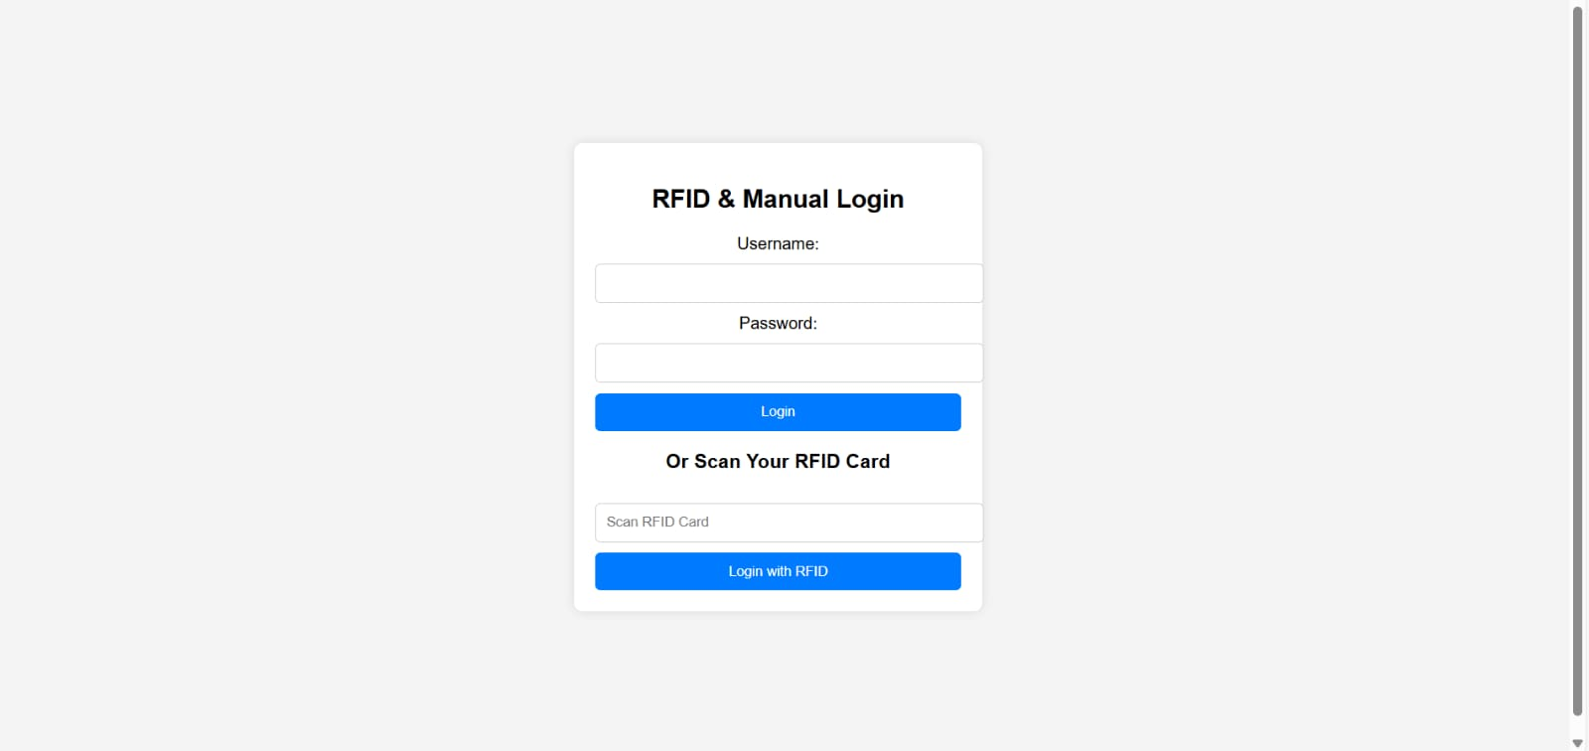

This is the UI interface for the login.

Diagrams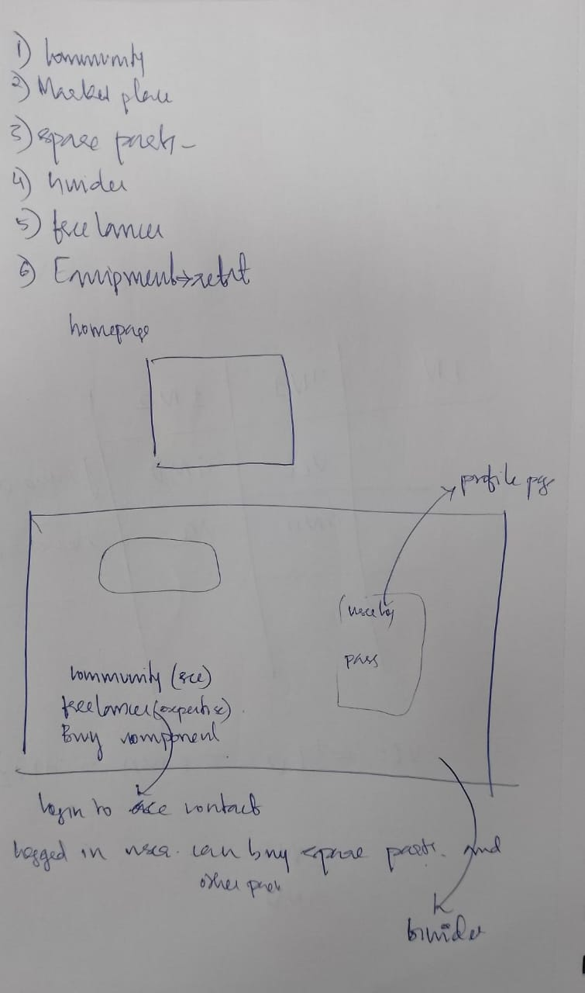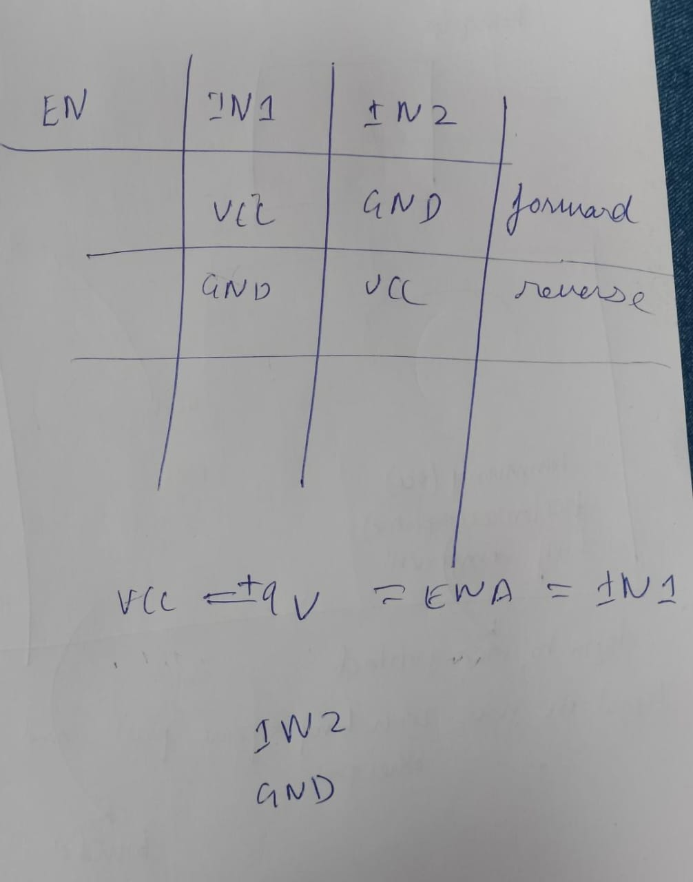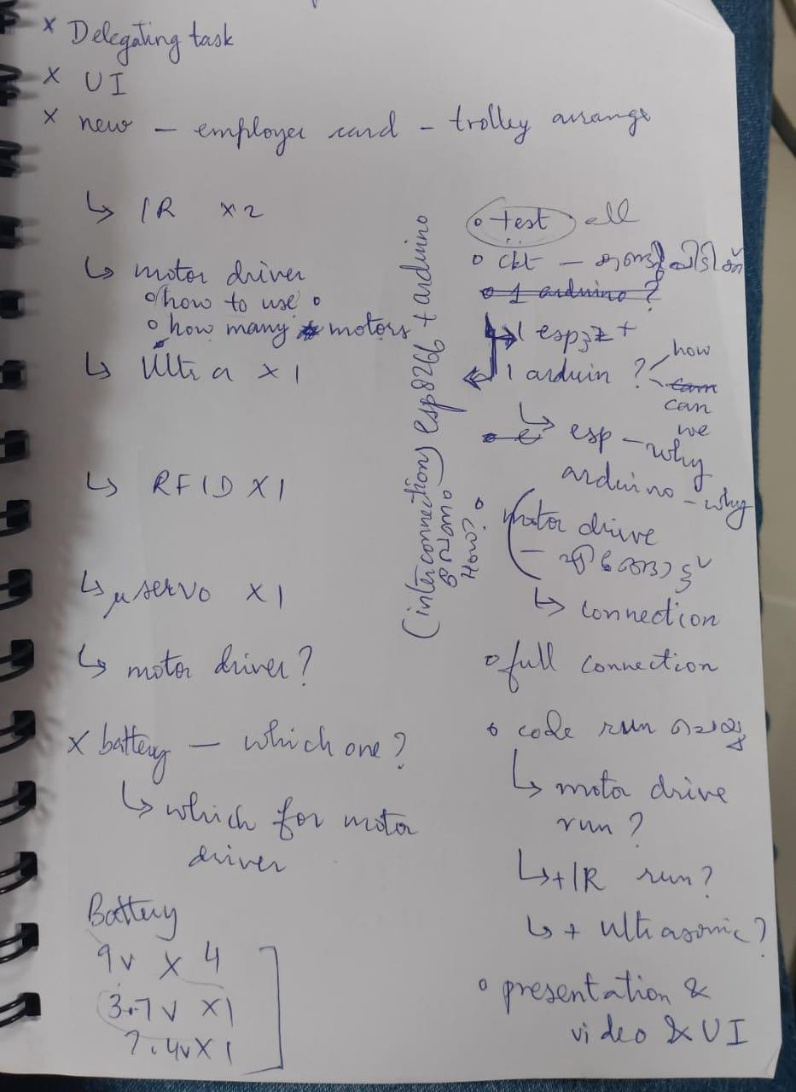

We tested all the components, the decided on the flow of logic

For Hardware:

Schematic & Circuit

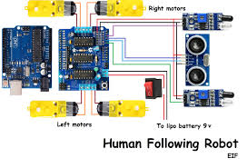

Add caption explaining connections

Build Photos

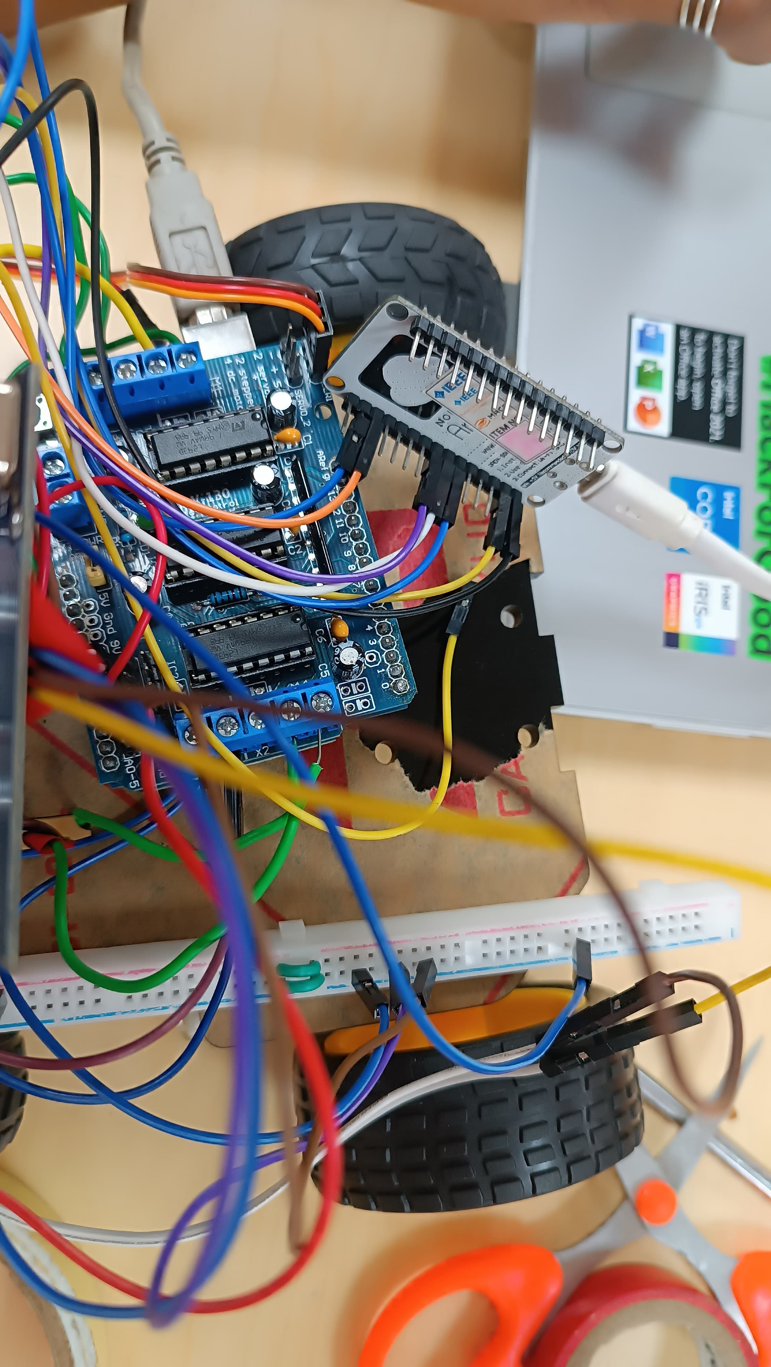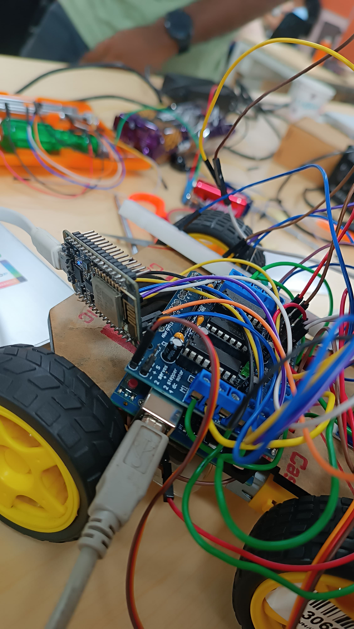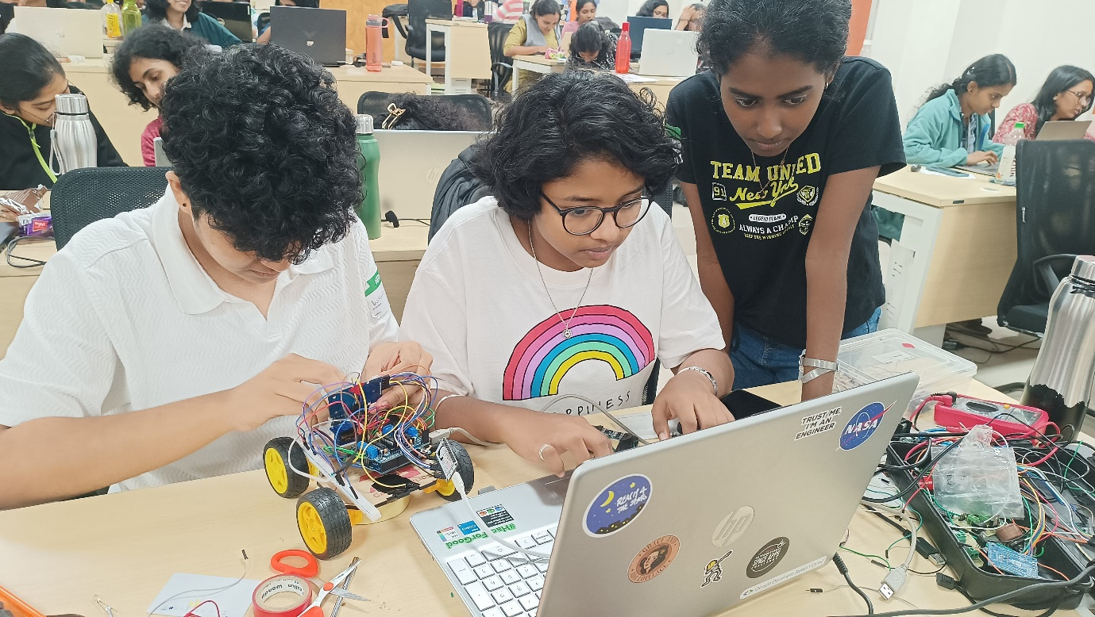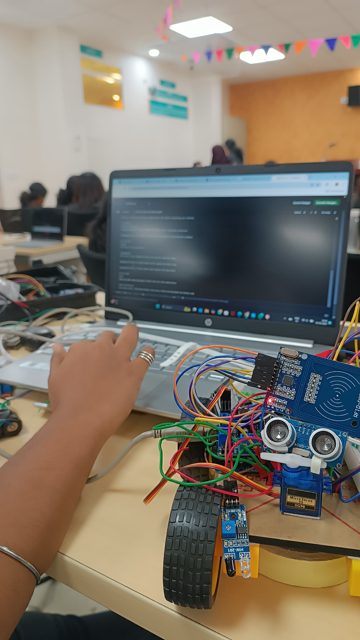

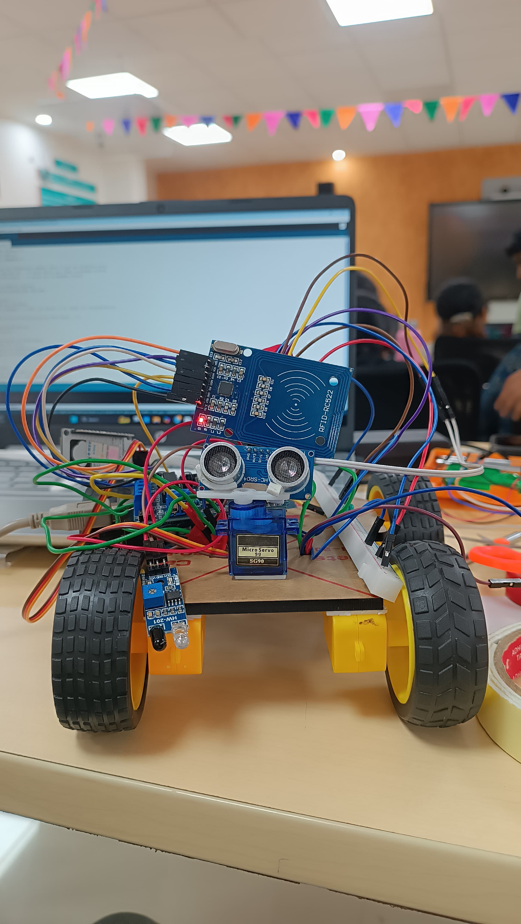

Team Contributions

Tessa Maria Sunil: Interfaced Arduino with driver shield and developed the Arduino code

Varuna PM: Interfaced ultrasonic sensor, IR sensor, RFID reader and all motors

Nanditha R: Developed the UI and tested the components