

MyFIU Revamped User Interface Manual

Alain Galvan | Jahkell Lazarre | Alastair Paragas

Table of Contents

User Login …………………………………………… 3

Edge Cases …………………………………………… 6

Control Panel …………………………………………… 7

Progress Tracking ……………..…………..…………..……. 9

Enrollment …………………..…………………..…… 12

# User Login

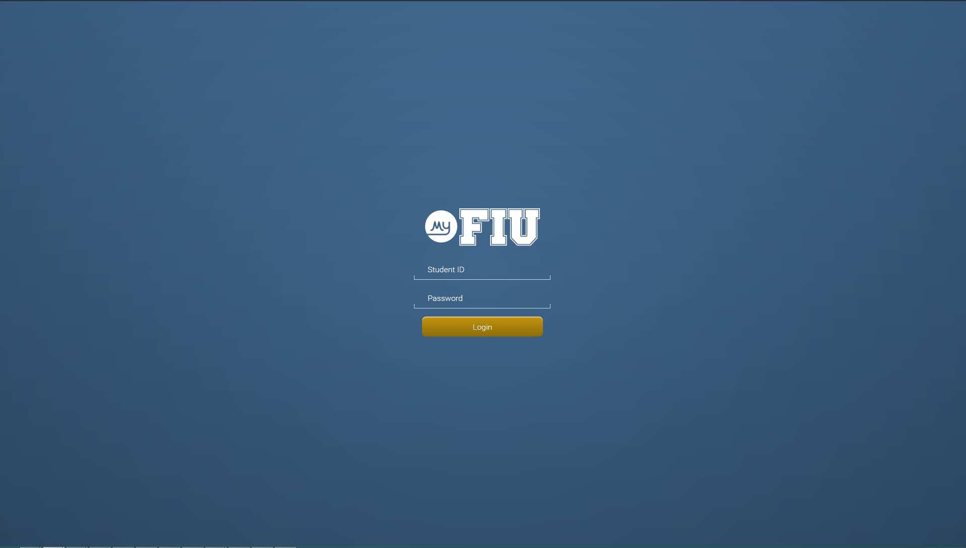

Figure 1: The first page you will encounter when visiting MyFIU Revamp page is the login page. Displayed here is a login dialog prompting the user to enter their Panther ID and password to attempt to login into the MyFIU Revamp application.

Upon entering the MyFIU Revamp website, you will be directed to the login page if you have not had any account activity i.e. no page requests were made while you were last logged in within the last twenty minutes. If you have had any account activity within the last twenty minutes during your last login session, please refer to page 7 of this document to learn about the control page.

As shown in Figure 1, at the login page, you will encounter a white MyFIU Revamp logo displayed on top of a blue backdrop. A login dialog will prompt you to enter your login credentials. Follow the next steps to proceed with logging into the MyFIU Revamp system:

1. Click on the first input box that says ‘Student ID.’ The input box will slightly increase in size to indicate that you have clicked on it (see Figure 2.)

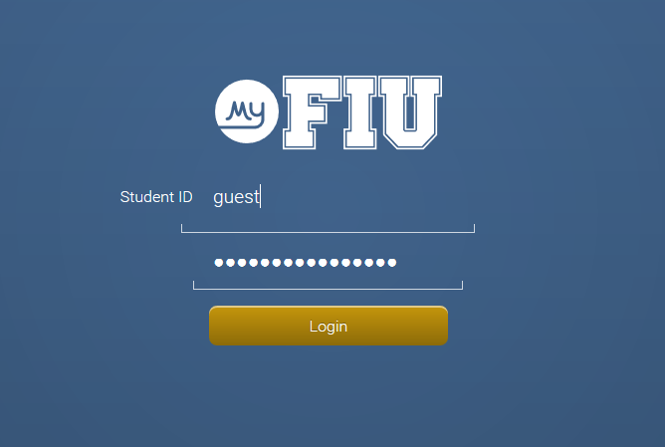Figure 2: Guest username being entered into the Student ID input box.

1. Enter your student Panther ID e.g. ‘1234567,” or the guest username ‘guest’ to take a tour of the MyFIU Revamp application (experience will be similar to that of a student; all steps in subsequent sections of document are still valid.)
2. Click on the second input box that says ‘Password.’ The input box will slightly increase in size to indicate that you have clicked on it (see Figure 3.)

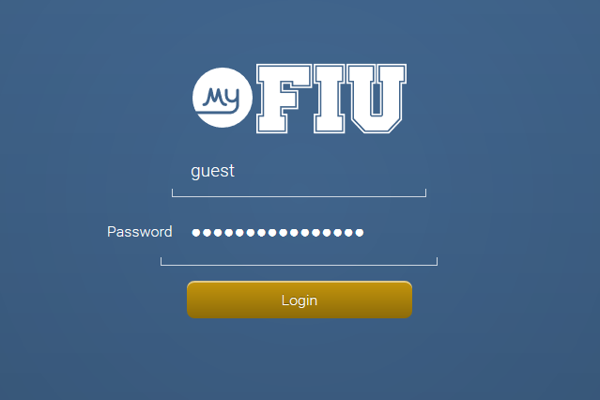

Figure 3: Password being entered into the password input box

1. Enter your MyFIU password (e.g. “ilovemyfiurevamp” for guest login.)
2. Click on the “Login” button. The system will now verify your credentials.
3. If you are your credentials are correct, then great! You have been successfully logged in the MyFIU Revamp system, and will now be redirected to the control panel page. Skip the following steps and visit the control page section on page 7 to learn how to navigate through the application.
4. Upon unsuccessful login i.e. the system could not verify your login credentials you have entered as authentic, the system will return a red-colored message box next to the login dialog dictating that you have either entered the wrong Panther ID or the wrong password (See Figure 4.) If you do not want to login again and would like to exit the web page, simply close your browser window.

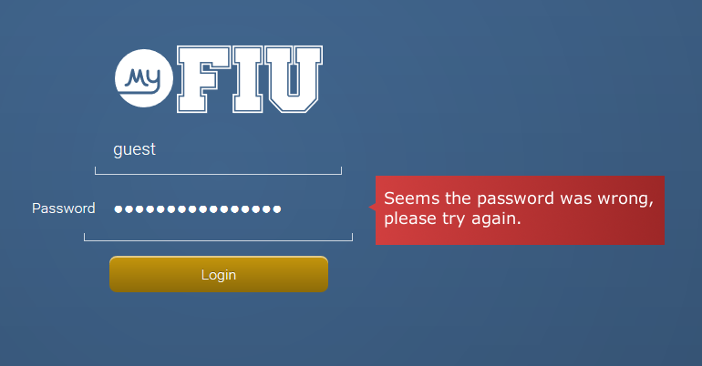

Figure 4: Shown is the red message box telling the user that they have entered the wrong password, and to re-enter their login credentials.

If you want to attempt to login again, go back to step 1, and repeat the login process; however, we recommend that you do not exceed 3 failed login attempts as the system might prevent you from logging in for an extended period of time.

If you are on your third failed login attempt, and still cannot login, please contact the Division of IT at FIU (<https://it.fiu.edu/about/contact/>) to sort out the issue. Return to step 1 and repeat the login in process only when you have solved the login issue with the Division of IT at FIU. If you have exceeded 3 failed login attempts, you may have to wait at least 24 hours to attempt to login again; however, we highly recommend you to contact the Division of IT at FIU before you attempt to login again, if this is the case.

# Control Panel

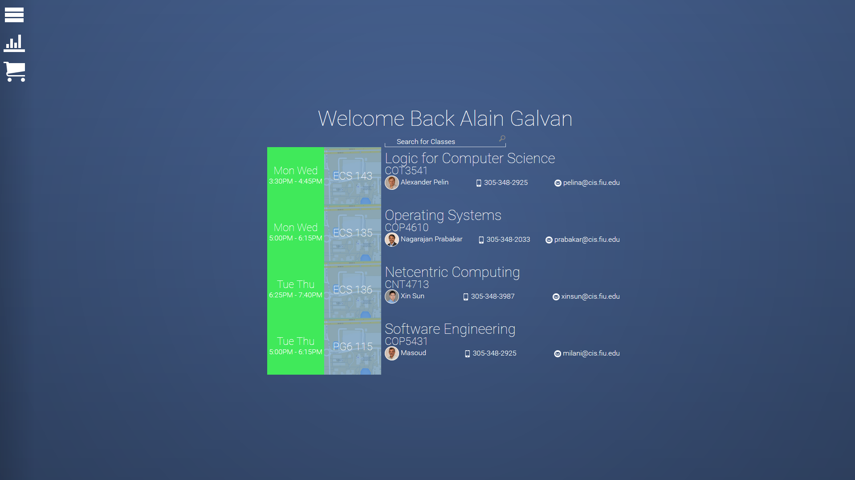

Figure 5: Shown is the control panel page which consists of the navigation panel on the left and the main content window in the center of the web page. The navigational panel consists of icons, and when clicked links you to the home, progress, search, and shopping cart pages. The main content window displays the information relevant to the current page. For example, since the student is currently on the homepage, the main content window displays the student’s course summary.

Once your login credentials have been verified as authentic, you will be redirected to the homepage of the My FIU Revamp application which consists of a navigation menu on the left and the main content window in the center. The navigation panel is always displayed no matter what page you are currently on within the website. It is comprised of links to the homepage, progress page, search page, and shopping cart page.

* The homepage shows you a message greeting you (e.g. ‘Welcome Back Alain Galvan’), and your course summary i.e. the current classes you are taking along with some detailed information about each course. If you would like to learn more about the homepage, please skip the following bullet points.
* The progress page details how far you have come along in your major and shows you detailed statistics about your academic progress. If you would like to learn more about the progress page, simply skip to page 9.
* The enroll page is used for enrolling in classes. If you would like to learn more about the enroll page, simply skip to page 12.
* If you would like to visit any of the three pages e.g. homepage, progress page, and enroll page, simply click on the desired menu link in the navigation menu (on the left). You will then be redirected to said page by the MyFIU Revamp application.

On the homepage, you have a summary of your enrolled courses for the current semester (see Figure 5.). For each course, the following is shown: the days and times that your class meets e.g. Mon Wed 3:30 - 4:45; the course name e.g. COT 3541; the profile picture, phone number, and email address of your main instructor; and a Google Maps picture and building/room number for your class’s location.

The Google Maps picture is shown at the far right corner for each course as a background image behind the room number. This picture serves as a visualization tool to help you figure out where your class is located (see Figure 6.)

Above the greeting, there is a search bar to quickly search for courses. This is similar to visiting the search page and using the search bar there. Refer to page 12 to learn more about the search page.



Figure 6: Shown are the details of each course: course name, course number, meeting times, room number, and instructor info. Behind the room number is a Google Maps thumbnail showcasing the location of the course.

The homepage is simply used as a summary of your current courses and to quickly search for courses. If you would like to explore more of the application, please visit these sections: Progress Tracking (page 9), and Searching for Classes (page 12.)

# Progress Tracking

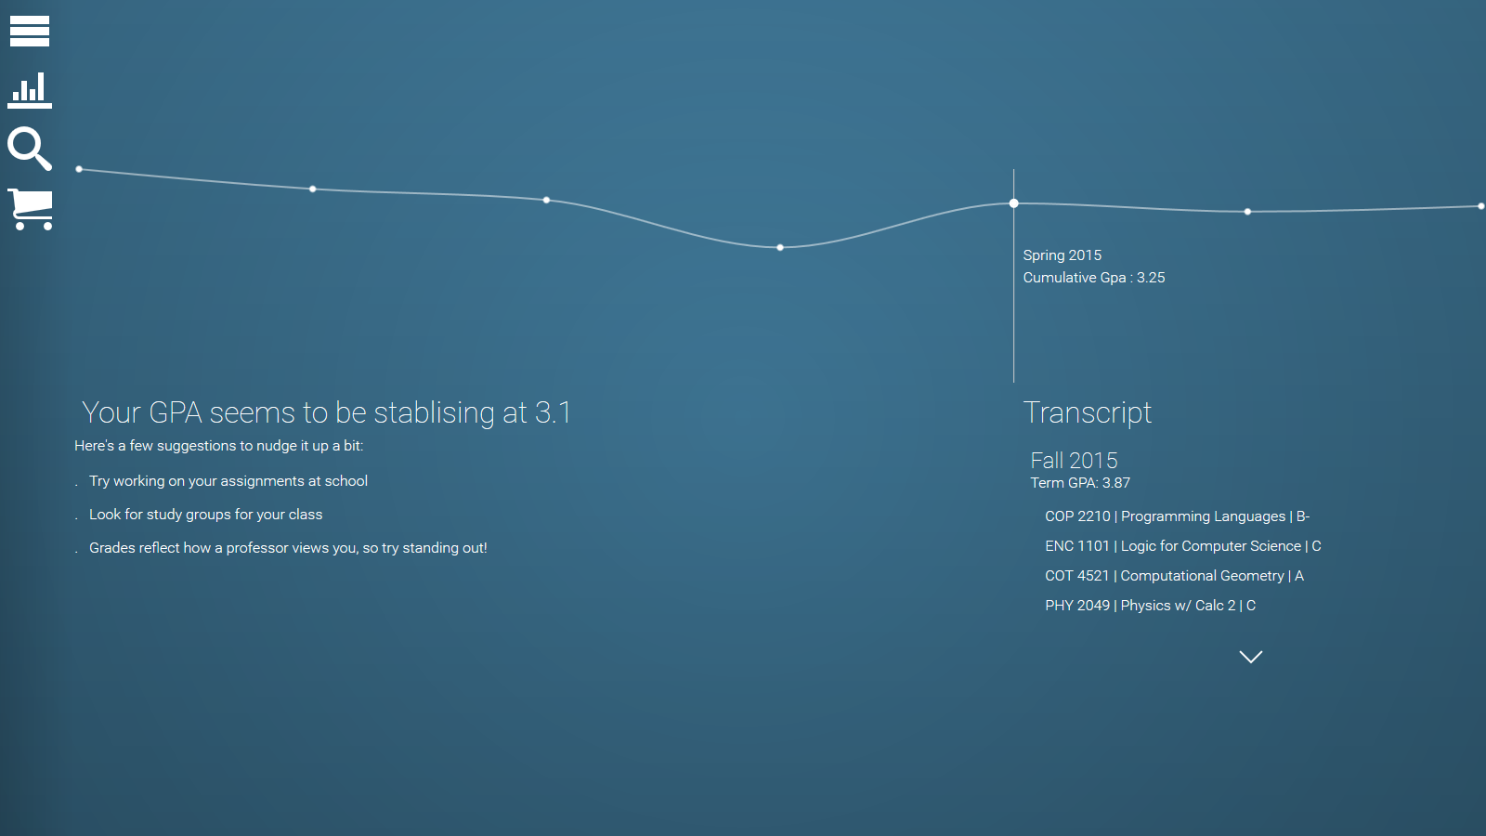

Figure 7: This is the progress page which displays statistics about your academic performance as well as some predictions about your future performance in the form of a line graph.

Upon clicking the progress link you will be directed to the progress page which consists of a summary of your recent cumulative GPAs in the center of the page in the form of a line graph, and your transcript data on the right-hand side of the page (see Figure 7.) This page is mostly used to view detailed statistics about your academic performance in FIU and some predictions about how well you will perform in the upcoming semesters.

The line bar graph is divided into two sections: ‘Past,’ and ‘Future.’

* The Past section, which is the leftmost part of the graph, consists of points where each point represents a discrete cumulative GPA value that you have received in a previous semester. For example, in Figure 8, the student received a cumulative GPA of 3.31 in the third semester that they attended FIU, which was during the Spring 2015 semester.

Each subsequent point on the line graph represents the cumulative GPA value of the succeeding semester that you have had at least one course in (see Figure 8.) For example, if you took 2 classes in Spring 2015, but you did not take any classes during the Summer or Fall semesters of 2015, and you took a class in Spring of 2016, then there will only be points for Spring 2015 and Spring of 2016 displayed in the line graph. All of this data is collected from your transcript.



Figure 8: The cumulative GPA for this student is 3.31 during Spring 2015.

* The Future section, which is the right part of the graph, consists of predicted term GPAs for the next two semesters e.g. Summer 2015 and Fall 2015 (if you have taken classes during these semesters.) These predicted GPAs are calculated using prior information about your academic performance such as grades received in previous courses, term GPAs, cumulative GPA, etc.
* An additional part of the graph, which is not considered a section of the graph, but rather a boundary between the Past and Future sections, is ‘Current.’ Current is simply the current semester during the academic year. Since no grades can be pulled from your transcript in regard to current courses because of the simple fact that you have not finished those classes yet, nothing will be shown except a predicted value of your current term GPA. This will be considered part of the Past section once the semester has past. The point in the Current section can be viewed as a Future point if the semester for that point is not over yet.
* To view any of the aforementioned information about a particular semester on the line bar graph, simply hover your mouse over a point and a tool-tip should pop up detailing the semester and the cumulative GPA you received at that time. This is shown in Figure 8.

The line graph is simply used a visualization tool; more data about your academic performance can be viewed by looking at your transcript data.

Your transcript data on the right-side of the page consists of your term GPA, and grades received for taken courses. For example, in Figure 9, it shows that the student has gotten a B- in Principles of Programming Languages, a C in Logic for Computer Science, an A in Computational Geometry, and a C in Physics with Calculus 2 in the Fall 2015 semester. The term GPA is also shown. If courses from a previous semester want to be seen, simply click on the down-arrow to show more courses.

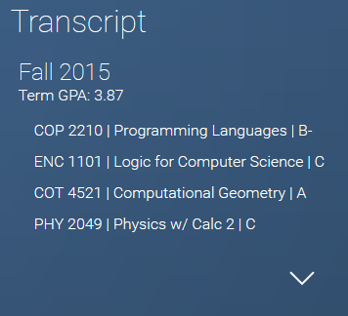

Figure 9: Grades received in courses taken in Fall 2015 as well as the student’s term GPA.

Some suggestions are also given to improve your grades on the left-side of the progress page (see Figure 10.)

  
Figure 10: Suggestions on how to improve academic performance.

# Searching for Classes

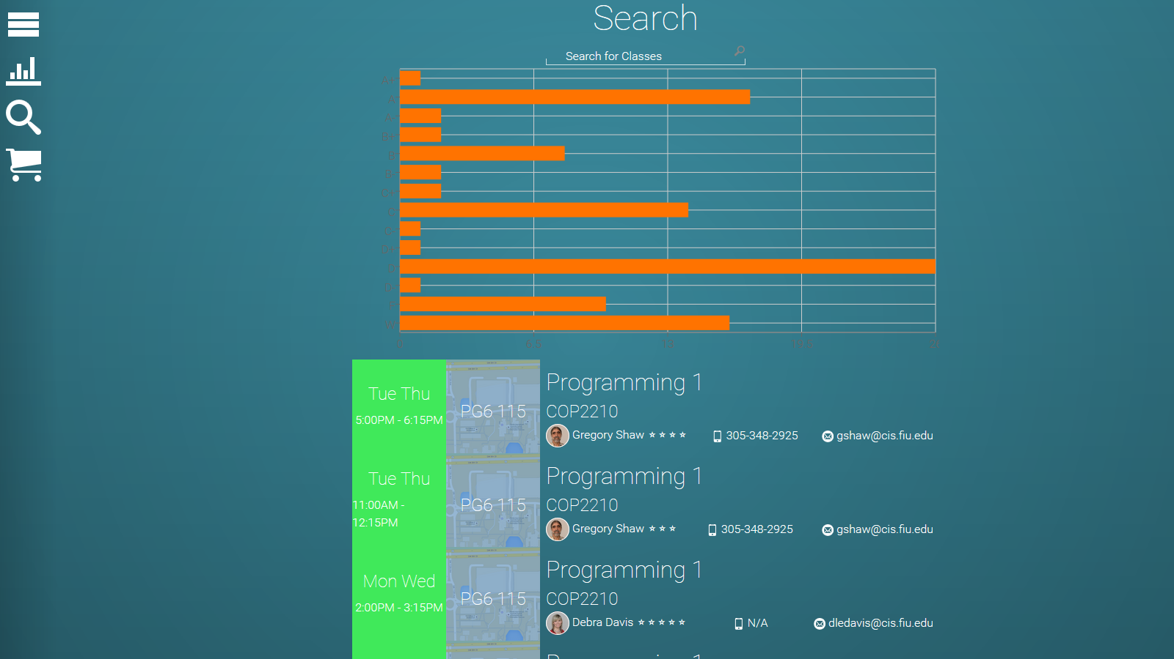

Figure 11: Shown is what is displayed to the user when the search icon (the magnifying class) is clicked on in the navigation menu on the left. Users must search for courses using the search bar on top of the main content window. Displayed are courses that the user searched for according to keywords and other predicates.

Upon visiting the enrollment page, you are able to search for the classes you want to take in the dark search bar on the top. Follow the next steps to search for a course:

1. Click on the search bar that says ‘Search for Classes’ (see Figures 11 and 12.)



Figure 12: Name of course being entered into the search bar.

1. Upon clicking the search bar, enter text to filter through courses i.e. Programming I in Figure 12.
2. Since courses show up real time, there is no need to press the ‘Enter’ button on your keyboard. Simply type the name of the course and courses will dynamically appear in the main content window in the same format as the courses displayed in the home page.

For each course, the following is shown: the days and times that your class meets e.g. Mon Wed 3:30 - 4:45; the course name e.g. COT 3541; the profile picture, phone number, and email address of your main instructor; and a Google Maps picture and building/room number for your class’s location.

The Google Maps picture is shown at the far right corner for each course as a background image behind the room number. This picture serves as a visualization tool to help you figure out where your class is located.

If you would like not like to enroll in a course, skip the following the steps – otherwise, continue.

1. Before enrolling in a course, you must first add the class to your shopping cart. Each class searched for and displayed in the enroll page, will have a ‘Add to Shopping Cart’ button next to it to add the selected class to your enrollment shopping cart. If you want to add a class to your shopping cart or you want to enroll in a course, click the ‘Add to Shopping Cart’ button.
2. Upon clicking the button, a confirmation message will display in the main content window detailing that you have successfully added the course to your enrollment shopping cart. However, an error message will be displayed in the main content window if something unknown went wrong or you have already added the class to your shopping cart. You can add as many classes as you want to your shopping cart. If you want to view or enroll in any class in the shopping cart, please proceed to the next section.

# Shopping Cart

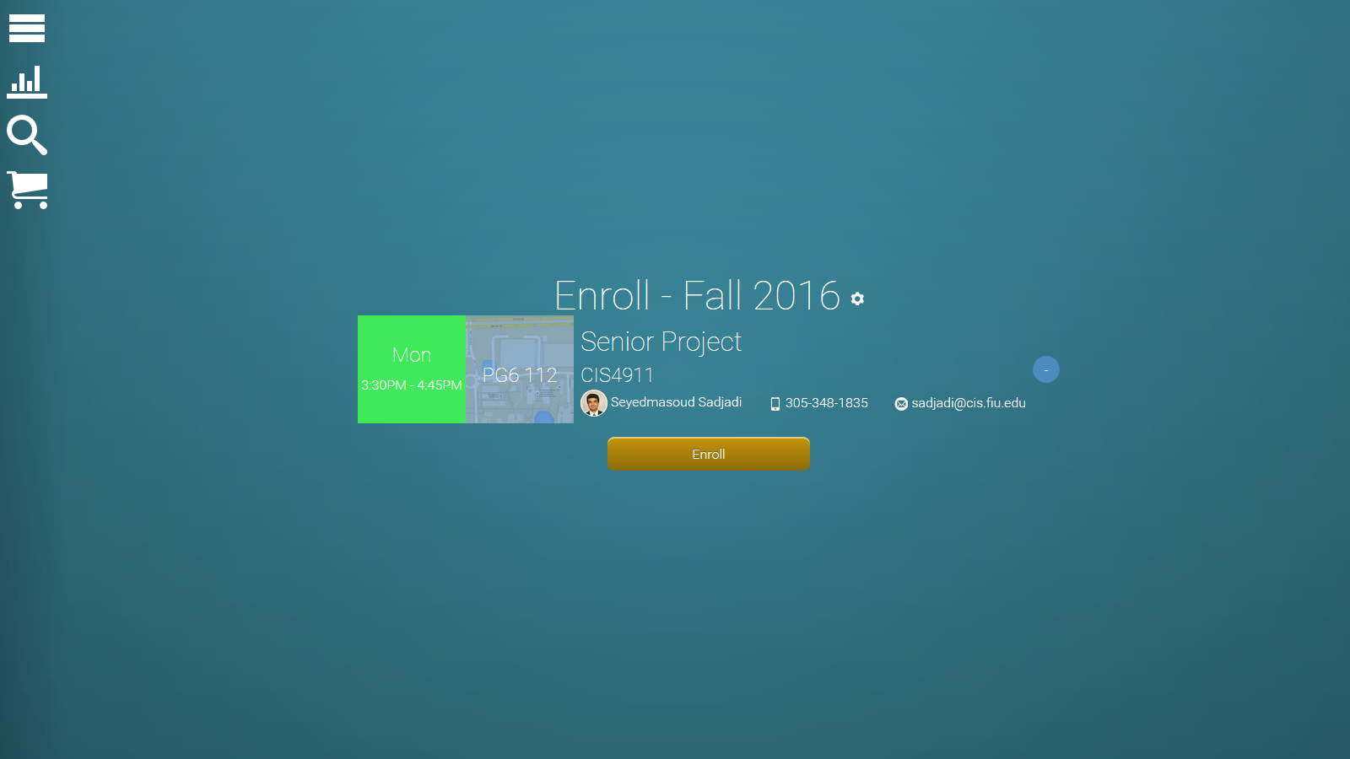

Figure 13: Shown is the shopping cart page which consists of all the courses you have added to your enrollment shopping cart. The same information that is seen with any course item on any other page is displayed here; however, an enroll button and a remove button as well.

Any classes you choose to enroll in will show up in the main content window of your shopping cart page, just like in MyFIU. Enrollment is based on your current semester; however you’re able to change that by clicking on the cog, which opens a module to access your different semesters (see Figure 13.)

If you would like to enroll in a course in your enrollment shopping cart, follow the next steps:

1. Click the gold enroll button below the course you want to enroll in.
2. Click the ‘Yes’ button that appears in the dialog box if you wish to enroll. If you wish to cancel, click the ‘No’ button and repeat step 1 if you want to enroll in another course.
3. A message will prompt you dictating whether the enrollment was successful or unsuccessful e.g. “You have successfully enrolled in CIS 4911!” or “Sorry, you could not enroll in the class because you do not have the necessary prerequisites. Please check MyFIU for the appropriate needed prerequisites courses. If your enrollment was successful, then great, you have enrolled in a course! If not, please repeat step 1 if you want to enroll in another course.

You can also choose to remove a class from your shopping cart by clicking the blue minus button next to the course.

If you would like to remove a class from your shopping cart, follow the next steps.

1. Click on the blue minus button next to the class you wish to remove from your shopping cart (see Figure 14.)
2. A message will display telling you that you successfully removed the class from your shopping cart i.e. “You removed CIS 4911 from your shopping cart.”
3. If you wish to drop another course, repeat step 1. If you would like to enroll in a course in your shopping cart, please refer to the beginning of the shopping cart section.

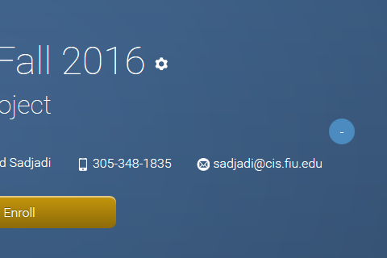

Figure 14: The remove from shopping cart button is colored blue and has a minus sign.