Software Design Specification
for
NCAA/March Madness Predictor
Version <1.0>
Prepared by <Camilo Riviere, Armando Zapata>
<St. Thomas University>
<02/24/2019>
<02/16/2019>
Table of Contents
Table of Contents ii
Revision History ii
1. Introduction 1
1.1 Goals 1
1.2 Statement of scope 1
1.3 Model context 1
1.4 Major constraints 1
2. Data design 1
2.1 Data sources 2
2.2 Internal data structure 2
2.3 Variable Description 2
2.3.1 Independent Variables 2
2.3.2 Dependent Variables 2
2.4 Pre-design Analysis 2
2.5 Tidying procedure 3
2.6 Database description 3
3. Model Architecture 3
3.1 Type of Model 3
3.2 Training set 3
3.3 Testing set 3
4. Approach 3
4.1 Implementation Details 4
4.2 System requirements 4
5. Testing Strategy 4
5.1 Classes of tests 4
5.2 Expected response 4
5.3 Performance bounds 4
5.4 External review and validation 4
6. References 5
Appendix A: Glossary 5
Appendix C: Issues List 5

Revision History
Name | Date | Reason For Changes | Version

Introduction
Every collegiate basketball team in the country wants a chance to play in the NCAA Men’s Basketball tournament. Only 68 teams make it, hence the excitement and thrill around this event. For seventy-seven years, the highly anticipated NCAA Division I collegiate basketball tournament has taken place. From the University of Oregon winning in 1939, to Villanova claiming the title in last year’s competition, there has been plenty of excitement throughout the years surrounding this event.
Given the event’s highly anticipated popularity and excitement, a prescriptive model is being created in an attempt to accurately predict the outcome of the upcoming tournament. To help with this matter, a preliminary analysis will be performed to determine the model’s accuracy, and it will be monitored as the tournament progresses. Further analysis will include incorporating advanced statistics such as:
- SOS Difference, which stands for strength of schedule measuring the quality of competition for each team.
- Location, whether the winning team was playing at home, away or on a neutral court.
- Three Point Reliance, which explains the percentage of points scored from three pointers for a team.
Part of the objective for implementing this project is to apply most of the skills acquired throughout the program in a setting that is applicable to both college and non-college students, as well as sports and non-sports fans. By creating this model, one can understand the complexities that exist in such an assignment, and one can further understand all the work that is required for other related assignments that exist across different industries. Plus, given that this galvanizes people and there is a lot of stake, individuals who attempt to create such model can get closer to a potential breakthrough in the world of analytics that may potentially shed some light into other analytics-related issues that are present in other sectors.

Goals
- Develop a prescriptive model in an attempt to predict the outcome for the upcoming NCAA Men’s Tournament (aka “March Madness”).
- The models’ prescriptive power should yield predictions based on data retrieved from kenpom based on efficiency statistics.

Statement of scope
Given the limited timeframe of 6 weeks to fulfill this project, it has been established that 15 years-worth of data is broad enough to create and implement a model. To increase the model’s accuracy, more refined and collegiate basketball statistics were incorporated into the model. Additionally, some other relevant statistics were incorporated that seem to be the more typical well-known metrics that most talk shows refer to when analyzing specific instances within college basketball games. Still, the presence of so many unknowns along with the innate complexity and unpredictability factor, may make the task an uphill battle in trying to increase the model’s accuracy. Also, it could potentially create flaws to the model rather than increase its validity.

The 15-year scope assigned for this project is considered a good sample size given the many attempts by previous data scientists and not being able to come close to an accurate result. Any discoveries or trends from this project could potentially be beneficial to the university. Maybe, some of these insights may be helpful to the school’s basketball program, and could result in better recruiting for the upcoming seasons as well as apply some tweaks to the current system that may be flawed or outdated.

Model context
A critical part of the project consists of creating a model that can validate the results it will generate. Given the complexity of such assignment and the lack of both resources and time, a close approximation to previous accurate models would be consider a success. Also worth pointing, the fact that the odds are absolutely and conservatively against us at 1 in 128 billion, it adds a little excitement into project. This model is not the typical 2-variable problem, where a logistic regression will be created. Instead, two models will be created, one for total score and another for difference. At least 3 dependent variables will be incorporated, and over 10 advanced/efficiency statistics will be incorporated as independent variables. For simplicity purposes, the team will create and test the models by implementing the programming language R. Moving further and deep into the analytical process, the validity of the model will be tested by inputting the different sub-variables and increase the model’s accuracy.

Major constraints
For the purposes of this project, no major constraints were encountered that would limit the model. At first, several attempts were made in an effort to have access to the data without incurring any additional monetary expense. Still, after the slight pivot and a moderate fee of $20, relevant college basketball statistics were obtained and no other impediments were presented. There were no clearly-defined guidelines or requirements as to what specific programming language needed to be used, or if this model was going to be integrated into any other institution’s website.

Still, a possible constraint during the model building phase is that the model may only accept school year figures. Therefore, the model will take years of data with larger variance in price differences to train a confident prediction model and increase its validity even more.

Data design
Aside from using the efficiency statistics as the basis for the models, additional sub-variables will be incorporated. Such statistics, those that give you an instant snapshot of what is happening in the game include: field goal attempts (FGA), effective field goal percentage (EFG%), free throw attempts (FTA), and free throw percentage (FT%). These sub-variables will be used to train the models, and subsequently use that result as a proxy and compare it with the one from the complement of the efficiency statistics and the traditional ones. This will help in training and validating the model, and therefore make the necessary tweaks that could potentially produce a more accurate result and increase the validity of both models.

Data sources
The sample data was retrieved from a private source using SQL queries. The statistics gathered were mostly from Kenpom, which gave access to the efficiency statistics previously mentioned, and some other relevant data was obtained from Kaggle as well. The structured data gathered by the team was formatted in a CSV file, where some preliminary testing was performed using Excel to generate a graphic representation of the sample data in order to visualize the changes, relationships, and subtleties that were present in the data.

Internal Data Structure

Variable Description

Dependent Variables
1. Overall score
1.1. Description: final score for each of the games for each team in the sample data.
1.2 Numeric
2. Difference in scores for each team.
2.1 Description: difference in scoring for each team on the road, at home, and at a neutral court.
2.2 Numeric
3. Implied probabilities
3.1 Description: probability that each team has of winning a particular game.
3.2 Numeric

Independent Variables

Independent Variables

1. Adjusted Offense
1.2 Description: offensive efficiency relative to number of possessions each team had. This takes efficiency of scoring into play, rather than just looking at points per game, since teams play at different speeds and get different numbers of opportunities per game.
1.3 Numeric
2. Adjusted Defense
2.1 Description: defensive efficiency relative to number of possessions each team has. This takes efficiency of scoring into play, rather than just looking at points per game, since teams play at different speeds and get different numbers of opportunities per game.
2.3 Numeric
3. Adjusted Tempo
3.1 Description: measures the speed at which teams play. The purpose of including this metric is to see if faster or slower teams have an advantage.
3.2 Numeric
4. SOS Difference
4.1 Description: strength of schedule is very important and does influence in seating; it measures the quality of competition for each team.
4.2 Numeric
5. Location
5.1 Description: whether the winning team was playing at home, on the road, or on a neutral field.
5.2 Numeric
6. Offensive Rebound Differential
6.1 Description: average offensive rebound differential per game for a team, calculated the same way as average point differential.
6.2 Numeric
7. Defensive Rebound Differential
7.1 Description: Average defensive rebound differential per game for a team, calculated the same way as average point differential.
7.2 Numeric
8. Turnover Differential
8.1 Description: average turnover differential per game for a team.
8.2 Numeric
9. Three-Point Reliance
9.1 Description: percentage of points scored from three pointers for a team.
9.2 Numeric
10. True Shooting Percentage
10.1 Description: true shooting percentage for a team. It is a more accurate version of shooting percentage, as it weighs shots based on their value.
10.2 Numeric
11. True Shooting Percentage Allowed
11.1 Description: True shooting percentage allowed for a team. Same as true shooting percentage, but what the team allows rather than shoots.
11.2 Numeric
12. Block Differential
12.1 Description: Average difference in blocks per game for team vs. opponents.
12.2 Numeric

Pre-design Analysis
Before the model was designed, when the initial idea was to create a model that provides a recommendation to bettors based on probabilities using live data, other widely-popular statistics were considered for observations. Among those include turnovers, fouls, shots attempt in the paint, defensive rebound percentage, and offensive rebound percentage. Still, because of the complex nature in the task and previous failed attempts, more refined statistics were incorporated instead in an effort to increase the models’ accuracy. Tidying procedure

Database Description
For this project we utilized an S3 (Simple Storage Service) data warehouse. The schema can be found on the following page.
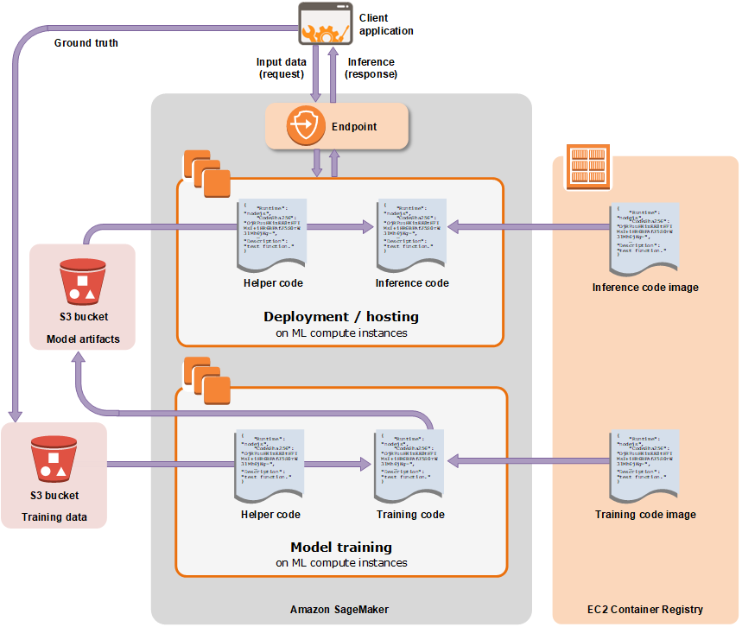

Model Architecture
The two models created are based on an aggregation of CSV files that were then formatted using Excel. During the data preparation phase, a preview of the various independent variables contained in the data was done to determine the final independent variables used.

Type of Model
For this model we used a classifier in the form of the XGBoost Algorithm (Xtreme Gradient Boosting). This model showed better accuracy when compared to other methods such as Logistic Regression.

Training set
Each instance in the training dataset provided contains all this information for the winning and losing team in each NCAA regular season and tournament game since 2003. Game-by-game statistics were provided, but all the statistics listed above were rolled into season averages for each team for use in the tournament predictor. This allows for predictive evaluation of teams, as using game-by game predictors of outcome is not helpful, since it is impossible to know the game statistics prior to the game occurring. All factors are expected to have a positive relationship with winning apart from adjusted defense, true shooting percentage allowed and turnover differential, where in all three cases the goal is to have lower figures than opponents. The object of this competition is to minimize log loss probability so a binary win loss indicator was created, however, a continuous predictor could be created using the margin of victory for each team in each game as well. The training set contains 40,069 rows.

Testing set
Each instance in the test dataset provided contains all this information for the winning and losing team in each NCAA regular season and tournament game since 2003. Game-by-game statistics were provided, but all the statistics listed above were rolled into season averages for each team for use in the tournament predictor. This allows for predictive evaluation of teams, as using game-by game predictors of outcome is not helpful, since it is impossible to know the game statistics prior to the game occurring. All factors are expected to have a positive relationship with winning apart from adjusted defense, true shooting percentage allowed and turnover differential, where in all three cases the goal is to have lower figures than opponents. The object of this competition is to minimize log loss probability so a binary win loss indicator was created, however, a continuous predictor could be created using the margin of victory for each team in each game as well. The test set contains 7,071 rows.

Approach

Implementation Details
Computer languages and versions: Python version 3.6
Platform: x86_64-apple-darwin15.6.0 (64-bit)
Running under: macOS High Sierra 10.13.6
libraries: seaborne, sklearn, sagemaker, numpy, pandas, matplotlib

System requirements
minimum hard drive space：16.7M
network bandwidth：Y
RMA amont：226.7M
CPU speed：0.8%/CPU

Testing Strategy

Classes of tests
White box test:
Unit testing performed on each method written in python.
Black box testing:
Black box testing performed by testing the actual function of the model where the model is currently being hosted as an application:
https://criviere.github.io/ncaa_camilo_armando/

Expected response
The total model provides the expected total score of a specific matchup.
The difference model provides the point difference for a selected matchup.
For example,
“The expected final score is: 2018 Duke 80.5 - 2018 Indiana 71.47. The expected combined score is: 151.96. Indiana should win 14.54% of the time.”

Performance bounds
Performance bounds are subject to the limitations of the hardware of our execution machine:
RAM- 8GB
Hard drive – 80GB
Processor – Intel i5

External review and validation
The validation process for this project will be post-implementation and as the tournament progresses. While there are specific aspects of the models that can be compared with others attempted in the past, the most ideal way to validate the models is to monitor and compare the results of the tournaments as it progresses. We will also be having the students in the class externally review and validate our model throughout the course of our presentation. They may see the functionality of the model at this link: https://criviere.github.io/ncaa_camilo_armando/

References
Appendix A: Glossary

Appendix C: Issues List

- Result interpretation is a potential issue since this is the first time this type of analysis has been done for St. Thomas university and the model possesses many complexities.

- Tidying procedures vary depending on the specific project and the model used, therefore selecting the right tidying method for the data will require a careful evaluation and may pose issues deeper into the analytical stages.

Website Entry (Github)
- https://github.com/Criviere/ncaa_camilo_armando

Website Entry (Model Enpoint/Application)
- https://criviere.github.io/ncaa_camilo_armando

