

Technische Hochschule Wildau

Telematik

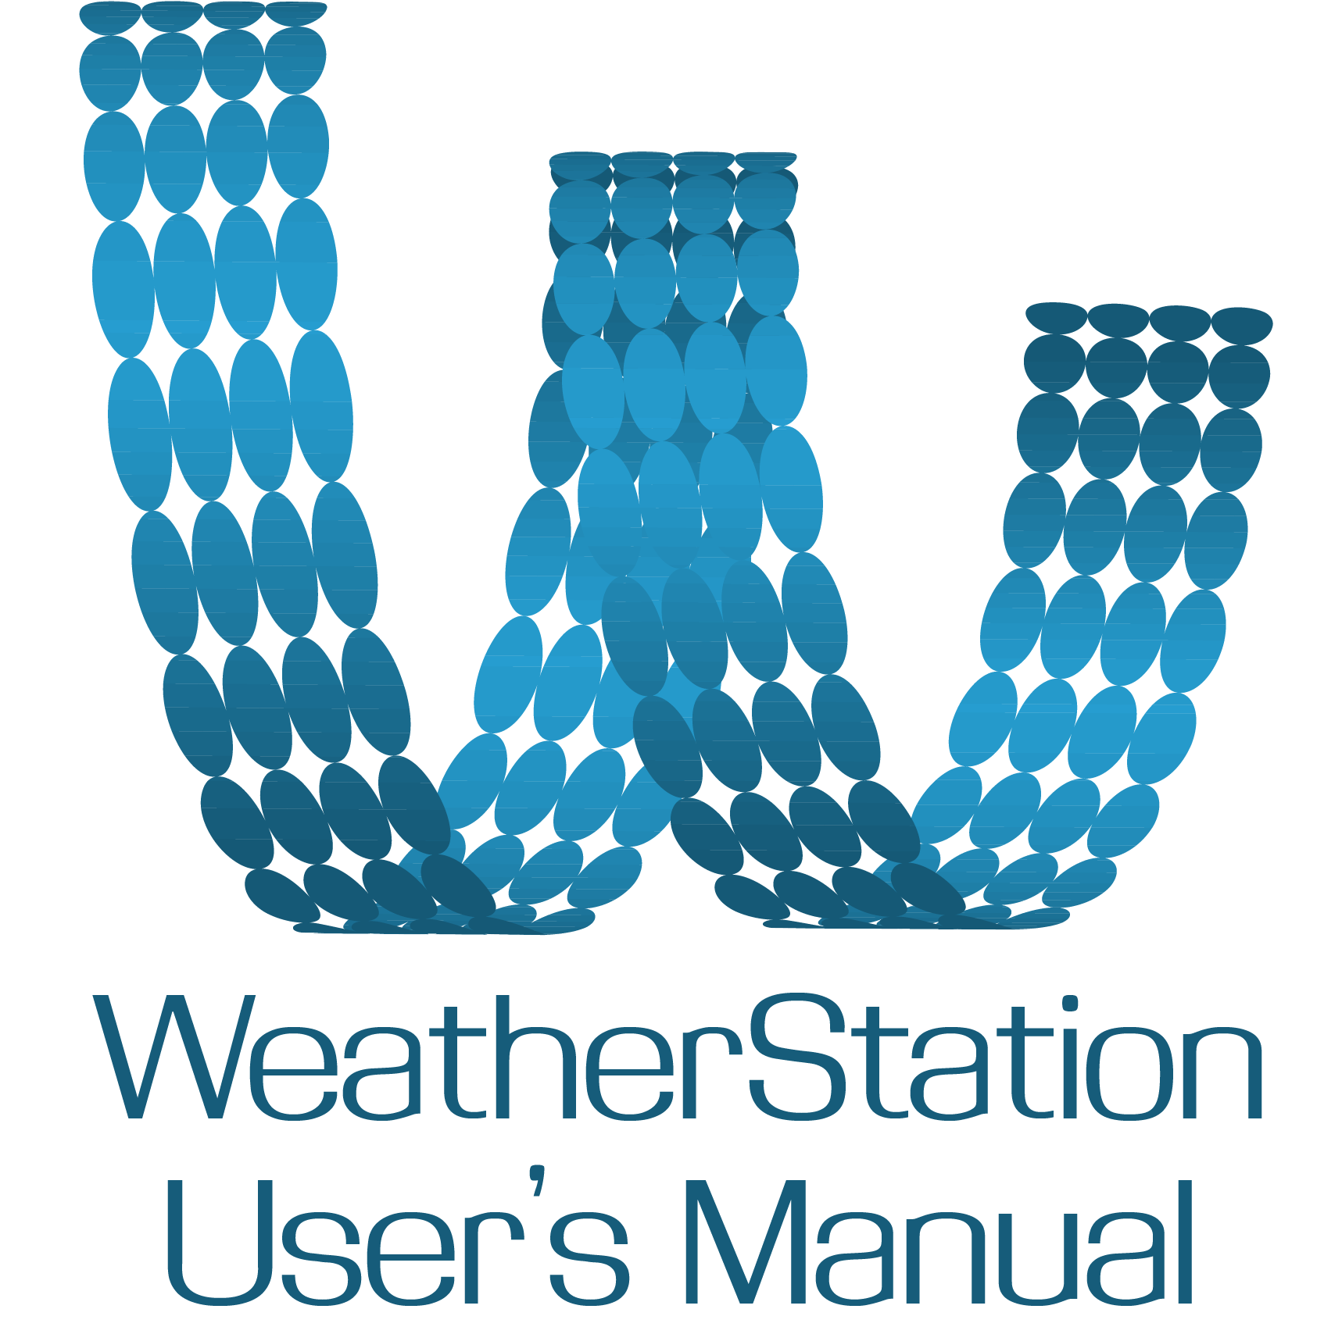

Wildau, 11.5.2015

**Contents**

**1. General Information** 3

1.1. System Overview 3

1.2. Organization of the Manual 3

1.3. References 3

**2. System Summary** 4

2.1. System Configuration 4

2.2. User Access Levels 4

**3. Using the program** 5

3.1. Starting the program 5

3.2. Registration and Logging in 5

*3.2.1. Changing your password* 6

3.3. Home Menu 7

*3.3.1. Home Menu (Administrator)* 9

3.4. Main panel (Connect) 10

*3.4.1. Adding new Weather Stations* 10

*3.4.2. Editing Weather Stations* 10

*3.4.3. Adding new recordings* 10

3.5. Historical 10

3.6. Language 10

3.7. User settings (Administrator) 11

3.8. Exiting the program 12

**Table of Figures** 13

**1. General Information**

1.1. System Overview

This WeatherStation program is a software program which displays weather related data measured by Raspberry Pi micro-controllers with the help of MEMS Sensor Boards. Users are able to view real time data from the micro-controllers and historical data from the database.

1.2. Organization of the Manual

This user’s manual consists out of three sections: *General Information*, *System Summary* and *Using the program*.

The *General Information* section explains the purpose of the program in short terms.

The *System Summary* section provides a general overview of the program. The system configuration is explained, which includes hardware and software requirements. User access levels are also included in this section.

The *Using the program* section provides a detailed but simple explanation of the system functions. This section is intended for the user and it helps him to get familiar with the use of the WeatherStation program.

1.3. References

http://www.arbowebforest.com/android/ArboWebForestUserManual.pdf

**2. System Summary**

2.1. System Configuration

The WeatherStation program is a cross-platform application which displays weather related data. To access the program the user is required to have a connection to the Internet.

2.2. User Access Levels

For using this program, the user needs to have a registered account, which he can make on the starting screen (Log in - more in the Using the program section).

There are two users of this program, the general user and an admin user.

The general user can log in into the program with his username and password and has access to all non-administrative functions of the program (viewing real-time data, viewing historical data, adding/editing new Weather stations, adding new recordings, changing the language of the program).

The admin user has access to all the mentioned functions and besides that he has also access to administrative functions (editing/deleting users, changing the interval of measuring for each Weather station, editing/deleting new and existing Weather stations).

**3. Using the program**

3.1. Starting the program

For starting the WeatherStation program you just need to double-click (or right mouse click -> open) the WeatherStation program icon.

3.2. Registration and Logging in

After starting the program, the first window is the *Log*-*in* *window*.

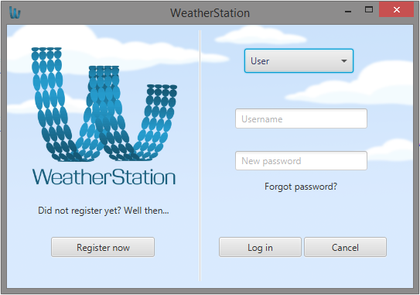

Figure 1 - Log-in window

But to log in into the program, you need to be registered first. To register you can click on the *Register now* button. A new *Registration* window will show.

REGISTER WINDOW SCREENSHOT

For registering you have to enter your desired username, two times your password and your e-mail address. After all required fields are filled you can click on the *Register* button to register yourself (of course if all fields are correctly filled).

After that, you can log in into the program by entering your username and password into the fields intended for that on the *Log-in* screen (Figure 1).

If you are an administrator, you have to select *Administrator* in the drop-down menu and register with the default admin account.

After logged in, the *Home* *screen* will appear. If logged in as an administrator a different *Home* *screen* will appear intended for the administrator (3.3. Home Menu).

*3.2.1. Changing your password*

If you have forgotten your password, or you just want to change it, there is an option for that on the *Log-in* screen. By clicking the button *Forgot password?* a new window will appear.

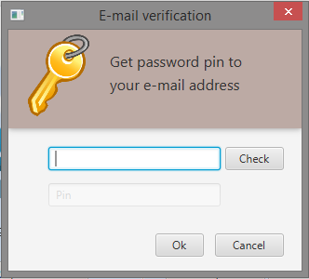

Figure 2 - Forgot password?

On this window you have to enter your e-mail address which you have used for registering. After you click the *Check* button, you will receive a pin for resetting your password by e-mail (if the entered e-mail is valid). This pin you have to enter into the *Pin* input field under the entered e-mail address. After that click the *Ok* button and a new window will show for setting your new password.

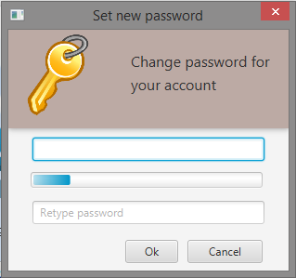

Figure 3 - Setting new password

On this window you just have to enter your new password, and retype it, into the intended fields and click Ok. Now your password is changed.

3.3. Home Menu

After logged in the *Home screen* will show.

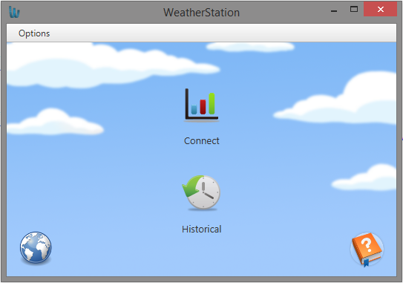

Figure 4 - Home screen

The *Home screen* consists out of two main buttons – Connect and Historical, and two side buttons – Language (Globus icon) and Help (Book icon). Besides those buttons, there is also an option to log out by clicking the *Options* button in the top left corner of the screen and selecting *Log out*. When you click on the *Log out* option you will return on the *Log-in screen*.

For viewing the current weather data click the *Connect* button (3.4. Main panel (Connect)).

For viewing historical data (in a chosen interval) click the *Historical* button (3.5. Historical).

For changing the language of the program click the Language button (3.6. Language).

And by clicking the *Help* button the User’s Manual of the WeatherStation program will show.

*3.3.1. Home Menu (Administrator)*

If you are logged in as an administrator, the *Home screen* intended for the administrator will show.

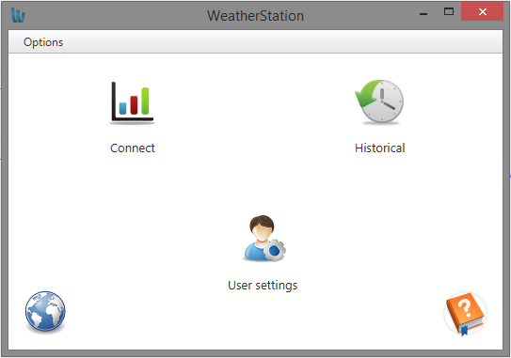

Figure 5 - Home screen (Administrator)

In this menu, besides all the options as in the user’s *Home screen*, you have also a *User settings* button where you can edit or delete users (3.7. User settings (Administrator)).

3.4. Main panel (Connect)

*3.4.1. Adding new Weather Stations*

*3.4.2. Editing Weather Stations*

*3.4.3. Adding new recordings*

3.5. Historical

3.6. Language

By clicking the *Language* button on the *Home* *screen*, the *Language* *window* will appear.

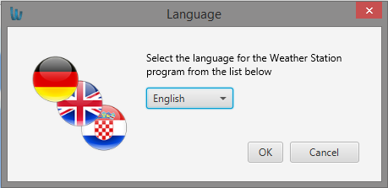

Figure 6 - Language window

Here you can change the language of the program by choosing one of the languages in the drop-down menu. You can choose between English, German and Croatian.

Please note that after starting the program (Log in window), the program will use the language of your operating system if it is one of the three mentioned above, if your default system language is not one of the those, then the program will start in German.

3.7. User settings (Administrator)

By clicking the *User setting* button on the administrator’s *Home* *screen*, the *User* *settings* *window* will appear.

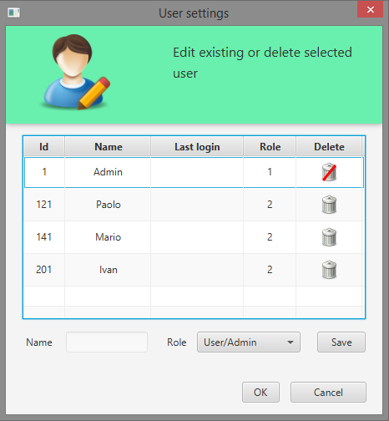

Figure 7 - User setting (Administrator)

Here you can edit or delete users.

For editing a user you need to click on one, the name and the role of the clicked user will be shown in the two fields under the table, then you can either change his name or his role (User or Administrator) and by clicking *Save* the changes will be saved.

For deleting a user you just need to click on the bucket icon in the *Delete column* and confirming this action (note that you cannot delete the administrators).

3.8. Exiting the program

To exit the WeatherStation program you can always click on the *x* icon in the top right corner of the program.

**Table of Figures**

Figure 1 - Log-in window 5

Figure 2 - Forgot password? 6

Figure 3 - Setting new password 7

Figure 4 - Home screen 8

Figure 5 - Home screen (Administrator) 9

Figure 6 - Language window 10

Figure 7 - User setting (Administrator) 11