

Technische Hochschule Wildau

Telematik

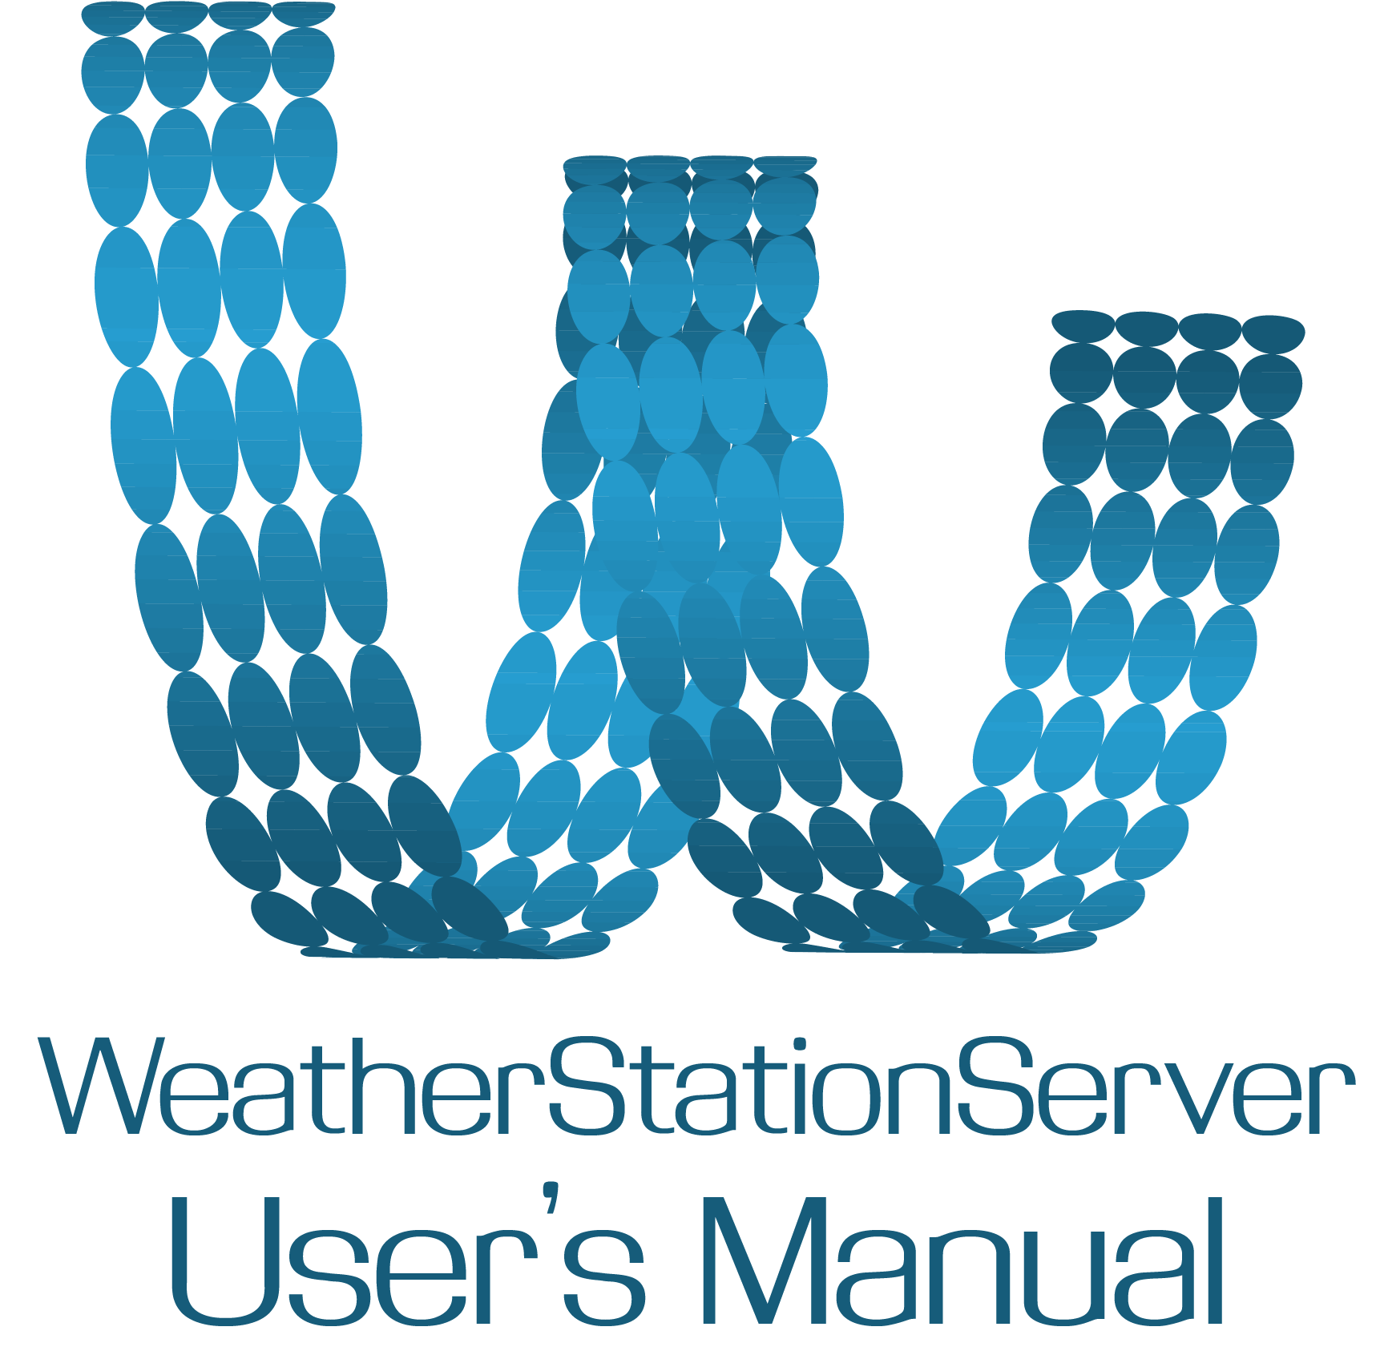

Wildau, 11.5.2015

**Contents**

1. General Information 3

1.1. System Overview 3

1.2. Organization of the Manual 3

1.3. References 3

2. System Summary 4

2.1. System Configuration 4

2.2. User Access Levels 4

3. Using the Server 5

3.1. Run the application 5

3.2. First use 5

3.3. Starting the Server 6

4. Configuration settings 7

5. User settings 7

6. Exiting the program 7

# 1. General Information

## 1.1. System Overview

## 1.2. Organization of the Manual

## 1.3. References

http://www.arbowebforest.com/android/ArboWebForestUserManual.pdf

# 2. System Summary

## 2.1. System Configuration

## 2.2. User Access Levels

# 3. Using the Server

## 3.1. Run the application

Server and Administration application are combined together. To run the application you need to open terminal and type:

java -jar server.jar [option]

If you enter the wrong argument or run application with **-HELP** pargument you will get the list of all available options. (*Figure 1*)

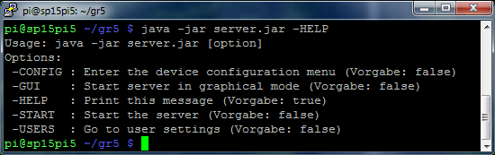

Figure 1- Help

## 3.2. First use

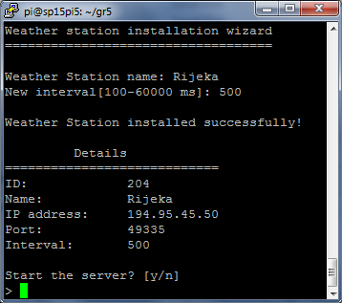

Figure 2- Installation wizard

When you start server (with **-START** or **-GUI** arguments) for the first time, the Installation Wizard would appear (*Figure 2*). Then you will be asked for the basic information about the device that you are registering. You must enter unique *Name* in order to successfully add a new device. Notice that ID, IP address and PORT will be inserted automatically.

## 3.3. Starting the Server

After installing the server you can simply run it with **-START** argument. (*Figure 3*)

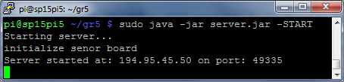

Figure 3- Server started

In case that the monitor is connected to the Weather station you can display current values in 7-segment digits by running the application with **-GUI** argument

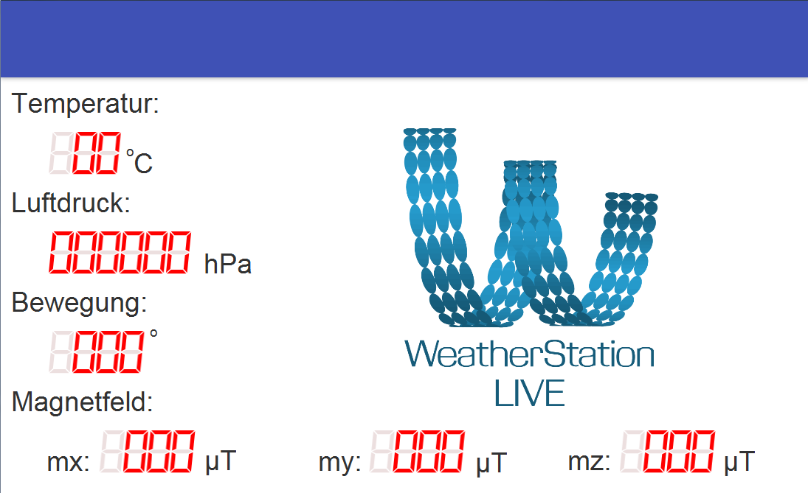

Figure 4- GUI application displayed on monitor

# 4. Device settings

In the Configuration menu you can show all the devices, and also edit or delete them.

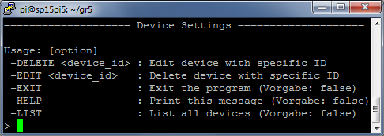

Figure 5- Configuration menu

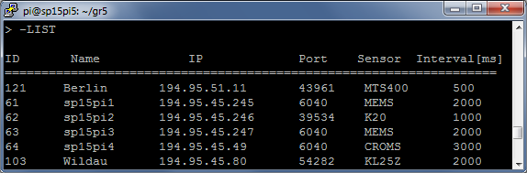

Figure 6- Device listing

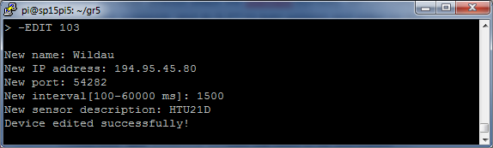

Figure 7- Editing a device

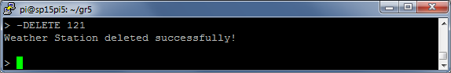

Figure 8- Deleting a device

# 5. User settings

In the User menu you can show all the users, add new user and edit or delete the existing one.

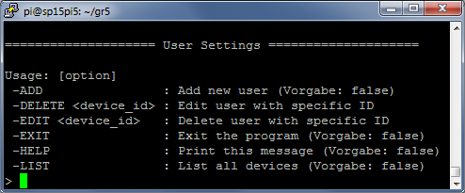

Figure 9- User menu

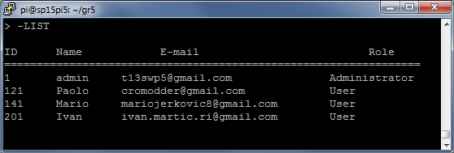

Figure 10- User listing

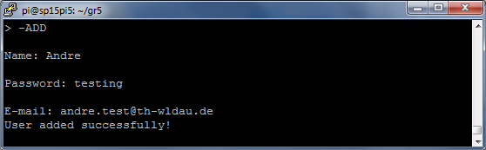

Figure 11- Adding new user

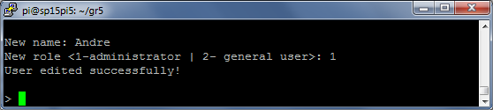

Figure 12- Editing existing user

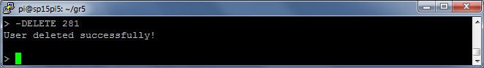

Figure 13- Deleting user

# 6. Exiting the program

To exit a program just enter **-EXIT**.