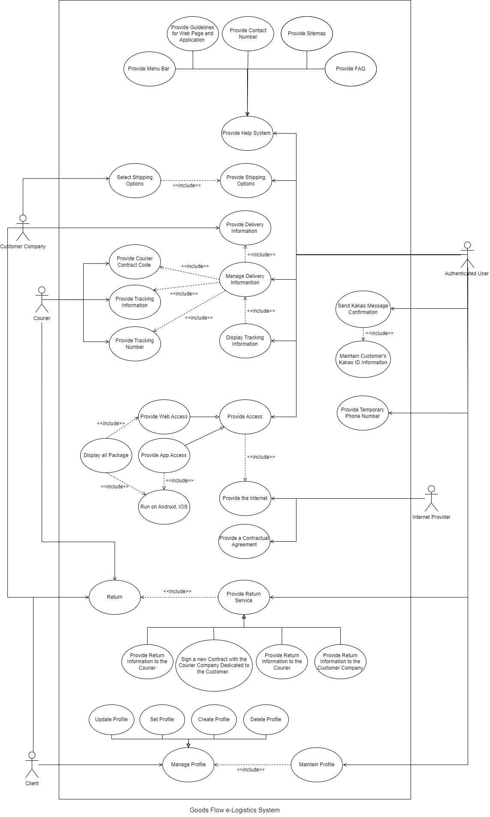

**Andre Kim**

**Use Case Specification:**

**<** **Delegate on data management >**

**Version <1.0>**

**Revision History**

|  |  |  |  |  |
| --- | --- | --- | --- | --- |
| **Date** | **Version** |  | **Description** | **Author** |
| <10/22/22> | <1.0> | First Draft |  | Kim DongIn,  Ahn ChanJun,  Lee ChangMin |

**Use Case Specification:**

**<** **Delegate on data management >**

# Delegate on data management

## Brief Description

The system receives data from the customer company, processes it into data that meets the specifications of the shipping company, and delivers it to the shipping company. In conclusion, the system sends the delivery information to the customer company.

# Actors

2.1. Authenticated user: Who has access to the system.

2.2. Courier: A company in charge of courier service.

2.3. Customer company: A company or organization that needs courier service.

2.4. Internet provider: An object that provides the Internet for system communication.

# Flow of Events.

## Basic Flow

1. The customer company sends the delivery information to the system. (2.1.1.R1)
2. The system receives the delivery information. (2.1.1.R1)
3. The system sends the received delivery information to the courier. (2.1.2.R1, 2.1.2.R2, 2.1.7.R8)
4. The courier sends the tracking number to the system. (2.1.3.R1)
5. The courier sends the courier contract code to the system.
6. The system receives the courier contract code from the carrier.
7. The system sends tracking information to the customer company. (2.1.4.R1, 2.1.4.R2)
8. The courier passes the tracking information to the system. (2.1.3.R2, 2.1.3.R3)
9. The system sends tracking information to the customer company. (2.1.4.R1, 2.1.4.R2)

# Pre-Conditions

1. The system is built using Python and MySQL. (2.6.1.R1)
2. The hardware is connected to the internet that is given by the internet provider. (2.7.2.R1, 2.3.1.R1, 2.3.1.R2)
3. The system displays the Goods Flow disclaimers, copyright, wordmark, trademark, and product warranties. (2.8.R1)
4. The system satisfies the industry standard (2.9.R1)
5. The system communicates with customer company and courier to receive an information. (2.7.4.R1, 2.7.4.R2)
6. The system uses HTTPS protocols. (2.7.5.R1, 2.7.5.R2)
7. The performance is dependent upon the hardware components. (2.4.R4)
8. The system provides guidelines with a document. (2.6.4.2.R1, 2.6.4.3.R1)
9. The system’s storage is only accessible to authenticated administrators. (2.5.2.R2)
10. The system’s storage shall be encrypted. (2.5.2.R3)

# Post-Conditions

The customer company receives the tracking information from the system.

**Andre Kim**

**Use Case Specification: <Track on a package>**

**Version <1.0>**

**Revision History**

|  |  |  |  |  |
| --- | --- | --- | --- | --- |
| **Date** | **Version** |  | **Description** | **Author** |
| <10/22/22> | <1.0> | First Draft |  | Kim DongIn, Ahn ChanJun, Lee ChangMin |

**Use Case Specification: <Track on a package>**

# Track on a package

## Brief Description

It receives data from the customer, processes it into data that meets the standards of the delivery company, and delivers it to the delivery company. In conclusion, the system visualizes the delivery information through the app and delivers it to the client.

# Actors

2.1. Authenticated user: Who has access to the system.

2.2. Client: Individuals who purchase products while using the app.

2.3. Courier: A company in charge of courier service.

2.4. Customer company: A company or organization that needs courier service.

2.5. Internet provider: An object that provides the Internet for system communication.

# Flow of Events

## Basic Flow

1. The customer sends the delivery information to the system. (2.1.1.R1)
2. The system receives the delivery information. (2.1.1.R1)
3. The system sends the received delivery information to the courier. (2.1.2.R1, 2.1.2.R2, 2.1.7.R8)
4. The courier sends the tracking number to the system. (2.1.3.R1)
5. The courier sends the courier contract code to the system.
6. The system receives the tracking number from the courier. (2.1.3.R1)
7. The system receives the courier contract code from the courier.
8. The courier sends tracking information to the system. (2.1.3.R2, 2.1.3.R3)
9. The system sends tracking information to the customer company. (2.1.4.R1, 2.1.4.R2)
10. The system sends the tracking information to the client. (2.1.5.1.R1, 2.1.5.1.R2, 2.1.5.1.R3, 2.1.5.1.R4, 2.1.5.1.R5, 2.1.5.1.R6, 2.1.5.1.R7, 2.1.5.1.R8, 2.1.5.1.R9, 2.1.5.1.R10)
11. Client receives delivery information from the system.
12. Client receives the package sent by courier.

# Pre-Conditions

1. The system is built using Python and MySQL. (2.6.1.R1)
2. The hardware is connected to the internet that is given by the internet provider. (2.7.2.R1, 2.3.1.R1, 2.3.1.R2)
3. The system displays the Goods Flow disclaimers, copyright, wordmark, trademark, and product warranties. (2.8.R1)
4. The system satisfies the industry standard (2.9.R1)
5. The system communicates with customer company and courier to receive an information. (2.7.4.R1, 2.7.4.R2)
6. The system uses HTTPS protocols. (2.7.5.R1, 2.7.5.R2)
7. The system does not leave any cookies. (2.5.1.R1, 2.5.1.R2, 2.5.1.R3)
8. The system provides a temporary phone number. (2.1.5.2.R1)
9. The system provides help services. (2.1.9.R1, 2.1.9.R2)
10. The system provides FAQ customer support. (2.1.9.R3, 2.1.9.R4)
11. The system provides shipping options. (2.1.11.R1)
12. The system is based on the web. (2.4.R1)
13. The system is run on Android and IOS. (2.4.R2, 2.4.R3)
14. There are no memory requirements. (2.6.2.R1)
15. The computers are equipped with web browsers. (2.6.2.R2)
16. The product’s information is stored that the client can easily access. (2.6.2.R3)
17. The client has a general knowledge of basic computer skills to use the website. (2.6.2.R4)
18. The app size should be less than 1GB. (2.6.3.R1)
19. The device is equipped with a wireless internet connection. (2.6.3.R2)
20. The client has a general knowledge of basic computer skills to use the app. (2.6.3.R3)
21. The system provides specific guidelines to the client. (2.6.4.1.R1)
22. R2 The system provides a menu bar to implement online user help. (2.6.4.1.R2)
23. The user interface for the software is compatible with the browser. (2.7.1.R1)
24. The wireless internet interface for the software is compatible with the browser. (2.7.3.R1)
25. The system displays 10 results on the current screen. (2.2.1.R1)
26. The system’s data storage does not display personal information. (2.5.2.R1)
27. The system’s storage is only accessible to authenticated administrators. (2.5.2.R2)
28. The system’s storage shall be encrypted. (2.5.2.R3)
29. The system provides a menu. (2.2.2.R1)
30. The system displays all package list on the current screen. (2.2.2.R2)
31. The system provides a scrolling on the shipping check page. (2.2.2.R3)
32. The system shall provide web pages and app access. (2.2.3.R1)
33. The system maintains customer's Kakao ID information. (2.1.10.R1)
34. The system sends a Kakao message to the user. (2.1.10.R2)

# Post-Conditions

The client receives shipment from Courier.

**Andre Kim**

**Use Case Specification: <Send on a package>**

**Version <1.0>**

**Revision History**

|  |  |  |  |  |
| --- | --- | --- | --- | --- |
| **Date** | **Version** |  | **Description** | **Author** |
| <10/22/22> | <1.0> | First Draft |  | Kim DongIn, Ahn ChanJun, Lee ChangMin |

**Use Case Specification: <Send on a package>**

# Send on a package

## Brief Description

When the client applies for delivery service by selecting information about the delivery item and transportation method, the system processes the delivery information sent by the client into data that meets the standards of the courier and delivers it to the courier. When the sequence is finished, the system receives shipping information from the courier. In conclusion, the system visualizes the delivery result through the app and delivers it to the client.

# Actors

2.1. Authenticated user: Who has access to the system.

2.2. Client: Individuals who purchase products while using the app.

2.3. Courier: A company in charge of courier service.

2.4. Internet provider: An object that provides the Internet for system communication.

# Flow of Events

## Basic Flow

1. The client sends the delivery information to the system. (2.1.1.R1)
2. The system receives the delivery information. (2.1.1.R1)
3. The system sends the received delivery information to the courier. (2.1.2.R1, 2.1.2.R2, 2.1.7.R8)
4. Courier sends the tracking number to the system. (2.1.3.R1)
5. The courier delivers the courier contract code to the system.
6. The system receives the tracking number from the courier. (2.1.3.R1)
7. The system receives the courier contract code from the courier.
8. Courier sends tracking information to the system. (2.1.3.R2, 2.1.3.R3)
9. The system sends the tracking information to the client. (2.1.5.1.R1, 2.1.5.1.R2, 2.1.5.1.R3, 2.1.5.1.R4, 2.1.5.1.R5, 2.1.5.1.R6, 2.1.5.1.R7, 2.1.5.1.R8, 2.1.5.1.R9, 2.1.5.1.R10)
10. Client receives delivery information from the system.
11. The client receives the delivery result from the system.

# Pre-Conditions

1. The system is built using Python and MySQL. (2.6.1.R1)
2. The hardware is connected to the internet that is given by the internet provider. (2.7.2.R1, 2.3.1.R1, 2.3.1.R2)
3. The system displays the Goods Flow disclaimers, copyright, wordmark, trademark, and product warranties. (2.8.R1)
4. The system satisfies the industry standard (2.9.R1)
5. The system communicates with customer company and courier to receive an information. (2.7.4.R1, 2.7.4.R2)
6. The system uses HTTPS protocols. (2.7.5.R1, 2.7.5.R2)
7. The system does not leave any cookies. (2.5.1.R1, 2.5.1.R2, 2.5.1.R3)
8. The system provides a temporary phone number. (2.1.5.2.R1)
9. The system provides help services. (2.1.9.R1, 2.1.9.R2)
10. The system provides FAQ customer support. (2.1.9.R3, 2.1.9.R4)
11. The system provides shipping options. (2.1.11.R1)
12. The system is based on the web. (2.4.R1)
13. The system is run on Android and IOS. (2.4.R2, 2.4.R3)
14. There are no memory requirements. (2.6.2.R1)
15. The computers are equipped with web browsers. (2.6.2.R2)
16. The product’s information is stored that the client can easily access. (2.6.2.R3)
17. The client has a general knowledge of basic computer skills to use the website. (2.6.2.R4)
18. The app size should be less than 1GB. (2.6.3.R1)
19. The device is equipped with a wireless internet connection. (2.6.3.R2)
20. The client has a general knowledge of basic computer skills to use the app. (2.6.3.R3)
21. The system provides specific guidelines to the client. (2.6.4.1.R1)
22. The system provides a menu bar to implement online user help. (2.6.4.1.R2)
23. The user interface for the software is compatible with the browser. (2.7.1.R1)
24. The wireless internet interface for the software is compatible with the browser. (2.7.3.R1)
25. The system displays 10 results on the current screen. (2.2.1.R1)
26. The system’s data storage does not display personal information. (2.5.2.R1)
27. The system’s storage is only accessible to authenticated administrators. (2.5.2.R2)
28. The system’s storage shall be encrypted. (2.5.2.R3)
29. The system provides a menu. (2.2.2.R1)
30. The system displays all package list on the current screen. (2.2.2.R2)
31. The system provides a scrolling on the shipping check page. (2.2.2.R3)
32. The system shall provide web pages and app access. (2.2.3.R1)
33. The system provides different shipping options. (2.1.12.R1)
34. The system enables the users to select the shipping method. (2.1.12.R2)

# Post-Conditions

The client checks the delivery result sent by Courier.

**Andre Kim**

**Use Case Specification: <Return on a package>**

**Version <1.0>**

**Revision History**

|  |  |  |  |  |
| --- | --- | --- | --- | --- |
| **Date** | **Version** |  | **Description** | **Author** |
| <10/22/22> | <1.0> | First Draft |  | Kim DongIn, Ahn ChanJun, Lee ChangMin |

**Use Case Specification: <Return on a package>**

# Return on a package

## Brief Description

When the customer applies the return process for the delivery request, the system sends the client's request to the customer company and progresses the return by contacting a courier. Also, the system processes the return information according to the specifications and sends it to the courier. And when the return is finished, the system receives the delivery completion information. In conclusion, the system visualizes the return result and sends it to the client.

# Actors

2.1. Authenticated user: Who has access to the system.

2.2. Client: Individuals who purchase products while using the app.

2.3. Courier: A company in charge of courier service.

2.4. Customer company: A company or organization that needs courier service.

2.5. Internet provider: An object that provides the Internet for system communication.

# Flow of Events

## Basic Flow

1. The client requests a return to the system.
2. The system receives a return request.
3. The system sends the received return request to the customer company. (2.1.8.R2)
4. The system sends the return request to the courier. (2.1.8.R3)
5. The client receives the return result through the system. (2.1.8.R5)

# Pre-Conditions

1. The system is built using Python and MySQL. (2.6.1.R1)
2. The hardware is connected to the internet that is given by the internet provider. (2.7.2.R1, 2.3.1.R1, 2.3.1.R2)
3. The system displays the Goods Flow disclaimers, copyright, wordmark, trademark, and product warranties. (2.8.R1)
4. The system satisfies the industry standard (2.9.R1)
5. The system communicates with customer company and courier to receive an information. (2.7.4.R1, 2.7.4.R2)
6. The system uses HTTPS protocols. (2.7.5.R1, 2.7.5.R2)
7. The system does not leave any cookies. (2.5.1.R1, 2.5.1.R2, 2.5.1.R3)
8. The system provides a temporary phone number. (2.1.5.2.R1)
9. The system provides help services. (2.1.9.R1, 2.1.9.R2)
10. The system provides FAQ customer support. (2.1.9.R3, 2.1.9.R4)
11. The system provides shipping options. (2.1.11.R1)
12. The system is based on the web. (2.4.R1)
13. The system is run on Android and IOS. (2.4.R2, 2.4.R3)
14. There are no memory requirements. (2.6.2.R1)
15. The computers are equipped with web browsers. (2.6.2.R2)
16. The product’s information is stored that the client can easily access. (2.6.2.R3)
17. The client has a general knowledge of basic computer skills to use the website. (2.6.2.R4)
18. The app size should be less than 1GB. (2.6.3.R1)
19. The device is equipped with a wireless internet connection. (2.6.3.R2)
20. The client has a general knowledge of basic computer skills to use the app. (2.6.3.R3)
21. The system provides specific guidelines to the client. (2.6.4.1.R1)
22. The system provides a menu bar to implement online user help. (2.6.4.1.R2)
23. The user interface for the software is compatible with the browser. (2.7.1.R1)
24. The wireless internet interface for the software is compatible with the browser. (2.7.3.R1)
25. The system displays 10 results on the current screen. (2.2.1.R1)
26. The system’s data storage does not display personal information. (2.5.2.R1)
27. The system’s storage is only accessible to authenticated administrators. (2.5.2.R2)
28. The system’s storage shall be encrypted. (2.5.2.R3)
29. The system provides a menu. (2.2.2.R1)
30. The system displays all package list on the current screen. (2.2.2.R2)
31. The system provides a scrolling on the shipping check page. (2.2.2.R3)
32. The system shall provide web pages and app access. (2.2.3.R1)

# Post-Conditions

The client checks the return result sent by the system.