Cyclistic Case Study Report
How annual members and casual riders use Cyclistic bikes differently
Chinua Eric Robinson · Google Data Analytics Certificate capstone case study · Cyclistic is a fictional company; the trip data are real public Divvy (Chicago) data.

1. Business task
Cyclistic's finance team has found that annual members are more profitable than casual riders. Marketing wants to convert casual riders into members. This analysis answers the first question in that plan: how do annual members and casual riders use the bikes differently?

2. Data
Divvy trip data for Q1 2019 (January to March 2019) and Q1 2020 (January to March 2020), published by Motivate International Inc. under the Divvy Data License Agreement. Each row is one trip, with start and end times, stations and user type. The files contain no personal information.

3. Cleaning
- Renamed the 2019 columns to the 2020 schema and combined both quarters.
- Recoded 2019 user types: Subscriber to member, Customer to casual.
- Parsed start and end times in Chicago time, so ride lengths stay correct across the March daylight-saving change.
- Removed rides that start at HQ QR, where bikes are taken out of service for quality checks. These include every ride with a zero or negative length.
Step | Rows
Raw rows (Q1 2019 + Q1 2020) | 791,956
Removed: start station HQ QR | 3,767
Removed: ride length zero or negative | 0
Removed: missing timestamps or user type | 0
Rows analysed | 788,189

4. Findings
Measure | Annual members | Casual riders
Rides | 720,312 | 67,877
Share of rides | 91.4% | 8.6%
Median ride length (min) | 8.5 | 23.2
Mean ride length (min) | 13.3 | 89.5
Share of all ride time | 61.1% | 38.9%
Share of own rides on weekends | 16.6% | 47.3%
Rides, Q1 2019 | 341,906 | 23,163
Rides, Q1 2020 | 378,406 | 44,714
Medians are the better guide to a typical ride: a small number of very long casual rides pull the casual mean up to 89.5 minutes.

Members ride more often, and mostly on weekdays
Members took 91.4% of all rides. Their busiest days were Tuesday to Thursday, and only 16.6% of their rides fell on weekends. Casual riders were busiest on Sunday and Saturday, with 47.3% of their rides on weekends.
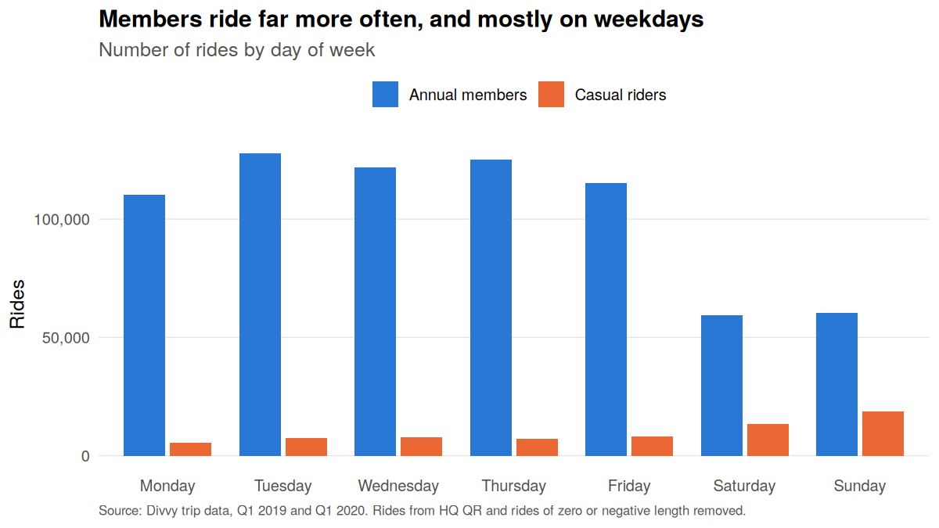
Figure 1. Rides by day of week.

Casual riders take longer rides every day of the week
The median casual ride was 23.2 minutes against 8.5 for members, and the gap holds on every day of the week. Casual riders took 8.6% of rides but accounted for 38.9% of all ride time.
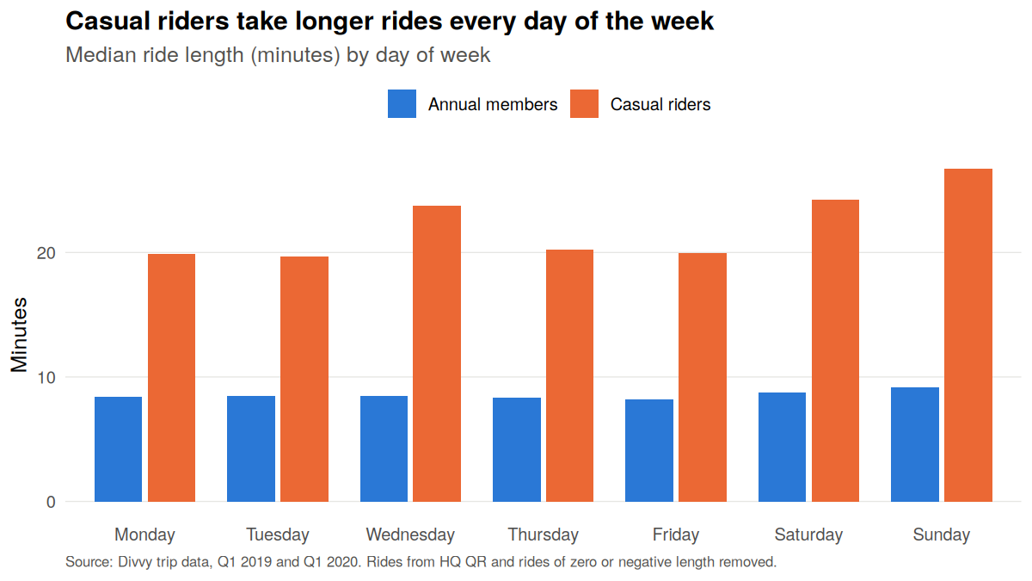
Figure 2. Median ride length by day of week.

Member weekday rides follow the commute
On weekdays, member rides peak sharply at 8 AM and 5 PM. Casual weekday rides build through the afternoon and peak at 5 PM, with no morning peak. This pattern is consistent with members commuting and casual riders riding for leisure.
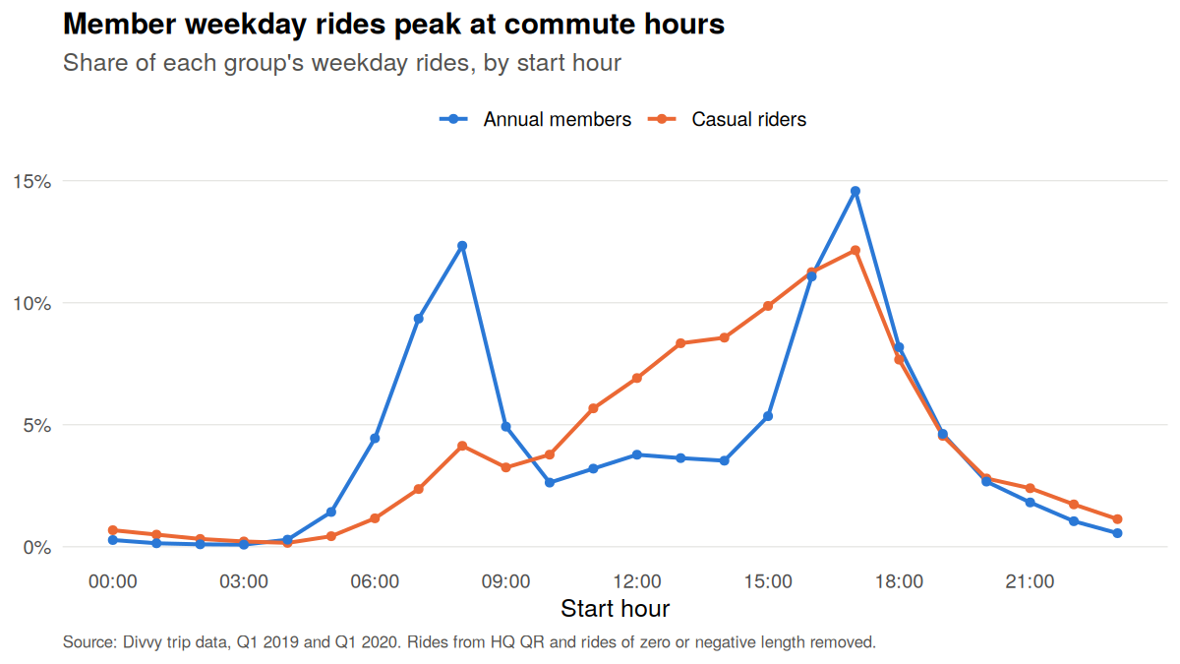
Figure 3. Share of each group's weekday rides by start hour.

Casual riders start at the lakefront and attractions
The top casual start stations are lakefront and attraction sites, led by Streeter Dr & Grand Ave (2,749 rides), Lake Shore Dr & Monroe St and Shedd Aquarium.
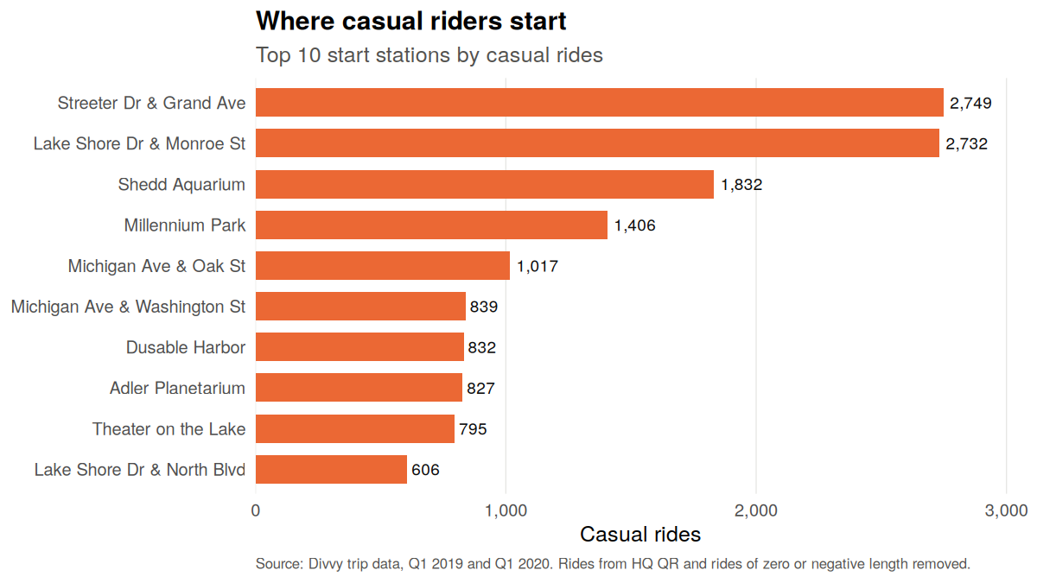
Figure 4. Top 10 start stations by casual rides.

5. Recommendations
- Lead with leisure, not commuting. Casual riders ride on weekends and take long rides, so pitch membership around weekend and longer leisure rides rather than commuting.
- Market where casual riders start. Place membership offers on dock screens and in the app at the top 10 casual start stations.
- Time the campaign to the season when casual riding is high. Casual rides rose from 23,163 in Q1 2019 to 44,714 in Q1 2020, but Q1 is winter. Confirm the seasonal peak with full-year data before scheduling spend.

6. Limits
- Two winter quarters only. Summer usage may differ and is not covered.
- No rider IDs, so repeat casual riders cannot be identified or counted.
- No pricing data, so the cost savings of membership cannot be quantified here.

7. Reproducibility
Every number and chart in this report is produced by analysis/cyclistic_analysis.R (R, dplyr, ggplot2). The script downloads the two Divvy files if they are missing and writes all tables to outputs/ and all charts to outputs/charts/.

