Arguments de fonction

- Positional and keyword arguments

> We can use positional function arguments :

def print_vars(a, b, c):
print(a, b, c)

print_vars(1, 2, 3)
This will print :
1 2 3

> We can use keyword arguments :

def print_vars(a, b, c):
print(a, b, c)

print_vars(c=1, a=2, b=3)
This will print :
2 3 1

> We can use both :

def print_vars(a, b, c):
print(a, b, c)

print_vars(1, c=2, b=3)
This will print :
1 3 2

Careful though, we can't use a positional argument after a keyword argument.

> We can also give default values to keyword arguments :

def print_vars(a, b, c, d=4):
print(a, b, c, d)

print_vars(1, c=2, b=3)
This will print :
1 3 2 4

Careful, default value arguments should be at the end of the argument list.

- Variable length arguments lists

> We can also have variable length argument lists. For that, we can use the following syntax :
- *[name] (most of the time, *args) : any number of positional arguments.
- **[name] (most of the time, **kwargs) : any number of keyword arguments.

The *args representing any number of positional arguments will store every positional argument it receives in a tuple.

The *kwargs representing any number of keyword arguments will store every keyword argument it receives in a dictionary.

def foo(a, b, *args, **kwargs):
print(a, b)
for arg in args:
print(arg)
for key,value in kwargs.items():
print(f"{key}:{value}")

foo(1, 2, 42, 44, hello="bla", hey="bluh")

> The following syntax forces the arguments after the * (so c and d) to be keyword arguments (they can't be positional or it will raise an error) :

def foo(a, b, *, c, d:
print(a, b, c, d)

- Unpacking iterables as function arguments

> We can unpack an iterable like a list or a tuple into function arguments pretty easily :

def foo(a, b, c):
print(a, b, c)

my_list = [1, 2, 3]
foo(*my_list)
This will print :
1 2 3

> Also works for dicts :

def foo(a, b, c):
print(a, b, c)

my_dict = {'a': 1, 'b': 2, 'c': 3}
foo(**my_dict)

- Global versus local variables

> You may access the value of a global variable from inside a function :

def foo():
x = number
print(f"[*] {x}")

number = 42
foo()
This will print :
[*] 42

> But, be careful when we want to change the value of a global variable from inside a function. To do that, we must first declare the variable with the global keyword :

def foo():
global number
number = 4444

number = 42
foo()
print(number)
This will print :
4444

If we don't use the global keyword, this won't work because this would have created a new local variable called number :
"Within a Python scope, any assignment to a variable not already declared within that scope creates a new local variable unless that variable is declared earlier in the function as referring to a globally scoped variable with the keyword global".

- Parameter passing (reference, or value ?)

Python’s argument passing model is neither “Pass by Value” nor “Pass by Reference” but it is “Pass by Object Reference”.

Consider a list :
a = ["X", "Y"]

Here “a” is a variable that points to a list containing the element “X” and “Y”. But “a” itself is not the list. Consider “a” to be a bucket that contains the object “X” and “Y” (or a pointer that points to the memory space containing the actual list) :

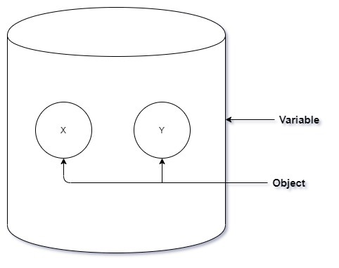

> Pass by reference configuration

In a pass by reference configuration, the variable (the bucket / pointer) is passed into the function directly. Any operation performed by the function on :
> the variable (pointer) or
> the object it points to,

Will be directly reflected on the pointer or the object it points to.

Here the pointer is modified in the function and points to a different object in memory (["A"]) ; this is reflected in the caller :
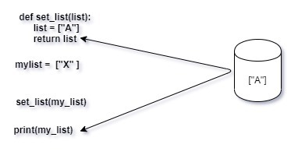
This would print ["A"] in a pass by reference language.

Here, the content pointed by the variable / pointer is modified, this is reflected in the caller as well :

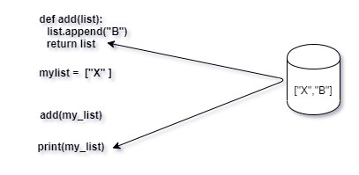
> Pass by value configuration

In pass by value the function is provided with a copy of the argument object passed to it by the caller. That means the original object stays intact and all changes made are to a copy of the same and stored at different memory locations.

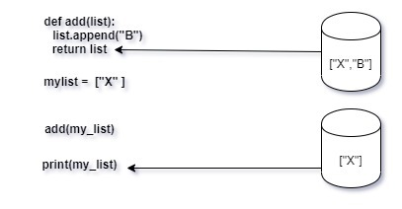
This would print ["X"] in a pass by value language.

> Pass by object reference (Python)

As python is different in this context, the functions in python receive a copy of the original variable that points to the same object as the caller. Maybe this will make more sense : in python, a function's argument is a copy of the pointer that refers to the original object :

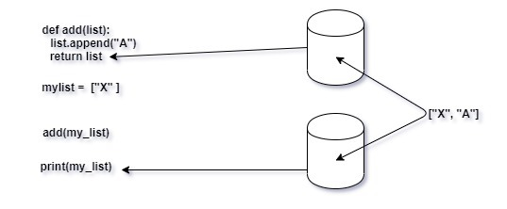

The difference with a pass by value configuration is that I can use the variable transmitted as function argument to modify the original object, because I have a pointer to that original object :

def foo(arg_list):
arg_list[0] = "Z"
return arg_list

my_list = ["C", "D"]
foo(my_list)
print(my_list)
This will print :
["Z", "D"]

The difference with a pass by reference configuration is that any change made to the function argument itself (the pointer) will not be applied to the original variable (pointer), since my function argument is nothing more than a copy of the original pointer, not the original pointer itself :

def foo(arg_list):
arg_list = ["Z"]
return arg_list

my_list = ["C", "D"]
foo(my_list)
print(my_list)
This will print :
["C", "D"]

Here, we modified the copy of the pointer and made it point to a different object in memory (a list containing ["Z"]), but the original pointer still points to ["C", "D"].

