Breakout Clone Coursework
https://github.com/Cromby5/Breakout-Coursework
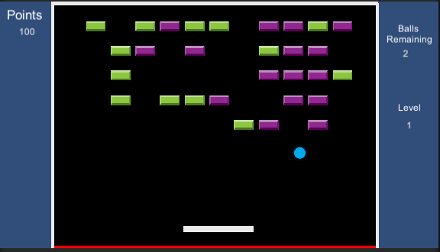

Ben Reid S2026838
BSc/BSc (Hons) Computer Games (Software Development)

I confirm that the code contained in this file (other than that provided or authorized) is all my own work and has not been submitted elsewhere in fulfilment of this or any other award.

Signature
Ben Reid

Table of Contents
1: The Challenge 3
2: The Code 3
3: The Explanation 4
4: The Issues 4

1: The Challenge
The part of code I consider to be the most challenging to implement for me was the question of how was I going to get the blocks to spawn in rows and columns automatically. I wanted to do this as it was more interesting to have code place in the rest of my blocks instead of duplicating the block for 4 rows manually and creating different scenes for levels. As a base I tried starting to adapt the BallSpawner code given in the labs. Another reason why I wanted this is I wanted to make the levels endless and random so it should be a different amount of blocks each time so some levels may be more precision based than the last one. My first challenge was figuring out how to make each block be at a different x and y point on this grid of blocks I wanted which led me down looking at various things and possible ways to do this such as vector2 and transform.position.

2: The Code
Below is the code used to spawn each block as seen in BlockSpawner.cs.
void SpawnBlock(Block templateToCopy)
{

//Give blocks a postion in the grid by giving them a x and y value e.g. (1,2) (1,3) (3,1) until no more rows and columns are left
for (int x = 0; x < columns; x++)
{
for(int y = 0; y < rows; y++)
{
//Gets Random Number
r = Random.Range(2, 4);
//If it is 3 skip this block from spawning in
if (r == 3)
{
print("skipped");
print(x);
print(y);
}
else
{
//Making a Block with the current x and y values but x is -5
// cause 0,0 is the camera location and so the left side of the play area isnt left out
Block blockClone = Instantiate(templateToCopy, new Vector2(x - 5, y), Quaternion.identity);
//Enables the block object
blockClone.gameObject.SetActive(true);
//Add the block to the list
blockList.Add(blockClone);
}

}
}

3: The Explanation
As you can see it has 2 for loops with one inside the other where it goes through the x values till it hits the value of columns (default is 4) so it would go x = 0 and go to the y loop where the amount of rows are set to 4 and give me each point as follows as it goes through y 0,1,2,3,4. (0,0), (0,1), (0,2),(0,3),(0,4). This uses the x and y of the points when the block is Instantiated to put it at these positions.
However the next issue was because the camera was at (0,0) my blocks started spawning in the middle. To solve this I took 5 away from x every time so it went all the way from left to right if all possible blocks 5 rows and 11 columns were to spawn. Keeping the blocks in a list allowed me to keep track and make sure all blocks were correctly at different positions by checking in unity inspector.
The if statement is for taking out blocks at random to create patterns so if r = 3 the block will be skipped else the block will be spawned. If you want to see this is action rapidly just hold down back space as that is the restart button and you can see what I mean by the variations it creates.

4: The Issues
I wasn’t sure spawning blocks like this would work well so the first issue I came across is getting different x and y values and setting them to the vector. I thought about setting the amount of blocks and spawning in that number but found it hard to decide how to get the x and y for them if I wasn’t going for a grid like structure so I thought to try and spawn in all the blocks and offset them by a set amount from the last block spawned by comparing the x and y values to the last block spawned in a way similar to how the block compares its position to the ball when it is hit to determine what side it is on. However I found that the way I done it the blocks were inside each other most of the time so I came back later and just did the for loops going through the rows and columns where as just before that I multiplied them together to get total blocks and tried to offset them based on position.
At first when creating the new vector2 with the points Quaternion.identity was not included which gave me errors. After looking around it turns out I had to put in an identity rotation. As described here https://docs.unity3d.com/ScriptReference/Quaternion-identity.html
“This quaternion corresponds to "no rotation" - the object is perfectly aligned with the world or parent axes.”
Which is useful and exactly what I was looking for as I don’t actually want to rotate the block to weird angles in this simple breakout clone and putting this after the values works and allows me to set the x and y values as I wanted.
I noticed as you play the stages with less blocks are on the left side rather than the right due to how this is written as it goes left to right. To make it less boring and more unique I got it to spawn all these blocks however some would be skipped to create differing patterns every time in the grid.

