Analysing The Weights Of Chicks – Report

**Q1** Plot the weights of each chick at each time for Diet 1 in the same figure.

Use different colours or different symbols for each chick.

*CODE:*

attach(ChickWeight)

plot.new()

plot.window(xlim=c(0,22), ylim = c(0,350))

axis(1)

axis(2)

plot(Time, weight, col=Chick)

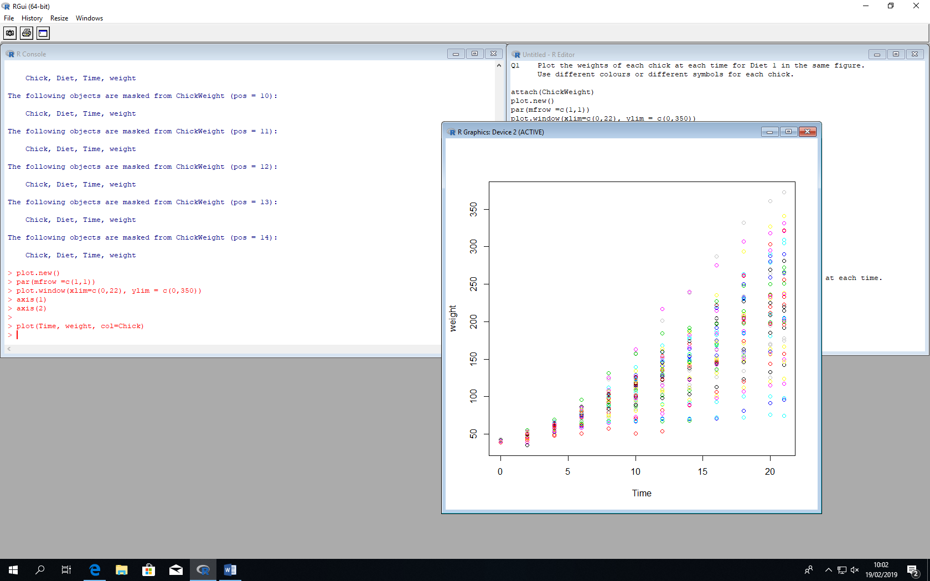

**Q2** Use the ~ operator to create boxplots of the weights at each time for Diet 1 in the same figure

*CODE:*

attach(ChickWeight)

plot.new()

par(mfrow=c(3,7))

for (i in c(1:21))

{

boxplot(weight, Time~i)

}

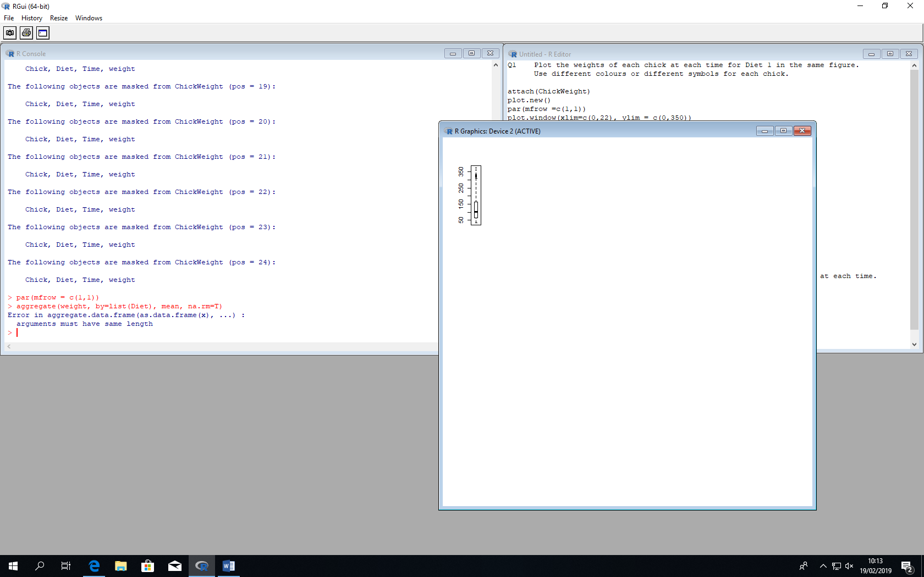

**Q3** Use the aggregate function to find the mean weight for each diet at each time.

Include this table in your report

*CODE:*

attach(ChickWeight)

par(mfrow = c(1,1))

aggregate(weight, by=list(Diet), mean)

**Q4** Plot the mean weight for each diet at each time on the same

figure with different colours for each diet.

*CODE:*

attach(ChickWeight)

plot.new()

par(mfrow =c(1,1))

plot.window(xlim=c(0,22), ylim = c(0,350))

axis(1)

axis(2)

plot(Time, mean(weight))

**Q5** Use the ~ operator to create boxplots of each diet at Time = 20 in the same figure

*CODE:*

attach(ChickWeight)

plot.new()

par(mfrow=c(2,2))

for (i in c(1:5))

{

boxplot(weight, Time=20, Diet~i)

}