Trend in MNIST Data – Report

I wanted to start with just the 0’s and 1’s to try to spot a trend from just these points.

I plotted these points on a colourless static plot from the point of view of just the x and y axis. I did this as I didn’t want to get any biases and wanted to try sport trends from just exploration.

I then decided to identify 25 points from different areas of the graph and to plot these images in a 5x5 display.

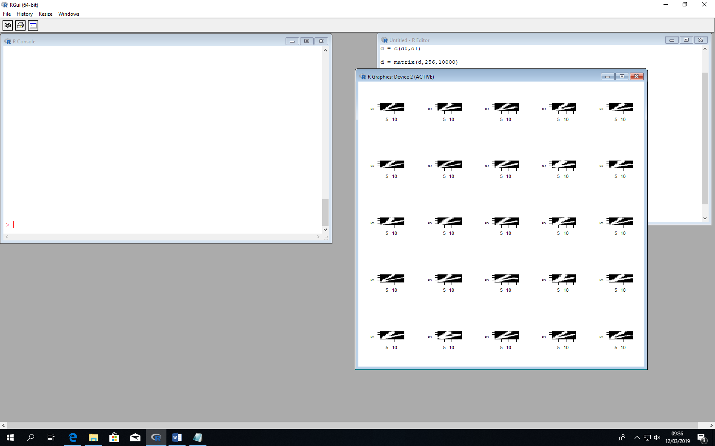

Identify 25 points from the bottom of the static plot of 0’s and 1’s.

These images start from the middle of the top of the image and draw a line towards the bottom left and then when they are near the bottom left, they draw a line towards the middle of the right.

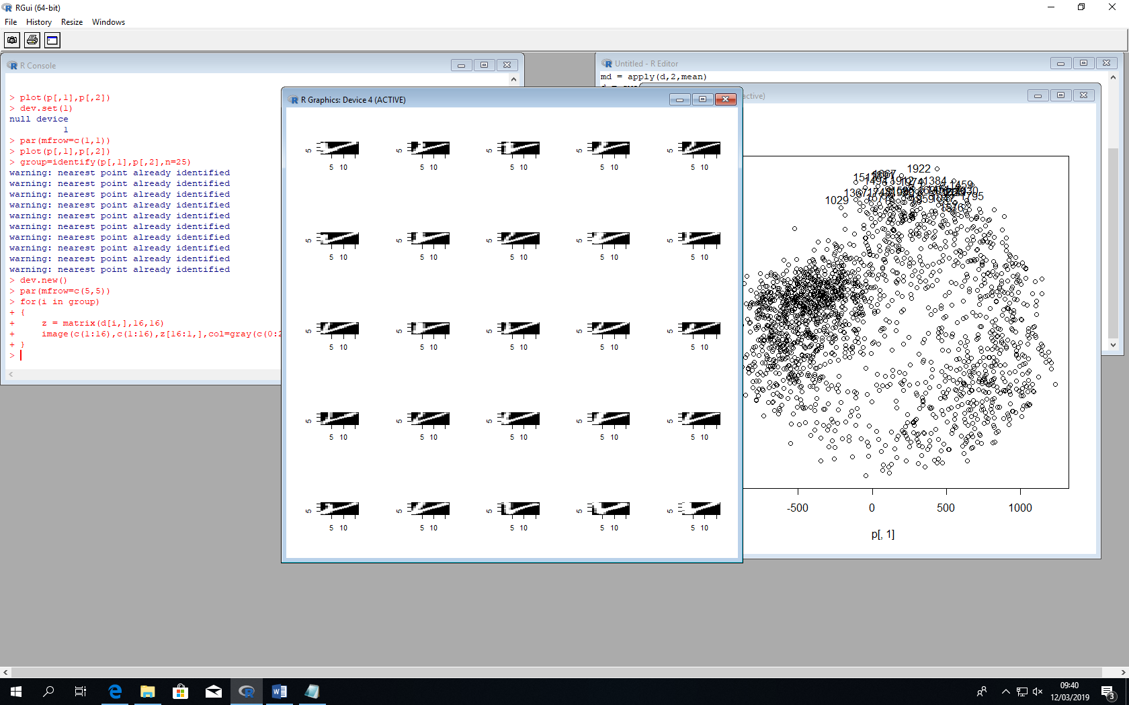

Identify 25 points from the top of the static plot of 0’s and 1’s.

These images seem to start from the top left and stay close to the LHS of the image and go straight down until they go near the bottom right and then they do a straight diagonal line towards the top right.

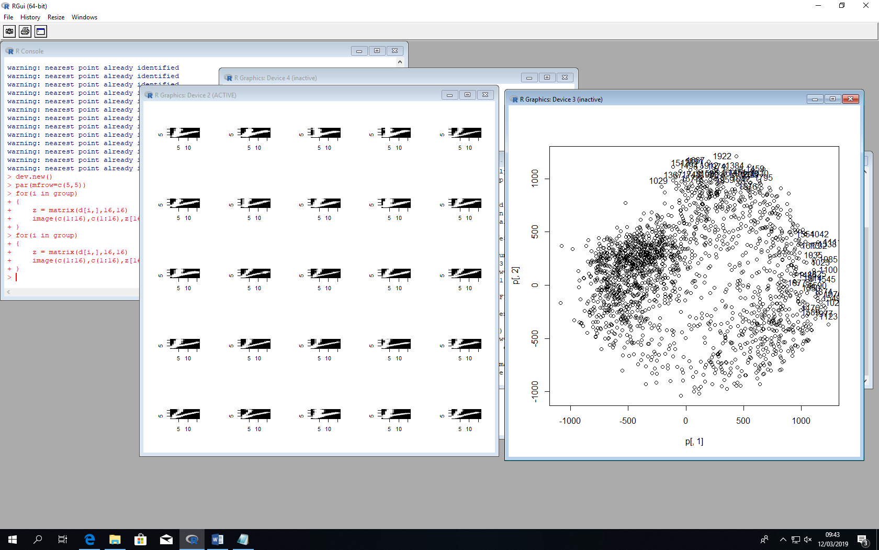

Identify 25 points from the right of the static plot 0’s and 1’s.

These images start somewhere between the 2 above sets of images, they all draw a line towards the bottom left and then towards the middle right of the image.

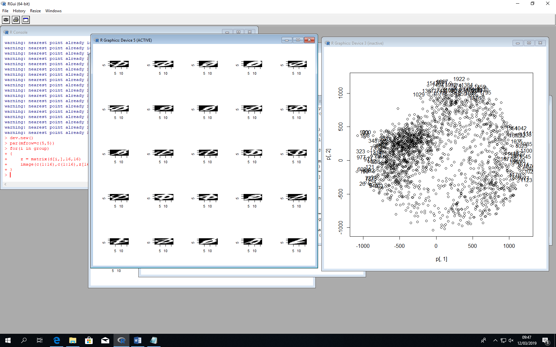

Identify 25 points from the left of the static plot of 0’s and 1’s.

These are different to the previous sets as they involve a circle as well as the diagonal line.

One 1 was still picked up on this side of the plot. This one was different to the other 1’s in the other plots as it starts in the top right and then goes towards the bottom left so its starting point is different.

Similar to the zero’s this 1’s diagonal starts in the top right.

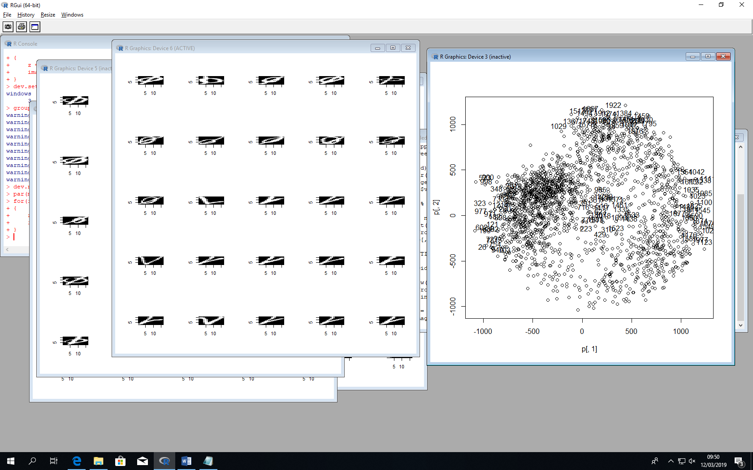Identify 25 points from the middle of the static plot of 0‘s and 1’s.

It seems from my plot as though the zeros are congregated on the left while the ones are spread from the bottom, around the right and up to the top depending on their shape.



My guess of the breakdown of the 0’s and 1’s from the trend I spotted.

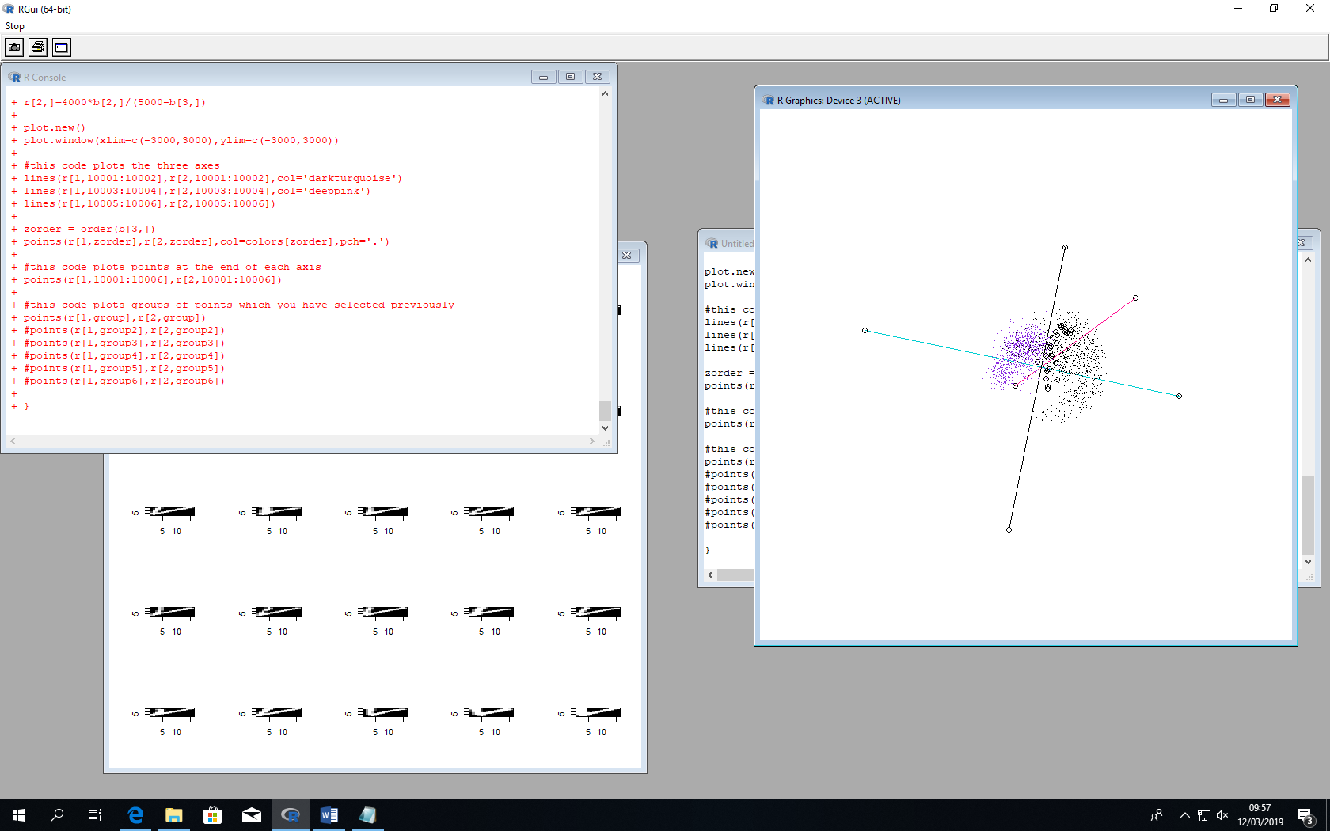

The actual breakdown.

This thought was backed up when I plotted the points with different colours in 3D.

1 and 0 are very different numbers with one being 2 straight lines and the other being a circle with a straight line through it so it makes sense that they are segregated like this.

The 0’s seem to be all within one quadrant of the axis’ while the ones are more diverse.

The 0’s seem to be all quite similar while the ones tend to differ a good bit as seen by their diversity on the plot.

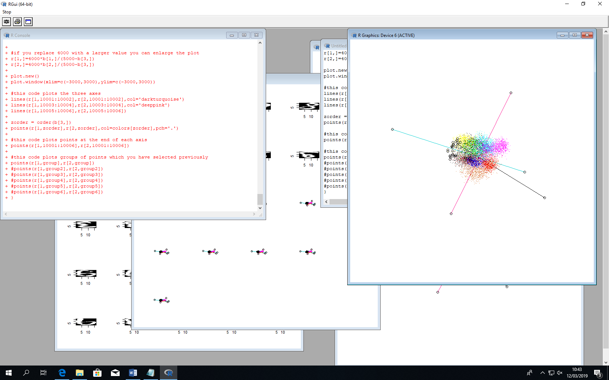

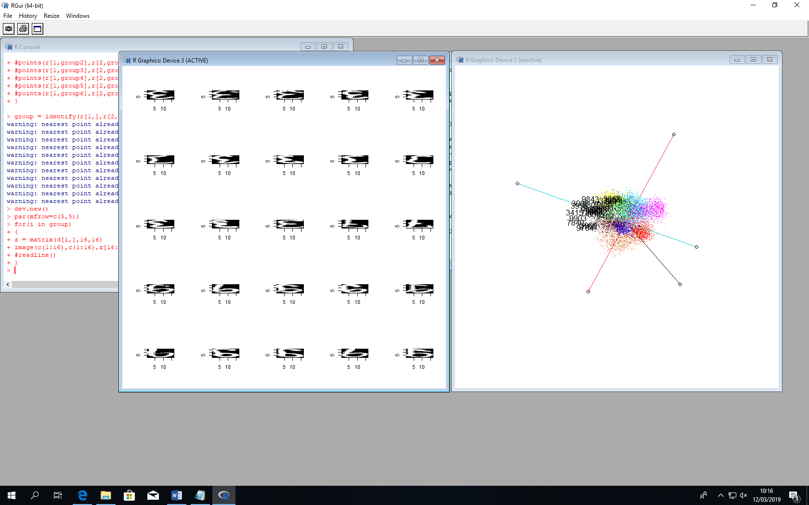

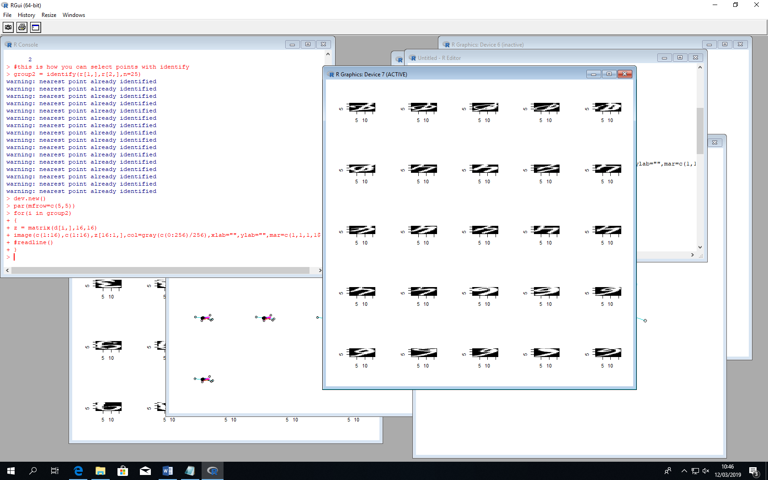

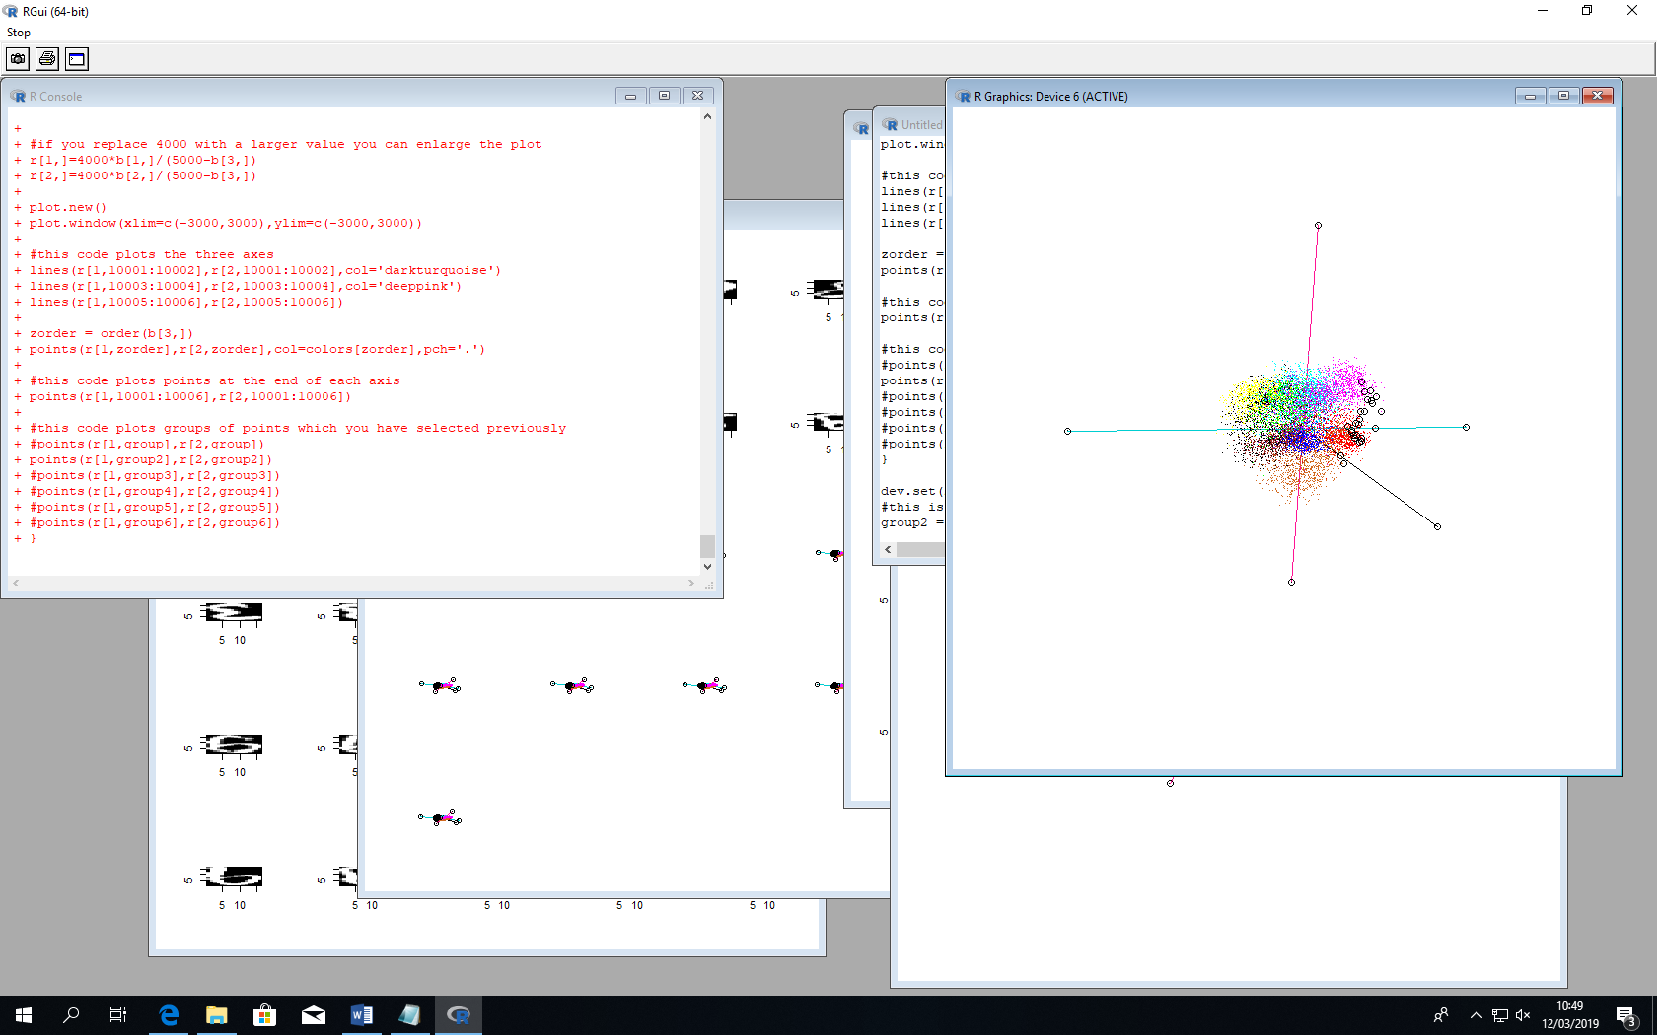

On the RHS of the blue axis, the white pixels in the image seem to be more concentrated at the top with a line from the bottom/middle right to the left/middle bottom.

On the LHS of the blue axis, there seems to be a more circular part at the bottom and a loop part at the top going from left to right.

These look like the opposite of each other with the LHS having a sort of loop on the bottom and line on the top and the RHS having a sort of loop at the top and a line at the bottom.

Along with this, the pixels in the images of the RHS seem to be very concentrated on the RHS of the image and the LHS’s pixels seem to concentrate on the LHS.

I think the trend here is where the concentration of pixels is and also where the loopy part is.

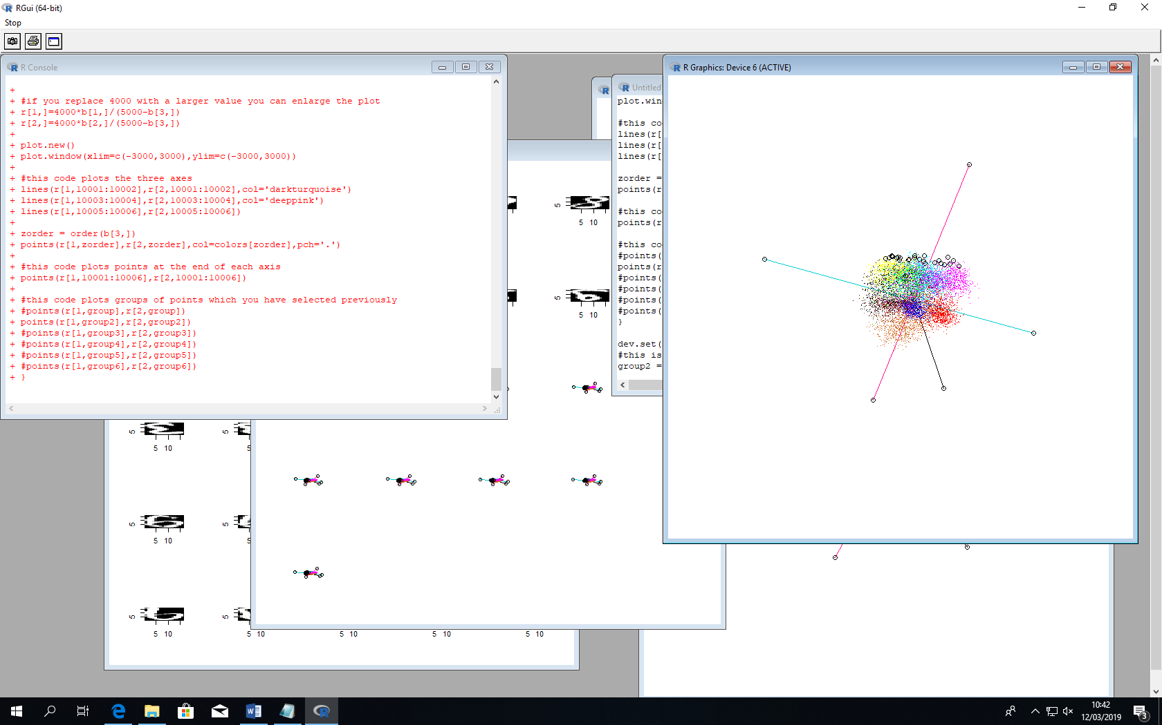

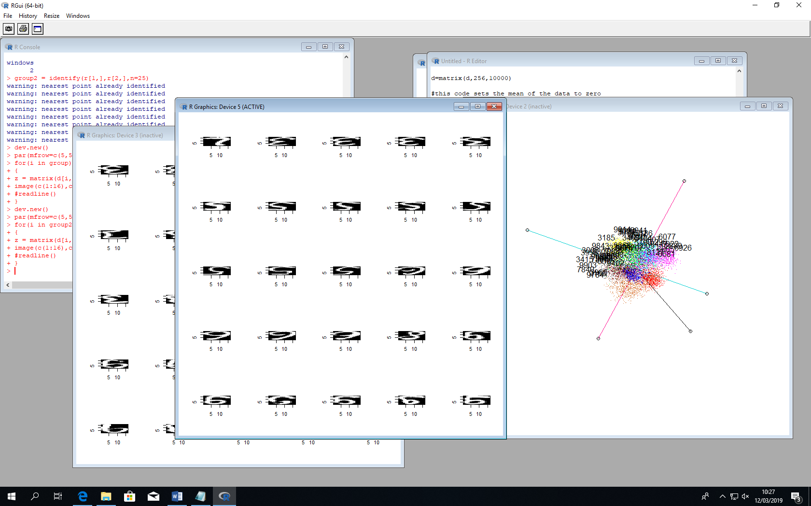

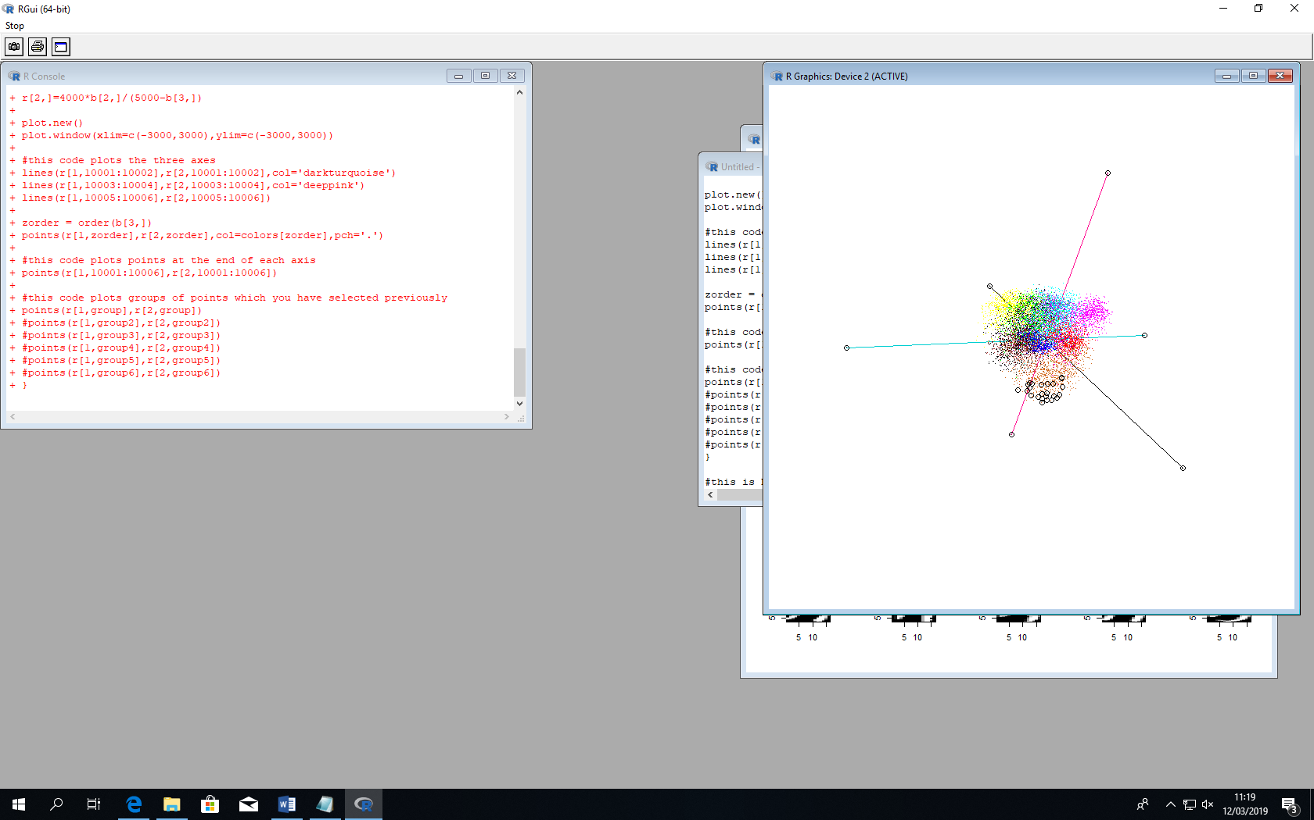

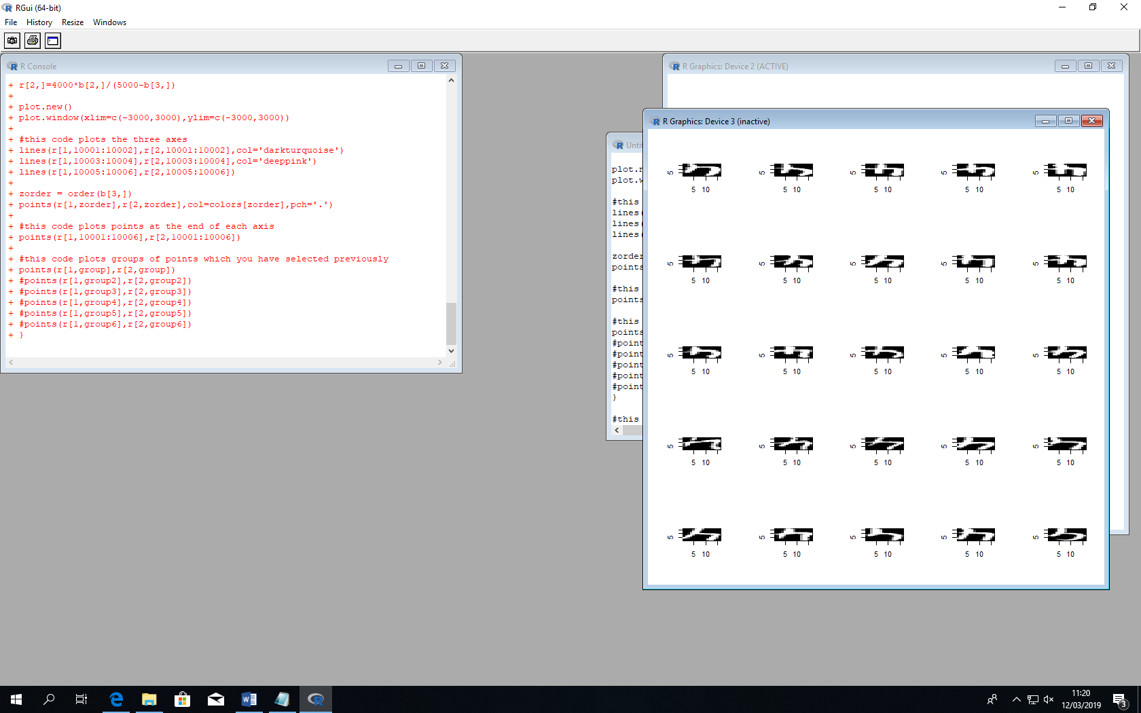

The bottom of the pink axis is all just the number 4. This number is dominant over this area of the plot which shows that it is very distinct which it is.

A 4 is made up of 3 straight lines which is unusual among numbers.

As we can see from the images of the top of this pink axis, these images are very curved. This are is also very diverse with numbers such as 2,3,5,6,8 and 9.

I think the trend here is curvature.

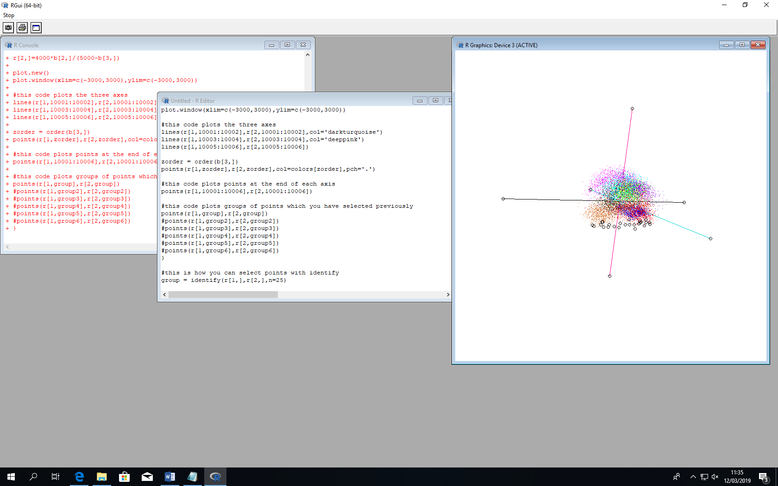

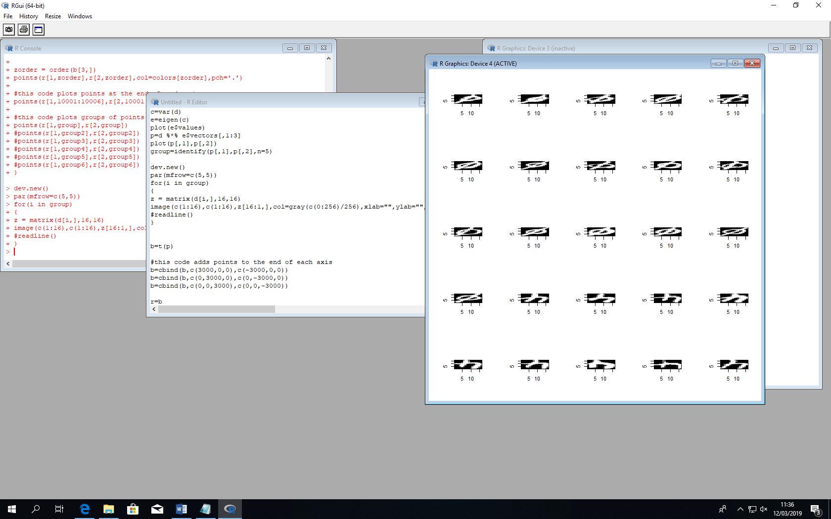

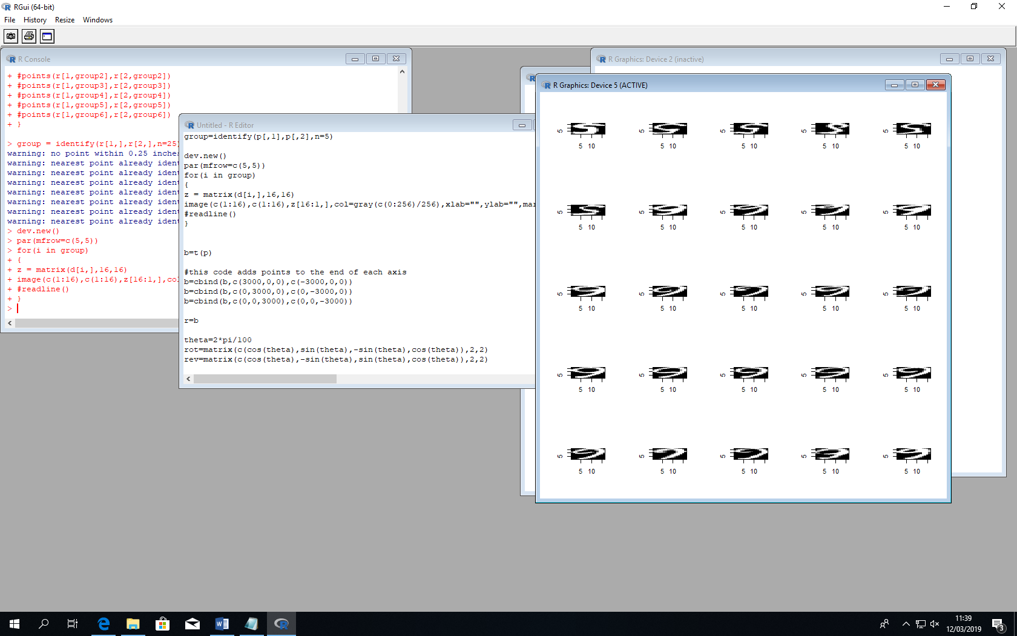

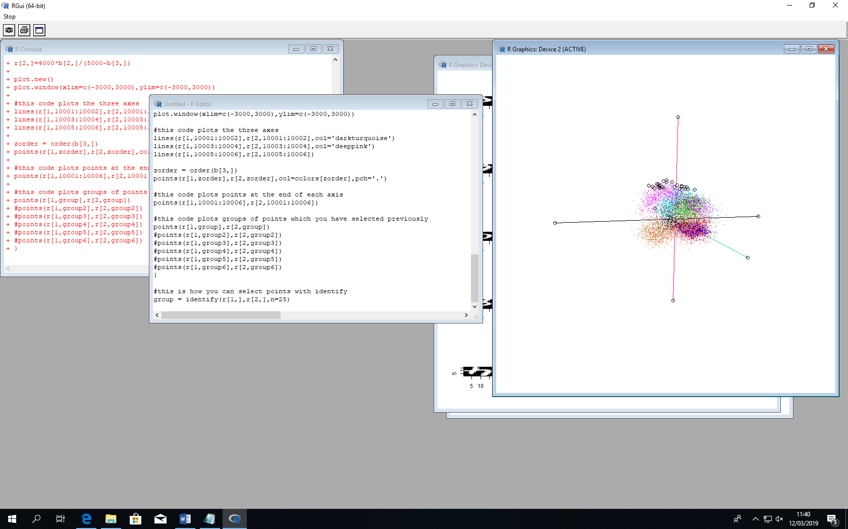

The points at the top of the black axis seem to have a distinctive loop at the top of the image. This loop goes from the top right to the top left and then around back to the middle right of the image.

In the images of the points at the bottom of the black line, there seems to be a straight line going from the top of the image to the bottom of the image. This is also coupled with a loop in the bottom to middle right of the image. Suh as on the 4’s and then the 0’s have this loop too.

I think the trend here is that the top has a loop at the top of the image and the bottom has a loop on the bottom-right of the image.

***SUMMARY:***

Overall the trends seem to be there the loops in the images are, where the concentration of the pixels is and whether there is curvature or not and where this curvature is.

The position of the pixels in the image looks like it is the main indicator of the position of the point.