**Aryan School of Engineering**

**Department of Information and Technology**

AFFILIATED TO: PURBANCHAL UNIVERSITY



**Minor Project Report on:**

**COLLEGE APP**

**[Code No: BIT279CO]**

**By**

**Anup Karki- Symbol No: 363412**

**Jit Bdr Rana- Symbol No: 363415**

**Pratik Shrestha- Symbol No: 363418**

**Seazone Joshi- Symbol No: 363420**

**Kathmandu, Nepal**

**2021**

**Aryan School of Engineering**

**Department of Information and Technology**

AFFILIATED TO: PURBANCHAL UNIVERSITY

**COLLEGE APP**

**[Code No: BIT379CO]**

**PROJECT REPORT SUBMITTED TO THE DEPARTMENT OF INFORMATION TECHNOLOGY IN PARTIAL FULFILLMENT OF THE REQUIREMENTS FOR THE BACHELOR OF INFORMATION TECHNOLOGY**



**By**

**Anup Karki- Symbol No: 363412**

**Jit Bdr Rana- Symbol No: 363415**

**Pratik Shrestha- Symbol No: 363418**

**Seazone Joshi- Symbol No: 363420**

**Kathmandu, Nepal**

**Sep 2021**

**PURBANCHAL UNIVERSITY**

**Aryan school of Engineering**

**Department of Information and Technology**

**Aryan College of Engineering**

**Department of Information Technology**

**Affiliated To: Purbanchal University**

**CERTIFICATE**

The undersigned certify that they have read and recommended to the Department of Information Technology, a minor project work entitled "COLLEGE APP" submitted by Anup Karki (363412) Jit Bdr Rana (363415) Pratik Shrestha (363418) and Seazone Joshi (363420) in partial fulfillment of the requirements for the degree of Bachelor of IT.

(Head of Department)

Department of Electronics and

Computer Engineering.

Aryan School of Engineering

(Project Coordinate)

Department of Electronics and

Computer Engineering.

Aryan School of Engineering

**ACKNOWLEDGEMENT**

We would like to extend our heartiest thanks with a deep sense of gratitude and respect to all those who provides me immense help and guidance during my training period. We have been greatly benefited from their regular critical reviews and inspiration throughout my work.

We would also like to thank my project supervisor **Mr.Ujwal Prajapati** for his unfailing cooperation and sparing his valuable time to assist us in our work for preparing proposal of the project.

We would like to express our sincere thanks to our Head of Department **Er. Nisha Karki** andour internal guide **Mr. Ujwal Prajapati,** who gave us an opportunity to undertake such a great challenging and innovative work. We are grateful to them for their guidance, encouragement, understanding and insightful support in the development process.

Last but not the least we would like to mention here that we greatly indebted to each and everybody who has been associated with our project at any stage but whose name does not find a place in this acknowledgement.

**ABSTRACT**

This project is mainly concerned with the Information Management System named ‘COLLEGE APP’ built to streamline college administration. The goal of this web app is to provide the information regarding college activities which includes Student registration, Result, Calendar and Events, Fee, News and Announcement .Students can see check their result and notice online. The data collected will be analyzed using MySQL. The main aim is to provide student access the website online enabling them to view their respective result and notices. Login page will be provided to Teacher and Admin. Teacher will be provided with a particular role to access the admin interface and perform their task. Administrator can add, edit, update, delete the records of student and manage every modules in the system but teacher can only access the models that has granted in the role. This system is designed to aid the day to day college administration.

**List of Figure**

Figure 2:FLOW CHART 18

Figure 3:CONTEXT DIAGRAM 19

Figure 4:DFD LEVEL 1 19

Figure 5:ER DIAGRAG 21

Figure 6:CLASS DIAGRAM 22

Figure 7:STATE DIAGRAM 23

Figure 9:GANTT CHART 25

**TABLE OF CONTENT**

CHAPTER 1: INTRODUCTION 1

4.1 BACKGROUND 2

4.2 PROBLEM OF STATEMENT 4

4.3 SCOPE 5

4.4 PROJECT FEATURES 6

4.5 OBJECTIVE 7

4.6 SYSTEM REQUIREMENT 8

1.6.1 Software Requirement (while developing) 8

1.6.2 Hardware Requirement (while developing) 8

4.7 System Design Overview 9

CHAPTER 2:LITERATURE REVIEW 11

2.1 BACKGROUND 12

CHAPTER 3:METHODOLOGY 15

3.1 FEASIBILITY STUDY 16

3.1.1 Operational Feasibility 16

3.1.2 Technical Feasibility 16

3.1.3 Economical Feasibility 17

3.2 BEHAVIOUR MODELING 18

3.2.1 FLOW CHART 18

3.2.2 DATA FLOW DIAGRAM 19

3.2.3 ER DIAGRAM 20

3.2.4 USE CASE DIAGRAM 22

3.2.5 STATE DIAGRAM 23

CHAPTER 4:SYSTEM TESTING 24

4.1 GANTT CHART 25

CHAPTER 5:OUTPUT 26

5.1 SCREEN SHOTS 27

5.1.1 FRONT END 27

5.1.2 BACKEND OUTPUT 29

CHAPTER 6:CONCLUSION 30

6.1 CONCLUSION 31

REFRENCE 32

# 

# CHAPTER 1: INTRODUCTION

## BACKGROUND

**“COLLEGE APP”** is online web app which is helpful for students and their parents as well as the college authorities. In the current time all the activities are done manually in college. It is very time consuming and costly. Our system deals with the various activities related to the college administration. Administration can manage various activities related to the students and other various activities. They can manage symbol number, marks and subject according to the semester and program. Teachers can also take benefit from this application by putting notice for students associated with their subject and semester. By using this application teachers can easily publish internal exam marks of the student by just putting the marks of each student into the system according to the subject and it will easily show that marks to the page.

This **“COLLEGE APP”** is mainly focus on the students, parents and teachers. Students who is already in the college wanted to see their internal exam results, notice and also to watch their assignment . Teacher who want to publish notice for the particular faculties and don’t have time to go college or don’t have time to visit each room to publish notice they can easily publish that notice in this application and all the student can easily read that notice.

In this application there is the dashboard which shows the overall view of the application like number of student, total number of results that have published, number of notice published, courses, faculties, program and number of teachers. There is also Student icon which shows the detail of the each student. In Program & faculties it shows the total faculties and how many faculties are there in this college. In the courses it shows different name of the courses according to the admission year, semester and faculties. In a teachers panel it will show the detail of each teacher according to the subject that they teach. In an assignment panel it will show all the assignment that are given by the teachers and finally marks & notice panel , in marks panel student can see there each subject marks according to the symbol number ,faculties, year. And in notice panel it show all the notice published by the teachers.

We as a developer or admin of this web application we will provide a access id & password for each person for example, for teacher we have provided a id and password which is just associated with that teacher and by login with that teacher id they can only access those panel which has assign for the teacher like publishing notice or publishing an internal exam marks. Similarly for the student they can only see result, notice board, different courses of the college and their associated fee structure like how much remaining payment that they have to pay to the college. Each person have their own role according to their id.

In This application there is super Admin who can do everything in this application. Super admin can add student information, he can add courses detail, teacher detail, what courses are there in the college, how much fees are remaining to pay for each student, and he can even add an assignment for the student if he want to. Super admin can also delete data of the student, teacher and college information. He can also publish a notice. Super admin can do whatever this application can do. The main purpose of the super admin module is to introduce new things and configure important aspects. For e.g. only super admin is authorized to edit and delete the data of the teachers and students so the master screens for all these are visible to only super admin role. This is done by the super admin module. So the main purpose of the super admin is to managing the dynamic working of the system.

## PROBLEM OF STATEMENT

Traditional college management process is inefficient as all the records are stored in paper. In the long it becomes quite expensive and difficult to manage. Not only the records takes allot of physical space but also they are highly prone to environmental damages. Retrieving particular record can take allot of time since we have to physically dig up the files. Student have to physically visit the account section to get information about their fee status. To get any notice and news student have to pay a visit to notice boards. The COLLEGE-APP eliminate the tradition college management system and streamlines the process.

## SCOPE

The main scope of this web app are:

* Student can see their exam results.
* Teachers can publish notice according to the subject and semester.
* College Administration can manage Student marks and Symbol Number.
* Digital notice board.
* College Administration can manage subject, course and program.

## PROJECT FEATURES

The projected feature are:

**Admin Control Structure**

* Add Co-Admin / Moderator
* News, Schedules
* Add Student & teachers
* Result Management
* View , Edit , Delete Students details
* Fees Structure and Fees Management
* Publish Notice, gallery management
* Login/Logout

**Moderator Control Structure**

* Login
* View all students Record added by admin
* View notice
* Attendances and Notices
* Logout

## OBJECTIVE

Objective of the website:

* To provide a digital platform to manage students ,their results, fees, noticeboard, academic calendar etc.

## SYSTEM REQUIREMENT

The system will developed using HTML, CSS, Bootstrap, JavaScript as front end user interface, MySQL as back end database server, **Spring Boot** **Framework**, **JSP and Servlet** to connect the client pages with the database server. Java Script Language for the validation of front end data. Dynamic Systems Development Method is used to develop the whole **COLLEGE APP**. Flowchart, ER Diagram, Use Case Diagram, Data Flow diagrams is used to Analyze and Design of the system. So we need to have following Technology and Tools required for complete the entire project:

### Software Requirement (while developing)

* Windows 10 or Linux
* Programming languages: Html, CSS, JavaScript, Java
* Framework: SpringBoot
* Text editor: Intelij idea, Eclipes

### Hardware Requirement (while developing)

The following is a list of computer hardware specifications that are suggested by the developer as the minimum requirements for a computer to efficiently run the system.

* Processor: Pentium IV or higher
* Memory: 2 GB minimum
* Hard drive: 40 GB free space

## System Design Overview

In an existing system, there is a lot of paperwork and manual processing. While writing a paper record the administration needs to keep the records carefully as the entire information is composed of those books. Everything is paper-based consequently it is very time-consuming. In excess of one person can’t get to the information at the same time.

“Online College Management System (COLLEGE APP) is used to manage all the activity related to College and their Students”. COLLEGE APP is an environment where all the process of the student in the institution is managed well structural formed. It is done through the automated computerized method. This system saves the time of the student and of the administrator. It includes process like registration of the student’s details, results, schedules, attendance and assigning the department based on their course and maintenance of the record and also important notices and announcement for the student. This system reduces the cost and workforce required for this job. As the system is online the information is globally present to everyone. This makes the system easy to handle and feasible for finding the omission with updating at the same time. We will implement following structure for designing our system.

**Admin Control Structure**

* Add Co-Admin / Moderator
* News, Schedules, Assignments
* Add Student & teachers
* Result Management
* View , Edit , Delete Students and Teachers Details
* Fees Structure and Fees Management
* Publish Notice & Assignment.
* Library Management
* Login/Logout

**Moderator Control Structure**

* Login
* View all students Record added by admin
* View notice and different assignments.
* Notices , Assignment Publish
* Logout

# CHAPTER 2:LITERATURE REVIEW

## BACKGROUND

A college (Latin: collegium) is an educational institution or a constituent part of one. A college may be a degree-awarding tertiary educational institution, a part of a collegiate or federal university, an institution offering vocational education, or a secondary school. In most of the world, a college may be a high school or secondary school, a college of further education, a training institution that awards trade qualifications, a higher-education provider that does not have university status (often without its own degree-awarding powers), or a constituent part of a university. In the United States, a college offers undergraduate programs; it may be independent or the undergraduate program of a university, it is generally also used as a synonym for a university[1]

A management information system (MIS) is an information system[2] used for decision-making, and for the coordination, control, analysis, and visualization of information in an organization The study of the management information systems involves people, processes and technology in an organizational context. In a corporate setting, the ultimate goal of the use of a management information system is to increase the value and profits of the business.[3] This is done by providing managers with timely and appropriate information allowing them to make effective decisions within a shorter period of time.[4] The terms management information system (MIS), Information management system (IMS), information system (IS), enterprise resource planning (ERP), computer science, electrical computer engineering, and information technology management (IT) are often confused. MIS is a hierarchical subset of information systems. MIS are more organization-focused narrowing in on leveraging information technology to increase business value. Computer science is more software-focused dealing with the applications that may be used in MIS.[5] Electrical computer engineering is product-focused mainly dealing with the architecture behind computer systems. ERP software is a subset of MIS and IT management refers to the technical management of an IT department which may include MIS. Principles of Management Information Systems.

The following are some of the benefits that can be attained using MIS:[6]

* Improve an organization's operational efficiency, add value to existing products, engender innovation and new product development, and help managers make better decisions.
* Companies are able to identify their strengths and weaknesses due to the presence of revenue reports, employee performance records etc. Identifying these aspects can help a company improve its business processes and operations.
* Giving an overall picture of the company.
* Acting as a communication and planning tool.
* The availability of customer data and feedback can help the company to align its business processes according to the needs of its customers. The effective management of customer data can help the company to perform direct marketing and promotion activities.
* MIS can help a company gain a competitive advantage.
* MIS reports can help with decision-making as well as reduce downtime for actionable items.

Some of the disadvantages of MIS systems:

* Retrieval and dissemination are dependent on technology hardware and software.
* Potential for inaccurate information.

Maven is a build automation tool used primarily for Java projects. Maven can also be used to build and manage projects written in C#, Ruby, Scala, and other languages. The Maven project is hosted by the Apache Software Foundation, where it was formerly part of the Jakarta Project. Maven addresses two aspects of building software: how software is built, and its dependencies. Unlike earlier tools like Apache Ant, it uses conventions for the build procedure. Only exceptions need to be specified. An XML file describes the software project being built, its dependencies on other external modules and components, the build order, directories, and required plug-ins. It comes with pre-defined targets for performing certain well-defined tasks such as compilation of code and its packaging. Maven dynamically downloads Java libraries and Maven plug-ins from one or more repositories such as the Maven 2 Central Repository, and stores them in a local cache.[7] This local cache of downloaded artifacts can also be updated with artifacts created by local projects. Public repositories can also be updated.[8]

# CHAPTER 3:METHODOLOGY

## FEASIBILITY STUDY

Early studies have been made on this, as it is a rising topic. Some research have been done before setting goals or objectives for the project and initializing the project. It has been known from the research that there had been earlier attempts for creating such products and there are some products that meets certain portion of the public and market demands. But from deep research we have come to know that there has not been any kind of complete product relating to this topic so we decided to have an attempt on creating more facilitated and complete product in comparison to the earlier products that already exist in the market.

Thus, after long term research and discussion among the group members we have decided to make a proposal for the project defining the researches and objectives we have set for the project.

There are three tests of Feasibility Study:-

* Operational
* Technical
* Economical /financial

### Operational Feasibility

This test of feasibility asks if the system will work when it is developed and installed. This feasibility observes the all operations like finding products, gathering information, getting supports & software & more.

### Technical Feasibility

This involves the technological consideration like available technology to run the purposed system. The system has been created with the most common technology available. Hence the system is technically feasible.

### Economical Feasibility

Cost of the system will be affordable for the user. As it is a simple product financial consideration was not a big deal for our project.

## BEHAVIOUR MODELING

### FLOW CHART

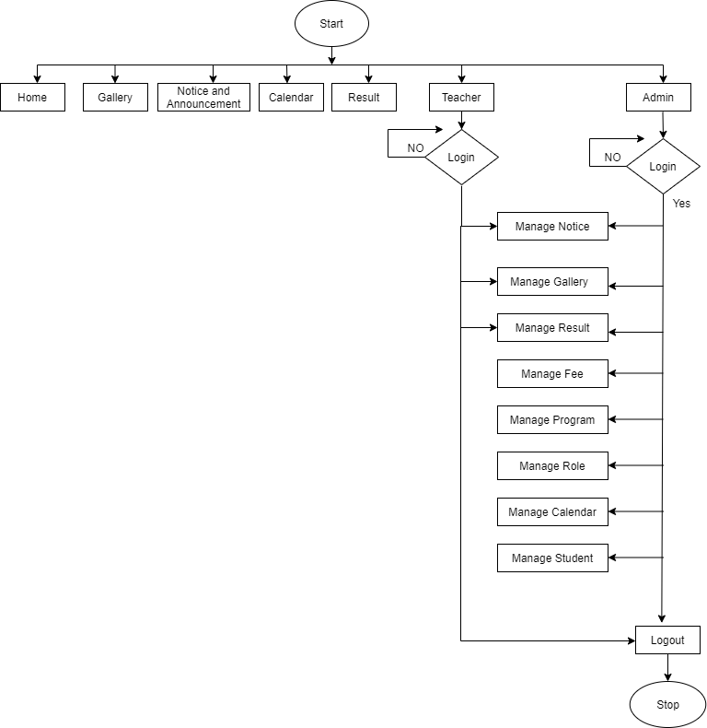

Figure 1:FLOW CHART

### DATA FLOW DIAGRAM

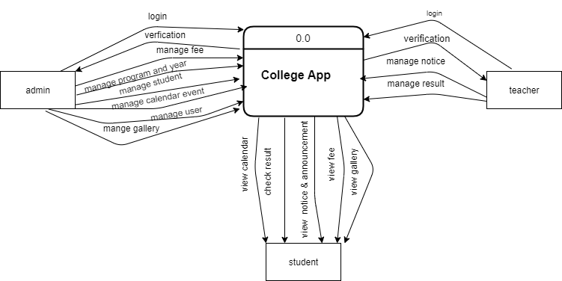

Figure 2:CONTEXT DIAGRAM

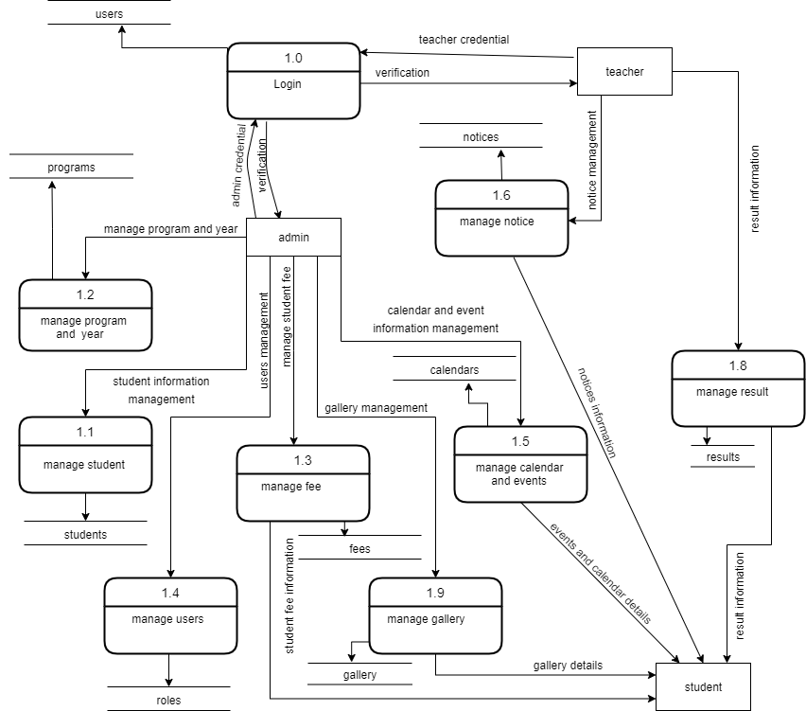

Figure 3:DFD LEVEL 1

### ER DIAGRAM

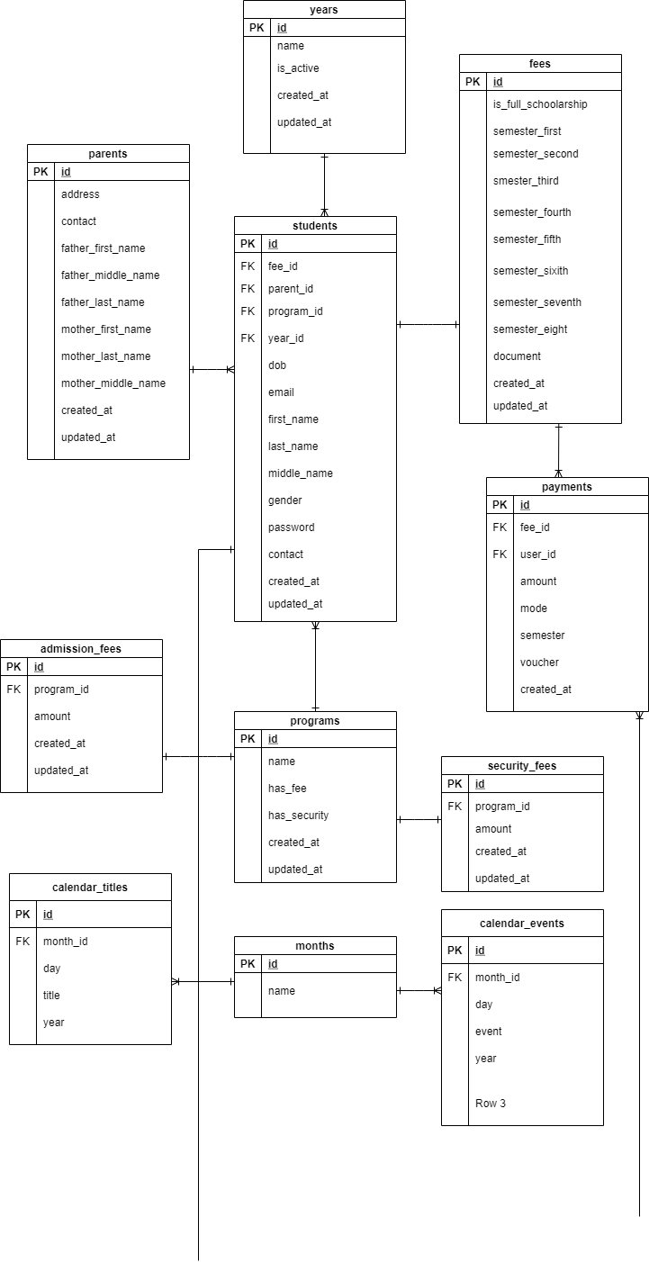

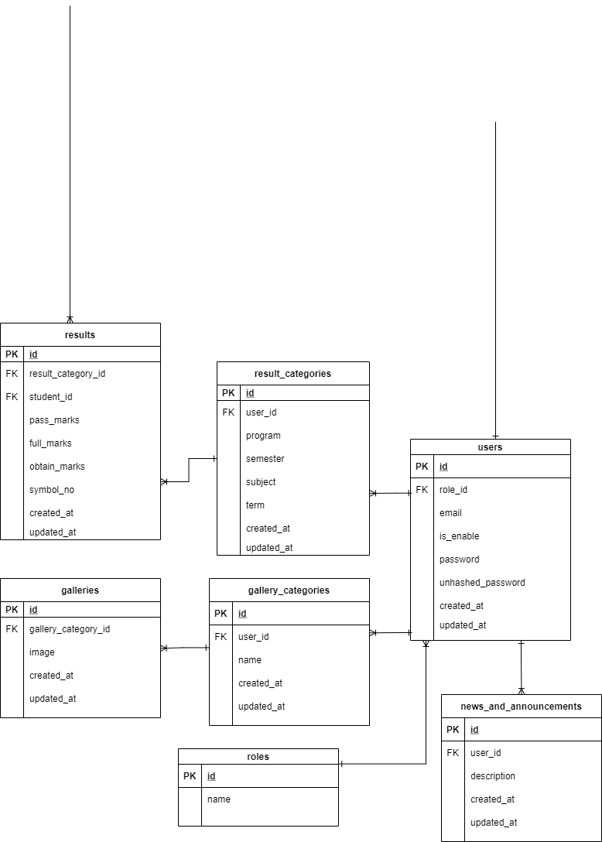

Figure 4:ER DIAGRAG

### USE CASE DIAGRAM

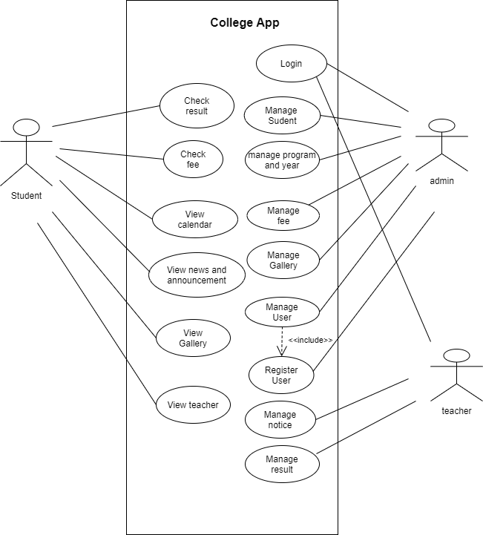

Figure 5:CLASS DIAGRAM

### STATE DIAGRAM

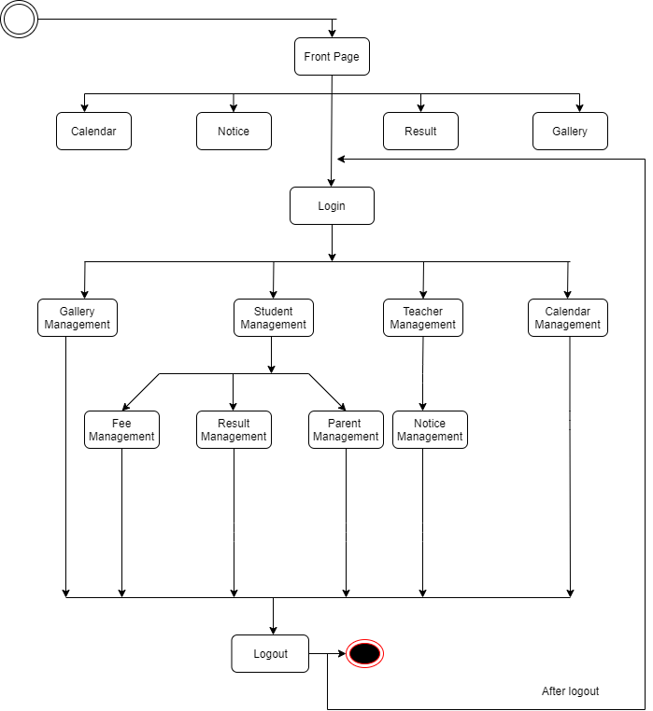

Figure 6:STATE DIAGRAM

# CHAPTER 4:SYSTEM TESTING

## GANTT CHART

Mar Apr May July Sep

Figure 7:GANTT CHART

# CHAPTER 5:OUTPUT

## SCREEN SHOTS

### FRONT END



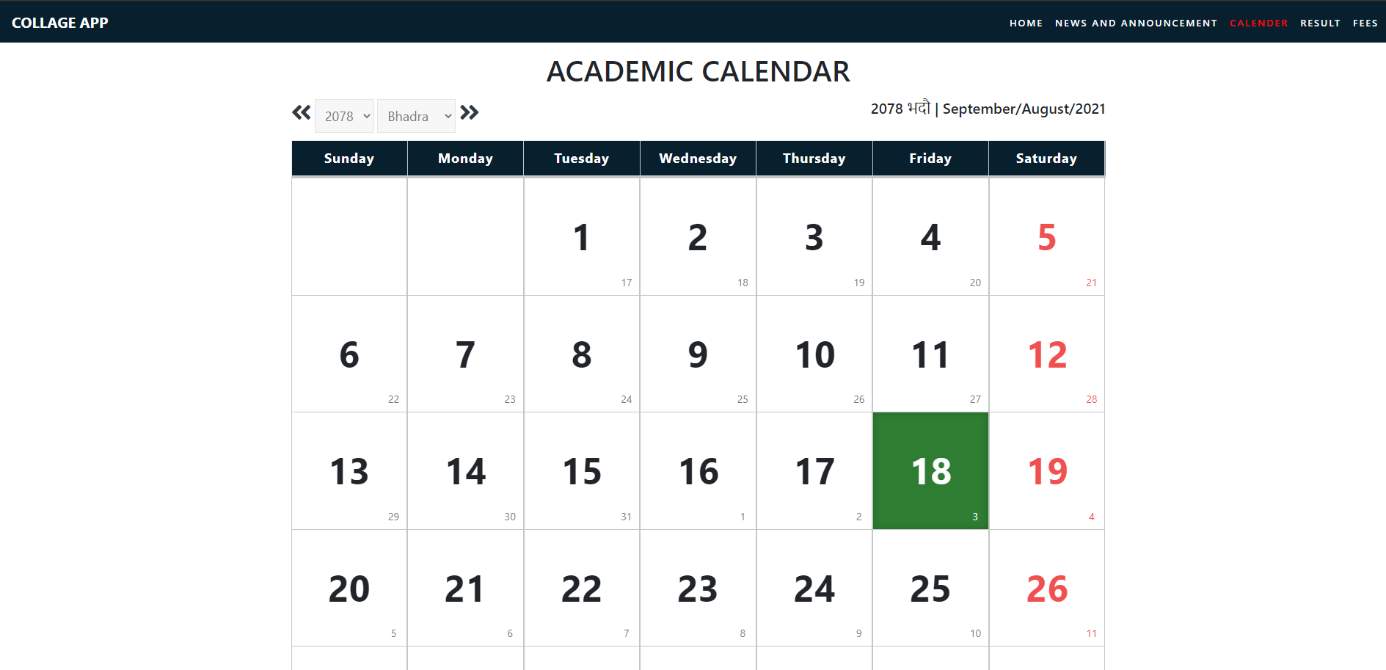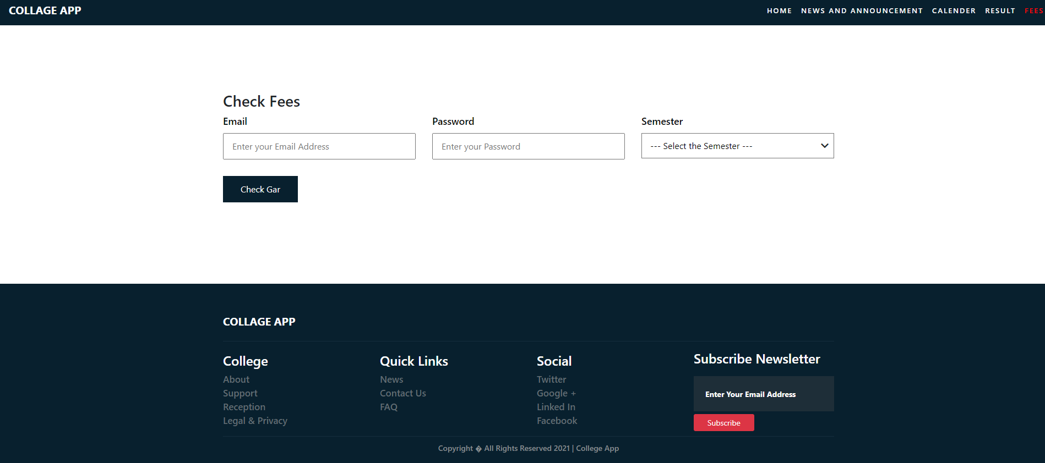

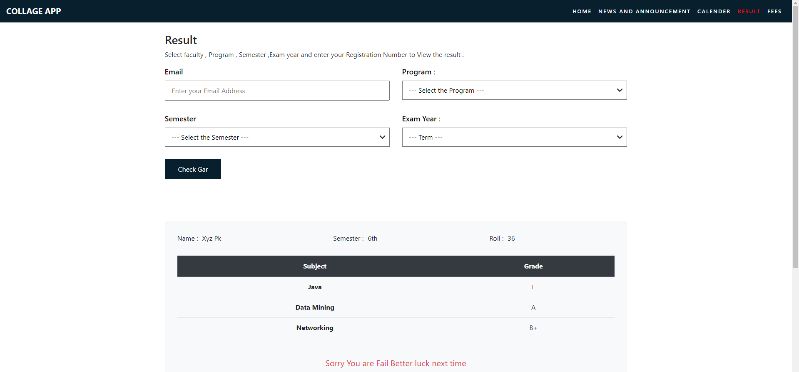

### BACKEND OUTPUT

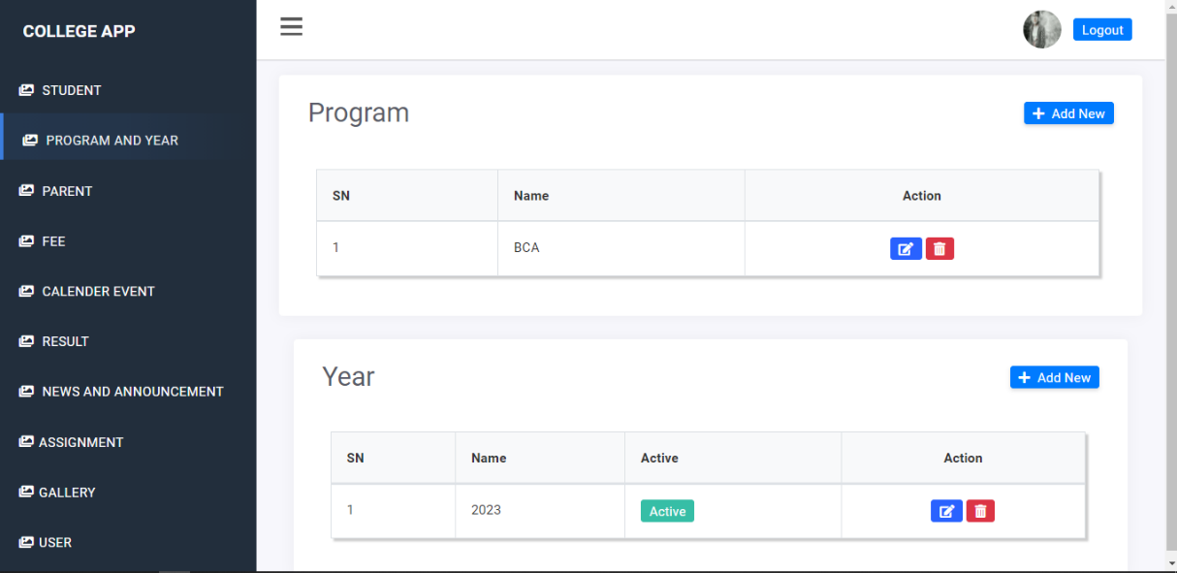

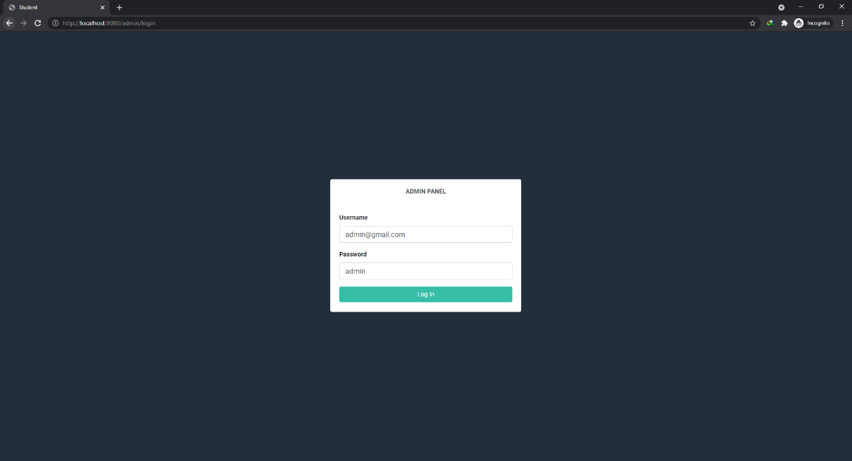

# CHAPTER 6:CONCLUSION

## CONCLUSION

We believe that we have achieved a system that will help streamline college administration. We are positive that our system will help colleges that are still running on traditional methodology by integration our system into their administration to make it more efficient .we have faith that it will provide trivial contribution in paving a digital path for college towards mainstream. We want to summarize this project report by saying that it was great pleasure working on this project , developing our skill set, working with our team mates.

# REFRENCE

* [1] [*Oxford English Dictionary*](https://en.wikipedia.org/wiki/Oxford_English_Dictionary), 1891, *s.v.*, definition 4c
* [2] Bourgeois, David T. (2014). *Information Systems for Business and Beyond*. The Saylo Academy. p. 5.
* [3] ["Management Information Systems"](https://www.umassd.edu/charlton/programs/mis/). *umassd.edu*. [University of Massachusetts Dartmouth](https://en.wikipedia.org/wiki/University_of_Massachusetts_Dartmouth).
* [4] Lucey, Terry; Lucey, Terence (2004). [*Management Information Systems*](https://books.google.com/books?id=A0bu30rNgJsC&q=what+is+management+information+system&pg=PR14). Cengage Learning EMEA.
* [5] The University of Arizona (2014-08-04). ["What is MIS?"](https://mis.eller.arizona.edu/what-is-mis).
* [6] (1995), *Strategic Information Systems Planning: A Review*. Information Resources Management Association International Conference, May 21–24, Atlanta.
* [7]["Index of /maven2/"](https://web.archive.org/web/20180917061140/http:/repo1.maven.org/maven2/). Archived from [the original](http://repo1.maven.org/maven2/) on 2018-09-17. Retrieved 2009-04-15.
* [8]ApacheMaven, <https://en.wikipedia.org/w/index.php?title=Apache_Maven&oldid=1041973061> (last visited Sept. 3, 2021).