**Aryan School of Engineering**

**Department of Information and Technology**

AFFILIATED TO: PURBANCHAL UNIVERSITY



**Minor Project Proposal on:**

**COLLEGE APP**

**[Code No: BIT279CO]**

**By**

**Anup Karki- Symbol No: xxxxxx**

**Jit Bdr Rana- Symbol No:xxxxxx**

**Pratik Shrestha- Symbol No: xxxxxx**

**Seazone Joshi- Symbol No: xxxxxx**

**Kathmandu, Nepal**

**2021**

**Aryan School of Engineering**

**Department of Information and Technology**

AFFILIATED TO: PURBANCHAL UNIVERSITY

**COLLEGE APP**

**[Code No: BIT379CO]**

**PROJECT PROPOSAL SUBMITTED TO THE DEPARTMENT OF INFORMATION TECHNOLOGY IN PARTIAL FULFILLMENT OF THE REQUIREMENTS FOR THE BACHELOR OF INFORMATION TECHNOLOGY**



**By**

**Anup Karki- Symbol No: xxxxxx**

**Jit Bdr Rana- Symbol No:xxxxxx**

**Pratik Shrestha- Symbol No: xxxxxx**

**Seazone Joshi- Symbol No: xxxxxx**

**Kathmandu, Nepal**

**Jan 2021**

**PURBANCHAL UNIVERSITY**

**Aryan school of Engineering**

**Department of Information and Technology**

**Aryan College of Engineering**

**Department of Information Technology**

**Affiliated To: Purbanchal University**

**CERTIFICATE**

The undersigned certify that they have read and recommended to the Department of Information Technology, a minor project work entitled "COLLEGE APP" submitted by Anup Karki (xxxxxx) Jit Bdr Rana (xxxxxx) Pratik Shrestha (xxxxxx) and Seazone Joshi (xxxxxx) in partial fulfillment of the requirements for the degree of Bachelor of IT.

(Head of Department)

Department of Electronics and

Computer Engineering.

Aryan School of Engineering

(Project Coordinate)

Department of Electronics and

Computer Engineering.

Aryan School of Engineering

**ACKNOWLEDGEMENT**

We would like to extend our heartiest thanks with a deep sense of gratitude and respect to all those who provides me immense help and guidance during my training period. We have been greatly benefited from their regular critical reviews and inspiration throughout my work.

We would also like to thank my project supervisor **Mr.sample and Er. sample** for his unfailing cooperation and sparing his valuable time to assist us in our work for preparing proposal of the project.

We would like to express our sincere thanks to our Head of Department **Er. Nisha Karki** andour internal guide **Mr. Sample Sample,** who gave us an opportunity to undertake such a great challenging and innovative work. We are grateful to them for their guidance, encouragement, understanding and insightful support in the development process.

Last but not the least we would like to mention here that we greatly indebted to each and everybody who has been associated with our project at any stage but whose name does not find a place in this acknowledgement.

**ABSTRACT**

**List of Figure**

**TABLE OF CONTENT**

CHAPTER 1: INTRODUCTION 1

4.1 BACKGROUND 2

4.2 PROBLEM OF STATEMENT 3

4.3 SCOPE 4

4.4 PROJECT FEATURES 5

4.5 OBJECTIVE 6

4.6 SYSTEM REQUIREMENT 7

1.6.1 Software Requirement (while developing) 7

1.6.2 Hardware Requirement (while developing) 7

CHAPTER 2:LITERATURE REVIEW 8

2.1 BACKGROUND 9

CHAPTER 3:METHODOLOGY 11

3.1 FEABILITY STUDY 12

3.1.1 Operational Feasibility 12

3.1.2 Technical Feasibility 12

3.1.3 Economical Feasibility 13

3.2 BEHAVIOUR MODELING 14

3.2.1 FLOW CHART 14

3.2.2 DATA FLOW DIAGRAM 15

3.2.3 ER DIAGRAM 16

3.2.4 USE CASE DIAGRAM 17

3.2.5 STATE DIAGRAM 18

CHAPTER 4:SYSTEM TESTING 20

4.1 COST ESTIMATION 21

4.2 GANTT CHART 22

CHAPTER 5:EXPECTED OUTPUT 23

5.1 SCREEN SHOTS 24

CHAPTER 6:CONCLUSION 25

6.1 CONCLUSION 26

REFRENCE 28

# 

# CHAPTER 1: INTRODUCTION

## BACKGROUND

## PROBLEM OF STATEMENT

## SCOPE

## PROJECT FEATURES

## OBJECTIVE

## SYSTEM REQUIREMENT

### 

### Software Requirement (while developing)

* Windows 10 or Linux
* Programming languages: Html, CSS, JavaScript, PHP
* Framework: Laravel
* Text editor: Sublime Text/VS Code

### Hardware Requirement (while developing)

The following is a list of computer hardware specifications that are suggested by the developer as the minimum requirements for a computer to efficiently run the system.

* Processor: Pentium IV or higher
* Memory: 2 GB minimum
* Hard drive: 40 GB free space
* 1024 * 768 Resolution Color Monitor

# CHAPTER 2:LITERATURE REVIEW

## BACKGROUND

A management information system (MIS) is an information system[1] used for decision-making, and for the coordination, control, analysis, and visualization of information in an organization The study of the management information systems involves people, processes and technology in an organizational context. In a corporate setting, the ultimate goal of the use of a management information system is to increase the value and profits of the business.[2] This is done by providing managers with timely and appropriate information allowing them to make effective decisions within a shorter period of time.[3] The terms management information system (MIS), Information management system (IMS), information system (IS), enterprise resource planning (ERP), computer science, electrical computer engineering, and information technology management (IT) are often confused. MIS is a hierarchical subset of information systems. MIS are more organization-focused narrowing in on leveraging information technology to increase business value. Computer science is more software-focused dealing with the applications that may be used in MIS.[4] Electrical computer engineering is product-focused mainly dealing with the architecture behind computer systems. ERP software is a subset of MIS and IT management refers to the technical management of an IT department which may include MIS. Principles of Management Information Systems.

The following are some of the benefits that can be attained using MIS:[5]

* Improve an organization's operational efficiency, add value to existing products, engender innovation and new product development, and help managers make better decisions.
* Companies are able to identify their strengths and weaknesses due to the presence of revenue reports, employee performance records etc. Identifying these aspects can help a company improve its business processes and operations.
* Giving an overall picture of the company.
* Acting as a communication and planning tool.
* The availability of customer data and feedback can help the company to align its business processes according to the needs of its customers. The effective management of customer data can help the company to perform direct marketing and promotion activities.
* MIS can help a company gain a competitive advantage.
* MIS reports can help with decision-making as well as reduce downtime for actionable items.

Some of the disadvantages of MIS systems:

* Retrieval and dissemination are dependent on technology hardware and software.
* Potential for inaccurate information.

A digital signature is a mathematical scheme for verifying the authenticity of digital messages or documents. A valid digital signature, where the prerequisites are satisfied, gives a recipient very strong reason to believe that the message was created by a known sender (authentication), and that the message was not altered in transit (integrity).[6] Digital signatures are a standard element of most cryptographic protocol suites, and are commonly used for software distribution, financial transactions, contract management software, and in other cases where it is important to detect forgery or tampering. Digital signatures are often used to implement electronic signatures, which includes any electronic data that carries the intent of a signature,[7] but not all electronic signatures use digital signatures. Digital signatures employ asymmetric cryptography. In many instances they provide a layer of validation and security to messages sent through a non-secure channel: Properly implemented, a digital signature gives the receiver reason to believe the message was sent by the claimed sender. Digital signatures are equivalent to traditional handwritten signatures in many respects, but properly implemented digital signatures are more difficult to forge than the handwritten type. Digital signature schemes, in the sense used here, are cryptographically based, and must be implemented properly to be effective. Digital signatures can also provide non-repudiation, meaning that the signer cannot successfully claim they did not sign a message, while also claiming their private key remains secret. Further, some non-repudiation schemes offer a timestamp for the digital signature, so that even if the private key is exposed, the signature is valid.[8][9] Below are some common reasons for applying a digital signature to communications:

* Authentication

Although messages may often include information about the entity sending a message, that information may not be accurate. Digital signatures can be used to authenticate the identity of the source messages.

* Integrity

In many scenarios, the sender and receiver of a message may have a need for confidence that the message has not been altered during transmission. Although encryption hides the contents of a message, it may be possible to change an encrypted message without understanding it. (Some encryption algorithms, called nonmalleable, prevent this, but others do not.) However, if a message is digitally signed, any change in the message after signature invalidates the signature.

* Non-repudiation

Non-repudiation,[10] or more specifically non-repudiation of origin, is an important aspect of digital signatures. By this property, an entity that has signed some information cannot at a later time deny having signed it. Similarly, access to the public key only does not enable a fraudulent party to fake a valid signature.

# CHAPTER 3:METHODOLOGY

## FEASIBILITY STUDY

Early studies have been made on this, as it is a rising topic. Some research have been done before setting goals or objectives for the project and initializing the project. It has been known from the research that there had been earlier attempts for creating such products and there are some products that meets certain portion of the public and market demands. But from deep research we have come to know that there has not been any kind of complete product relating to this topic so we decided to have an attempt on creating more facilitated and complete product in comparison to the earlier products that already exist in the market.

Thus, after long term research and discussion among the group members we have decided to make a proposal for the project defining the researches and objectives we have set for the project.

There are three tests of Feasibility Study:-

* Operational
* Technical
* Economical /financial

### Operational Feasibility

This test of feasibility asks if the system will work when it is developed and installed. This feasibility observes the all operations like finding products, gathering information, getting supports & software & more.

### Technical Feasibility

This involves the technological consideration like available technology to run the purposed system. The system has been created with the most common technology available. Hence the system is technically feasible.

### Economical Feasibility

Cost of the system will be affordable for the user. As it is a simple product financial consideration was not a big deal for our project.

## BEHAVIOUR MODELING

### FLOW CHART

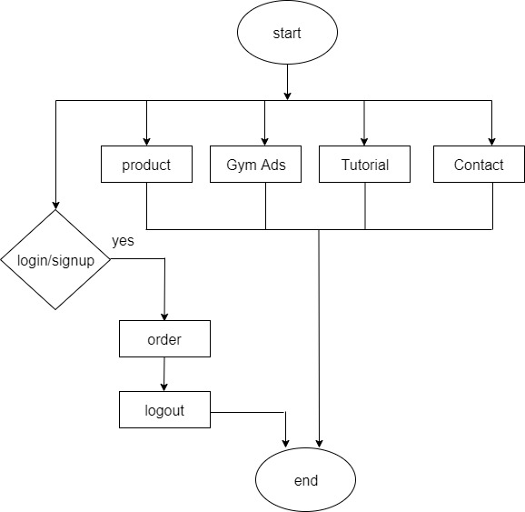

Figure 2:FLOW CHART

### DATA FLOW DIAGRAM

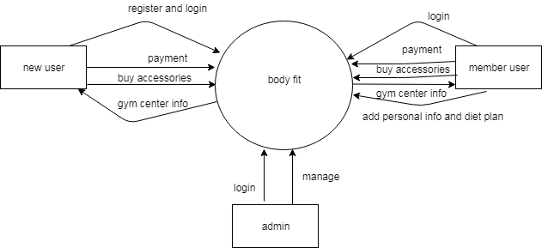

Figure 3:CONTEXT DIAGRAM

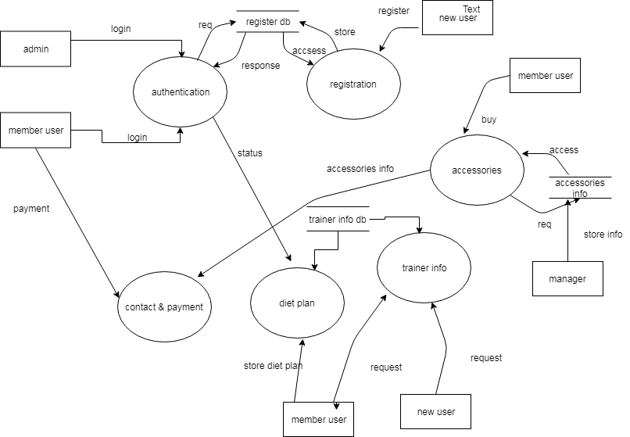

Figure 4:DFD LEVEL 1

### ER DIAGRAM

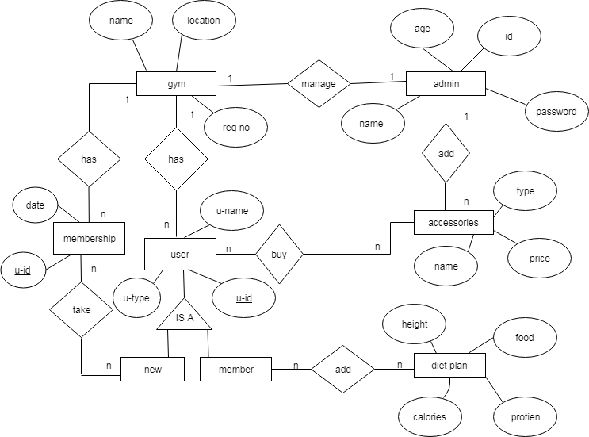

Figure 5:ER DIAGRAGM

### USE CASE DIAGRAM

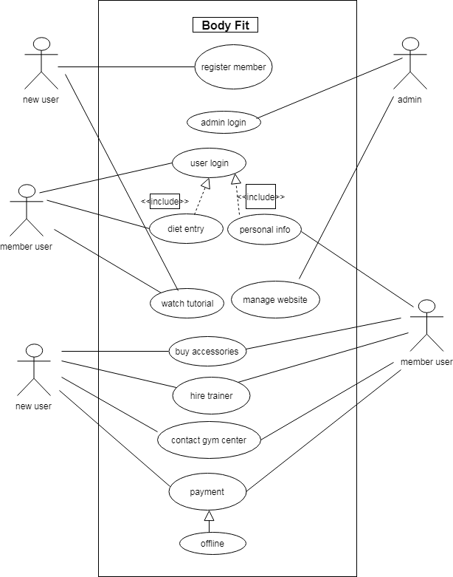

Figure 6:CLASS DIAGRAM

### STATE DIAGRAM

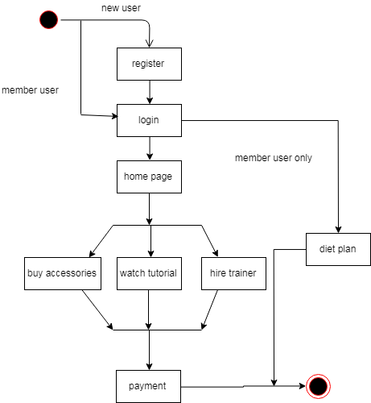

Figure 7:STATE DIAGRAM

# CHAPTER 4:SYSTEM TESTING

## COST ESTIMATION

These documents will provide the necessary data to feed into the budget line items. The accuracy of the budgets requires that attention be given both to individual expense per item. The budget goal, is to the extent possible, directly map the project expense to actual costs within 10 per-cent difference if there be any disparity.

|  |  |  |  |
| --- | --- | --- | --- |
| **ITEM** | **PRICE**  **(Rs)** | **UNITS** | **TOTAL**  **(Rs)** |
| **Backup device (Portable hard disk)** | 800 | 1 | **800** |
| **Modem** | 3,000 | 1 | **3,000** |
| **Antivirus software** | 3,000 | 1 | **3,000** |
| **Printing Costs** | 5 per page | Over 25 pages | **125** |
| **Miscellaneous** | - | - | **1,000** |
| **Total** | - | - | **7,225** |

Figure 8:COST ESTIMATION

## GANTT CHART

Jan Feb Mar May June

Figure 9:GANTT CHART

# CHAPTER 5:OUTPUT

## SCREEN SHOTS

# CHAPTER 6:CONCLUSION

## CONCLUSION

# REFRENCE

* [1] Bourgeois, David T. (2014). *Information Systems for Business and Beyond*. The Saylo Academy. p. 5.
* [2] ["Management Information Systems"](https://www.umassd.edu/charlton/programs/mis/). *umassd.edu*. [University of Massachusetts Dartmouth](https://en.wikipedia.org/wiki/University_of_Massachusetts_Dartmouth).
* [3] Lucey, Terry; Lucey, Terence (2004). [*Management Information Systems*](https://books.google.com/books?id=A0bu30rNgJsC&q=what+is+management+information+system&pg=PR14). Cengage Learning EMEA.
* [4] The University of Arizona (2014-08-04). ["What is MIS?"](https://mis.eller.arizona.edu/what-is-mis).
* [5] (1995), *Strategic Information Systems Planning: A Review*. Information Resources Management Association International Conference, May 21–24, Atlanta.
* [6] Paul, Eliza (12 September 2017). ["What is Digital Signature – How it works, Benefits, Objectives, Concept"](http://www.emptrust.com/blog/benefits-of-using-digital-signatures).
* [7] [National Archives of Australia](http://www.naa.gov.au/recordkeeping/er/Security/6-glossary.html) [Archived](https://web.archive.org/web/20141109/http:/www.naa.gov.au/recordkeeping/er/Security/6-glossary.html) November 9, 2014
* [8] Fang, Weidong; Chen, Wei; Zhang, Wuxiong; Pei, Jun; Gao, Weiwei; Wang, Guohui (2020-03-04). ["Digital signature scheme for information non-repudiation in blockchain: a state of the art review"](https://doi.org/10.1186%2Fs13638-020-01665-w).
* [9] Zhou, J.; Lam, K.Y. (May 1999). ["Securing digital signatures for non-repudiation"](https://dx.doi.org/10.1016/s0140-3664(99)00031-6). *Computer Communications*. **22** (8): 710–716. [doi](https://en.wikipedia.org/wiki/Doi_(identifier)):[10.1016/s0140-3664(99)00031-6](https://doi.org/10.1016%2Fs0140-3664%2899%2900031-6).
* [10] Zhou, J.; Lam, K.Y. (May 1999). ["Securing digital signatures for non-repudiation"](https://dx.doi.org/10.1016/s0140-3664(99)00031-6). *Computer Communications*. **22** (8): 710–716. [doi](https://en.wikipedia.org/wiki/Doi_(identifier)):[10.1016/s0140-3664(99)00031-6](https://doi.org/10.1016%2Fs0140-3664%2899%2900031-6).