**Aryan School of Engineering**

**Department of Information and Technology**

AFFILIATED TO: PURBANCHAL UNIVERSITY



**Minor Project Proposal on:**

**JBOT**

**[Code No: BIT279CO]**

**By**

**Sample SampleRoll No: xxxxxx**

**Sample Sample- Symbol No:xxxxxx**

**Sample Sample- Roll No: xxxxxx**

**Kathmandu, Nepal**

**2020**

**Aryan School of Engineering**

**Department of Information and Technology**

AFFILIATED TO: PURBANCHAL UNIVERSITY

**JBOT**

**[Code No: BIT379CO]**

**PROJECT PROPOSAL SUBMITTED TO THE DEPARTMENT OF INFORMATION TECHNOLOGY IN PARTIAL FULFILLMENT OF THE REQUIREMENTS FOR THE BACHELOR OF INFORMATION TECHNOLOGY**



**By**

**Sample SampleRoll No: xxxxxx**

**Sample Sample- Symbol No:xxxxxx**

**Sample Sample- Roll No: xxxxxx**

**Kathmandu, Nepal**

**Jan 2021**

**PURBANCHAL UNIVERSITY**

**Aryan school of Engineering**

**Department of Information and Technology**

**Aryan College of Engineering**

**Department of Information Technology**

**Affiliated To: Purbanchal University**

**CERTIFICATE**

The undersigned certify that they have read and recommended to the Department of Information Technology, a minor project work entitled "JBOT" submitted by Sample Sample (xxxxxx) Sample (xxxxxx) and samplesample (xxxxxx) in partial fulfillment of the requirements for the degree of Bachelor of IT.

(Head of Department)

Department of Electronics and

Computer Engineering.

Aryan School of Engineering

(Project Coordinate)

Department of Electronics and

Computer Engineering.

Aryan School of Engineering

**ACKNOWLEDGEMENT**

We would like to extend our heartiest thanks with a deep sense of gratitude and respect to all those who provides me immense help and guidance during my training period. We have been greatly benefited from their regular critical reviews and inspiration throughout my work.

We would also like to thank my project supervisor **Mr.sample and Er. sample** for his unfailing cooperation and sparing his valuable time to assist us in our work for preparing proposal of the project.

We would like to express our sincere thanks to our Head of Department **Er. Nisha Karki** andour internal guide **Mr. Sample Sample,** who gave us an opportunity to undertake such a great challenging and innovative work. We are grateful to them for their guidance, encouragement, understanding and insightful support in the development process.

Last but not the least we would like to mention here that we greatly indebted to each and everybody who has been associated with our project at any stage but whose name does not find a place in this acknowledgement.

**ABSTRACT**

**List of Figure**

**TABLE OF CONTENT**

CHAPTER 1: INTRODUCTION 1

4.1 BACKGROUND 2

4.2 PROBLEM OF STATEMENT 3

4.3 SCOPE 4

4.4 PROJECT FEATURES 5

4.5 OBJECTIVE 6

4.6 SYSTEM REQUIREMENT 7

1.6.1 Software Requirement (while developing) 7

1.6.2 Hardware Requirement (while developing) 7

CHAPTER 2:LITERATURE REVIEW 8

2.1 BACKGROUND 9

CHAPTER 3:METHODOLOGY 11

3.1 FEABILITY STUDY 12

3.1.1 Operational Feasibility 12

3.1.2 Technical Feasibility 12

3.1.3 Economical Feasibility 13

3.2 BEHAVIOUR MODELING 14

3.2.1 FLOW CHART 14

3.2.2 DATA FLOW DIAGRAM 15

3.2.3 ER DIAGRAM 16

3.2.4 USE CASE DIAGRAM 17

3.2.5 STATE DIAGRAM 18

CHAPTER 4:SYSTEM TESTING 20

4.1 COST ESTIMATION 21

4.2 GANTT CHART 22

CHAPTER 5:EXPECTED OUTPUT 23

5.1 SCREEN SHOTS 24

CHAPTER 6:CONCLUSION 25

6.1 CONCLUSION 26

REFRENCE 28

# 

# CHAPTER 1: INTRODUCTION

## BACKGROUND

## PROBLEM OF STATEMENT

## SCOPE

## PROJECT FEATURES

## OBJECTIVE

## SYSTEM REQUIREMENT

### 

### Software Requirement (while developing)

* Windows 10 or Linux
* Programming languages: Html, CSS, JavaScript, PHP
* Framework: Laravel
* Text editor: Sublime Text/VS Code

### Hardware Requirement (while developing)

The following is a list of computer hardware specifications that are suggested by the developer as the minimum requirements for a computer to efficiently run the system.

* Processor: Pentium IV or higher
* Memory: 2 GB minimum
* Hard drive: 40 GB free space
* 1024 * 768 Resolution Color Monitor

# CHAPTER 2:LITERATURE REVIEW

## BACKGROUND

# CHAPTER 3:METHODOLOGY

## FEASIBILITY STUDY

Early studies have been made on this, as it is a rising topic. Some research have been done before setting goals or objectives for the project and initializing the project. It has been known from the research that there had been earlier attempts for creating such products and there are some products that meets certain portion of the public and market demands. But from deep research we have come to know that there has not been any kind of complete product relating to this topic so we decided to have an attempt on creating more facilitated and complete product in comparison to the earlier products that already exist in the market.

Thus, after long term research and discussion among the group members we have decided to make a proposal for the project defining the researches and objectives we have set for the project.

There are three tests of Feasibility Study:-

* Operational
* Technical
* Economical /financial

### Operational Feasibility

This test of feasibility asks if the system will work when it is developed and installed. This feasibility observes the all operations like finding products, gathering information, getting supports & software & more.

### Technical Feasibility

This involves the technological consideration like available technology to run the purposed system. The system has been created with the most common technology available. Hence the system is technically feasible.

### Economical Feasibility

Cost of the system will be affordable for the user. As it is a simple product financial consideration was not a big deal for our project.

## BEHAVIOUR MODELING

### FLOW CHART

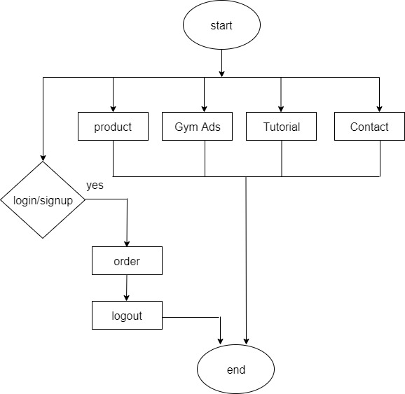

Figure 2:FLOW CHART

### DATA FLOW DIAGRAM

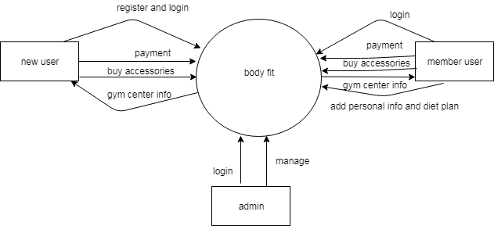

Figure 3:CONTEXT DIAGRAM

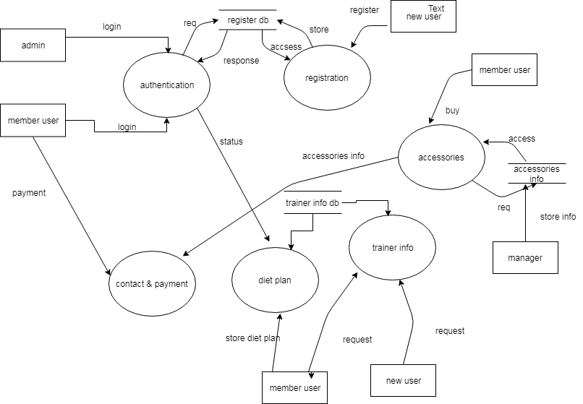

Figure 4:DFD LEVEL 1

### ER DIAGRAM

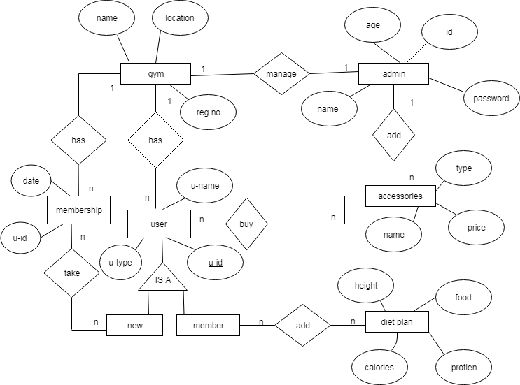

Figure 5:ER DIAGRAGM

### USE CASE DIAGRAM

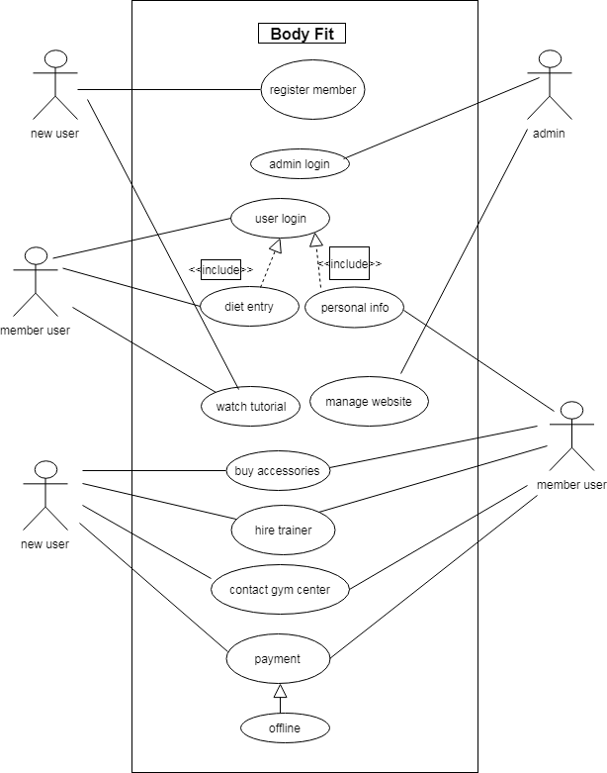

Figure 6:CLASS DIAGRAM

### STATE DIAGRAM

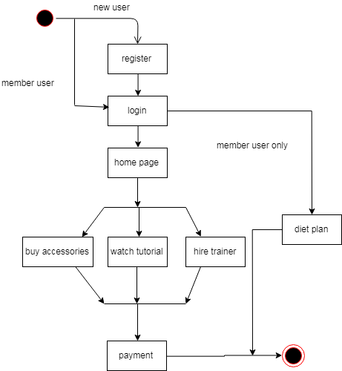

Figure 7:STATE DIAGRAM

# CHAPTER 4:SYSTEM TESTING

## COST ESTIMATION

These documents will provide the necessary data to feed into the budget line items. The accuracy of the budgets requires that attention be given both to individual expense per item. The budget goal, is to the extent possible, directly map the project expense to actual costs within 10 per-cent difference if there be any disparity.

|  |  |  |  |
| --- | --- | --- | --- |
| **ITEM** | **PRICE**  **(Rs)** | **UNITS** | **TOTAL**  **(Rs)** |
| **Backup device (Portable hard disk)** | 800 | 1 | **800** |
| **Modem** | 3,000 | 1 | **3,000** |
| **Antivirus software** | 3,000 | 1 | **3,000** |
| **Printing Costs** | 5 per page | Over 25 pages | **125** |
| **Miscellaneous** | - | - | **1,000** |
| **Total** | - | - | **7,225** |

Figure 8:COST ESTIMATION

## GANTT CHART

Jan Feb Mar May June

Figure 9:GANTT CHART

# CHAPTER 5:OUTPUT

## SCREEN SHOTS

# CHAPTER 6:CONCLUSION

## CONCLUSION

# REFRENCE