# Lab 2

## Part 1

Check out the lab2 Branch from the repo. Do to this either:

git checkout –b lab2

Or if you already have the branch type:

git fetch origin lab2

BTW The master branch has all the steering behaviours implemented (amongst lots of other cool stuff)

The aim of this lab is to achieve three things:

Implement the seek steering behaviour as we described in the class

Implement path following

Set up a scenario to test the above

You will also be getting familiar with Unity in this lab. When you run the lab code you should see this:

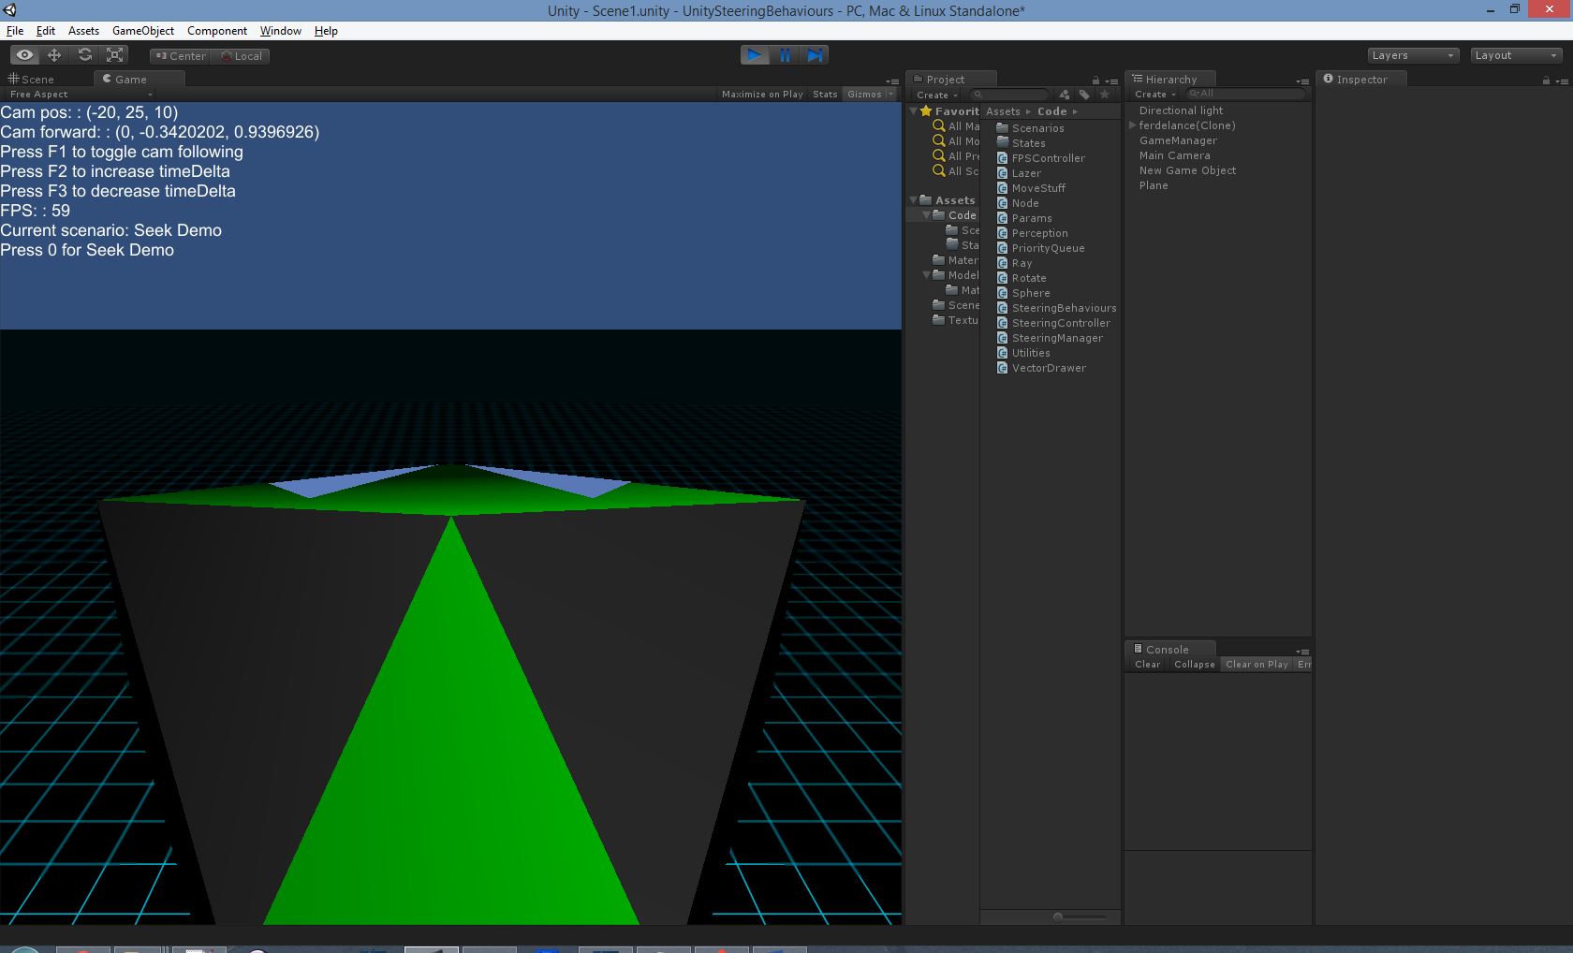

Edit the file SteeringBehaviours.cs and put code in the Seek method to seek to the target pos parameter. Check out the notes to see how to implement seek.

To get the max speed use:

Params.GetFloat("max_speed");

When you are happy you have the steering behaviour working, you can test it out by setting up a scenario. The easiest way to do this in the framework I have made is to edit the file SeekScenario.cs

What you have to do:

Check out the method CreateBoid to see what this does...

In summary it:

Creates a new GameObject from the leaderPrefab

Attaches a SteeringBehaviours script to it

Sets the starting position

What you need to in SteeringScenario.cs:

Get access to the SteeringBehaviours component.

Turn off all the steering behaviours except the seek behaviour

Set the seek target to be the position you want to seek to.

If all goes well, your space ship should seek to the point

## Part 2

Now we want to implement a Path following behaviour. What we want to do is store a list of waypoints somewhere and then seek to each one. When your ship reaches a waypoint you need to advance to the next waypoint. When you reach the last waypoint, you should go back to the first one again. I suggest you:

Create a Path class with a list of Vector3’s as a field

Create the following methods: