8. Managing Nursery Data in IRIS: The Workbook
Introduction:

The Data Management System (DMS) is the component of ICIS that manages environmental data, germplasm characterization data and evaluation data for genetic resources and crop improvement projects. DMS links these data to genotype information in the ICIS Genealogy Management System (GMS) and to location information in the Location Management Module (LMM) as well as providing links to other specialized data sources. DMS also allows integration of data from different studies, thus permitting a broad range of queries across trials or types of factors and variates. For further discussion about DMS, see Chapter 7 of the technical documentation of ICIS.

Objective: At the end of this of this chapter, the user should be able to:

- Grasp the concepts of the ICISworkbook
- Know how it manages data of a nursery trial.

The ICIS Workbook

Understanding Component Concepts

Study – is a basic, reportable unit of research, it is synonymous with the notions of experiment, nursery or survey.
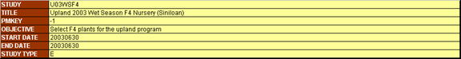

Factor – is classifying variable in a study which take finite sets of discrete levels (e.g. Entries, Replication, Fertilizer applied)
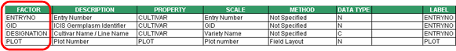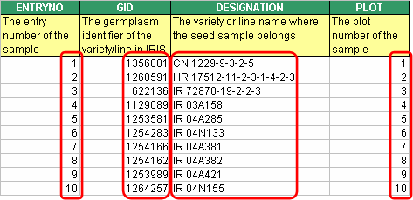

Condition – is a factor with single level value (e.g. Location if single location trial)

Variate – is a variable being measured or observed in the study (e.g. Grain Yield).
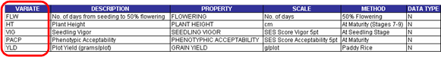
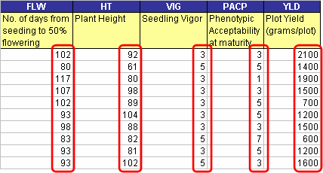

Constant – is a variable that is measured once in the study (e.g. Soil pH)

Observation Unit – is a combination of levels of one or more factors. It is equivalent to a row of a spreadsheet.
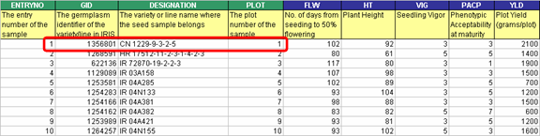

Property – is a measurable characteristic of an experimental unit or experimental material, which is manipulated or measured in a study.

Scale – is a unit of measurement used in expressing a property.

Method – is the manner a property is measured, observed or applied.

Description and Observation Sheets

The ICIS Workbook uses a standard input file shown in Fig. 1. It is created when you click Study ► New menu or the icon. The Workbook consists of the Description and Observation sheets. The Description sheet is for entering information about the study and describing the different variables used in the study. The Observation sheet is for entering the data gathered from the study.

Description Sheet

The Description sheet has 5 named ranges of cells. The STUDY, CONDITION, FACTOR, CONSTANT, and VARIATE are used to identify the cells containing related information. These named ranges are automatically created by the ICISworkbook and are used in the loading process.

Fig. 1. ICIS Workbook file (showing the Description sheet)
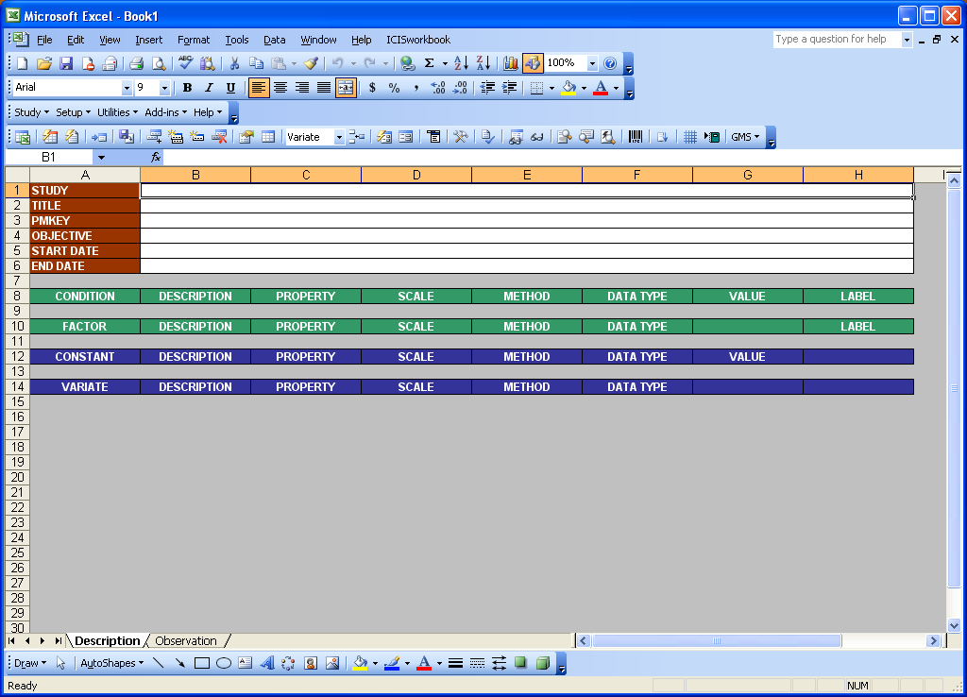

In the Description sheet, the user enters a unique study name in the STUDY cell. The title, objective, start date, end date details should be entered in the appropriate cells.

The names of the factor are entered under the CONDITION and FACTOR headings and the names of variates are entered under the CONSTANT and VARIATE headings. There must be a blank row separating each section. The factors and variates of the study must have associated properties, scales, methods, and data types. The user can select these from lists provided under the Setup ► Variable ► Custom Setup menu. If there is no appropriate property, scale, or method in the lists, the user can enter a new one. For cases where a factor has more than one label in the data set, the name(s) of subsequent labels are entered in the FACTOR section, but the name of the first or defining label must be specified under the LABEL column.

Factors with a single level applying to all observations in the dataset are called CONDITIONS. Condition factor names are entered under the CONDITION heading (not in the FACTOR cells) and the single level value must be entered in the VALUE column. If the factor condition applies to the entire data of the study, then enter "STUDY" in the LABEL column.

Observation Sheet

Data are entered in the Observation sheet. The first row of this sheet must contain the factor and variate names entered in the Description sheet. To copy the variable names from the Description sheet, click the Setup ► Observation Sheet menu or the icon. The Observation sheet has one named range called ROWTAG. Rows that have markings (comments) under the ROWTAG column will be ignored when data are uploaded to the DMS local database.

Fig 2. Observation sheet.
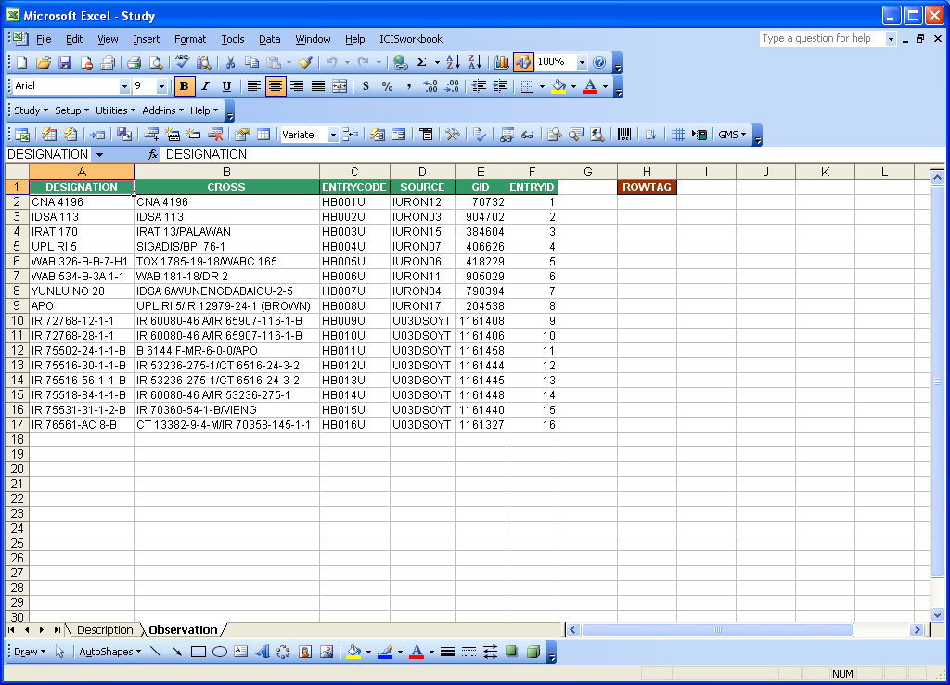

C. Creating a Workbook File for a Germplasm List

Objective: To create an ICISworkbook file for Upland Hybridization Trial. The trial is unreplicated. Grain yield, plant height, flowering days, phenotyphic acceptability, and seed selection are measured in the trial.

VARIATE | PROPERTY | SCALE | METHOD | DATA TYPE
PLTHT | PLANT HEIGHT | Cm | At Maturity (Stages 7-9) | N
GRNYLD | GRAIN YIELD | Kg/ha | Paddy Rice | N
FLW | DAYS TO FLOWER | No. of days | Days Elapsed | N
PACP | PHENOTYPHIC ACCEPTABILITY | SES Score Acceptability 5pt | At Maturity | N
SEEDSEL | PLANT SELECTED | No. of plants | Breeding Selection | N

Tutorial Steps:

Launching the ICIS Workbook:

- Start the ICIS Workbook from the Launcher.

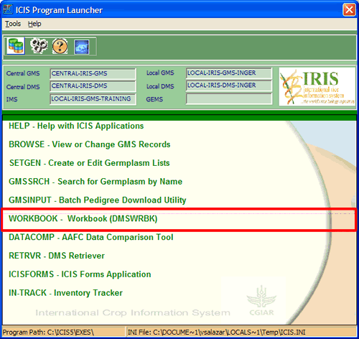

- Depending on the security level of your Excel application (which might be Very High, High, Medium, or Low), different dialog interfaces will appear.

Very High:

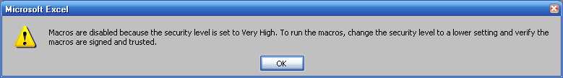

High:

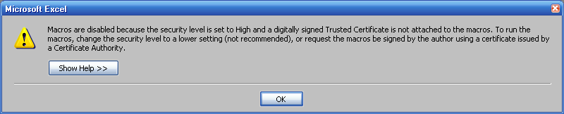

Medium:

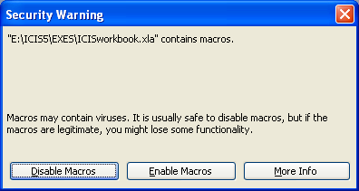

To be able to use the ICISworkbook, the security level must be set to “Medium”. Make this change by clicking on the Tools ► Macro ► Security menu.

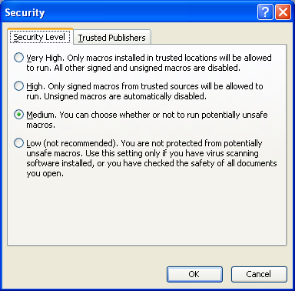
- After the security level has been set to Medium, a “Security Warning” dialog interface appears offering three options: Disable Macros, Enable Macros, and More Info. Click on “Enable Macros”.

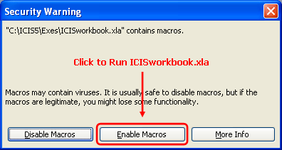

- As the Workbook is being loaded into memory, the “About ICISworkbook” dialog interface appears.

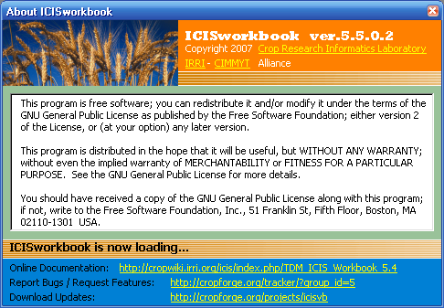

- Look at the main menu of your Excel application. See that a new menu item named ICIS Workbook has been added. It has two submenus: Show Menu (which shows the ICISworkbook menu and toolbar) and About (which shows the About ICIS Workbook dialog interface).

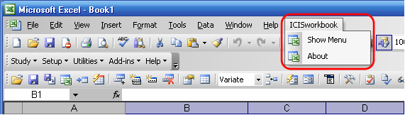

- The ICIS Workbook menu and toolbar is your tool to access all the functionalities of the ICIS Workbook.

Retrieving entries from SETGEN lists:

- Click on the Add-ins ► Import Data From ► SetGen menu or click the icon.
- The “Import Data from SetGen” dialog interface appears. In the search box under the section “SetGen List”, type→ U03WSHB. Notice that as you type along the system searches for a match from the list. You can also scroll down the list manually and select an item if you can’t remember the exact name. Alternatively, you can use the “Directory View” at the bottom left of the dialog interface and search for the list name within the directories.
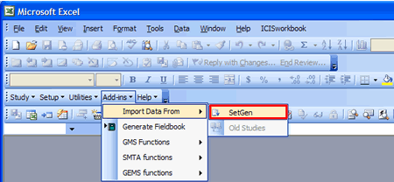

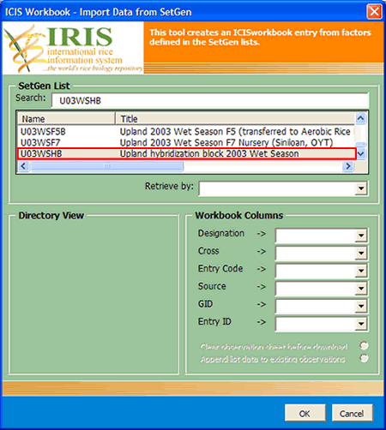

- At the right side of the dialog interface, there is a section entitled “Workbook Columns”. This is useful if you have a Workbook template to use other than creating a new Workbook file. If you have an open Workbook template, the column names in that template will appear in the dropdown lists.
- Once the desired germplasm list has been selected, click the “OK” button.
- A new ICIS Workbook file will be created for you with some information already filled-in such as the study name and title and some variables used in the study.

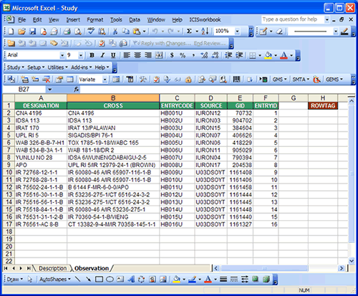

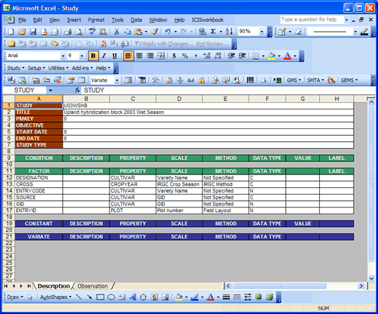

Entering study information:

- On the cell beside the label START DATE, type → 20031001.
- On the cell beside the label END DATE, type → 20040301.

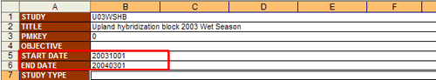
Describing the variable:

- Under the VARIATE section, insert 5 additional white rows. Notice the pair of icons ? Click on the icon to select which variable section you would like to add a row to. Then, click on the icon five times to add 5 blank white rows.
- Under the cell labeled VARIATE, type on each row → PLTHT, GRNYLD, FLW, PACP, SEEDSEL.
- To define the ontology for the newly-added variates, click on the Setup ► Variable ► Express Setup menu or click the icon. The “Express Variable Setup” dialog interface will appear asking you which database table you would like the system to search for an existing name resembling each variate name.

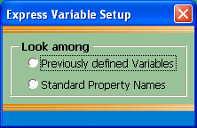

Click on the “Previously defined Variables”. The system then searches for variable names that you have used before and were already recorded in the database. However, there could have been possible variants of a variable name. If there is no exact match for a variable name, the system gives you the closes match it can find. Thus, you may encounter red cells in your variable names which call your attention to take a look at the closest match it found.

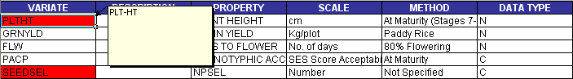

Now, notice that there was a change in the ICIS toolbar when you clicked on the red cell.

The “Use” menu gives you the option to choose which variable name you will use; either the “New” name which you declared or the “Existing” name that the system found.

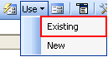

You have the freedom to use any variable name that you may have been accustomed to. However, the system provides you the utility to maintain a standard naming convention. So, choose your variable names well at the beginning and maintain a discipline in naming your variables. For the two red cells, choose the “Existing” names.

- The property, scale, and method for the factors and variates are already complete. However, we need to modify some of the ontology to give a more appropriate value. In this case, you will need to click on the Setup ► Variable Section ► Custom Setup menu or click the icon.
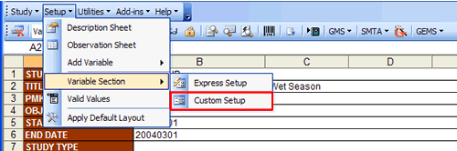
- To use this interface, first, select the variable section (e.g. FACTOR). Notice that the factor variables appeared on the list below the section name. As you select each of the variables, its definition appears on the right side of the dialog interface. This is where you can make changes.

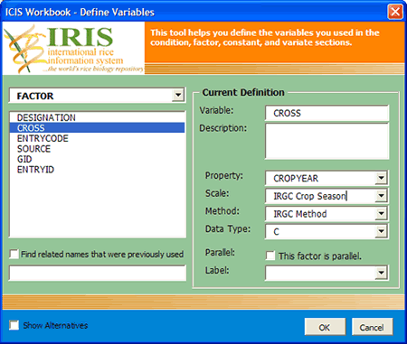
For the factor CROSS, change the Scale (which is “IRGC Crop Season”) to → Parents. You can select from the dropdown list the name of the scale. However, in this case, “Parents” doesn’t exist yet in the database and so it’s not on the list. So, just type the word in the dropdown list.

- Now, go to the VARIATE section then change the Scale of the variate GRNYLD (which is “Kg/plot”) by choosing from the dropdown list the entry → Kg/ha.
- Change the Method of the variate FLW (which is “80% Flowering”) by typing on the box the entry → Days Elapsed.
- Change the Data Type of the variate PACP (which is “C”) by selecting from the dropdown list the entry → N.
- Finally, click on the “OK” button.

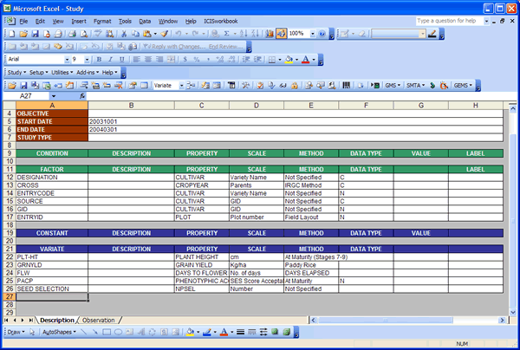

Setting up the Observation sheet:

- Click on the tab at the bottom of the Workbook to go to the Observation sheet. Notice that the column headings contain only the factors. To assign columns for the variates, you need to re-create the Observation sheet. An easy way to do this is to click on the Setup ► Observation sheet menu or click the icon.

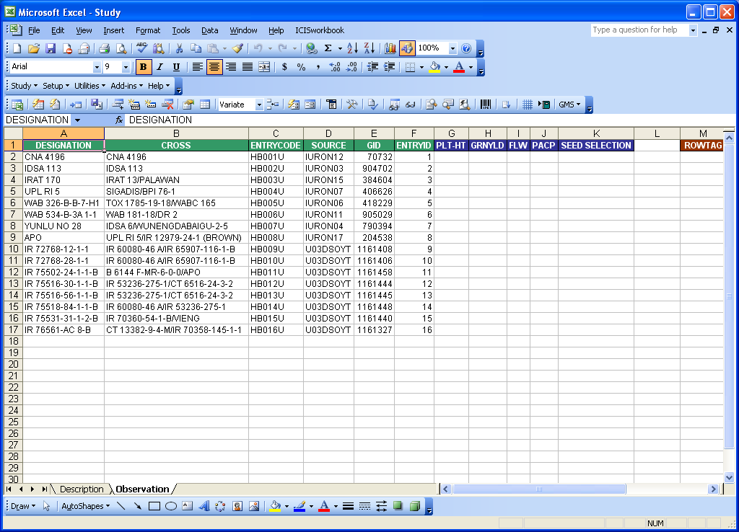

- You can delete columns in the Observation sheet that you may not want to use. The factor ENTRYID for example may not be useful in this study, so remove the column. However, such change should be reflected in the Description sheet.
- Also, you may want to place the column GRNYLD before PLTHT. This can be done by the usual Excel procedure. To reflect these changes in the Description sheet, click on the Setup ► Description sheet menu or click the icon.
- You will be asked to specify the first variate through a dialog interface. Select the appropriate item from the dropdown list and click the “OK” button.

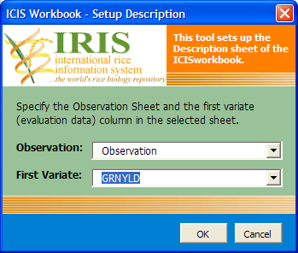

- Now, fill-in the data for the variates. Open the file named “U03WSHB_data.xls”. Copy the content of each variate column (GRNYLD, PLTHT, FLW, PACP) and paste them on the appropriate column in the Workbook file that you’re working on.

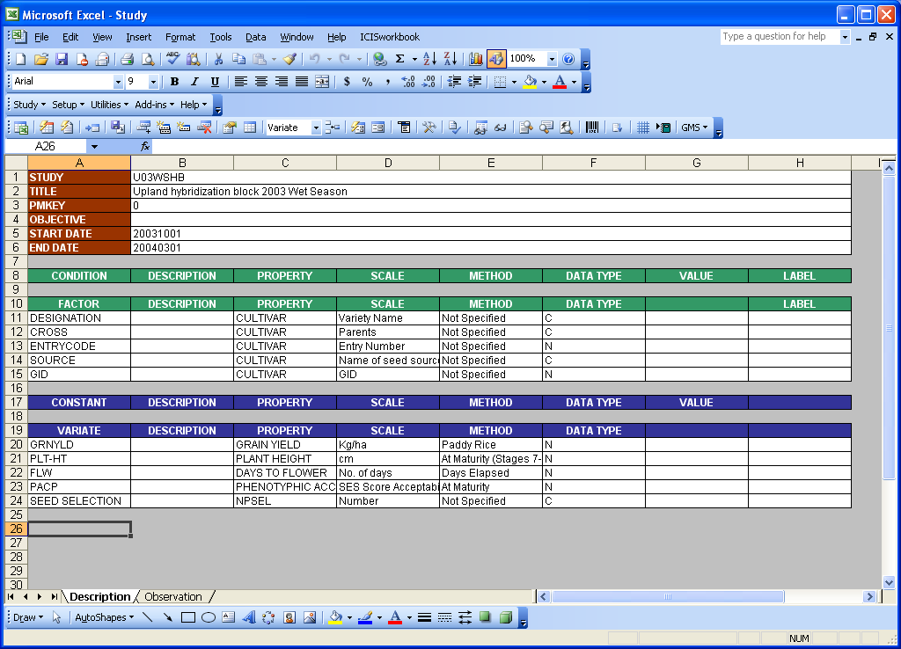

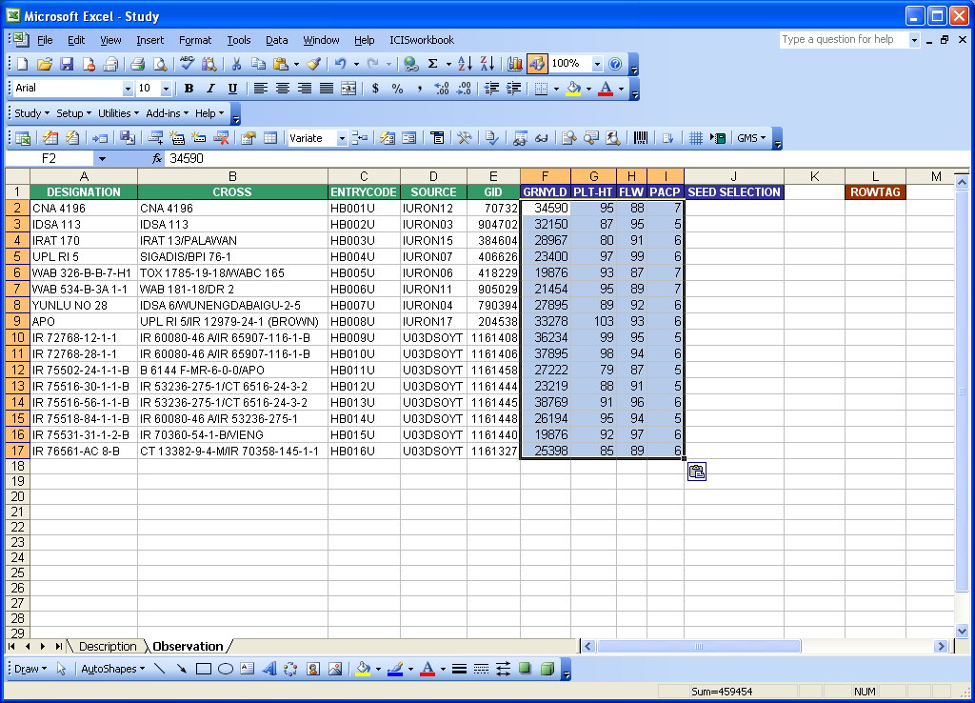

Loading the data:

- You are now ready to load the data. Click on the Study ► Load menu or click the icon. The check routines dialog interface will appear where you can specify the data checks that you want to perform. However, checkboxes with checks and are disabled are mandatory. The rest are checked by default. It is recommended to perform those check routines to ensure the completeness and integrity of your data. There might be special cases, however, where you need to skip those tests. For this exercise just leave them checked and click on the “OK” button.

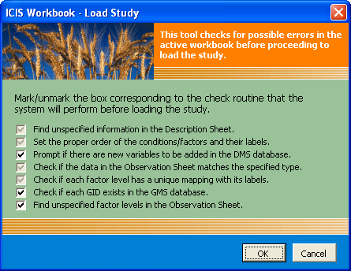

Select GID Column displays select from the drop down arrow ‘GID’ then ‘OK’.
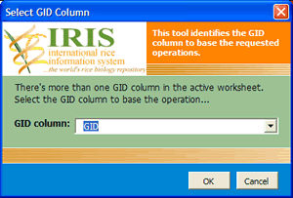
Data Validation Tools displays then click the “Use New” button at the bottom left of the Data Validation window. For the Labels, select the appropriate label from the list on the right section of the Data Validation window then click the “Use” button at the bottom right. In this case, use ‘E’ for Study Type.
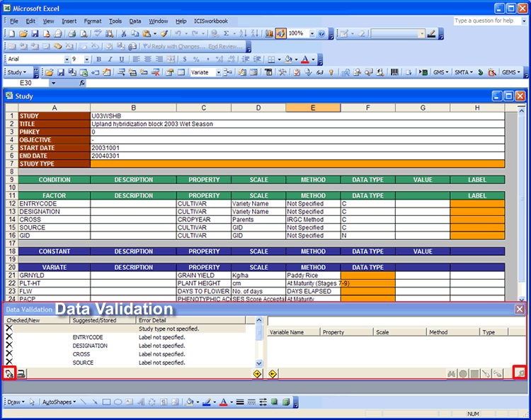

- As the program performs the check routines, most errors are automatically corrected as long as the program has the information needed. But when user decisions are required, the program would do some automation but will eventually ask the user to check the result.

- For example, the LABEL column was left blank previously so the program made each factor variable a true factor even if some are actually just label factors.

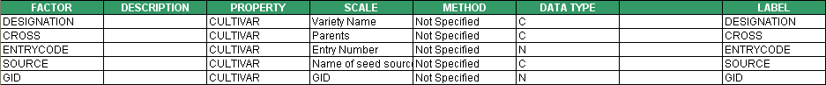

- Since the factor variables came from a SetGen list, only the ENTRYCODE is a true factor and the rest are just labels. So, for the label factors, change the values under the label column to → ENTRYCODE.

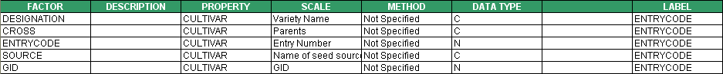

- Load the study again by clicking on the Study ► Load menu or the icon.

- Another error was caught by the program which is a data type mismatch under the column ENTRYCODE.

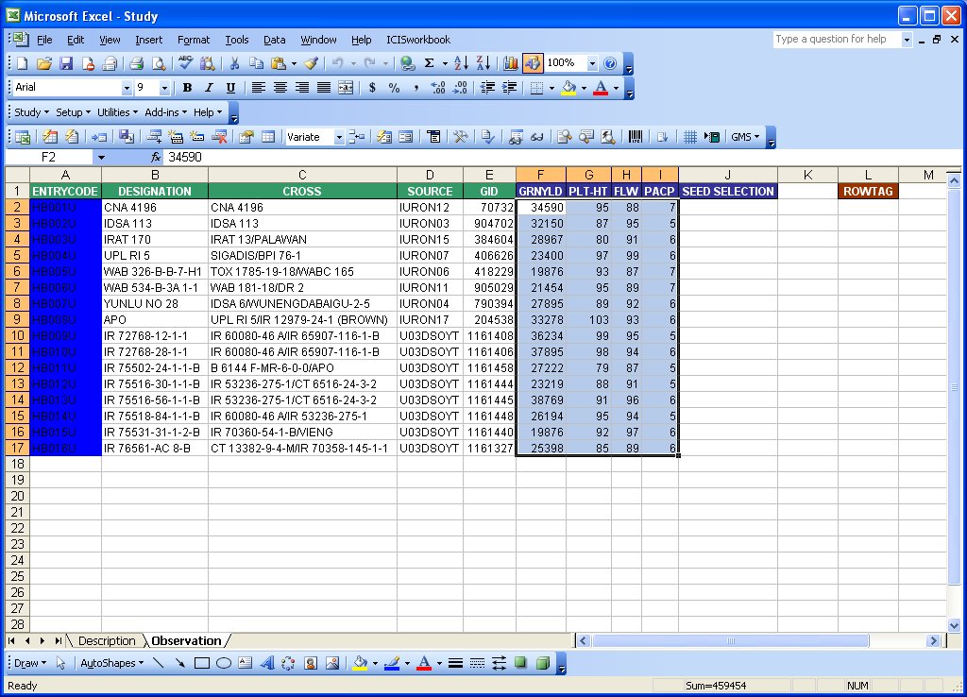
This was an error because the declaration on the Description sheet on the data type of ENTRYCODE is “N” and yet there are non-numeric values under the corresponding column in the Observation sheet. So change the data type of the factor ENTRYCODE from “N” to → C.

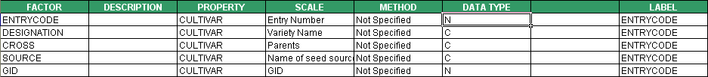

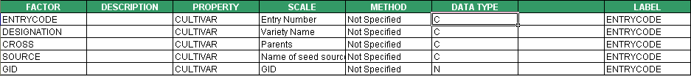

- Load the study again by clicking on the Study ► Load menu or the icon.
- The program then proceeds to perform the other check routines. But since the data in this exercise is now complete, the program proceeds to load the study. It may take some time depending on the amount of your data. But when it’s through, you would be prompted and the color of the cells of your variate data will turn to gray.

