4. InTrack and Managing Seed Stock – Reservation

Introduction:

Objectives: At the end of this tutorial, the user will be able to learn how to:

- View inventory information;
- Reserve seeds;
- Commit reservations.

Tutorial Steps:

A. Viewing Inventory Information

- Start Setgen from Launcher, double-click on U03WSHB from the List Selector.
- Tag all items in the edit window to view inventory.
- Right-click on the white space and select <View Inventory> on the pop-up menu.

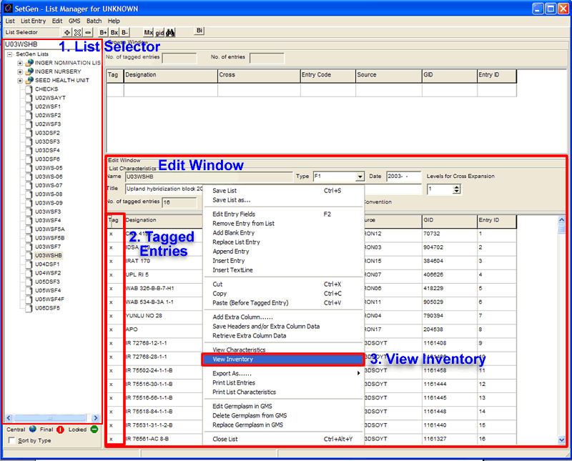

- The Inventory Tracker window is displayed on the screen. The Inventory Details section shows how much seed is available in storage.

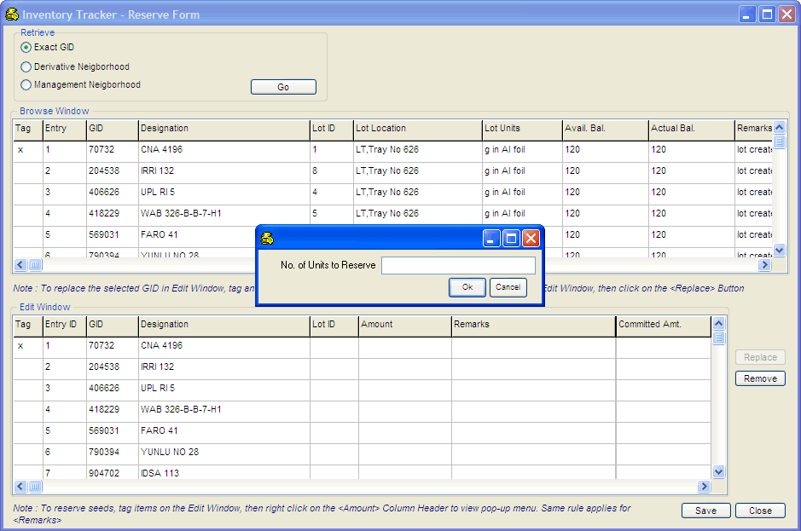

B. Reserving Seeds

- To reserve seeds, tag items on the Edit Window, then right click on the <Amount> Column Header to view pop-up menu. Encode on the space provided for the number of units to reserve and click <Save>. Information window will appear to confirm the transaction(s) added. Same rule applies for <Remarks>. Notice the decrease number of units in the <Available Balance> of the <Browse> window.

