4. InTrack and Managing Seed Stock – Reservation

Introduction:

Objectives: At the end of this tutorial, the user will be able to learn how to:

- View inventory information;
- Reserve seeds;
- Commit reservations.

Tutorial Steps:

A. Viewing Inventory Information

- Start Setgen from Launcher, double-click on U03WSHB from the List Selector.
- Tag all items in the edit window to view inventory.
- Right-click on the white space and select <View Inventory> on the pop-up menu.

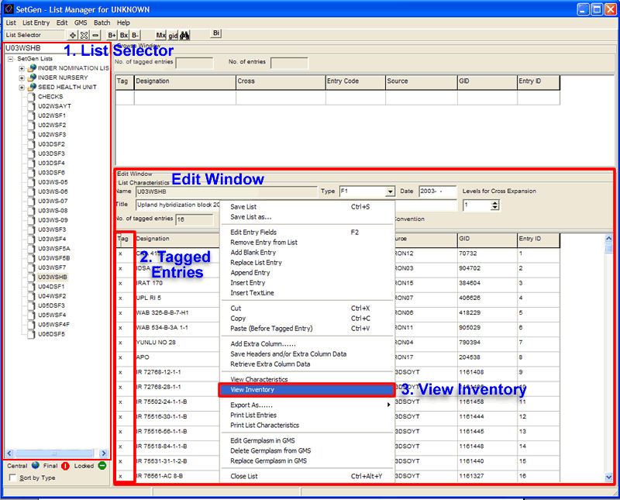

- The Inventory Tracker window is displayed on the screen. The Inventory Details section shows how much seed is available in storage.

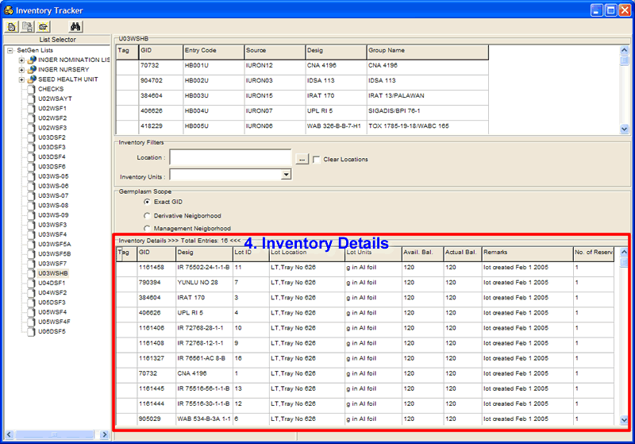

B. Reserving Seeds

- Tag all the items in the inventory details section of the Inventory Tracker window to reserve seeds by clicking on the <Tag> column of the Inventory Details window.
- Right-click on the white space and select <Reserve> on the pop-up menu. The Transaction window will display on the screen.
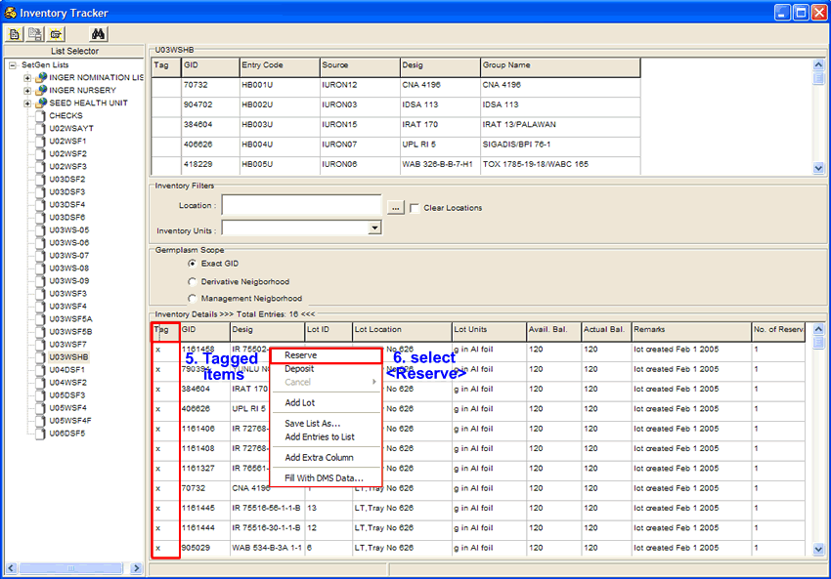

- Encode on the space provided for each item the number of units to reserve, fill in commitment date of the reservation and any comment on the reservation being made.

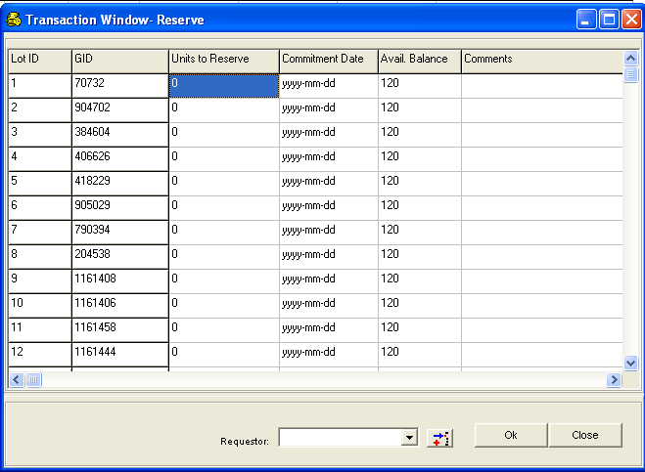

- If the values for all items are the same, click on the column headers of <Units to Reserve>, <Commitment Date> and <Comments>, then a pop-up menu will be displayed.

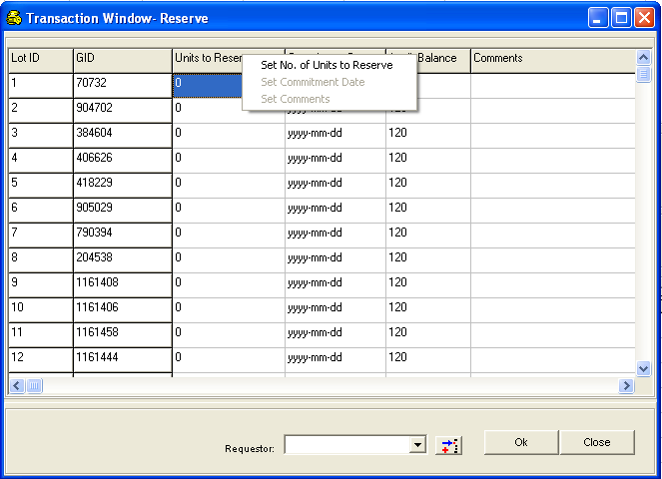

- Click on the enabled sub-menu item to display a small window where data can be entered.

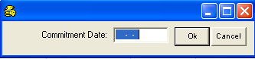
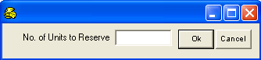
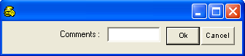
- Click on <Ok> then the Transaction window is updated.
- When you want to assign a requestor for this transaction, select an item from the Requestor drop-down list.
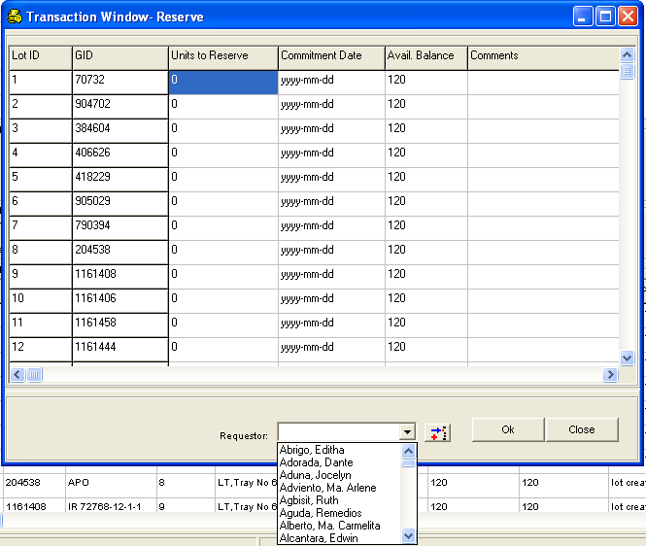

- The system will show a confirmation message on sending an email request to the administrator.

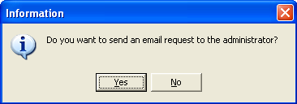

- Click on <No> to continue without sending an email message to the administrator.
- Click <Ok> to save changes to the database. The Transaction Window closes and the system goes back to the Inventory Tracker window. Close Inventory Tracker.

