3. Germplasm Lists: Formation of the Hybridization Block

Introduction:

Once you have selected the parents you wish to cross you need to make a list of those lines for planting in a Hybridization Block. In this exercise, we assume that all the parents are already in the IRIS database. If this is not the case, then these can be entered together with their pedigrees during the formation of the HB or prior to its formation if it is already known which lines are not in the database.

Objectives: At the end of this chapter, the user should be able to:
- Add lines to the HB list.
- Use the IRIS database to form the HB list.

Tutorial Steps:
- Launch ICIS-IRIS
- Check if the Launcher is using the Training.ini
- Start Setgen
- Forming the HB

The process of forming the HB list is identical to that of forming an OYT or AYT list or any list of existing lines for any purpose. The steps are as follows:

- Select List>New>List from the List menu. Enter the name for the new list (U03WSHB), enter a title (Upland hybridization block 2003 Wet Season), select the list type (HB) and check the date.

- Click the + button on the tool bar to add lines to the list (http://cropwiki.irri.org/icis/index.php/TDM_SET_GENERATION_5.4#Basic_Lists). Enter the first designation (CNA 4196), leave the Entry Code field, but fill the Source (IURON12). Click OK.

- This starts a name search for CNA 4196; if there are several hits, select the one with the IRTP number as the parent since the seed came from INGER IURON nursery.

- Repeat steps 2 and 3 for the other 15 lines in the table below.

Designation | Cross | GID | Entry Code | Source
CNA 4196 | CNA 4196 | 70732 | HB001U | IURON12
IDSA 113 | IDSA 113 | 904702 | HB002U | IURON03
IRAT 170 | IRAT 13/PALAWAN | 569031 | HB003U | IURON15
UPL RI 5 | SIGADIS/BPI 76-1 | 406626 | HB004U | IURON07
WAB 326-B-B-7-H1 | TOX 1785-19-18/WABC 165 | 418229 | HB005U | IURON06
WAB 534-B-3A 1-1 | WAB 181-18/DR 2 | 905029 | HB006U | IURON11
YUNLU NO 28 | IDSA 6/WUNENGDABAIGU-2-5 | 790394 | HB007U | IURON04
IRRI 132 | UPL RI 5/IR 12979-24-1 (BROWN) | 204538 | HB008U | IURON17
IR 72768-12-1-1 | IR 60080-46 A/IR 65907-116-1-B | 1161408 | HB009U | U03DSOYT
IR 72768-28-1-1 | IR 60080-46 A/IR 65907-116-1-B | 1161406 | HB010U | U03DSOYT
IR 75502-24-1-1-B | B 6144 F-MR-6-0-0/NSIC RC 9 | 1161458 | HB011U | U03DSOYT
IR 75516-30-1-1-B | IR 53236-275-1/CT 6516-24-3-2 | 1161444 | HB012U | U03DSOYT
IR 75516-56-1-1-B | IR 53236-275-1/CT 6516-24-3-2 | 1161445 | HB013U | U03DSOYT
IR 75518-84-1-1-B | IR 60080-46 A/IR 53236-275-1 | 1161448 | HB014U | U03DSOYT
IR 75531-31-1-2-B | IR 70360-54-1-B/VIENG | 1161440 | HB015U | U03DSOYT
IR 76561-AC 8-B | CT 13382-9-4-M/IR 70358-145-1-1 | 1161327 | HB016U | U03DSOYT

Now it is possible to fill the Entry Code columns in several ways. We may want to enter a list of Plot Numbers in this field. To do this, right click on the Entry Code column heading and select Fill with Sequence. In the Naming Convention Box enter HB as the Prefix, 1 in the Start No, U as the Suffix, check Include Leading Zeros and set Numeric Field Width to 3. Click Ok. The Entry Code field should be filled as in the table above. Save the list, then export, (List>Export As>XLS Excel File) it to Excel as HB nursery planting list.

Figure 3.1 Filling the Entry Code column with plot numbers
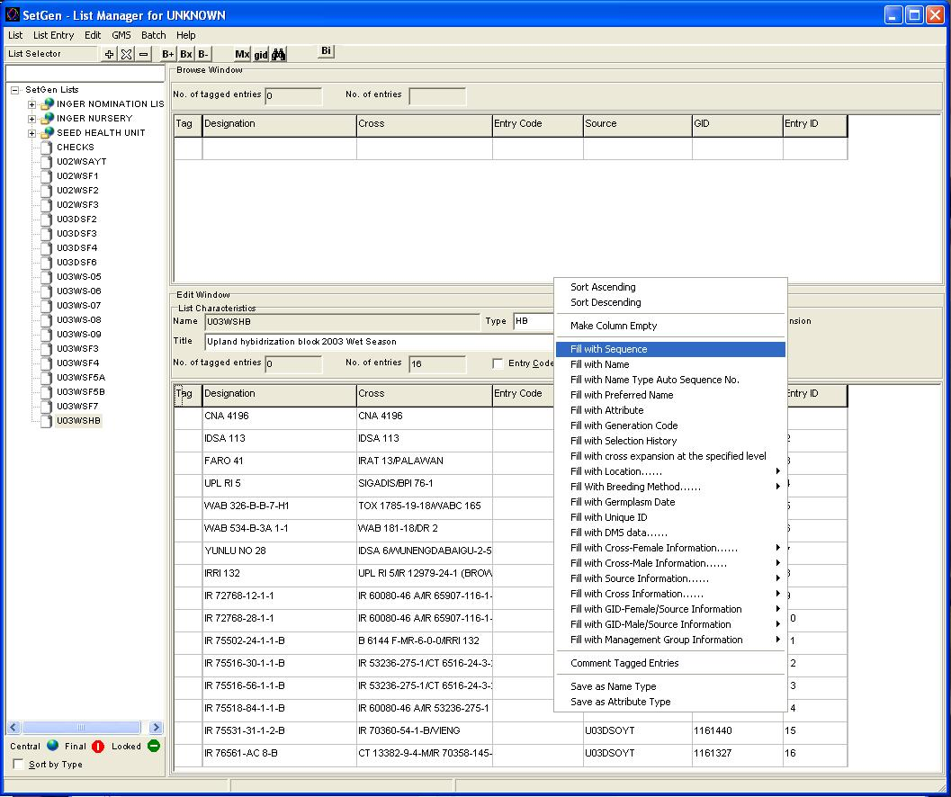

Figure 3.2 Specifying format for the Plot number.

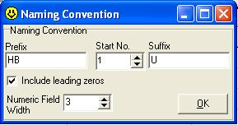

Figure 3.3 Hybridization Block nursery list.

