Managing Nursery Data in IRIS: The Workbook

The Data Management System (DMS) is the component of ICIS that manages environmental data, germplasm characterization data, and evaluation data for genetic resources and crop improvement projects. DMS links these data to genotype information in the ICIS Genealogy Management System (GMS) and to location information in the Location Management Module (LMM) as well as providing links to other specialized data sources. DMS also allows integration of data from different studies, thus permitting a broad range of queries across trials or types of factors and variates. For further discussion about DMS, see Chapter 7 of the technical documentation of ICIS.

ICIS Workbook is the data entry application for the DMS. It provides more than 40 different functionalities via a dedicated menu and toolbar that bind with the MS Excel application.

Objectives:
- Grasp the concepts of the ICIS Workbook.
- Know how it manages data of a nursery trial.

Definition of Terms

Study

A study is the basic, reportable unit of research. It is synonymous with the notions of experiment, nursery or survey. A STUDY must be uniquely identified by a name which can be a combination of alphanumeric characters, space, underscore, and dash not exceeding a database field limit of 50 characters or a shorter soft limit which can be set in the *.ini file. A study TITLE, however, is used to provide a more descriptive name of up to 255 characters. An ICIS-intrinsic PMKEY or project management key is also definable but is currently not being used. An OBJECTIVE for the study can be defined for up to a limit of 255 characters. The START DATE and END DATE of the study can also be set as a numeric entry of the form yyyymmdd. And finally, the STUDY TYPE classifies the study to be either an experiment (E), nursery (N), survey (S), and so on.

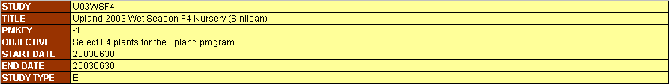

Figure 1. Study description
Factor and Level

A classifying variable whose value is already known before the study is conducted is called a FACTOR. A common example would be an entry no. which identifies each individual entry on a given list. The discrete values given to a factor variable are called Levels. Thus, in the illustration below, the nos. 1, 2, 3, and so on… are the levels of the factor “ENTRYNO”. These levels can be either numeric (N) or character (C) DATA TYPE, and may be composed of the printable ASCII characters. Factor variables are identified by their name which can also be made up of alphanumeric characters, space, underscore, and dash not exceeding a database field limit of 50 characters. However, same as the Study Title, a DESCRIPTION field with a limit of 255 characters is allotted to contain a clearer definition of a most likely abbreviated factor name.

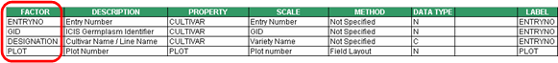
Figure 2. Factor variables

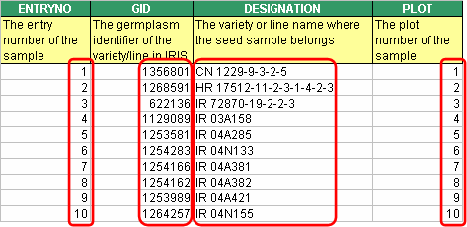

Figure 3. Factor levels

Condition

A factor that has a single level throughout the study is called a CONDITION. A common example is “YEAR” if the study was conducted within a year, or “LOCATION” if the study took place in a single location.

Figure 4. Condition variables

Label

A factor whose levels present additional information regarding the corresponding levels of another factor is called a LABEL of that factor. The “GID” and “DESIGNATION”, for example, give other information about entry no. 1, having a germplasm identifier 1356801, and a cultivar name CN 1229-9-3-2-5. Thus, “GID” and “DESIGNATION” are labels of “ENTRYNO”.

To distinguish between whose a label of whom, the encoder must choose which factor is best suited to be the primary factor that can uniquely identify each individual entries. Once a certain factor was chosen, the next step would be to have that factor’s name appear under the LABEL column on the same row as the factor variable. Thus, a primary factor would have the same value for the variable name and label columns. Furthermore, to denote the other factors as labels of the primary factor, they must have the name of the primary factor appear under the LABEL column on their corresponding rows.

For the conditions, there is a special label called “STUDY” which is placed under the LABEL column of the condition rows. This signifies the variables in the condition section to be conditions of the study. This assumption conveys that not all variables in the condition section apply to the whole study. If the condition variables have under the LABEL column their own name or the name of other condition variables, they are actually just factors having initially a single level for the time the current study is defined. But they may take a different value in another declaration of the study using the same study name.

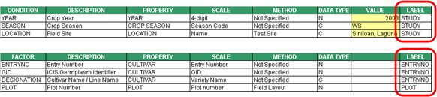

Figure 5. Labels

Variate and Data

A variable that is being measured or observed in the study is called a VARIATE. The value of this variate variable is termed as Datum or Data. Variate names, like factors, can be composed of alphanumeric characters, space, underscore, and dash not exceeding a database field limit of 50 characters. A DESCRIPTION field with a limit of 255 characters is also allotted to contain a clearer definition of a most likely abbreviated variate name. And variates may contain data of numeric (N) or character (C) DATA TYPE as well.

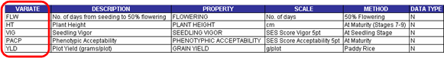

Figure 6. Variate variables

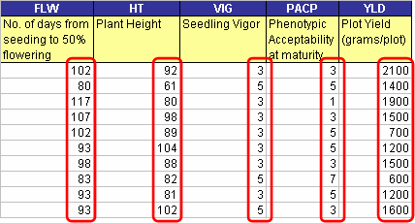

Figure 7. Variate data
Constant

A variable that is measured only once in the study is called a CONSTANT. Typical examples are the characteristics of the soil used in a particular study that is conducted in one location.

Figure 8. Constant variables

Property, Scale, and Method

PROPERTY is a measurable characteristic of an experimental unit or experimental material that is manipulated or measured in a study. SCALE is a unit of measurement used in expressing a property. METHOD is the manner a property is measured, observed or applied. Collectively these are called ontology. Ontology are controlled vocabularies. This enables different studies using different variable names but pertaining to similar concepts to be compared and summarized. Thus, the investigators have the freedom to choose their variable naming conventions but can still communicate the same concepts by defining their variables through a common ontology.

Observation Unit

An observation unit is a combination of the levels of one or more factors that as a whole defines the datum that was measured. It is equivalent to a row in a spreadsheet excluding the variate data which resulted from the measurements.

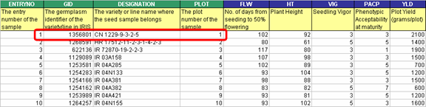

Figure 9. Observation unit

The ICIS Workbook Structure

Since MS Excel provides so much flexibility to be done on a worksheet, it is possible but time-consuming for the ICIS Workbook to know where exactly a particular piece of information can be read from the worksheet. Thus, in order to have a standard place to look for different kinds of data, ICIS Workbook uses a formatted input file composed primarily of two sheets: the Description and Observation sheets. The Description sheet is for entering information about the study and for describing the different variables used in the study while the Observation sheet is for entering the data gathered from the study.

Description Sheet

The Description sheet is divided into five sections: STUDY, CONDITION, FACTOR, CONSTANT, and VARIATE. Each of this section has a corresponding named range of cells which are defined automatically along with the creation of the input file.

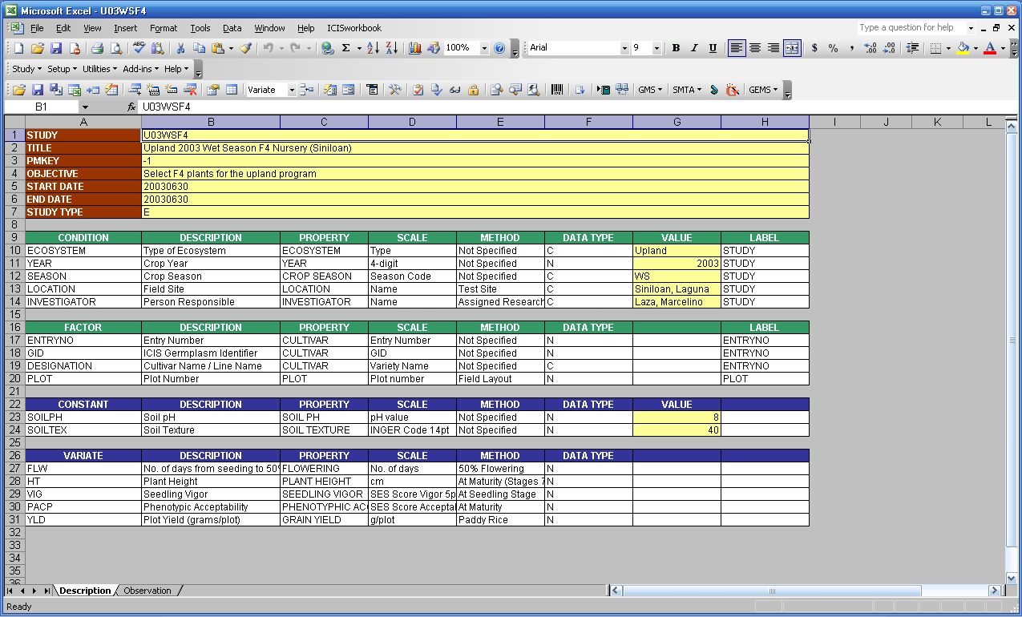

Figure 10. Description sheet

The named ranges are listed on the Name Box which can be seen on the upper left corner of MS Excel. By clicking on a cell, the cell’s address is displayed on the box except when that cell or group of cells has a defined name. By selecting a name from the list, the corresponding cell or group of cells get selected on the worksheet.

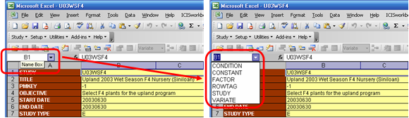

Figure 11. Named ranges

The STUDY section has seven rows with two columns each. The first column contains the row labels while the second column is for entering the corresponding row values. The seven rows are labeled as STUDY, TITLE, PMKEY, OBJECTIVE, START DATE, END DATE and STUDY TYPE. The STUDY row contains the name of the study that uniquely identifies each study in the database. If you intend to load a new study, the name must not exist yet. Otherwise, the content of your new study will be merged to an existing study in the database that has the same name.

The CONDITION, FACTOR, CONSTANT, and VARIATE sections use a fixed set of columns while their rows vary according to the number of variables used. The Condition section makes use of eight columns. The Factor and Constant sections use only seven. The Variate section uses only six except when a parallel factor is defined in the study.

In all four sections, the label of the first column is the name of the section. Variable names to be used in the study are entered in this first column. The second column, labeled DESCRIPTION, is where you can completely describe the variable name used. The third, fourth, and fifth columns are for the PROPERTY, SCALE, and METHOD or what we have previously defined as the ontology of the variable. The sixth column is for the DATA TYPE. The seventh column, called VALUE, is only found under the Condition and Constant sections while the eighth column, called LABEL, exists only in the Condition and Factor sections.

Observation Sheet

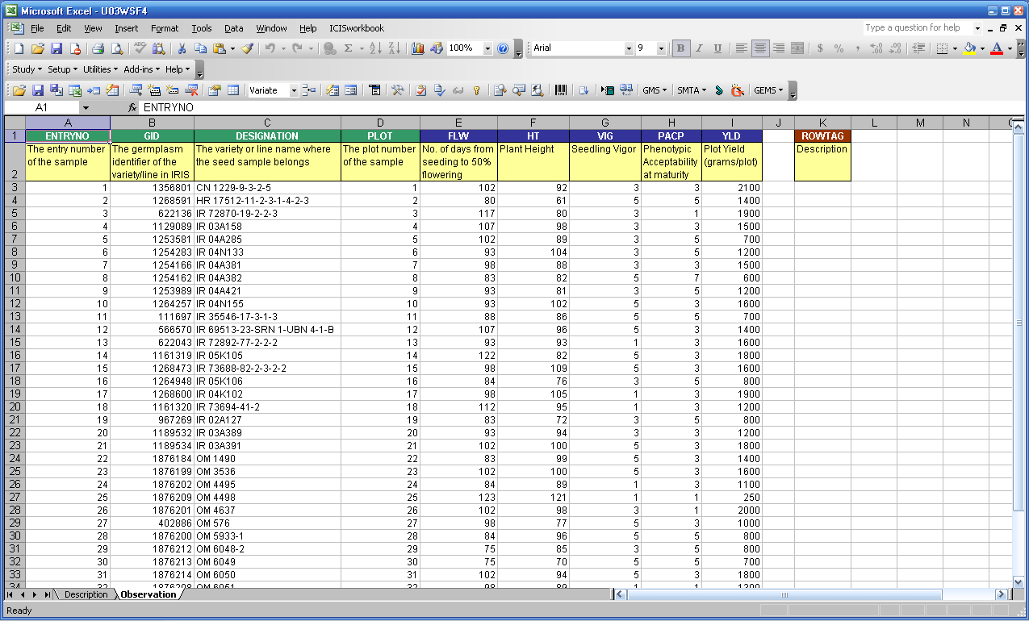

Figure 12. Observation sheet

The Observation sheet is initially blank upon creation of the input file. But by using the Setup ► Sheet ► Observation menu, the factors and variates defined in the Description sheet are automatically assigned as column headings in the Observation sheet. Note that only the factors and variates are carried over from the Description sheet to the Observation sheet. This is because conditions and constants have fixed values throughout the study and a VALUE column is already provided for these in the Description sheet. Note further that the order of the factor and variate rows in the Description sheet is the same as the order of the columns in the Observation sheet. This is required by the application to eliminate the need to always check if the right data is on the right place.

There is a special column called the ROWTAG column in the Observation sheet. This is found one blank column away from the last variate column. Any mark under this column would render the corresponding row as a comment and will be ignored during the loading of the observations to the database. A named range is automatically created and used by the system to refer to this column.

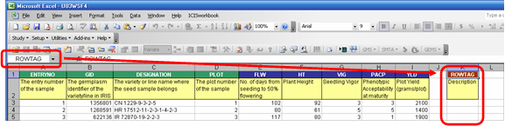

Figure 13. ROWTAG column

Setting MS Excel Security Level

ICIS Workbook is a collection of VBA macros packaged as an Excel Add-in application. Being a macro, it has to pass through Excel’s security feature which has four levels: Very High, High, Medium, and Low. The security levels can be accessed through Excel’s Tools ► Macro ► Security menu:

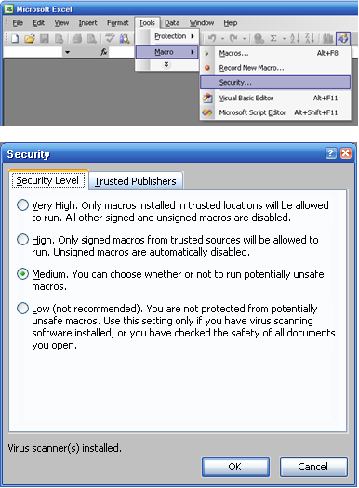
Figure 14. MS Excel Security Levels
Depending on the current security level set, running a macro will prompt the following message:

Very High: (Figure 15)

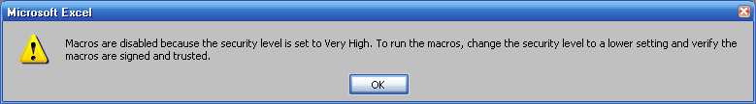

High: (Figure 16)

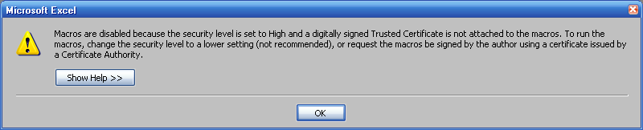
Medium: (Figure 17)

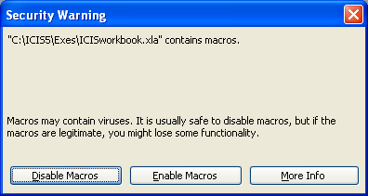

Low:

This security setting will no longer show any message. Any macro run will just load seamlessly, even viruses, so try to avoid this setting.

In order to run the ICIS Workbook, the security level must be set to Medium.

Starting ICIS Workbook

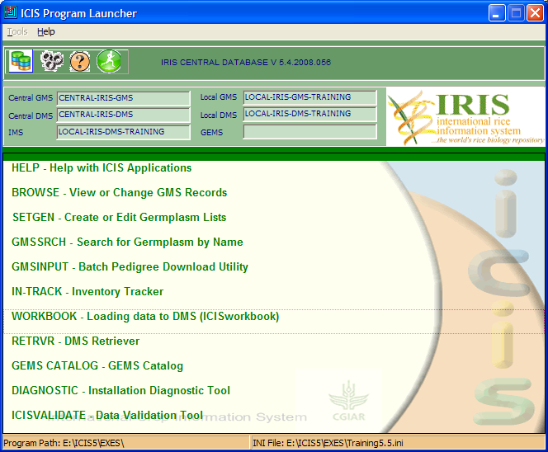

Figure 18. Running ICIS Workbook from the ICIS Program Launcher

After you’ve set the MS Excel security level to Medium and you have double-clicked the WORKBOOK entry from the ICIS Launcher, the Security Warning dialog interface will be shown.
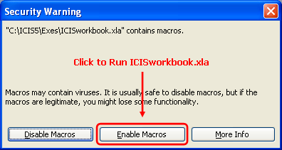

Figure 19. Security Warning dialog interface

You must click the “Enable Macros” button for ICIS Workbook to run. After this, the About ICISworkbook dialog interface will be shown as the welcome screen.

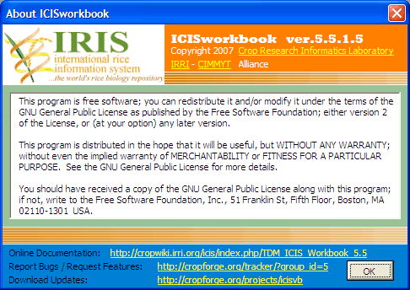

Figure 20. About ICISworkbook welcome screen

Once ICIS Workbook has been launched, a menu item labeled ICISworkbook will be added to the main menu of Excel. This is useful for identifying if ICIS Workbook is currently running. It contains two submenus, namely, Show Menu and About. “Show Menu” displays the ICIS Workbook menu and toolbar, while “About” displays the About ICISworkbook dialog interface.

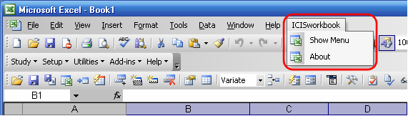

Figure 21. ICISworkbook Excel menu

The ICIS Workbook menu and toolbar address the needs of both novice and experienced ICIS Workbook users.

The ICIS Workbook menu provides hierarchical groupings of menu items for novice users to have an idea on where to find a specific function. It consists of five groupings: Study, Setup, Utilities, Add-ins, and Help.

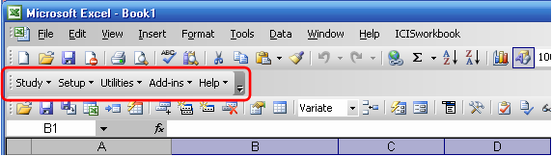

Figure 22. ICISworkbook menu

The ICIS Workbook toolbar provides quick access to experienced users when they are already familiar with the toolbar icons and their associated functions. But letting the mouse pointer stay on top of an icon for a few seconds will also reveal the name of the function.

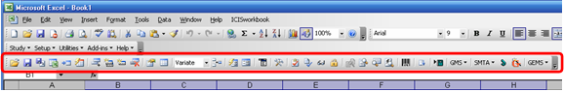

Figure 23. ICISworkbook toolbar

Creating a Workbook File from a Germplasm List

The succeeding steps will teach you how to create an ICISworkbook file for an Upland Hybridization Trial. The trial is unreplicated. Grain yield, plant height, flowering days, phenotyphic acceptability, and seed selection are measured in the trial.
- Click on the Add-ins ► Import SetGen List menu or click the icon. “Open Template” window displays and asks for the template to be used else if you don’t have one just click <Cancel>.

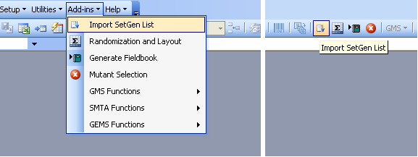

- From the “Import Setgen List” appears the “Retrieve List” dialog interface. In the search box, type→ U03WSHB. Notice that as you type along, the system searches for a match from the list. You can also scroll down the list manually and select an item if you can’t remember the exact name. Alternatively, you can use the tree structure in the leftmost of the dialog interface and search for the list name within the directories.

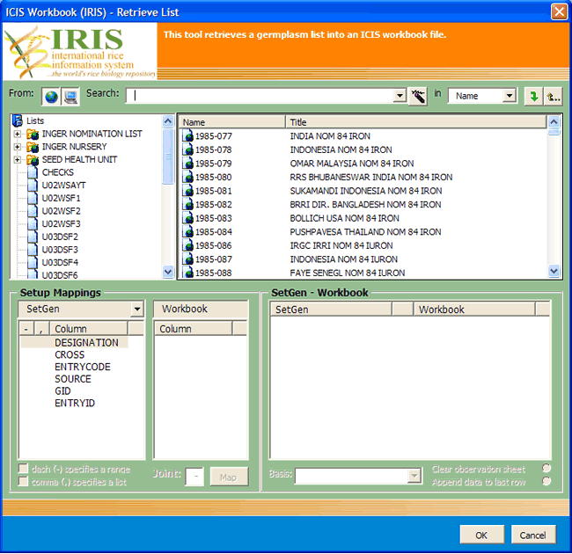

At the right side of the dialog interface, there is a section entitled “Workbook Columns”. This is useful if you have a Workbook template to use other than creating a new Workbook file. If you have an open Workbook template, the column names in that template will appear in the dropdown lists.

- Once the desired germplasm list has been selected, click the “OK” button. A new ICIS Workbook file will be created for you with some information already filled-in such as the study name and title and some variables used in the study.

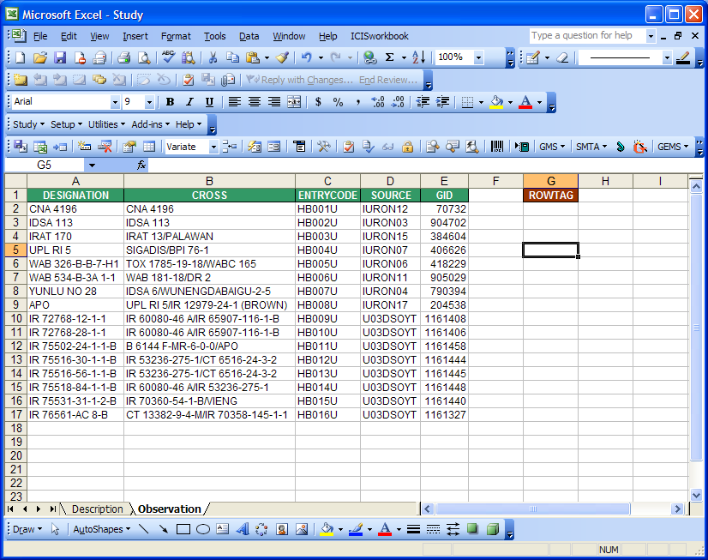

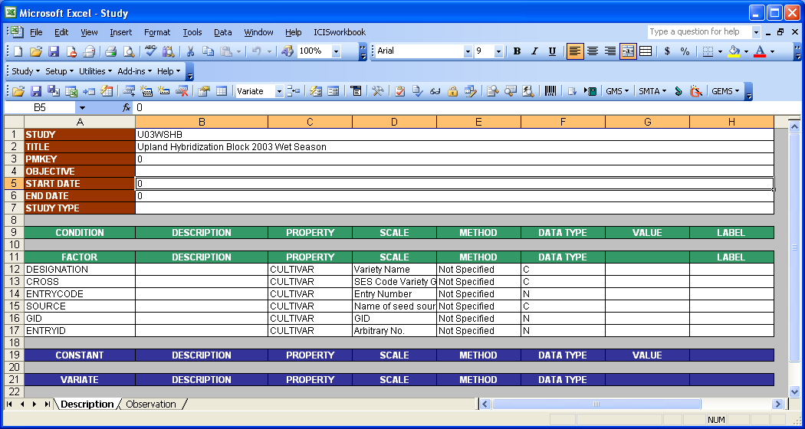

- 4On the cell beside the label START DATE, type → 20031001.

- On the cell beside the label END DATE, type → 20040301.

- On the cell beside the labels STUDY TYPE, type → ‘E’ for experiment.

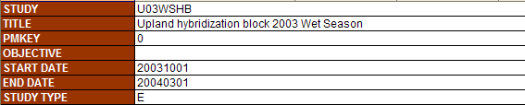
Describing the Variable:

VARIATE | PROPERTY | SCALE | METHOD | DATA TYPE
PLTHT | PLANT HEIGHT | Cm | At Maturity  (Stages 7-9) | N
GRNYLD | GRAIN YIELD | Kg/ha | Paddy Rice | N
FLW | DAYS TO FLOWER | No. of days | Days Elapsed | N
PACP | PHENOTYPHIC ACCEPTABILITY | SES Score  Acceptability 5pt | At Maturity | N
SEEDSEL | PLANT SELECTED | No. of plants | Breeding Selection | N

- Under the VARIATE section, insert 5 additional white rows. Notice the pair of icons . Click on the icon to select which variable section you would like to add a row to. Then, click on the icon 5 times to add 5 blank white rows.

- Under the cell labeled VARIATE, type on each row → PLTHT, GRNYLD, FLW, PACP, SEEDSEL.

- To define the ontology for the newly-added variates, click on the Setup ► Variable Section ► Express Setup menu or click the icon.

- The “Express Variable Setup” dialog interface will appear asking you which database table you would like the system to search for an existing name resembling each variate name.

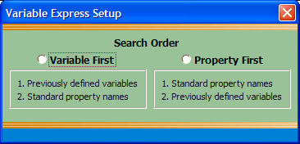

Click on the “Property First”. The system then would search first for a similar property name for each variable name that you have used, then if no exact match was found it will proceed to search for the previous variable names used. However, there may be possible variants of a variable name. If there is no exact match for a variable name, the system gives you the closest match it can find. Thus, you may encounter cells with comments in your variable names which call your attention to take a look at the closest match it found.

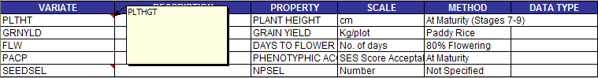

As you select a cell with a comment, notice that there was a change in the ICIS toolbar - a new menu has been added. In this exercise, select the ‘PLTHGT’ cell and click the toolbar icon.

The “Use” menu gives you the option to choose which variable name you will use; either the “New” name which you declared or the “Existing” name that the system found.

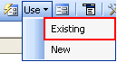

You have the freedom to use any variable name that you may have been accustomed to. However, the system provides you the utility to maintain a standard naming convention. So, choose your variable names well at the beginning and maintain a discipline in naming your variables. For the two red cells, choose the “Existing” names.
- The property, scale, and method for the factors and variates are already complete. However, we need to modify some of the ontology to give a more appropriate value. In this case, you will need to click on the Setup ► Variable Section ► Custom Setup menu or click the icon.
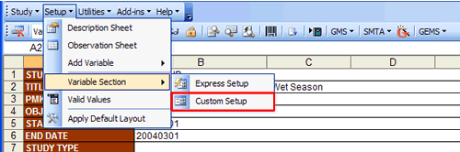
- To use this interface, first, select the variable section (e.g. FACTOR). Notice that the factor variables appeared on the list below the section name. As you select each of the variables, its definition appears on the right side of the dialog interface. This is where you can make changes.
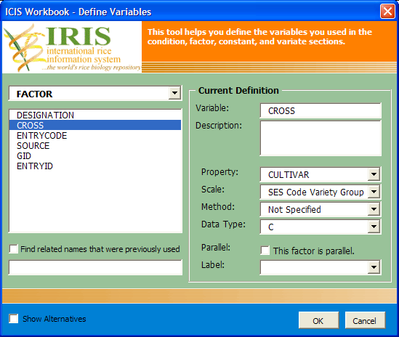
- For the FACTOR section, select the <CROSS>. Change the <Scale> (which is “SES Code Variety Group”) into → Parents. You can select from the dropdown list the name of the scale. However, in this case, “Parents” doesn’t exist yet in the database. So, just type the word in the dropdown list box.
- For the <ENTRYCODE>, change the <Data Type> to ‘C’.

- Now, go to the VARIATE section, for PLTHT choose <Data Type> ‘N’ for numeric.
- Change the <Scale> of the variate GRNYLD (which is “Kg/plot”) by choosing from the dropdown list the entry → Kg/ha. For the <Data Type>, choose ’N’.

- For FLW, set the <Data Type> to ‘N’.

- For PACP, set the <Data Type> ‘N’.

- For SEEDSEL, set the <Data Type> ‘N’.

- Finally, click the “OK” button.

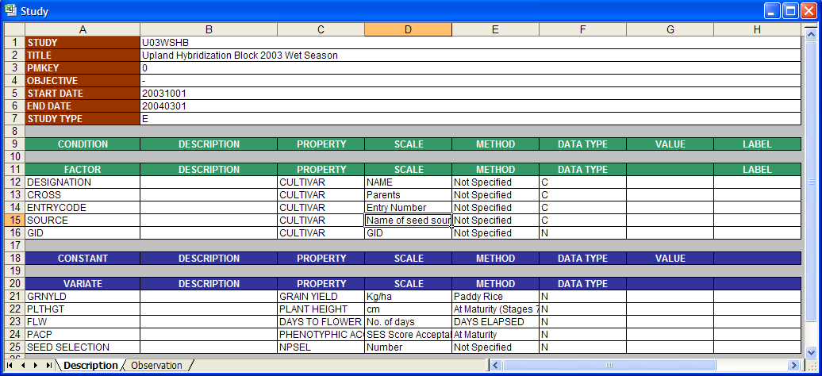

Setting up the Observation sheet:

- Click on the tab at the bottom of the Workbook to go to the <Observation sheet>. Notice that the column headings contain only the factors. To assign columns for the variates, you need to re-create the Observation sheet. An easy way to do this is to click on the <Setup> ► <Observation> sheet menu or click the icon.

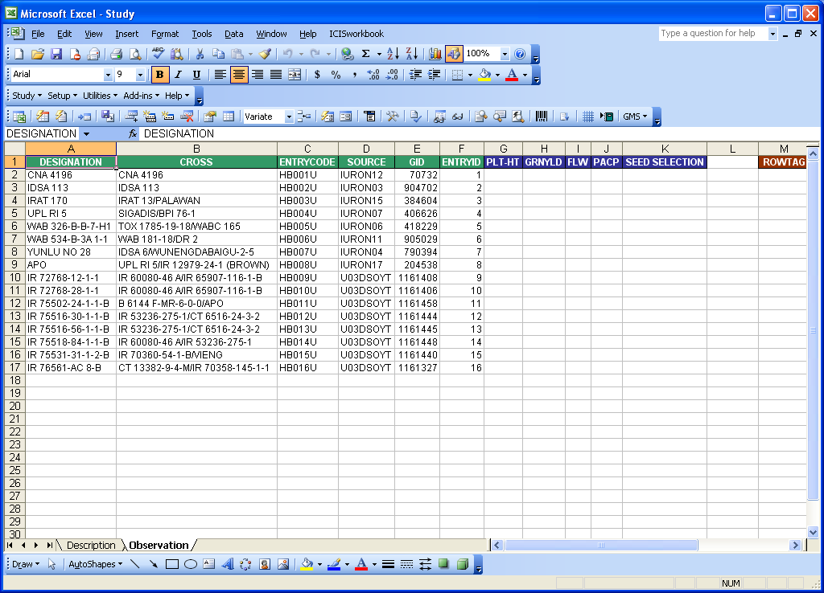

- You can delete columns in the <Observation sheet> that you may not want to use. The factor ENTRYID for example may not be useful in this study, so remove the column. However, such change should be reflected in the <Description sheet>.

- Also, you may want to place the column GRNYLD before PLTHT. This can be done by the usual Excel procedure. To reflect these changes in the Description sheet, click on the <Setup> ► <Description> sheet menu or click the icon.

- You will be asked to specify the first Variate through a dialog interface. Select the appropriate item from the dropdown list and click the “OK” button.

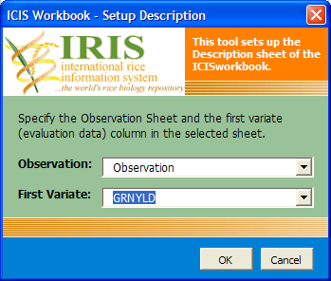
- Now, fill-in the data for the Variates. Open the file named “U03WSHB_data.xls”. Copy the contents of each variate (GRNYLD, PLTHT, FLW, PACP) and paste them on the appropriate column in the Workbook file that you’re working on.

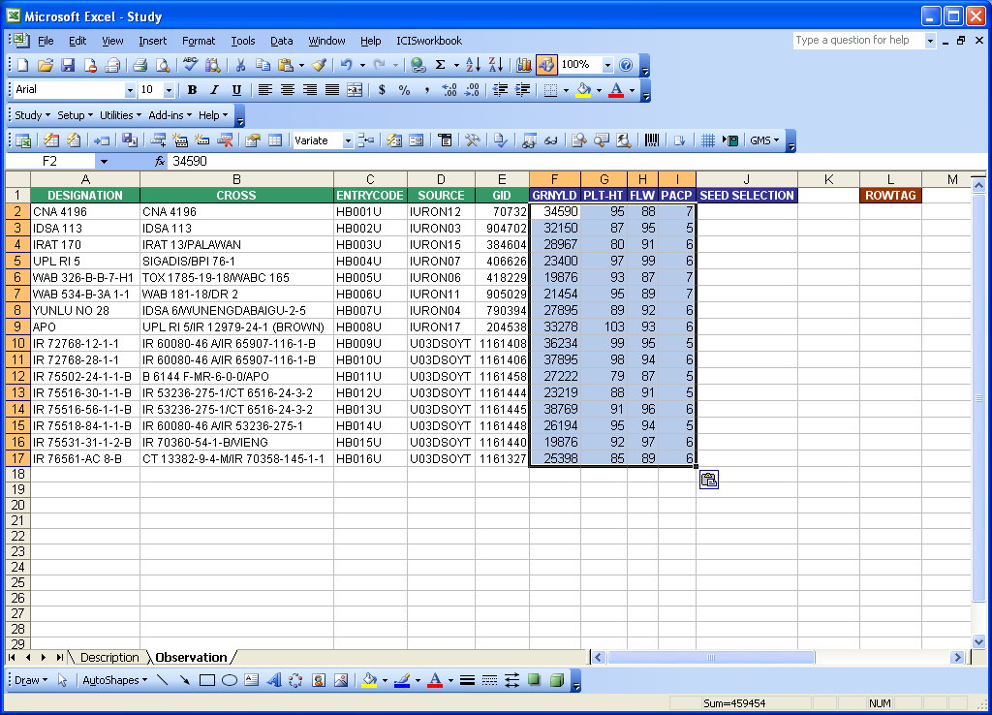

Loading the data:

- You are now ready to load the data. Click on the <Study> ► <Load> menu or click the icon. The Load Study interface appears and confirms the study to be loaded to be loaded in the DMS local database.
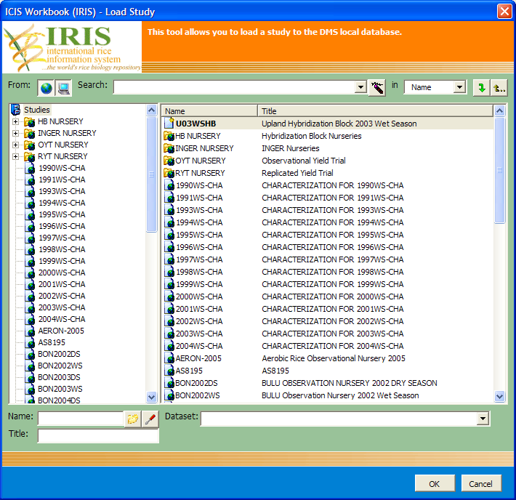
- The check routines dialog interface will appear where you can specify the data checks that you want to perform. However, it is recommended to perform all check routines to ensure the completeness and integrity of your data. There might be special cases, however, where you need to skip those tests. For this exercise just leave them checked and click on the “OK” button.
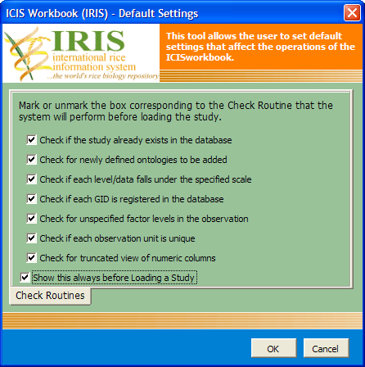
- As the program performs the check routines, most errors are automatically corrected as long as the program has the information needed. But when user decisions are required, the program would do some automation but would eventually ask the user to check the result.

In this exercise, the LABELs are missing, so the program highlighted the cells and gave suggestions at the bottom window for the user to choose from.

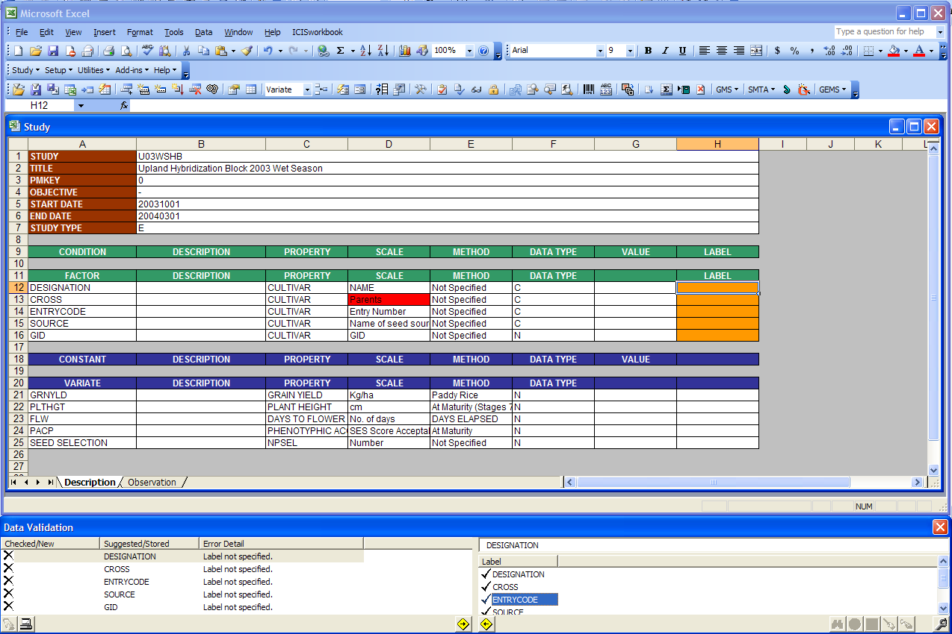

- Since the factor variables came from a SetGen list, only the ENTRYCODE is the primary factor and the rest are just labels. So, for the label factors, change the values under the label column to → ENTRYCODE.

- First, select ENTRYCODE on the left section of Data Validation window. Then, select ENTRYCODE on the right section. Click the “Replace” toolbar icon located at the rightmost corner of the Validation window.

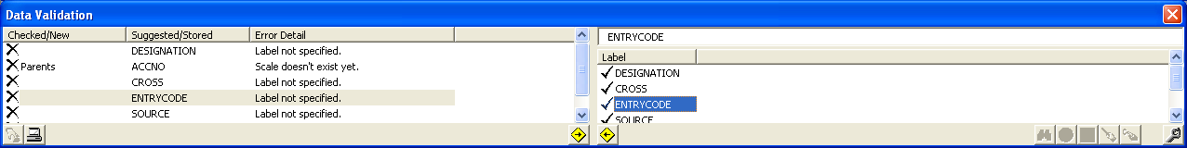

- Select DESIGNATION on the left section. Then, select ENTRYCODE on the right. Then click the <Replace> toolbar.

- Do the same for CROSS, SOURCE, and GID.
- For the newly-defined scale “Parents” which was added earlier, just click on the “Use New” toolbar icon to register the scale to the database.

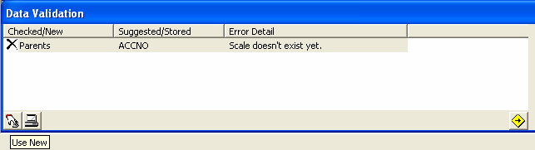

- Load the study again by clicking on the Study ► Load menu or the icon.
- The program then proceeds to perform the other check routines. But since the data in this exercise is now complete, the program proceeds to load the study. It may take some time depending on the amount of your data. But when it’s through, you would be prompted and the color of the cells of your variate data will turn to gray.

