11. Managing Seed Stock – Deposit and Barcode

Introduction:

Objectives: At the end of this chapter, the user will be able to:

- Create lot locations for the F₅ list.
- Deposit F₅ seeds for stocking.
- Committing transactions.
- Viewing seed stock through the Reporting Tool.
- Generate labels and barcode

Tutorial Steps:

A. Creating lot location for the F5 list

- Open SETGEN, select U06DSF₅ from the List Selector (double click).
- Tag all entries on the Edit Window of SETGEN
- Right-click on the white space and select <View Inventory> on the pop-up menu. A message will display prompting the user to deposit now.
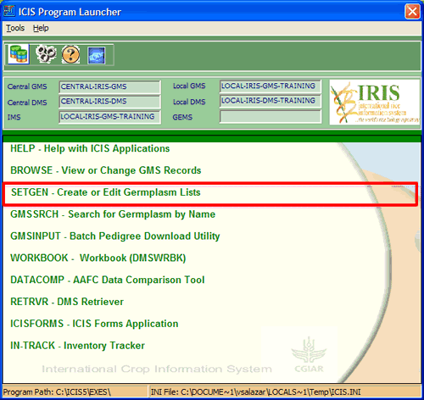
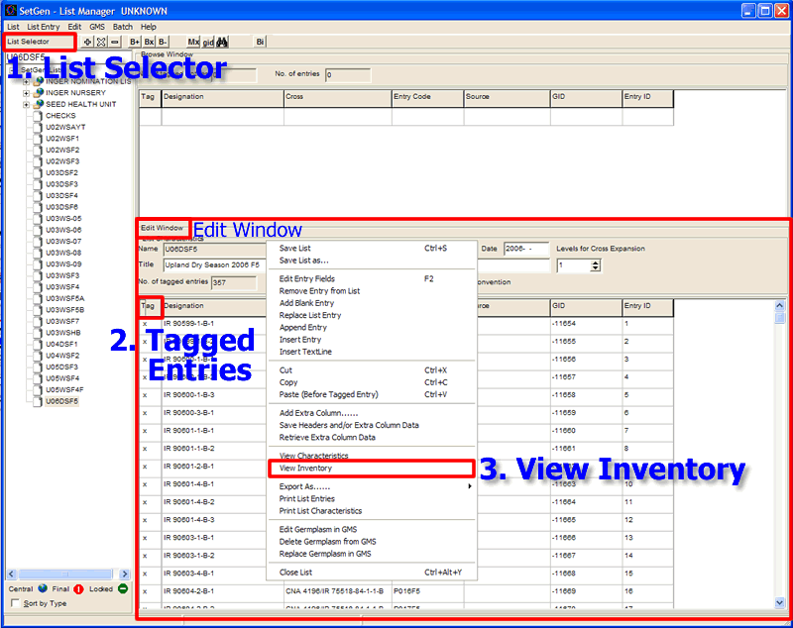

- The Non-Existent Lot Data window will display.
- Click on the <tag> column header to tag all records.
- Step 1a: Selecting a location. Click on the ellipses button to view the location window.
- The Location window displays.
- Select <Short Term> on the Collection drop-down list then select <ST, Tray No. 998> on the Tray drop-down list. Click on the <OK> button to close the window and update the location field on the inventory details section.

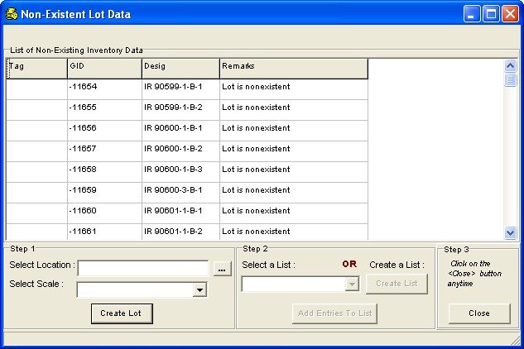
6.
5. Tag Entries
9.
10.
12.

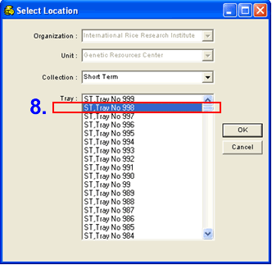

- Select <Packet> on the Inventory Units drop-down list.
- Click on <Create Lot> to add records to the database.

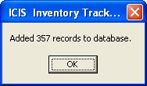
- A message window displays informing how many records are added to the database.
- Click on <Close> to exit from this window.
- The Inventory Tracker window will display. The new lots are displayed on the Inventory Details section.

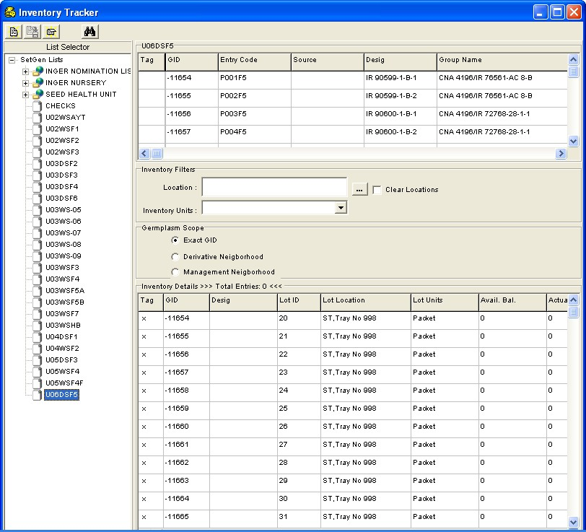
B. Depositing seed stock for the F₅ list

- Tag all the items in the Inventory Details section.

- Right-click on the white space and select <Deposit> on the pop-up menu. The Transaction window will display on the screen.

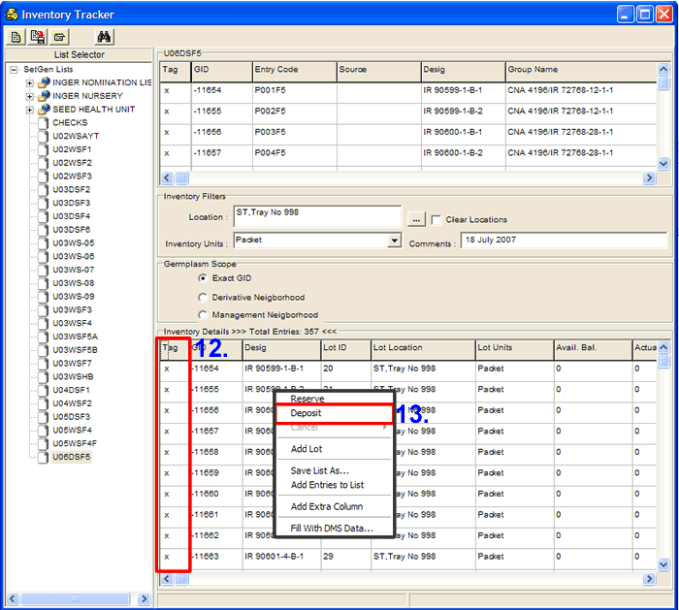
14.
15.

- Encode the number of units to deposit, commitment date of the deposit and any comment on the deposit being made, on the space provide for each item.

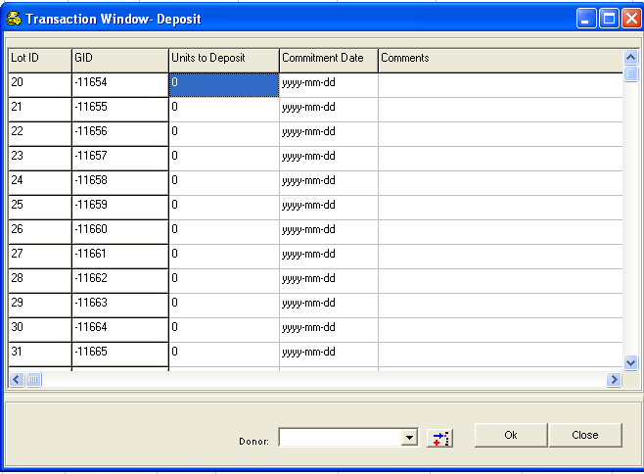

- If the values for all items are the same, click on the column headers of <Units to Deposit>, <Commitment Date> and <Comments>, then a pop-up menu will be displayed.

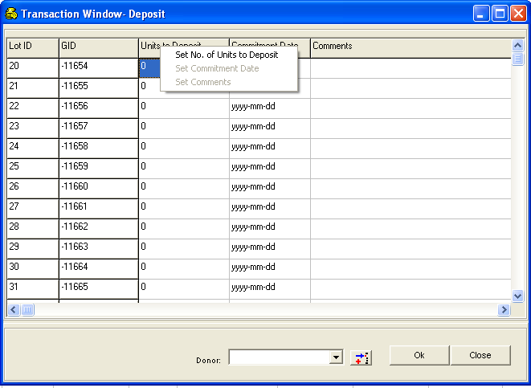

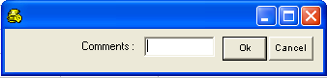
- Click on the enabled sub-menu item to display a small window where data can be entered.
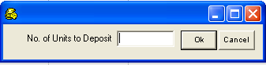
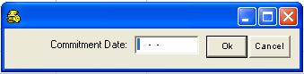

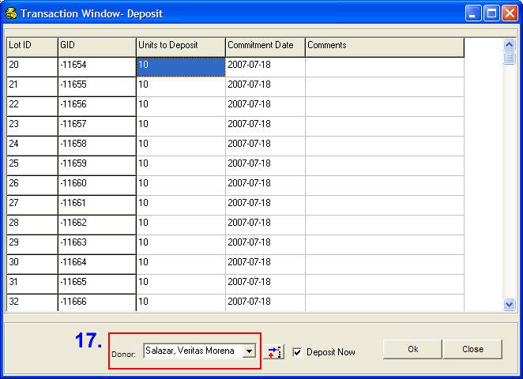
19.

- When you want to assign a donor for this transaction, select an item from the Donor drop-down list.
- The system will show a confirmation message on sending an email request to the administrator.

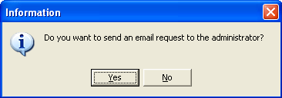

- Click on <No> to continue without sending an email message to the administrator.
- Click <Yes> a Send Email confirmation window displays, select recipient from the drop down arrow <To> and click <Add> then <Send Mail> button.
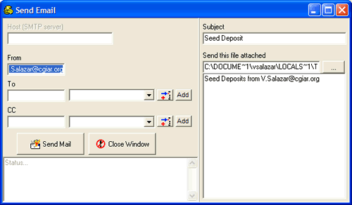

- Click on <Ok> to save changes to the database. The Transaction Window closes and the system goes back to the Inventory Tracker window. Check for Seed Deposit attachment in your mailbox.

C. Committing Transactions
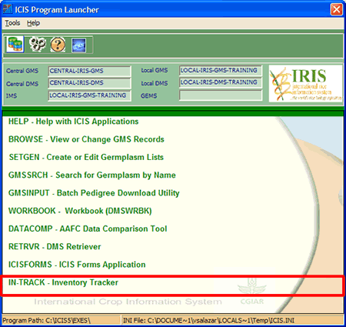
- Close the SetGen Application. Open InTrack from the Launcher.
- Select <Security><LogOn as Administrator> from the menu.

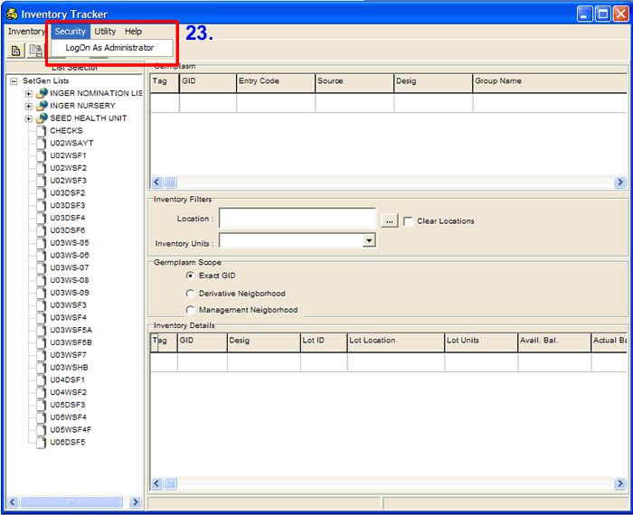
25.

- The Administrator LogOn window appears. For the purpose of this training, the administrator’s username and password are provided. Click on the <Ok> button to access the Administrator form.

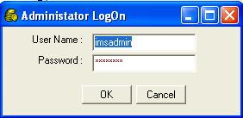

- Select the U06DSF₅ from the List Selector (click). Select <Inventory> <Retrieve> <Deposits> from the menu. The deposit transactions are retrieved on the Inventory window.

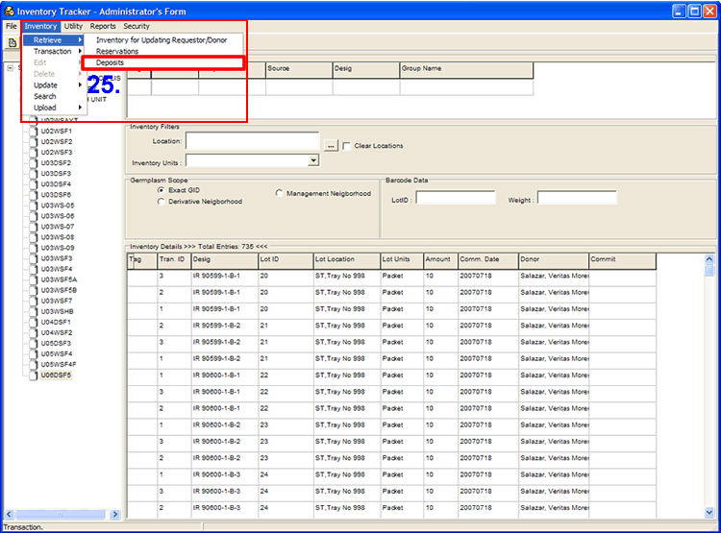
27.

- Right-click on the <Commit> header then select <Commit All> from the pop-up menu to commit all transactions. You will notice that the column is filled with ‘Yes’, meaning these records are ready for commitment.

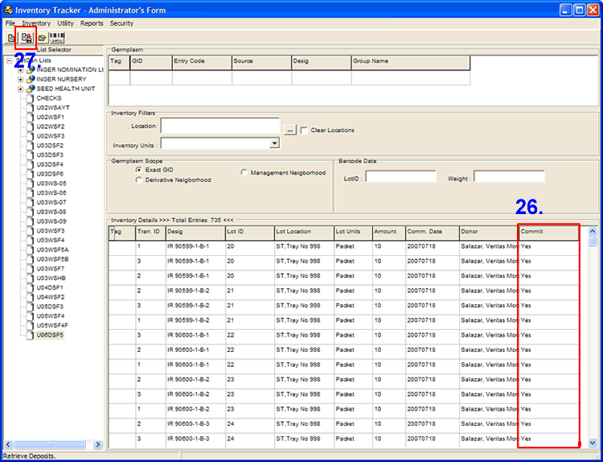
29.
28.

- Click on the <Save> button to commit these transactions. An information window is displayed specifying the total number of transactions processed, the number of successful transactions and the number of transactions that failed.

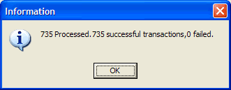

- Select U03WSHB from the List Selector.

- Select <Inventory> <Retrieve> <Reservations> from the menu. The reserve transactions are retrieved on the Inventory window.
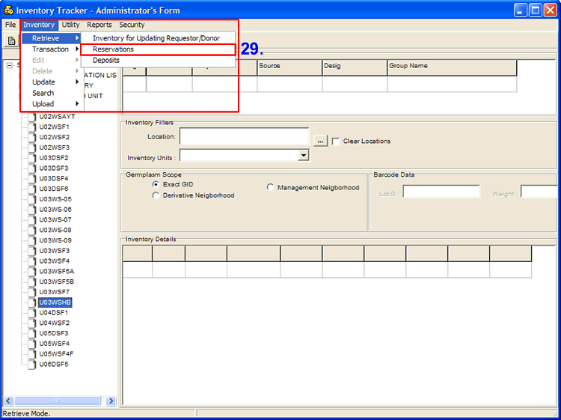
31

- Right-click on the <Commit> header then select <Commit All> from the pop-up menu to commit all transactions. You will notice that the column is filled with ‘Yes’, meaning these records are ready for commitment.
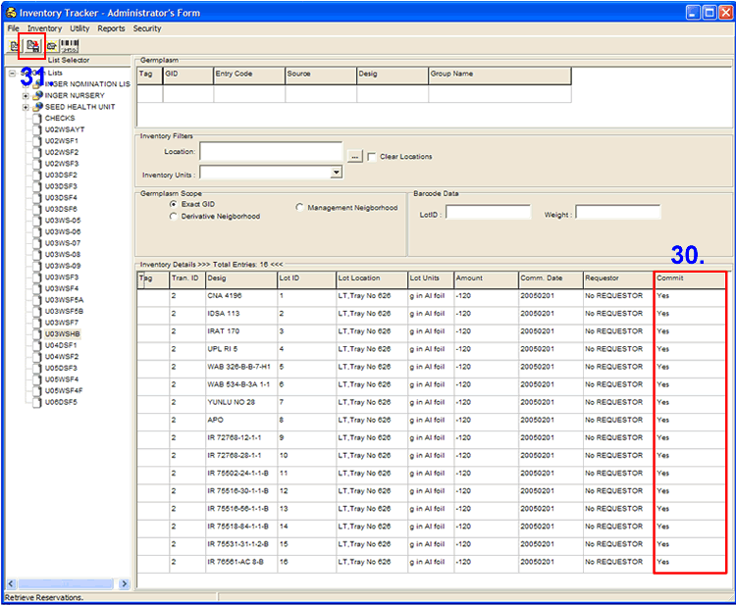
33.
32.

- Click on the <Save> button to commit these transactions. An information window is displayed specifying the total number of transactions processed, the number of successful transactions and the number of transactions that failed.

D. Viewing seed stock through the Reporting Tool.

- Without closing the Inventory Tracker window, select <Reports> <Empty Lots> from the menu.
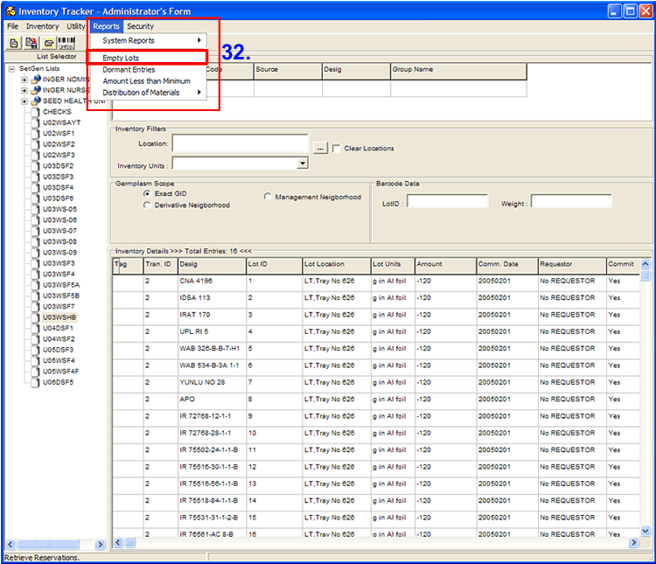
34.

- The system will display a Report Form. You can choose from the toolbars if you want to Show Report, Preview or Print. MS Word format is also created from here, you can edit the layout of the report like the header, footer, page number et al. You can print the report the usual way as printing word documents.
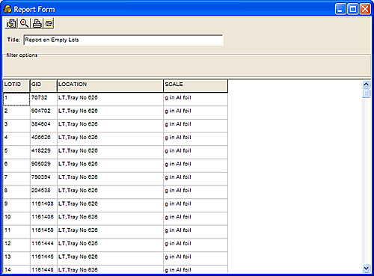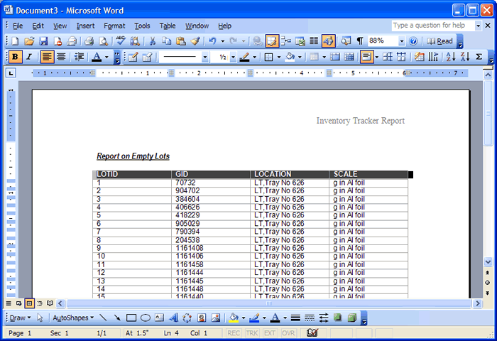

E. Generating and Printing Barcode Labels
Generating and printing barcode labels is done by :
(a) selecting an item from the List Selector,
(b) tagging on items on the List Data window,
(c) clicking on the Retrieve Inventory button on the toolbar to display inventory information on the Inventory Details window,
(d) tagging on items on the Inventory Details window,
(e) and clicking on the Generate Barcode button on the toolbar.
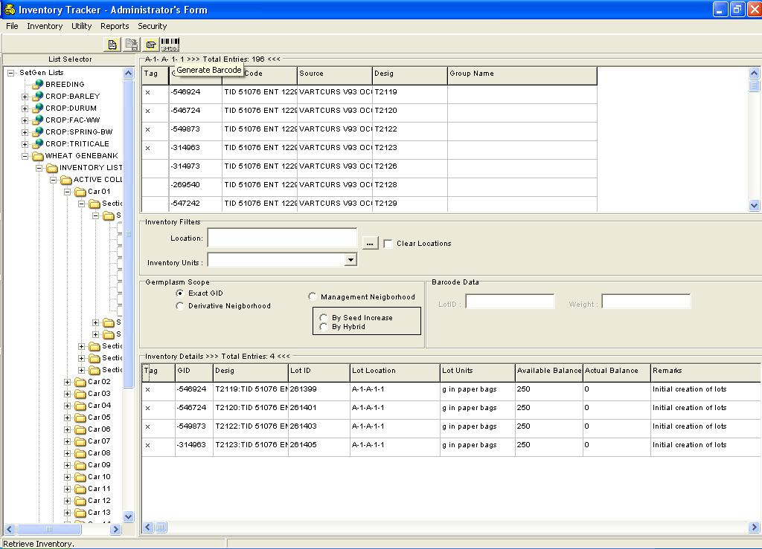

The IMS Barcode Generation Window displays.
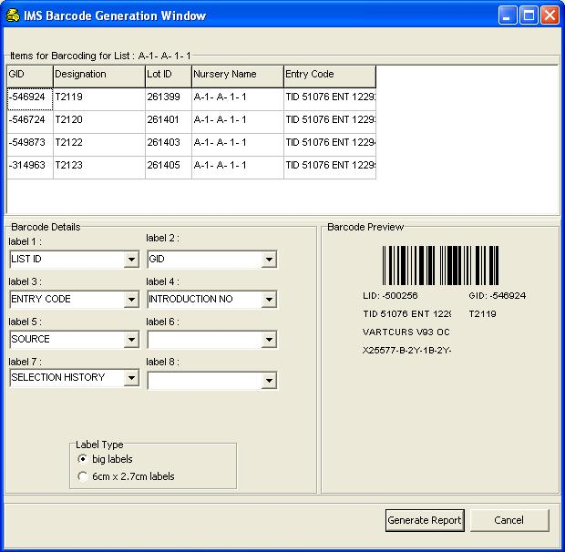
This window is divided into three parts:
- The first part is the Items for Barcoding list which displays all the items selected from the previous window.
- The second part, found on the lower left-hand side, is the Barcode Details window where the layout is designed by specifying the position of the barcode label text. This is done by selecting from the pull-down windows the text to be printed. It also provides the type of labels to choose from – big labels or 6cm x 2.7cm labels(please take note that these are the available sizes at the moment).
- The third part is the Barcode Preview window found on the lower right-hand side which gives the user an idea on how the barcode would look like when printed.
To start with barcode label generation and printing, do the following :
- Design the barcode label by selecting label items on the provided dropdown windows.
- Select a label type on the Label Type radiogroup.
- Click on the Generate Report button to continue. Otherwise click on the cancel button to abort the operation.
When opting to continue, a confirmation window will display
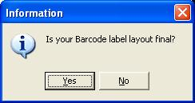
Clicking on the No button will abort the operation while clicking on the Yes button will display an Output Options window.
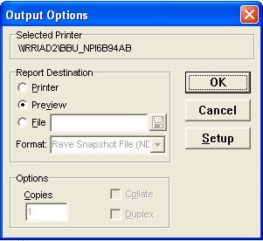
Click on the OK button to preview the report before printing.A Report Preview window will appear on screen.
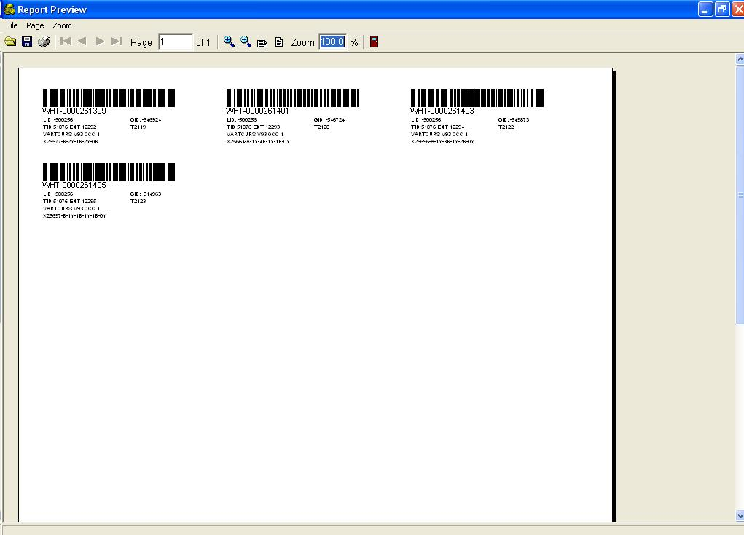

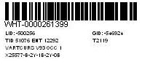
The barcode combines the PREFIX (retrieved by the system from the [IMS] section of the INI file) with the LOTID; together they constitute the unique identifier for many records in the IMS database. In theory, this combination identifies a sample of biological materials across crops.
Close the Report Preview window. Then select Cancel button from the IMS Barcode Generation Window to go back to the Inventory Tracker - Administrator's Form.

