19 Checking your ICIS installation using the Diagnostic Tool
Objective: At the end of this tutorial, the user should know how to detect & correct common problems in an ICIS installation that may cause application errors and/or failure.

EXERCISE 1: CONFIGURATION TEST
1. Select the configuration file (.INI):
i. Click the “Change…” button to change the .INI file.
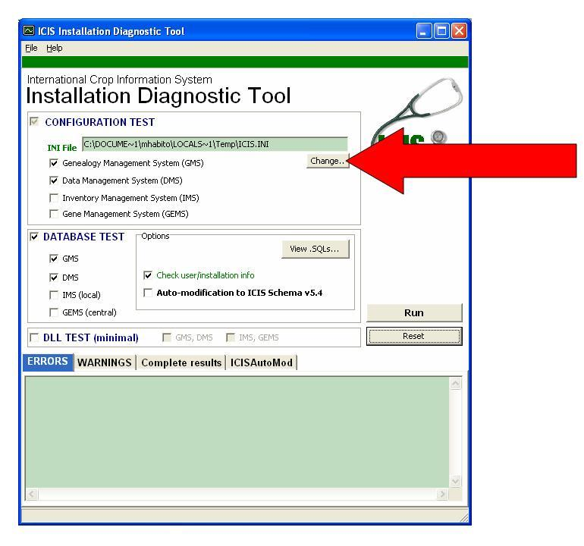
ii. Select “Training.ini”, then click the “Open” button.
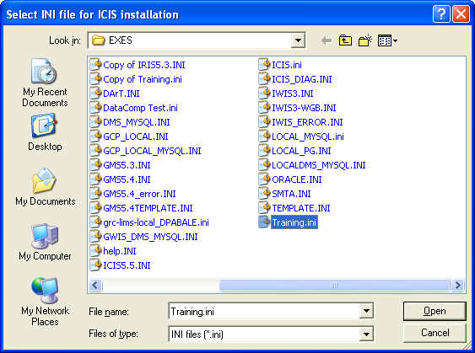

2. Select the databases to include in the Configuration Test
i. Select all four checkboxes: Genealogy Management System (GMS), Data Management System (DMS), Inventory Management System (IMS), and Gene Management System (GEMS).
ii. Deselect the “Database Test”.
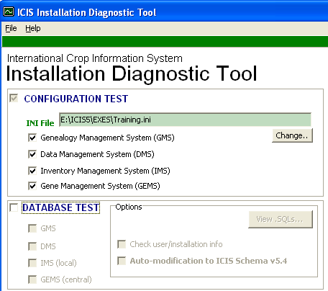
iii. Click the “Run” button.
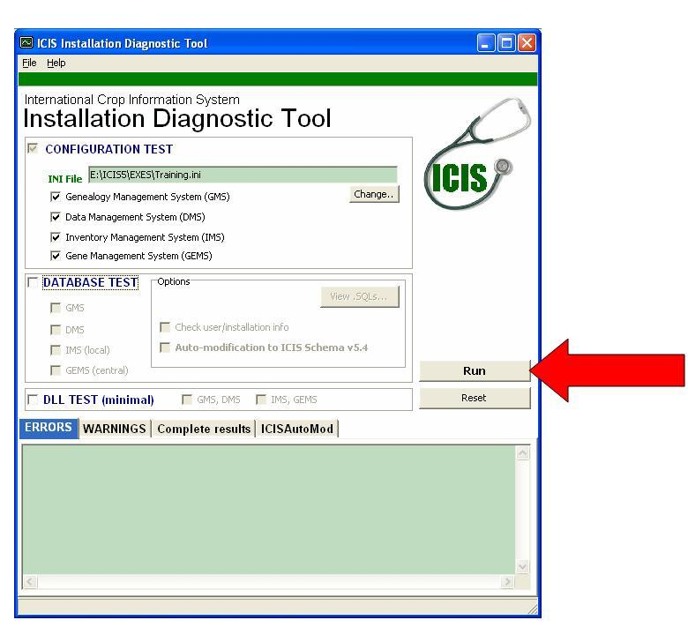
3. Read the results.
i. Go to the “Complete results” tab at the bottom of the form (3rd tab from the left).
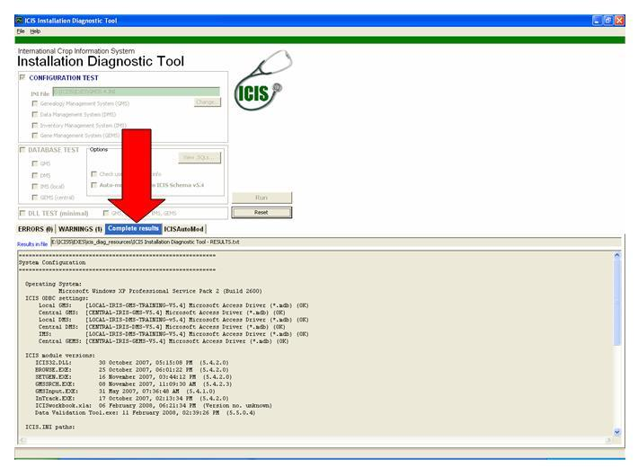
(Note: Results of the Configuration Test, Database Test, and DLL Test are all displayed here. Your ICIS installation must pass the Configuration Test before proceeding with the other tests.)
ii. Look under “ICIS ODBC settings”.
a. What is the datasource name (DSN) of the Central GMS? ____________________
b. What kind of ODBC driver is associated with the Central GMS? ______________
__________________________________________________________________
iii. Look under “ICIS module versions”.
a. On what date and time was SetGen (SETGEN.EXE) last modified? ____________
__________________________________________________________________
b. What is the version no. of SETGEN.EXE? (Enclosed in parentheses) __________

iii. Look under “ICIS INI paths”. Are they all “OK”?

EXERCISE 2: DATABASE TEST
- Click the “Reset” button.
- Change the INI file to “Training_DB.INI” .
- Click the “View .SQLs…” button under the Database Test.
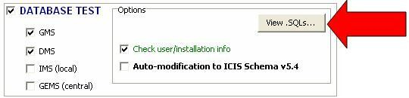
- Clicking the “View .SQLs…” button displays the name and location of the .SQL files containing the schema template for each database.
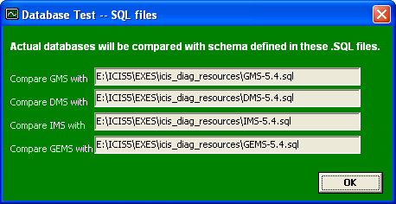
- Under “Configuration Test” and “Database Test”, select GMS and DMS. For the meantime, deselect the “Check user/installation info” option.
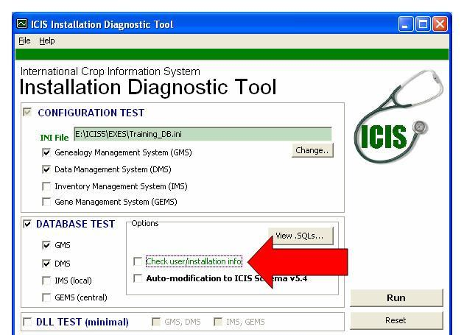
- Click the “Run” button.
- Read the results.
  - For easier viewing of results, errors & warnings are also displayed separately in their own tabsheets. Errors (critical issues) are displayed in the leftmost tabsheet, while warnings (less critical issues) are displayed in the second tabsheet from the left.
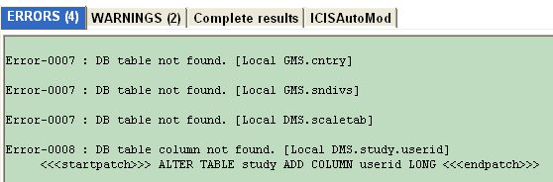

  - If we check the underlying database of the Local DMS (Training_DB.mdb), we can see that the STUDY table does not have a USERID field.
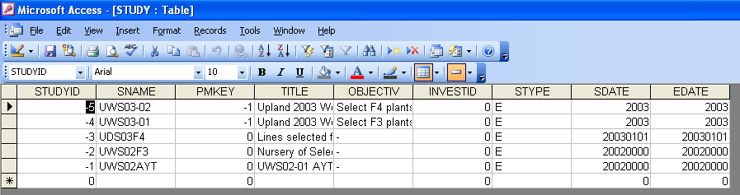

EXERCISE 3: AUTO-MODIFICATION OF ICIS DATABASES (ICISAutoMod)
- Click the “Reset” button.
- Change the INI file to “Training_DB.INI” .
- Under “Configuration Test” and “Database Test”, select GMS and DMS.
  - Deselect the “Check user/installation info” option.
  - Select the “Auto-modification to ICIS Schema v5.4” option.
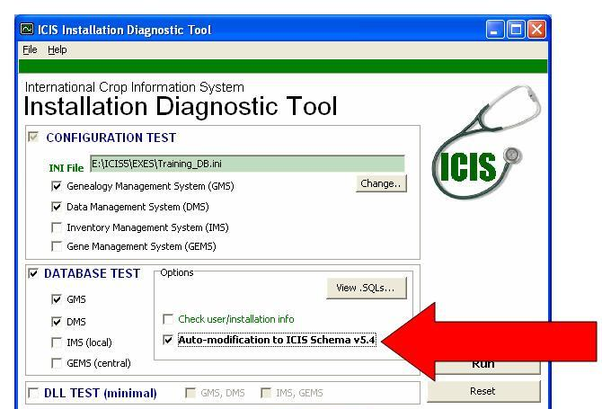
- Click the “Run” button.
- Read the results.
  - According to the ICISAutoMod Log message (in the “Errors” tabsheet), the missing field USERID has been created on table STUDY.
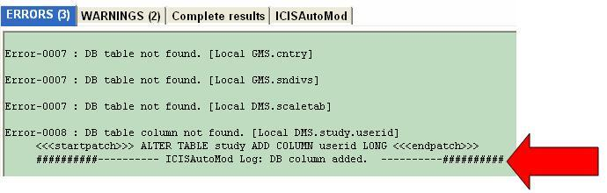

  - All successful auto-modification activities are also logged on a separate tabsheet (Fourth tabsheet from the left).
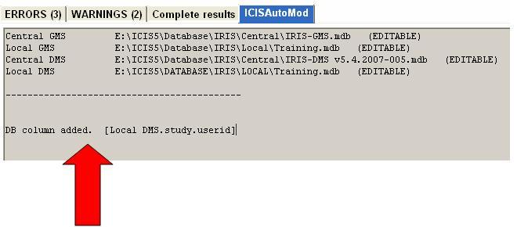
  - If we check the underlying database for the Local DMS, we can see that the STUDY table now has a USERID field.
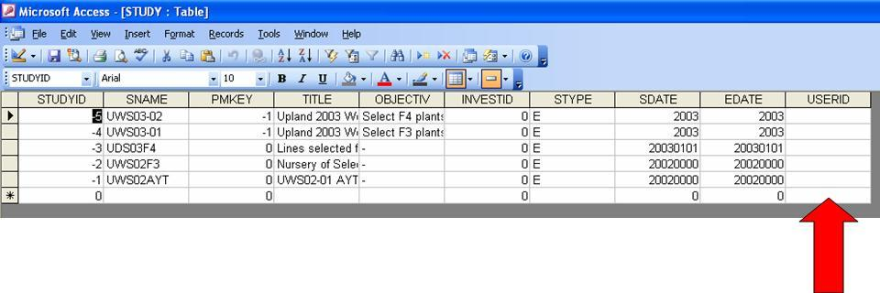

EXERCISE 4: ERROR CORRECTION and the DLL TEST
1. Check the INI file and the local database
- Go to the ICIS Launcher. Change the INI file to “Test1.INI”, then run the Workbook application.
- Is the launching of Workbook successful? What message is displayed?
__________________________________________________________________
__________________________________________________________________

- Launch/reset the Installation Diagnostic Tool. Change the INI file to “Test1.INI”
- Select the “Configuration Test”, and deselect the “Database Test”. Click the “Run” button.
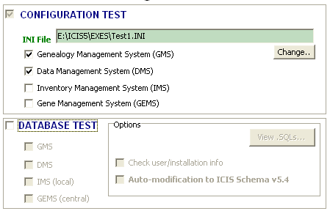

v. Were there any problems detected? If yes, state the problem(s): _______________
__________________________________________________________________
vi. What should be done to correct the detected problem(s)? ____________________
__________________________________________________________________

vii. After corrections, go to the ICIS Launcher again. Change the INI file to “Test1.INI”, then run the Workbook application. The application should start up successfully this time.
2. Check USERS and INSTLN information. Data in the USERS and INSTLN tables in both local GMS and central GMS are very important to your ICIS setup.

Example Case 1: Local GMS check
- Go to the ICIS Launcher. Change the INI file to “Test2.INI”, then run the Browse application.
- Is the launching of Browse successful? What status message is displayed?
_______________________________________________________________
_______________________________________________________________

- Launch/reset the Installation Diagnostic Tool. Change the INI file to “Test2.INI”
- Select all three tests: Configuration, Database and DLL. “Check user/installation info” should be selected. Click the “Run” button.
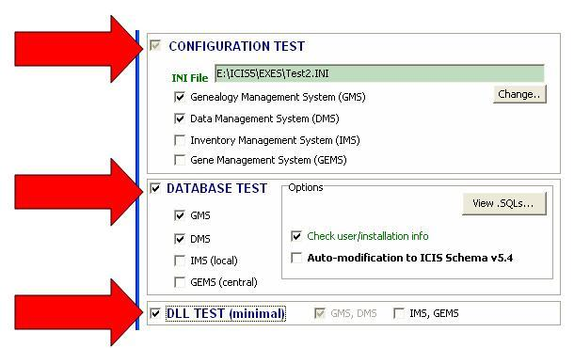
- Read the results. Are there any error messages related to the USERS/INSTLN tables? If yes, what are the error codes associated with them? _____________
_______________________________________________________________
_______________________________________________________________

- The DLL test confirms the status message displayed by the Browser earlier.
  - What is the error code for DLL-related issues? Error-__________
  - An ICIS DLL function returns an integer value. What is the resulting value? __________

- Open the MS Access database associated with the local GMS (Training2.mdb).
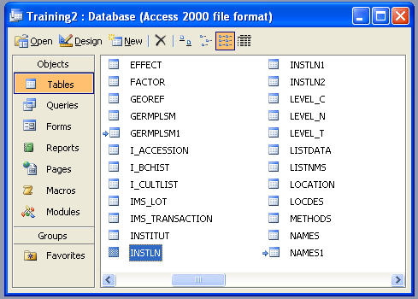
- View data in the INSTLN table. What is the installation ID (INSTALID)? __________
- View data in the USERS table. What is the installation ID? _________
- For a correct ICIS setup, the installation ID in the USERS table must have a corresponding INSTLN record with the same installation ID.
- To correct the error: Change the USERS.INSTALID to the INSTALID in the INSTLN table.

- After corrections, go to the ICIS Launcher again. Change the INI file to “Test2.INI”, then run the Browse application. The application should start up successfully this time.
Example Case 2: Cross-checking between local and central GMS
- Go to the ICIS Launcher. Change the INI file to “Test3.INI”, then run the SetGen application.
- Is the launching of SetGen successful? What status message is displayed?
___________________________________________________________
___________________________________________________________

  - Launch/reset the Installation Diagnostic Tool. Change the INI file to “Test3.INI”
  - Leave the default settings as they are. “Check user/installation info” should be selected. Click the “Run” button.

  - Read the results. Are there any error messages related to the USERS/INSTLN tables? If yes, what are the error codes associated with them? __________________________________________________________
__________________________________________________________
__________________________________________________________

  - The DLL test confirms the status message displayed by SetGen earlier.
    - An ICIS DLL function returns an integer value. In this case, what is the resulting value? __________

  - Open the MS Access database associated with the local GMS (Training3.mdb), and the central GMS (IRIS-GMS).
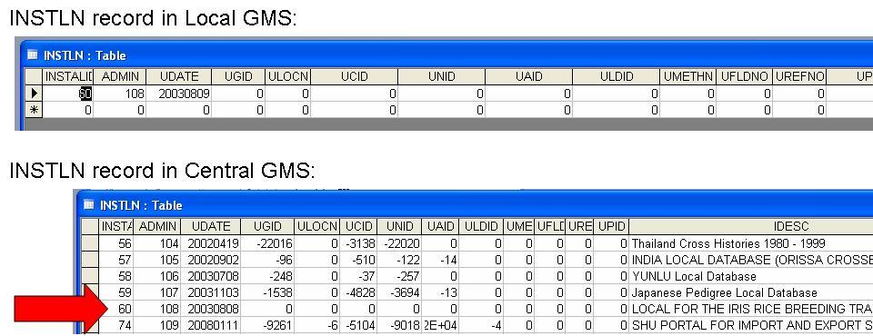

    - View the INSTLN table in the local GMS.
    - View the INSTLN table in the central GMS. Look for the record with installation ID equal to the installation ID in the local GMS.INSTLN table.
    - For a correct ICIS setup, the INSTLN record in the local GMS must be identical to its corresponding INSTLN record in the central GMS for every table column.

    - What is/are the problematic table column(s) in our setup?
______________________________________________________

    - To correct the error: change the data in the specific table column(s) indicated by the Diagnostic Tool.

  - After corrections, go to the ICIS Launcher again. Change the INI file to “Test3.INI”, then run the SetGen application. The application should start up successfully this time.

