14. Querying the ICIS database through ICIS Retriever

Objective: At the end of this tutorial, the user can
- Link ICIS databases to Retriever
- Retrieve a dataset of a Study
- Retrieve data about the entries in the list.
- Build a query by describing the criteria and properties or traits of interest.
- Use the different types of Data Retriever queries: main query, sub-query and aggregate query.
- Format a query in parallel
- Create a SetGen list from a query
- Retrieve a SetGen list and used as criteria to a main query.

- Link ICIS databases to Retriever
Exercise: Link the IRIS central databases and the training database.
Tutorial Steps
- Run DMS Retriever from Launcher. (See Chapter II Section A.8 of the technical documentation of ICIS for extensive discussion of the DMS Retriever).
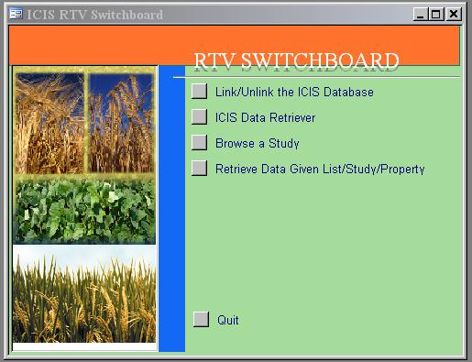

- On the Switchboard form, click “Link/Unlink the ICIS database”
- Then, select “MS Access Database.”
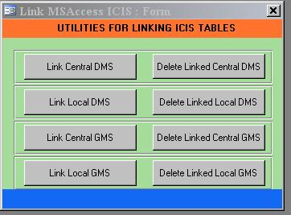
- Click “Link Central DMS” button.
- Go to the ICIS\Database\IRIS\Central folder and select IRIS-DMS.mdb
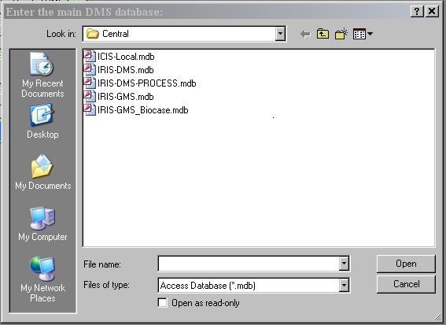
- Similarly, do steps 4 and 5 to link Central GMS, selecting IRIS-GMS.mdb
- Click “Link Local DMS” button
- Go to the ICIS5\Database\Training folder and select IRIS-GMS.mdb
- Similarly, do steps 4 and 5 to link local GMS
- Close the “Link MS Access” form.
- Click “Return to Main Menu” button on the Switchboard.

- Retrieving data set of a Study.
Exercise: Retrieve data of a local and a central Study
Tutorial Steps:
- Return to the Main Menu of the Switchboard
- Click the Browse a Study button
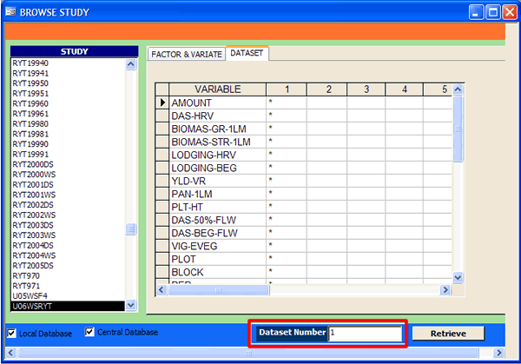
- Select the Study U06WSRYT
- Click the tab Data Set
- Determine the data set where GID is marked with *. In this exercise, the data set number is 1.
- Enter that number on the text box beside Dataset Number.
- Click Retrieve.
- A table named BROWSE-STUDY containing the retrieved data will be displayed. After viewing the data, close the table
- Select the Study IURON-1998. You will notice it contains several data sets. One set is for the environment profile of the location, the other one is the climate data. There is also another one for the evaluation data of the entries.
- To retrieve the climate data of the different locations of that trial, enter the Data set number where MONTH, RAINFALL, RAINDAYS, MINTEMP, MAXPTEMP variables are marked with * on the textbox beside Dataset Number. In this exercise, the data set number is 3.
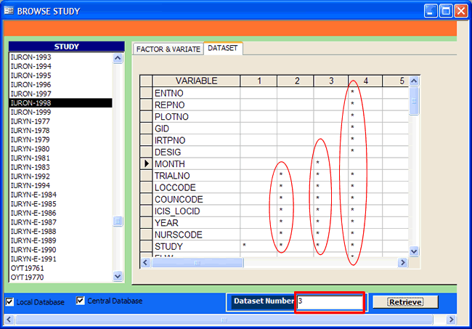

- A table named BROWSE-STUDY containing the retrieved data will be displayed. After viewing the data, close the table
- To retrieve the evaluation data of the entries of that trial, enter the Data set number where ENTNO, IRTPNO, GID etc are marked with *. In this exercise, the data set number is 4.
- Close the BROWSE-STUDY table and form.

C. Retrieve data about the entries of a list.
Exercise: Select U03WSHB list and retrieve all data about it in the DMS database
Tutorial Steps:
- On the Main Menu of the Switchboard, click “Retrieve Data Given Study/List/Property” button
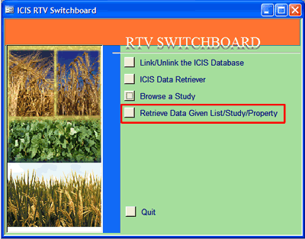
- On the succeeding menu, click “Any of the Germplasm is tested in the study” button.
- Select U03WSHB from the LIST_NAME selection box. Then click Select.
- Under PROPERTY section, select all properties by clicking ALL.
- Under STUDY section, select all studies by clicking ALL.
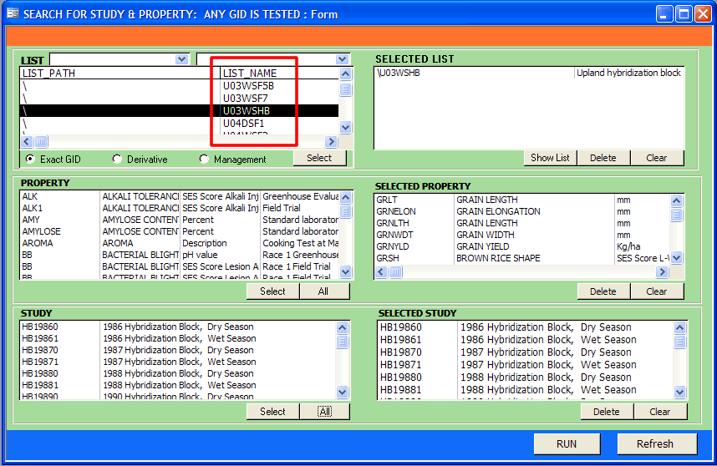
- Then, click the RUN button.
- Close the “SEACH FOR STUDY & PROPERTY: ANY GID IS TESTED” form
Exercise: Retrieve the data from a study where all entries in INGER Nursery\IURON 1998 list were tested.

- On the Switchboard form, click “All Germplasms are tested in the Study” button.
- Under LIST section, go to the INGER Nomination list path and highlight the 1998 list name. Click Select button.
- Under PROPERTY section, select all properties by clicking ALL.
- Under STUDY section, click the ALL button.
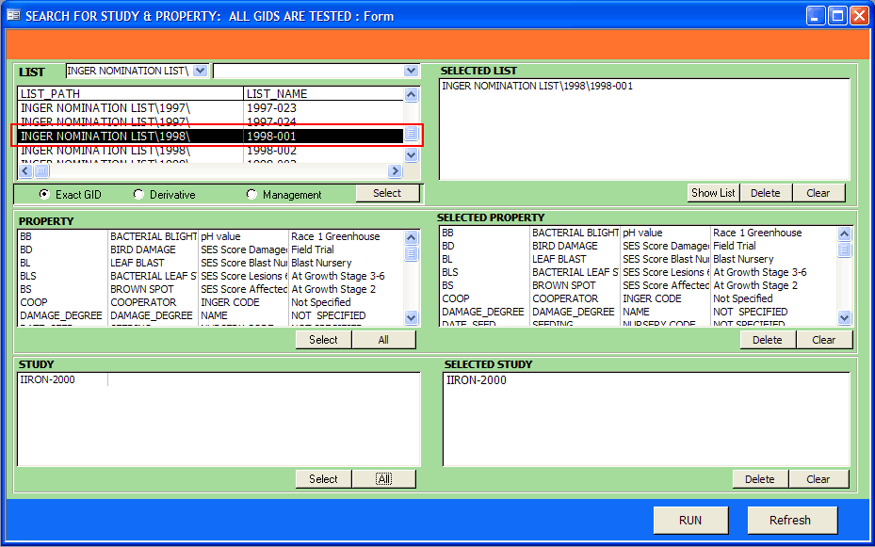
- Then, click the RUN button.
- Close the “SEACH FOR STUDY & PROPERTY: ALL GIDS ARE TESTED” form
- Click “Return to Main Menu” on the Switchboard.

D. Building a Main Query
Exercise: Compare the grain yield of varieties tested in RYT19960 and RYT19961.
Tutorial Steps:
- Click “ICIS Data Retriever” on the main menu of the Switchboard form.
- Click the button “MAIN QUERY”.
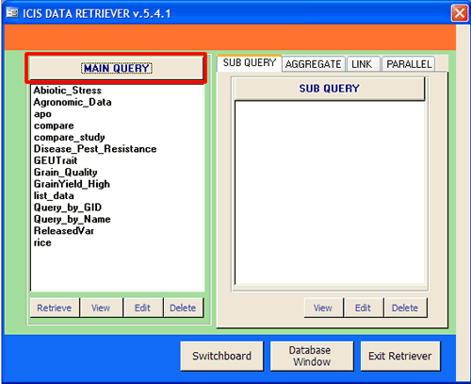
- Specify the main query characteristics
Main Query Name: In the search name field, enter a name for the query to create. For this tutorial, enter “Compare_Study.”
Query Date: In the date field, the current date and time appears as the default query creation data. For this tutorial, do not change the default date
Query Description: If desired, document the query by describing it in the description field. Enter “Compare the grain yield of varieties tested in two studies.”
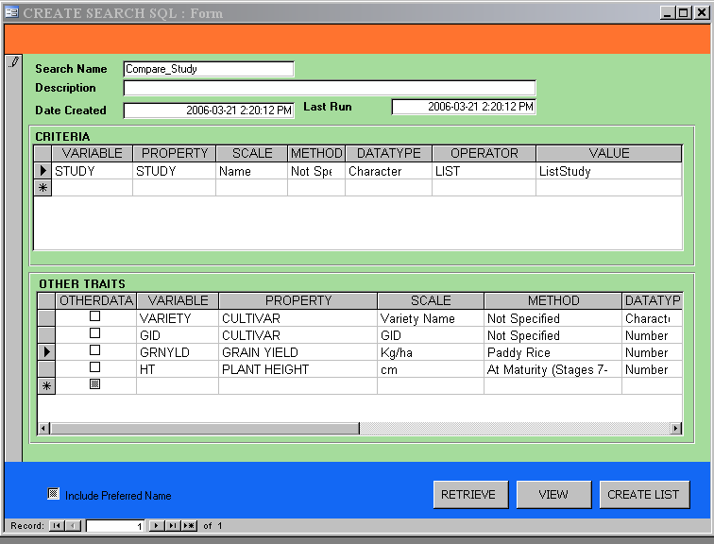
- Describe Criteria. Specify in this section the known information of the query problem. A criterion includes a variable name and the associated trait, scale, method, data type and value. (Refer to Chapter III.A.4 of the technical documentation of ICIS for the explanation of the Trait, Scale and Method).
VARIABLE: Under the variable column, specify a variable name for the known information. The name should have no blank character in between letters. Enter STUDY under this column since the query problem provides the trial name.
TRAIT: Specify the general property or trait of the variable under the trait column. A default trait is given based on the entered variable name. For this exercise, verify it is STUDY, else select it from the list.
SCALE: Specify the measurement unit under the scale column. A default scale is given based on the entered variable name. For this tutorial, verify it is Name, else select it from the list.
METHOD: Specify the appropriate method that defines how the specified variable is measured or applied. A default scale is given based on the entered variable name. For this tutorial, verify it is Not Specified, else select it from the list.
DATA TYPE: If the value of the specified variable is numeric, select Number from the pick list under the data type column; otherwise, select Character. For this exercise, select Character.
OPERATOR: Specify an operator to restrict the data values to retrieve. Under the operator column, select a desired operator. If there are several values like entries of germplasm list, select LIST. For this tutorial, select LIST.
VALUE: Specify a restricting value or the information indicated from the query problem. If there are several values, specify a table name that contains the values (a table can be created by double clicking on the name). For this exercise, enter “ListStudy.” Move the cursor on the cell below OPERATOR. Then, double click on ListStudy and a table is shown. Enter “RYT19960” and “RYT19961” on two rows.
For each criteria or known information of the query problem, add another row in the Criteria window and repeat this step.
- Describe Other Traits: Describe variables to retrieve in the “Other Traits” window. Specify each variable to retrieve. For each variable, repeat the process described in step 4 for indicating the variable name, trait, scale, method and data type.
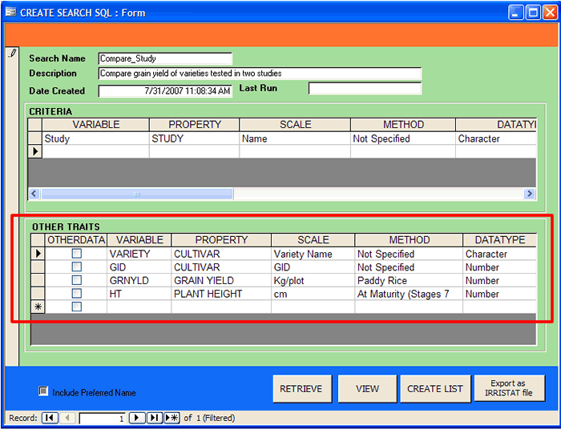
For this tutorial, retrieve three other variables: Variety, GID, GRNYLD, and HT. Describe each of these in the Other Traits window. See the above figure for details.
- Retrieve the data. When all traits in the “Criteria” and “Other Traits” window have been specified, click <Retrieve Data> to run the query and retrieve data from the DMS. The result of the query is a table named after the search name. The query is added to the main query listbox of the Data Retriever.
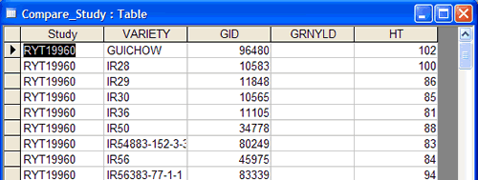
- Close the Compare_Study table and the “CREATE SEARCH SQL” form to return to the Data Retriever screen.

E. Building a Sub Query

A sub query is built from the main query. It creates a subset of that query based on criteria.
Exercise: Determine the varieties with grain yield greater than 8000 from the main query “Compare_Study”.
Tutorial Steps:
- Click the <Sub Query> tab on the ICIS Data Retriever form, followed by the <Sub Query> button in the ICIS Data Retriever window
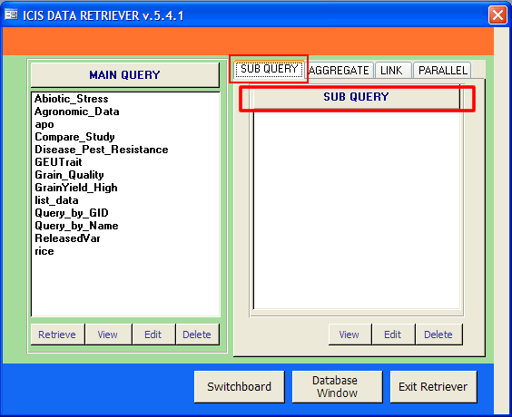
- Specify sub query characteristics.
SUB QUERY NAME: Specify an appropriate name for the sub-query. Enter it in the sub-query field. For this tutorial, type Sub_HighYield.
MAIN SEARCH: Specify the main query to build a sub-query on. Select the main query name from a pick list in the main search field. For this exercise, select Compare_Study.
DESCRIPTION: If desired, document the sub-query by describing it in the description field. For this exercise, type “High yielding varieties from the Compare_Study query.”
- Describe criteria. Describe a criterium in the Restricting Variables window. For each criterium, specify the following characteristics: variable, operator, and value.
VARIABLE: Specify a variable to subset a query. Select a desired variable from the pick list under the varname column. For this tutorial, select GRNYLD.
VARIABLE OPERATOR: Specify the operator to subset a specified main query by. Select the operator from the pick list under the operator column. For this tutorial, scores less than or equal to three indicate a blast resistance score. Select the >= operator.
VARIABLE VALUE: Specify the restricting value to subset a main query by. Enter the restricting value under the value column. For this tutorial, enter 8000.
Repeat this step for each criteria variable to define. For this tutorial, there are no other criteria to include
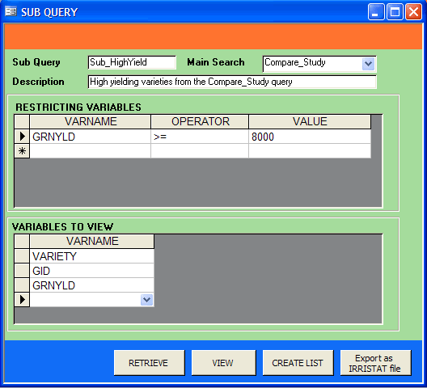
- Specify traits. Specify all variables to include in the output of the sub-query. Specify each variable to include in the “Variables to View” window. For this tutorial, the desired output is grain yield of varieties. Therefore, the variables of interest are: Variety, GID and its yield(GRNYLD).
- Click <Retrieve> to create the sub-query.
- Close the Sub_HighYield query and Sub Query window. Return to the ICIS Data Retriever window. The query name entered in step 2 is added to the list of existing sub-queries in the sub-query tab.

- Building an Aggregate Query
Exercise: Get the average grain yield of varieties in Compare_Study query.
Tutorial Steps:
- Click the <AGGREGATE> tab on the Data Retriever window, then the AGGREGATE> button.
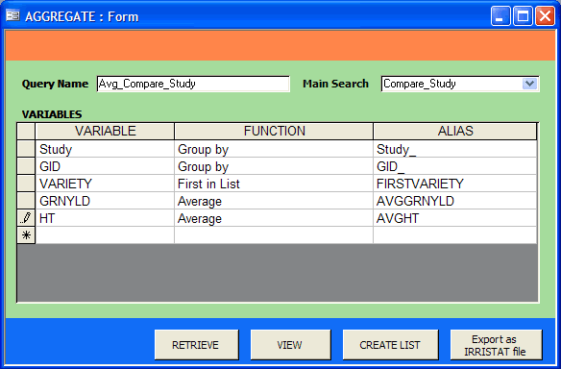
- In the main query field, select a main query from the pick list. For this exercise, choose Compare_Study as the main query.
- In the query name field, type a meaningful name for the aggregate query. Enter Avg_Compare_Study as the name of the aggregate query.
- Describe the variables.
VARIABLE: Select a variable of the main query, which you intend to determine the aggregate values. For this tutorial, select STUDY and GID variables.
FUNCTION: Select an appropriate aggregate function.
NOTE: Not all functions are appropriate to any variable. SUM and AVG functions are only applicable for numeric data. Not all functions included in the list are for determining aggregate values. One special function is the GROUP BY which you usually associate to a variable you want to group your other aggregate values
For the first variable of this exercise, select the GROUP BY function since we want to determine average values by trial and variety.
ALIAS. Enter an alias name for the variable under the ALIAS column. Use an alias name that gives hint to the aggregate function applied on the variable.
- Repeat steps 4 on succeeding rows for other variables you intend to determine the aggregate values. See the above figure for other variables on this exercise.
- Click <RETRIEVE> button to create the query.
- Close the Avg_Compare_Study query and AGGREGATE form.

- Format the Compare_Study data to show the comparative values of varieties in RYT19960 and RYT19961.
Exercise: Compare the grain yield attained by the varieities in RYT19960 and RYT19961 trials.
Tutorial Steps:
- Click the <PARALLEL> tab on the Data Retriever screen, followed by the <Parallel> button.
- Enter an appropriate name in the parallel name box. For this tutorial, enter Par_Compare_Study.
- Select one of the queries to format to parallel arrangement from the list beside Main Query. For this exercise, select Compare_Study.
- Select variables, which will be heading of the rows. For this tutorial, select GID and Variety.
- Select a variable from the list box beside Column Heading, which you intend to arrange in parallel. The values of the selected variable will be the heading of the columns. For this exercise, select STUDY.
- On the list box beside Cell Value, select the variable whose values will be the basis of comparison. For this exercise, GRNYLD.
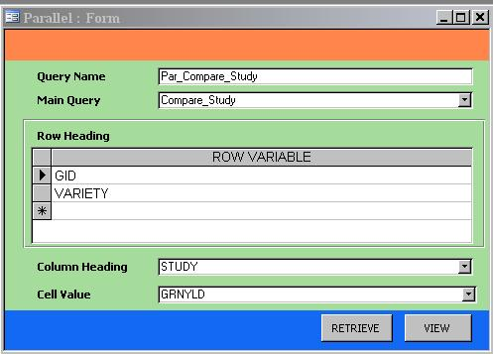
- Click RETRIEVE button.
- Close the Par_Compare_Study query and the PARALLEL form. Return to the ICIS Data Retriever.

- Save the result of a query to a SetGen List
Exercise: Run the GrainYield_High main query and save the entries to a SetGen List.
Tutorial Steps:
- On the Data Retriever , highlight the GrainYield_High main query.
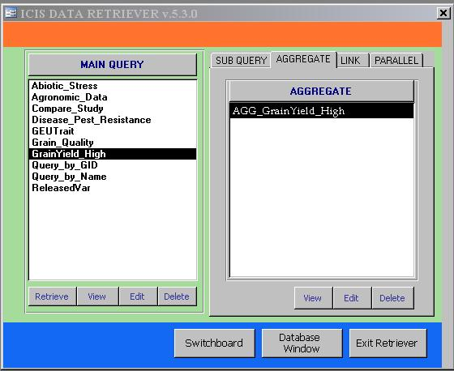
Figure 7. The Data Retrieve form with GrainYield_High query highlighted
- Click Retrieve. Close table displayed after.
- Click AGGREGATE tab and highlight AGG_GrainYield_High.
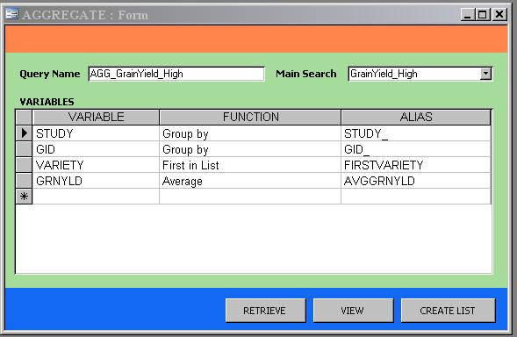
- Click Edit button under the AGGREGATE list of queries
- Click <CREATE LIST> button.

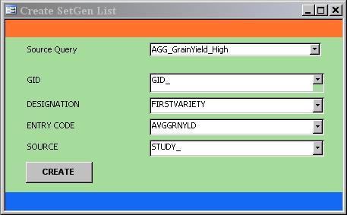
- Verify that the Source Query is AGG_GrainYield_High
- Select GID_ from the list box for GID .
- Select FIRSTVARIETY for DESIGNATION.
- Select AVGGRNYLD for the ENTRY
- Select STUDY_ for the SOURCE label.
- Click CREATE.
- Close the “CREATE SETGEN LIST” and AGGREGATE forms.
- Go to SETGEN and view the created list

- Use a SetGen list as criteria to a defined Query

Exercise: Edit the Agronomic_Data in the <Main Query> and select the U03WSHB list as criteria to the query.
- Go back to the Data Retriever form.
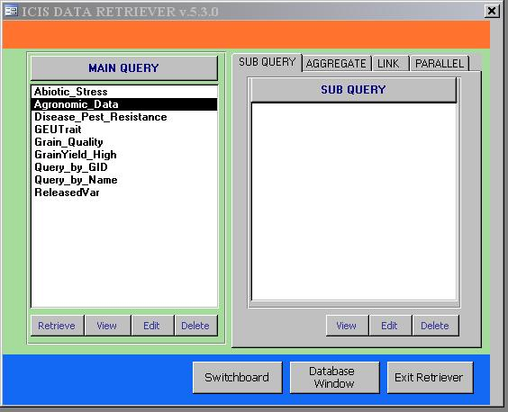
- Highlight the Agronomic_Data <Main Query> and click Edit button
- Go to the CRITERIA section and double click on RTV-LIST which is on the first row under VALUE column.
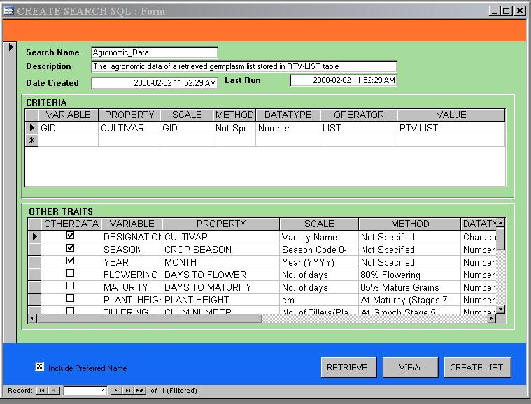

- Select U03WSHB list on the “RETRIEVE GMS LIST OF ENTRIES” form.
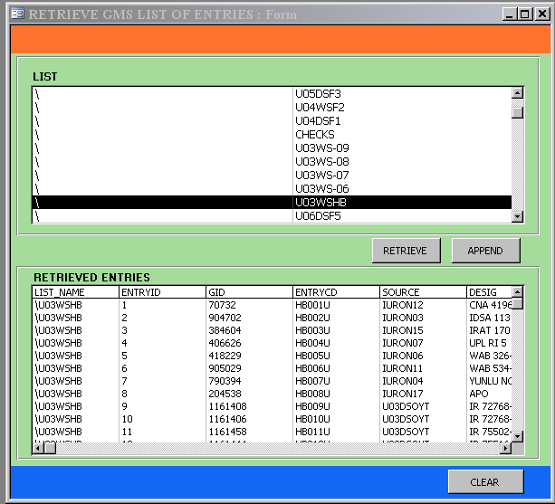

- Click the RETRIEVE button.
- Close the “RETRIEVE GMS LIST OF ENTRIES” form.
- Go back to the “CREATE SEARCH SQL” form and click the RETRIEVE button.

- Try running the other main queries in the Data Retriever or create your own query.

